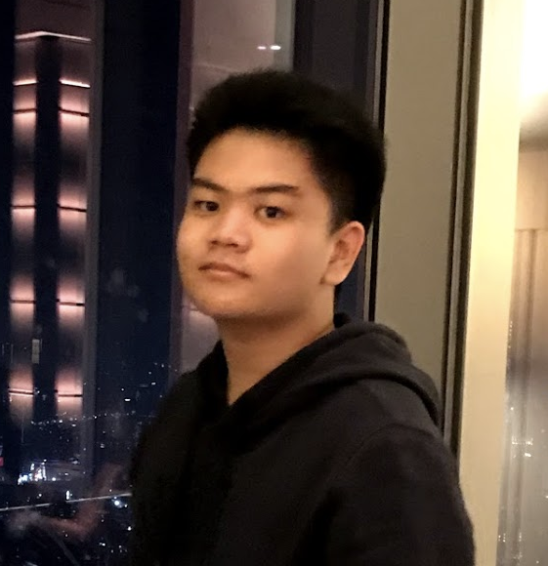

SELF TAUGHT

Face Recognition, Full Stack Social Media, GoogleSearchData Growth with Python, and other 20 projects, all of these have been developed and published.

SMAK 1 PENABUR 2016 - 2018

One of the most prestigious school in Indonesia, place where I gained a lot of connections until I decided to do full time code since I didn’t have any coding background.

BSP 2018

IGCSE

I learnt and took IGCSE curriculum in just 5 months with no international curriculum experience, after I got accepted into UNNC, I invested myself into 10 months to reach the point of mastery.

EDUCATION

Creative Zone - 2019 - Current

Tutor

A community for programming I created, accommodated with discord channel, social media I’ve created, and a website that I developed to put my sources of education and covers Javascript programming language from basic into intermediate. Covers things like ES6, regex, DOM, functional programming, and a lot of my study sources.

EXPERIENCE

EDWARD TANOTO

software engineer apprentice

Profile

T Phone

+62 811 811 8850

E-mail

[edwardt.dev@gmail.com](mailto:edwardt.dev@gmail.com)

Address

Jl Pinisi Permai, North Jakarta,Indonesia, 14460

social

[edwardtanotoo](https://twitter.com/edwardtanotoo)

about me

I am passionate about computer science, and have honed my skills over 20 projects. I am familiar with OOP, module pattern design, time and space complexity, Regular Expression, Version Control such as Github, and unix terminal.

PERSONAL SKILLS

90%

Javascript

80%

Github

80%

Tutoring

90%

%

Python

[edwardtanoto](https://www.linkedin.com/edwardtanoto)

[edwardtanoto.github.io](https://edwardtanoto.github.io)

HTML.CSS

90%

%