Department of Computing
Hong Kong Polytechnic University
Comp 5527 Mobile Computing and Data Management

Laboratory One
(Venue QT402)

This week's lab is designed to help you become familiar with the iOS application development environment and procedure on a Mac platform.

PART ONE : Develop a simple application “Hello world”
In this part, you will learn how to develop an iOS application showing “Hello world” in an iPhone’s screen. Please follow the steps given below.

- Open the development environment Xcode by clicking in the top-right of the screen. Type “Xcode” in searching box and, on the page shown, click .

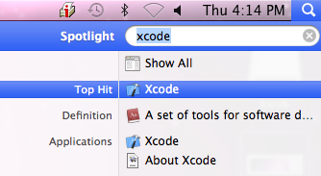

Alternatively you can browser Xcode in the file system using the path Developer/Applications/ Xcode.

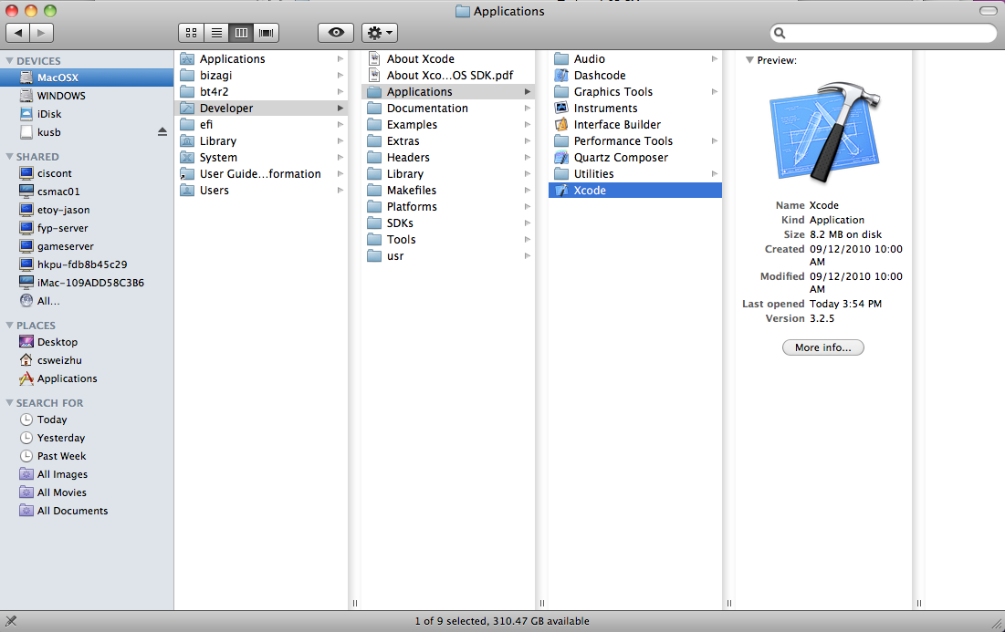

- From the splash screen that appears, click “Create a new Xcode project”.
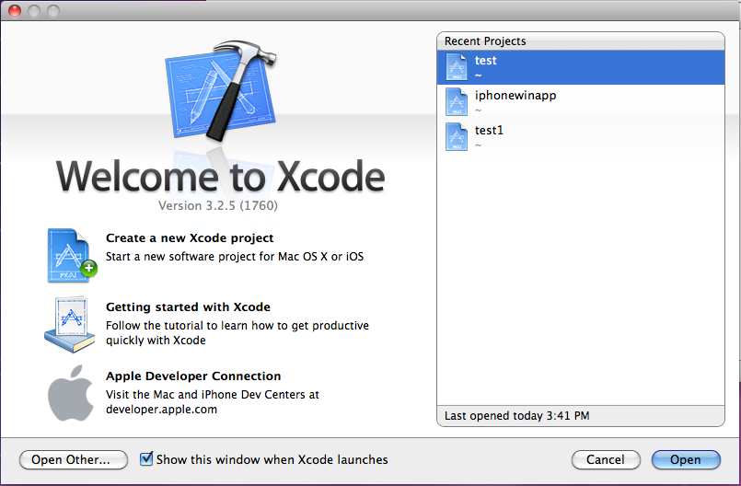
- In the dialog box that appears, select “application” under “iOS” in the left panel, and select “View-based application” in the right panel. Click the button “Next”.
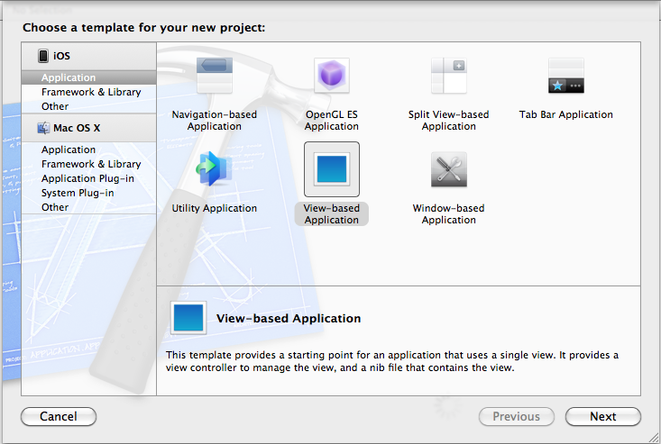
- Type “HelloWorld” as the Product Name and “comp.polyu” as the Company Identifier, then click the button “Next”.

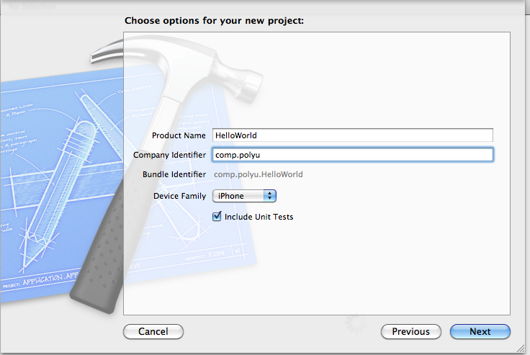
- Select the directory to store your project. Click the button “Create”.
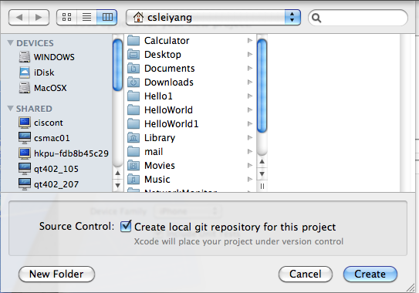
- You will see the main window of the project:

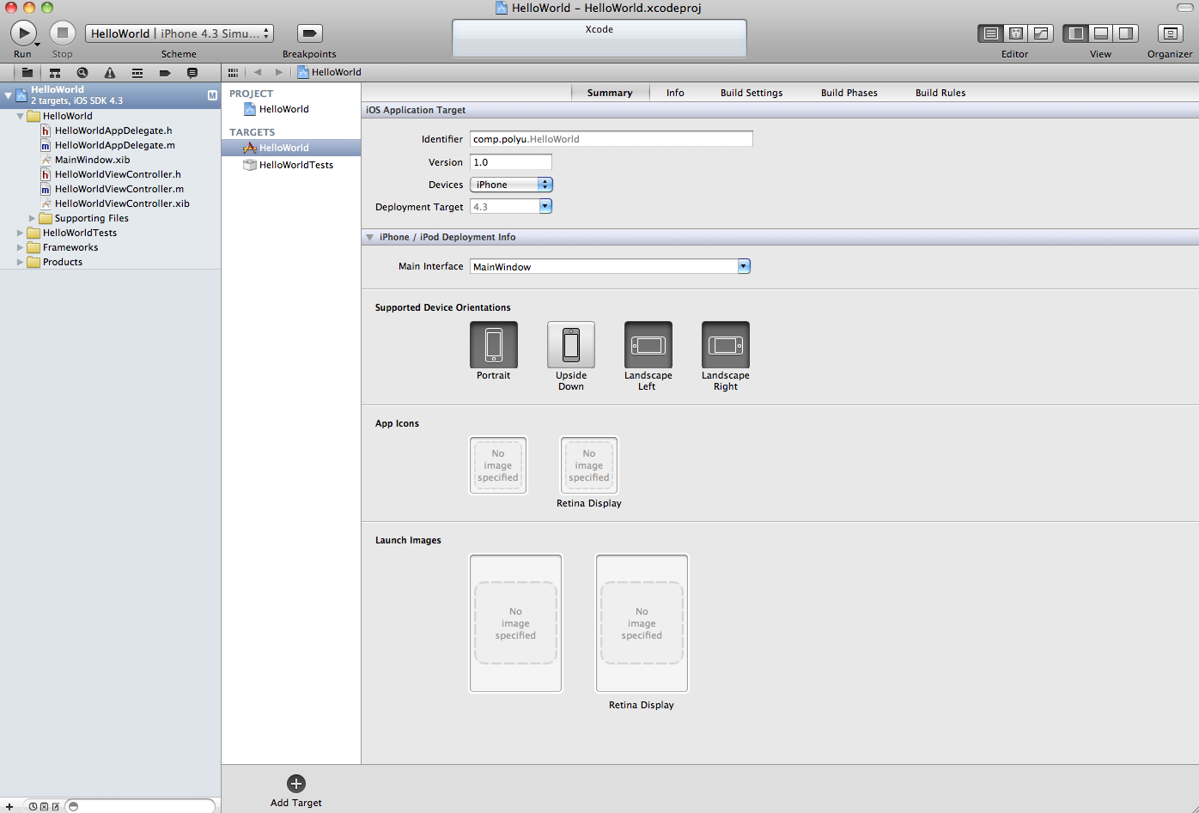

- To run this project, click the button “Run” on the top left corner. The application will be compiled, deployed and run in the iPhone Simulator. Currently, there is no text in the main screen of the simulator.

GE T 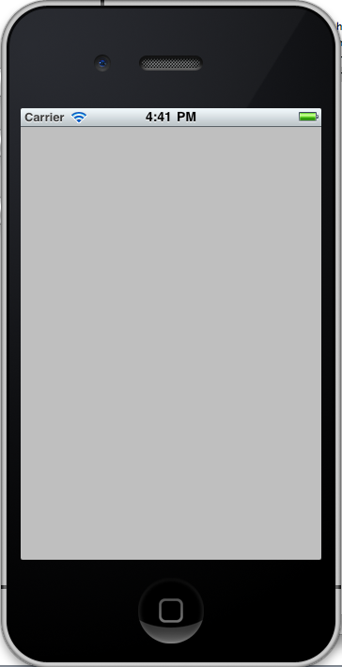

- In the left side panel, click the file “HelloWorldViewController.m” under “HelloWorld”. The content of this file will be shown in the editor panel on the right side.
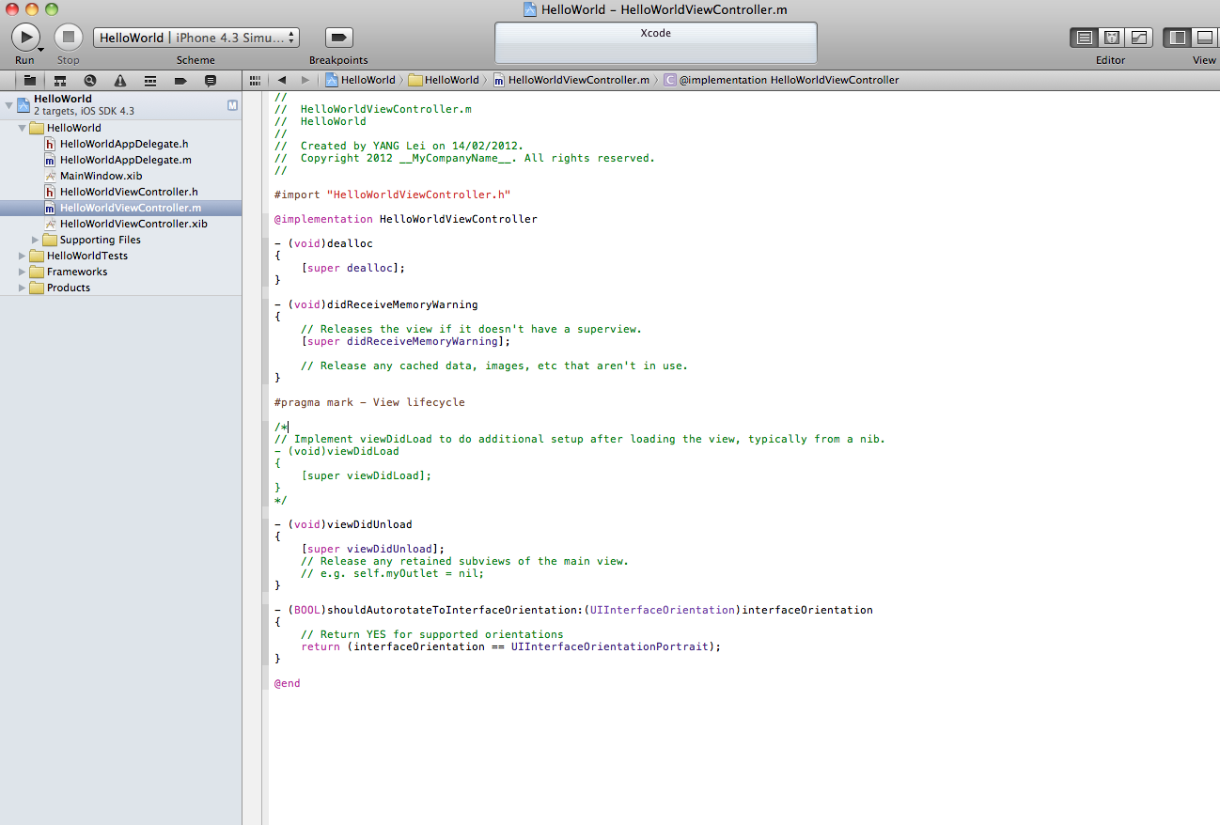

- Find the function named “viewDidLoad” in the editor window. This function is commented by default. Uncomment it and change the content as follows:

// Implement viewDidLoad to do additional setup after loading the view, typically from a nib.
- (void)viewDidLoad {
[super viewDidLoad];

int w=self.view.frame.size.width;
int h=self.view.frame.size.height;

UILabel* label=[[UILabel alloc] initWithFrame:CGRectMake(0, 0, 100, 50)];

label.center=CGPointMake(w/2, h/2);
label.textAlignment=UITextAlignmentCenter;
label.backgroundColor=[UIColor clearColor];
label.text=@"Hello World";

[self.view addSubview:label];
[label release];
}
The above code creates a label in the iPhone’s screen and sets the text of the label as “Hello World”
- Build and run the project again. If “Hello World” is shown in the screen, congratulations that you have finished the first iOS application!
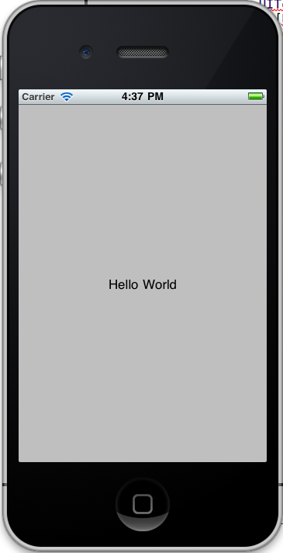

Useful Links:
- Join in the iOS developer program: http://developer.apple.com/programs/ios/
- iOS app development environment setup and iOS app deployment:
http://its.vanderbilt.edu/apple-iphone-developer-program/dev-dep

Further Study:
1) Apple iOS dev center: http://developer.apple.com/devcenter/ios/index.action
2) Stanford iPhone application development (Lecture 1):
http://www.stanford.edu/class/cs193p/cgi-bin/drupal/
- MVC design pattern: Design Patterns Explained: A New Perspective on Object-
Oriented Design (2nd Edition) (Software Patterns Series)
- The model, view, controller song:
http://www.youtube.com/watch?v=YYvOGPMLVDo

