Department of Computing
Hong Kong Polytechnic University
Comp 5527 Mobile Computing and Data Management

Laboratory Two
(Venue QT402)

This week's lab is designed to help you have a better understanding of the MVC design pattern and use Xcode and Interface Builder to develop simple iOS applications.

PART ONE : Develop a simple calculator

In this part, you will develop a simple calculator. This calculator will have ten digit buttons numbered from 0 to 9, a “clear” button and a display. When the user presses any digit button, the number will be shown in the display and when the user presses the “clear” button, the number will be cleared.

Please follow the steps given below.

- Following the steps below, as in the Laboratory One, create a View-based application named Calculator.

1) Open the development environment Xcode by clicking in the top-right of the screen. Type “Xcode” in searching box and, on the page shown, click .
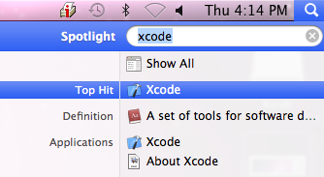

2) From the splash screen that appears, click “Create a new Xcode project”
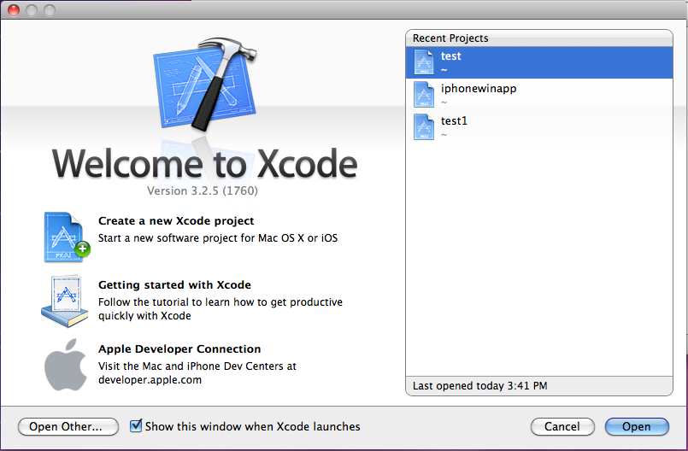
3) In the dialog box that appears, select “application” under “iOS” in the left panel, and select “View-based application” in the right panel. Select “iPhone” in the product dropdown list. Click the button “Choose”.
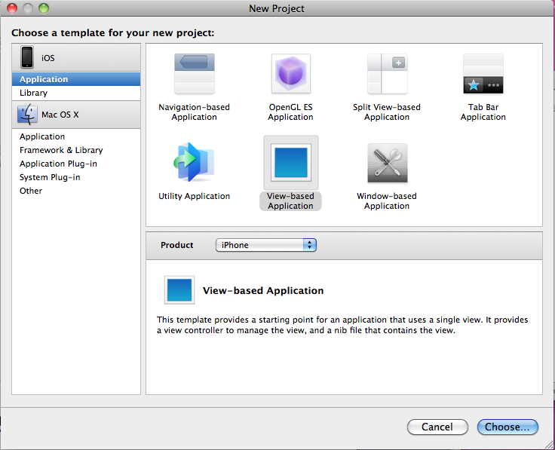
4) Type “Calculator” as the project name and click the button “Next”.
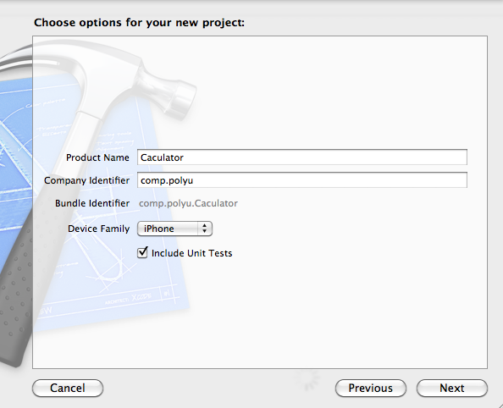

- In the MVC design pattern, the files of “CalculatorViewController.h” and “CalculatorViewController.m” are the controller of the application and the file of “CalculatrorViewController.xib” is the view of the application. There is no file serving as the model of the application. Now, add new class into the project.

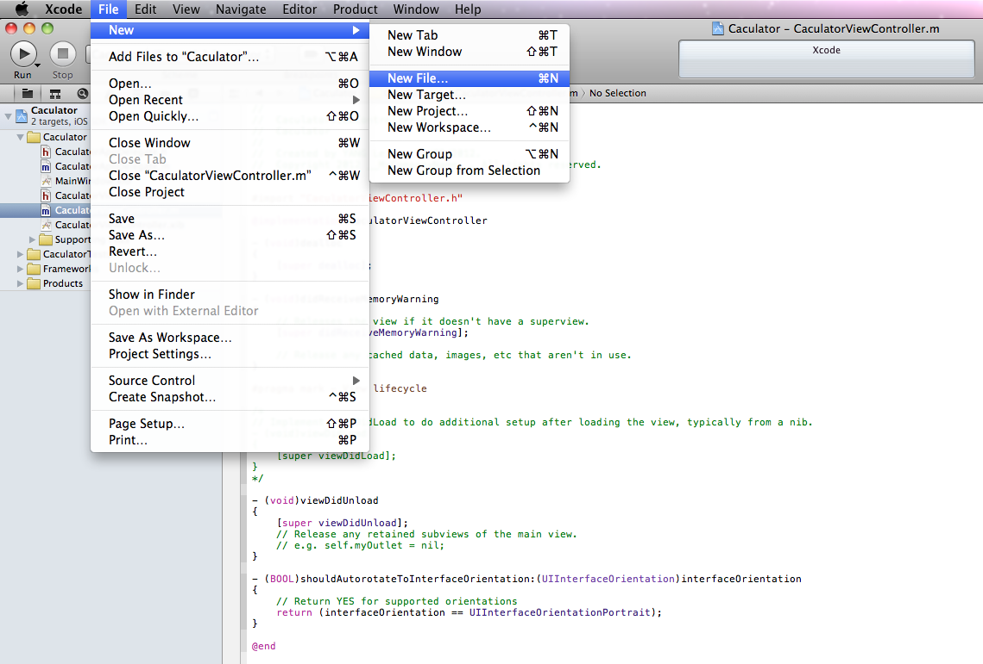

- The iOS application is developed using the Objective-C language. Select the “Objective-C class”, and click the button “Next”. Note that this class we will create is a subclass of “NSObject”.

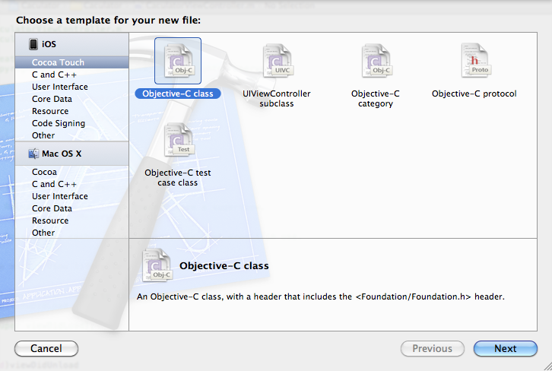
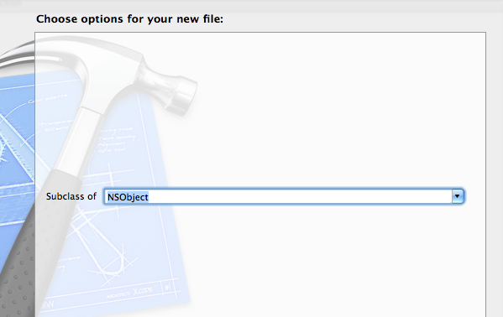
- In the dialog box, type the filename as “CalculatorBrain.m”. Click the button “Save”.
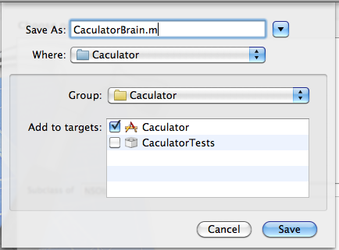
- Return to the main window and you can see that the files of “CalculatorBrain.h” and “CalculatorBrain.m” have been added already.
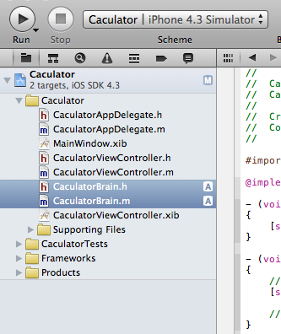
- Edit the content of the files “CalculatorBrain.h” and “CalculatorBrain.m” as follows.

// CalculatorBrain.h
// Calculator

#import <Foundation/Foundation.h>

@interface CalculatorBrain : NSObject {
double operand;
}

- (void)setOperand:(double)aDouble;
- (double)performOperation:(NSString *)operation;
@end
In the file “CalculatorBrain.h”, the variable operand denotes the number input by the user and the two methods setOperand and performOperation are used to process the event when the digit button and “clear” button are pressed.
// CalculatorBrain.m
// Calculator

#import "CalculatorBrain.h"

@implementation CalculatorBrain

- (void)setOperand:(double)aDouble {
operand = aDouble;
}
- (double)performOperation:(NSString *)operation {
if ([operation isEqual:@"c"]) {
operand = 0;
}
return operand;
}
@end
In the file “CalculatorBrain.m”, the methods defined in the head file are implemented. When a digit button is pressed, the operand is set as the corresponding digit. When the “clear” button (showing the text “c” in the button) is pressed, the operand is set to 0.
- Run the project and make sure there is no error and only have several warnings.

8. We add some logics in the application. In the CalculatorViewController.h and CalculatorViewController.m, add the following code:

// CalculatorViewController.h
// Calculator

#import <UIKit/UIKit.h>
#import "CalculatorBrain.h"

@interface CalculatorViewController : UIViewController {
IBOutlet UILabel *display;
CalculatorBrain *brain;
}

- (IBAction)digitPressed:(UIButton *)sender;
- (IBAction)operationPressed:(UIButton *)sender;
@end

// CalculatorViewController.m
// Calculator
//

#import "CalculatorViewController.h"

@implementation CalculatorViewController

- (CalculatorBrain *) brain {
if (!brain) brain = [[CalculatorBrain alloc] init];
return brain;
}

- (IBAction)digitPressed:(UIButton *)sender {
NSString *digit = [[sender titleLabel] text];
[display setText:digit];
}

- (IBAction)operationPressed:(UIButton *)sender {
NSString *operation = [[sender titleLabel] text];
double result = [[self brain] performOperation:operation];
[display setText:[NSString stringWithFormat:@"%g", result]];
}

- Double click the file “CalculatrorViewController.xib”, the Interface Builder will be opened. Before we start to edit the graph interface of the caculater, we need to open the UI elememts list. First click the button at the right top corner of the main editing pannel. Second, switch the view mode, then the “Interface Builder Documents” shows up. Third, choose the “Object” tab, then UI element list appears.



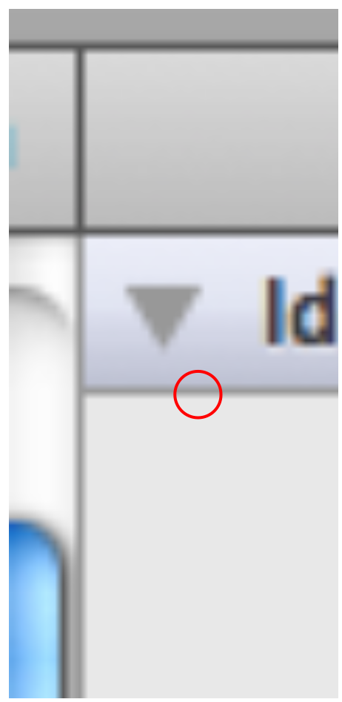

- From the UI element list, find the “Round Rect Button”, drag it to the “View” window.

- Now it is the most important part. Let’s connect the button to the controller (the File’s Owner in the main window) so that it will send event digitPressed to the controller: whenever the user touches it. Just hold down the control key and drag a line from the button to the File’s Owner. If you don’t hold down control while trying to drag this line, it’s just going to pick the button up and start dragging it instead.

As you get close to the File’s Owner, a blue box should appear around it. Select the “digitPressed”.

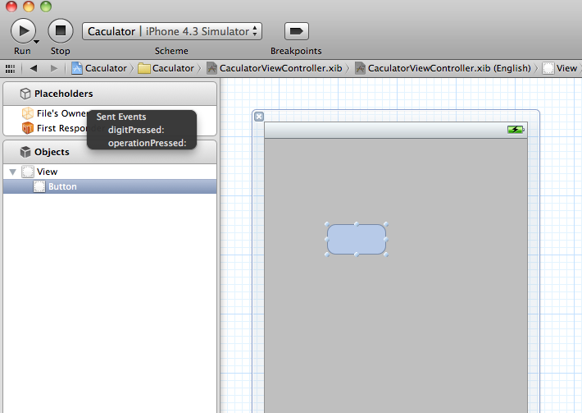

- Copy and paste (using “command”+C and “command”+V) other nine buttons in the View window. Because copying and pasting an object in Interface Builder maintains connections, all of them will send event digitPressed to the controller. Double click each button to modify the text shown in the button into 0 to 9.

- Add another “Round Rect Button” in the view as the “clear” button. Modify the text as “c”. Hold down the control key and drag a line from the button to the File’s Owner. As you get close to the File’s Owner, a blue box should appear around it. Select the “operationPressed”.

- In the UI elements list, find the “Label” and drag one to the View window, modify the text into “0”. This is the display of the calculator. Hold down the control key and drag a line from the File’s Owner to the button. As you get close to the button, a blue box should appear around it. Select the “display”.
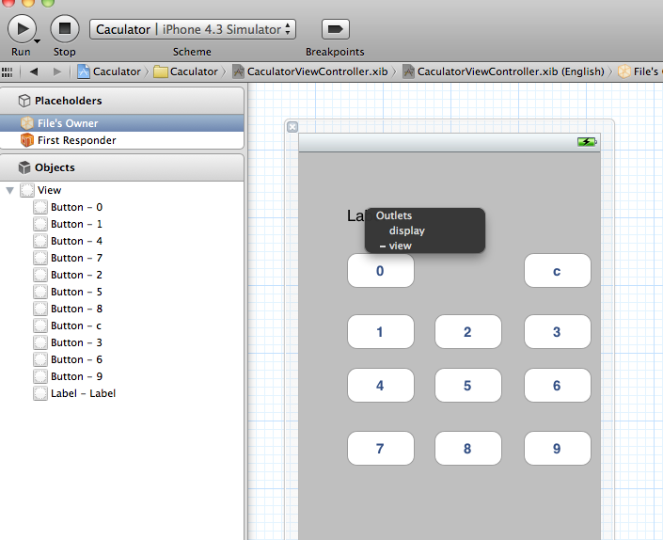

Now we finish the UI design of the application. The following is the final result of the View window. Use “Command+S” to save work.

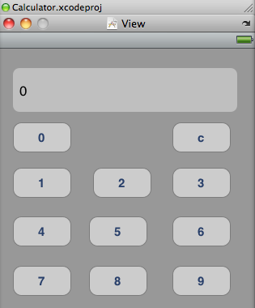

14. The application is finished. Run the project in the Xcode. When the user presses any digit button, the number will be shown in the display and when the user presses the “clear” button, the number will be cleared.

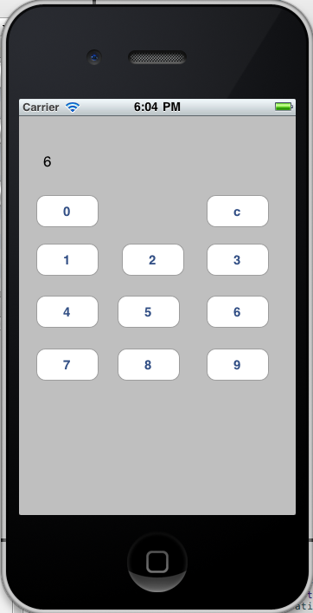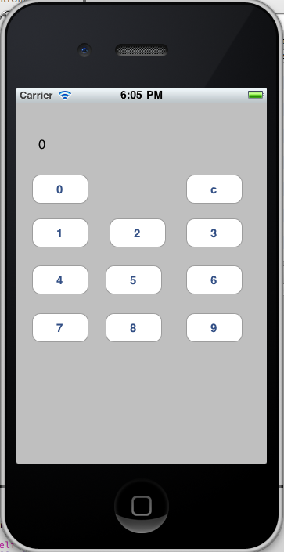

Exercise: Try to add more operations for this calculator.

Further study:
1) Apple ios dev center: http://developer.apple.com/devcenter/ios/index.action
2) Stanford iPhone application development (assignement 1):
http://www.stanford.edu/class/cs193p/cgi-bin/drupal/

