Department of Computing
Hong Kong Polytechnic University
Comp 5527 Mobile Computing and Data Management

Laboratory Three
(Venue QT402)

This week's lab is designed to help you develop the iOS applications connecting to the network.

PART ONE : Detect network status

Before the application attempts to make a network connection, you need to know whether there is a network available. In this part, you will develop a simple iOS application to detect the network status.

Please follow the steps given below.

- Download the sample code “Reachability.zip” from the Apple website
http://developer.apple.com/iphone/library/samplecode/Reachability/
We also have a copy in the WebCT under the “Tutorials and Labs” section. Unzip it and extract the files “Reachability.h” and “Reachability.m” to your Desktop (or any convenient location).

- Open Xcode and start a new project. Choose a view-based application, and when prompted, name it “NetworkMonitor”.

- Drag and drop “Reachability.h” and “Reachability.m” into the project directory. When the pop-up dialog prompts, tick the “Copy items into destination group’s folder (if needed)” checkbox and click “Add” button.

- Add the “SystemConfiguration.framework” into the project because the Reachability code needs it, by following the steps below.
- In the project navigator, select your project
- Select your target
- Select the 'Build Phases' tab
- Open 'Link Binaries With Libraries' expander
- Click the '+' button
- Select “SystemConfiguration.framework”

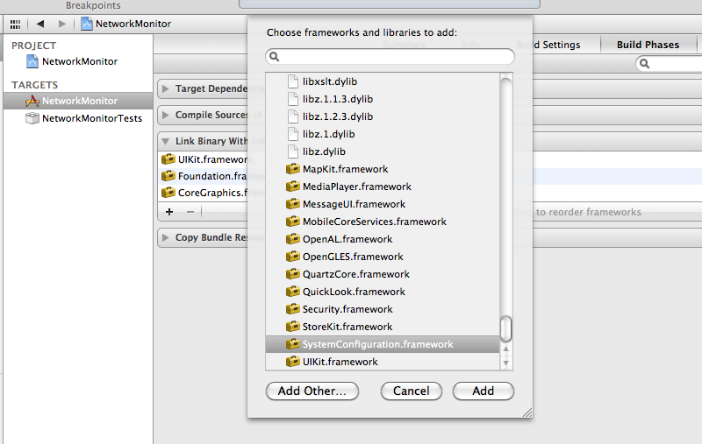

5. Modify the file “NetworkMonitorAppDelegate.h” as follows. The added codes are bolded.
//NetworkMonitorAppDelegate.h
#import <UIKit/UIKit.h>
#import "Reachability.h"

@class NetworkMonitorViewController;

@interface NetworkMonitorAppDelegate : NSObject <UIApplicationDelegate> {
UIWindow *window;
NetworkMonitorViewController *viewController;
}

@property (nonatomic, retain) IBOutlet UIWindow *window;
@property (nonatomic, retain) IBOutlet NetworkMonitorViewController *viewController;

- (NSString *)stringFromStatus:(NetworkStatus )status;

@end

6. Find the function “application didFinishLaunchingWithOptions” in the file “NetworkMonitorAppDelegate.m” and modify it as follows.

- (BOOL)application:(UIApplication *)application didFinishLaunchingWithOptions:(NSDictionary *)launchOptions {

// Override point for customization after application launch.

// Add the view controller's view to the window and display.
[self.window addSubview:viewController.view];
[self.window makeKeyAndVisible];

Reachability *reach = [[Reachability reachabilityForInternetConnection] retain];
NetworkStatus status = [reach currentReachabilityStatus];
UIAlertView *alert = [[UIAlertView alloc]
initWithTitle:@"Reachability"
message:[self stringFromStatus: status]
delegate:self
cancelButtonTitle:@"OK"
otherButtonTitles:nil];
[alert show];
[alert release];

return YES;
}

Add the function “stringFromStatus” which translates the NetworkStatus flag into an NSString.

- (NSString *)stringFromStatus:(NetworkStatus ) status {

NSString *string;
switch(status) {
case NotReachable:
string = @"Not Reachable";
break;
case ReachableViaWiFi:
string = @"Reachable via WiFi";
break;
case ReachableViaWWAN: string = @"Reachable via WWAN";
break;
default:
string = @"Unknown";
break;
}
return string;
}

7. Build and run the project in the Xcode. You will see the result like the following picture.

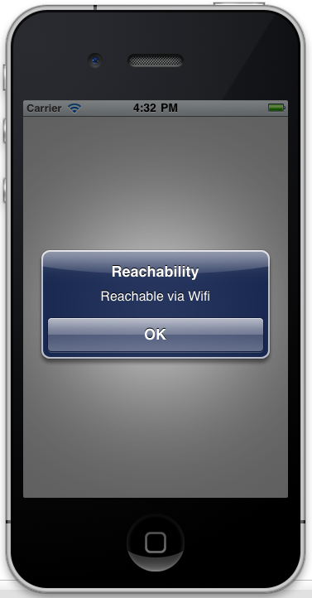

PART TWO: Develop a application to browse the website

The UIWebView class allows you to embed web content inside your application. This class is the simplest but least flexible way of getting network content into your application. A UIWebView is best used to display content. If you want to manipulate the content programmatically, you may use NSURLConnection class. In this part, you will learn how to use the UIWebView in your iOS applications.

Please follow the steps given below.

1. Open Xcode and start a new project. Choose a view-based application, and when prompted, name it “Prototype”.

2. In the main view, there is a single button that the user can click to bring up the web view. Modify the file “PrototypeViewController.h” as follows:

#import <UIKit/UIKit.h>

@interface PrototypeViewController : UIViewController {
IBOutlet UIButton *goButton;
}
-(IBAction) pushedGo:(id) sender;
@end
The codes add a button “goButton” and its action “pushedGo”. Then modify the “PrototypeViewController.m” as follows. The implementation of pushedGo will open the web view and now just left it blank.
//PrototypeViewController.m
- (void)dealloc {
[goButton release];
[super dealloc];
}

-(IBAction) pushedGo:(id) sender {
// Code goes here later
}

3. Add a new class “WebViewController” into the project. When the dialog box pop up, select “UIViewController subclass” and check the “With XIB for user interface” box. Click the “Next” button, and name the new class “WebViewController”. Three files will be created: WebViewController.h, WebViewController.m and WebViewController.xib

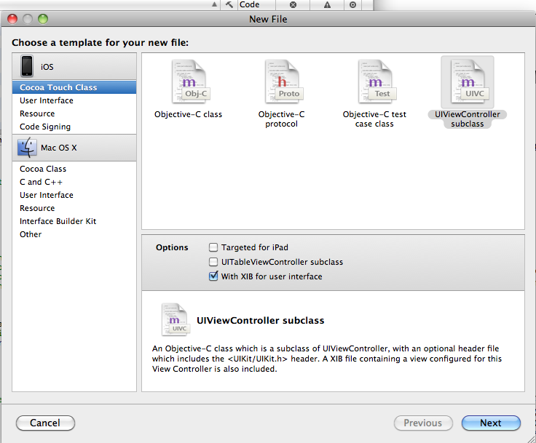

4. Modify the file “WebViewController.h” as follows. From this file, we can see that the class includes a website URL, a website title, a UIWebView using to display the website and a UINavigationItem using to display the website title.
//WebViewController.h
#import <UIKit/UIKit.h>

@interface WebViewController : UIViewController <UIWebViewDelegate> {
NSURL *theURL;
NSString *theTitle;
IBOutlet UIWebView *webView;
IBOutlet UINavigationItem *webTitle;
}

- (id)initWithURL:(NSURL *)url;
- (id)initWithURL:(NSURL *)url andTitle:(NSString *)string;
- (IBAction) done:(id)sender;
@end
5. In the file “WebViewController.m”, add two constructors “initWithURL” and a function “done” used for closing the view. You also need to modify other three functions “viewDidLoad”, “viewWillDisappear” and “dealloc” as follows.
//WebViewController.m
#import "WebViewController.h"

@implementation WebViewController

- (id)initWithURL:(NSURL *)url andTitle:(NSString *)string {
if( self = [super init] ) {
theURL = url;
theTitle = string;
}
return self;
}
-(id)initWithURL:(NSURL *)url {
return [self initWithURL:url andTitle:nil];
}

- (IBAction) done:(id)sender {
[self dismissModalViewControllerAnimated:YES];
}

// Implement viewDidLoad to do additional setup after loading the view, typically from a nib.
- (void)viewDidLoad {
[super viewDidLoad];
webTitle.title = theTitle;
NSURLRequest *requestObject = [NSURLRequest requestWithURL:theURL];
[webView loadRequest:requestObject];
}

- (void)viewWillDisappear:(BOOL)animated {
[super viewWillDisappear:animated];
webView.delegate = nil;
[webView stopLoading];
}
- (void)dealloc {
[webView release];
[webTitle release];
[super dealloc];
}

6. Go to the function “pushedGo” in the file “PrototypeViewController.m” and replace the content with the codes as follows:

-(IBAction) pushedGo:(id) sender {
NSURL *url = [NSURL URLWithString:@"http://www.apple.com/"];
WebViewController *webViewController =[[WebViewController alloc]
initWithURL:url andTitle:@"Apple"];
[self presentModalViewController:webViewController animated:YES];
[webViewController release];
}

And also add the head file in the file
#import "WebViewController.h"

7. Now we begin to design the UI. Double click on the “PrototypeViewController.xib” file to open the NIB file in Interface Builder. Drag and drop a round rect button into the view and change its text to “Go!”.

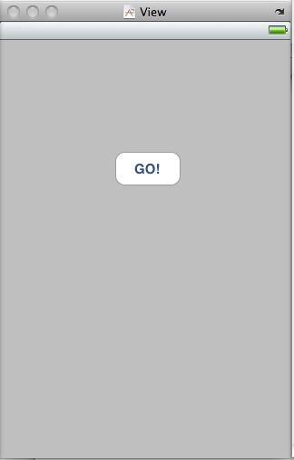

- We use a new way to establish the connection. Select “File’s Owner” and open the connections tab in the Inspector window.

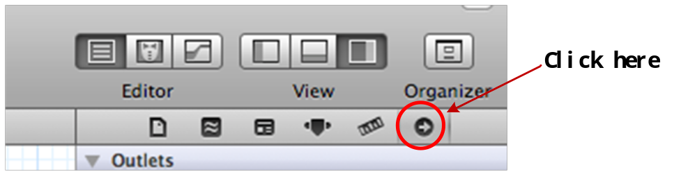

- Connect “pushedGo” action to the button and when you just dropped into the button, choosing “Touch Up Inside” as the specific action; Similarly, connect “goButton” outlet and “view” outlet to the button. The final result should be like the following picture.

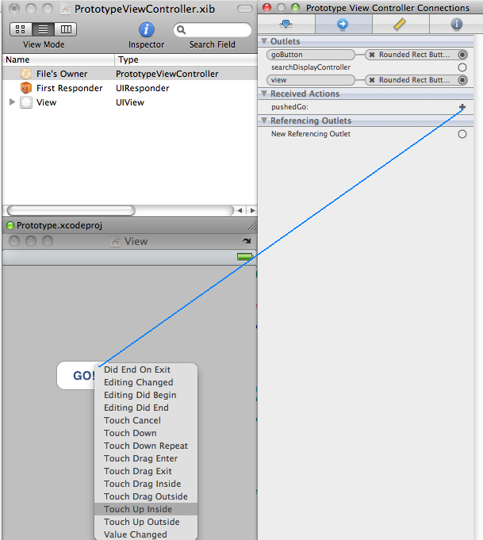

- Double click “WebViewController.xib” to open the NIB file in Interface Builder. Drag and drop a navigation bar and position it at the top of the view. Then drag a web view into the view and resize it to fill the remaining portion of the View window.. Finally, drag a bar button item onto the navigation bar, Once you’re done, your view will look similar to the Fig. (a) below.

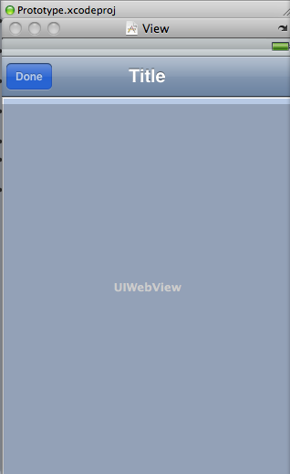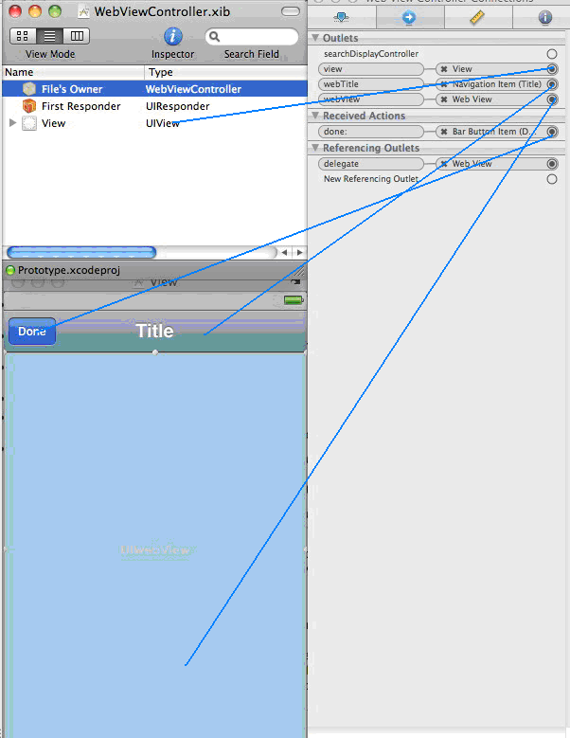
Fig. (a) Fig. (b)
- Select “File’s Owner”, in the Connection Inspector window 1) connect the webTitle outlet to the added UINavigation bar 2) connect the webView outlet to the added web view. 3) connect the view outlet to the UIView. 4) connect the done action to the added bar button item. It is shown in the Fig. (b) above.

- Select the added web view, in the Connection Inspector window connect the delegate outlet back to “File’s Owner”.
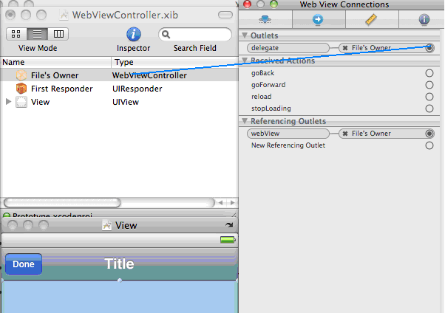
13. The application is finished. Build and run the project in the Xcode. The result will be like the following picture. Tap the “Go!” button in the first view and you will open a new view to show the Apple’s homepage.

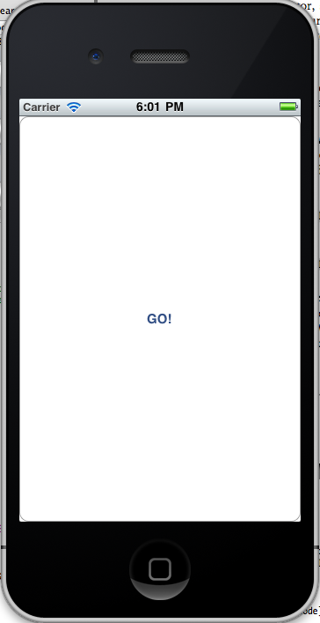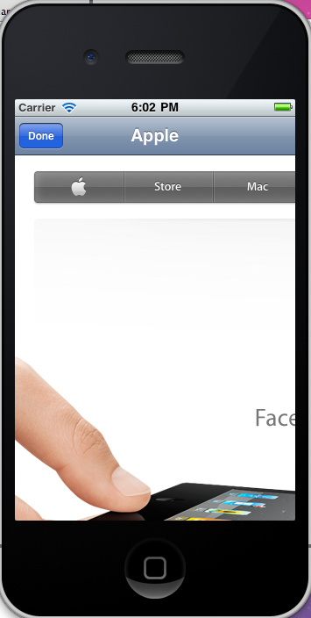

Further study:
1) Learning iPhone Programming, O’Reilly, March 2010, Chapter 7

