Department of Computing
Hong Kong Polytechnic University
Comp5527 Mobile Computing and Data Management

Mid-term Quiz
- Which of the following are true?
- 2G introduced digital communication technologies, and majority of the 2G systems use CDMA.
- Application architectures for the mobile client-server model usually have a gateway as a major component.
- In location dependent query, the result depends on the geographical location of the origin of the query.
- Bluetooth piconets with overlapping coverage can exist simultaneously, and node can serve as the master of multiple overlapping piconets to bridge their communications.
(10 marks)
- Which of the following are true?
- Zigbee is suitable for applications that require high speed data transmission and secure networking.
- Bluetooth uses an unlicensensed spectrum and require line of sight.
- One possible way to send SMS in an application is to use email interface.
- Mobile P2P systems can be constructed not only on an ad-hoc network, but also on infrustructured wireless networks.
(10 marks)
- Which of the following are true?
- The thin client C/S model is mostly for online access to Web content, while the smart client C/S model allows offline access to data when disconnected from the network.
- In mobile transaction management, sometimes it is not possible to ensure the strict “ACID” requirements so we need to allow “weaker” consistent models.
- One essential objective of mobile data management is to reduce the response time of accessing data via wireless networks.
- In the flat disk model, the record blocks of greater interest will have higher frequency to be transmitted.
(10 marks)
- Which of the following are true?
- 802.15.1, 802.15.2, 802.15.3, 802.15.4 are all WLAN standards.
- Bluetooth uses an unlicensensed spectrum but requires line of sight.
- In the broadcast disk program, selective tuning is used because it helps save data access time.
- The Wi-Fi wireless cards can work on continuous aware mode or power-saving polling mode.
(10 marks)
- Explain why developing applications in a mobile and wireless networking environment faces more challenges and traditional approaches for distributed systems are no longer suitable.
(15 marks)

- Give the two basic approaches for data dissemination, and describe the advantages and disadvantages of the two approaches when they are applied into the wireless environment.
(15 marks)
- Frequency hopping can be thought of as a combination of FDMA and TDMA in terms of the frequency use and time multiplexing. Why? .
(15 marks)

- Most wireless Internet applications are based on the Client-Proxy-Server model, as depicted by the following figure. Describe the locations, roles and functionality of each component in the architecture mode.
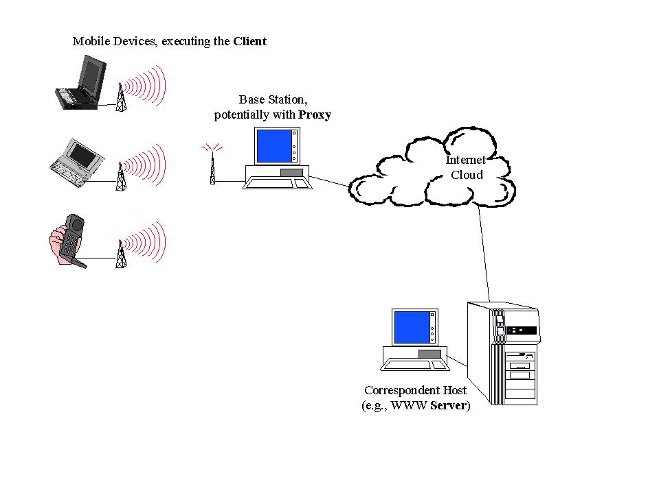
(15 marks)
Mid-term Test Suggested Solutions

1. Solution:
a) False
b) True
c) True
d) False

2. Solution:
a) False
b) False
c) True
d) True

3. Solution:
a) False
b) True
c) True
d) False

4. Solution:
a) False
b) False
c) False
d) True

5. Solution:
This is mainly because mobile and wireless networking environments have special characteristics which made the development more difficult. The following is a list of some of these characteristics and their effect on application development.
- Mobility:
- Constraints on device (screen size, limited resources and power):
- Low network bandwidth:
- Coverage and penetration, intermittent connectivity:
- Reduced security:
Mobile and wireless applications must be tailored to the characteristics of the device and network that they run on. Therefore, traditional approaches to designing distributed systems cannot be applied directly and new methods need to be developed to overcome the above constraints:
- Need to keep communication and operational cost down
- Need to conserve energy
- Need to design special interfaces for small devices
- Need to enforce wireless security
- Need for new computing paradigms
    - adaptation (may need user’s involvement)
    - asynchronous interactions
    - handling of disconnections

6. Solution:
Pull-based mechanisms
Advantage:
- Pull is the best option when the server has very little contention and is able to respond to many device requests within expected time intervals
- No unsolicited or irrelevant data arrives at the device
Disadvantage:
- Pull bandwidth limits the number of pull requests in a given period of time

Push-based mechanisms
Advantage:
- Push is suitable when information is transmitted to a large number of clients with overlapping interests
- Push is more scalable. Performance does not depend on the number of clients. Pull cannot scale beyond the capacity of the server or the network.
Disadvantage:
- Unrelevant data disseminated even when the user do not ask for it
- Not personalized for the users

7. Solution:
This is because, in frequency hopping, one user employs one channel (with a specific frequency) for a pre-specified time period and then changes to another channel for transmission. The sequence is repeated after all channels to be used in the sequence have been exhausted. For multiple users, different frequency hopping sequences can be used for transmitting information as long as, at any given time, one channel is used by only one user.

8. Solution:
There are three major components: client on mobile device, server on fixed network, and proxy.
- The mobile devices execute the client, which provides the user interface and some part of the application logic. It connects to the fixed network through a base station for wireless communications, which is the access point for all devices in a certain geographical area.
- Through some switching fabric, the base station provides connectivity with other hosts in the network, such as a WWW server or an SMTP server.
- The third component of the model is the proxy, a component of the application that executes in the wired network and supports the client. One possible location for the proxy would be the base station, but this is not the only possibility. Any computer on the communication path between client and server can host the proxy. Logically, the proxy hides the "mobile" client from the server, who thinks it communicates with a standard client (i.e., a client that executes on a powerful desktop directly connected to the wired network). The application logic of the "standard client" is split between the mobile client and the proxy to adapt to the dynamic wireless environment and to address the limitations of the portable device. Where bandwidth limitations over the wireless link are of major concern, the proxy could provide filtering and compression functions.

