

COMP5527 Mobile Computing and Data Management

Group Project Report

Group Members:
QING Pei 11500811g
Mei Youzhi 11521683g
SHAO Shuai 11552402g
RAN Jun 09694163g

Table of Contents
Overview 3
System Design 4
Client Design 4
Application Framework 4
User Interface 4
Offline Storage 5
Application Logic 6
Server Design 7
Server side function 7
Web Interface 8
SQL Schema 16
Data synchronization 21
Push 21
Contribution List 22
Deployment Guide 23
For Installation 23
For Pushing 23
Get Started 24
Get the app installed 24
Starting point 25
Patient List 26
Patient Information 27
Healthcare Record 28
Appointments 29
Appointment view 30
New appointment 31

Overview

In this project, a Mobile Healthcare (MH) application is created.

Required features include:
- Cross-platform.
- Mobile access to healthcare information.
- Mobile management of healthcare data.
- Synchronization between client and server.
- Mobile healthcare services.

What we achieved is an app that can
- run on iOS, Android, Blackberry, Windows Phone and Symbian platforms with the default browser
(or packaged as an installable native application)
- view and update healthcare data stored on the server
- view or make appointments with doctors
- work in a disconnected environment with cached data

System Design

Client Design
The client is built with HTML5 and javascript. The following frameworks/tools are used.
- PhoneGap
- jQTouch
- Lawnchair

Application Framework
To build a cross-platform app, we adopted PhoneGap framework.

It is an HTML5 app platform that allows us to author native applications with web technologies and get access to APIs and app stores.
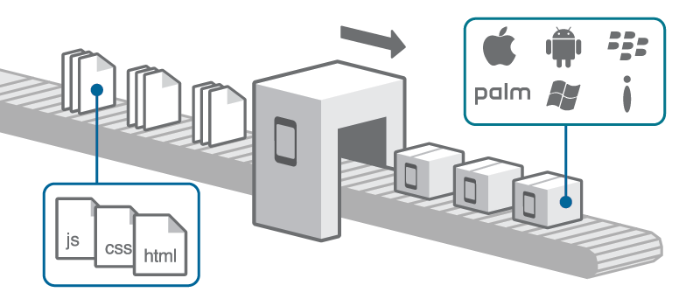
The application framework enables us to build the app once with web-standards using HTML5 and javascript, wrap it with PhoneGap and deploy to multiple platforms.

User Interface
Our client app provide a user interface built upon jQTouch. It is a Zepto/jQuery plugin for mobile web development on the iPhone, Android, iPod Touch, and other forward-thinking devices.
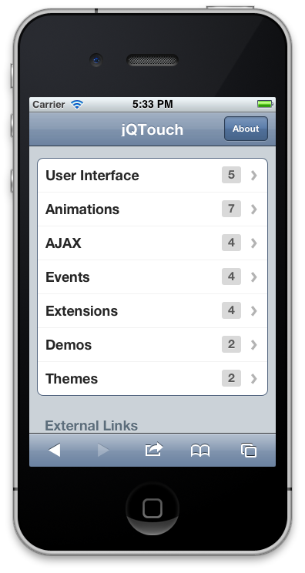
With jQTouch, the app UI is a stack of pages. By forward/backward navigation, we push/pop views from the stack. Each view is a <div> element with an unique id attribute. Jumping to another view is done by rendering the correspondent part of the HTML body.

Offline Storage

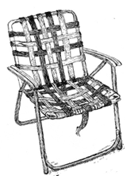
Lawnchair is used for offline storage. Lawnchair is a lightweight, adaptive, simple and elegant persistence solution perfect for html5 mobile apps. It has the following features.
- super micro tiny storage without the nasty sql: pure and delicious JSON.
- default build weighs in at 3.4k minified; 1.5 gzip'd!
- adaptors for any clientside store.
- designed with mobile in mind.
- clean and simple API.
- key/value store ...key is optional.
- terse syntax for searching/finding.
- battle tested in app stores and on the open mobile web.
- framework agnostic. (if not a framework atheist!)
- MIT licensed.
By default, Lawnchair uses HTML5 localStorage (often called DOM storage). In our application, we will test whether the platform supports indexed-db which is said to be 3 times faster. If so, we use indexed-db, otherwise, localStorage is always a fallback choice.

Application Logic

Patient information management
This function is used for supporting Mobile Access to Healthcare Information (MAHI) and
Mobile Healthcare Data Management (MHDM). Depend on user’s type (doctor/patient), client side show different contents. For doctor, all patients’ name list will appear, and he can notify patient’s detail information and all medical records between him and each patients. For patient, his basic information and all medical records can be checked.

Appointment management
This function is used for supporting Mobile Healthcare Service (MHS). For a user as a patient, he can make an appointment with any doctor. Moreover he can update or delete any booked appointments under available situation.

Cache data management
This function is used for supporting mobile computing environment. One basic strategy is running a repeated thread to check any failed data requests existing on cache database. A request list table is used to store any failed user operations’ data on cache DB. When client system cannot connect to server side, it will store any user request data to this request list table on cache DB. Another strategy is storing any transmitting data on cache DB. Once failed to connect server side, client system will check any existing data on cache DB and show them to user.

Data synchronization
An attribute name “last_updated_time” is setting on every data record both in client cache and in server database. Client side will check current data with server side, before user does any update operation. If server side found client’s current data are not latest, it will response latest data to client. Then, user will be reminded to notice new data before he updates information.

Server Design

Server side function

The server side is for administration and maintenance of user accounts. It is basically the same interface as the client application except that it does not have push notification since the administrator is not supposed to receive any of them. Also, the server side GUI is presented in a mobile Web page instead of an independent application.

As an important function of this application, server side is responsible for data synchronization. So we use attribute timestamp, which is datetime type, to mark the most recent timing point of update. With the help of this timestamp, the decision of which copy of data to use could be facilitated.

The server side has the following modules:

- Registration
  - Register a new patient user
- Logging
  - Log into the system
  - Log out of the system
- User Profile
  - Modify the user’s profile
  - Download the patient’s record
- Patient’s Record
  - Update the patient’s record
  - Add a patent’s record
- Disease Information
  - Query disease information
  - Add a disease information to the system
  - Delete a disease from the system
- Hospital Information
  - Query the hospital information
  - Add a hospital to the system
  - Delete a hospital from the system
- Schedule List
  - View the schedule list
  - Submit a schedule by a patient
  - Accept a schedule by a doctor
  - Delete a schedule
- Meeting Minutes
  - Add some meeting minutes
  - View the meeting minutes
  - Delete meeting

The above modules as well as their sub-modules are further explained with their functions and applications in the Web interface.

Web Interface
This part will be filled out locally on a MS Word.

Name | register
Description | Register a new patient user
Parameters | loginName | The login name, which is picked by patient
Parameters | password | The password for the patient
Parameters | fullName | Full name of the patient
Parameters | email | Email address of the patient
Parameters | birthdate | Birth date of the patient, in YYYYMMDD format
Parameters | gender | Gender of the patient, “male” or “m” for male, “female” or “f” for female.
Parameters | married | Marriage status of the patient. “single” or “s” for single, “married” or “m” for married, “divorced” or “d” for divorced.
Parameters | allergies | Description on the patient’s allergies.
Returns | Successful | {  ‘return’ : {  ‘code’ : ‘0’,  ‘description’ : ‘success’  }
Returns | Failed | Refer to the error list
Example | register?loginName=wen&password=123456&fullName=Wen%20Li&email=li%2ewen%40polyu%2eedu%2ehk&birthdate=19300101&gender=female&married=m&allergies=

Name | Login
Description | User login
Parameters | loginName | The login name, which is picked by patient
Parameters | password | The password for the patient
Returns | Successful | {  ‘return’ : {  ‘code’ : ‘0’,  ‘description’ : ‘success’,  ‘sessionid’ : ‘38fe9023ba0232cd1’  }
Returns | Failed | Refer to the error list
Example | login?loginName=wen&password=123456  A unique session is assigned for the continuous operations.

Name | Logout
Description | User logout, the session is terminated
Parameters | sessionid | The session id
Returns | Successful | {  ‘return’ : {  ‘code’ : ‘0’,  ‘description’ : ‘success’  }
Returns | Failed | Refer to the error list
Example | logout?sessionid=38fe9023ba0232cd1

Name | Modifyprofile
Description | Modify user’s profile
Parameters | sessionid | The session id which is assigned while login
Parameters | oldpassword | The old password
Parameters | newpassword | The new password
Parameters | fullName | Full name of the patient
Parameters | email | Email address of the patient
Parameters | married | Marriage status of the patient. “true” or “t” for married, “false” or “f” for not married.
Parameters | allergies | Description on the patient’s allergies.
Returns | Successful | {  ‘return’ : {  ‘code’ : ‘0’,  ‘description’ : ‘success’  }
Returns | Failed | Refer to the error list
Example | modifyprofile?sessionid=38fe9023ba0232cd1&oldpassword=123456&newpassword=654321&fullName=Wen%20Li&email=li%2ewen%40polyu%2eedu%2ehk&birthdate=19800101&allergies=green%20bean

Name | Downloadrecord
Description | Download the patients records
Parameters | sessionid | The session id which is assigned while login
Parameters | patientName | The patient name, useful when inquiring by a doctor user. Wildcards are applied. “*Li”, “Wen*Li”
Returns | Successful | {  'return': {  'code':'0',  'description':'Success'  'patient':{  'userid':'1',  'name':'WEN LI',  'record' : {  'id' : '1',  'timestamp' : '20120409201918',  'date' : '20120407162349',  'doctor' : '2',  'symptom' : 'cough',  'diagnosis' : '', 'treatment' : 'rest',  'remark' : ''  },  }  }  }
Returns | Failed | Refer to the error list
Example | downloadrecords?sessionid=38fe9023ba0232cd1

Name | Updaterecords
Description | Update patient’s record
Parameters | sessionid | The session id which is assigned while login
Parameters | recordid | The id of a record
Parameters | date | The date
Parameters | doctorid | The doctor’s user id
Parameters | sympton | The symptom
Parameters | diagnosis | The diagnosis
Parameters | treatment | The treatment
Parameters | remark | Remark
Returns | Successful | {  ‘return’ : {  ‘code’ : ‘0’,  ‘description’ : ‘success’  }
Returns | Failed | Refer to the error list
Example | updaterecord?sessionid=38fe9023ba0232cd1&recordid=1&treatment=intravenous%20drip

Name | Addrecord
Description | Add a patient’s record, operable by a doctor only.
Parameters | sessionid | The session id which is assigned while login
Parameters | patientid | The id of a patient
Parameters | date | The date
Parameters | doctorid | The doctor’s user id
Parameters | sympton | The symptom
Parameters | diagnosis | The diagnosis
Parameters | treatment | The treatment
Parameters | remark | Remark
Returns | Successful | {  ‘return’ : {  ‘code’ : ‘0’,  ‘description’ : ‘success’  }
Returns | Failed | Refer to the error list
Example | addrecord?sessionid=38fe9023ba0232cd1&patientid=1&date=20120325&doctored=2&symton=toothache&diagnosis=tooth%20decay&treatment=canalis%20radicis%20dentis&remark=

Name | Querydisease
Description | Query disease information
Parameters | sessionid | The session id which is assigned while login
Parameters | diseasename | The name of a disease, wildcard is applicable, i.g. “tooth*”
Parameters | department | The name of department, wildcard is applicable, i.g. “dental*”
Returns | Successful | {  ‘return’ : {  ‘code’ : ‘0’,  ‘description’ : ‘success’,  ‘disease’ : {  ‘id’ : ‘1’,  ‘timestamp’ : ‘20120409192132’,  ‘diseasename’ : ‘flu’,  ‘department’ : ‘Internal Medicine’  }  ‘disease’ : {  ‘id’ : ‘2’,  ‘timestamp’ : ‘20120409192132’,  ‘diseasename’ : ‘Tooth Decay’,  ‘department’ : ‘Dentistry’  }  }  }
Returns | Failed | Refer to the error list
Example | querydisease?sessionid=38fe9023ba0232cd1&diseasename=Fl%2a

Name | Adddisease
Description | Add disease information into MHS
Parameters | sessionid | The session id which is assigned while login
Parameters | diseasename | The name of a disease
Parameters | department | The name of department
Returns | Successful | {  'return': {  'code':'0',  'description':'Success'  }  }
Returns | Failed | Refer to the error list
Example | adddisease?sessionid=38fe9023ba0232cd1&diseasename=fever&department=Intern Medicine

Name | Deletedisease
Description | Delete a disease information
Parameters | sessionid | The session id which is assigned while login
Parameters | diseaseid | The id of a disease
Returns | Successful | {  'return': {  'code':'0',  'description':'Success'  }  }
Returns | Failed | Refer to the error list
Example | deletedisease?sessionid=38fe9023ba0232cd1&diseaseid=1

Name | Queryhospital
Description | Query hospital information
Parameters | sessionid | The session id which is assigned while login
Parameters | hospitalname | The name of a hospital, wildcard is applicable, i.g. “hospital*”
Returns | Successful | {  ‘return’ : {  ‘code’ : ‘0’,  ‘description’ : ‘success’,  ‘hospital’ : {  ‘id’ : ‘1’,  ‘timestamp’ : ‘20120409201554’,  ‘name’ : ‘Prince Wales Hospital’,  ‘email’ : ‘service@abcd.com’,  ‘address’ : ‘Shatin, N.T.’,  ‘tel’ : ‘12345678’,  ‘fax’ : ‘87654321’  },  }  }
Returns | Failed | Refer to the error list
Example | queryhospital?sessionid=38fe9023ba0232cd1

Name | Addhospital
Description | Add hospital information
Parameters | sessionid | The session id which is assigned while login
Parameters | hospitalname | The name of a hospital, wildcard is applicable, i.g. “hospital*”
Parameters | email | The email address of the hospital
Parameters | address | The address of the hospital
Parameters | tel | The tel number
Parameters | fax | The fax number
Returns | Successful | {  'return': {  'code':'0',  'description':'Success'  }  }
Returns | Failed | Refer to the error list
Example | addhospital?sessionid=38fe9023ba0232cd1&hospitalname=abc&email=service@abc.com&address=Beijing%20Shanghai%20Chengdu&tel=88888888&fax=77777777

Name | Deletehospital
Description | Delete a hospital information
Parameters | sessionid | The session id which is assigned while login
Parameters | hospitalid | The name of a hospital, wildcard is applicable, i.g. “hospital*”
Returns | Successful | {  'return': {  'code':'0',  'description':'Success'  }  }
Returns | Failed | Refer to the error list
Example | deletehospital?sessionid=38fe9023ba0232cd1&hospitalid=1

Name | Viewschedule
Description | View schedule list
Parameters | sessionid | The session id which is assigned while login
Parameters | scheduleid | The id of a schedule
Parameters | doctoreid | The id of a doctor
Parameters | begintime | The begin time
Parameters | endtime | The end time
Parameters | patientid | The id of a patient
Returns | Successful | {  'return': {  'code':'0',  'description':'Success',  'schedule' : {  'id' : '3',  'timestamp' : '20120409202854',  'doctorid' : '2',  'doctorname' : '',  'patientid' : '1',  'patientname' : 'WEN LI',  'begintime' : '201204081400',  'endtime' : '201204081600',  'status' : 'confirmed'  },  }  }
Returns | Failed | Refer to the error list
Example | viewschedule?sessionid=38fe9023ba0232cd1&doctorid=1

Name | Submitschedule
Description | Submit a schedule request
Parameters | sessionid | The session id which is assigned while login
Parameters | doctorid | The id of a doctor
Parameters | begintime | The begin time
Parameters | endtime | The end time
Parameters | patientid | The id of a patient
Returns | Successful | {  ‘return’ : {  ‘code’ : ‘0’,  ‘description’ : ‘success’  }
Returns | Failed | Refer to the error list, also returns the current schedule list of the specified doctor.
Example | addschedule?sessionid=38fe9023ba0232cd1&doctorid=1&begintime=20120325%2011%3a30&endtime=20120325%2012%3a00&patientid=5

Name | Acceptschedule
Description | Accept a schedule request
Parameters | sessionid | The session id which is assigned while login
Parameters | scheduleid | The id of the schedule
Returns | Successful | {  ‘return’ : {  ‘code’ : ‘0’,  ‘description’ : ‘success’  }
Returns | Failed | Refer to the error list, also returns the current schedule list of the specified doctor.
Example | changeschedule?sessionid=38fe9023ba0232cd1&begintime=20120325%2011%3a30&endtime=20120325%2012%3a30&patientid=5

Name | Deleteschedule
Description | Delete a schedule
Parameters | sessionid | The session id which is assigned while login
Parameters | scheduleid | The id of the schedule
Returns | Successful | {  ‘return’ : {  ‘code’ : ‘0’,  ‘description’ : ‘success’  }
Returns | Failed | Refer to the error list, also returns the current schedule list of the specified doctor.
Example | deleteschedule?sessionid=38fe9023ba0232cd1&scheduleid=3

Name | Addmeetingminutes
Description | Add a meeting minutes
Parameters | sessionid | The session id which is assigned while login
Parameters | scheduleid | The related schedule id, if any
Parameters | attender | The attender user id list, separated by ‘,’(comma)
Parameters | date | The meeting date time
Parameters | minutes | The meeting minutes
Returns | Successful | {  ‘return’ : {  ‘code’ : ‘0’,  ‘description’ : ‘success’  }
Returns | Failed | Refer to the error list.
Example | addmeetingminutes?sessionid=38fe9023ba0232cd1&attender=1,2&scheduleid=1&date=20120409&minutes=make an urgent operation

Name | Viewmeetingminutes
Description | View meeting minutes
Parameters | sessionid | The session id which is assigned while login
Parameters | attender | The attender’s id list, separated by comma, wildcard “*” is applicable.
Parameters | scheduleid | The related schedule id, if any. Wildcard “*” is applicable.
Parameters | date | The specified date in YYYYMMDD format
Returns | Successful | {  ‘return': {  'code':'0',  'description':'Success',  'meetingminutes' : {  'id' : '1',  'timestamp' : '20120410011723',  'attenders' : 'attenders',  'scheduleid' : '0',  'date' : '20120410',  'minutes' : 'made an operation'  },  'meetingminutes' : {  'id' : '2',  'timestamp' : '20120410011834',  'attenders' : '1,2',  'scheduleid' : '0',  'date' : '20120410',  'minutes' : 'made an operation'  },  }  }
Returns | Failed | Refer to the error list.
Example | viewmeetingminutes?sessionid=38fe9023ba0232cd1&attender=2

Name | Deletemeetingminutes
Description | Delete a meeting minutes
Parameters | sessionid | The session id which is assigned while login
Parameters | meetingminutesid | The id of the meetingminutes
Returns | Successful | {  ‘return’ : {  ‘code’ : ‘0’,  ‘description’ : ‘success’  }
Returns | Failed | Refer to the error list.
Example | deletemeetingminutes?sessionid=38fe9023ba0232cd1&meetingminutesid=1

Error Code | Error Description
0 | Success
1 | Login name is already taken
2 | Incorrect password
3 | Wrong full name
4 | Invalid email address
5 | Wrong date format
6 | Invalid schedule id
7 | Invalid doctor id
8 | Conflict begin time
9 | Conflict end time
99 | Unknown Error
10000+ | Database Error Code, starting from 10000.  For example: Code 11062 represents the database error code 1062

SQL Schema
DROP DATABASE if exists mhs;

#################################################
# Create Database
#################################################
CREATE DATABASE mhs;
USE mhs;

#################################################
# Table: push
#################################################
CREATE TABLE push
(
needPush BOOLEAN NOT NULL DEFAULT False
);

INSERT INTO push VALUES('FALSE');

#################################################
# Table: user
# -----------------------------------------------
# For the user profile data
#################################################
CREATE TABLE user
(
id INT not null auto_increment primary key, # primary key
loginName VARCHAR(64) not null unique, # login name
timestamp DATETIME not null, # last modified time stamp
password VARCHAR(64) not null, # password
fullName VARCHAR(64), # full name
userType CHAR(1) not null default 'p', # 'p' for patient, 'd' for doctor, 'b' for both
emailAddress VARCHAR(256), # user email address
birthDate DATETIME not null, # birth date
gender CHAR(1) not null, # gender, "M/m" for male, "F/f" for female
married CHAR(1) not null, # marriage status, 's' for single, 'm' for married, 'd' for divorced
allergies VARCHAR(1024) default '' # allergies
);
DELIMITER |
CREATE TRIGGER push_user BEFORE INSERT ON user
FOR EACH ROW BEGIN
UPDATE push SET needPush=True;
SET new.timestamp = now();
END;
CREATE TRIGGER update_user BEFORE UPDATE ON user
FOR EACH ROW BEGIN
UPDATE push SET needPush=True;
SET new.timestamp = now();
END;
CREATE TRIGGER delete_user BEFORE DELETE ON user
FOR EACH ROW BEGIN
UPDATE push SET needPush=True;
END;
|
DELIMITER ;

################################################
# Table: session
################################################
CREATE TABLE session
(
userId INT NOT NULL UNIQUE PRIMARY KEY, # user Id
sessionId VARCHAR(16) NOT NULL, # session id
lastAccess TIMESTAMP NOT NULL # last access time
);

DELIMITER |

CREATE TRIGGER insert_session BEFORE INSERT ON session
FOR EACH ROW BEGIN
SET new.lastAccess = now();
END;
CREATE TRIGGER update_session BEFORE UPDATE ON session
FOR EACH ROW BEGIN
SET new.lastAccess = now();
END;
|

DELIMITER ;

################################################
# Table: record
# ----------------------------------------------
# For healthy record
###############################################
CREATE TABLE record
(
id INT NOT NULL AUTO_INCREMENT PRIMARY KEY, # primay key
timestamp DATETIME NOT NULL, # last modified time
patientId INT NOT NULL, # the patient user id
createDate DATETIME, # date
doctorId INT NOT NULL, # the doctor user id
sympton TEXT, # symptom
diagnosis TEXT, # diagnosis
treatment TEXT, # treatment
remark TEXT # remark
);

DELIMITER |
CREATE TRIGGER insert_record BEFORE INSERT ON record
FOR EACH ROW BEGIN
SET new.createDate = IFNULL(new.createDate, now());
SET new.timestamp = now();
UPDATE push SET needPush=True;
END;
CREATE TRIGGER update_record BEFORE UPDATE ON record
FOR EACH ROW BEGIN
SET new.timestamp = now();
UPDATE push SET needPush=True;
END;
CREATE TRIGGER delete_record BEFORE DELETE ON record
FOR EACH ROW BEGIN
UPDATE push SET needPush=False;
END;
|
DELIMITER ;

################################################
# Table: disease
################################################
CREATE TABLE disease
(
id INT not null auto_increment primary key, # primary key
diseaseName TEXT not null, # disease name
department TEXT not null, # department
timestamp DATETIME not null # timestamp
);

DELIMITER |
CREATE TRIGGER insert_disease BEFORE INSERT ON disease
FOR EACH ROW BEGIN
SET new.timestamp = now();
UPDATE push SET needPush=True;
END;
CREATE TRIGGER update_disease BEFORE UPDATE ON disease
FOR EACH ROW BEGIN
SET new.timestamp = now();
UPDATE push SET needPush=True;
END;
CREATE TRIGGER delete_disease BEFORE DELETE ON disease
FOR EACH ROW BEGIN
UPDATE push SET needPush=True;
END;
|
DELIMITER ;

################################################
# Table: organization
################################################
CREATE TABLE organization
(
id INT not null auto_increment primary key, # primary key
orgName varchar(256) not null, # organization name
orgType char(1) not null default 'h', # "h" for hospital, 'o' for organization
email varchar(256), # email address for the orgnization
address text(1024), # address of the orgnization
tel varchar(256), # phone number
fax varchar(256), # fax number
timestamp DATETIME # time stamp for modification
);

DELIMITER |
CREATE TRIGGER insert_organization BEFORE INSERT ON organization
FOR EACH ROW BEGIN
SET new.timestamp = now();
UPDATE push SET needPush=True;
END;
CREATE TRIGGER update_organization BEFORE UPDATE ON organization
FOR EACH ROW BEGIN
SET new.timestamp = now();
UPDATE push SET needPush=True;
END;
CREATE TRIGGER delete_organization BEFORE DELETE ON organization
FOR EACH ROW BEGIN
UPDATE push SET needPush=True;
END;
|
DELIMITER ;

################################################
# Table: schedule
################################################
CREATE TABLE schedule
(
id INT not null auto_increment primary key, # primary key
doctorId INT not null, # doctor user id
patientId INT not null, # patient user id
status varchar(16) not null default 'new', # status, "new", "confirmed"
beginTime DATETIME not null, # begin time
endTime DATETIME not null, # end time
timestamp DATETIME not null # last updated timestamp
);

DELIMITER |
CREATE TRIGGER insert_schedule BEFORE INSERT ON schedule
FOR EACH ROW BEGIN
SET new.timestamp = now();
UPDATE push SET needPush=True;
END;
CREATE TRIGGER update_schedule BEFORE UPDATE ON schedule
FOR EACH ROW BEGIN
SET new.timestamp = now();
UPDATE push SET needPush=True;
END;
CREATE TRIGGER delete_schedule BEFORE DELETE ON schedule
FOR EACH ROW BEGIN
UPDATE push SET needPush=True;
END;
|

DELIMITER ;

################################################
# Table: meetingminutes
################################################
CREATE TABLE meetingminutes
(
id INT NOT NULL AUTO_INCREMENT PRIMARY KEY, # primary key
attenders TEXT NOT NULL, # attender user Id list, separated by ','
scheduleId INT, # related schedule, if any
timestamp DATETIME NOT NULL,
date DATETIME NOT NULL, # meeting time
minutes TEXT # meeting minutee
);
DELIMITER |
CREATE TRIGGER insert_meetingminutes BEFORE INSERT ON meetingminutes
FOR EACH ROW BEGIN
SET new.timestamp = now();
UPDATE push SET needPush=True;
END;
CREATE TRIGGER update_meetingminutes BEFORE UPDATE ON meetingminutes
FOR EACH ROW BEGIN
SET new.timestamp = now();
UPDATE push SET needPush=True;
END;
CREATE TRIGGER delete_meetingminutes BEFORE DELETE ON meetingminutes
FOR EACH ROW BEGIN
UPDATE push SET needPush=True;
END;
|
DELIMITER ;

Data synchronization
According to the last updated time, server system can compare every client request data with corresponded data in server database, and store latest updated data. Moreover, as we said in client’s data synchronization, server will make sure user get latest data, before they do any operation.

Push
As an Apple Push Notification Service(APNS) is required to support server positively sending notifications to mobile side which is based on mobile device UDID.
Reference: http://developer.apple.com/library/mac/#documentation/NetworkingInternet/Conceptual/RemoteNotificationsPG/ApplePushService/ApplePushService.html

Contribution List

- QING Pei
  - Client Side
- Mei Youzhi
  - Client Side
- SHAO Shuai
  - Server Side
- RAN Jun
  - Server Side

Deployment Guide

For Installation

1. Make sure that MySQL5.1 or above, PHP5.3 is ready
2. Install the necessary packages
sudo apt-get install php5-mysql php5-curl
3. Execute below command to build up the database.
mysql --user=root --password=****** < db/schema.sql
4. copy all the files onto webserver mhs/
cd php
cp -r * /var/www/mhs/
chown -R go+rw /var/www/mhs

For Pushing

Before using, the following needs to be done:
1. install the curl module for PHP. In Ubuntu:
sudo apt-get install php5-curl
2. Re-construct the database
mysql --user=root --password=your-password < db/schema.sql
3. Test the push function via: http://ipaddr/mhs/push.php?registration=RegistrationIDByGoogle&auth=YourGoogleAuth

Making some changes to the database is necessary, i.e. addrecord, addhospital. Otherwise, PUSH is not triggered if there is no change to the data.

Get Started

Get the app installed
So far, we do not have a iOS Developer membership to distribute the app. The following is based on iPhone Simulator 5.1.
Alternatively, you may use this as an web app. Just visit this link.
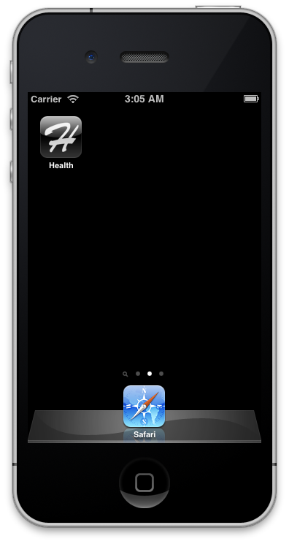

Starting point
Start the app and you will be shown the homepage.
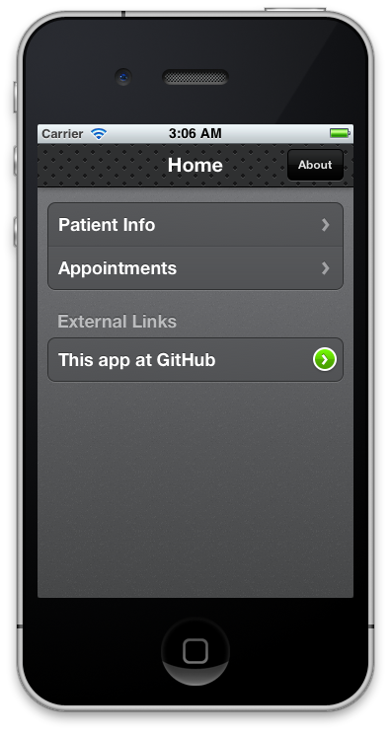

Patient List
Tap “Patient Info” will lead you to a list of patient names.
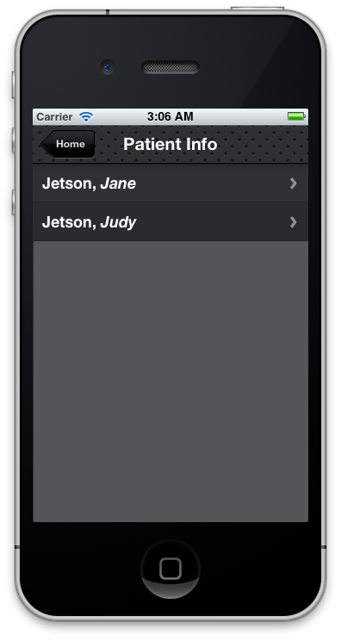

Patient Information
Tap a name and you will see the details.
Healthcare records are listed after some basic information.
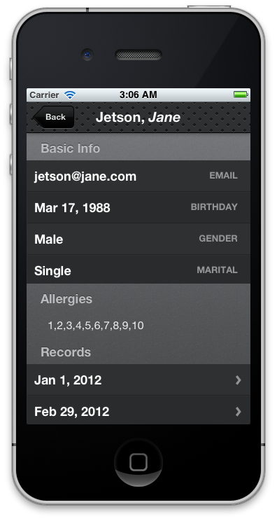

Healthcare Record
By tapping the record date, you can view the healthcare record information.
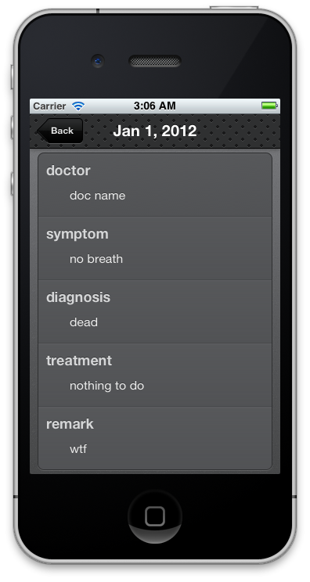

Appointments
Tapping “Appointments” in the homepage, you will see a list of appointments.
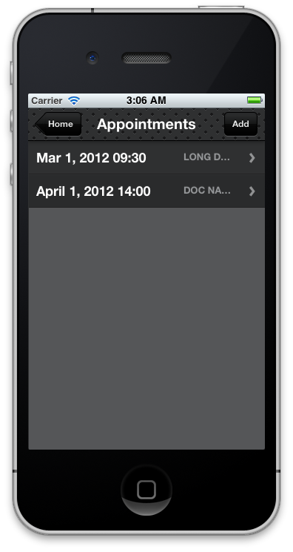

Appointment view
You can check the appointment details by tapping on one of the appointments.
You may make changes to it and tap “Update”.
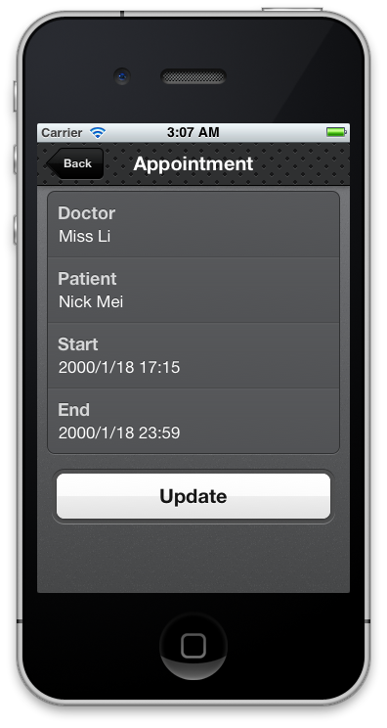

New appointment
By clicking the “Add” button at the top right corner in Appointments view, you can create a new appointment.
Type in the data and tap the “Add” button.
