Open [Control Panel] → [Add Hardware]

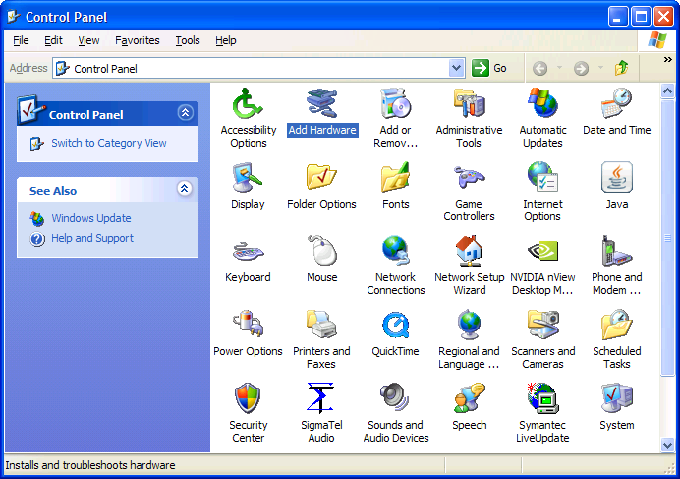
Click [Next]

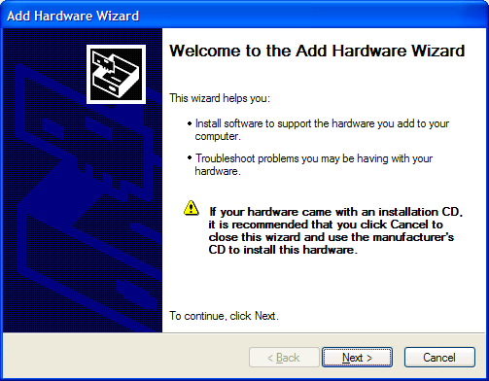
Choose [Yes, I have already connected the hardware] → [Next]

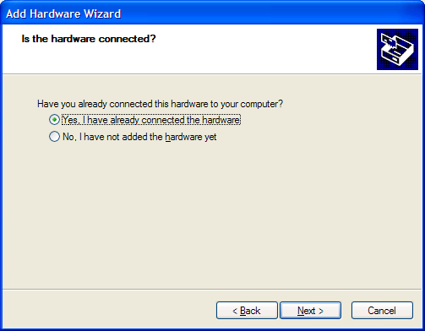
Select [Add a new hardware device] → [Next]

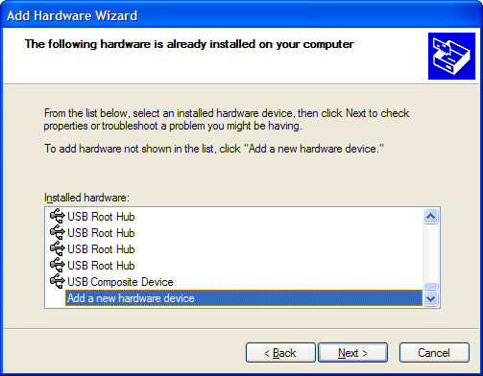

Choose [Install the hardware that I manually select from a list] → [Next]

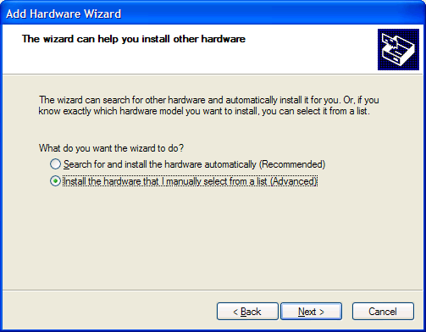
Select [Network adapters] → [Next]

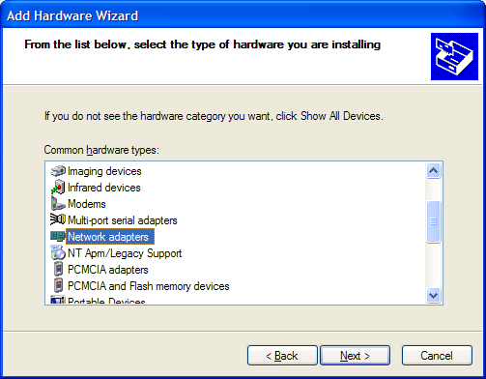

Select [Microsoft] in the left window and [Microsoft Loopback Adapter] in the right and then click [Next]

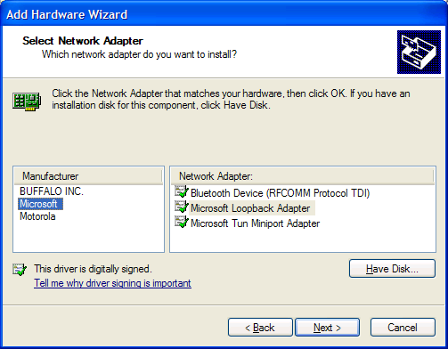
Click [Next]

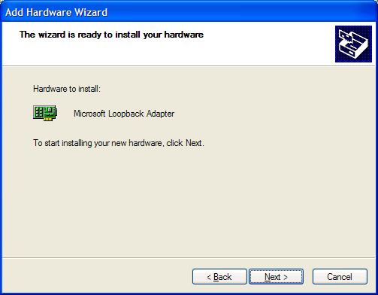

Click [Finish] to complete the installation.

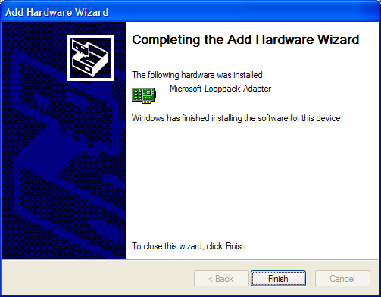
We may now configure the [Microsoft Loopback Adapter]. Open [Network Connections] and right click the connection which has the device name, Microsoft Loopback Adapter, and then choose [Properties]

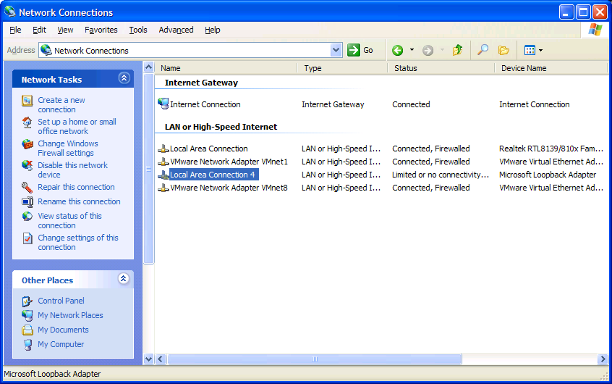
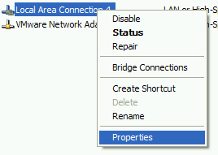

Choose [Internet Protocol (TCP/IP)] and click [Properties]
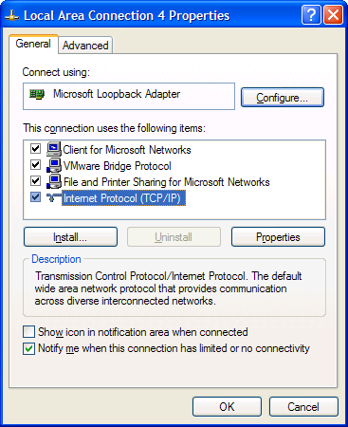
Choose [Use the following IP address] and input [10.10.10.10] as the IP address and [255.255.255.0] as the Subnet mask. Then click [OK].

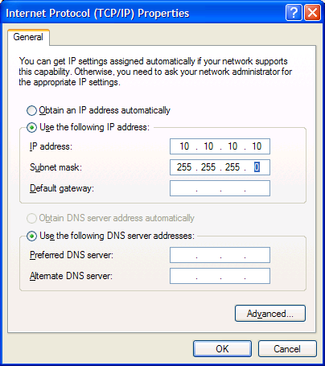
Click [Close].

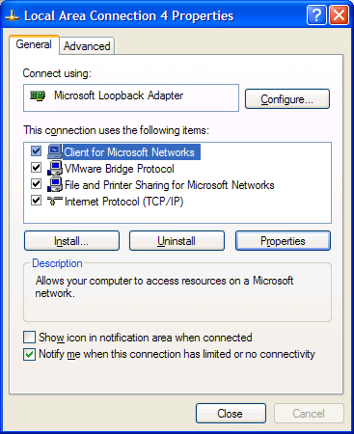
You may rename the connection as [Microsoft Loopback] if you like.

