Please download the application through Oracle web site
http://www.oracle.com/technology/products/database/oracle11g/index.html
Once download is complete, you may extract files to a folder.

For example, I extract the application to [F:\ora11\database], see below.

Click [setup.exe] to start the installation.

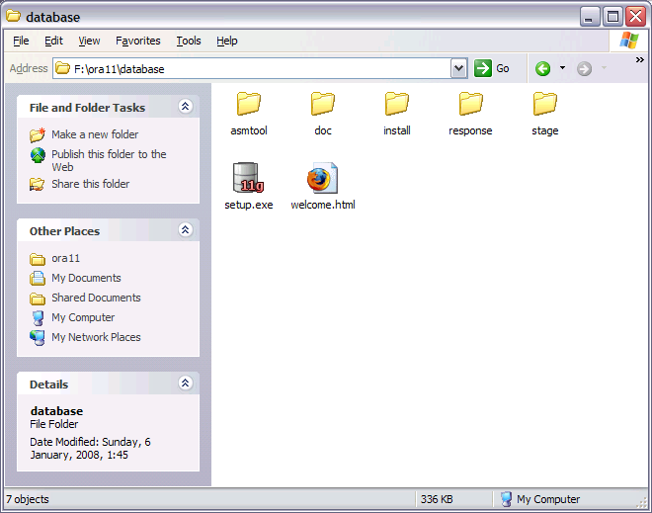
Setup is starting the installation.

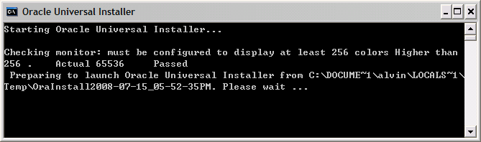

Keep default settings and enter PASSWORD for the database [orcl]. Click [Next] to continue.

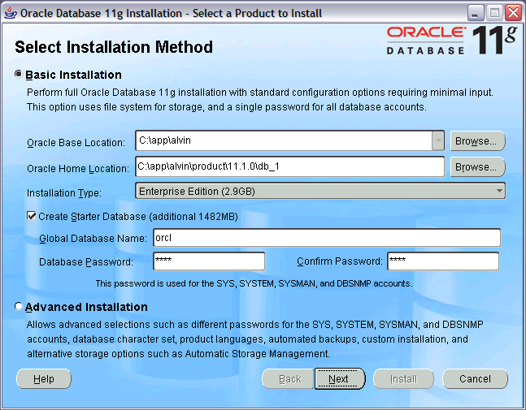
Setup is getting ready to install the application.

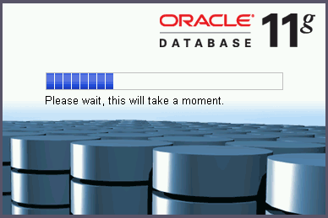

Setup has checked the machine whether or not suitable for installation.

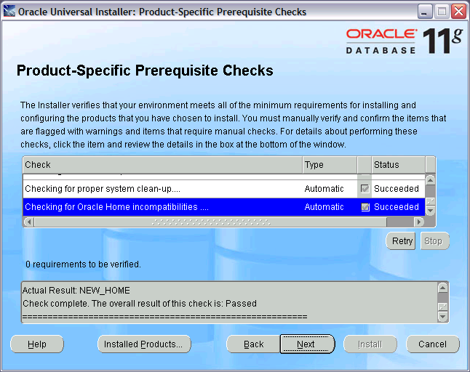
If not all “Status” are “Succeeded”, don't try to go on the installation. You must fix all problems before you can continue.

Click [Next].

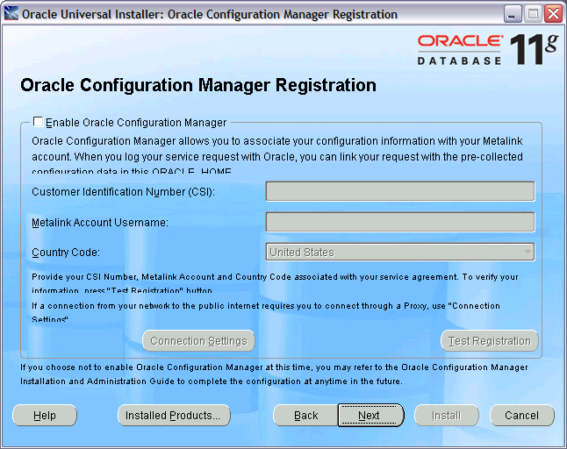

Click [Install].

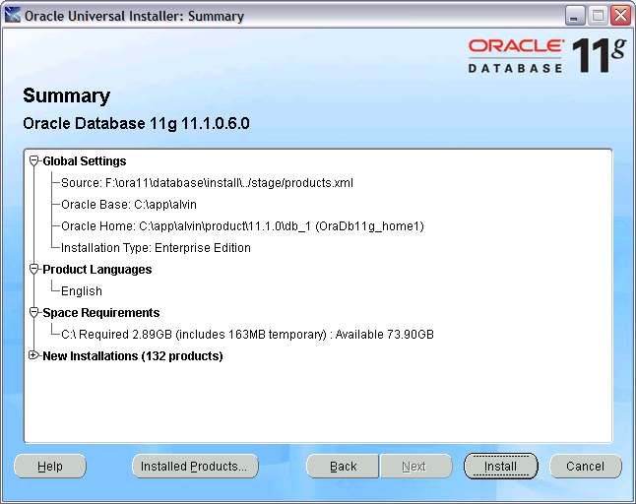

Oracle is being installed. It takes some time. Please wait. During the installation, you may see the following screens.

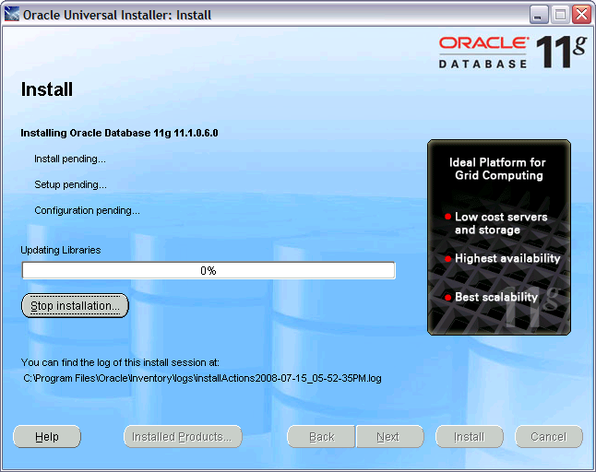
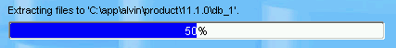
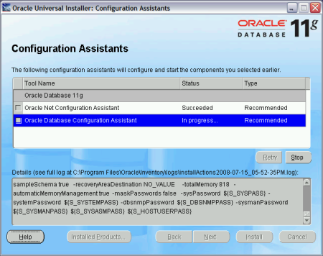
The database, [orcl], is being created.

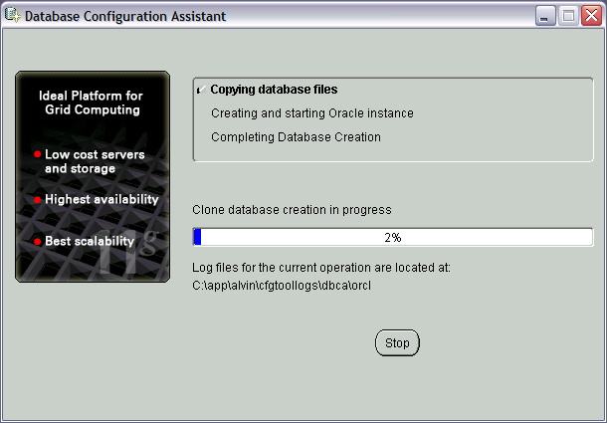
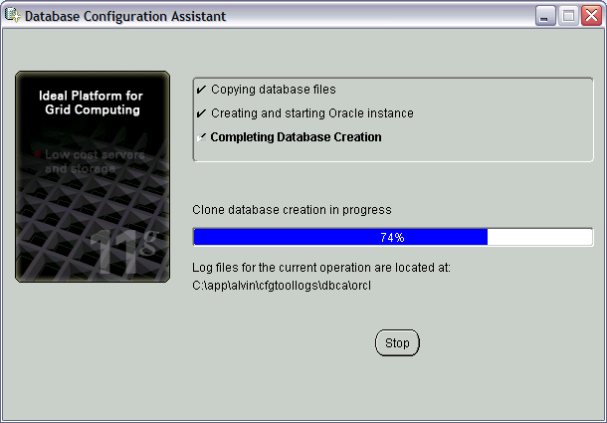
Click [Exit] to complete the installation.

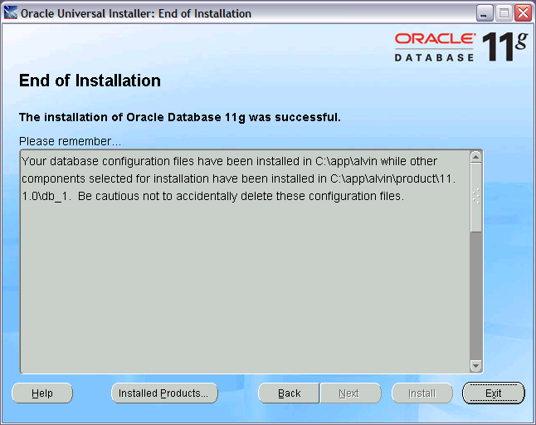

Congratulations! You have successfully installed the application.
Check that [All Programs] → [Oracle – OraDb11g_home1] → ... You can see Oracle's menu on your machine.

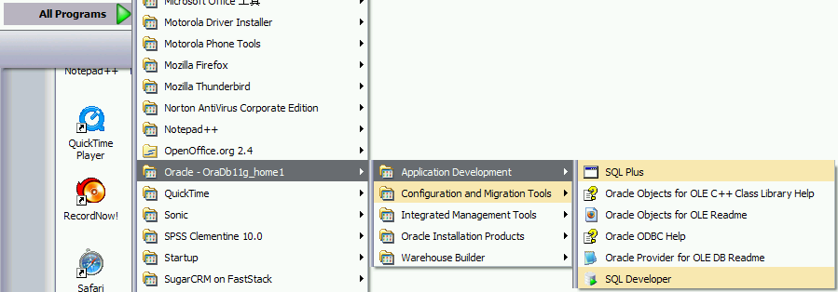
- End -

