Preparation of OWB

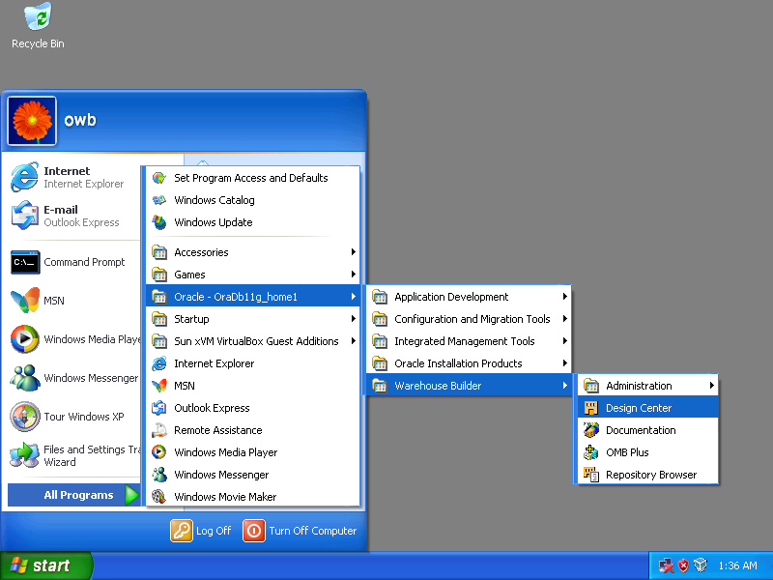

[Start] ➔ [All Programs] ➔ [Oracle-OraDb11g_home1] ➔ [Warehouse Builder] ➔ [Design Center]

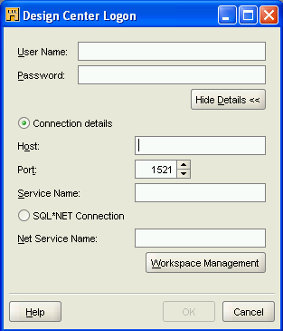

Click [Workspace Management].

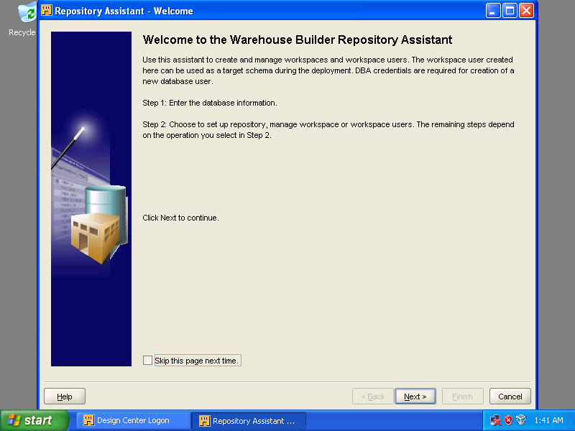

Click [Next].
Host Name: LOCALHOST
Port Number: 1521
Oracle Service Name: orcl
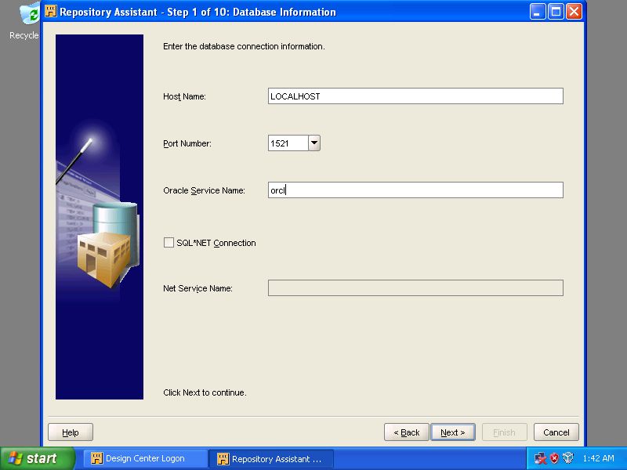

Click [Next].
Select [Manage Warehouse Builder workspaces]
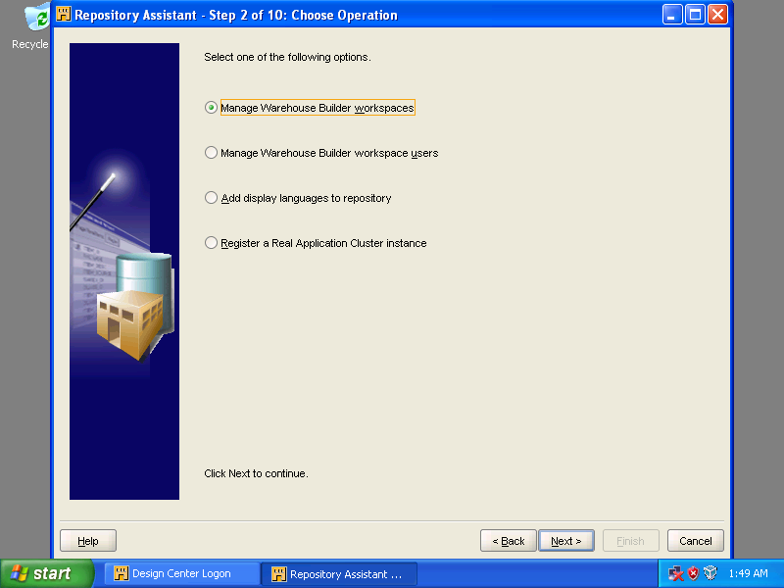
Select [Manage Warehouse Builder workspaces].

Click [Next].

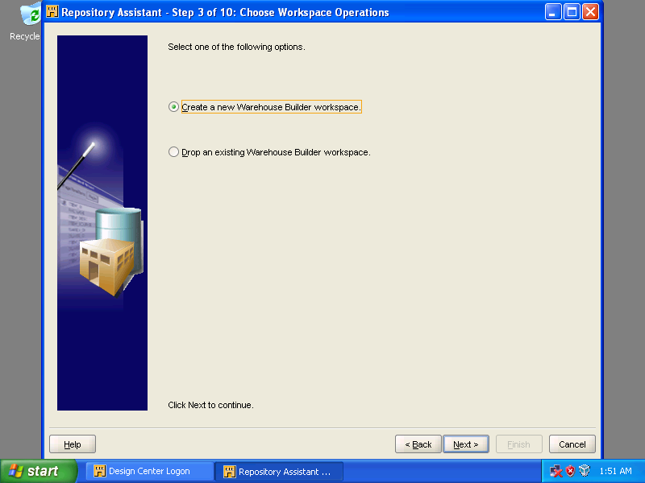
Select [Create a new Warehouse Builder workspace].

Click [Next].

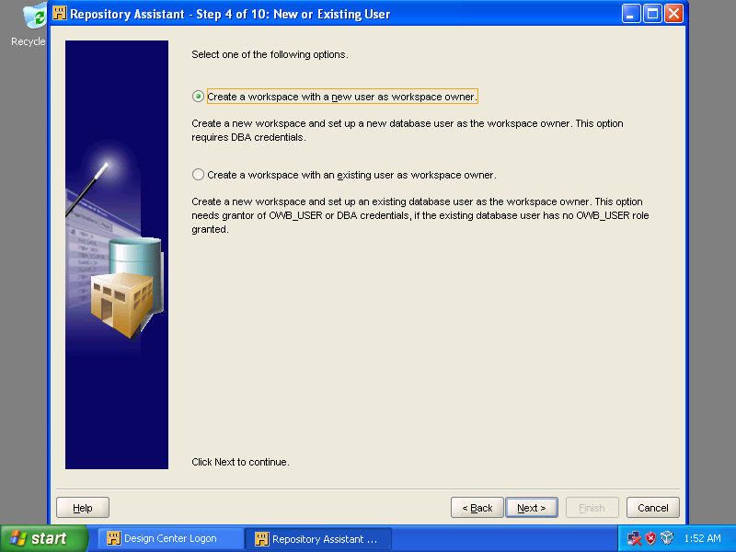
Select [Create a workspace with a new user as workspace owner].

Click [Next].

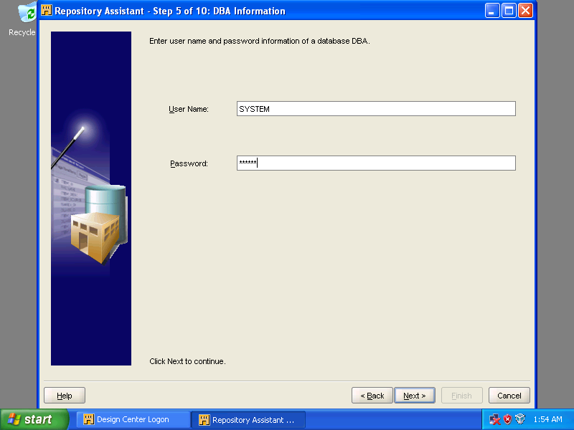

Type the password for the user, SYSTEM, and then click [Next].

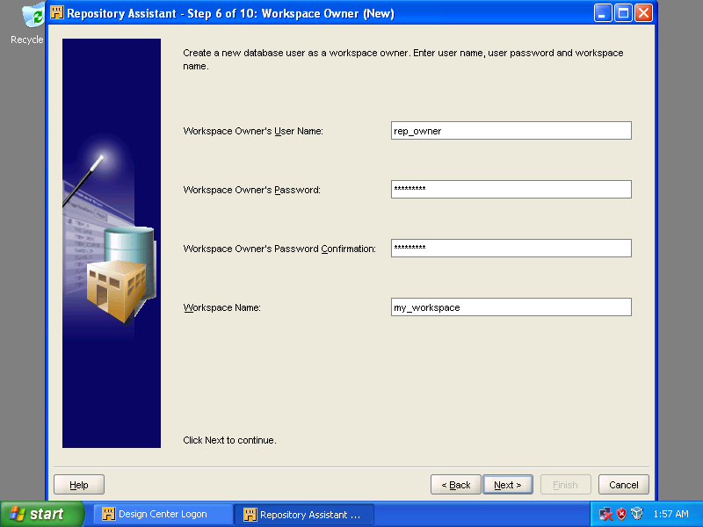
Workspace Owner's User Name: rep_owner
Workspace Owner's Password: rep_owner
Workspace Owner's Password Confirmation: rep_owner
Workspace Name: my_workspace

Click [Next].

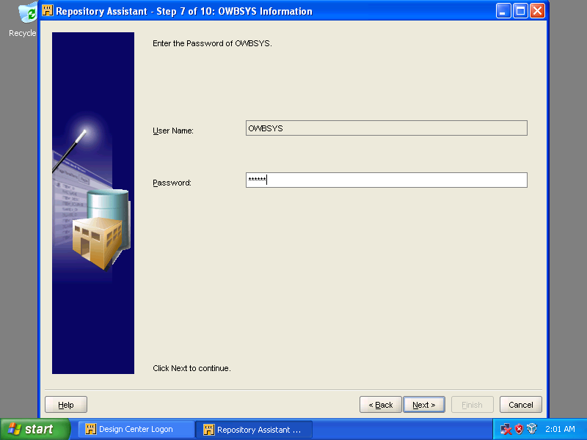

Type the password for the user, OWBSYS, and then click [Next].

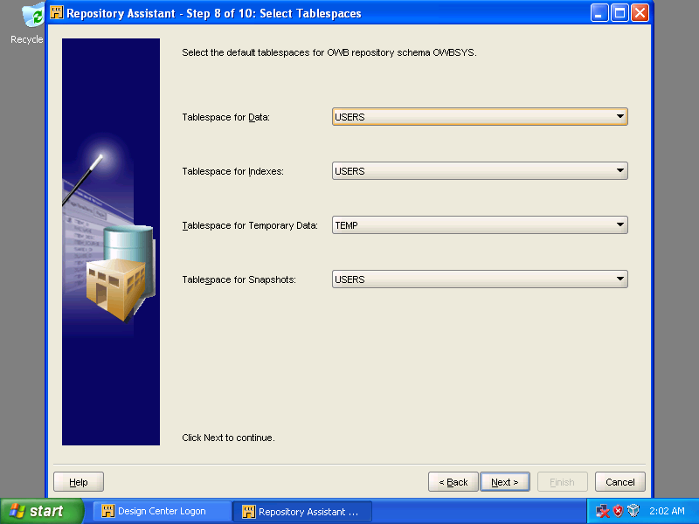

Accept the default settings and click [Next].

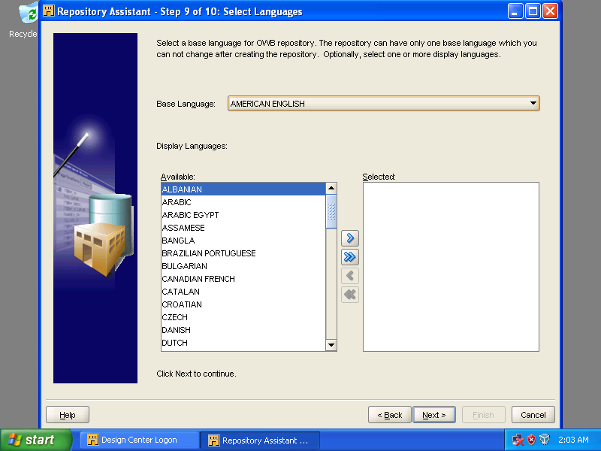

Accept the Language setting, AMERICAN ENGLISH, and click [Next].

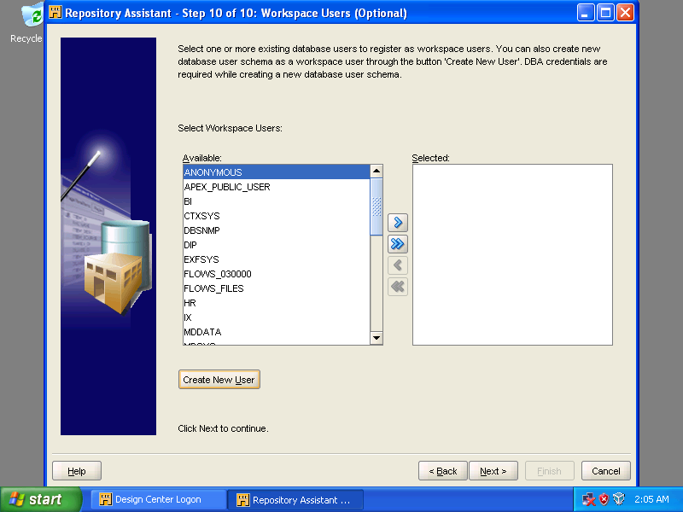

Click [Create New User].

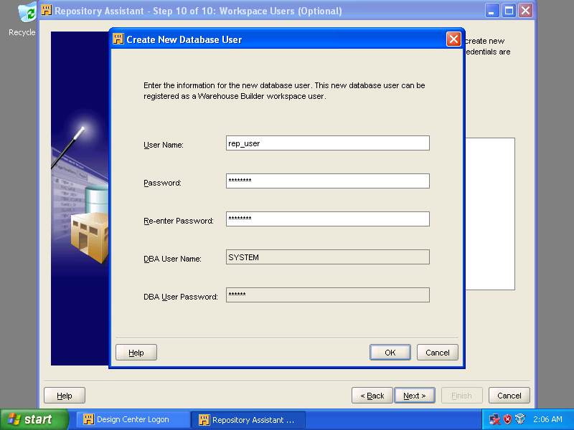
User Name: rep_user
Password: rep_user
Re-enter Password: rep_user
DBA User Name: SYSTEM
DBA User Password: oracle

Click [OK].

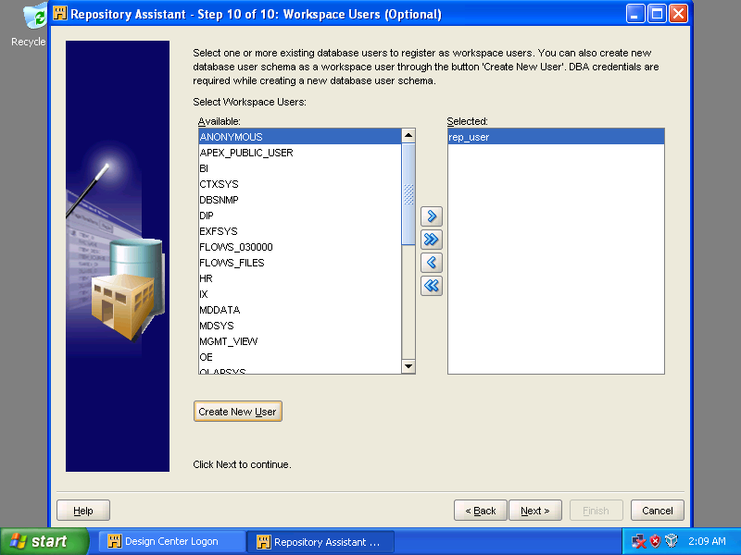

Click [Next].

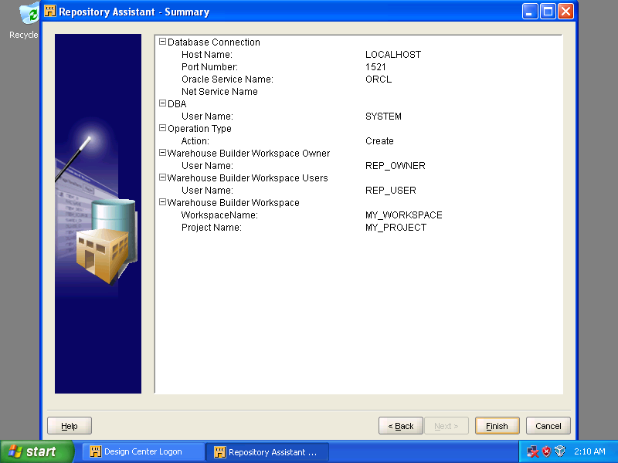

Click [Finish].

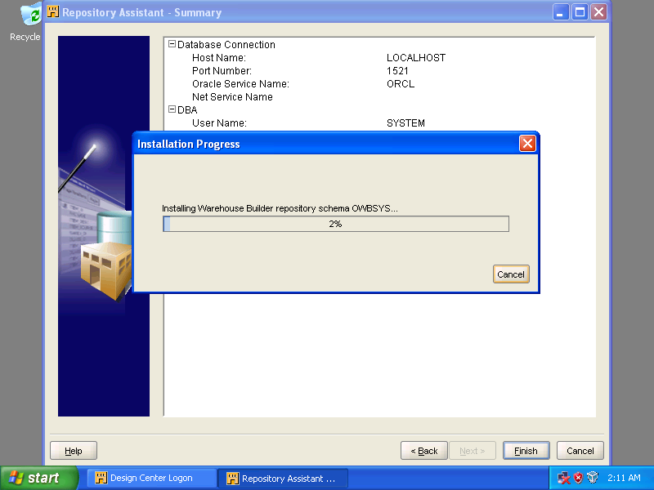

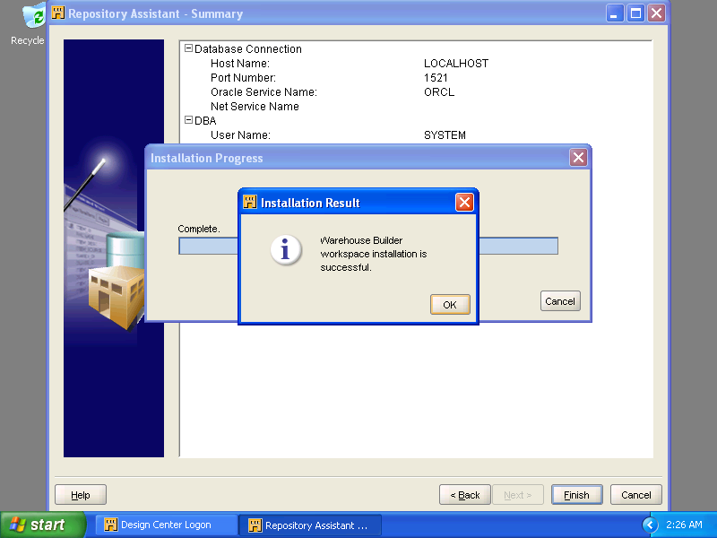
Click [OK].
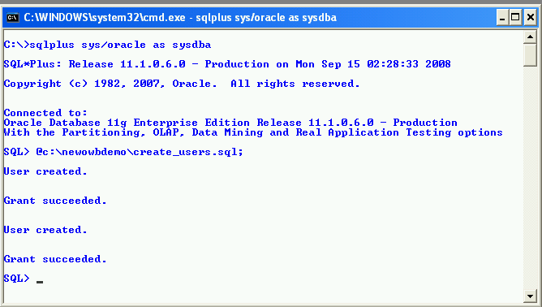

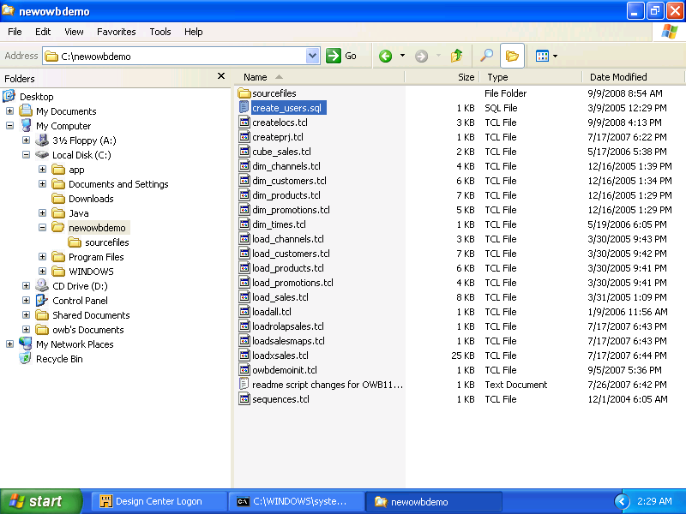

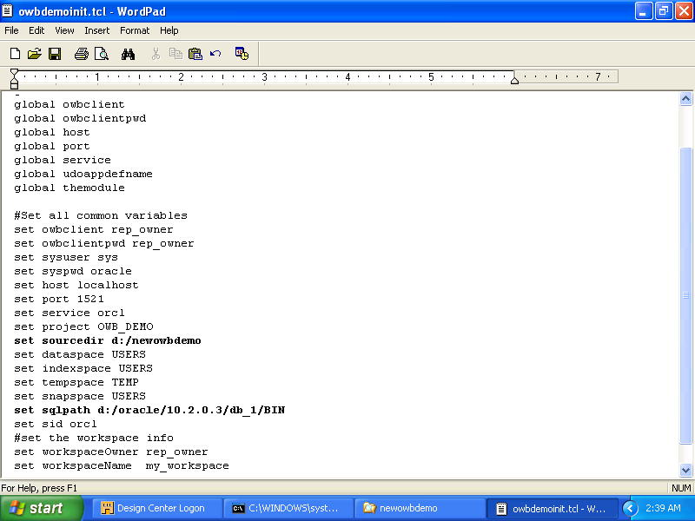

Run [@d:\newowbdemo\create_users.sql;] using SQLPLUS with login as SYSDBA (i.e. user = SYS).

Use Notepad to open the file, [c:\newowbdemo\owbdemoinit.tcl], and correct the statements (bold) to point to the right destinations.

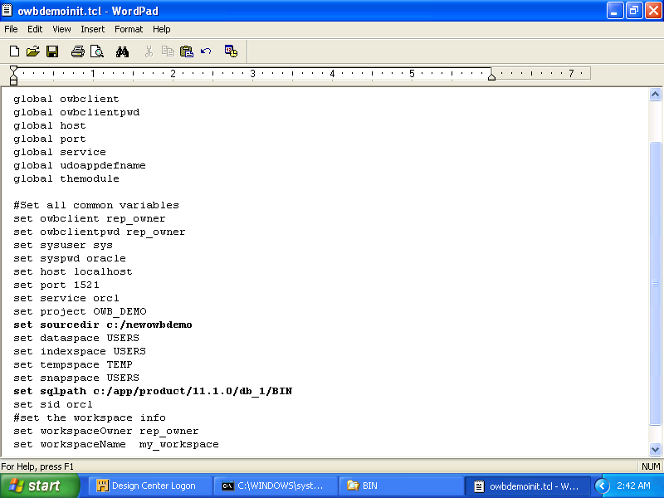

Content of [owbdemoinit.tcl]. Remember to correct the paths which should point to the correct folders in your machine.

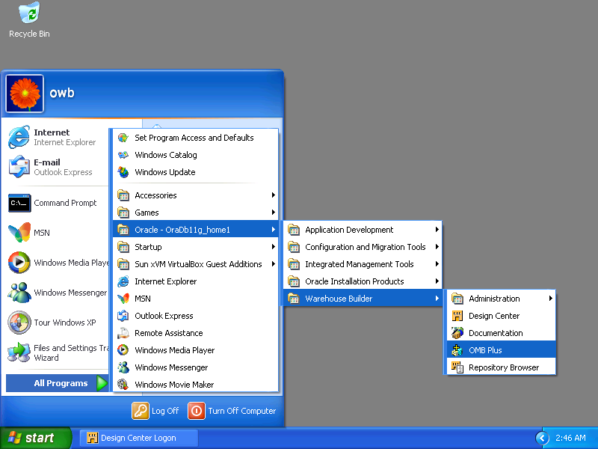

[Start] => [Oracle-OraDb11g_home1] => [Warehouse Builder] => [OMB Plus]
Use [OMB Plus] to import sources.

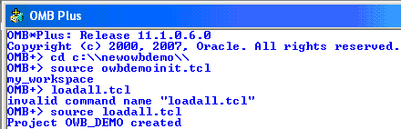
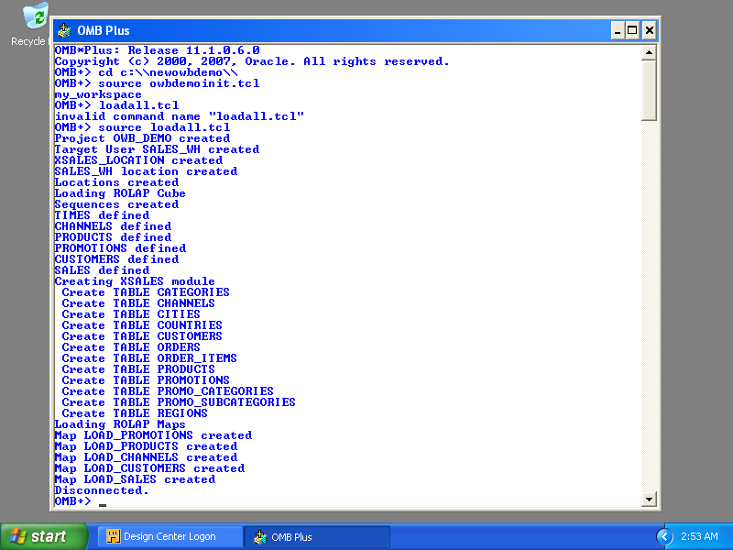

In OMB Plus, change the directory first (type [cd c:\\newowbdemo\\]), enter the source command: [source owbdemoinit.tcl] and then enter another source: [source loadall.tcl]. Once [Disconnected.] appears, exit the OMB Plus environment.
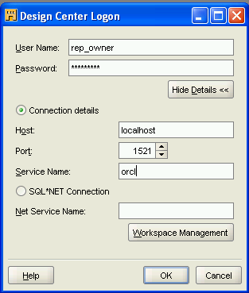

Try log in OWB by using the user account already created (rep_owner).

