Creating a Flat File Source Module

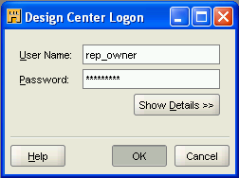

Log in as [rep_owner / rep_owner]

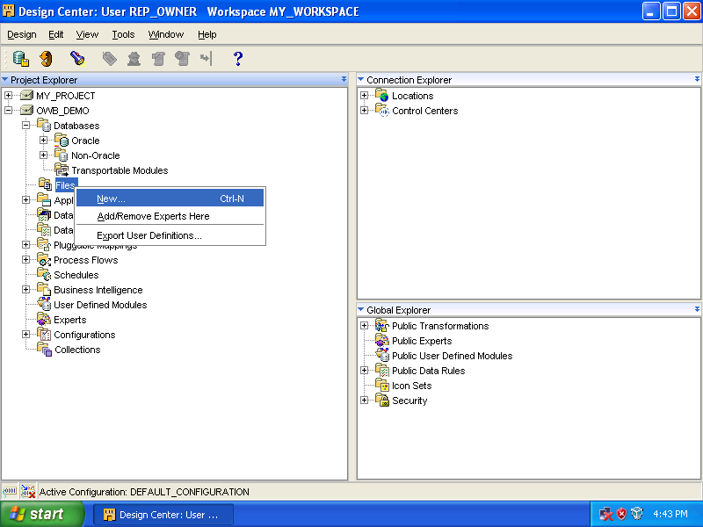

Expand the [OWB_DEMO], right click the [Files] node, select [New].

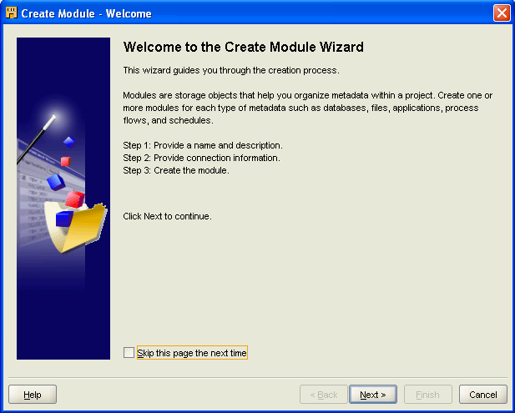

Click [Next].

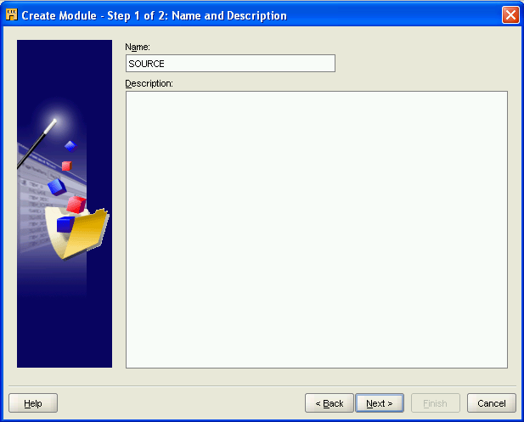

Enter [SOURCE] as the name, then, click [Next].

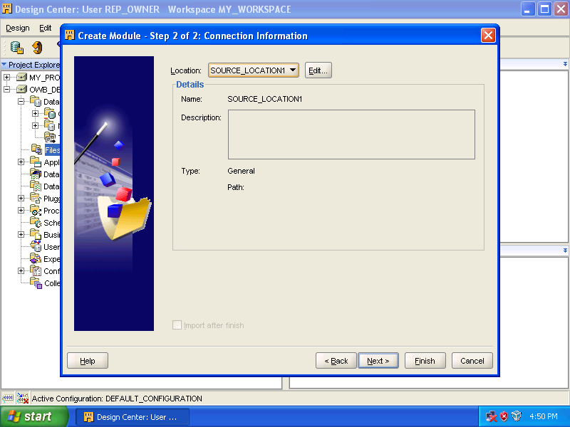

Click [Edit...].

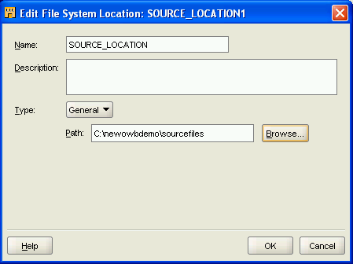
Rename [SOURCE_LOCATION1] to [SOURCE_LOCATION], then select [c:\newowbdemo\sourcefiles] (the directory which contains the source files), and finally click [OK].

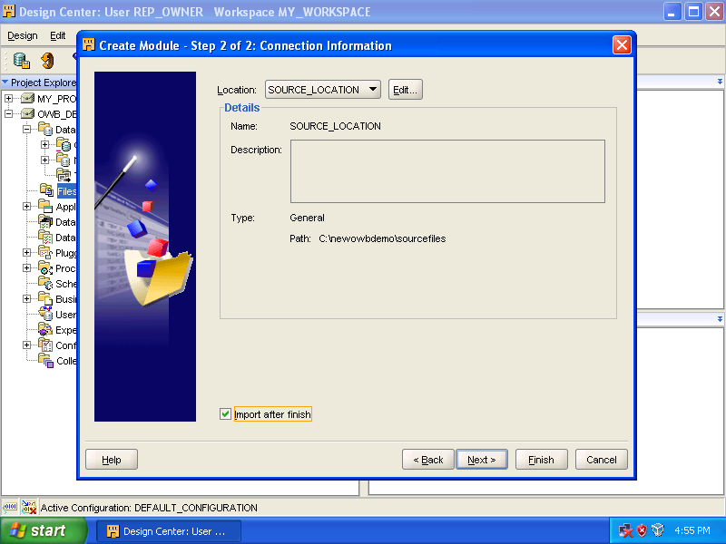
Check [Import after finish] and click [Finish].

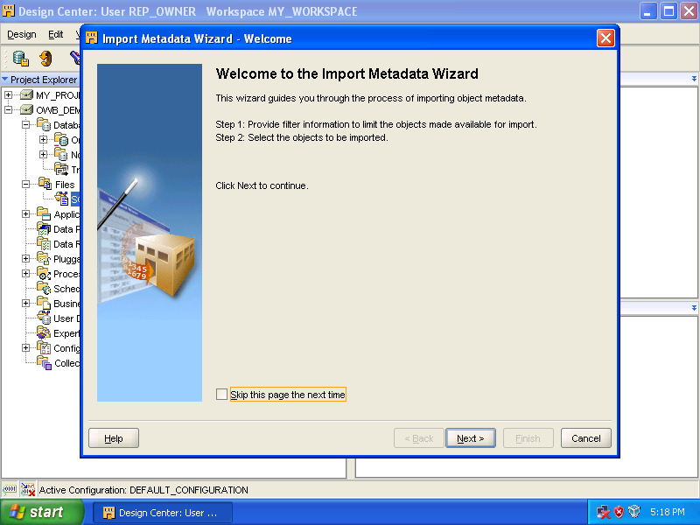
Click [Next].

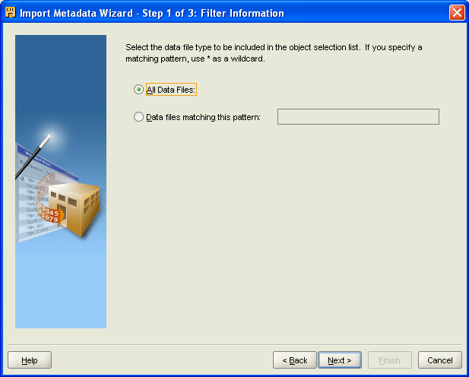

Accept the default selection, [All Data Files], and click [Next].

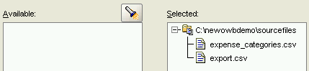
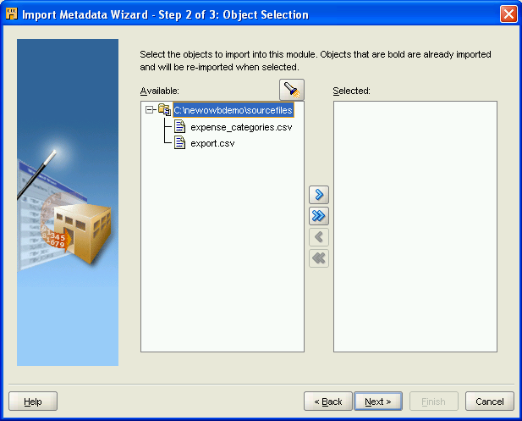

Click the double arrow button to select all files. Then, click [Next].
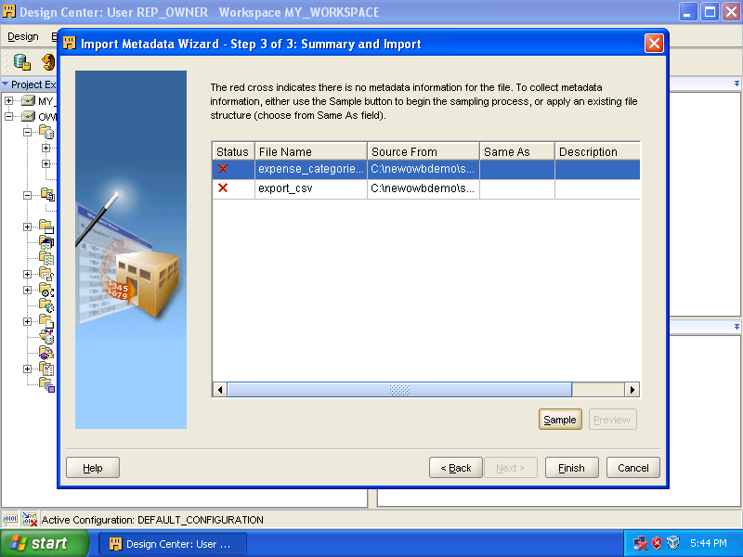

Select [expense_categories_csv] and click [Sample].

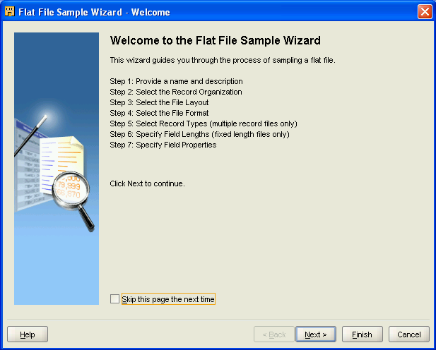

Click [Next].
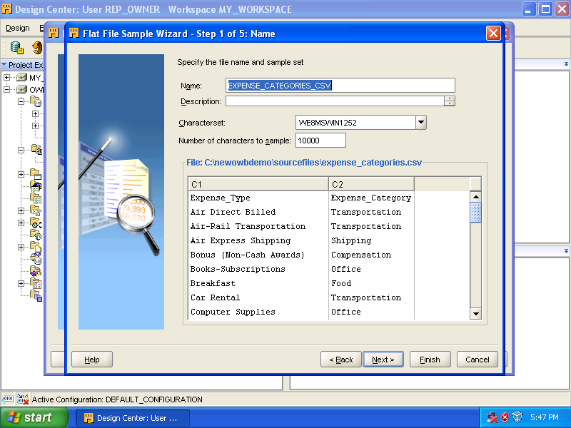

Click [Next].

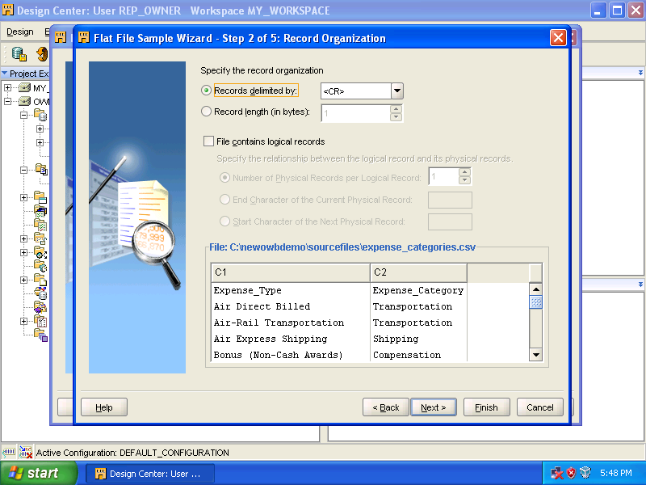

Click [Next].
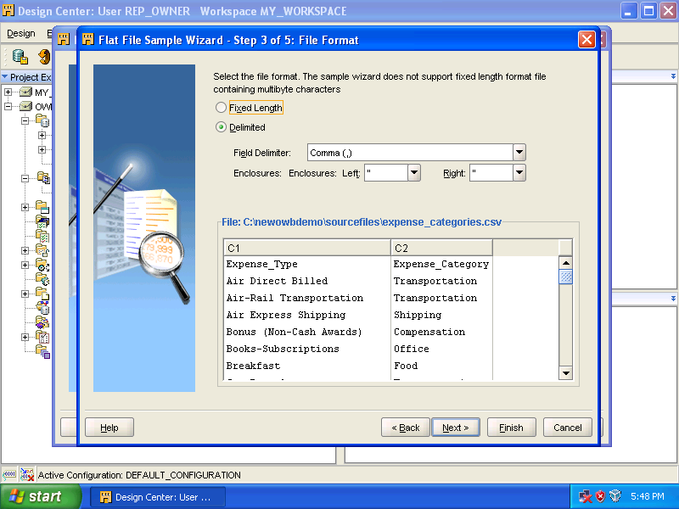

Click [Next].

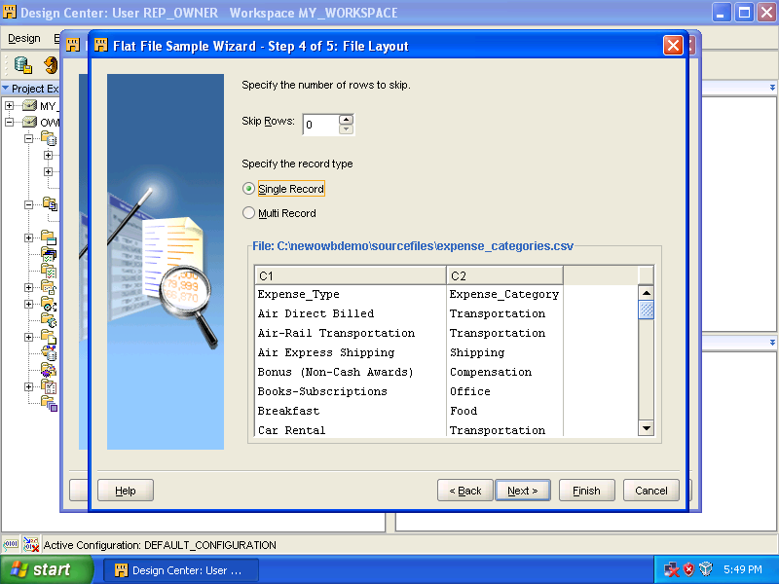

Click [Next].

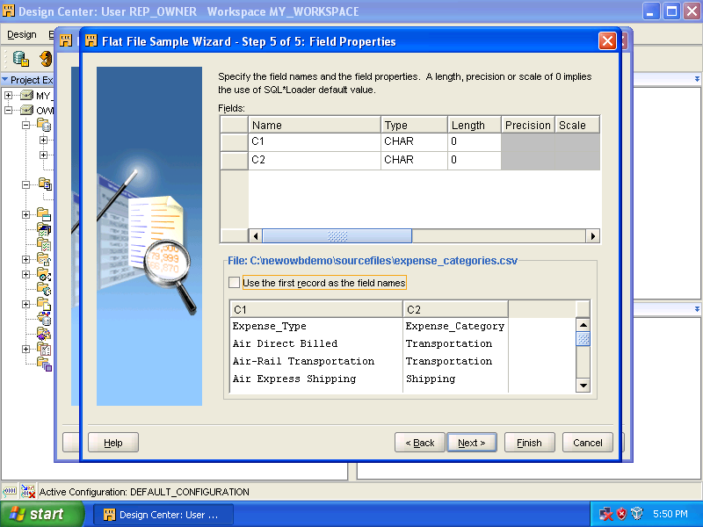

Check [Use the first record as the field names].

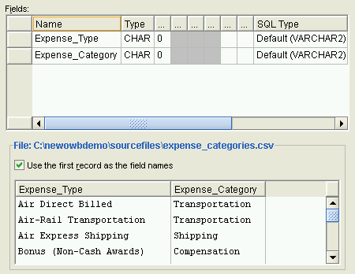

Click [Next].

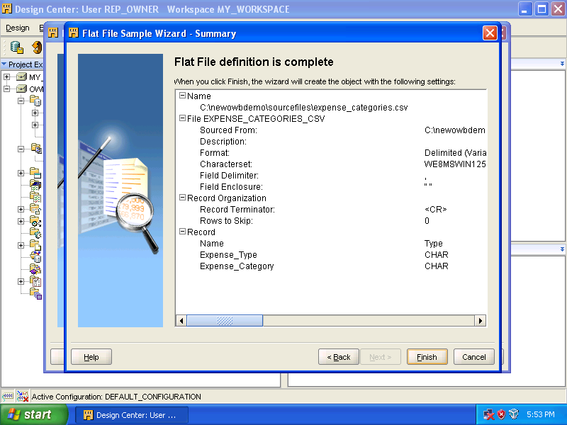

Click [Finish].

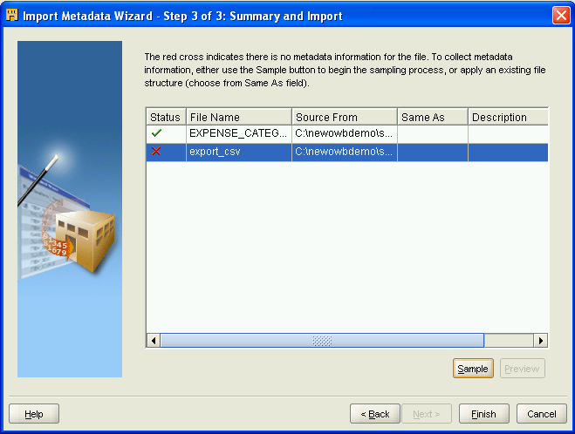

Select [export_csv] and click [Sample] again.

Click the [Next] buttons until you reach the following screen.

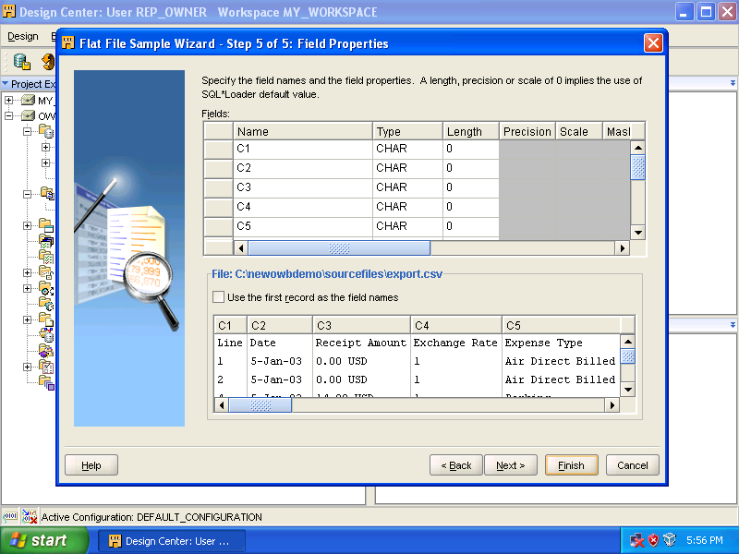

Not only check the [Use the first record as the field name], but also do the following.

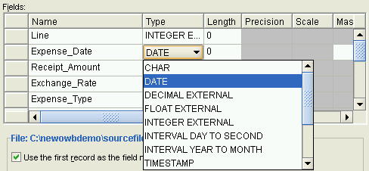

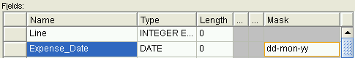

Rename [Date] to [Expense_Date], choose [Date] as the [Type], and finally enter [dd-mon-yy] in the [Mask] box.

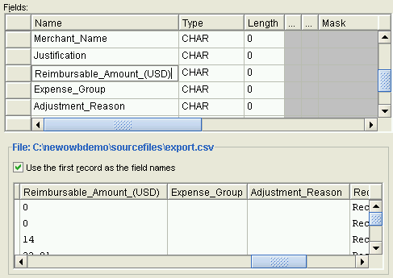

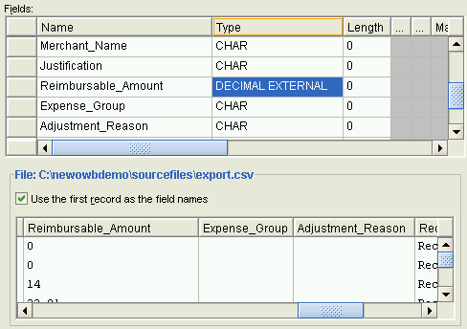

Rename [Reimbursable_Amount(USD)] to [Reimbursable_Amount] and select [DECIMAL EXTERNAL] as the [Type].

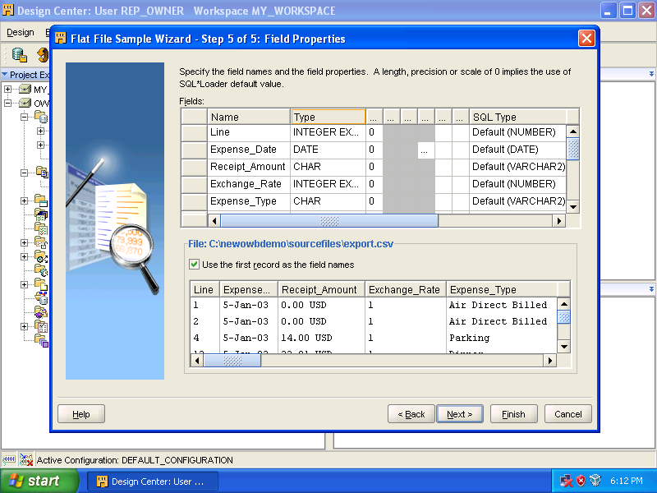

Click [Next].

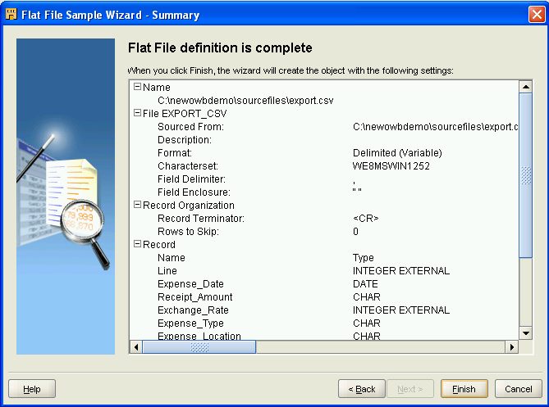

Click [Finish].

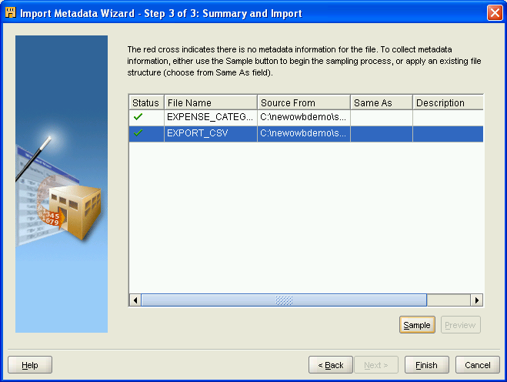

Click [Finish].

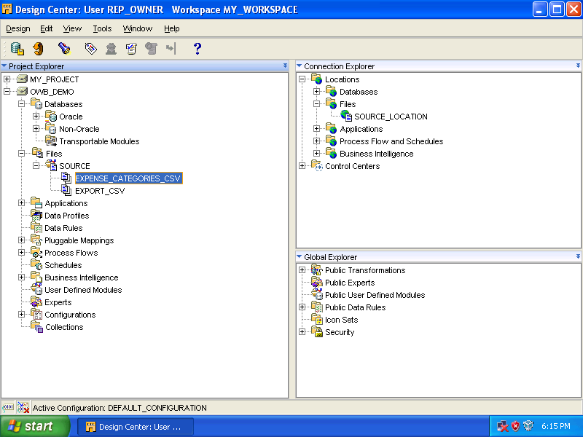

As you can see, the two flat files are imported and the location has been defined.

