Create a Target User and Target Location

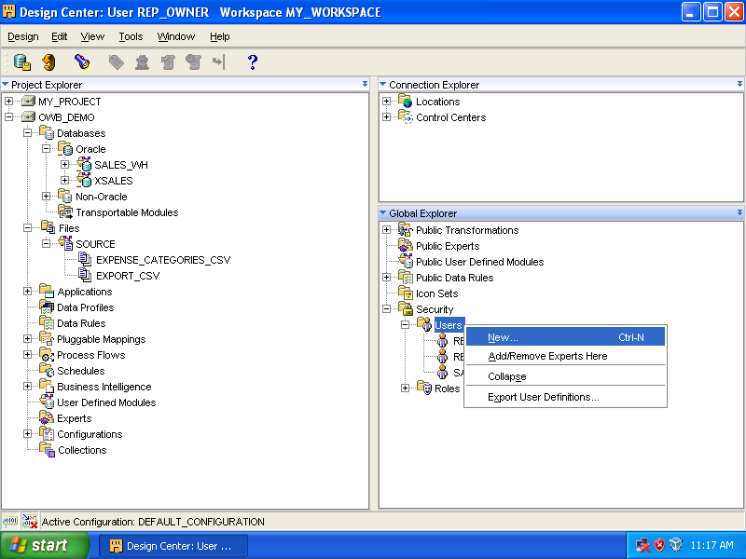

Expand the [Security] node. Right click the [Users] node and select [New…].

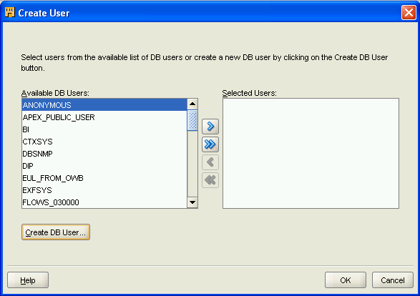

Click [Create DB User…].

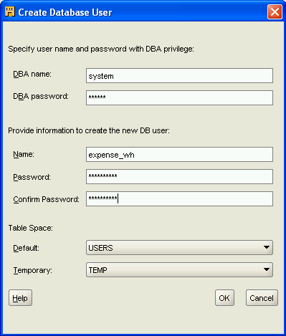
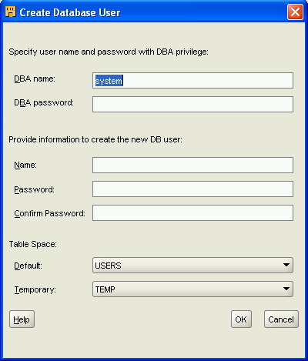
Input the following:

DBA name: system
DBA password: oracle

Name: expense_wh
Password: expense_wh
Confirm: expense_wh

Click [OK].

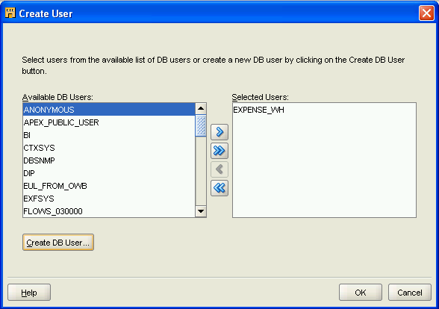

Click [OK].

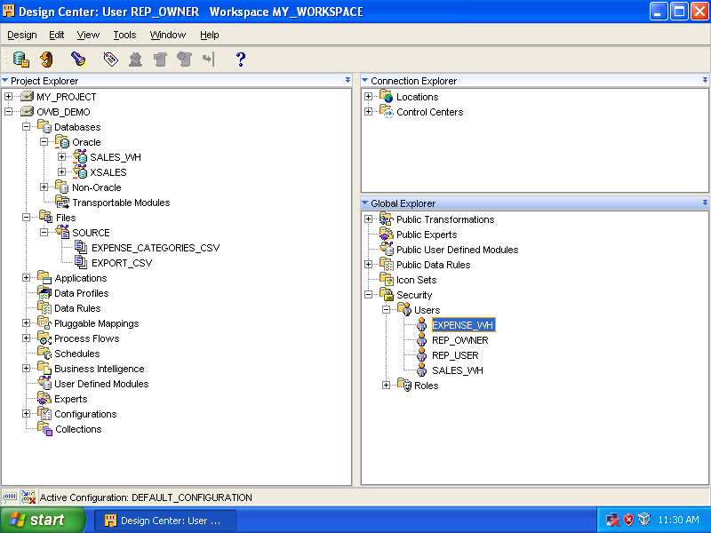

User [EXPENSE_WH] is added and is on the list.

Create target location

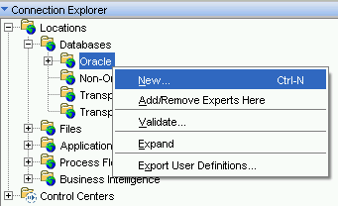
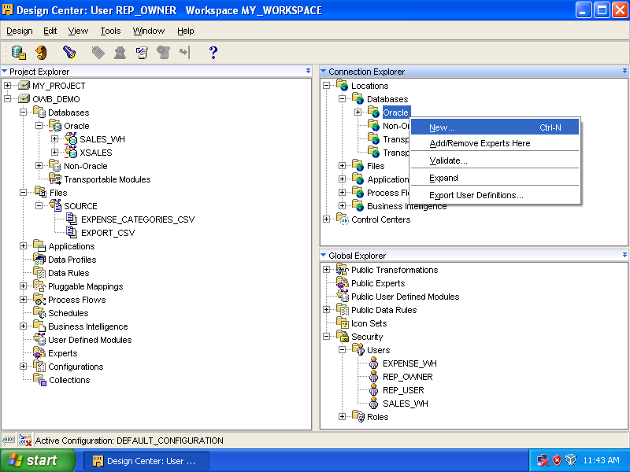

Expand [Databases], right click [Oracle] and select [New…].

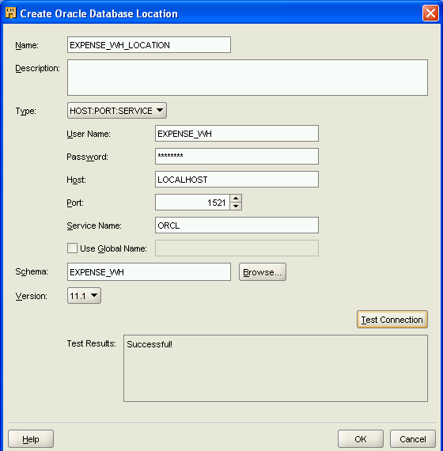
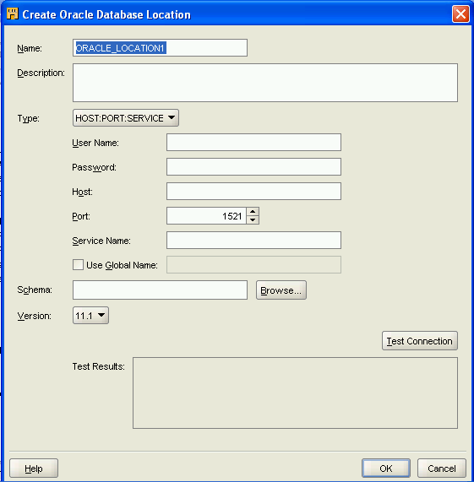
Input the following:

Name: EXPENSE_WH_LOCATION
User Name: EXPENSE_WH
Password: expense_wh
Host: localhost
Port: 1521
Service Name: orcl
Schema: expense_wh
Version: 11.1

Click

Click [Test Connection].
If [Successful!] appears in [Test Results] box, click [OK].

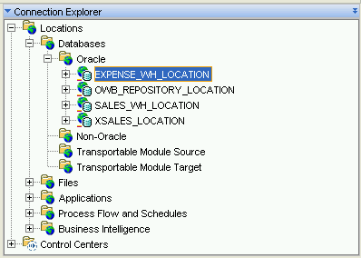

[EXPENSE_WH_LOCATION] is added to the list.

Create a Target Module

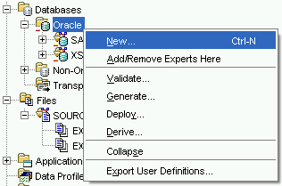
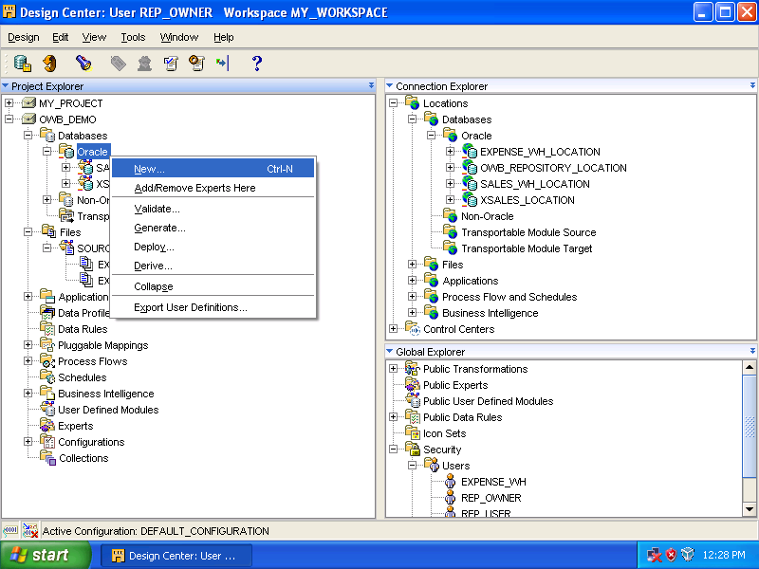

Expand [Databases] ➔ right click [Oracle] ➔ select [New…]

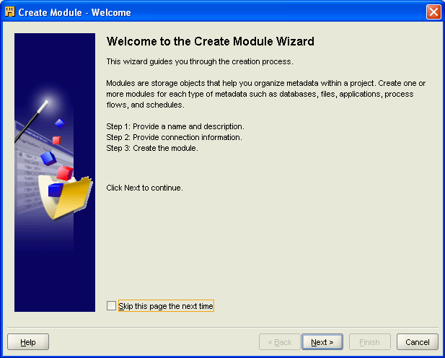

Click [Next]

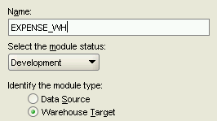
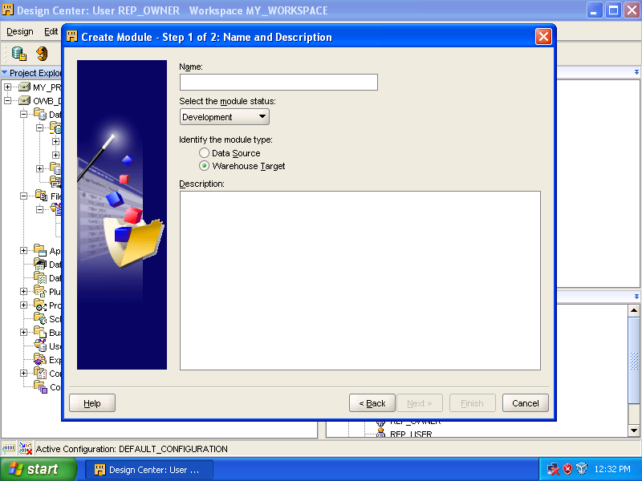

Enter [EXPENSE_WH] as the name. Click [Next]

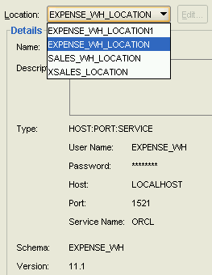
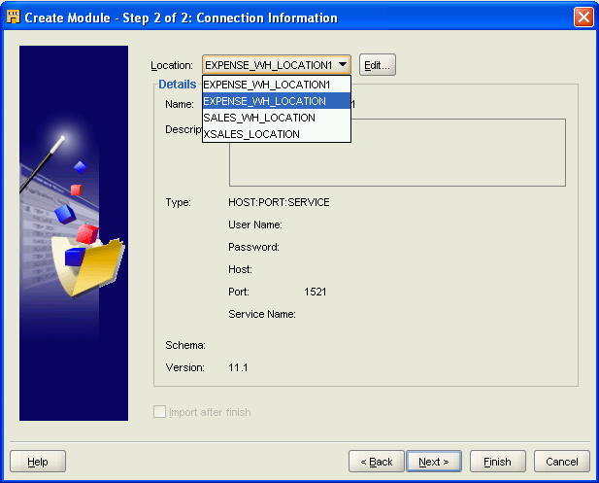

By default, system gives the name [EXPENSE_WH_LOCATION1], but we select [EXPENSE_WH_LOCATION] from the pull down menu. Click [Next].

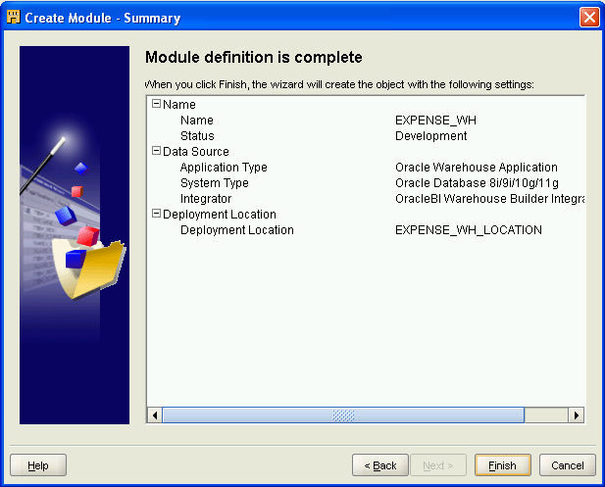

Click [Finish].

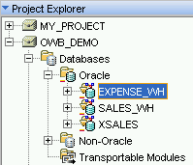
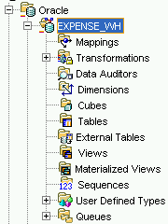
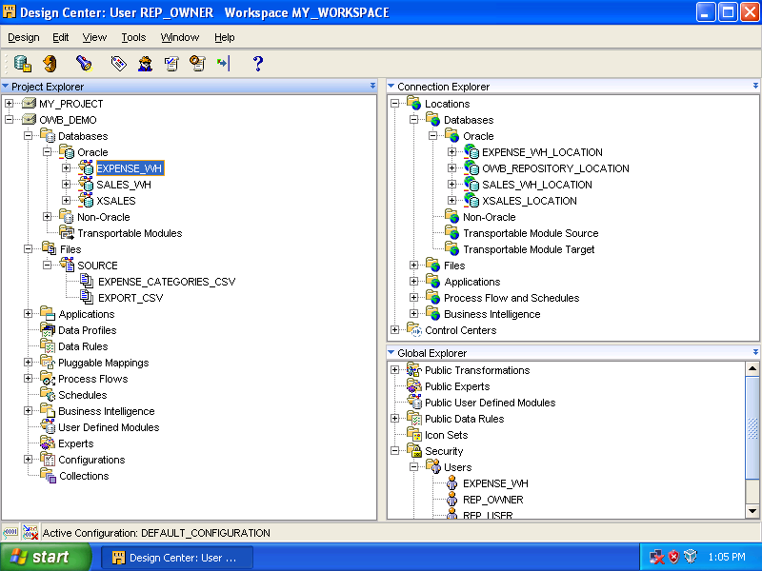

Target module added.

Creating External Tables

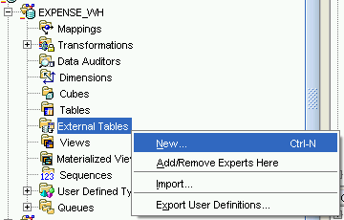
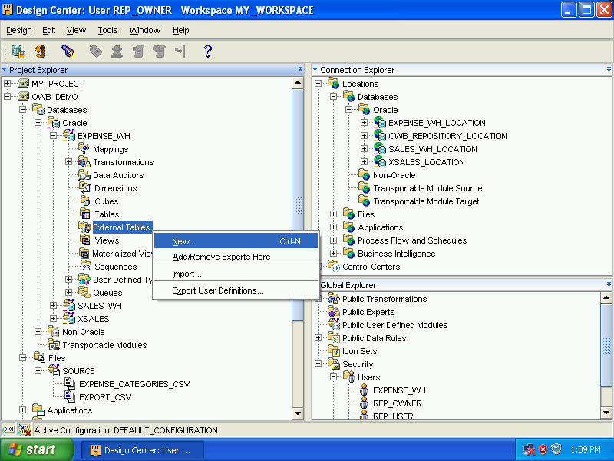

Expand [Databases] ➔ [Oracle]
➔ [EXPENSE_WH]
Right click [External Tables]
Select [New…].

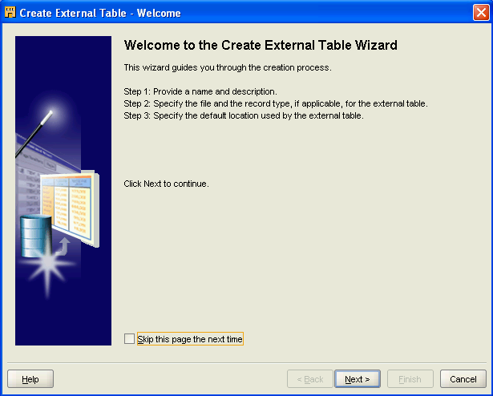

Click [Next].

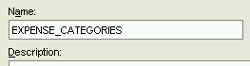
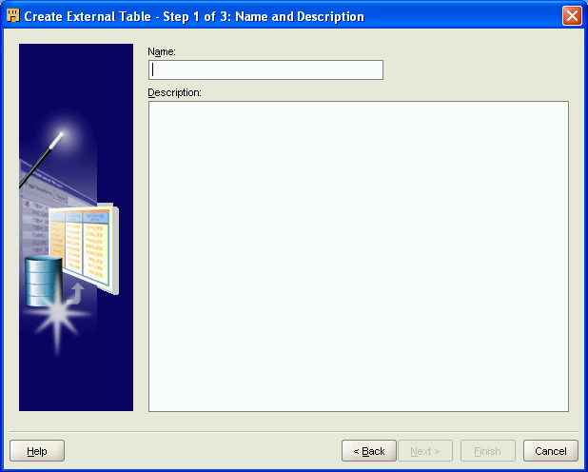

Enter [EXPENSE_CATEGORIES] as the name. Click [Next].

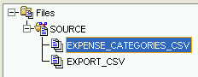
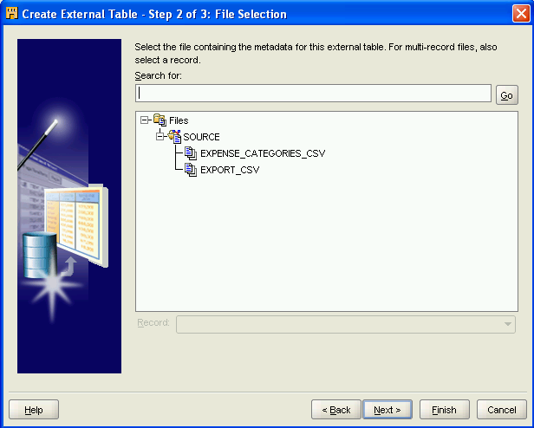

Select [EXPENSE_CATEGORIES_CSV]. Click [Next].

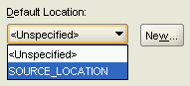
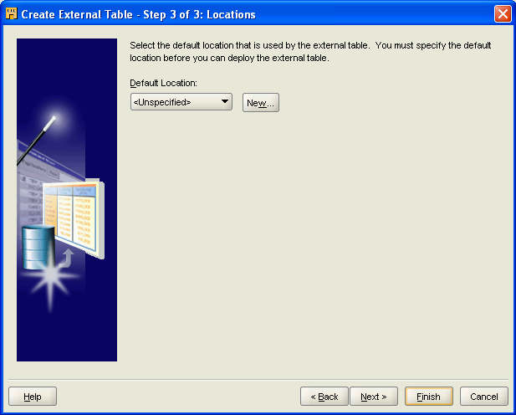

Select [SOURCE_LOCATION] from the drop down menu. Click [Next].

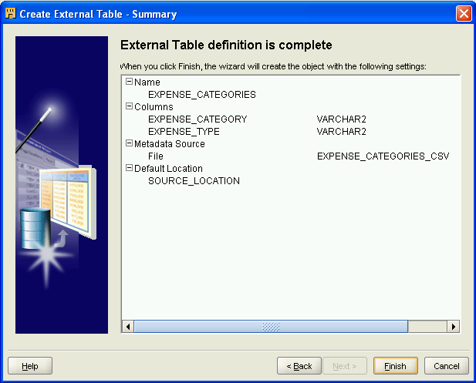

Click [Finish].

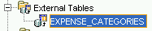
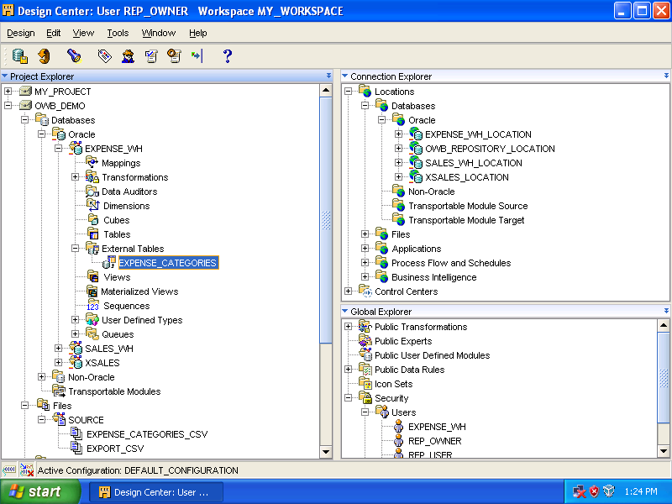

[EXPENSE_CATEGORIES] has been added to [External Tables].

Repeat above procedures to add one more external table, [EXPENSE_DATA].

But remember: when arrive at 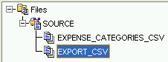, select [EXPORT_CSV]. At the last screen, below screens should be seen.

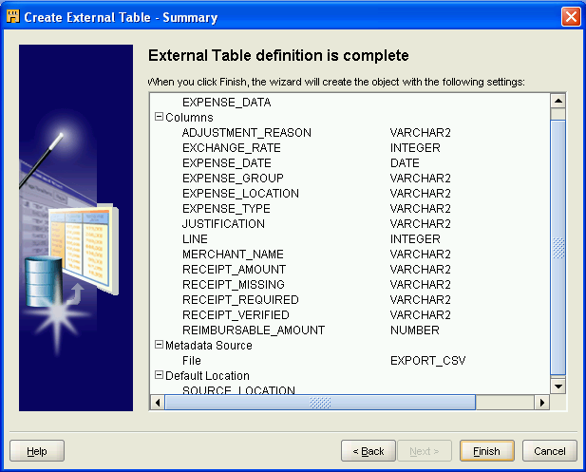

Click [Finish].

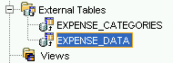

Configure Physical File System

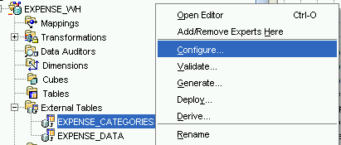

Right click [EXPENSE_CATEGORIES]. Select [Configure…].

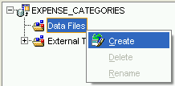
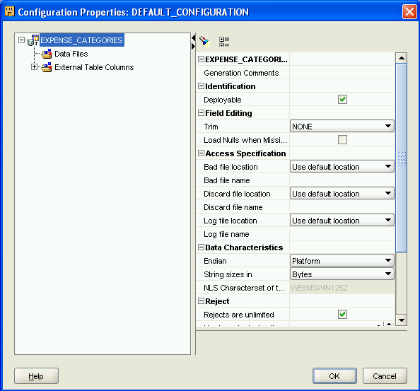

Right click [Data Files], select [Create].

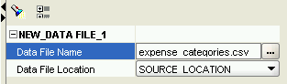
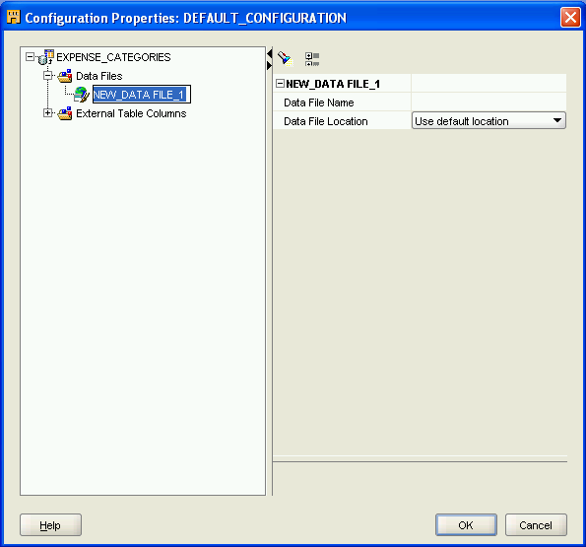

Enter [expense_categories.csv] as the Data File Name and select [SOURCE_LOCATION] from the drop down menu. Click [OK].

Repeat procedures for the other flat file, EXPENSE_DATA.

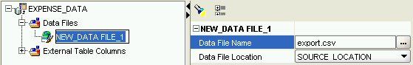
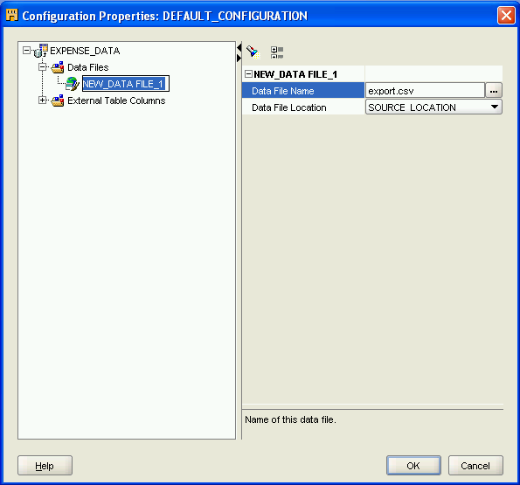

Click [OK].

Designing Dimensions

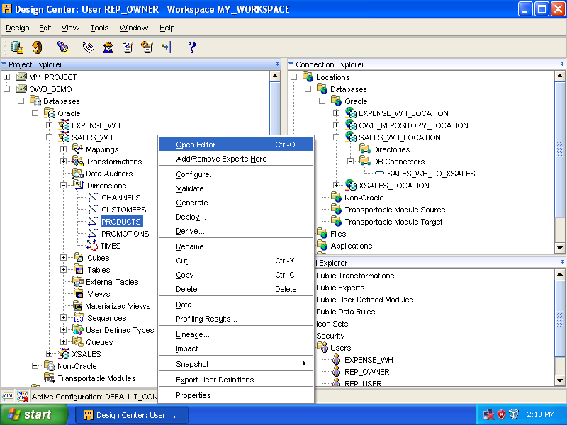

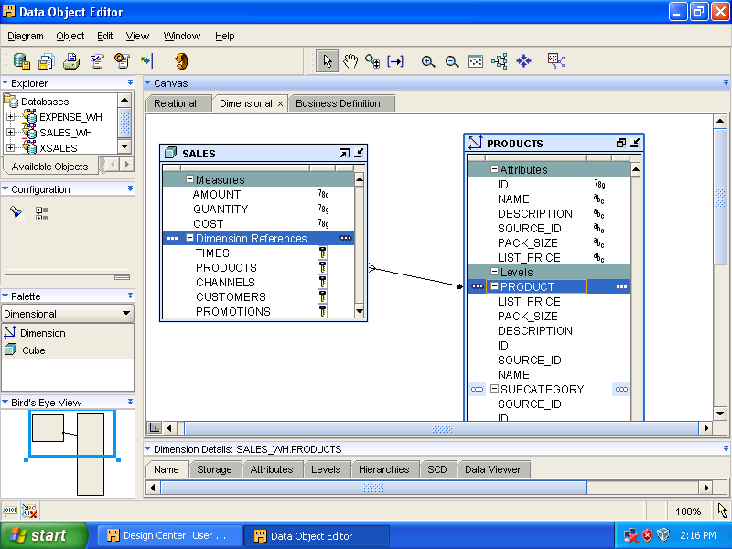

Select the tab, [Attributes].

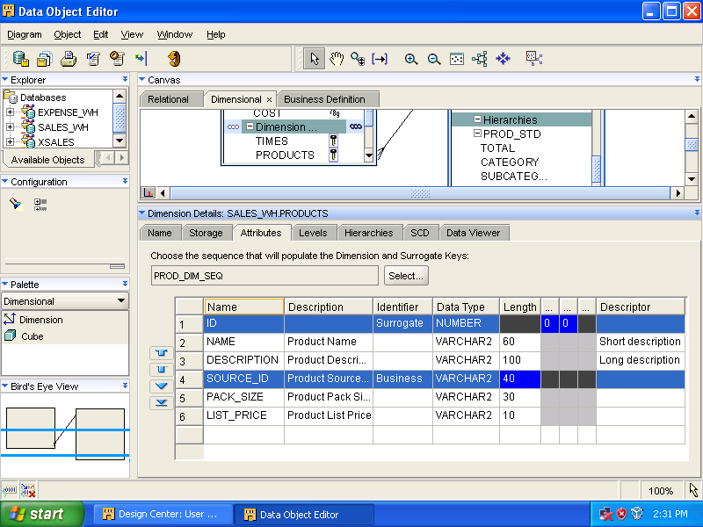

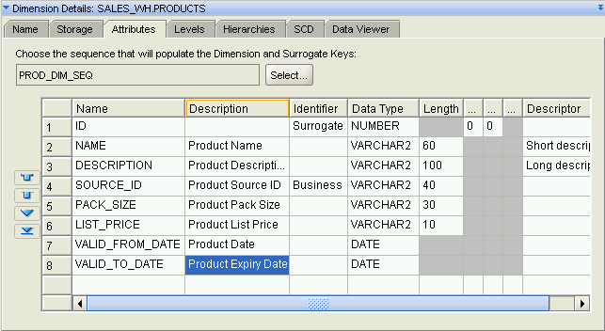

Click in the [Name] column and add two DATE attributes, [VALID_FROM_DATE] and [VALID_TO_DATE].

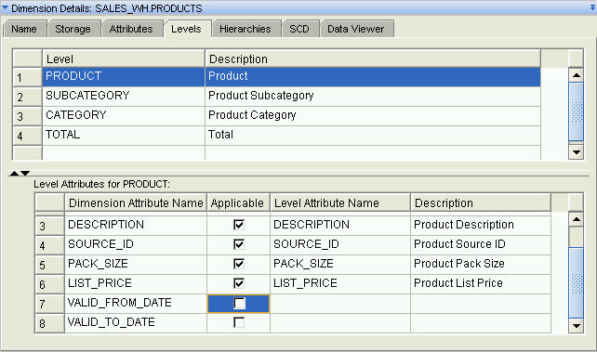

Switch to [Levels] tab. Check [Applicable] for both [VALID_FROM_DATE] and [VALID_TO_DATE].

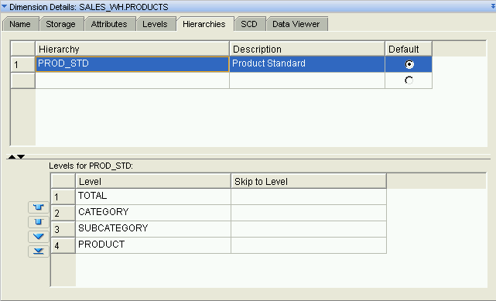

View the tab, Hierarchies.

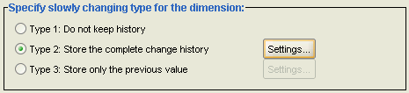
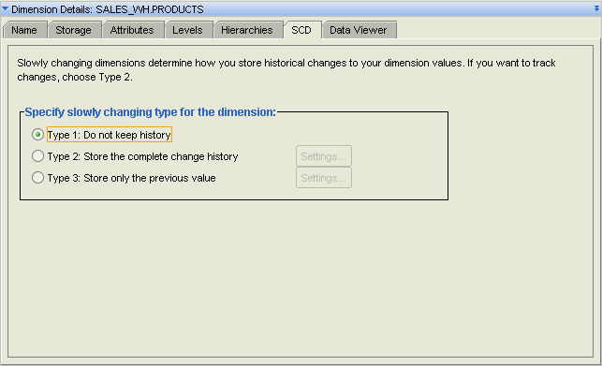

Switch to [SCD] tab. Select [Type 2: Store the complete change history and then [Settings …].

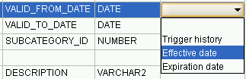
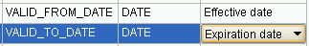
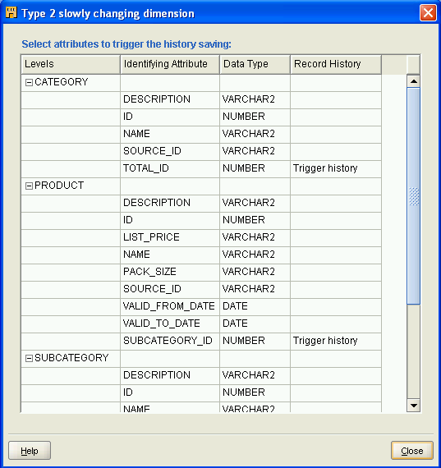

Select [Effective date] for [VALID_FROM_DATE] and [Expiration date] for [VALID_TO_DATE]. Click [Close].

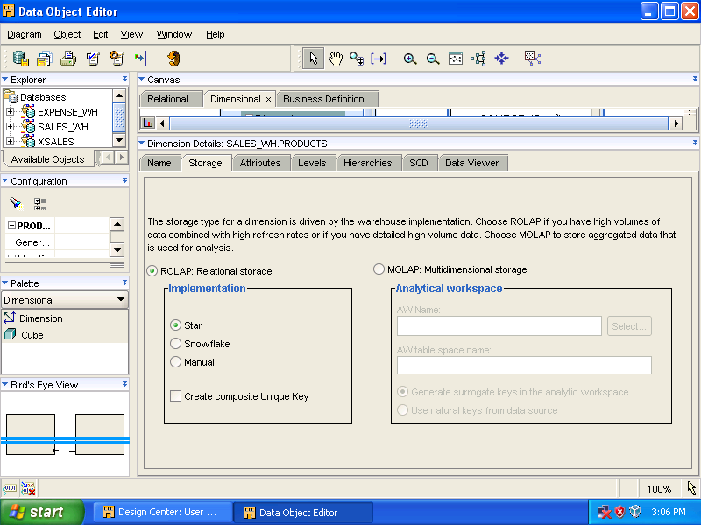

Change the tab to [Storage]. Close the [Data Object Editor].

Create REL_TIME Dimension

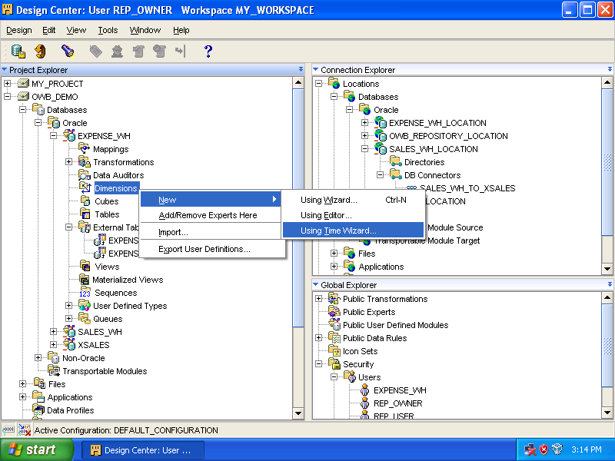

Expand [Databases] ➔ [Oracle] ➔ [EXPENSE_WH], right click [Dimensions], select [New…] ➔ [Using Time Wizard…].

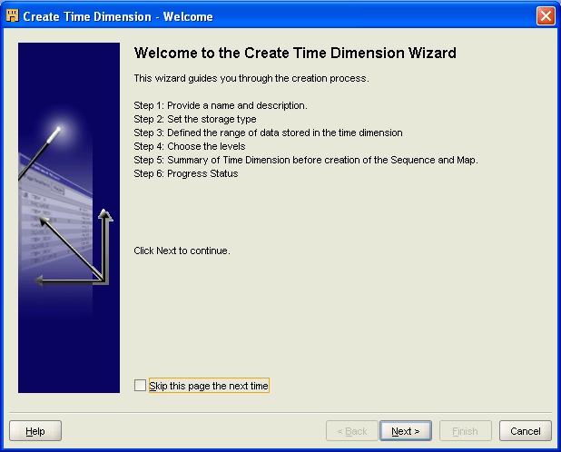

Click [Next].

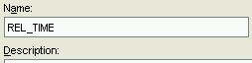
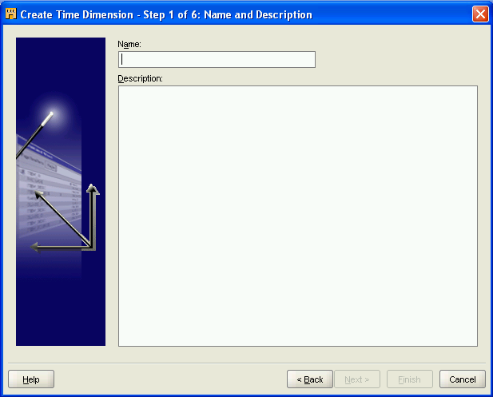

Enter [REL_TIME] as the name and click [Next].

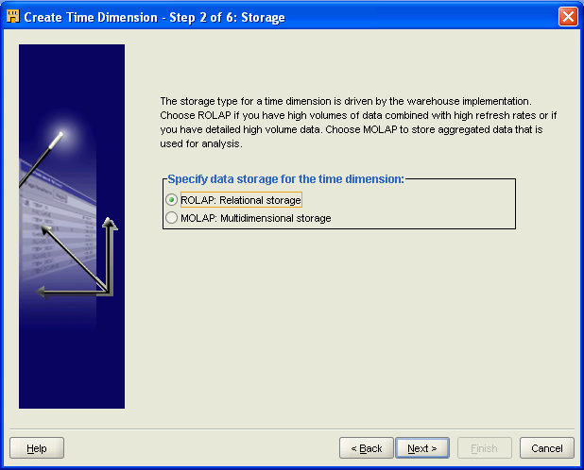

Click [Next].

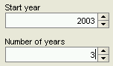
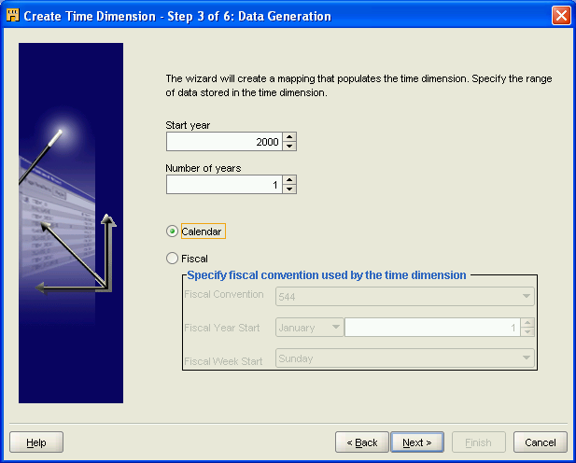

Change [Start year] from [2000] to [2003] and [Number of years] from [1] to [3].
Click [Next].

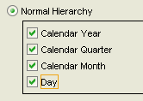
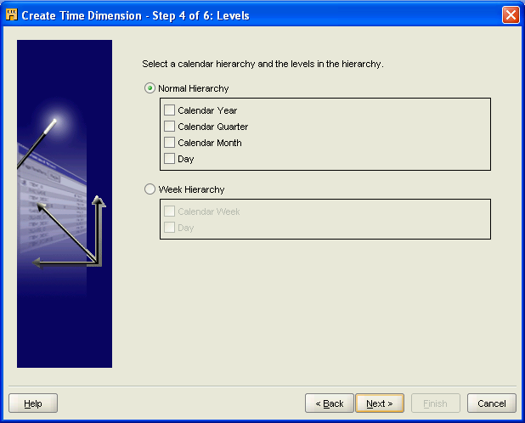

Select [Normal Hierarchy] and all the levels: [Calendar Year], [Calendar Quarter], [Calendar Month], and [Day]. Click [Next].

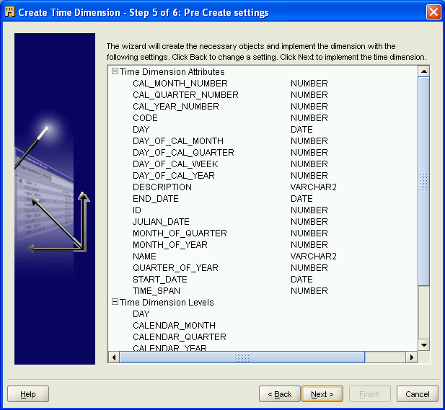

Click [Next].

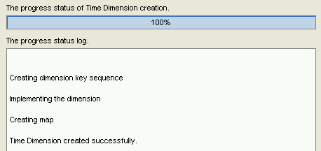
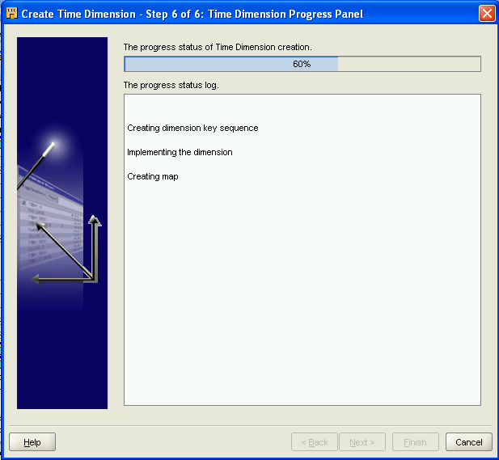

Click [Next].

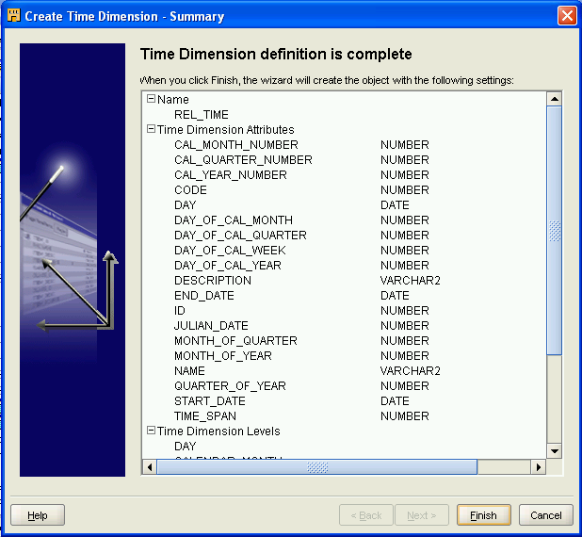

Click [Finish].

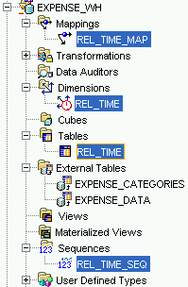
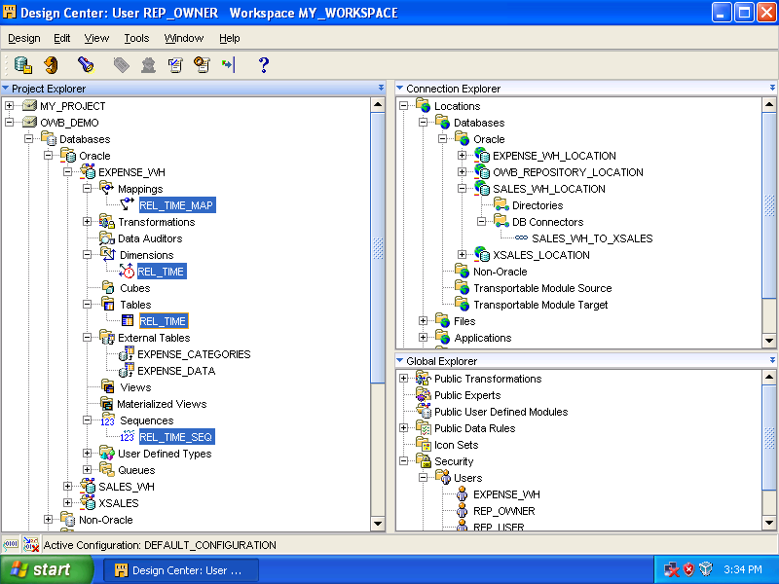

Double click [REL_TIME_MAP] and below screen should be seen.

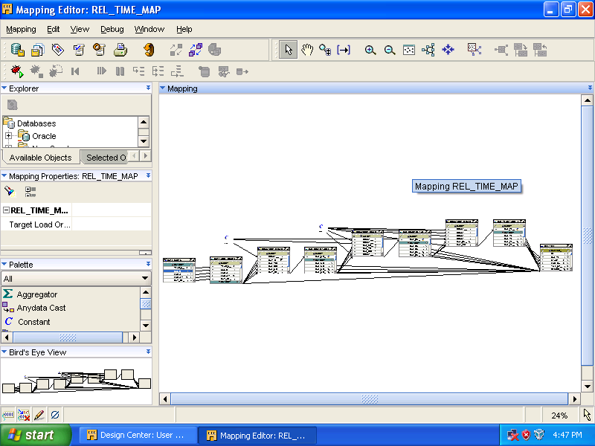

Close it.

Create REL_CATEGORY Dimension

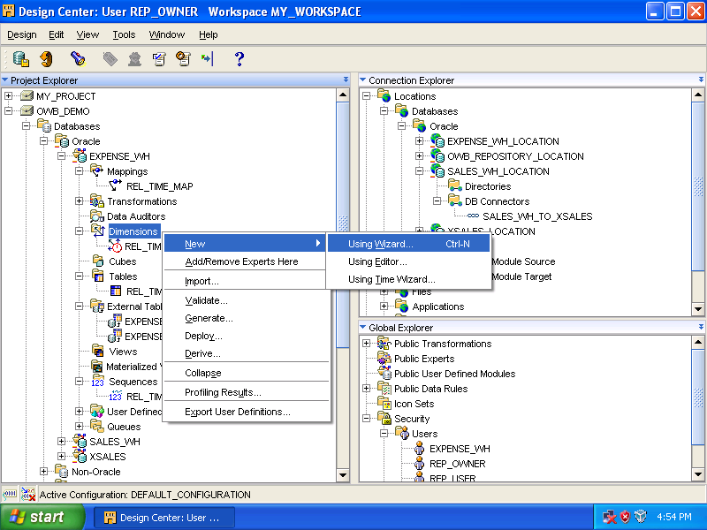

Right click [Dimensions], select [New] ➔ [Using Wizard].

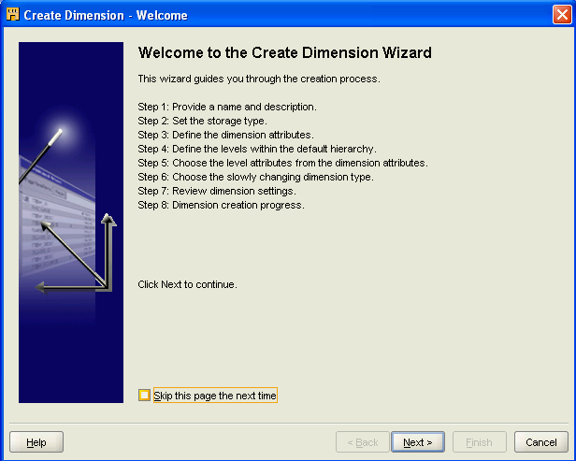

Click [Next].

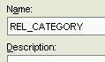
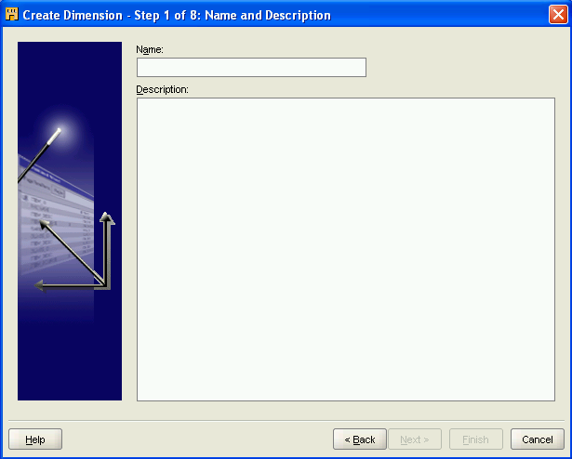
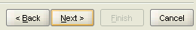
Enter [REL_CATEGORY] as the name.
Click [Next].

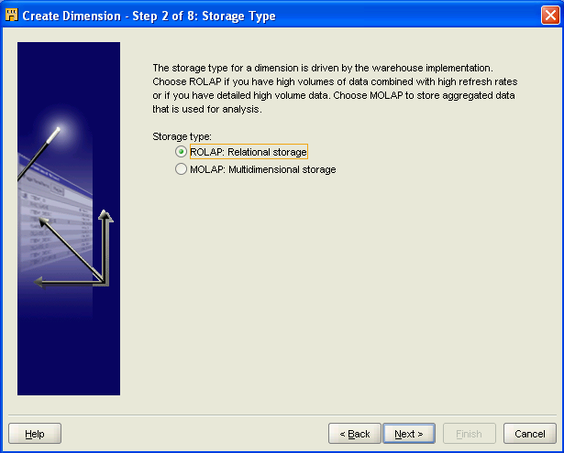

Accept default setting, click [Next].

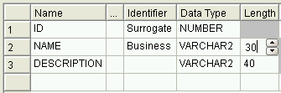
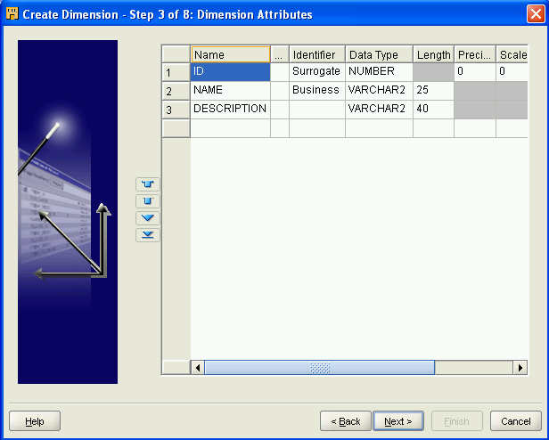

Change [Name]’s length to 30. Click [Next].

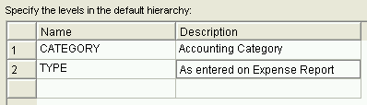
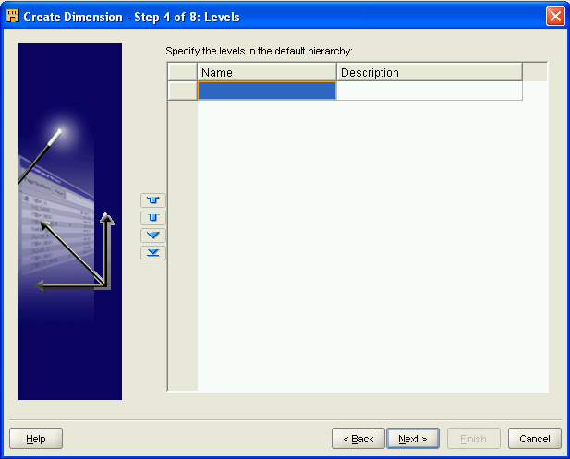

Enter the two levels as above, click [Next].

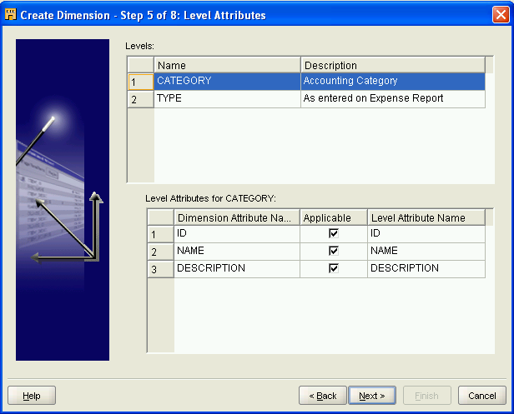

Accept default selection, click [Next].

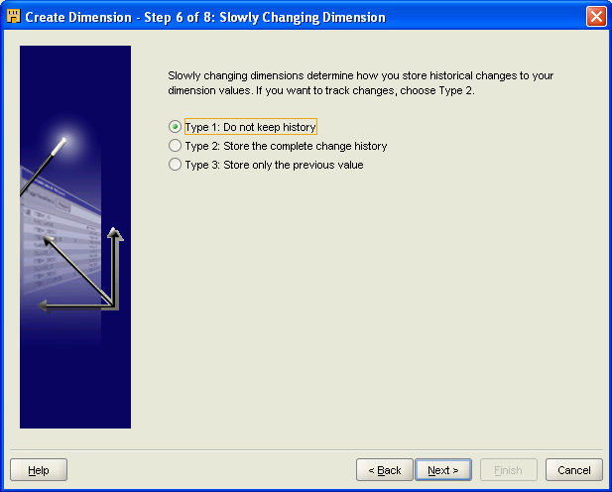

Click [Next].

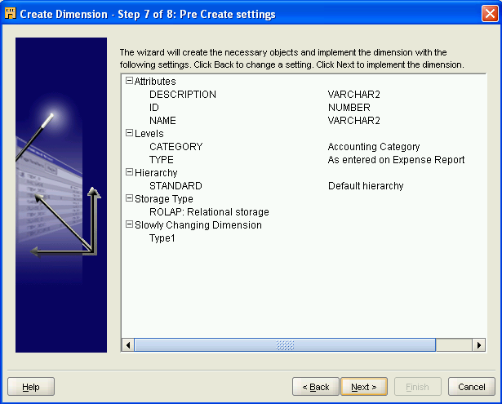

Click [Next].

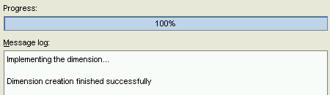
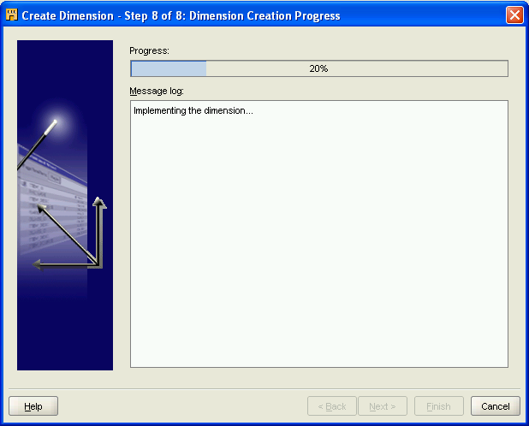
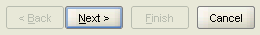
Click [Next].

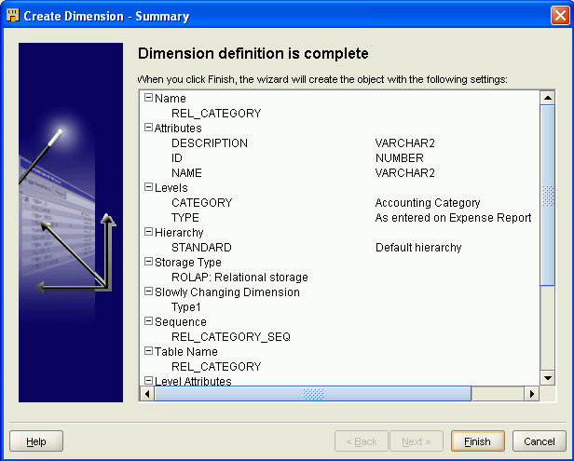

Click [Finish].

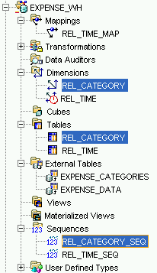
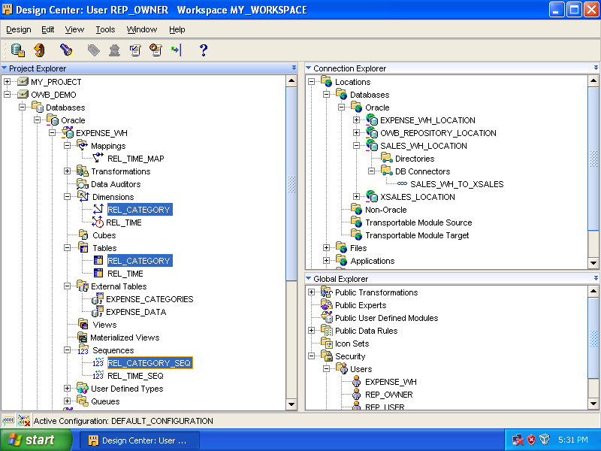

Designing Cubes

Create REL_EXPENSE Cube

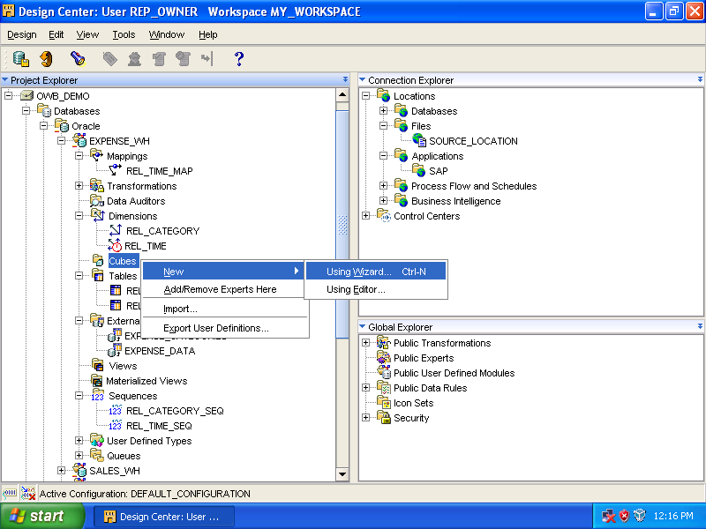

Expand [OWB_DEMO] ➔ [Databases] ➔ [Oracle] ➔ [EXPENSE_WH].
Right click [Cubes], select [New] ➔ [Using Wizard…].

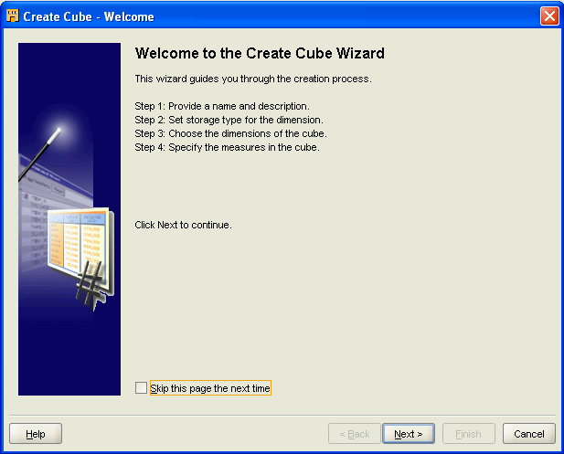

Click [Next].

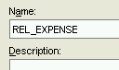
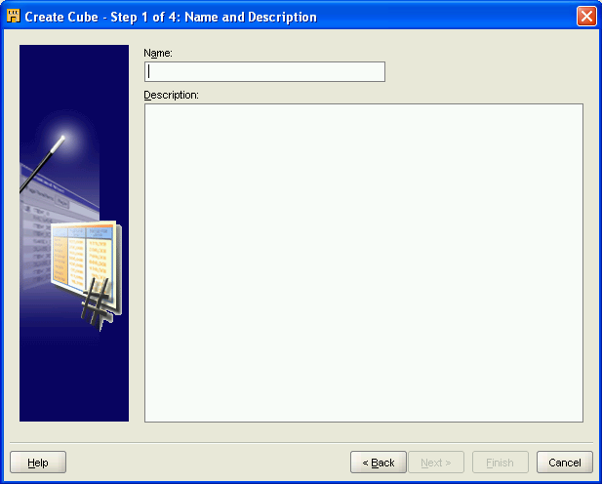

Enter [REL_EXPENSE] as the name. Click [Next].

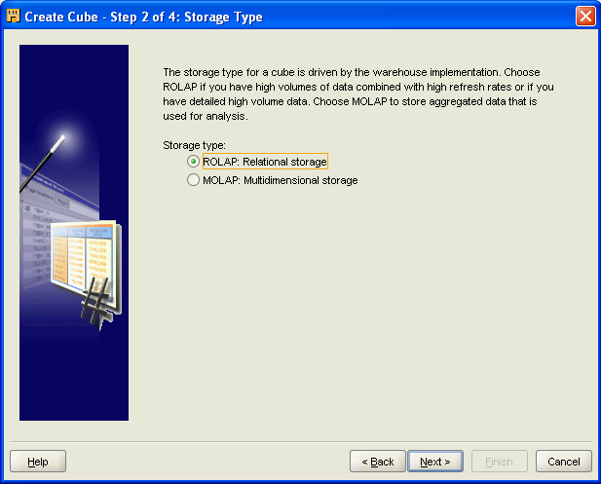

Accept the default setting: [ROLAP: Relational storage]. Click [Next].

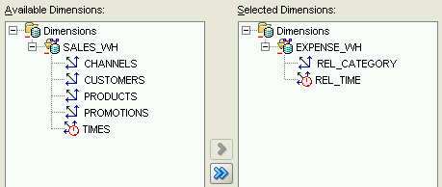
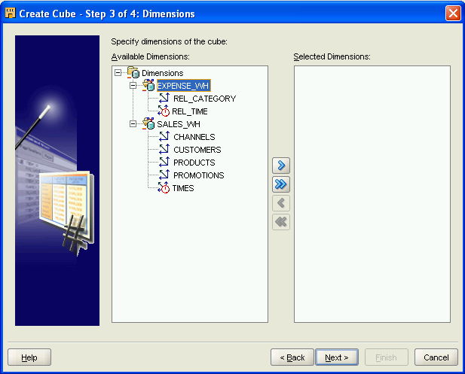

Select [EXPENSE_WH] and click [>]. Two dimensions (REL_CATEGORY and REL_TIME) are moved from left window to right window. Click [Next].

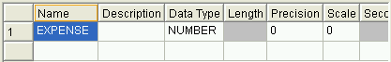
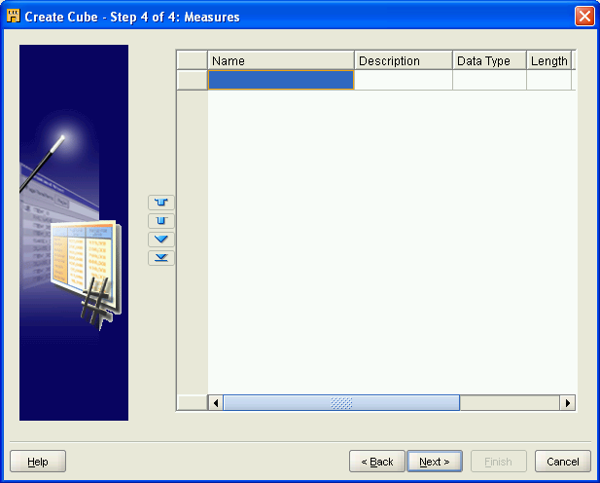

Enter [EXPENSE] as the name. Click [Next].

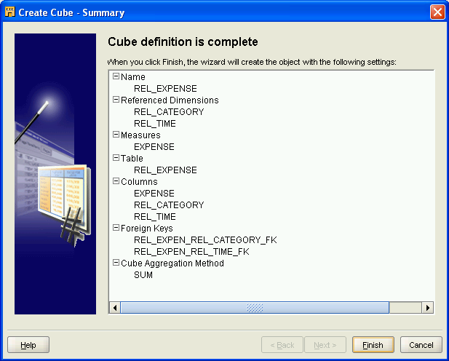

Click [Finish].

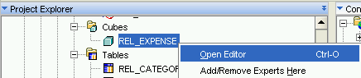
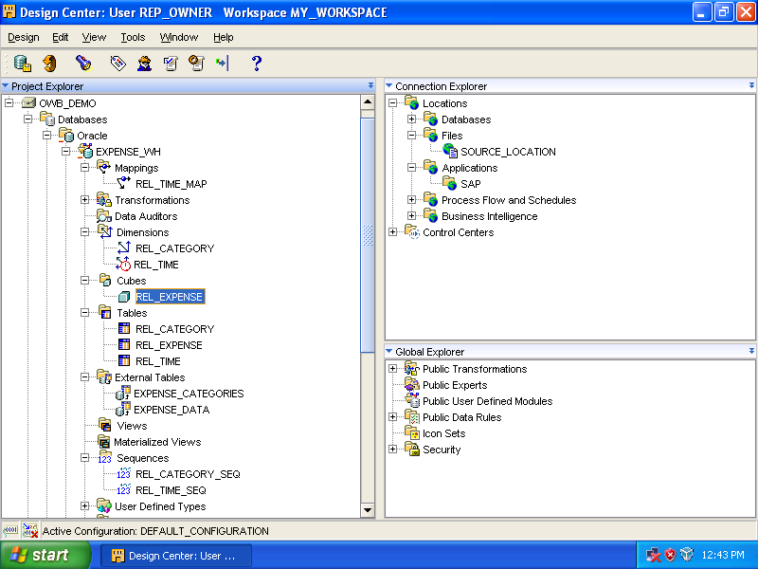

Right click [REL_EXPENSE], select [Open Editor].

