Designing ETL Data Flow Mappings

Prerequisites

Workflow Server 2.6.4 is required

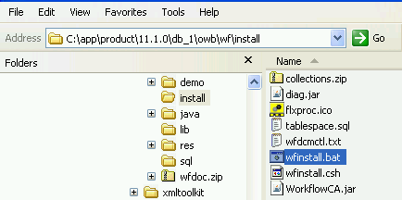

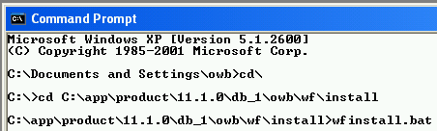

Use a [Command Prompt]. Run the batch file, [wfinstall.bat].

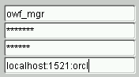
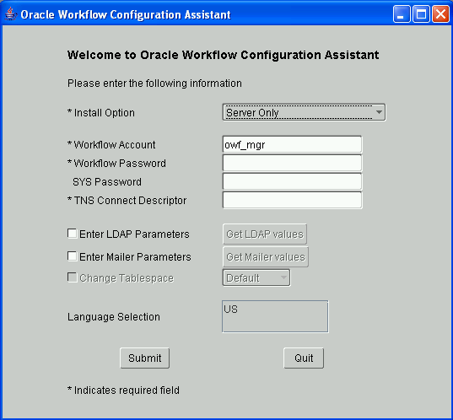

Enter [owf_mgr] as the *Workflow Password, password for SYS: [oracle], and [localhost:1521:orcl] for *TNS Connect Descriptor. Click [Submit].

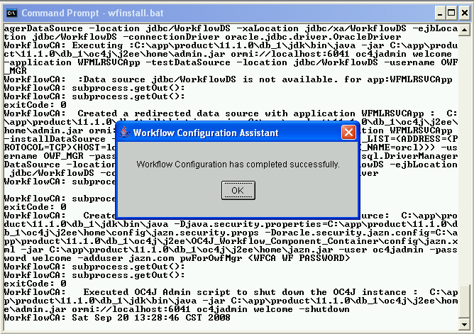

Click [OK].

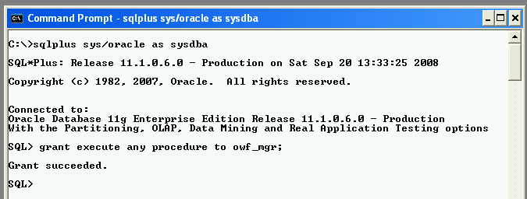

Grant the “EXECUTE ANY PROCEDURE” privilege to the OWF_MGR user.

Design a Mapping between External Table and Dimension

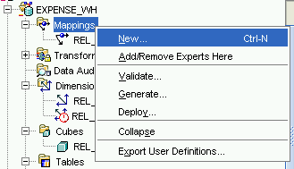
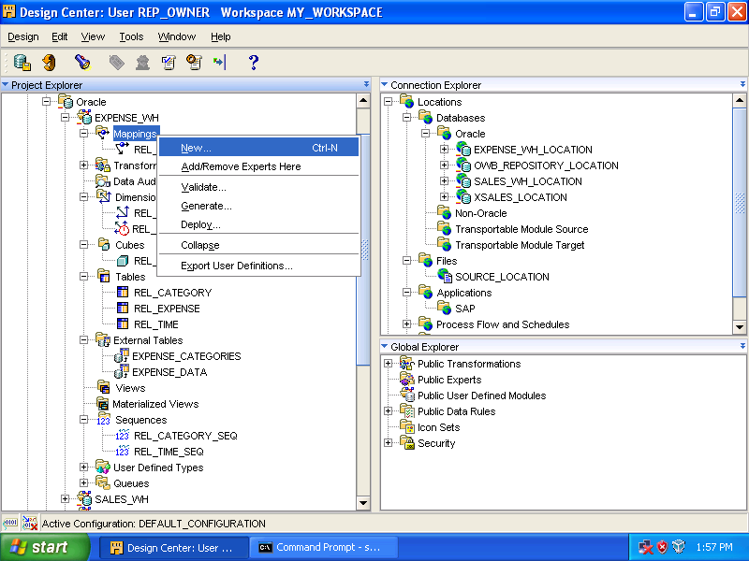

Right click [Mappings], select [New…].

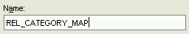
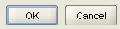
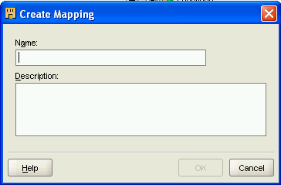

Enter [REL_CATEGORY_MAP] as the name. Click [OK].

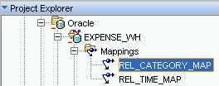

[REL_CATEGORY_MAP] is added under the node [Mappings].

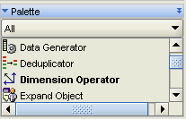
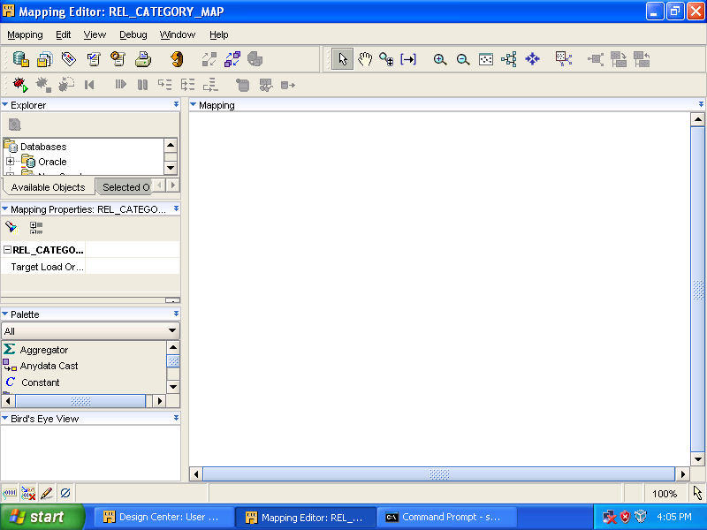

Drag the [Dimension Operator] to the canvas (Mapping window).

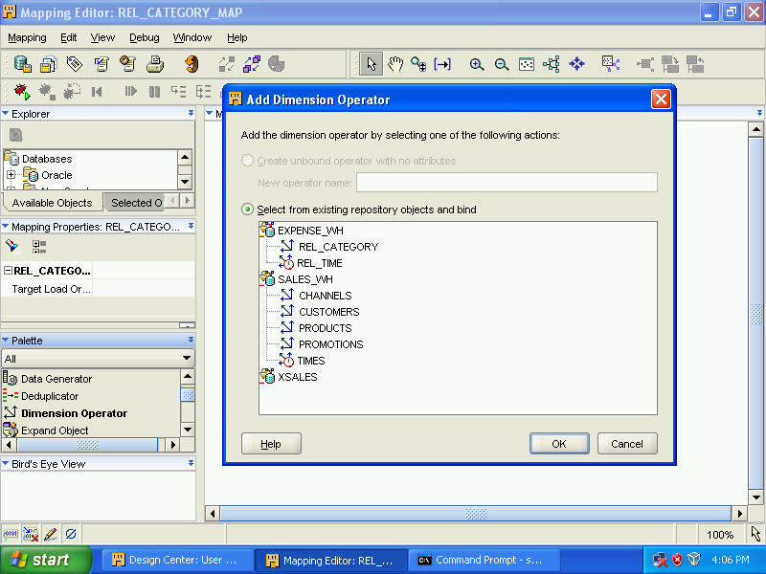

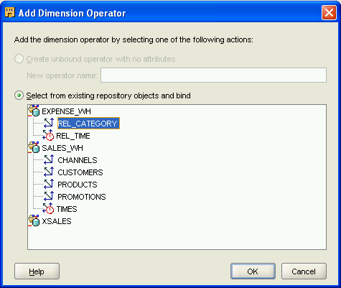

Select [REL_CATEGORY] and click [OK].

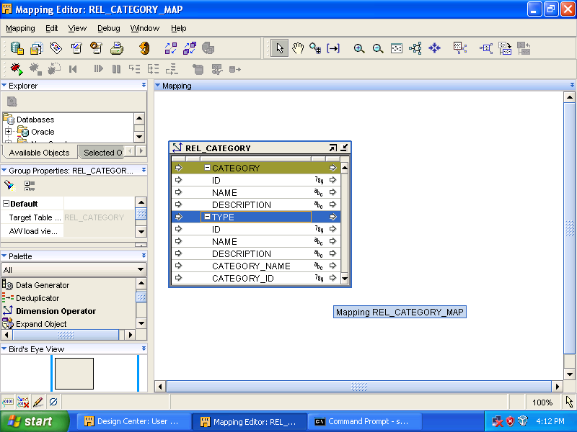

[REL_CATEGORY] is added.

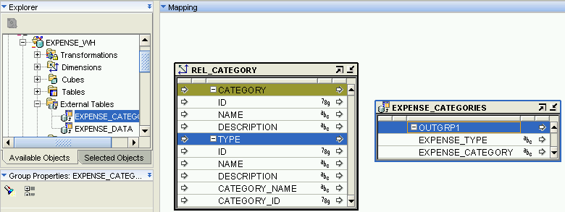

Expand [Oracle] ➔ [EXPENSE_WH] ➔ [External Tables].
Drag [EXPENSE_CATEGORIES] to canvas.

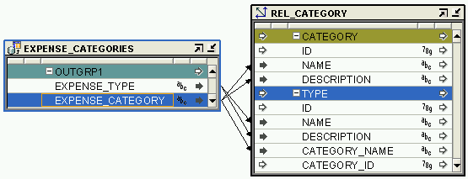

- Drag a connection line from [EXPENSE_CATEGORIES.OUTGRP1.EXPENSE_TYPE] to [REL_CATEGORY.TYPE.NAME]
- Drag a connection line from [EXPENSE_CATEGORIES.OUTGRP1.EXPENSE_TYPE] to [REL_CATEGORY.TYPE.DESCRIPTION]
- Drag a connection line from [EXPENSE_CATEGORIES.OUTGRP1.EXPENSE_CATEGORY] to [REL_CATEGORY.CATEGORY.NAME]
- Drag a connection line from [EXPENSE_CATEGORIES.OUTGRP1.EXPENSE_CATEGORY] to [REL_CATEGORY.CATEGORY.DESCRIPTION]
- Drag a connection line from [EXPENSE_CATEGORIES.OUTGRP1.EXPENSE_CATEGORY] to [REL_CATEGORY.TYPE.CATEGORY_NAME]

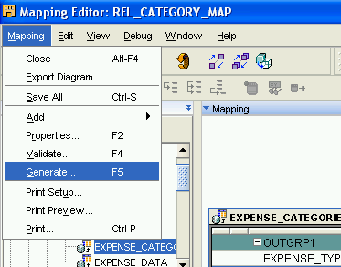

Select [Mapping] ➔ [Generate…].

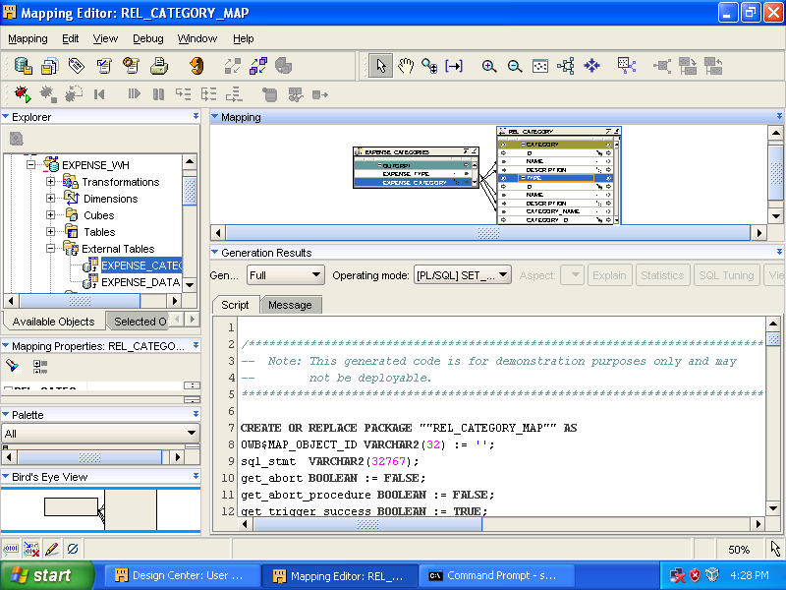

[Mapping Editor] can now be closed.

Design a Mapping between External Table and Cube

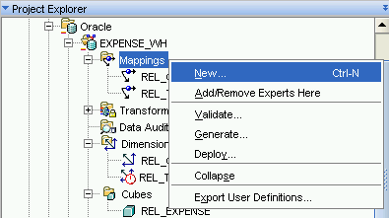

Expand [Oracle] ➔ [EXPENSE_WH].
Right click [Mappings], select [New…].

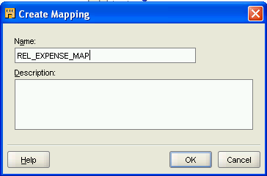
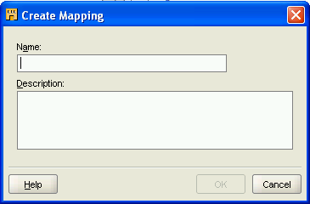

Enter [REL_EXPENSE_MAP] as the name and click [OK].

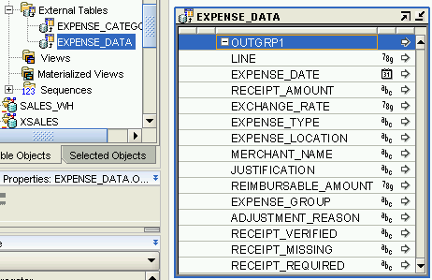
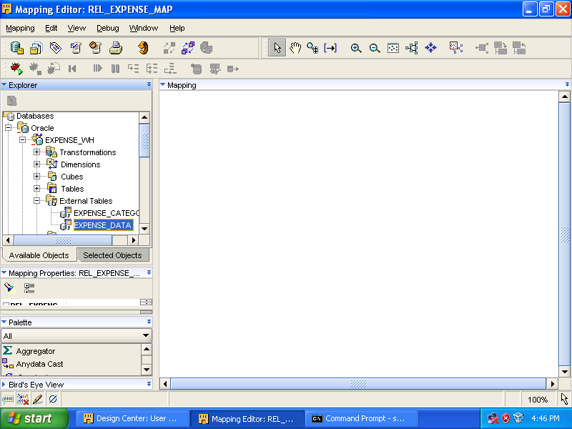

Expand [Oracle] ➔ [EXPENSE_WH] ➔ [External Tables].
Drag [EXPENSE_DATA] to canvas.

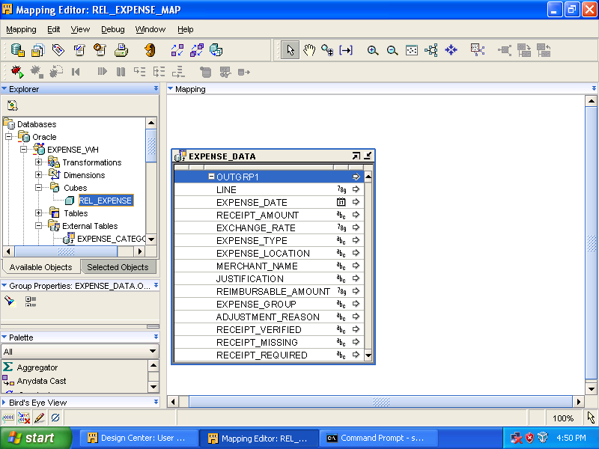

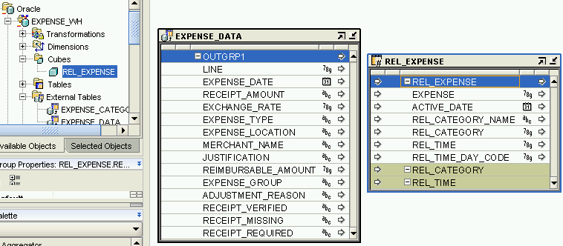

Expand [Oracle] ➔ [EXPENSE_WH] ➔ [Cubes].
Drag [REL_EXPENSE] to canvas.

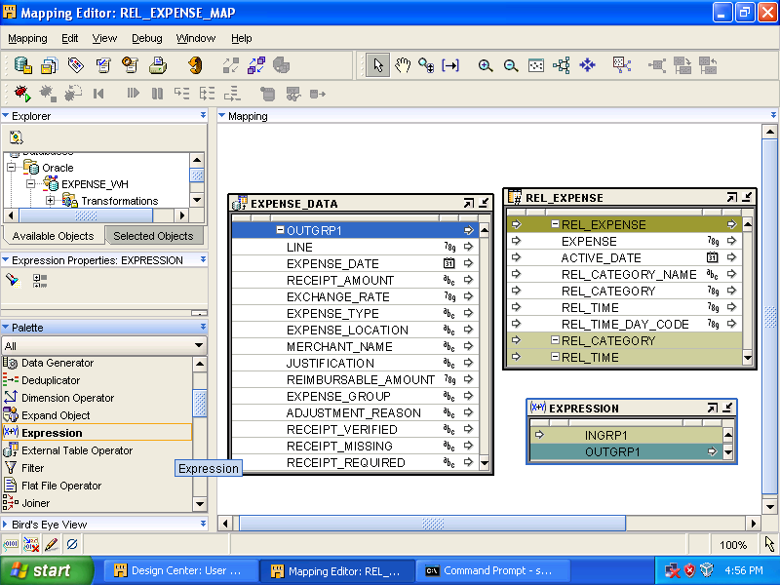
From [Palette] window, drag [Expression] to canvas.

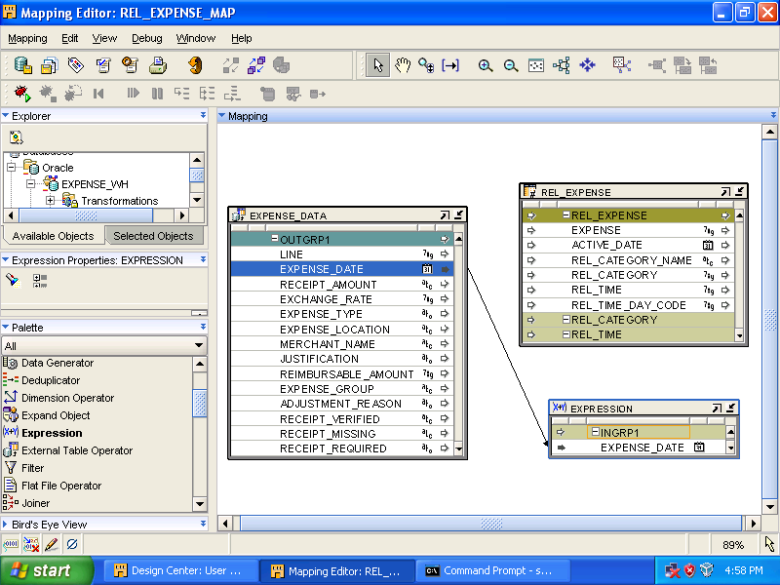
Drag a connection line from [EXPENSE_DATA.OUTGRP1.EXPENSE_DATE] to [EXPRESSION.INGRP1].
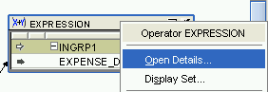
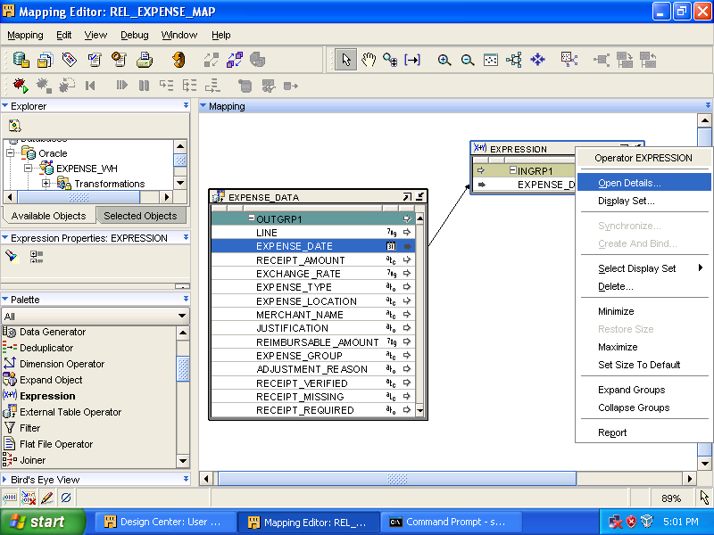
Right click [EXPRESSION] header and select [Open Details…].

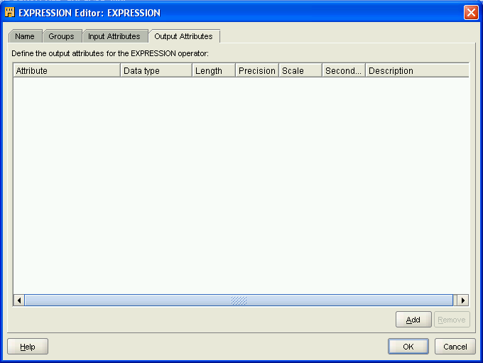
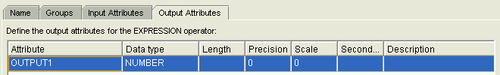
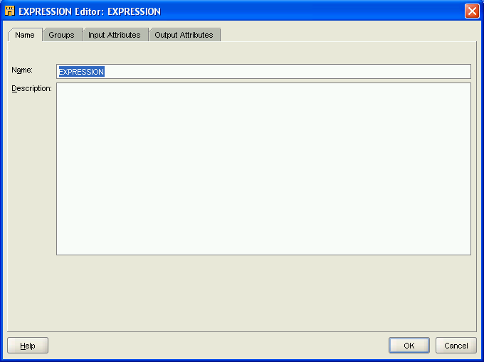

Select [Output Attributes] tab and click [Add].
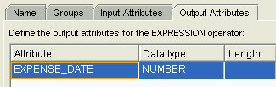

Replace [OUTPUT1] with [EXPENSE_DATE] and click [OK].

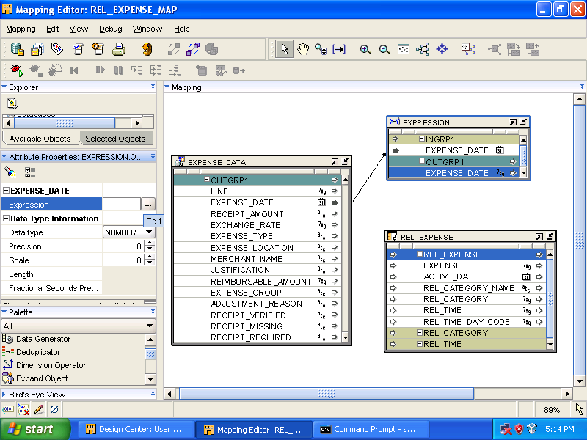

Select [EXPRESSION]’s [OUTGRP1.EXPENSE_DATE]. In [Attribute Properties] panel, click the field next to [Expression] property. Click […] (edit) button on the right.

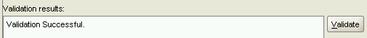
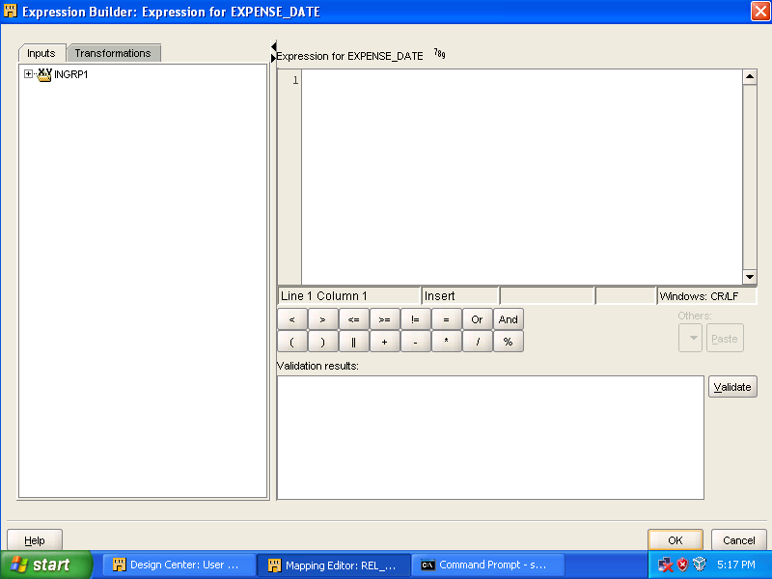

Expand [INGRP1] and select [EXPENSE_DATE].
Enter the statement, [TO_NUMBER(TO_CHAR(INGRP1.EXPENSE_DATE, ‘YYYYMMDD’), ‘99999999’)] in [Expression for EXPENSE_DATE].
Click [Validate]. If [Validation Successful.] appears, click [OK].

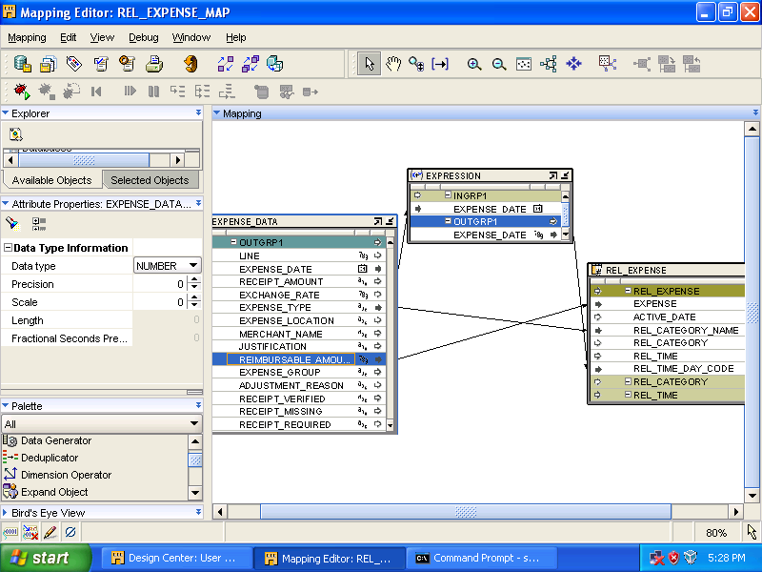

- Drag a connection line from [EXPRESSION.OUTGRP1.EXPENSE_DATE] to [REL_EXPENSE.REL_EXPENSE.REL_TIME_DAY_CODE]
- Drag a connection line from [EXPENSE_DATA.OUTGRP1.EXPENSE_TYPE] to [REL_EXPENSE.REL_EXPENSE.REL_CATEGORY_NAME]
- Drag a connection line from [EXPENSE_DATA.OUTGRP1.REIMBURSABLE_AMOUNT] to [REL_EXPENSE.REL_EXPENSE.EXPENSE]

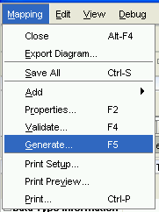

Select [Mapping] ➔ [Generate…].

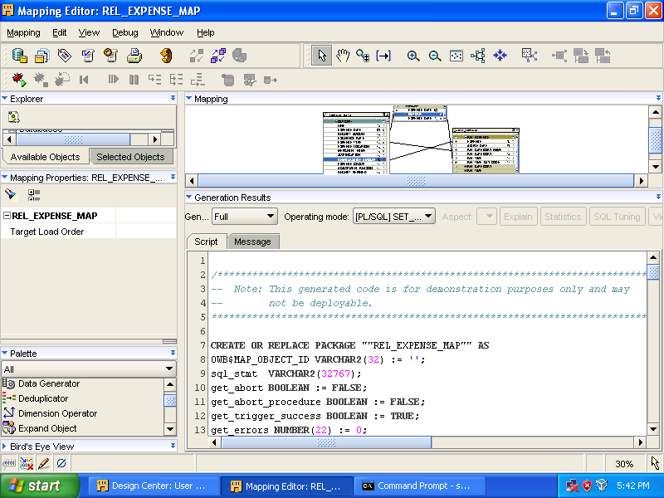
Click [Save All] to commit the work. Close the Mapping Editor.

Design Process Flow

Register the Oracle Workflow User
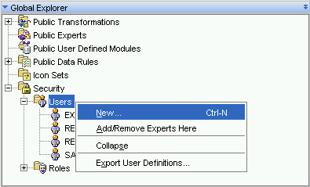
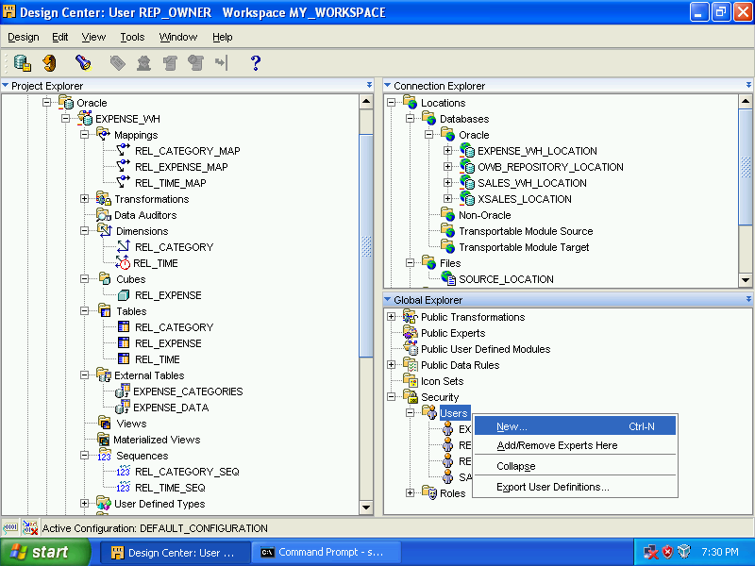
Expand [Security], right click [Users] and select [New…].

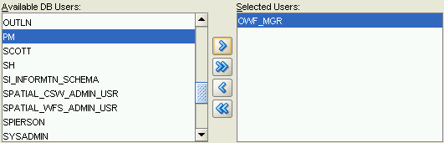
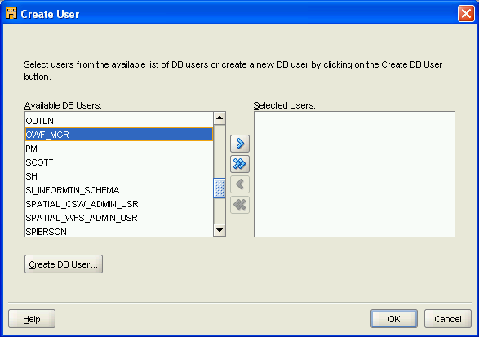

Select [OWF_MGR] from [Available DB Users], click [>] button. Click [OK].

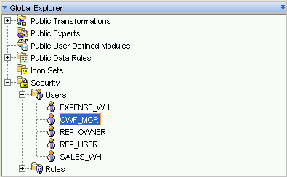

User [OWF_MGR] is added.

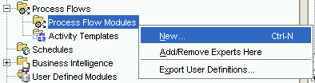
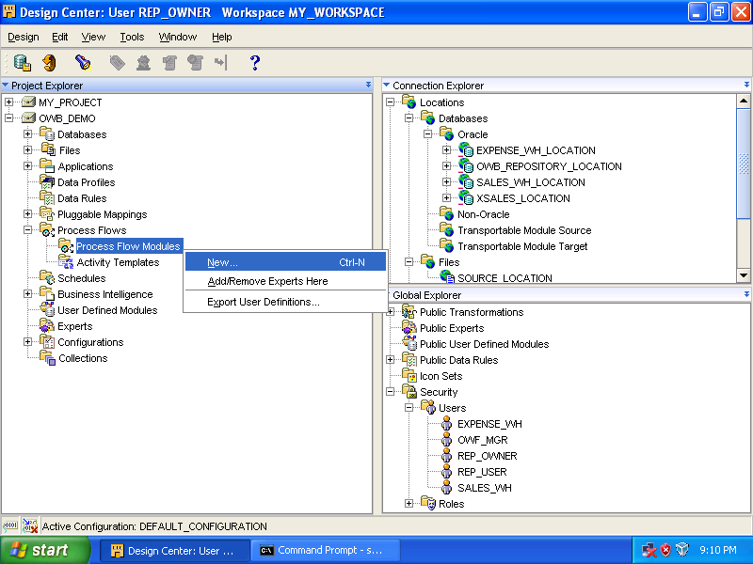

Expand [OWB_DEMO] ➔ [Process Flows].
Right click [Process Flow Module], select [New…].

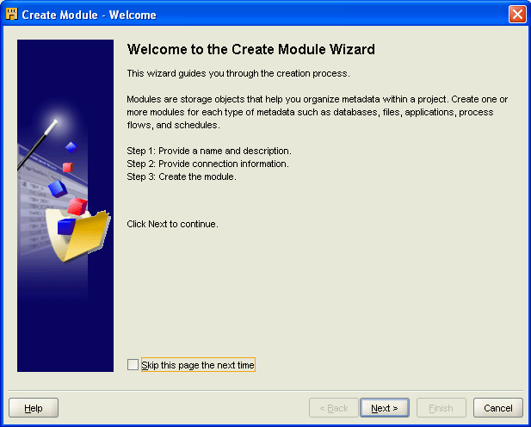

Click [Next].

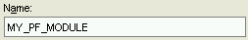
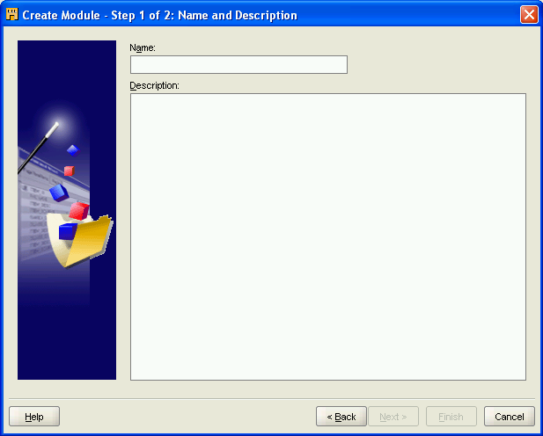

Enter [MY_PF_MODULE] as the name, click [Next].

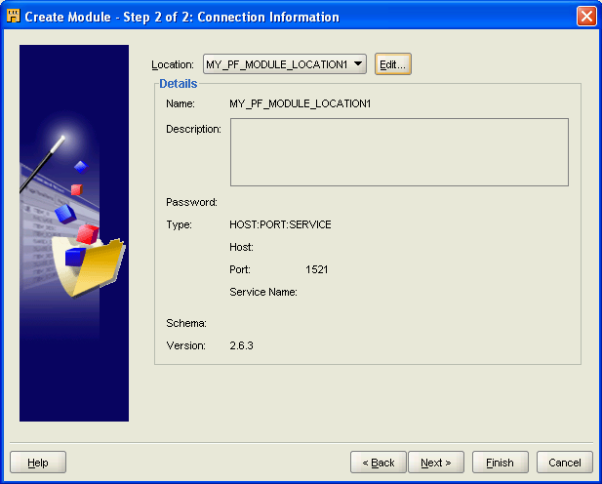
Click [Edit…].

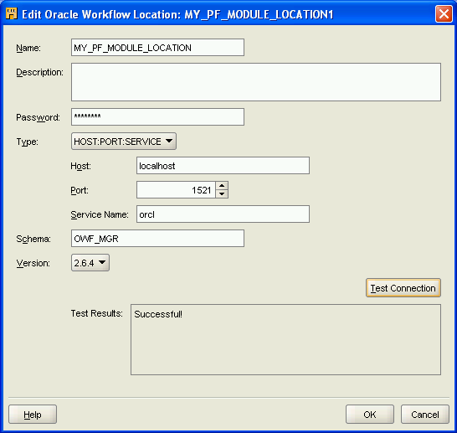

Rename [MY_PF_MODULE_LOCATION1] to [MY_PF_MODULE_LOCATION].
Enter the following:
Password: owf_mgr
Host: localhost
Port: 1521
Service: orcl
Schema: owf_mgr
Version: 2.6.4
Click [Test Connection]. If [Successful!] appears in [Test Results], click [OK].

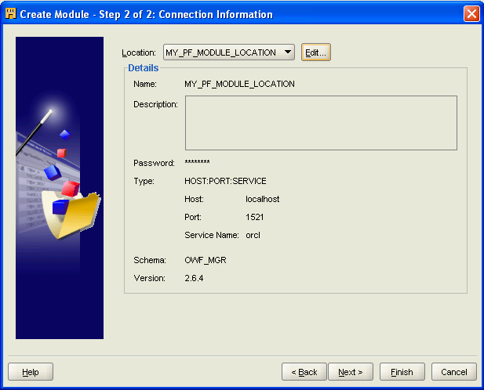
Click [Next].

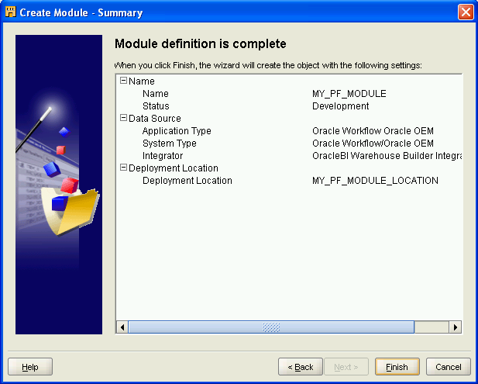
Click [Finish].

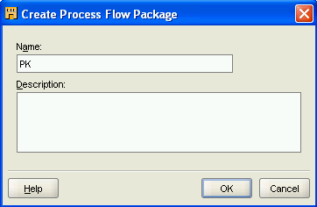
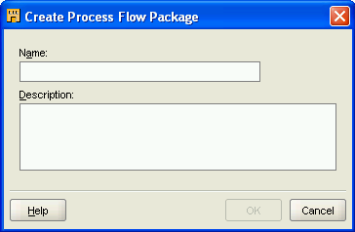

Enter [PK] as the name.
Click [OK].
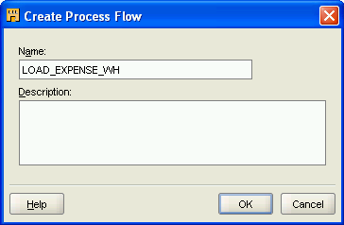
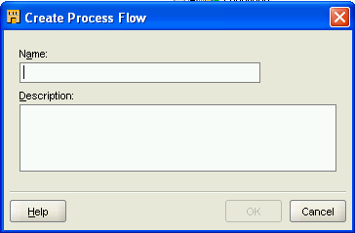

Enter [LOAD_EXPENSE_WH] as the name.
Click [OK].

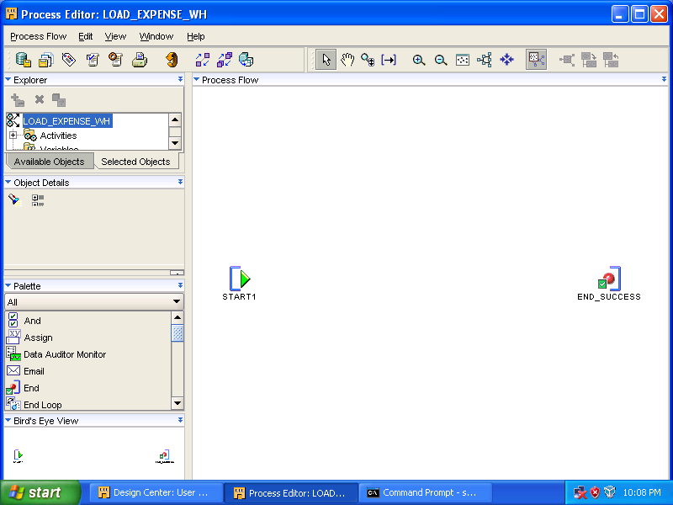
[Process Editor] appears.
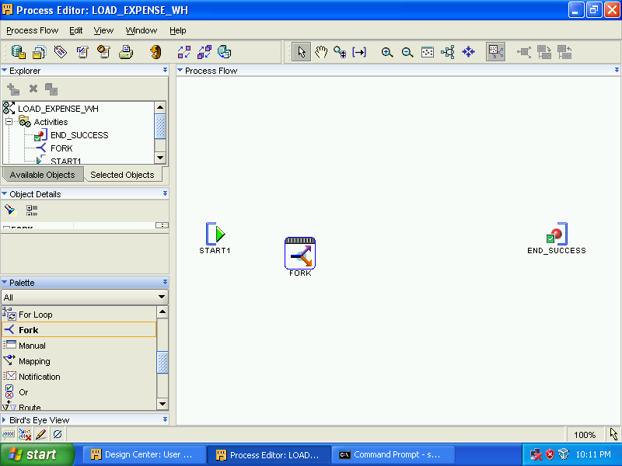

From [Palette], drag [Fork] to canvas.

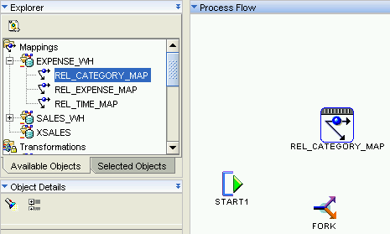

Drag [REL_CATEGORY_MAP] from [Explorer] to canvas.

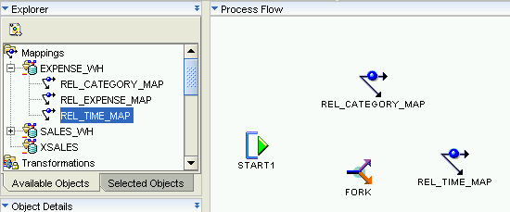

Again, drag [REL_TIME_MAP] to canvas.

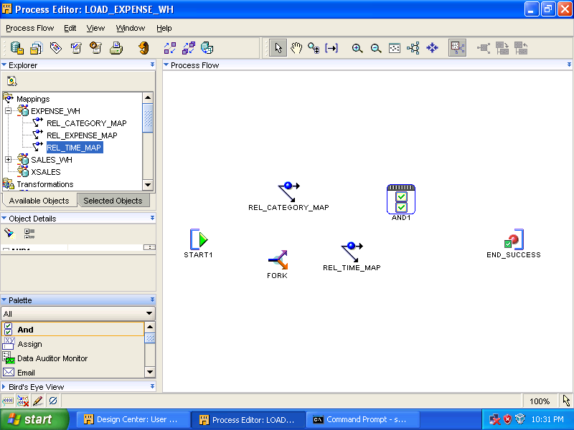

Drag [And] from [Palette] to canvas.

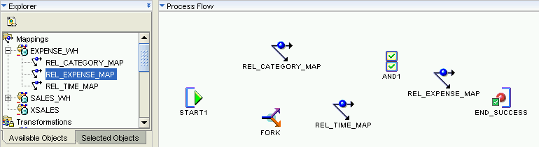

Drag [REL_EXPENSE_MAP] to canvas.

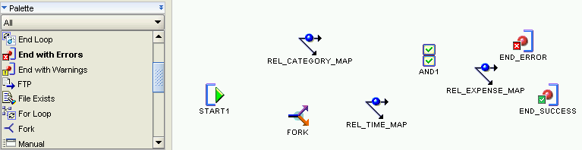

Drag [End with Errors] to canvas

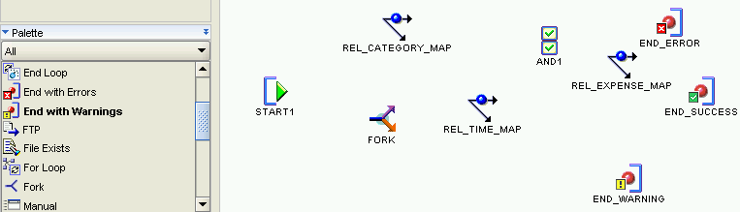

Drag [End with Warnings] to canvas.

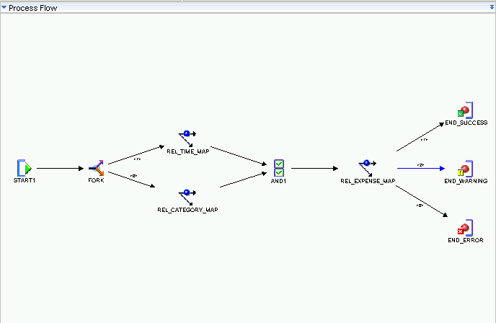

To drag a transition, the mouse pointer must change to ().
- Drag a transition from [START1] activity to the mapping activity [FORK].
- Drag a transition from [FORK] activity to the mapping activity [REL_CATEGORY_MAP].
- Drag a transition from [FORK] activity to the mapping activity [REL_TIME_MAP].
- Drag a transition from mapping activity [REL_CATEGORY_MAP] to the [AND1] activity.
- Drag a transition from mapping activity [REL_TIME_MAP] to the [AND1] activity.
- Drag a transition from [AND1] activity to the mapping activity [REL_EXPENSE_MAP].
- Drag a transition from mapping activity [REL_EXPENSE_MAP] to [END_ERROR] activity.
- Drag a transition from mapping activity [REL_EXPENSE_MAP] to [END_SUCCESS] activity.
- Drag a transition from mapping activity [REL_EXPENSE_MAP] to [END_WARNING] activity.

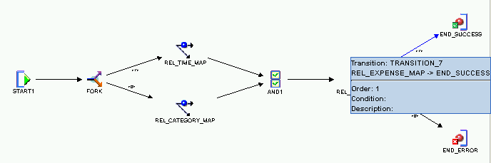

Select the transition (the line) from the [REL_EXPENSE_MAP] mapping activity to the [END_SUCCESS] activity.

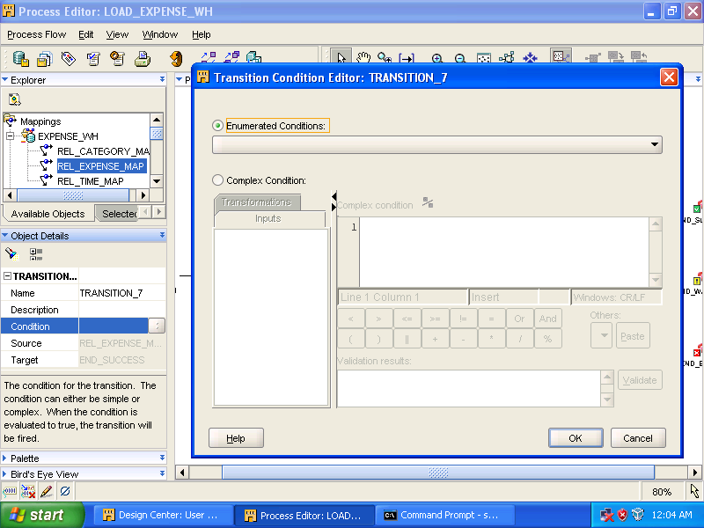

Click [] button on the right of [Condition] in [Object Details].

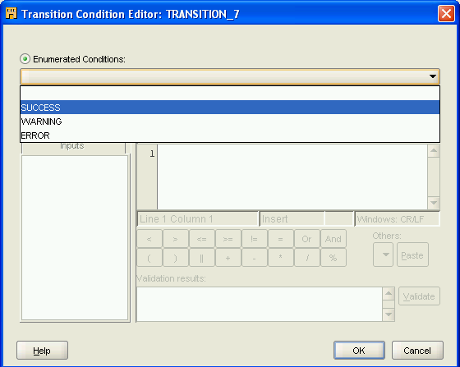
Select [SUCCESS] from the drop down menu.

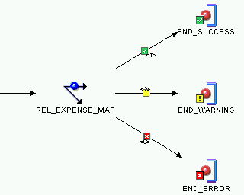
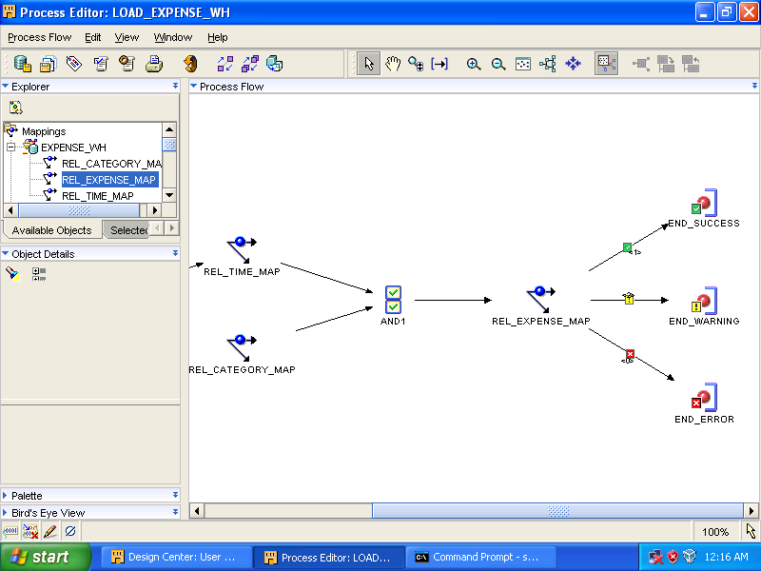

Repeat above procedures to set [Condition] for [END_ERROR] and [END_WARNING].

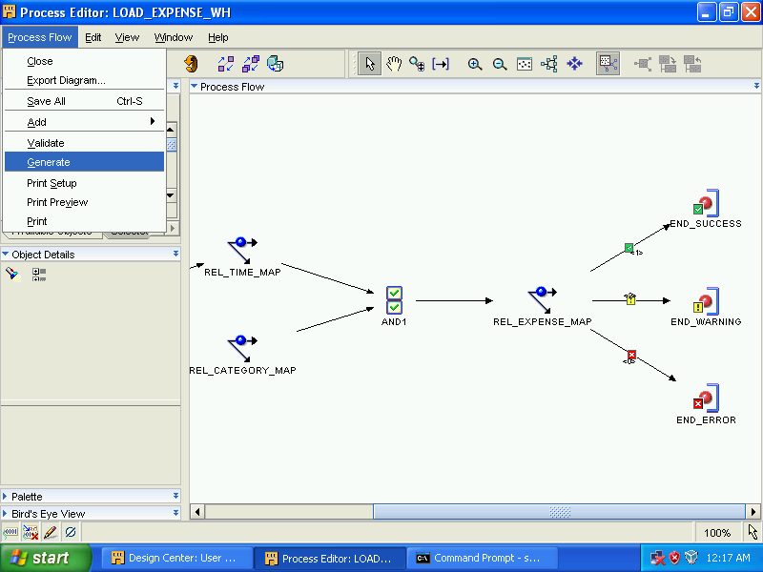
Select [Process Flow] ➔ [Generate].
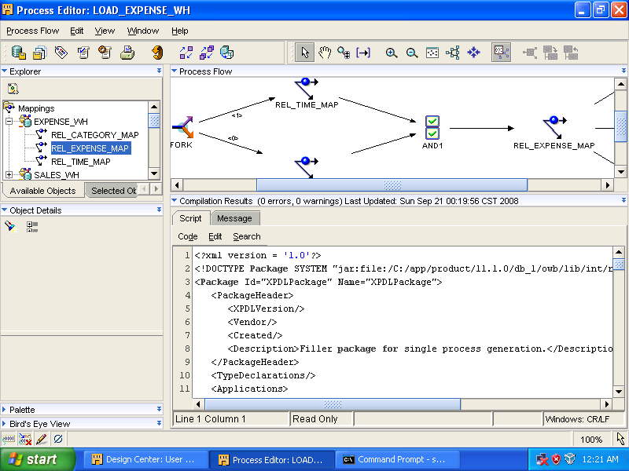
Click [Save All]. Close [Process Editor].

