Deploying Objects in Target Warehouse

Deploying External Table

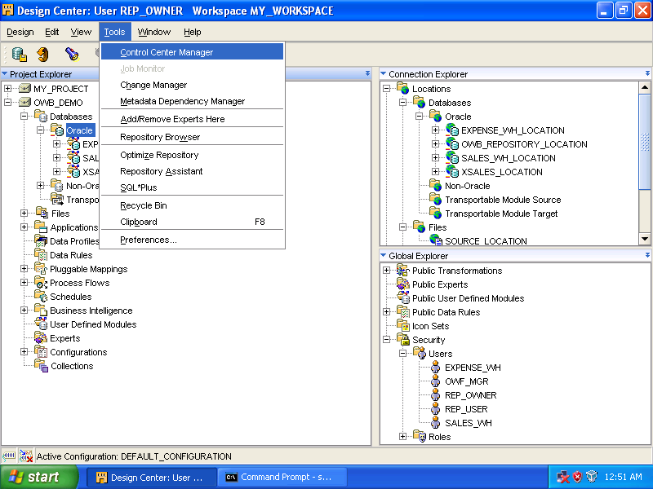

Select [Tools] ➔ [Control Center Manager].

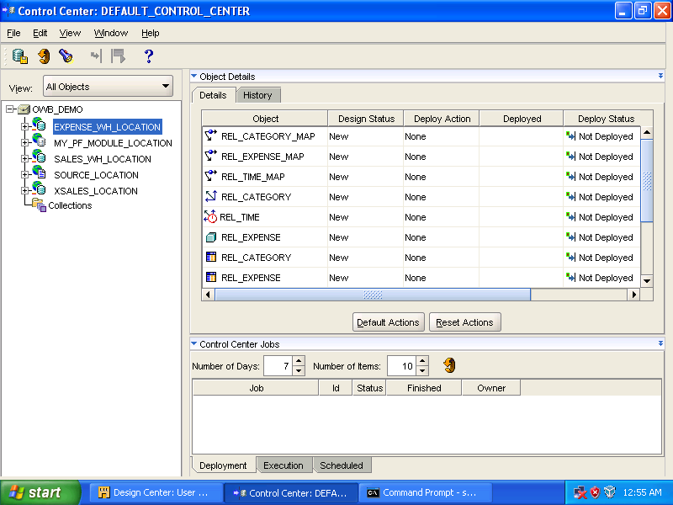

Control Center window appears.

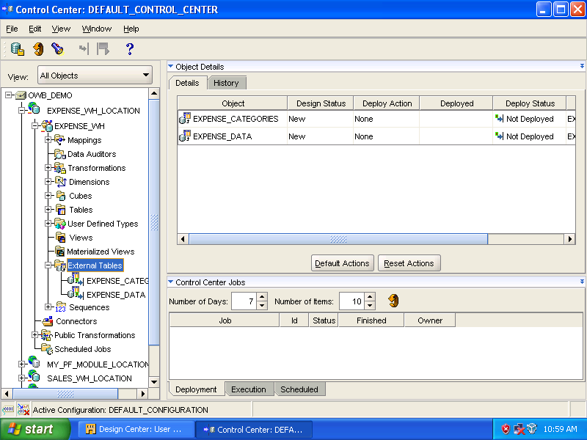

Expand [EXPENSE_WH_LOCATION] ➔ [EXPENSE_WH]. Select [External Tables].

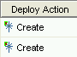
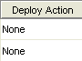
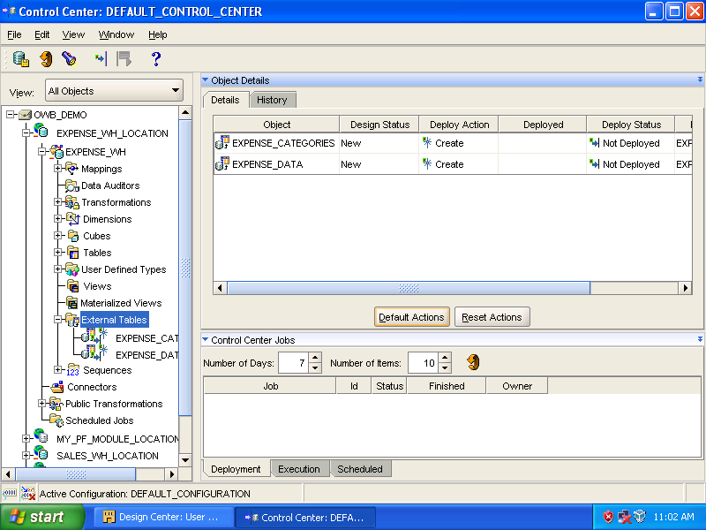

Click [Default Actions]. (Column: Deploy Action changes from “None” to “Create”.)

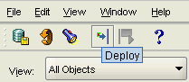

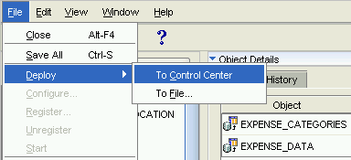

Click [] (Deploy icon) or select [File] ➔ [Deploy] ➔ [To Control Center] from menu bar.

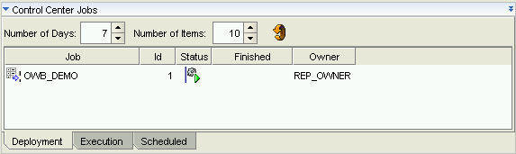

[Control Center Jobs] panel can monitor the progress of deployment.

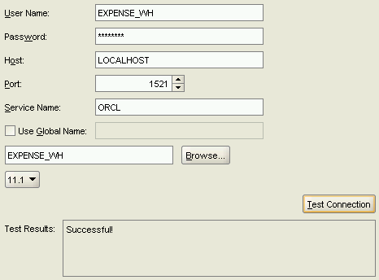
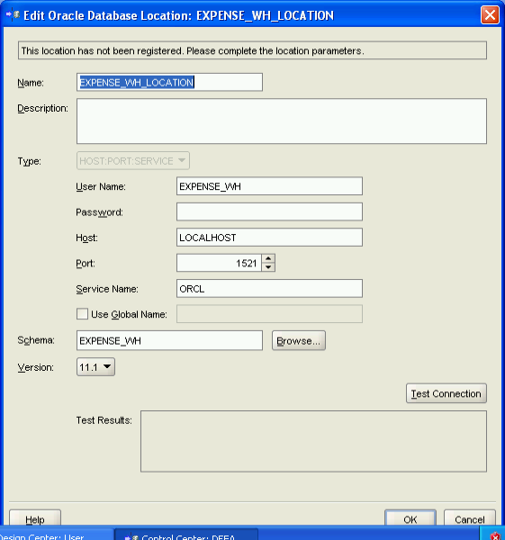

Enter password for user [EXPENSE_WH].
Click [Test Connection].
If [Successful!] appears in Test Results, click [OK].

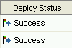
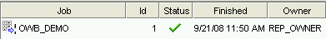
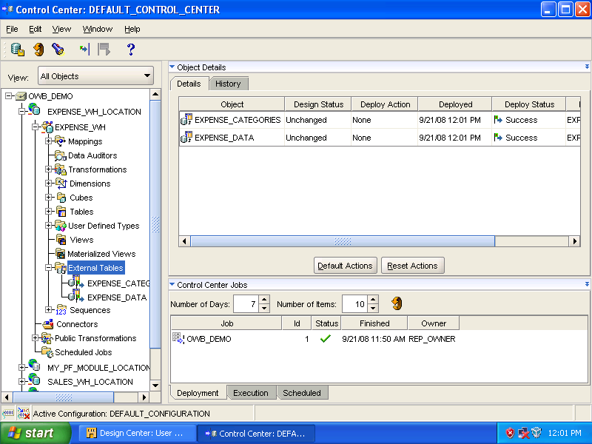

[Deploy Status] changes to [Success]. Double click [OWB_DEMO] in [Job] column in [Control Center Jobs] panel.

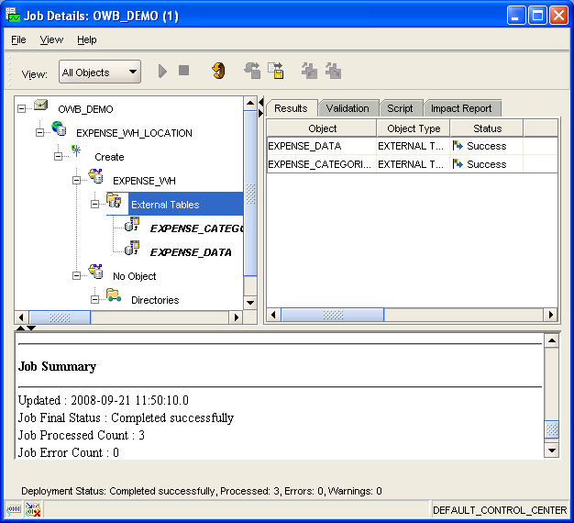

Select [External Tables] in left panel. Select [Script] tab in the right.

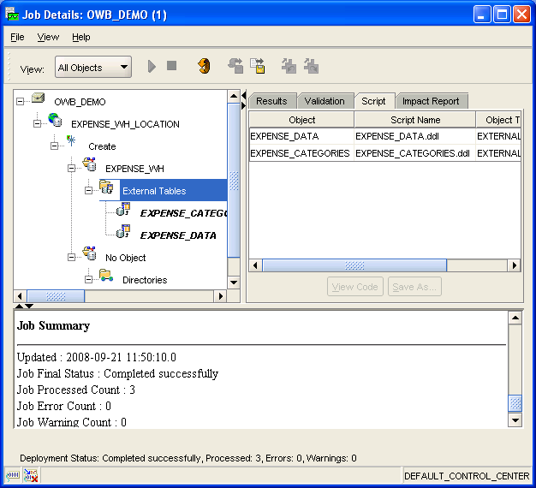

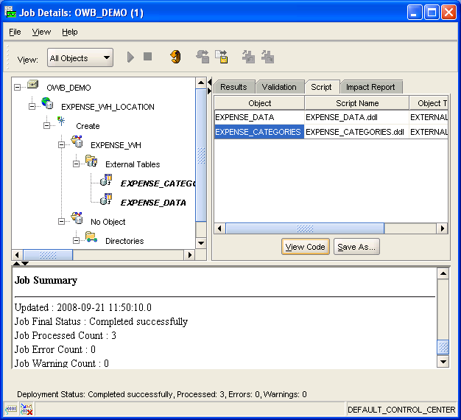

Select [EXPENSE_CATEGORIES] in [Object] column. Click [View Code].

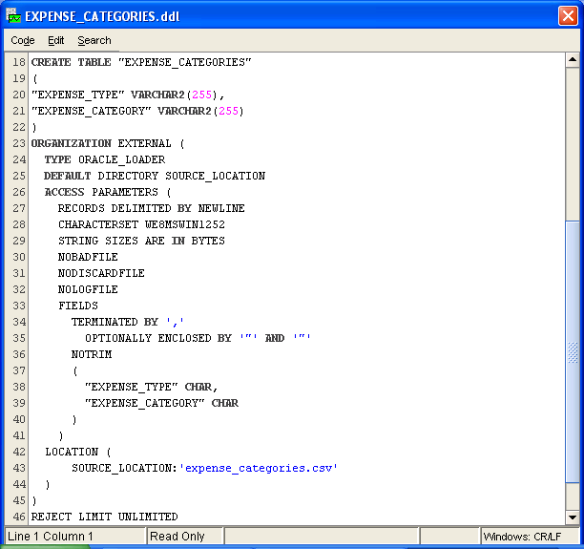

Close the window by clicking [Code] ➔ [Close].

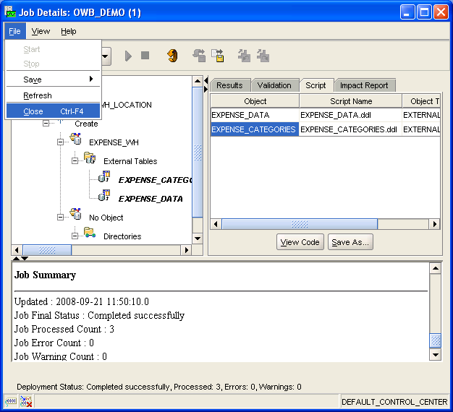

[File] ➔ [Close] to close the dialog box.

Deploy Cube and Referenced Dimensions

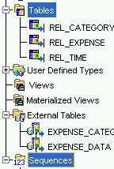
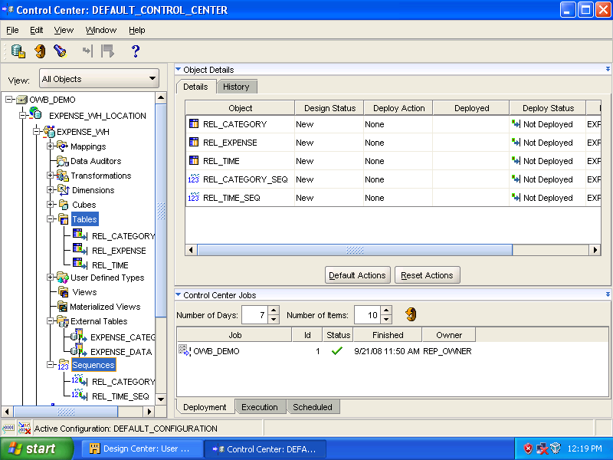

Select [Tables], hold down [Ctrl] key, select [Sequences] as well. Related objects are listed on the right panel, [Object Details].

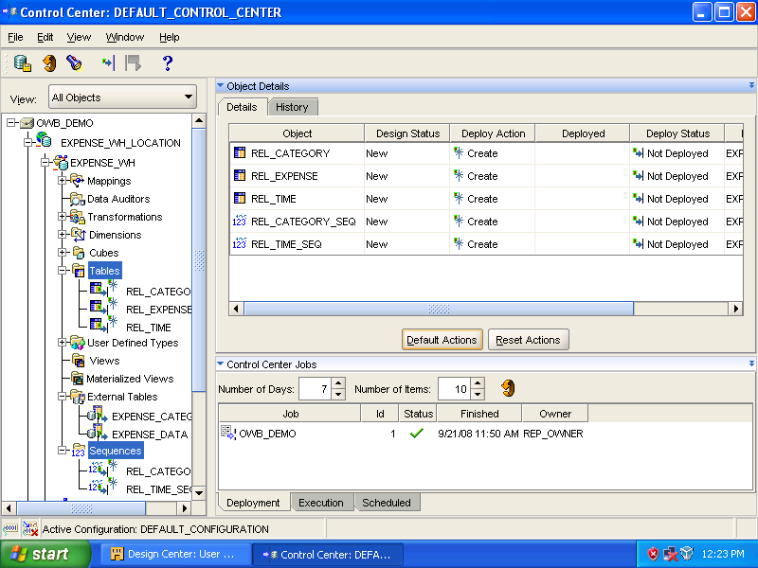

Click [Default Actions].

Click [] (Deploy icon) or select [File] ➔ [Deploy] ➔ [To Control Center] from menu.

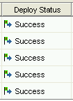
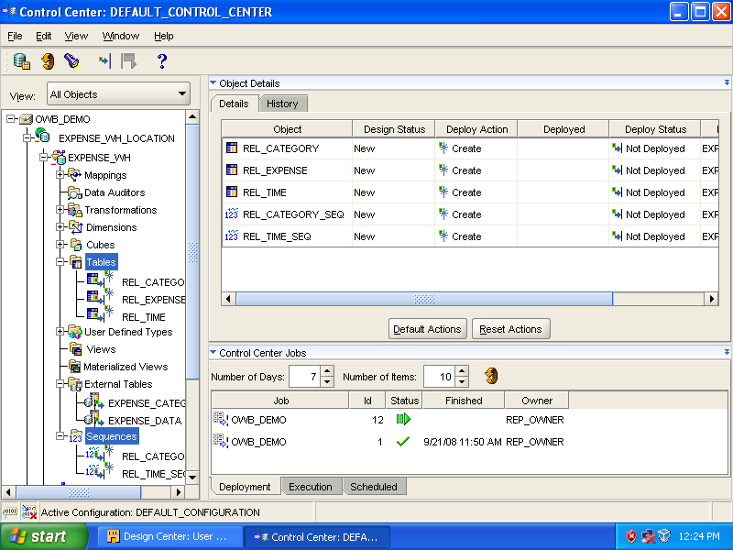

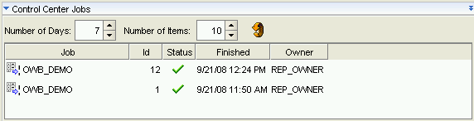

Selected objects are deployed successfully.

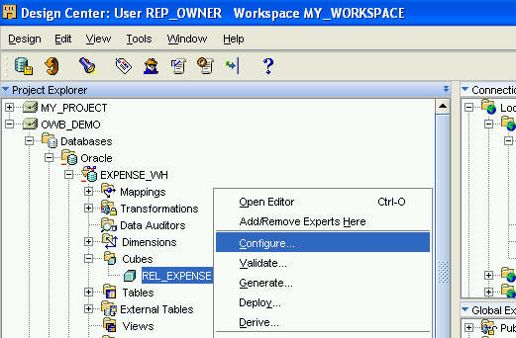

To ensure the deployment option is set to [Deploy to Catalog Only]. Right click the appropriate dimension (here, it is the cube [REL_EXPENSE]), select [Configure].

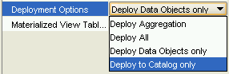
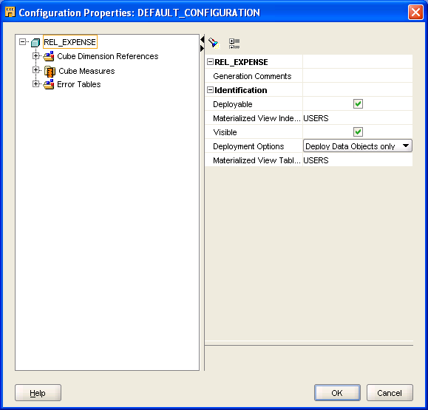

Open the [Deployment Options]’s drop down menu to select [Deploy to Catalog only].
Click [OK].

Perform the change to these objects:
- REL_EXPENSE cube
- REL_CATEGORY dimension
- REL_TIME dimension

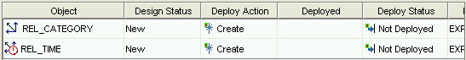
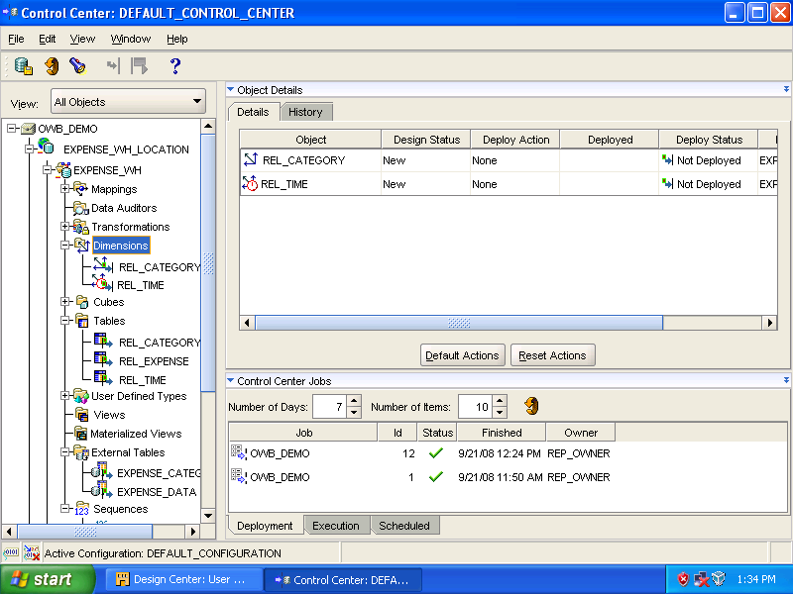

Expand [EXPENSE_WH_LOCATION] ➔ [EXPENSE_WH] ➔ [Dimensions]. Select [Dimensions] node. Click [Default Actions] in the right panel.

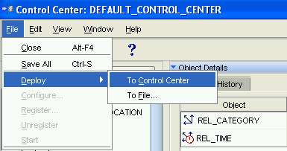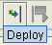

To deploy, select [File] ➔ [Deploy] ➔ [To Control Center] or click the [Deploy] icon.

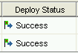
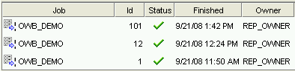
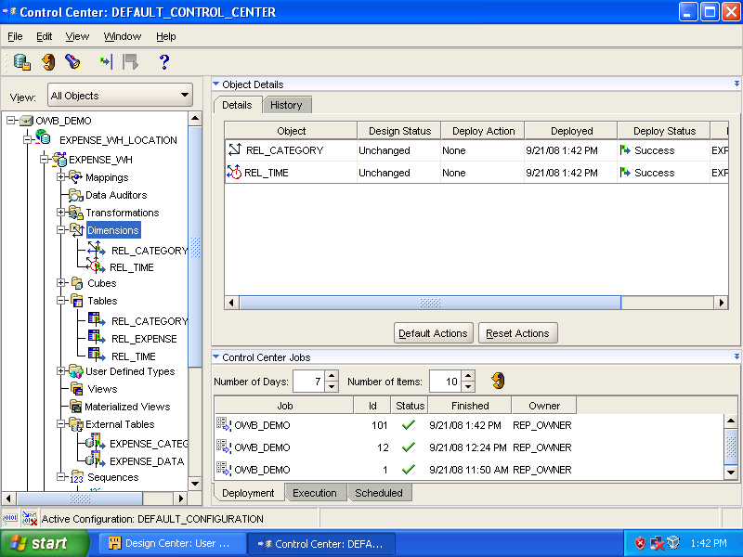

In Control Center Jobs panel, deployment status changes from [generate] to [run] to [completed successfully].

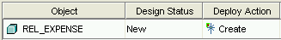
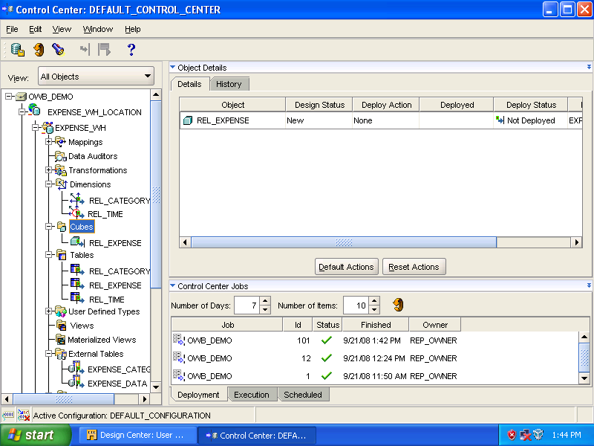

Select [Cube] node to deploy [REL_EXPENSE]. Click [Default Actions].

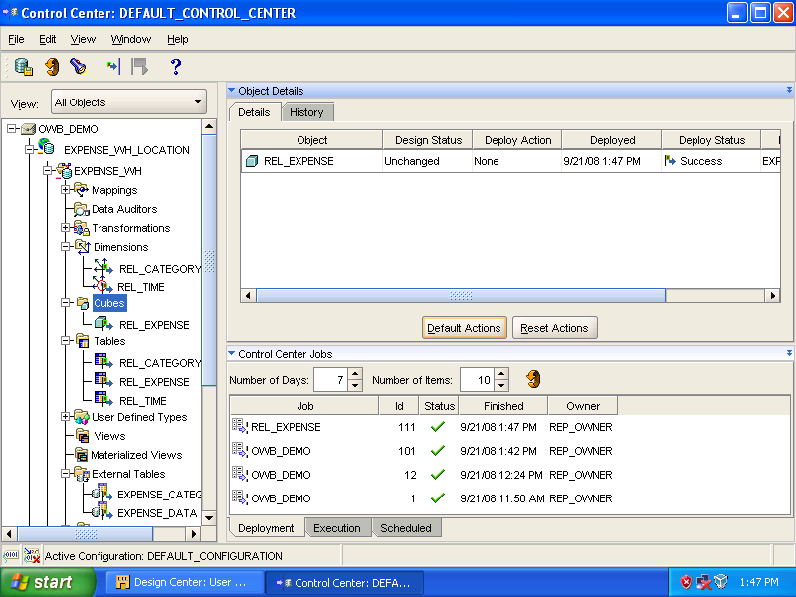

Click [Deploy] icon to start the action.

Deploy the Mappings

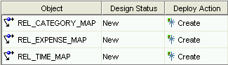
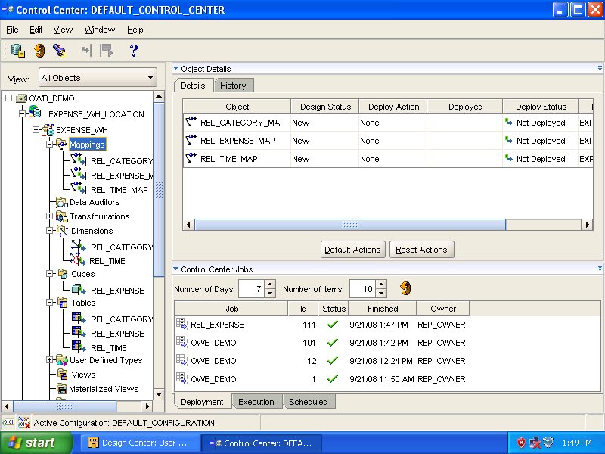

In [EXPENSE_WH] select [Mappings] node. Click [Default Actions].

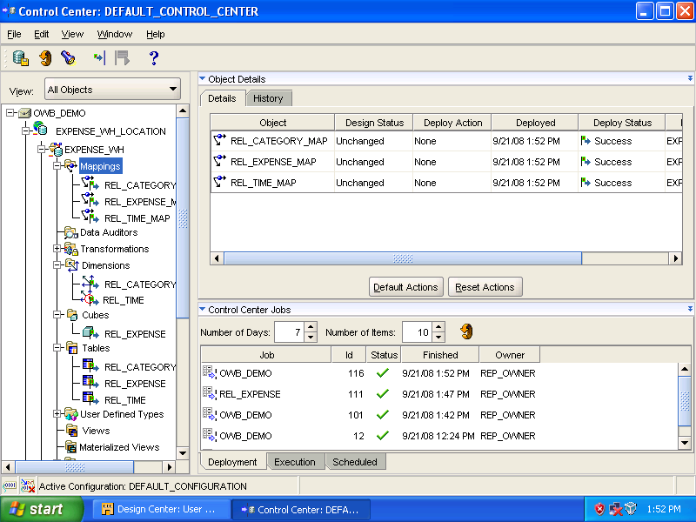

Click [Deploy] icon or select [File] ➔ [Deploy] ➔ [To Control Center] to start the action.

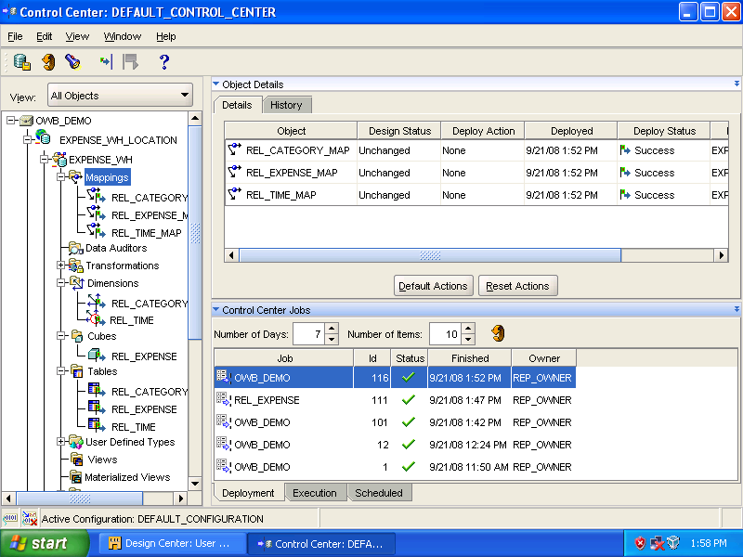
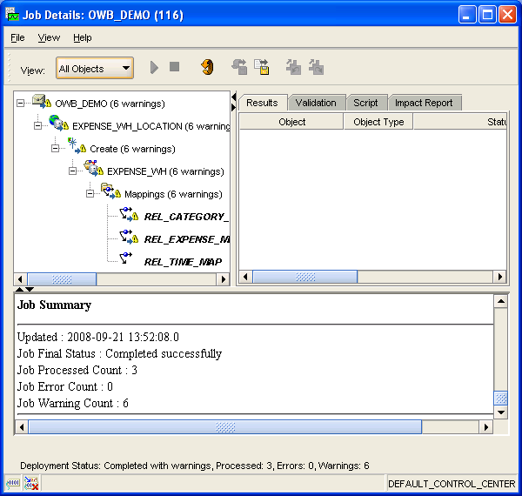

Select [OWB_DEMO] job at the top of the list in the [Control Center Jobs] panel. Double click on it. [Job Details: OWB_DEMO (116)] dialog box appears.

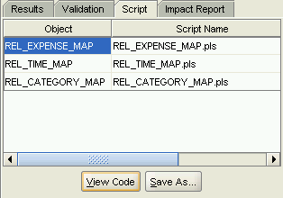
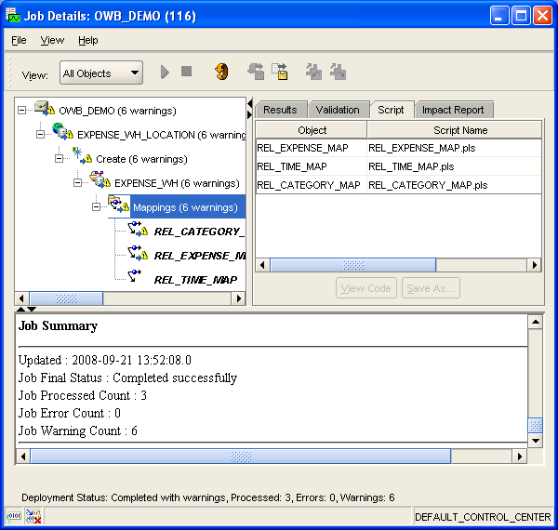

Switch the tab to [Script] in the right panel. Select [Mappings] under [EXPENSE_WH] in the left panel then select [REL_EXPENSE_MAP] object in the right panel. Click [View Code].

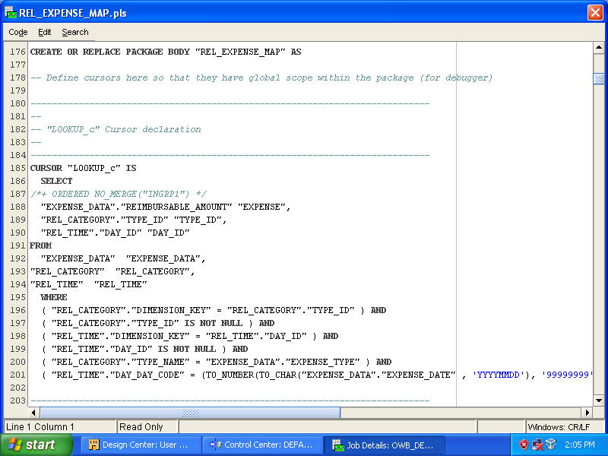

Content of [REL_EXPENSE_MAP.pls], generated code.

Deploy Process Flow

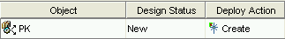
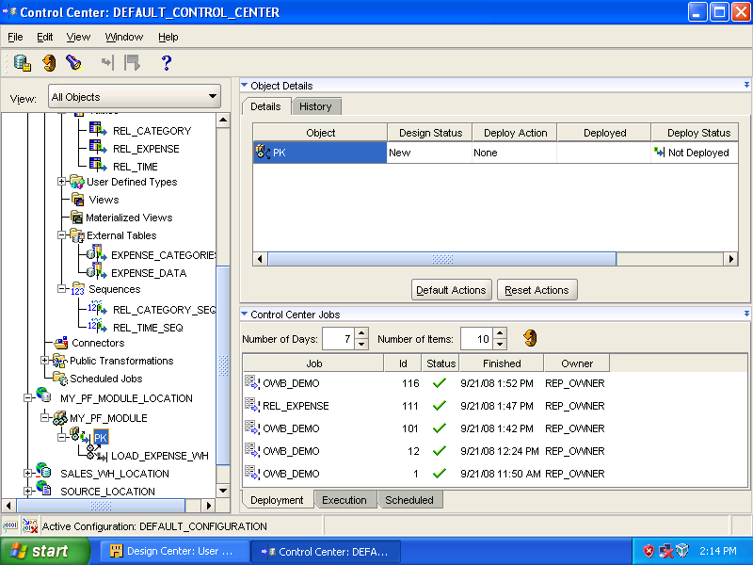

In [Control Center], expand [MY_PF_MODULE_LOCATION] ➔ [MY_PF_MODULE] ➔ [PK], select [PK]. Click [Default Actions].

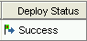
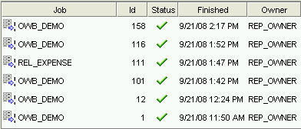
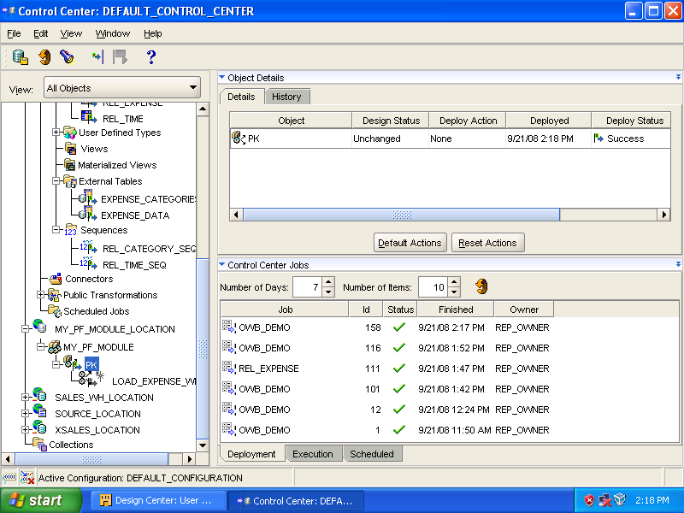

Click [Deploy] icon to run the deployment.

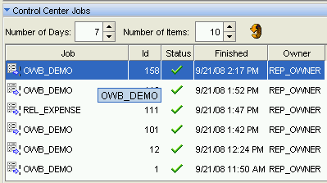

Double click [OWB_DEMO – 158] (top of the Job list) to view the details.
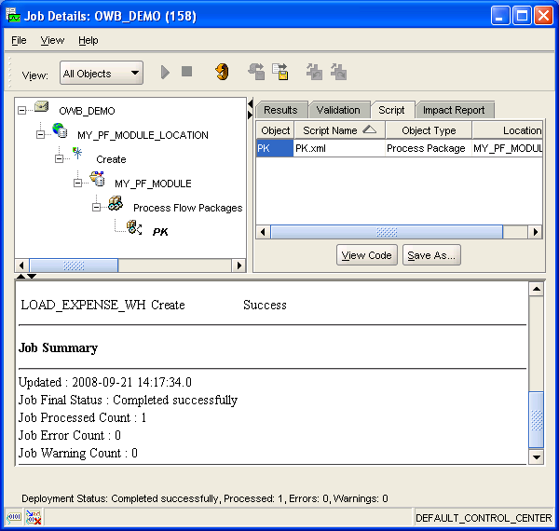

Change the tab to [Script]. Expand [MY_PF_MODULE_LOCATION] ➔ [CREATE] ➔ [MY_PF_MODULE] ➔ [Process Flow Packages], select [PK]. In the right panel, select the object [PK] and then click [View Code].

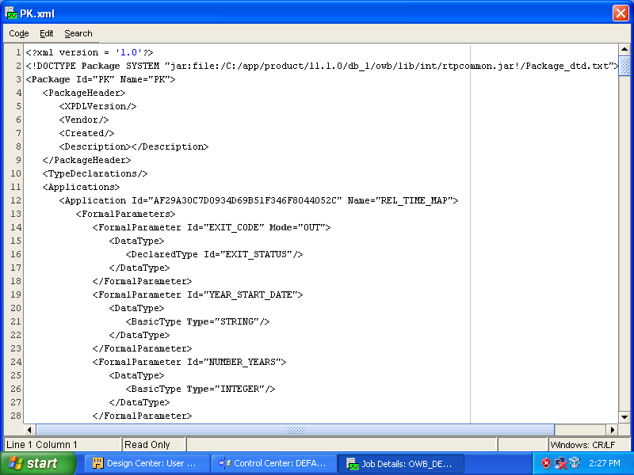

Generated code of [PK.xml] file.

