Loading Target Warehouse

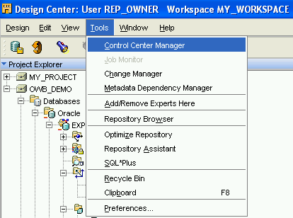

From menu, choose [Tools] ➔ [Control Center Manager].

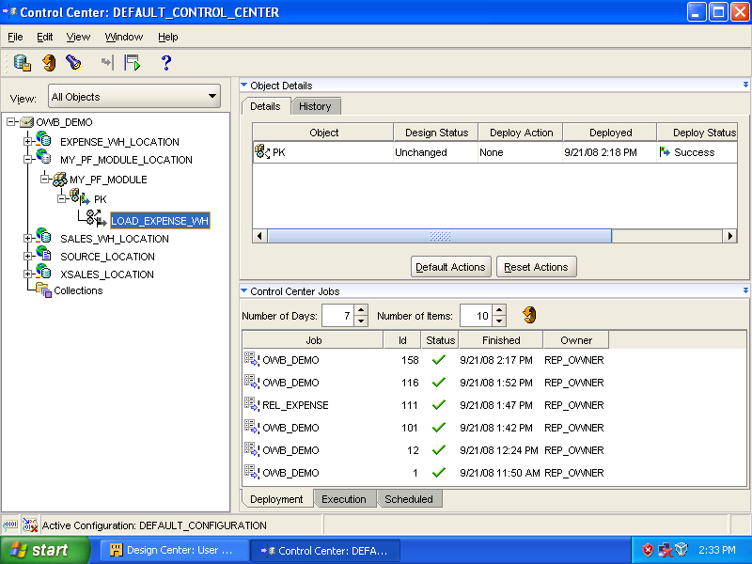

In [Control Center], expand [MY_PF_MODULE_LOCATION] ➔ [MY_PF_MODULE] ➔ [PK], select [LOAD_EXPENSE_WH].

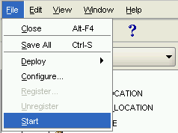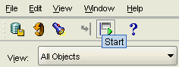

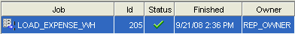
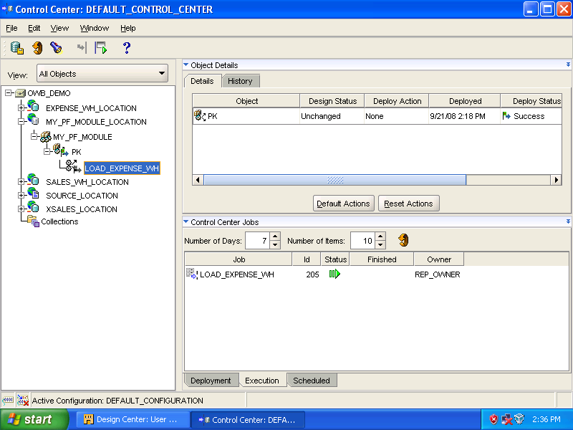

To execute a process flow, select [Start] from the menu bar or click the [Start] icon. Then, double click [LOAD_EXPENSE_WH] in Job column of Control Center Jobs panel.
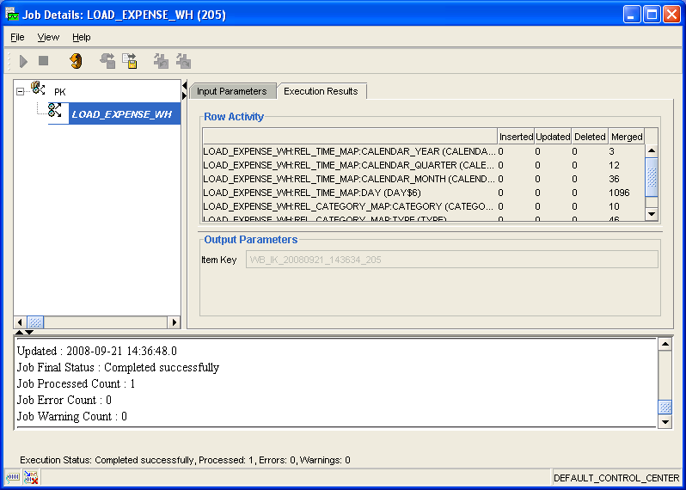

Click the tab, [Execution Results] to view the content.

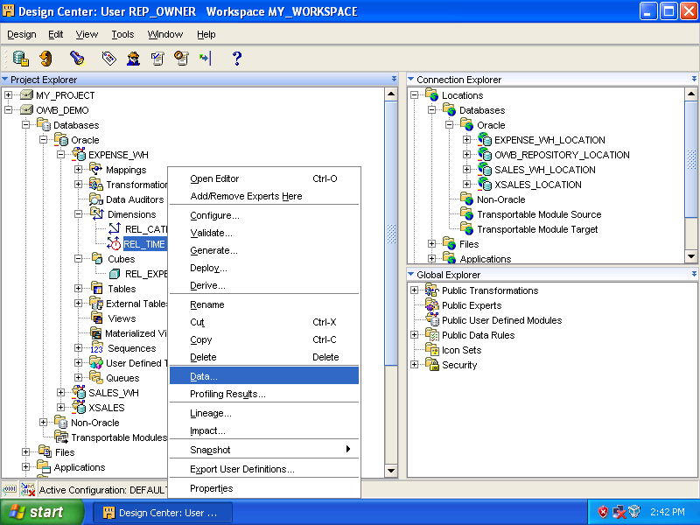

Right click [REL_TIME] and select [Data] to view [REL_TIME] data.

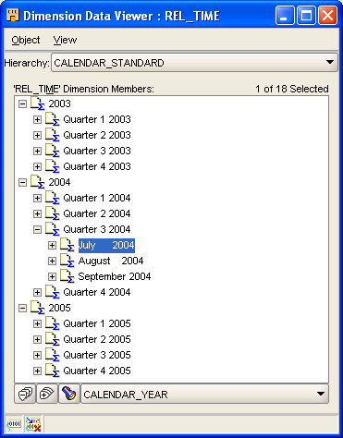
[REL_TIME] data are divided into different levels.

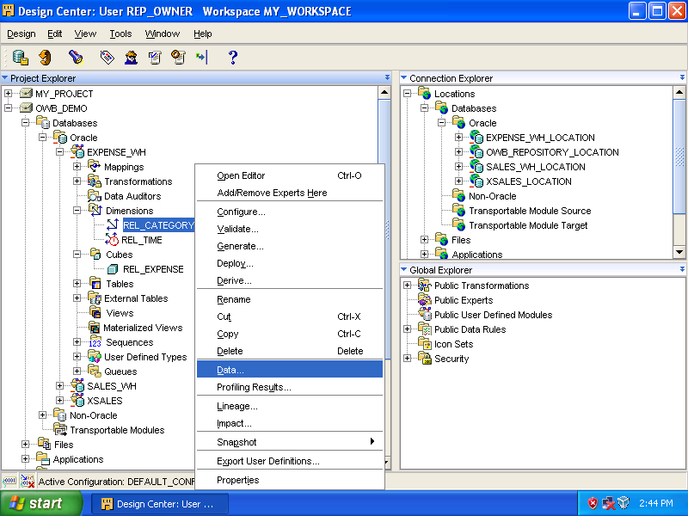
Right click [REL_CATEGORY] and select [Data].

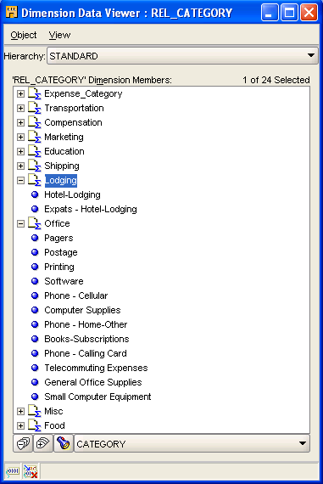

Different levels of [REL_CATEGORIES].
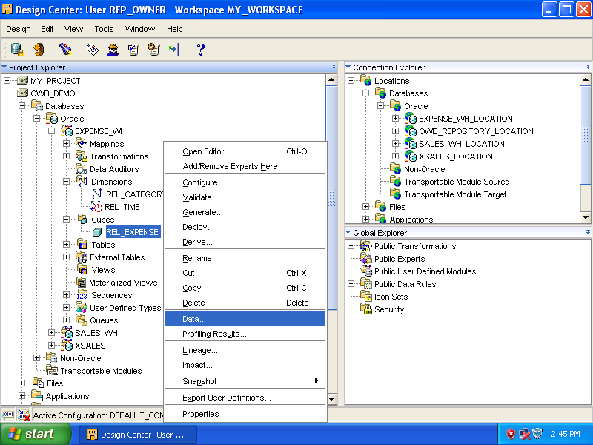

Right click [REL_EXPENSE] and select [Data].

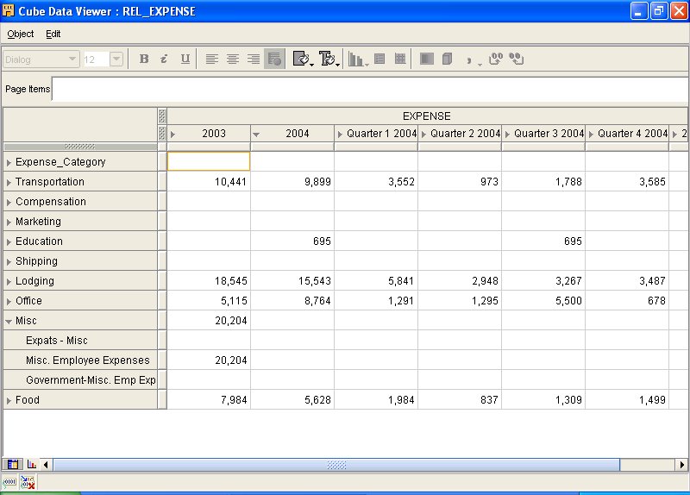

Data are shown based on the dimensions.
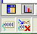
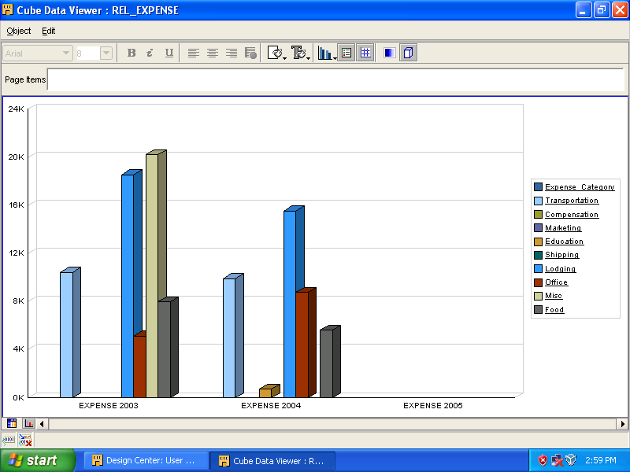

Click the [Graph] icon to view data in graphic mode.

