# OpenStudio: Building Envelope

## Terminology

Envelope – Walls, roofs, ground, fenestration (doors, skylights, windows)

Construction – the assembly of different layers of material that make up an envelope

## OpenStudio Construction tab UI

See this [guide to the construction tab in OS](https://openstudiocoalition.org/getting_started/creating_your_model/#constructions) that describes the UI

## Organizing your envelope data and defining your construction in OS

Sources for thermal property data – ASHRAE Fundamentals 2021 Ch. 26 Table 1

Organize each construction’s material layers with properties

* See “building_data.xlsx”
* Calculate U-value (compare it with OpenStudio’s auto-calculated value later on)
* Each layer must contain its own thickness and material property in OS

## Types of materials

* There are several types of material to be define in OpenStudio. In most cases, **Materials** is used to define physical opaque material (e.g. masonry, insulation, gypsum etc.)
* Air gaps can be define separately as an **Air Gap Material** (enter RSI for the air gap - ASHRAE Fundamentals 2021 Ch. 26 Table 3
* **No Mass Material** are used when the material has negligible thermal mass (very low density or specific heat capacity) – enter a single RSI
* Layers for windows are defined as a **Glazing Window Material** (glass) and **Gas Window Material** (e.g. air, argon etc.)
  + **Simple Glazing System Window** is a simpler window model, requiring a only U-value and solar heat gain coefficient (SHGC). There may be significant differences compared to the window construction defined above.

## Envelope exercise

1. Define the opaque material layers (i.e., everything except the air gap) for the “blu_wall”, “attic_flr”, and “roof” construction found in “building_data.xlsx” in OpenStudio. The **Materials** subtab is under the **Construction** tab . Click on the  to define a new material layer

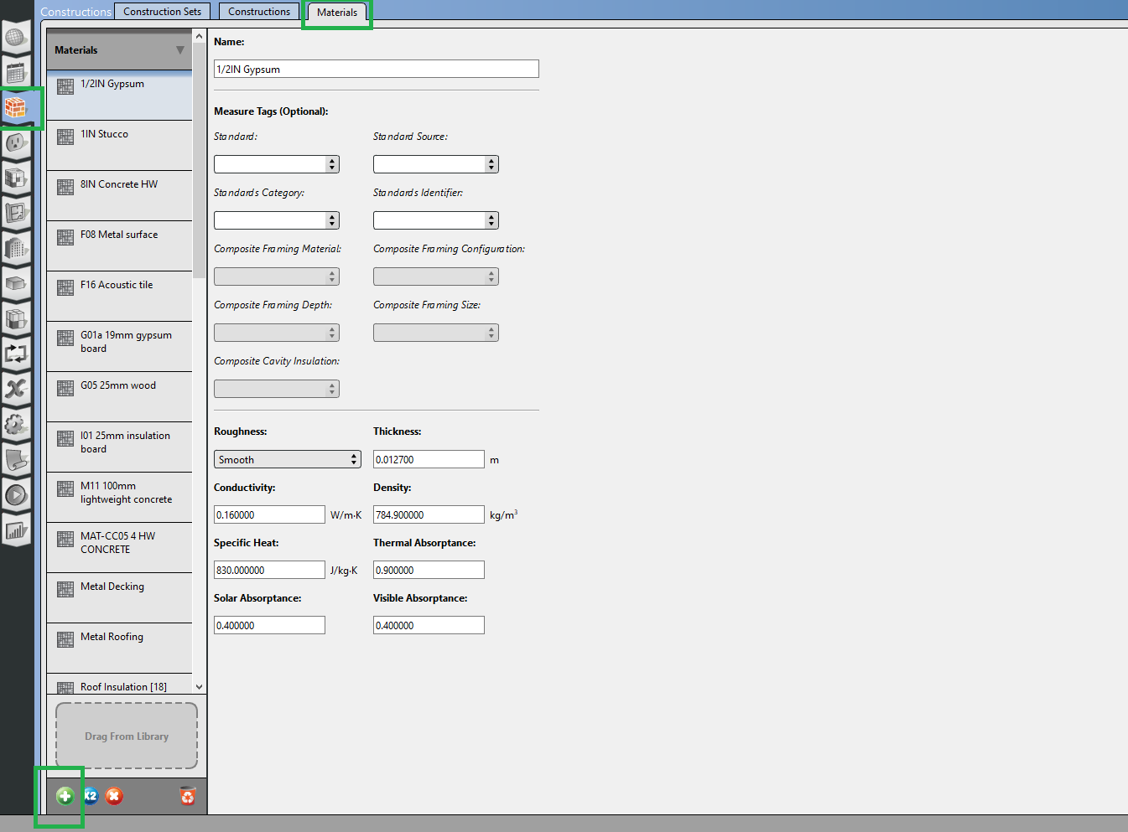

1. On the left menu, collapse **Materials** and open **Air Gap Materials**. By default, there are air gap layers pre-defined. Other air gap orientation (e.g., diagonal) and distances can be found in ASHRAE Fundamentals 2021 Ch. 26. For this exercise we’ll use the “F04 Wall air space resistance”

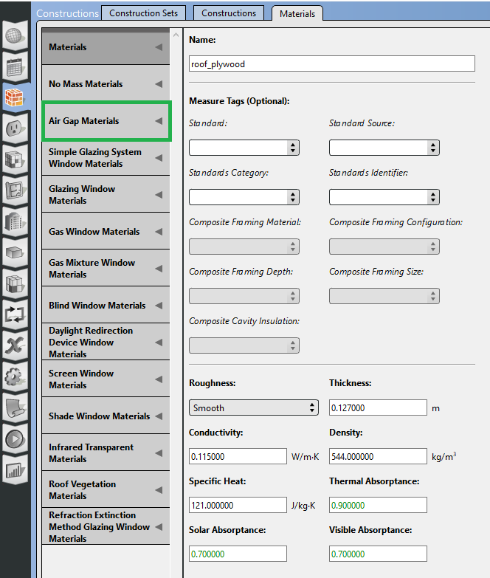

1. Move to the **Construction** subtab (next to the **Materials** subtab). Click on the  to define a new construction

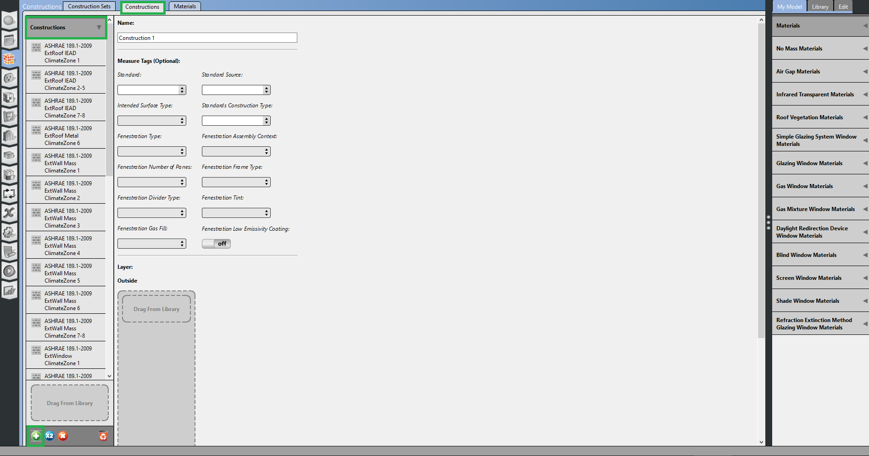

1. On the right hand side, there’s another collapsible menu with a list of the materials previously defined. Drag and drop these into the gray box. Don’t forget the **Air Gap Materials** on the right hand contains that predefined air gap layer.

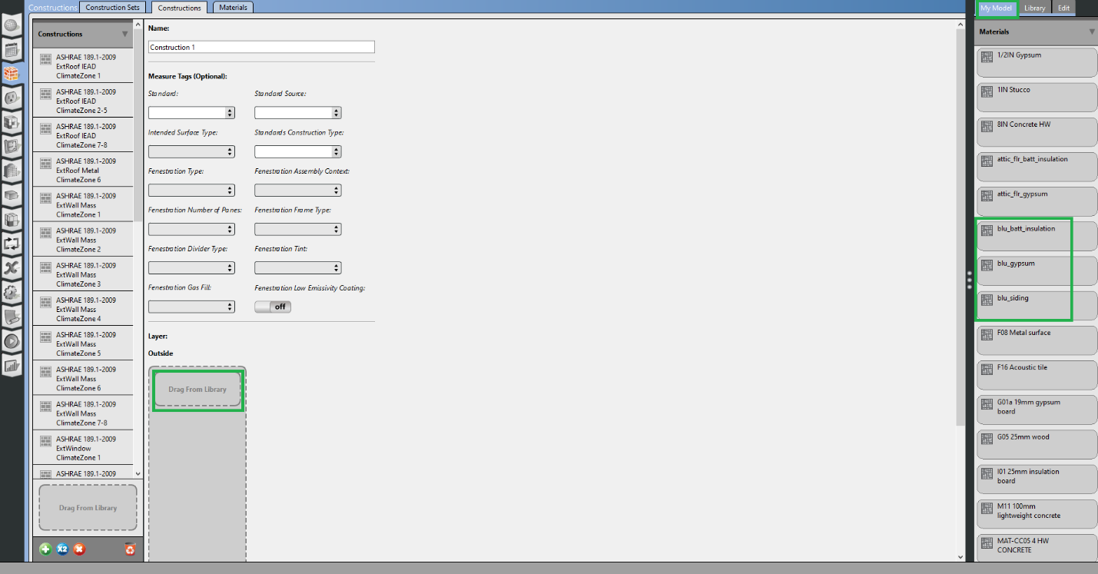

1. Arrange the layers so the siding is on the outside because the order of the material matters.
   * Thermal & solar absorptance
   * Smoothness
   * Adjacent constructions

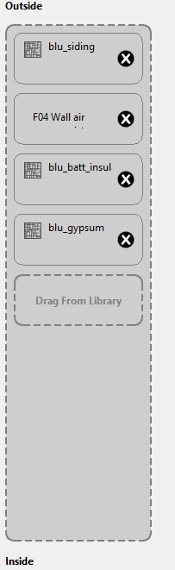

1. To define a simple window object, go back to the **Materials** subtab and create a new object under **Simple glazing system window materials**. Set the **U-value** to 0.83 W/m2K and the **solar heat gain** **coefficient** to 0.6. Then create a new construction object with this new material.
2. Construction needs to be set to each surface. Go to the **Space** tab  and then select the **Surfaces** tab. Before doing so, note:
   * In the attic space, the lists of surfaces are shown under **Surface Name** and its type under **Surface Type**. It’s also a good time to check if thesurfaces’ environmental conditions are properly set. For example, “blu 3”surface is an exterior wall, that’s exposed to the outside environment.
     1. Under **Outside Boundary Condition** it’s set to “**Outdoors**”.
     2. Under **Sun Exposure** and **Wind Exposure**, this exterior wall is exposed to both conditions.

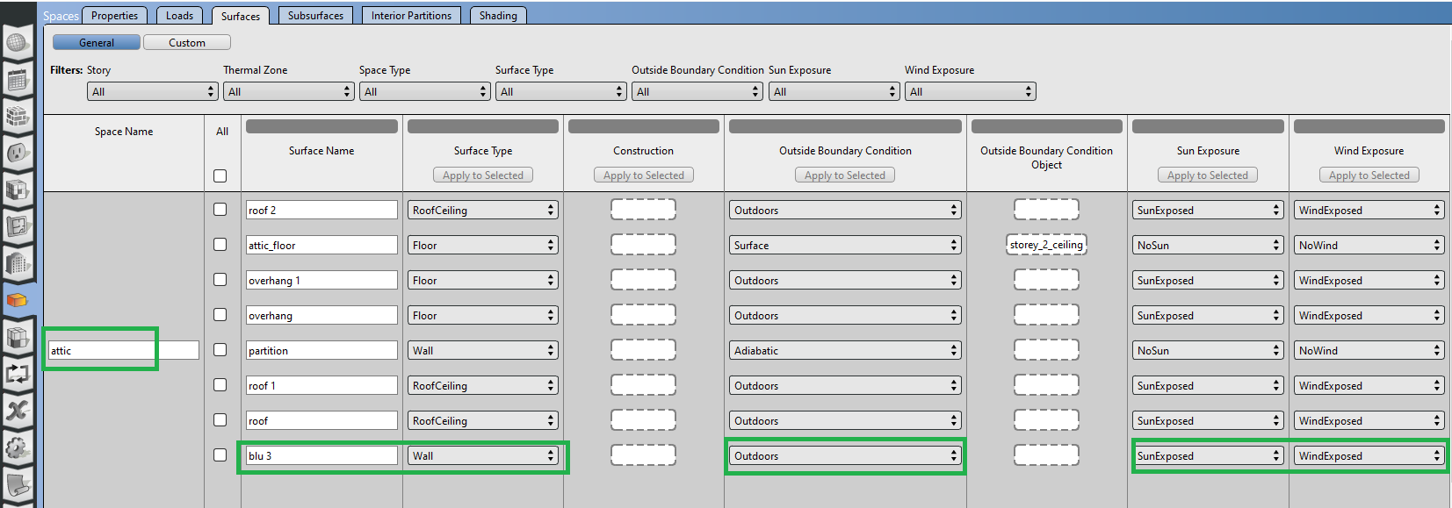

* + Some surfaces are assumed to be adiabatic – the partition wall has no sun or wind exposure.

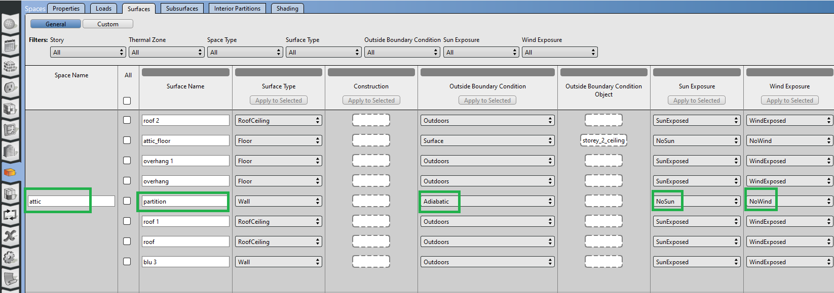

* + Surfaces that have another **Surface** as the **Outside Boundary Condition** means a construction (e.g. one zone’s ceiling is the another zone’s floor) is shared and heat transfers through it between the adjacent zones.
  + The adjacent surface is specified under the **Outside Boundary Condition Object**.

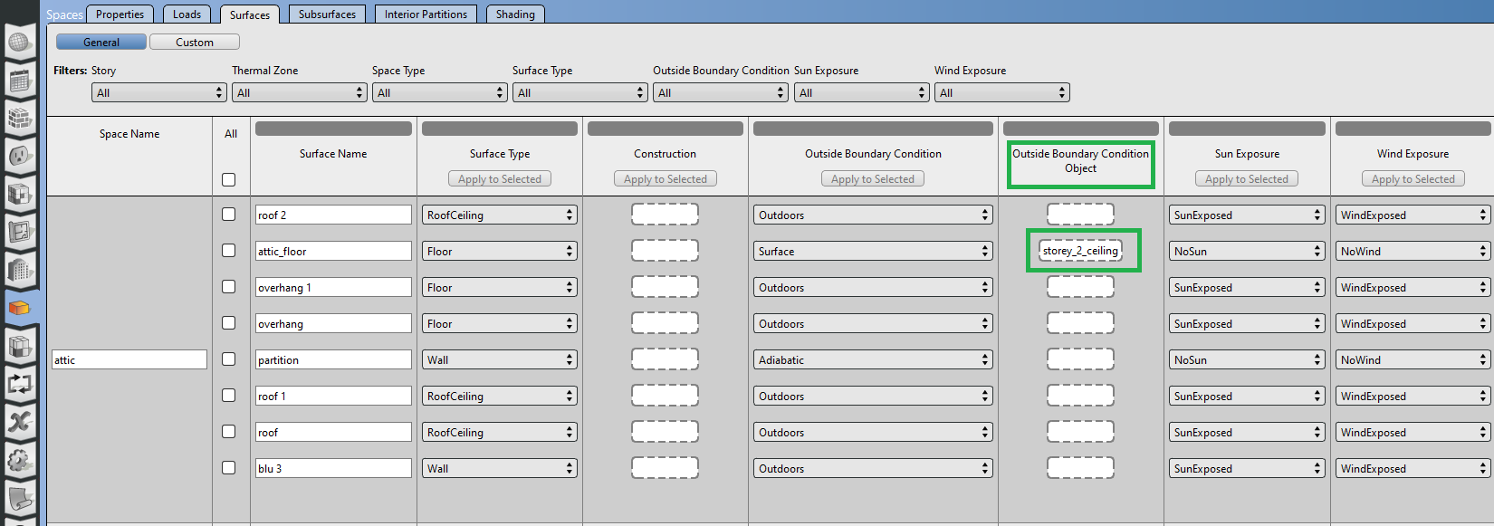

* + Setting the construction on either surface will automatically populate the same construction (with the material layers reversed – that’s why order matters) for the other. The reversed construction will show up as green (you may need to navigate away and back for it to show up in the GUI).

1. Drag and drop the construction to each surface from the **constructions** the **My Model** tab on the menu on the right.

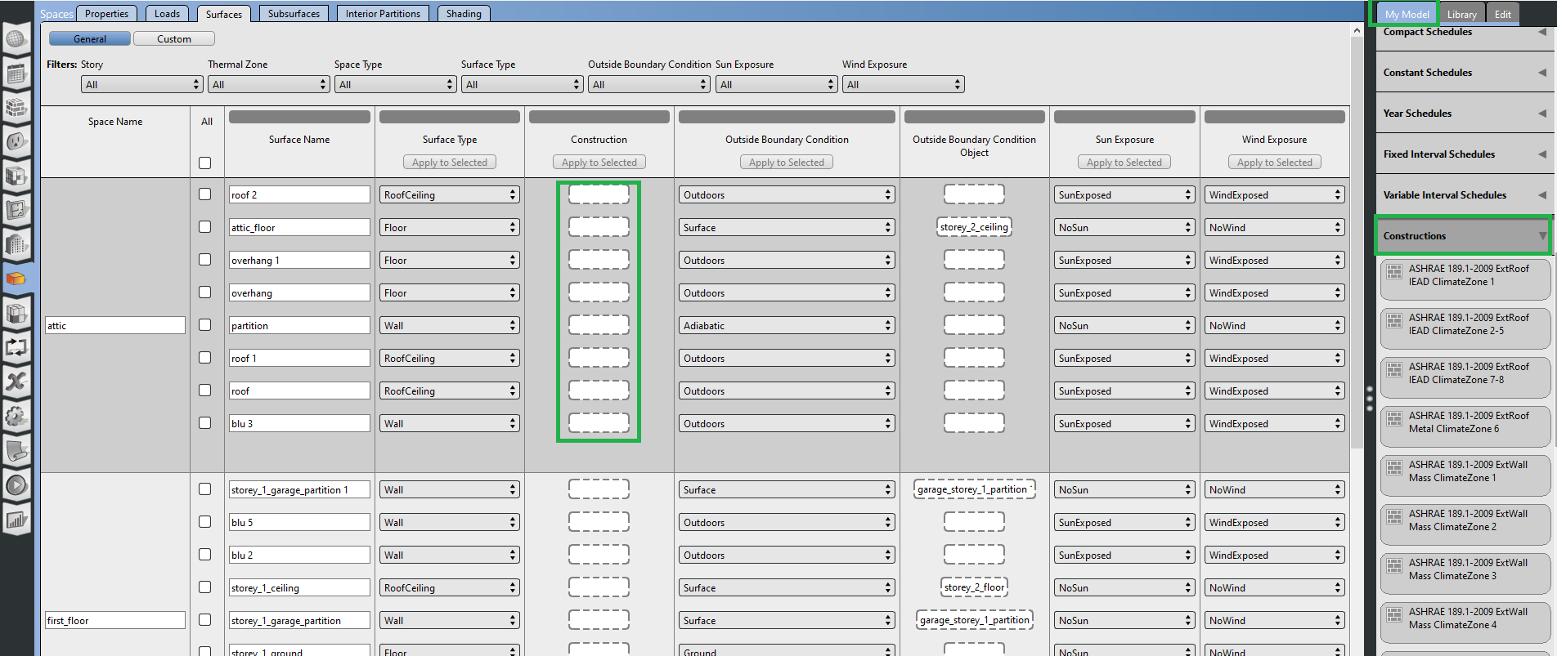

For simplicity,

* + Roofs with **Outside Boundary Condition** set to **Outdoors** – use “roof”
  + Walls with **Outside Boundary Condition** set to **Outdoors** – use “blu_wall”
  + Floors with **Outside Boundary Condition** set to **Ground** – use “grd_floor”
  + Partition Walls with **Outside Boundary Condition** set to **Adiabatic** or **Surfaces** – use the default generated “Interior Partition” (located in **Construction**, under the **Library** tab on the right)

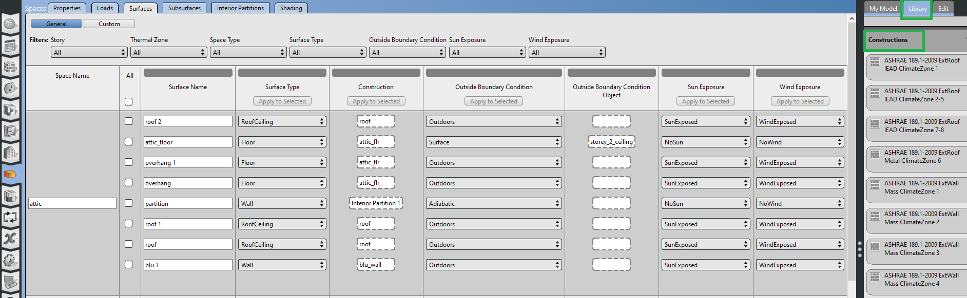

Except,

* + In the attic space, all floors, regardless of **Outside Boundary Condition** - use “attic_flr”
  + In the garage, “garage_ceiling” - use “attic_flr”

1. The construction of the windows and doors are set in the same manner, in the **Subsurfaces** tab, next to the **Surfaces**.
   * Apply the “Window” construction to all windows
   * Apply the default “Exterior Door” construction from the **Library** tab on the right
2. Infiltration modelling

* blower door test: 1 ACH (air change per hour) at 50 Pa
* typical operating pressure differential is 5 Pa
* The blower door test results can be characterized as

Similarly, the 5 Pa infiltration rate can be characterized as

Some manipulation yields

Assume

1. To add infiltration modelling, navigate to **Spaces** tab, **Properties** subtab, and click on **Airflow**. Infiltration objects can’t be directly created; an existing **Space Infiltration Design Flow Rates** object needs to be dropped into the slot for each space.

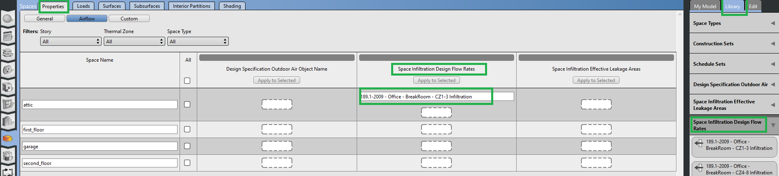

The inputs for the object can be edited by clicking on the object afterwards.

Because the infiltration calculated above is an ACH, the Design Flow Rate Calculation Method needs to be set to AirChanges/Hour and the value entered under the AirChanges/Hour box. Make sure to 0 other flowrates that are not used. Lastly, set the **Velocity Term Coefficient** to 0.244 s/m.

More information on the infiltration model can be found on the online [EnergyPlus documentation](https://bigladdersoftware.com/epx/docs/23-1/input-output-reference/group-airflow.html#zoneinfiltrationdesignflowrate).

1. Repeat the same for the other spaces.

# OpenStudio: Lights and Plug loads (Internal gains)

Internal gain objects are assigned to spaces in OpenStudio so the nominal values (e.g., max power, number of people) reflect the spaces they represent.

1. Click on the  to manage the internal gains objects. Create a new **Lights Definition** object and enter the Lights information from the “gains” sheet.
2. Create new objects under **Electric Equipment Definitions** for each plug load. Note the loss fractions for each object.
3. Create new objects under **People Definitions** for each plug load. Under **Number of People** enter “4” for each of the two people objects.
4. Schedule objects are needed to modulate the operation of lights and the activity of people. Schedules are accessible on the  tab, then **Schedules** sub tab. The list on the left contains existing schedules (right now they’re filled with default generated schedules).
5. To create a schedule for the “1st_storey_lights” lighting object, click on to create a new schedule object, and set the schedule type to **Fractional**,

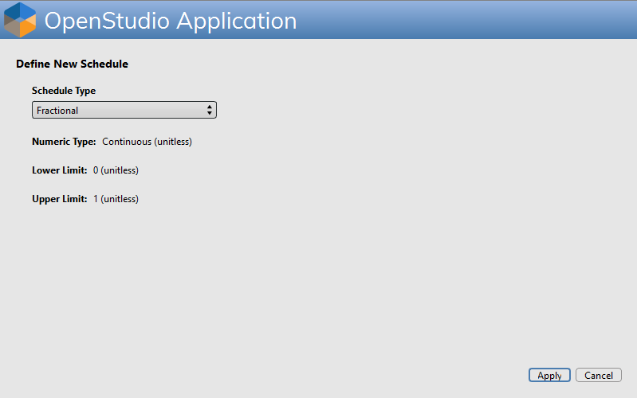

1. A single schedule object can contain multiple **Run Period Profiles** (highlighted in the menu on the right). The **Default** profile runs for everyday of the year. More profiles can be defined by click on the  next to the **Run Period Profiles**; these allow different schedules to apply on weekends for example.

The schedule for “1st_storey_lights” is set to turn on between 07:00 to 08:00 and remain off until it turns back on from 17:00 to 23:00. The schedule values are set by hovering the double clicking on the line in the plot at the hour and then entering the schedule value. Note the time scale can be set to **Hourly**, **15-min**, or **1-min** (i.e. schedule values can be set at “irregular intervals” 07:43-08:16). The “storey” schedule is a “on or off” schedule and is represented as “1” or “0”; this value is multiplied with the max or nominal value (lighting power max = 105 W in this case).

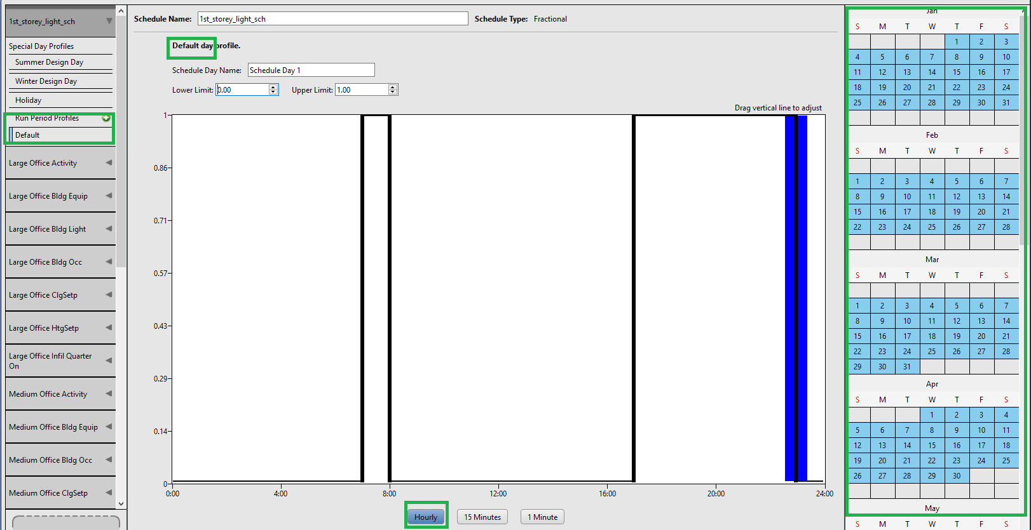

On the other hand, the “2nd_storey_lights” has a variable power draw (70 W between 18:00 to 23:00) 🡪 the schedule value in this case should be “0.67”.

1. Add the schedule for the other internal gains, note the power draw schedule for each object relative to the max/nominal power.
2. The activity schedule (the “power schedule”) for **People** requires an **ActivityLevel** schedule type. The schedule values are in units of“W/person”.

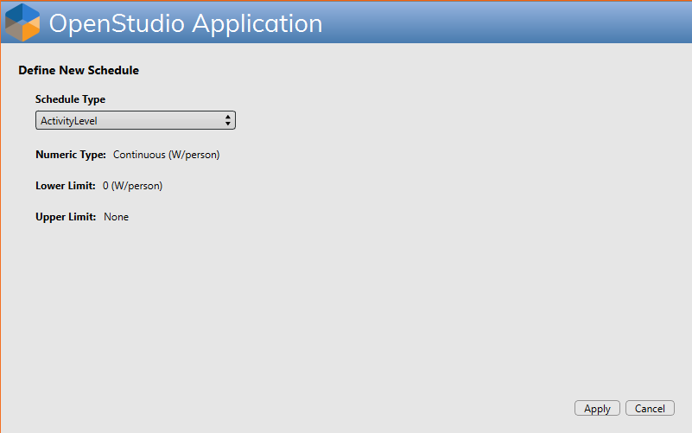

The 1st_storey people activity schedule should look like the following:

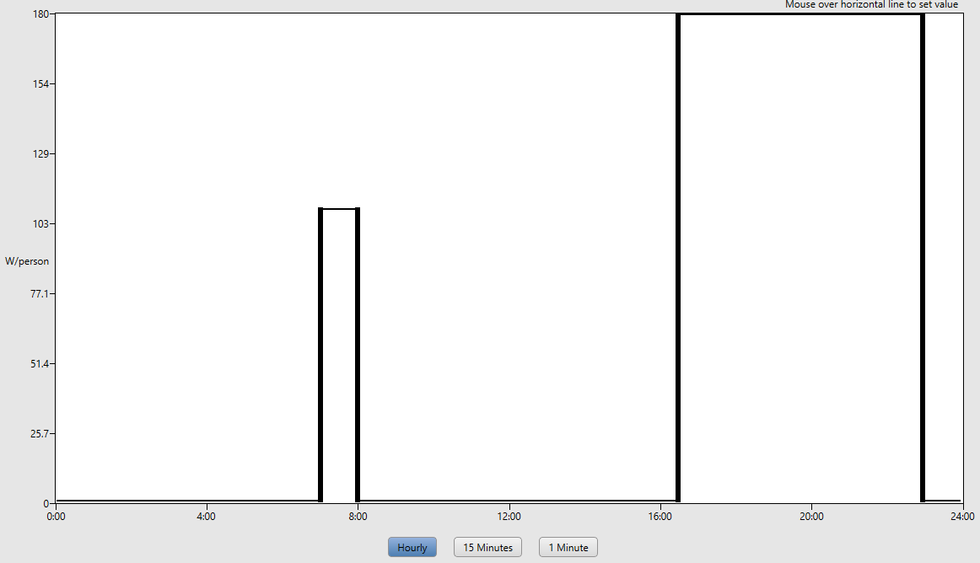

1. The occupancy schedule (number of people in a space at a time) needs to be set as well. This is schedule value is multiplied with the max number of person in the **People definition** to determine the number of persons in a space. The schedule type should be **Fractional**. The 1st_storey_occupancy should look like the following:

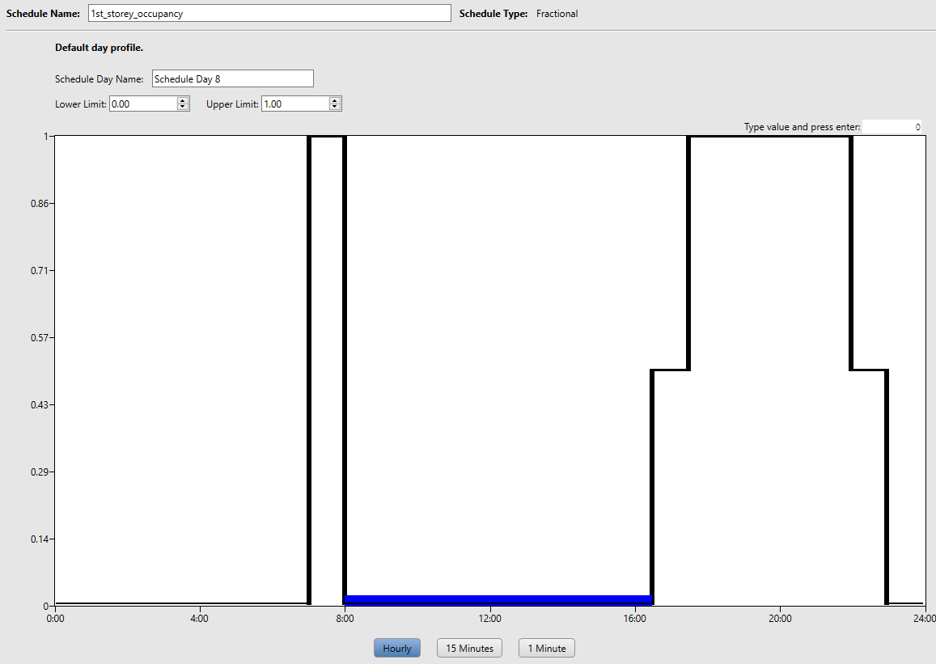

1. Next, to set the internal loads for each space, navigate to the following tabs and from underneath the **My Model** tab from the menu on the right, expand the **Lights Definitions** heading and drag and drop the 1st_storey_lights and 2nd_storey_lights lighting definitions under the **Definitions** column. Repeat the same for other loads (all kitchen equipment are located in the first storey).

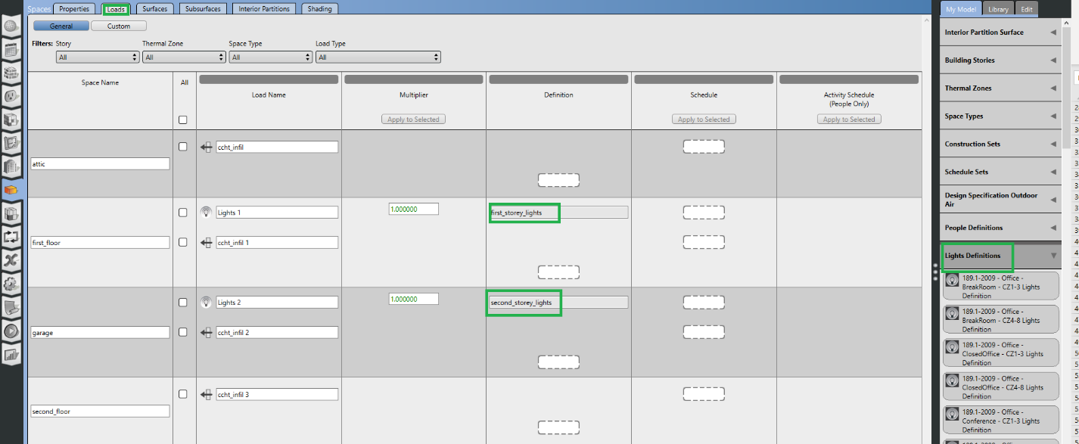

1. To apply the schedule to each load, under the **My** Model tab, look for the **Ruleset Schedules**, and drag and drop the schedule next to each load under the **Schedule** column. Note, for “People” loads, drag and drop the occupancy schedule from step 9 (not the activity level schedule).

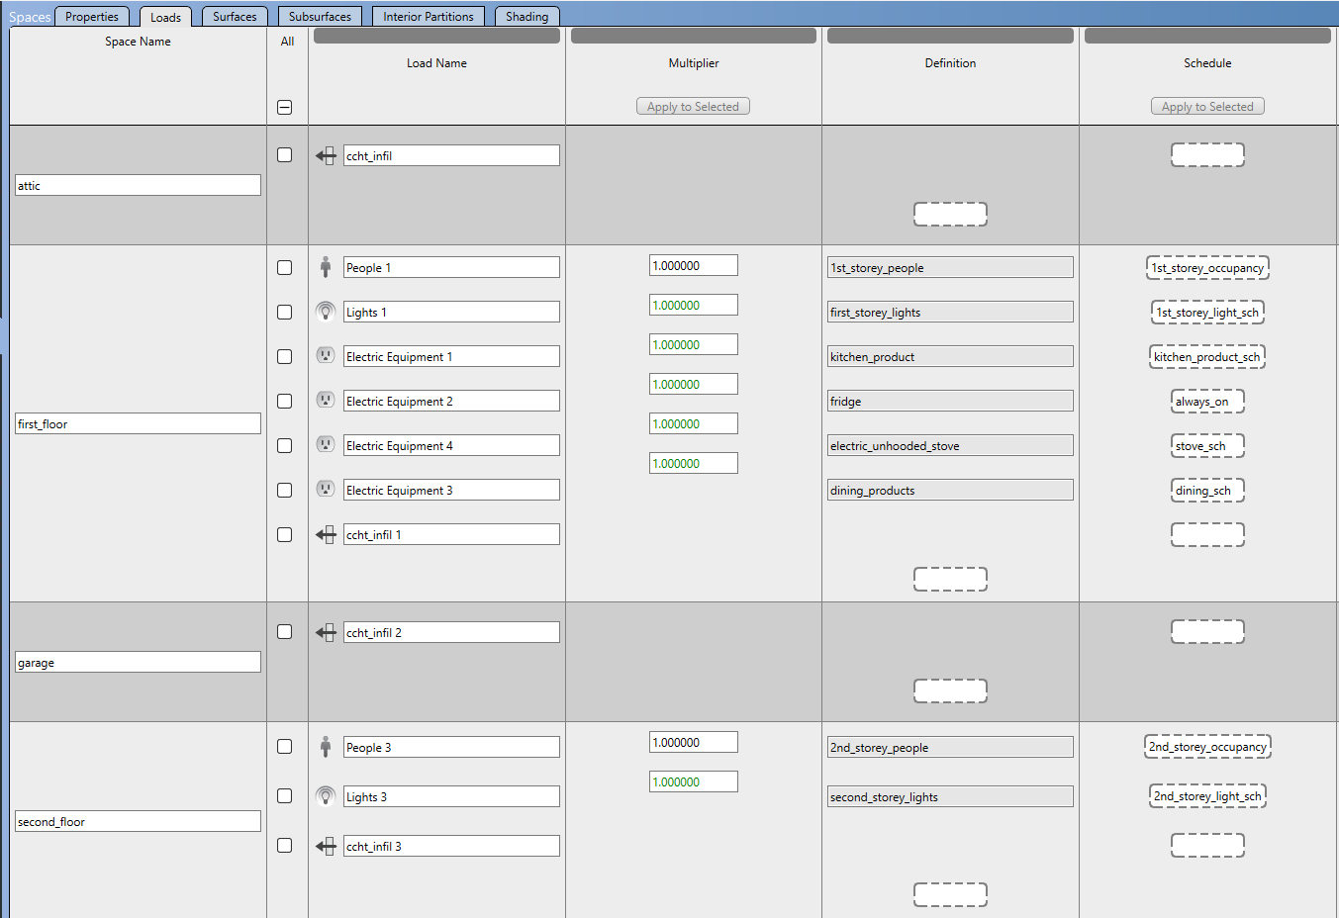

1. Drag and drop the activity level schedules from step 8, to the empty slots under the **Activity Schedule (People Only) column**, next to each people definition.
2. Lastly, drag and drop the always on schedule (create a fractional schedule with a constant 1) next to the “ccht_infil” objects for each space.

# OpenStudio: HVAC

1. Set the weather file and design day condition. The .ddy contains multiple design day datasets; we will only use **Ottawa Intl AP Ann Clg .4% Condns DB=>MWB** and **Ottawa Intl AP Ann Htg 99.6% Condns DB**. Delete the rest.
2. Create a constant schedule for cooling (24oC) and heating (21oC) setpoints (select **Temperature** for schedule type)
3. Navigate to the thermal zones tab and drag and drop the setpoints under the **Heating** and **Cooling** **Thermostat** **Schedule**.

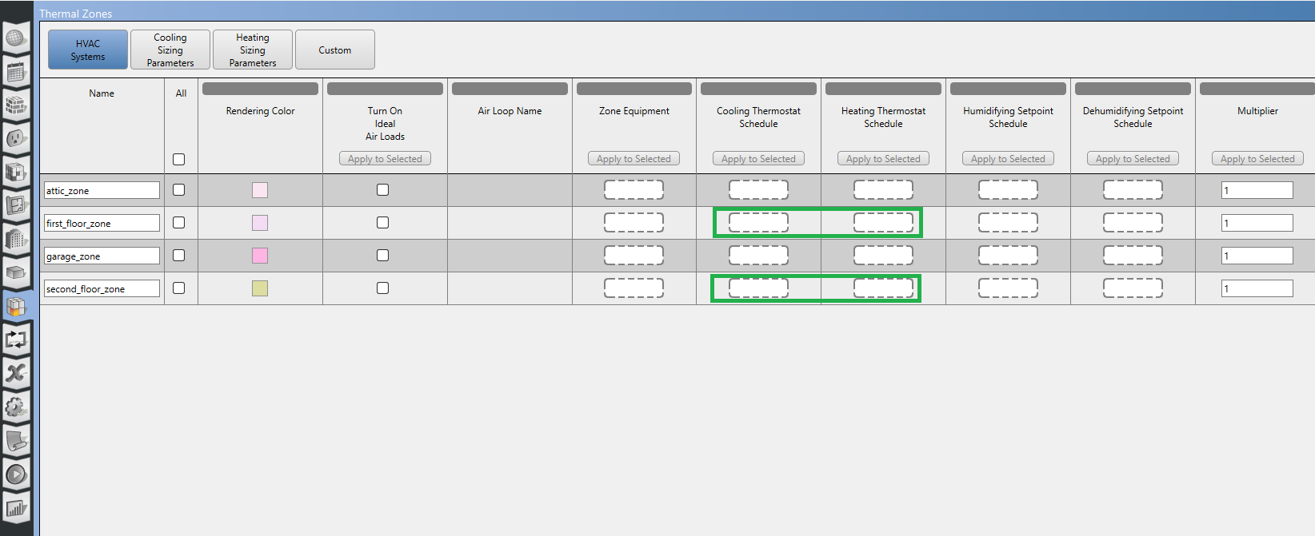

1. To specific outdoor air (ventilation) requirements, navigate to the following tabs

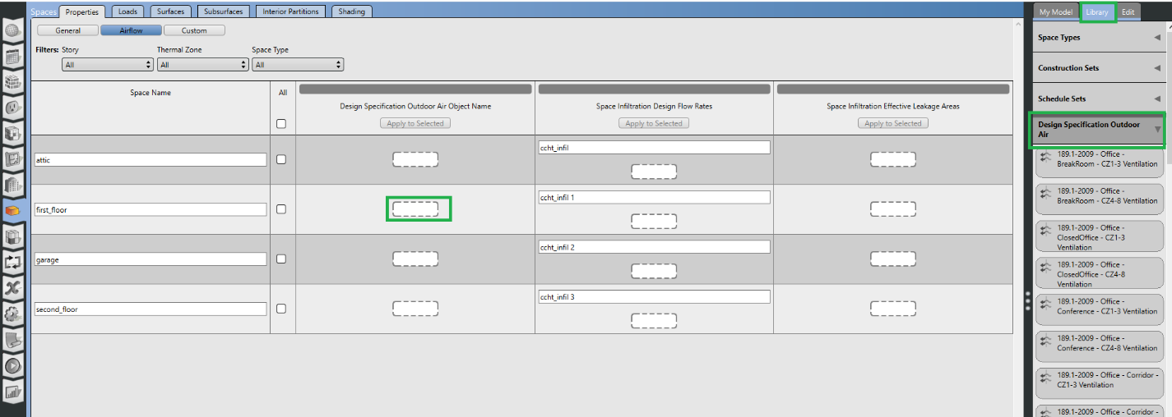

Just like before with the **Space InfiltrationDesign Flow Rates** object, the **Design Specification Outdoor Air Object** can only be created by dropping and editing an existing object from the **Library** menu on the right. Create outdoor air requirements for the “first_floor” and “second_floor”.

1. Edit the **Design Specification Outdoor Air Object** as follows

* outdoor air per person flowrate – 0.0035 m3/s/person
* outdoor air per area flowrate – 0.00015 m/s
* outdoor air flow rate fraction schedule name – blank (default is a constant 1 schedule i.e., always on)

1. Navigate to the HVAC  tab. By default it lands you in the “Service Hot Water” loop, to create a new loop and click on . Select the **Packaged Rooftop Unit**. You can navigate back to any loop from the drop down menu highlighted.

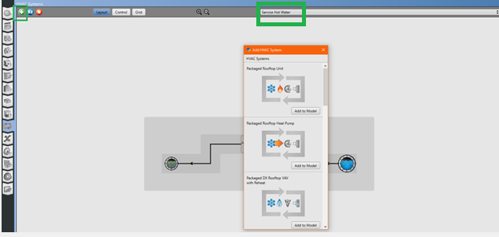

1. This creates the following air loop containing:
   1. Single speed DX cooling coil
   2. Heating gas coil
   3. Constant volume fan
   4. Setpoint manager
   5. Diffuser (**AirTerminal:SingleDuct:ConstantVolume:NoRheat**)

Clicking the dotted lines highlighted below will open access to the **Sizing:System** object. Parameters for the equipment sizing is set here. Set the system to size the **Total** load under the **Type of Load to Size On** (default is sensible).

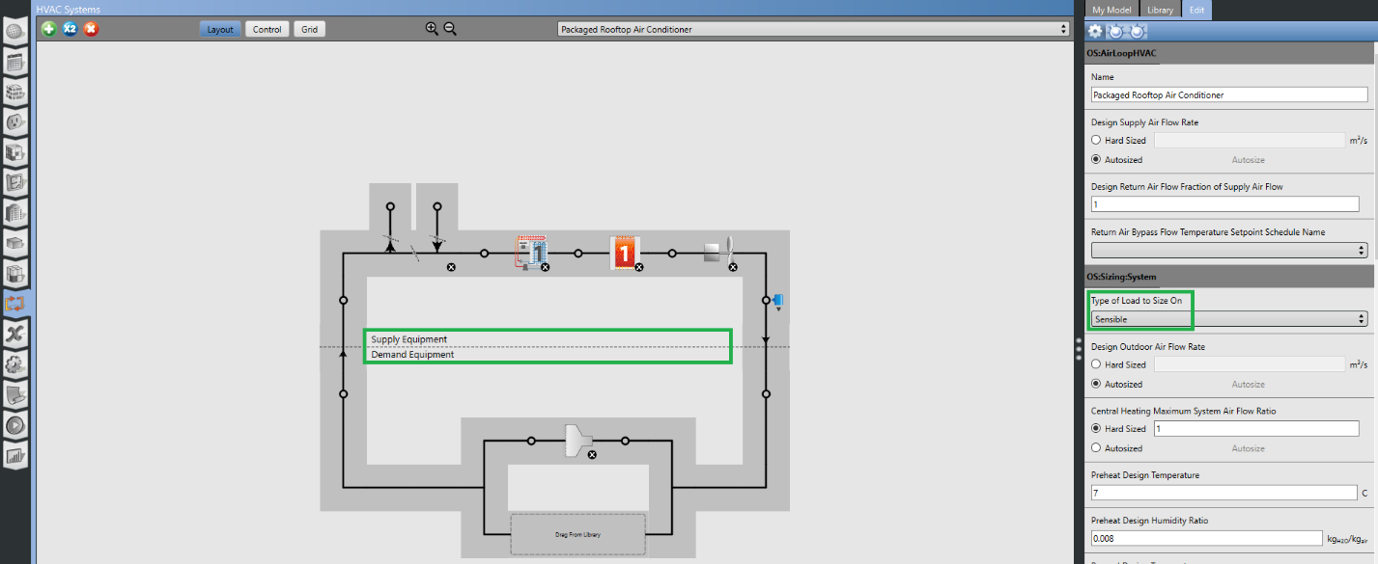

1. Drag and drop the zones this system will serve (“first_floor” and “second_floor”)

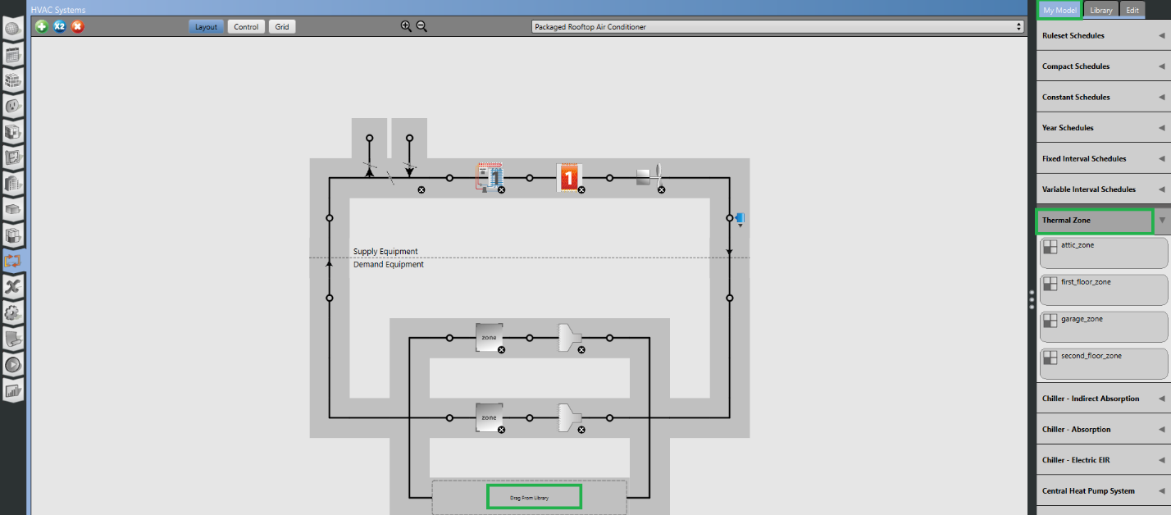

Then click on the **SetpointManager:SingleZone:Reheat** object and set the parameters as follows,

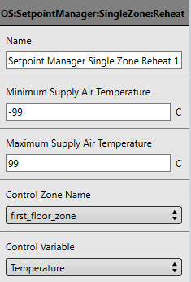

1. In the **Library** tab (from the menu on the right), under **Heat Exchanger Air to Air Sensible and Latent** drag and drop the **ERV HX** (energy recovery ventilator heat exchanger) onto node above the **AirLoopHVAC:OutdoorAirSystem**. Click on the **ERV HX** object and set

* set the **Heat Exchanger Type** to “Rotary”

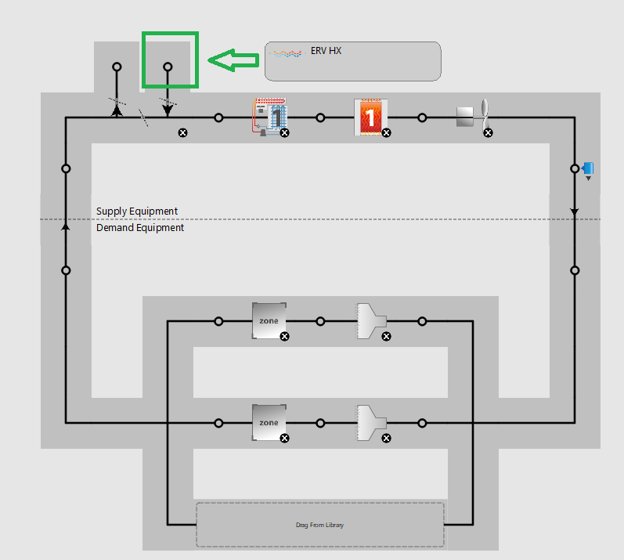

1. Additional parameters/settings that needs to be set

* ERV
  + Defrost control – set to ExhaustAirRecirculation
  + Nominal Power - set to 60W
  + Defrost control types
  + Sensible and latent efficiencies
* Controller:OutdoorAir
  + Minimum air flowrate – set to Autosize
  + Economizer control
* Coil:Cooling:DX:SingleSpeed
  + Rated COP – set to 3
  + Performance curves
  + Sizing
* Coil:Heating:Gas
  + Set Efficiency to 96%
  + Set Fuel type to NaturalGas

# OpenStudio: DHW

1. Create water demand objects
   1. Create a constant temperature schedule set to 60oC for the hot water setpoint schedule (“Hot Water Temperature”)
   2. Navigate to the Internal Loads tab and create a new **Water Use Equipment Definition** object and set the parameters as follows

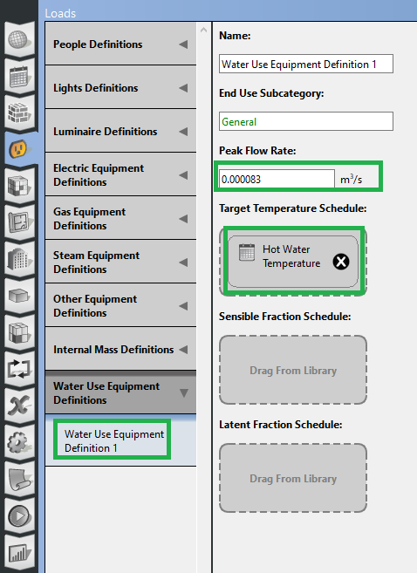

* 1. Manually create hot water load profile as a 5-min-step schedule found in the “DHW” sheet of “building_data.xlsx” OR import the “dhw_load_profile.osm” as a library by going to File>Load Library

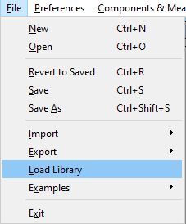

Afterwards, the dhw_load_profile schedule should appear under the **Library** tab on the menu on the right, under **Ruleset Schedules**/**Schedule Ruleset**. To add this to model, navigate to the Schedules  tab > **Schedules** sub-tab, and drag and drop the schedule to the bottom right corner under the left-handed menu.

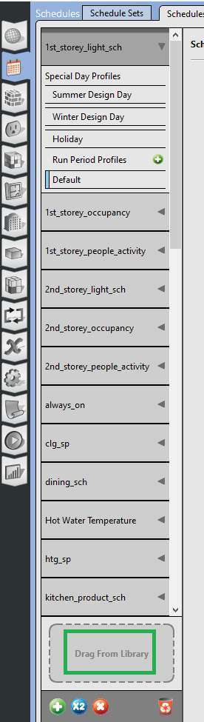

1. In the **HVAC**  tab, create a new **Service Hot Water Plant Loop**

* On the demand side, click on the **Water Use Connection** 
* Delete the existing **Water Use Equipment Definition** 
* Drag the **Water Use Equipment Definition** (from the **My Model** tab) created in 1.b) into the empty spot
* Select **Space Name** (“first_floor”) and **Flow Rate Fraction Schedule Name** (“dhw_load_profile”).
* Set the Pump:ConstantSpeed object’s **Pump Head** 200/300 for a house
* Set the water tank’s
  + 1. **Tank Volume** to autosize
    2. **Setpoint Temperature Schedule** to the 60oC schedule
    3. **Deadband Temperature Difference** 2oC
    4. **Heater Maximum Capacity** to 4 kW
    5. **Fuel type** to electricity
    6. **Thermal Efficiency** to 1
    7. **On** & **off** **cycle** **parasitic** fuel consumption to 0
       1. Pilot light, electronic control
       2. (default values are for commercial, resident 0)
    8. **Ambient** **temperature** **indicator** to ThermalZone
    9. **Ambient temperature thermal zone name** to first_floor
    10. **On**/**off** **cycle** **loss** **coefficient** to ambient temperature
        1. 6 is really high again commercial
        2. 1.3 W/K for Skin loss, UA- factor (part of UEF, SL metric)
        3. Procedures not well defined, bits and pieces
    11. **On cycle loss fraction to ambient** to 1 🡪 all heat loss to the zone
    12. scroll down to find the OS:Waterheater:sizing – set **Time for tank recovery** – 2 hours for elects, 1 hour for gas

# OpenStudio: Output Variables and Report

Output variables are found in the  tab. Individual output variables can be selected. Next to each variable, the report period can be selected (Hourly, Monthly, Detailed, Timestep etc.)

* Zone Air Temperature
* Heating Coil NaturalGas Energy (J) – input energy for the duration of the reporting period (reports output for all heating coil that uses gas objects kin the model)
* Fan Electricity Rate (W) - average input fan electrical power for the report period (for all fans objects)
* Cooling Coil Total Cooling Rate (W) – Cooling output (all cooling coil objects)
* System Node Standard Density Volume Flow Rate – volumetric flowrate for each node using standard density regardless of actual temperature

The results tab  defaults to the EnergyPlus HTML Results

* Contains multiple Reports (e.g., at the top is **the Annual Building Utility Performance Summary** - ABUPS)
* In the ABUPS
  + **Site and Source Energy** table – high level summary energy consumption (source energy based on default conversion factors; needs to be adjusted for each location)
  + End Uses – detailed summary breakdown of the consumption for different types of components
  + Comfort and Setpoint Setpoint Not Met Summary – number of unmet heating and cooling hours
* Other reports can be accessed by clicking on the Table of Contents link:
  + Component Sizing Summary – Sizing information for individual components
  + HVAC Sizing Summary – Zone cooling and heating load information

Individual outputs can be view by using DView.

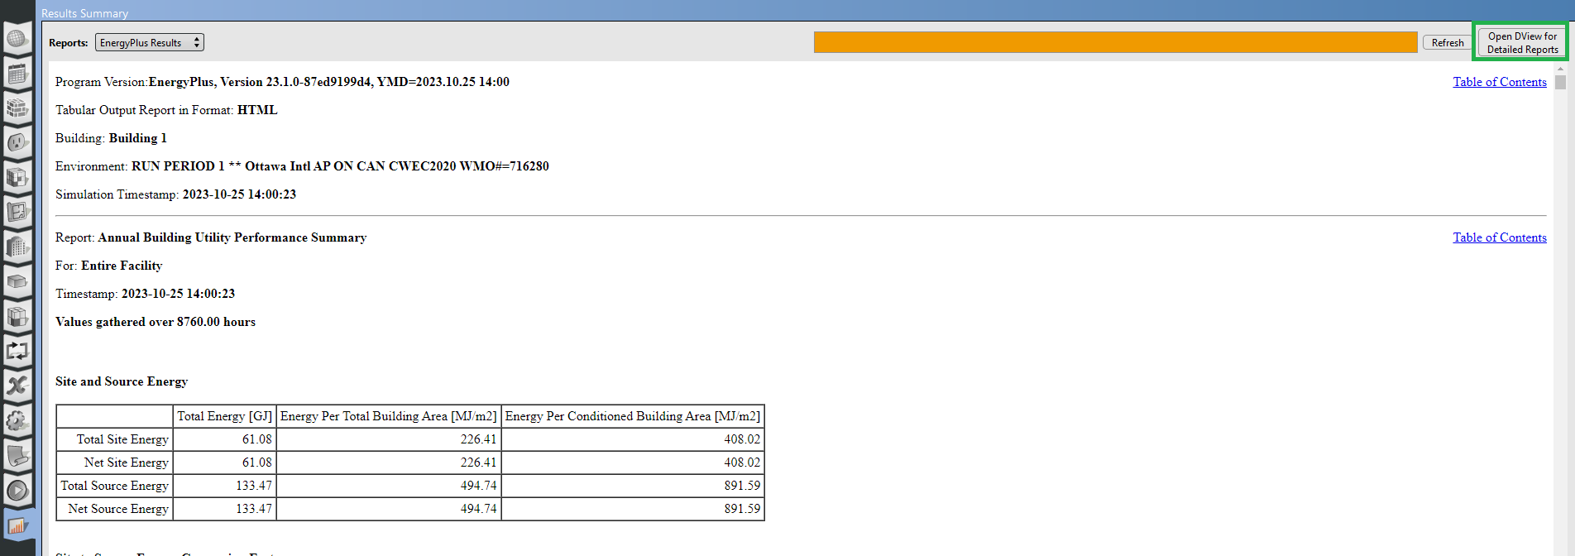

You may need to set up DView first by linking OpenStudio to the .exe file

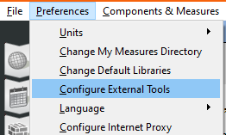

# Miscellaneous settings

Simulation settings can have an impact on the validity of the simulation results; these settings are found in the  tab.

* 4-6 Timestep per hour (15 min to 10 min timesteps)
* Ground Temperature (OS default 18oC) – not accessible through the OpenStudio Application (edit the EnergyPlus .idf file)
* Run Period (Start and End date of the simulation)
* Solar Distribution
* Convergence tolerances

# Validating/Calibrating

Even if the simulation completes successfully, the model may not be running exactly as you thought. Much like coding, each model needs to be validated/checked.

* Check the number of unmet hours
  + 8760 hours in a year
  + NECB unmet heating hours <= 100 hours
  + How to resolve them?
    - Is the equipment turning on?
    - Is it running at max capacity?
    - Is heating and cooling going against each other?
    - Are internal gains too low? Too high?
    - Depends on what’s the cause
* Review the air flowrate delivered by the HVAC
  + Flat? Fluctuating? As expected?
* Review the annual energy consumption
  + Compare to back of the envelope calculation
* Look into output variables,
  + see if the calculations make sense
  + components running at the right time
* Error message?
  + <https://unmethours.com/questions/>