Magic Halloween Lantern

# Skills outcome

JavaScript, functions, CSS, HTML

# Introduction

In this tutorial you will learn how create an interactive page where you can ask the magic lantern a question and it will be answered! The basic page has already been built, your job is to wire it up and make it work.



# Step 1. SETUP

* 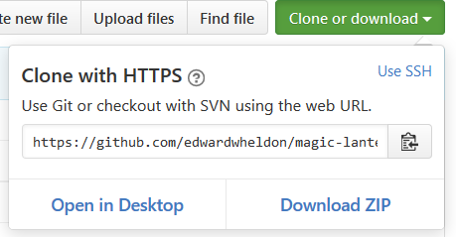Go to the following address and click the **‘Clone or download’** button then click ‘**Download zip’**. https://github.com/edwardwheldon/magic-lantern/tree/task



* Extract the files to a folder on your computer
* Using the text editor of your choice, for example [notepad++](https://notepad-plus-plus.org/) or [sublime text](http://www.sublimetext.com/), open the files.

# Step 2. Link up the CSS

If you view the html file inside your browser now it won’t look very good. Go ahead and have a look by double clicking on **index.html** in your folder. You now need to add a link to the css file inside the head elements **<head></head>** of **index.html**, in your text editor add the following code and save the file…

<link rel="stylesheet" href="styles.css">

That should look a little better now, but we need to add a few styles and some css to make it look awesome! In your text editor open the **styles.css** file and the following code inside your body element…

body {

background: black;

background-image: url("images/background-tile.gif");

background-repeat: repeat;

}

Hit save and view the file, we now have a nice background. Let’s add some more to make it look even better. In the css file look for the **.flame** class and add the following lines of code, this will make the lantern flash!!

animation-name: glow;

animation-duration: 0.5s;

animation-iteration-count: infinite;

We also need to reference this class inside index.html. Look for the following div with the id flame and add the flame class so that the div now looks like this…

<div **class="flame"** id="flame">

</div>

We can also give the heading text a spooky glow by applying text shadow to the **h1** style, add this line of code anywhere inside the **h1** style…

text-shadow: 0px 0px 30px white;

That’s the styles finished with on the page now, go ahead and take a look!

# Step 3. Link up the javascript

We now need to link the javaScript file to the page. This will make the page interactive by answering the question when you click the button. Inside the **<head>** elements of **index.html**, add the following code…

<script src="javascript.js"></script>

We also need to add a **click event** to the button on this page. Inside the <button> element add an onclick event to reference the **answerMe()** function in the javaScript file. The button code should now look like this…

<button class="button" id="answerButton" **onclick="answerMe()**"> Answer me </button>

That’s it, you have completed your job and the page should look great and be fully functional now. Well done ☺

Feel free to take a look inside the **javascript.js** file. See if you can add your own responses to the answers variable.

***If something has gone wrong and the page is not working, don’t worry this can happen and well done for having a go. You can download the completed page here to analyse. Happy Halloween!***

*https://github.com/edwardwheldon/magic-lantern/tree/complete*