


Integration Guide 2.0
Final Revision: May 17, 2013
Contents
I. General 2
1. Application Scope 2
2. Definition 2
II. Integration Process 3
Step 1 Apply for APP ID for the game 3
Step 2 Import the SDK into the project 3
Step 3 Add the dependency project 3
Step 4 Add the function calls 5
Step 5 Test 5
III. adding function calls 6
1. game start and close 6
2. statistics of player accounts 7
3. Player rechrage tracking 10
4. Game spending points tracking 11
5. mission, level or Instance 12
6. Customized events 13

I. General

1. Application Scope

TalkingData Game Analytics helps mobile game developers with all complex challenges from real time player data tracking, collection to cleansing, standardization and systematic analytics. Data are highly visualized and displayed through the reporting system in the form of industry-standard metrics.

The software development kit (SDK) is applicable to the ARMv7 (operating systems later than IOS4.2) devices.

Note: for games developed by using the Unity 3D, please unload the special SDK and use the special Unity development guide manual for integration.

2. Definition
In statistics, we use the game account as a player unit for better integration with the game system. In addition to player’s basic information, the data collected contains detailed information about player behaviors during gameplay including upgrade, missions, payments, spending, etc. Regarding the definition of behaviors, the following description is given for reference:
➢ Player
It refers to a game account. Generally, it is in the form of a unique ID, name, or file ID and it is also the basic unit for statistics and calculation in our platform.

➢ Device
It refers to a terminal with the game app installed.

➢ Session
It refers to a complete process from the launch of the game app to the exit. If the player re-launches the game app within 30 seconds from the last exit (e.g. switches back to the game app), it will be deemed as continuation to the last session.

➢ Payment
It refers to the process of player charging in exchange for virtual currency. The sum of cash charging will be calculated as revenue.

➢ Spending
It refers to the process of virtual currency spending for virtual item purchase.

II. Integration Process

Step 1 Apply for APP ID for the game
After signing up at talkinggame.com with your registered account, please create a game and then you will get a 32-bit hexadecimal APP ID as the unique identifier for the game created.

Step 2 Import the SDK into the project
Download the compressed package of SDK and decompress it into local directory (It’s best to decompress the SDK into the peer directory of cocos2d-x, which will simplify the configuration of paths)

Step 3 Add the dependency project
- Android
- In Eclipse, select File->Import and select cocos2dx-talkingdata/proj.android as the targeted directory to be imported.
- Add dependency to the previous step in the game project. Select the project and do File->Properties->Android
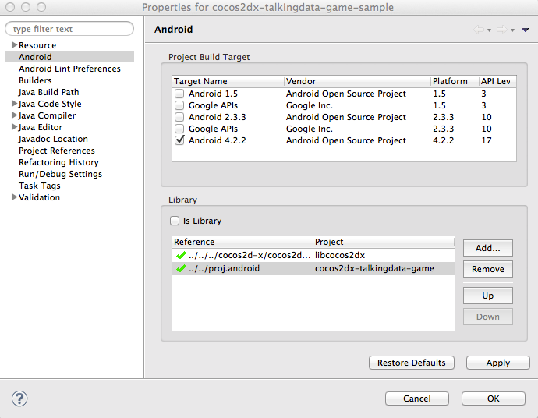
- Set Android.mk of the game project.
LOCAL_C_INCLUDES: Add the include directory of the dependent project.
LOCAL_WHOLE_STATIC_LIBRARIES: Add the name of the module compiled by the dependent project.
Suggest to refer to cocosdx-talkingdata/sample/proj.android .

- iOS
- Export the project and drag and drop the iOS project under cocos2dx-talkingdata/proj.ios into the game’s xcode project.
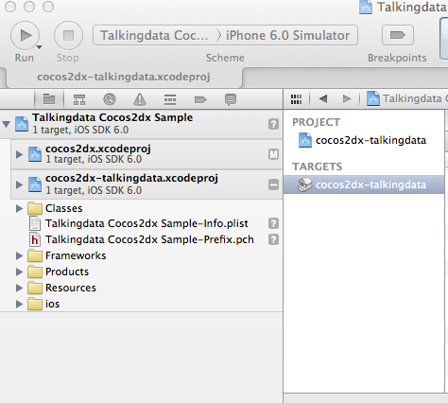

- Set the Build Setting of the game project
Search->Header Search Paths
Search->Library Search Paths
Suggest to refer to cocos2dx-talkingdata/sample/proj.ios

Step 4 Add the function calls
Refer to “III. Adding Function Calls” to complete the development.

Step 5 Test
After adding the function calls, pack the game and test the data to ensure correct integration.

III. adding function calls

game start and close

Purpose and usage
➢ To track game sessions and duration
➢ Import TalkingDataGA.h into the files that need to call functions of the SDK.
Call onStart() within the method of application:didFinishLaunchingWithOptions: for session initialization.
➢ You can optionally fill in the field of channelId with the name of the targeted promotion channel. After that you can query data of certain targeted channel in the Channel Data report. Each unique device is recorded and attributed to the channel source with the initial launch of the app. If the channelId is changed with recompiled app package, the device won’t be recorded again. For different promotion channels, the developer needs to recompile the app into different packages with different channelId set respectively.
Notes: SDK will automatically detect the events of “screen lock”, “switch to background” and “Home” to determine whether the player has closed the game or not. No extra functions need to be called.
Interface description: (TDCCTalkingDataGA Class)
static void onStart(const char* appID, const char* channelId); (Only for iOS)
Parameter description:
Parameter | Type | Description
appId | char | The App ID obtained when you fill in to create the game. It is used to uniquely identify your game.
channelId | char | Used to mark the game promotion channel and check the statistics by player sources.  Format: less than 32 characters, supporting Chinese, English, number, space, English dot, and underscore; other symbols not allowed.

Code sample:
TDCCTalkingDataGA::onStart("APP_ID", "CHANNEL_ID");

2. statistics of player accounts
Purpose and usage
➢ Define a player unit and update the latest player attribute information.
➢ After the player account is identified, call setAccount as soon as possible to import the accountId. Analysis on a player depends on such an accountId.
➢ The accountId should be globally unique and unvaried during the whole life. Import the same accountId into devices. The data will belong to the same one player and the number of players does not rise.
➢ Where an attribute (including the level attribute) of a player is identified or changes, call the corresponding set as soon as possible to update the account attribute.
Interface description: (TDCCAccount Class)
//Set the account
TDCCAccount* setAccount(const char* accountId)
//Set the account type
static void setAccountType (TDCCAccountType accountType)
//Set the explicit name of the account
static void setAccountName(const char* accountName)
//Set the level
static void setLevel (int level)
//Set the gender
static void setGender (TDCCGender gender)
//Set the age
static void setAge (int age)
//Set the realm
static void Realm：setGameServer（const char* gameServer）
Parameter description:
Parameter | Type | Description
accountId | char | Set a unique account ID to identify a player. Other calls depend on the ID. The attributes and behaviors are all included into the ID before it is changed.
accountType | TDCCAccountType | Import the account type and reserve two types, i.e. anonymity and explicit account registration. Other types defined by you such as QQ and microblog should be supported.  Anonymity: kAccountAnonymous  Explicit registration: kAccountRegistered  Mainstream third-party accounts of China:  Sina Microblogging: kAccountSianWeibo  QQ: kAccountQQ  Tencent Microblogging: kAccountTencentWeibo  NetDragon 91: kAccountND91  In addition, the system reserves 10 self-defined account types from kAccountType1 to kAccountType10.
accountName | char | If an account has an explicit name, the name can be used to set the account name which supports up to 64 characters.
level | int | When setting the current player level, call as soon as possible when the player level is identified or changes. The platform deems level “0” as the default first level and supports level “1000” as the highest level.
gender | TDCCGender | Set the player gender:  Male: kGenderMale  Female: kGenderFemale  Unknown: kGenderUnknown
age | int | Set the player age in a range of 0-120.
gameServer | char | Import it to the zone server to which the player logs in and the number of characters should be up to 16.

Sample Case 1:
An anonymous game player with the UID as 10000 log in under the anonymous mode (fast login) on the National Realm 2 and leveled from level 1 to level 2 in the game. Then, the player registered under the explicit mode in the game with QQ number 5830000 and set the age as 18 and gender as male.
The sample code for this process is as follows:

TDCCAccount* account = TDCCAccount::setAccount(“10000”);
account->setAccountType(kAccountAnonymous);
account->setLevel(1);
account->setGameServer(“National Realm 2”);
When a player leveled up , call the following:
account->setLevel(2);
When a player explicit registration is successful, call the following:
account->setAccountName(“5830000@qq.com”);
account->setAccountType(kAccountAnonymous);
account->setAge(18);
account->setGender(kGenderMale);

Sample Case 2:
For games with only one realm and requires explicit registration of the player.
A player log in the game with the registered account: xiaoming@163.com (the game server assigned an internal number 101111 to the player).
TDCCAccount * account = TDCCTalkingDataGA::setAccount(“101111”);
account->setAccountName(“xiaoming@163.com”);
account->setAccountType(kAccountAnonymous);

Sample Case 3:
For casual games similar to Angry Birds in which players directly access and start game play.
The developer may define the unique ID rule using the IMEI, MAC address, etc. or use the unique device ID interface provided by TalkingData:
TDCCAccount* account = TDCCTalkingDataGA::setAccount(TDCCTalkingDataGA::getDeviceId());
account->setAccountType(kAccountAnonymous);

3. Player rechrage tracking
Purpose and usage
➢ Track the player’s behavior of recharging currency to get the virtual currency. The currency charged will be included into the game income.
➢ Track the process of charge in two stages: sending a valid charge request and a successful charge confirmed by the server. Call onChargeRequest when a charge request is sent while call onChargeSuccess when a player charge succeeds.
Interface description: (TDCCVirtualCurrency Class)
//Charging Request
static void onChargeRequest(const char* orderId, const char* iapId, double currencyAmount, const char* currencyType, double virtualCurrencyAmount, const char* paymentType)

+//Charging Successful
static void OnChargeSuccess (const char* orderId)

Parameter description:
Parameter | Type | Description
orderId | char | Order ID, up to 64 characters
iapId | char | Charge package ID, up to 32 characters  Such as VIP3 gift package and 500 Yuan 10000 gem package
currencyAmount | double | Currency amount or currency equivalence quota
currencyType | char | Please use the 3-letter code specified in ISO 4217 to mark the currency type. Click here for reference  For example, CNY for Renminbi, USD for US dollars, and EUR for Eurodollars.  (if you use other self-defined equivalences as currency, you may import the currency type by using the combination of 3 letters not specified in ISO 4217. We provide the exchange rate set function on the list page.)
virtualCurrencyAmount | double | Virtual currency amount
paymentType | char | Payment type, up to 16 characters.  For example, “Alipay”, “Official Apple Store”, and “XX Payment SDK”

Sample Case 1:
A player successfully purchased a “Large treasure box” through the Alipay (actually spent RMB 100 on a gift package of 1000 gold ingots), and the order number of the operation is order001. Call as follows:
1) When a request is sent to the Alipay Payment SDK, call the following at the same time:
TDCCVirtualCurrency::onChargeRequest(“order001”, “Large treasure box”, 100, “CNY”, 1000, “AliPay”);
2) After charging order001 succeeds, call the following:
TDCCVirtualCurrency::onChargeSuccess(“order001”);

Sample Case 2:
In a game under joint operation with the 91.com, the payment aggregation SDK of 91.com is used. A player purchased a “Diamond gift package 1” (10 “91 beans” for 60 diamonds), the order number of the operation is “7837331”. As such aggregation SDK usually requires using its own “token” (91.com uses the 91 beans at a RMB exchange rate of 1:1) as the evidence of charge, it is suggested to call for statistics after converting the “token” into Renminbi.
1) When a request is sent to the 91 Payment SDK, call the following:
TDCCVirtualCurrency::onChargeRequest(“7837331”, “Diamond gift package 1”, 10, “CNY”, 60, “91 SDK”);
2) After Charging order00 succeeds:
TDCCVirtualCurrency::onChargeSuccess(“7837331”);

4. Game spending points tracking
Purpose and usage
➢ Track all the spending points where the virtual currency is used in the game to purchase virtual items, VIP services, and resurrections, etc.
➢ Track the use-ups of an item or service.
➢ Call onPurchase as soon as possible when spending happens at any spending point and call onUse when an item/service is used up (disappears).
➢ A spending point refers to the consumption process of the virtual currencies with values. If there are virtual items that can be purchased by hard currencies, statistics is not recommended here.
Interface description: (TDCCItem Class)
//Record the spending point
static void onPurchase(const char* item, int itemNumber, double priceInVirtualCurrency)

//Use-up of items of service
static void onUse(const char* item, int itemNumber)
Parameter description:
Parameter | Type | Description
item | char | The number of a spending point, up to 32 characters
itemNumber | int | Consumed quantity
priceInVirtualCurrency | double | Unit price of virtual currency

Sample Case 1:
If a player purchased two helmets with type number of “Helmet1” at a unit price of 25 gold ingots, call the following:
TDCCItem::onPurchase(“helmet1”, 2, 25);
One helmet was seriously damaged or disappeared in the fighting.
TDCCItem::onUse(“helmet1”, 1);

Sample Case 2:
If the character die at a level and the player spent 5 diamonds on resurrection, call the following:
TDCCItem.onPurchase(“revival”, 1, 5);

5. mission, level or Instance

Purpose and usage
➢ Track the status of mission/level/Instance
Interface description: (TDCCMission Class)
//Begins a mission
static void onBegin(const char* missionId)

//Mission completed
static void onCompleted(const char* missionId)

//Mission failed
static void onFailed(const char* missionId, const char* cause)
Parameter description:
Parameter | Type | Required or not | Description
missionId | char | Required | Mission, level or instance ID, up to 32 characters
cause | char | Required | Failure cause, up to 16 characters

Sample Case 1:
When a player entered the level named “Domain of blue dragon”, call the following:
TDCCMission::onBegin(“Domain of blue dragon”);
If the player completed the level, call the following:
TDCCMission::onCompleted(“Domain of blue dragon”);

Sample Case 2:
After receiving “Major Mission 5” and then a straight-line mission “Earning 1”, a player found the mission too difficult and failed due to quiting the mission in the process of mission “Earning 1”.
TDCCMission::onBegin(“Major Mission 5”);
TDCCMission::onBegin(“Earning 1”);
TDCCMission::onFailed(“Earning 1”， “quit”);

6. Customized events
Purpose and usage
➢ Used for statistics of all the data that you expect to track, such as clicking a function button, filling in an input box, and triggering an advertisement, etc.
➢ The eventId can be self defined. Call according to the point to be tracked in a game. Make sure not to use space or other escape characters in the eventId.
➢ In addition to statistics of the triggered frequency by a self-defined eventId, the attribute of the event triggered at that time can be also described through an key-value parameter set. For example, when the eventId is defined for an charactor death event, such attributes as game level at death, gold coins balance at death can be added and sent via the key-value parameters.
➢ Up to 200 different eventIds can be defined for each game and 500 types of different values (char) of 20 types of different keys can be supported under each eventId. For call of each single event, up to 10 types of different keys can be added.
Interface description
➢ To add a customized event is very easy. Simple add the following code into your game and a simple customized event is successfully set then.
static void onEvent(const char* eventId, EventParamMap* map = NULL);

Sample Case 1:
When tracking a charactor death by using a self-defined customized event and recording such information as the player level at death, scene, game level, cause, call the following at the death of the player:
EventParamMap paramMap;
paramMap.insert(EventParamPair("level ", "50-60"));
paramMap.insert(EventParamPair("map ", "The Village"));
paramMap.insert(EventParamPair("mission ", "Dragon Kill Instance"));
paramMap.insert(EventParamPair("coin ", " PK"));
TDCCTalkingDataGA::onEvent("dead ", &paramMap);
Note: where the values of a key are discrete, do not directly fill in the value but import the value after range division. Otherwise, different values are very likely to exceed the maximum number limit of the platform and thus influence the final effect of the data displayed.
For example, the number of gold coins in the case may be very discrete, please properly divide the range at first.
Sample Case 2:
Track the failure of each step in the process of registration by using the self-defined customized event:
void XXXX::onClick() {
TalkingDataGA.OnEvent("eventId", dic);
EventParamMap paramMap;
paramMap.insert(EventParamPair("step ", "Step1"));
TDCCTalkingDataGA::onEvent("eventId ", &paramMap); // After the completion of each step of the registration process, set the value with the name of the step
}

