AI-FMS: Development and Phase I Evaluation of an Explainable Human-in-the-Loop System for Functional Movement Screen Video Review
Authors and affiliations: [AUTHOR TEXT REQUIRED - omitted in this Standard blind-review authoring copy; do not add identifying information]
Abstract: [AUTHOR TEXT REQUIRED - write one 200-250 word paragraph in this order: background/objective, methods, results, conclusion]
Keywords: [AUTHOR TEXT REQUIRED - select four to eight indexing terms separated by commas]
Introduction
[AUTHOR TEXT REQUIRED - 650-800 words in the student author's own sentences: define FMS; explain live/video review limitations; explain the human-in-the-loop purpose; state the seven-movement product scope, four-movement Phase I scope, research questions, and non-diagnostic boundary; insert verified superscript citations]
Methods
Human-centered system design
[AUTHOR TEXT REQUIRED - describe the review tasks that motivated the system and explain why the product supports rather than replaces human judgment]
Table 1 | [AUTHOR TO WRITE: a one-line description of the human review problems, implemented functions, and boundaries]
Human review problem | AI-FMS function | Help and boundary
Remote or asynchronous review | Local video import; anonymous queue; resumable state | Supports review across time and place
Fast movement is difficult to revisit | Rep segments; loop playback; pause and seek | Enables repeated observation
Finding reps in long video | Timing detector; draft segmentation; correction | Reduces search work; human correction remains
Continuous quantities are hard to record by eye | Pose overlay; angles; distances; trajectories | Quantitative evidence; not clinical goniometry
View, side, and protocol context can be lost | Camera view; side; attempt; clearing metadata | Preserves context; AI does not determine pain
Occlusion or weak evidence | Quality gates; watch; abstain | Flags uncertainty instead of forcing a score
Disagreement is difficult to trace | Blind review; append-only events; adjudication; export | Supports independent review and lineage
Seven-movement product architecture
[AUTHOR TEXT REQUIRED - describe Workbench, Study Mode, Video Manager, movement adapters, export lineage, and the distinction between implementation scope and validation strength]
Table 2 | [AUTHOR TO WRITE: a one-line description of the seven-movement product scope and human review boundaries]
Movement | Timing / annotation | Pose evidence | AI suggestion | Human boundary
Deep Squat | Rep cycle; floor/board context | Depth; torso; hip/knee/ankle | Staged; explainable; abstain | Protocol; pain
ASLR | Left/right raise cycle | Active/stationary leg; pelvis; side | Side and raise quality | Side uncertainty
Hurdle Step | Forward/return cycle | Clearance; stance leg; pelvis/trunk | Dynamic movement quality | Dowel; contact; recovery
In-Line Lunge | Lunge-depth cycle | Depth; trunk/pelvis; knee-foot line | Movement quality and side | Ankle clearing
Shoulder Mobility | Best-reach evidence | Reach distance; visibility; side | Conservative reach | Shoulder clearing; pain
Trunk Stability Push-Up | Push-up lift event | Lift; body line; arm extension; hip drift | Conservative body-line | Extension clearing; pain
Rotary Stability | Setup-touch-extension-return | Touch; extension; lift; return; balance | Cycle score 1/2/3 or abstain | Flexion clearing; pain
Canonical data reconstruction and Phase I sample
[AUTHOR TEXT REQUIRED - describe checksum deduplication, stable IDs, the 110-rep canonical pool, blindability and feature-readiness gates, and the formal 32-rep selection without treating reps as independent participants]
Table 3 | [AUTHOR TO WRITE: a one-line description of the four-movement Phase I sample and evidence gates]
Movement | Source videos | Reps | Blindable | Feature-ready | Formal | Round B consensus
ASLR | 7 | 17 | 11 | 11 | 8 | 6
Deep Squat | 11 | 34 | 31 | 31 | 8 | 4
Hurdle Step | 7 | 41 | 37 | 16 | 8 | 8
Rotary Stability | 3 | 18 | 18 | 8 | 8 | 8
Total | 28 | 110 | 97 | 66 | 32 | 26
Pose estimation, timing, and movement features
[AUTHOR TEXT REQUIRED - describe MediaPipe Pose Landmarker, normalized 2D features, cycle detection, camera-view applicability, subject selection, quality gates, and why these measures are interpretable proxies rather than diagnoses]
Blind reviewer study
[AUTHOR TEXT REQUIRED - describe two reviewers, two rounds approximately 51 hours apart, re-randomization, isolated storage, reviewer-visible fields, append-only events, signed exports, and agreement metrics]
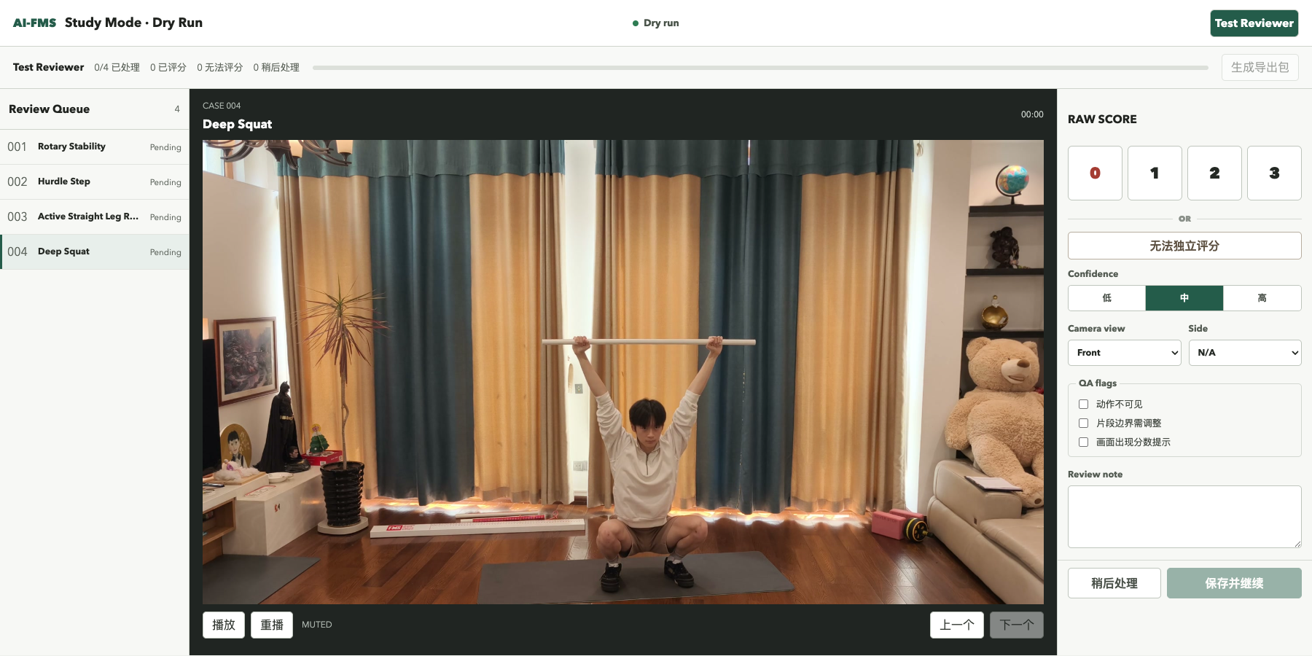
Figure 1 | [AUTHOR TO WRITE: a single-line description of Study Mode and the information hidden from blind reviewers]
Locked AI comparison
[AUTHOR TEXT REQUIRED - describe label-free inputs, isolation from reviewers, coverage and abstention, score comparison metrics, and why the final comparison is an internal benchmark rather than held-out validation]
Secondary quantitative analyses
[AUTHOR TEXT REQUIRED - describe the four movement-specific analysis units and methods without forcing one shared pairwise template]
Ethics, privacy, and data governance
[AUTHOR TEXT REQUIRED - state the secondary-video design, lack of prospective research recruitment, private data boundaries, separate consented demonstration footage, and the pending journal/SRC/IRB determination]

Results
Seven-movement system implementation
[AUTHOR TEXT REQUIRED - report implemented functions and the engineering quality gate objectively; do not equate software tests with scientific validity]
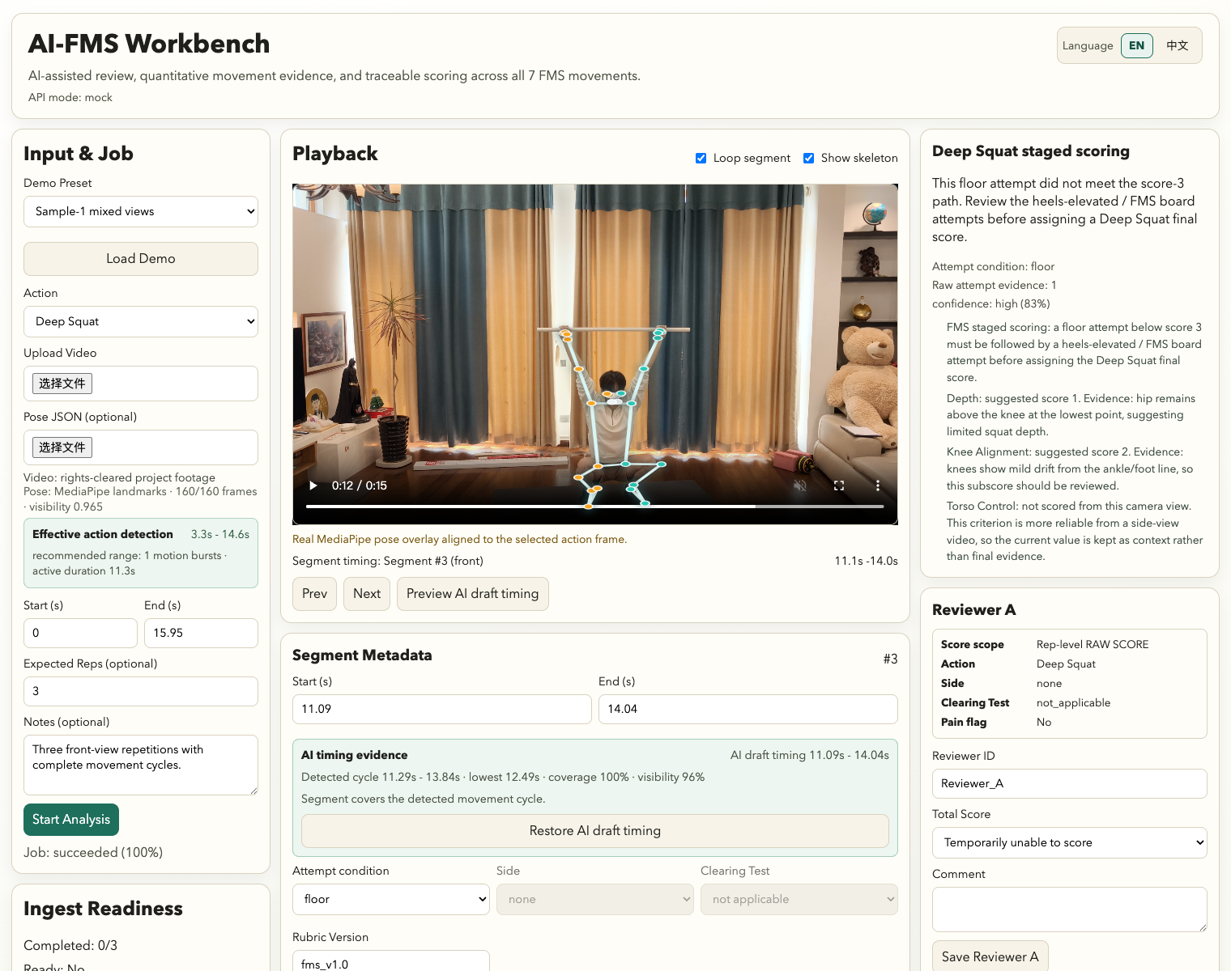
Figure 2 | [AUTHOR TO WRITE: a single-line description of the Workbench, aligned pose evidence, reviewer controls, and privacy-safe demonstration frame]
Phase I data quality and review outcomes
[AUTHOR TEXT REQUIRED - report canonical, blindable, feature-ready, and formal counts, followed by Round A and Round B human results and the final AI-human comparison]
Table 4 | [AUTHOR TO WRITE: a one-line description of human agreement and AI-human internal concordance]
Analysis | Coverage / comparable | Exact | Within one | MAE | Linear weighted kappa
Human Round A | 31/32 status; 26 scored | 26/26 | N/A | 0.0000 | 1.0000
Human Round B | 32/32 status; 26 scored | 26/26 | N/A | 0.0000 | 1.0000
Final AI vs Round B | 28/32 score coverage; 25 comparable | 16/25 | 23/25 | 0.4400 | 0.4917
Deep Squat: continuous movement strategy
[AUTHOR TEXT REQUIRED - report the 15 audited side-view reps from seven videos and describe the observed depth/hip/knee continuum without assigning a diagnosis]
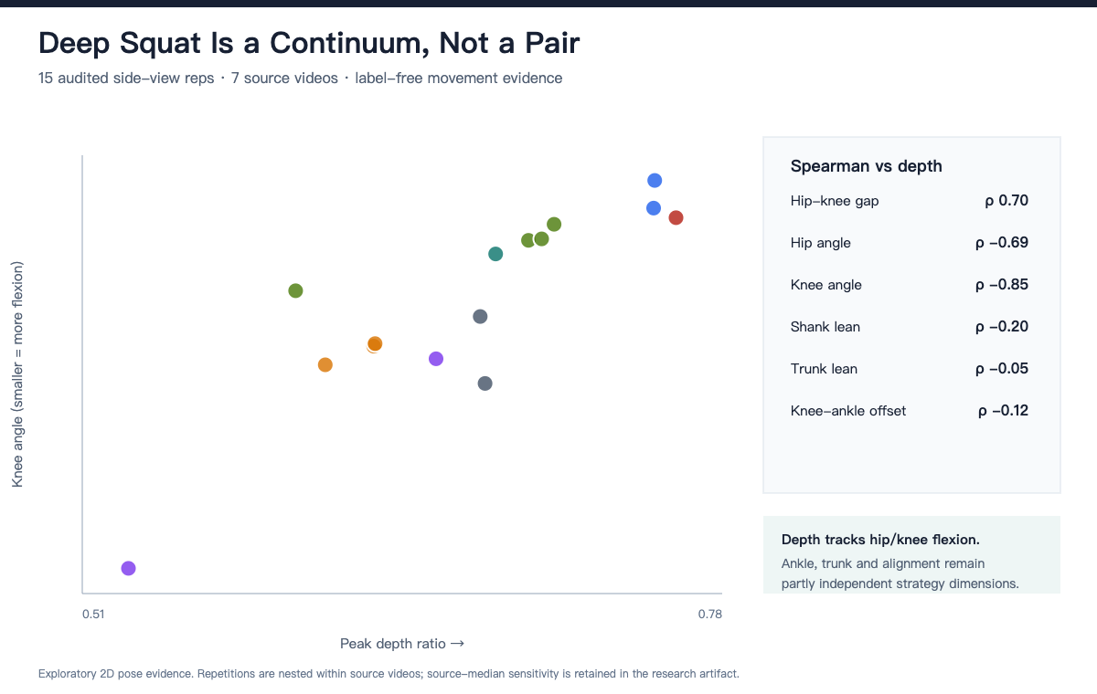
Figure 3 | [AUTHOR TO WRITE: a single-line description of the Deep Squat depth and joint-strategy continuum]
ASLR: bilateral repeatability and side control
[AUTHOR TEXT REQUIRED - report the four-rep same-source sequence, identify stable and variable features, and state the one-source and weak-label limitations]
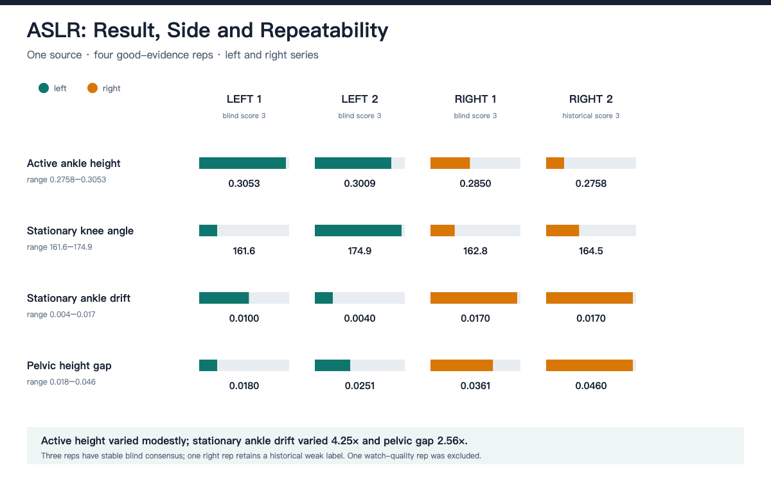
Figure 4 | [AUTHOR TO WRITE: a single-line description of the ASLR bilateral repeatability sequence]
Hurdle Step: multiple score-2 pathways
[AUTHOR TEXT REQUIRED - report five reps from five videos and distinguish the observed pathway coding from causal or diagnostic classification]
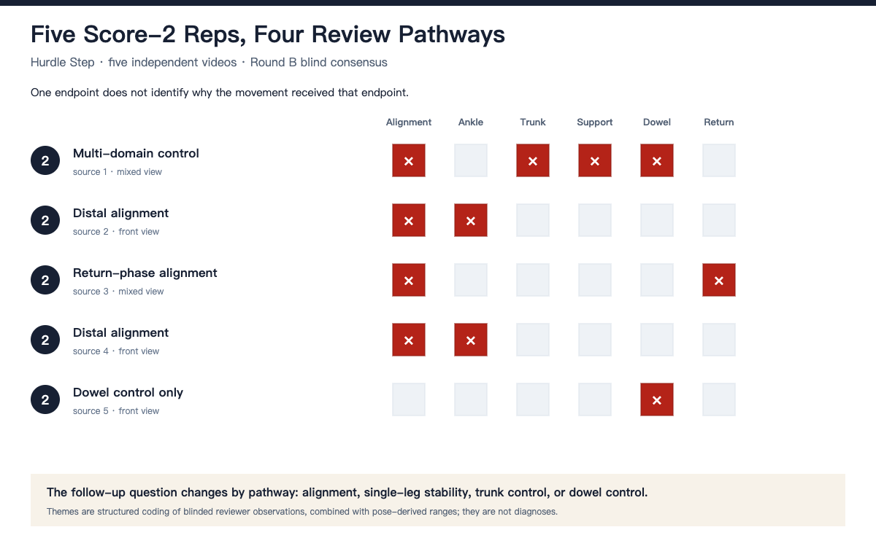
Figure 5 | [AUTHOR TO WRITE: a single-line description of the five score-2 Hurdle Step pathways]
Rotary Stability: full-cycle event evidence
[AUTHOR TEXT REQUIRED - report the eight formal reps and explain why sequence, touch, extension, return, and balance require full-cycle evidence rather than one peak frame]
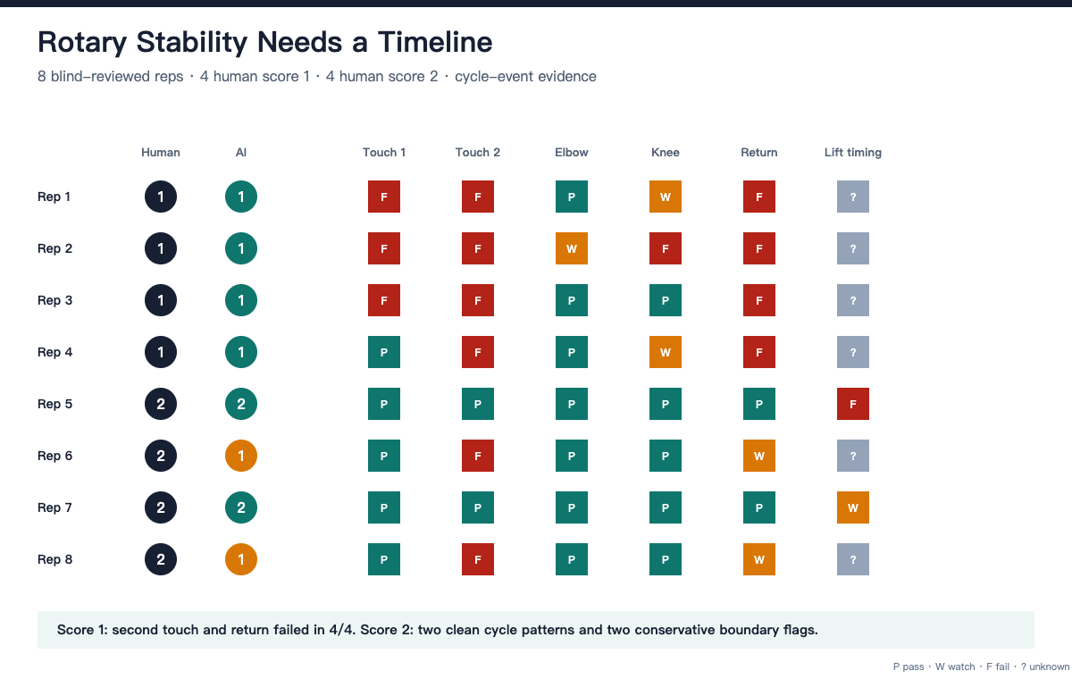
Figure 6 | [AUTHOR TO WRITE: a single-line description of the Rotary Stability cycle-event matrix]

Discussion
Principal contribution
[AUTHOR TEXT REQUIRED - interpret the seven-movement human-in-the-loop system as the main contribution and the four-movement study as bounded internal evidence]
Human reliability and AI concordance
[AUTHOR TEXT REQUIRED - interpret the selected-sample human agreement and moderate AI-human concordance without generalizing to clinical reliability or held-out performance]
Information retained beyond ordinal scores
[AUTHOR TEXT REQUIRED - connect the four differentiated analyses to continuous movement profiles and clearly label functional interpretations as hypotheses]
Limitations
[AUTHOR TEXT REQUIRED - cover selected sample, two reviewers, nested reps, mixed views, 2D projection, iterative development data, non-held-out AI comparison, and absence of clinical outcomes]
Future work
[AUTHOR TEXT REQUIRED - propose targeted held-out collection, stronger protocol controls, additional independent reviewers, and external evaluation without reopening Phase I tuning]
Data and code availability
[AUTHOR TEXT REQUIRED - state what may be released publicly and what remains private; do not promise a release that has not occurred]
AI use, funding, and conflicts
[AUTHOR TEXT REQUIRED - write the complete human-approved disclosure of MediaPipe and Codex use, funding, and conflicts; remove identifying details from the blind version if required]
References
[AUTHOR CHECK REQUIRED - open and read every source; keep only references actually cited; reorder by first appearance.]
1. G. Cook, L. Burton, B. Hoogenboom. Pre-participation screening: the use of fundamental movements as an assessment of function - part 1. North American Journal of Sports Physical Therapy. Vol. 1, pg. 62-72, 2006, https://pubmed.ncbi.nlm.nih.gov/21522216/.
2. G. Cook, L. Burton, B. Hoogenboom. Pre-participation screening: the use of fundamental movements as an assessment of function - part 2. North American Journal of Sports Physical Therapy. Vol. 1, pg. 132-139, 2006, https://pubmed.ncbi.nlm.nih.gov/21522225/.
3. J. W. Cuchna, M. C. Hoch, J. M. Hoch. The interrater and intrarater reliability of the Functional Movement Screen: a systematic review with meta-analysis. Physical Therapy in Sport. Vol. 19, pg. 57-65, 2016, https://doi.org/10.1016/j.ptsp.2015.12.002.
4. N. A. Bonazza, D. Smuin, C. A. Onks, M. L. Silvis, A. Dhawan. Reliability, validity, and injury predictive value of the Functional Movement Screen: a systematic review and meta-analysis. American Journal of Sports Medicine. Vol. 45, pg. 725-732, 2017, https://doi.org/10.1177/0363546516641937.
5. R. Morgan, S. LeMire, L. Knoll, E. Schuster, C. Tietz, A. Weisz, G. Schindler. The Functional Movement Screen: exploring interrater reliability between raters in the updated version. International Journal of Sports Physical Therapy. Vol. 18, pg. 737-745, 2023, https://doi.org/10.26603/001c.74724.
6. V. Bazarevsky, I. Grishchenko, K. Raveendran, T. Zhu, F. Zhang, M. Grundmann. BlazePose: on-device real-time body pose tracking. arXiv, 2020, https://doi.org/10.48550/arXiv.2006.10204.
7. S. L. Colyer, M. Evans, D. P. Cosker, A. I. T. Salo. A review of the evolution of vision-based motion analysis and the integration of advanced computer vision methods towards developing a markerless system. Sports Medicine - Open. Vol. 4, pg. 24, 2018, https://doi.org/10.1186/s40798-018-0139-y.
8. L. Kidzinski, B. Yang, J. L. Hicks, A. Rajagopal, S. L. Delp, M. H. Schwartz. Deep neural networks enable quantitative movement analysis using single-camera videos. Nature Communications. Vol. 11, pg. 4054, 2020, https://doi.org/10.1038/s41467-020-17807-z.
9. L. Wade, L. Needham, P. McGuigan, J. Bilzon. Applications and limitations of current markerless motion capture methods for clinical gait biomechanics. PeerJ. Vol. 10, pg. e12995, 2022, https://doi.org/10.7717/peerj.12995.
10. D. Pagnon, H. Kim. Sports2D: compute 2D human pose and angles from a video or a webcam. Journal of Open Source Software. Vol. 9, pg. 6849, 2024, https://doi.org/10.21105/joss.06849.
11. J. Cohen. Weighted kappa: nominal scale agreement with provision for scaled disagreement or partial credit. Psychological Bulletin. Vol. 70, pg. 213-220, 1968, https://doi.org/10.1037/h0026256.
12. S. Amershi, D. Weld, M. Vorvoreanu, A. Fourney, B. Nushi, P. Collisson, J. Suh, S. Iqbal, P. N. Bennett, K. Inkpen, J. Teevan, R. Kikin-Gil, E. Horvitz. Guidelines for human-AI interaction. Proceedings of the 2019 CHI Conference on Human Factors in Computing Systems. pg. 1-13, 2019, https://doi.org/10.1145/3290605.3300233.

