Survey Meter Readings due to Na-24 Activation in Criticality Accident
Stable Na-23 is activated by neutron exposure in a criticality accident to Na-24 (T_{1/2} of 15 h) which emits 1.37 and 2.75 MeV gamma rays. The response of a probe against the abdomen with the subject bent over can be used to obtain an estimate of the neutron dose as indicated below.
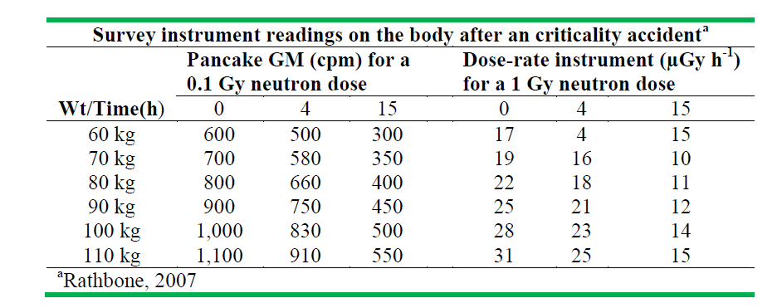
BA Rathbone 2007. Hanford External Dosimetry Technical Basis Manual, PNL-MA-842 (Pacific Northwest National Laboratory, Richland, WA)

