Threshold for Deterministic Effects

Examples of deterministic effects are erythema (injury of blood capillaries) and other skin damage such as skin burns; suppression of ovulation or sperm production; hair loss; bone marrow failure; damage to intestinal cells; lung fibrosis; and cataracts. With the exception of cataracts, deterministic effects are caused by cell killing. Most deterministic effects occur within hours, days, or weeks after the dose is received. Relatively high doses of radiation received in a short period of time (acute exposure) acts in this manner. If tissue damage is widespread throughout the body, radiation sickness may occur followed by death.

At absorbed doses above about 0.5–1 Gy, associated mainly with accident situations, deterministic effects may occur. In the table below D₀ denotes the threshold absorbed dose for the effect and D₅₀ represents the dose at which 50% of exposed persons are expected to show the effect.

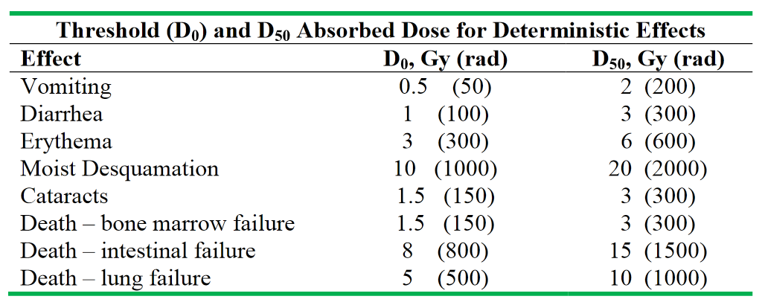

Table based on NUREG/CR-4214 and Scott (Radiation Protection Management 21:9-25; 2004).

