Relative Biological Effectiveness (RBE)

Alpha particles, a high LET radiation, deposit their energy in a very dense manner over their short path length in traversing tissue (LET denoted linear energy transfer). Because of resultant high density of ionizations these radiation are more biologically damaging than beta and gamma radiations, low LET radiations. Radiation protection weights the absorbed dose by radiation weighting factors (earlier referred to as quality factors) to place low and high LET radiation on the common scale of equivalent dose used to limit the occurrence of stochastic effects. Experience has indicated that the radiation weighting factors are generally too high to be used as relative biological effectiveness (RBE) factors for the various deterministic effects. Tabulated below are the RBE values for alpha particles. All other radiations are assigned an RBE of 1 (See IAEA-TECDOC-1432, 2005).

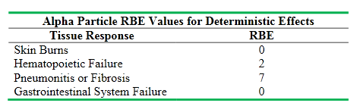

Alpha particles are assigned an RBE value of zero for the skin and gastrointestinal tract as they are unable to penetrate the dead layer of the skin and the mucous lining of the gastrointestinal tract, respectively.

