Radiation Skin Injury
High levels of radiation exposure can damage the basal cells of the skin and lead to blistering (wet desquamation), peeling (dry desquamation), reddening (erythema), and loss of hair (epilation). It is important to note that one can have a high skin dose with little corresponding dose to the deeper lining organs and tissues. Tabulated below are the stages and symptoms of radiation skin injury based on Gusev et al (2001) and IAEA (1998).
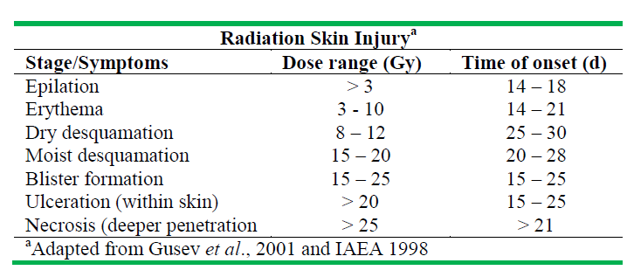
References:
Gusev IA, AK Guskova, FA Mettler, Jr. Eds 2001. Medical Management of Radiation Accidents, 2nd ed (CRC Press Boca Raton).
IAEA 1998. Diagnosis and Treatment of Radiation Injuries, Safety Report Series No 2 (IAEA Vienna).

