Natural Background Radiation
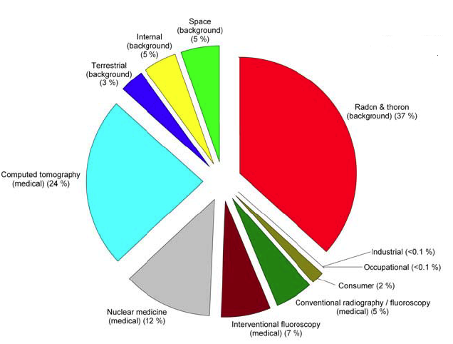
NCRP 2009. Ionizing Radiation Exposure of the Population of the United States, National Council on Radiation Protection and Measurements, 7910 Woodmont Avenue, Suite 400, Bethesda, MD.
Per capita annual effective dose in the U.S.
 | Annual Effective Dose
Exposure Category | (mSv) | (mrem)
Ubiquitous background
Radon and thoron | 2.28 | 228
Space radiation | 0.33 | 33
Internal | 0.29 | 29
Terrestrial | 0.21 | 21
Medical
Computed tomography | 1.47 | 147
Nuclear medicine | 0.77 | 77
Interventional fluoroscopy | 0.43 | 43
Conventional radiography/fluoroscopy | 0.33 | 33
Consumer Products | 0.13 | 13
Industrial | 0.003 | 0.3
Occupational | 0.005 | 0.5
Total | 6.2 | 620

