**MY Application Presentation**

The application has two classes and main file to run the whole project

Classes are Student and StudentDA

**Student**

The student class is responsible for the student management and to do all the validations.

**StudentDA**

The DA stands for Direct Access, the studentDA is responsible for adding, editing, searching and deleting students

**Run**

Run is the main file responsible for running the whole application calling the class methods

**1.Add Student**

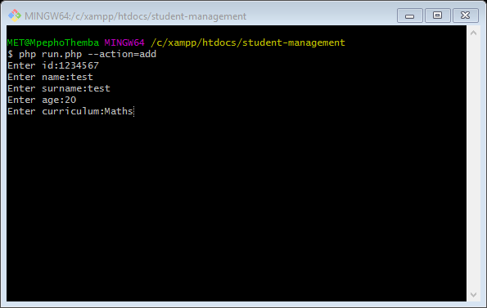

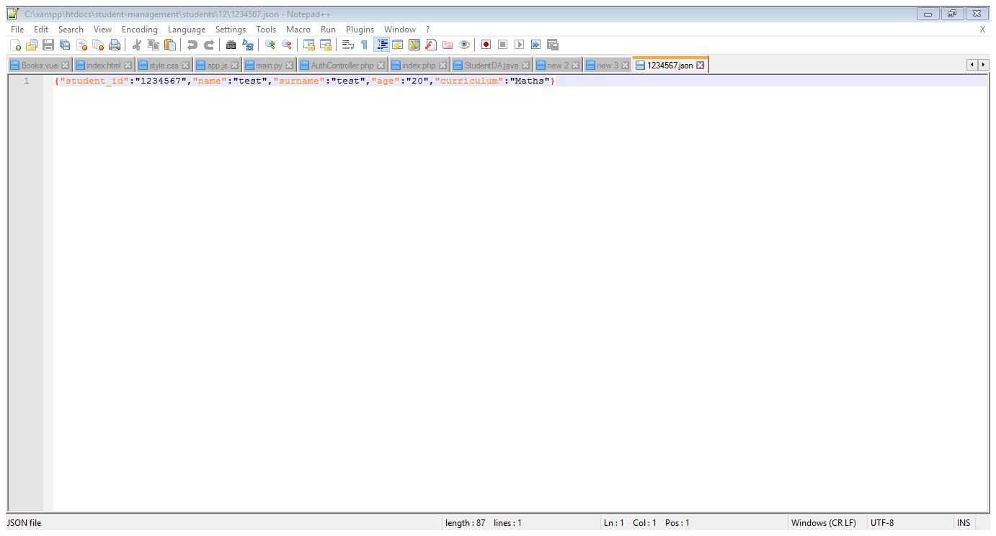

**2.Edit**

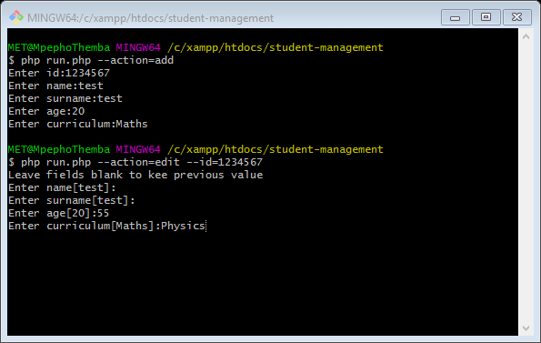

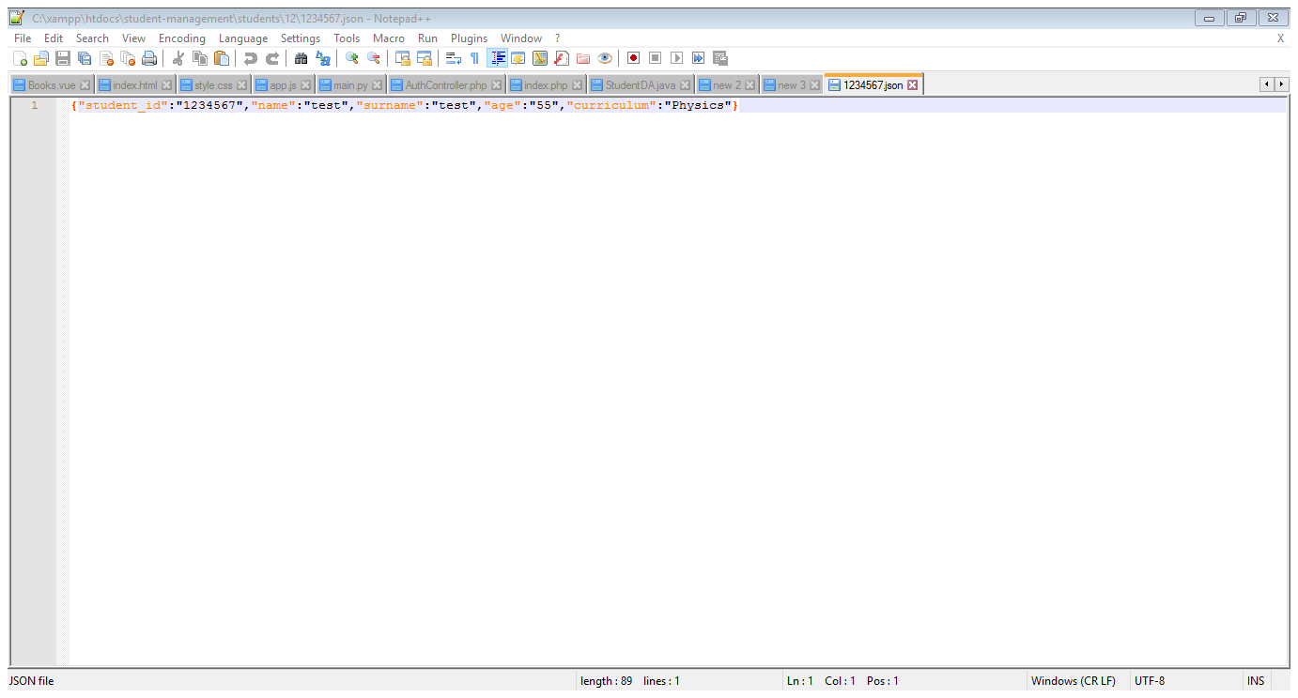

**3 Search**

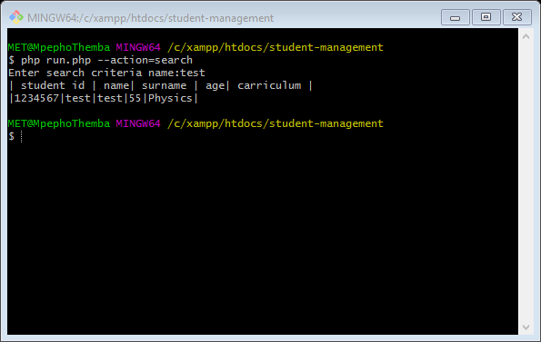

**4. Delete**

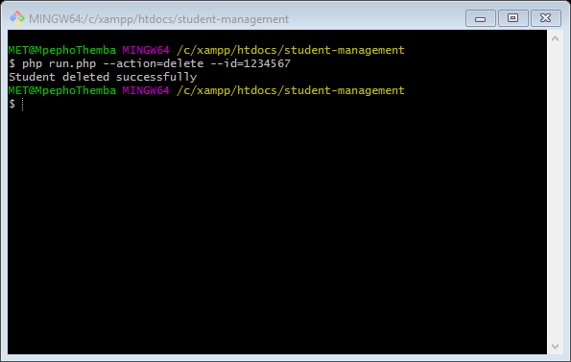

**Overall application**

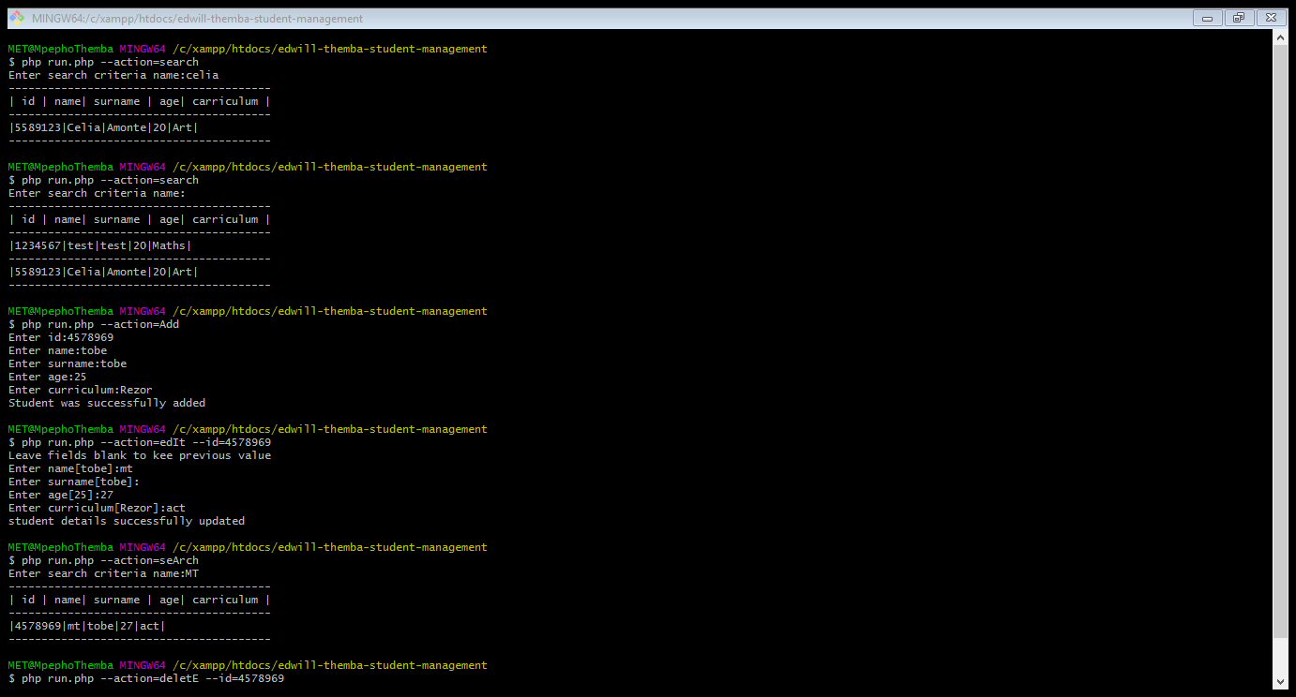

Nb: my application is case insensitive.