How to Make Money Each March by Betting on College Basketball
2026 Brandeis Datathon | Team ASA: Anokh Palakurthi, Samiya Islam, Aastha Chavan
MS Business Analytics ’26 | Brandeis International Business School

Data & Approach
Each March, roughly 70 million Americans fill out a bracket predicting college basketball playoff matches, and most of them lose money in the process by making wrong predictions. To discover if there were any potential edges to be found in sports betting for March Madness, we built a dataset of 1,144 NCAA tournament games across multiple seasons (2008–2025, with 2020 excluded due to the tournament being cancelled) and trained three ML models (regularized XGBoost, Random Forest, and a neural network) to predict matches and champions. We tested our approaches against four single-metric baselines: chalk (always picking highest seed), TR RATING, KADJ EM, and BARTHAG, also tracking performance against Las Vegas closing lines and pre-tourney championship odds.

Q1: Which seeds do well or poorly? Who overperforms?

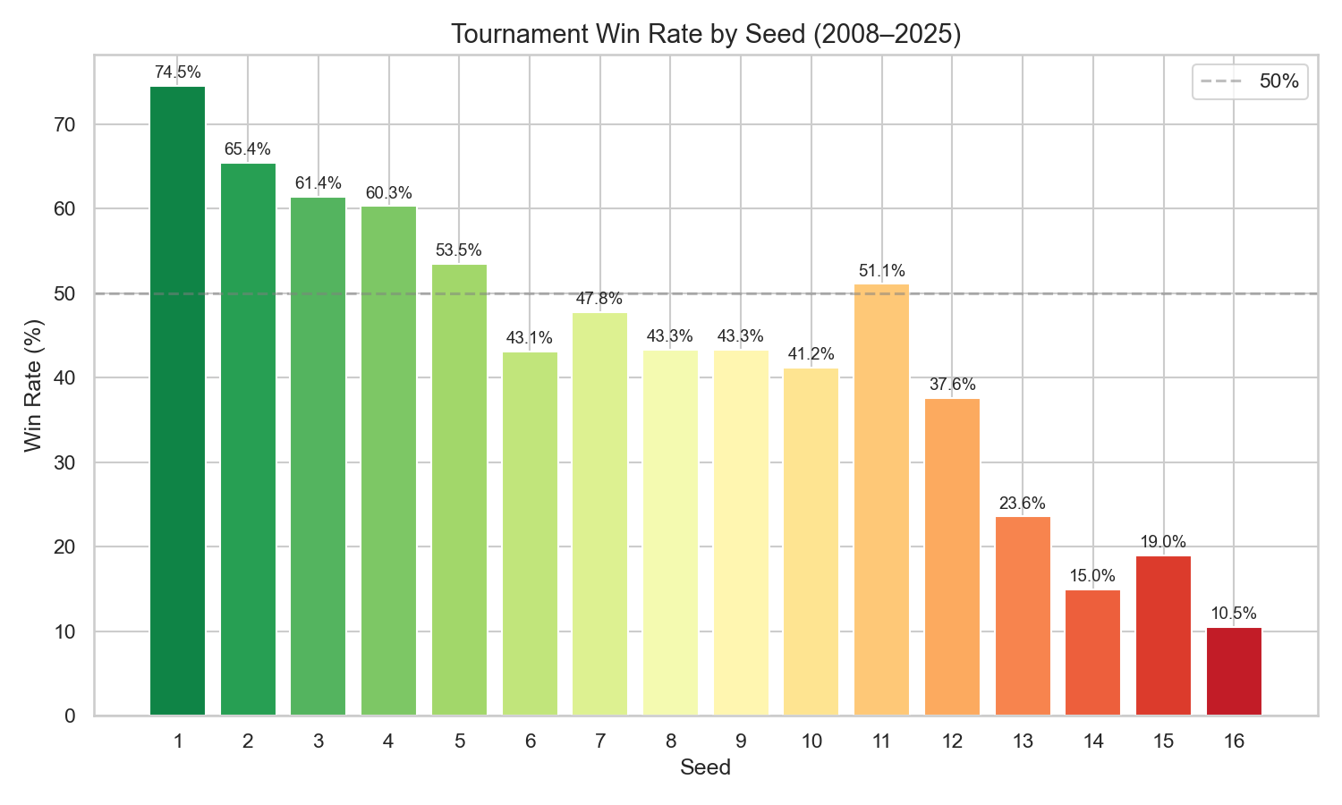
1-seeds win 74.5% of tournament games, but 11-seeds (51.1%) outperform 6, 8, 9, and 10-seeds, showcasing the committee systematically under-seeding teams at the 11-line. Top historical overperformers include 2014 UConn (7-seed, 1st place), 2011 Butler (8-seed, 2nd place), 2014 Kentucky (8-seed, 2nd place), 2022 UNC (8-seed, 2nd place), and 2023 UConn (4-seed, 1st place).

Q2: What attributes predict tournament success?
Schedule-adjusted efficiency composites dominate, as shown by BADJ EM (r=0.363), TR RATING (r=0.357), KADJ EM (r=0.353), WAB (r=0.349). Raw shooting stats (3PT%, FT%, AST%) have near-zero predictive power, which only goes up about 10% when normalized for league-wide single season standards. The mechanism behind upsets is efficiency mispricing; median KADJ EM gap in upsets is 3.73 vs 8.24 in non-upsets. All predictive models converge on 67–72% accuracy, with Random Forest leading at 71.2%. Vegas closing lines finish 7th out of 8 methods at 69.9%. However, when models disagree with Vegas, betting the model’s pick at underdog money line odds with simulated $100 bets remains profitable, showcasing that there’s still edges to be found in betting against Vegas.
Method | Bets | Wins | Win % | Profit | ROI
Random Forest | 32 | 18 | 56.2% | +$955 | +29.8%
TR RATING | 18 | 11 | 61.1% | +$650 | +36.1%
XGBoost (regularized) | 34 | 17 | 50.0% | +$570 | +16.8%
Neural Net | 41 | 16 | 39.0% | –$220 | –5.4%
At the same time, the market wins on champion prediction. The pre-tournament favorite has won 7/17 tournaments (41.2%), netting $1,815 in profit on $1,700 in simulated $100 bets. Conversely, two of our ML models went 0/5 (RF, XGBoost) with only the Neural Net correctly picking UConn in 2024 when tested on 2021-2025 data. This illustrates how the market is optimized for picking champions, which is where the most high-consequence betting occurs. ML models are not necessarily a free money machine.

Q3: 2026 Final Four and Champion Prediction
 | Duke | Arizona | Michigan | Florida | Houston | Purdue | Iowa St.
Final Four | 7/7 | 6/7 | 6/7 | 4/7 | 3/7 | 1/7 | 1/7
Champion | 3/7 | 0/7 | 3/7 | 0/7 | 0/7 | 0/7 | 1/7

While RF and XGBoost models selected Michigan and NN picked Iowa St. as champions, market favorites win 41% of the time profitably (at $1,815 net profit on simulated pre-tournament bets each season), and Duke enters as a leading favorite at +325. For a one-shot prediction, we defer to market efficiency over ML model consensus, picking Duke.
Limitations:
No method predicted the right champion more than once in five years. In 2023, every method got 0/4 Final Four teams. Our models also can’t account for injuries, coaching adjustments, or single-elimination psychology. The betting ROI uses small samples (18–41 bets) with wide confidence intervals, further showcasing the inherent volatility of picking March Madness matches.

For games without listed odds (~3% of them), they were excluded from betting analysis.
These predictions were made before the March Madness; ergo they do not account for Florida’s surprise loss in the Sweet 16, though all three ML models predicted Houston wins that division.

