EJ Cervantes

Mikey G

21FEB19

CSCI335

1.

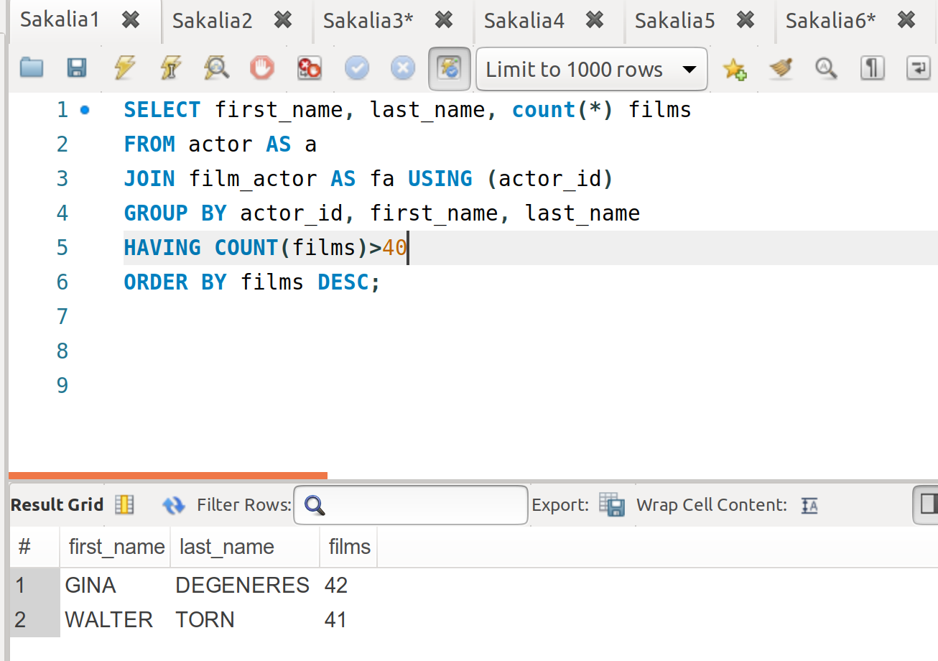

2.

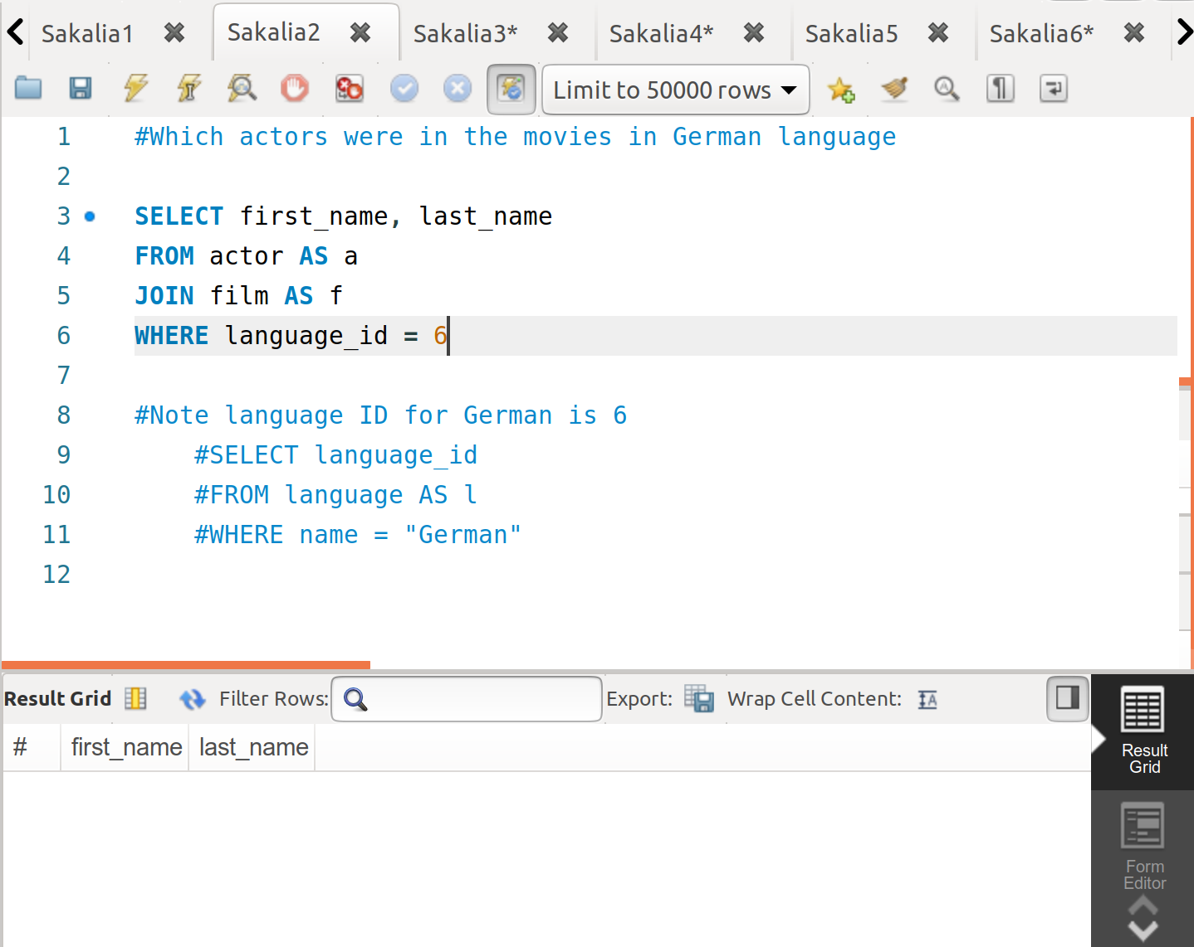

3.

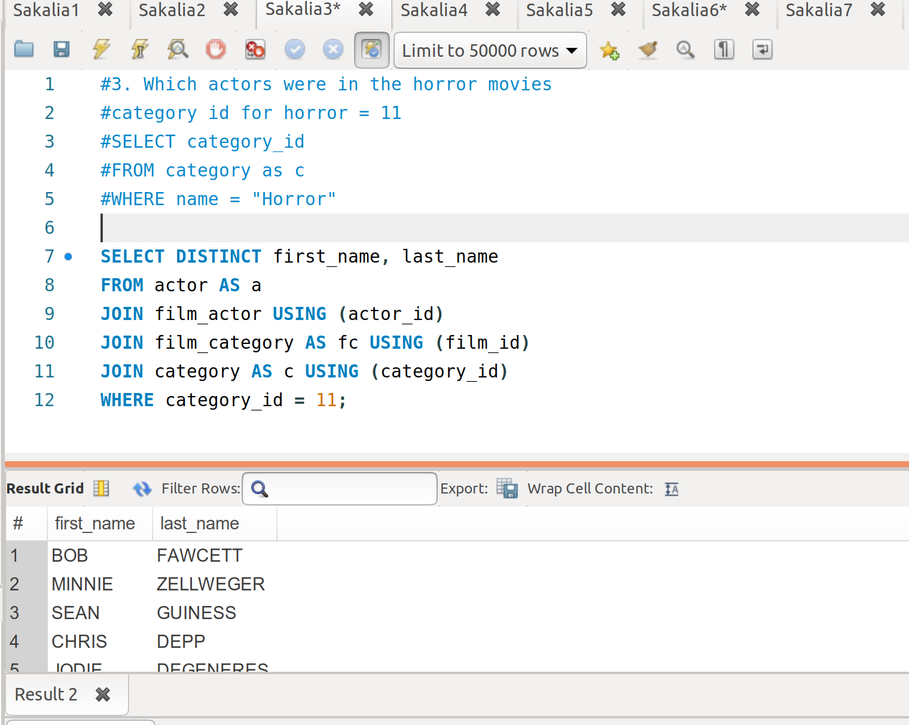

4.

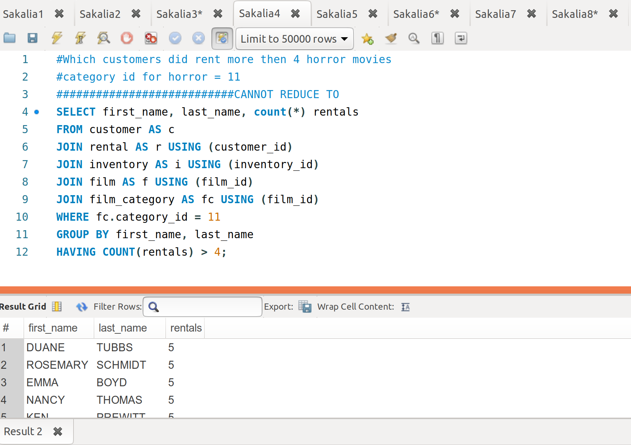

5.

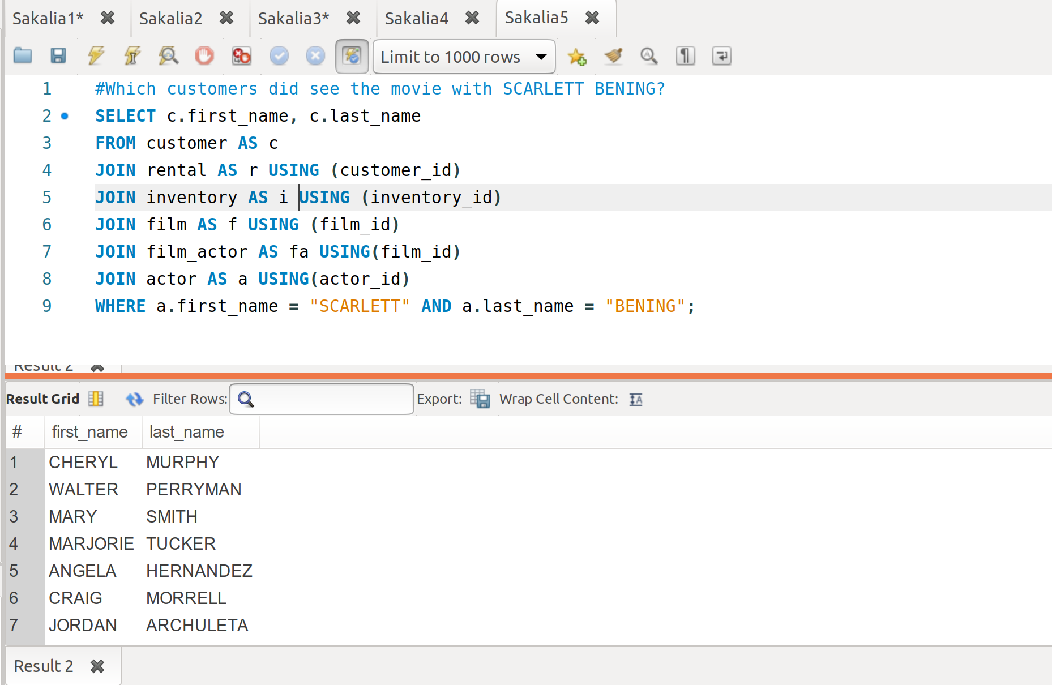

6.

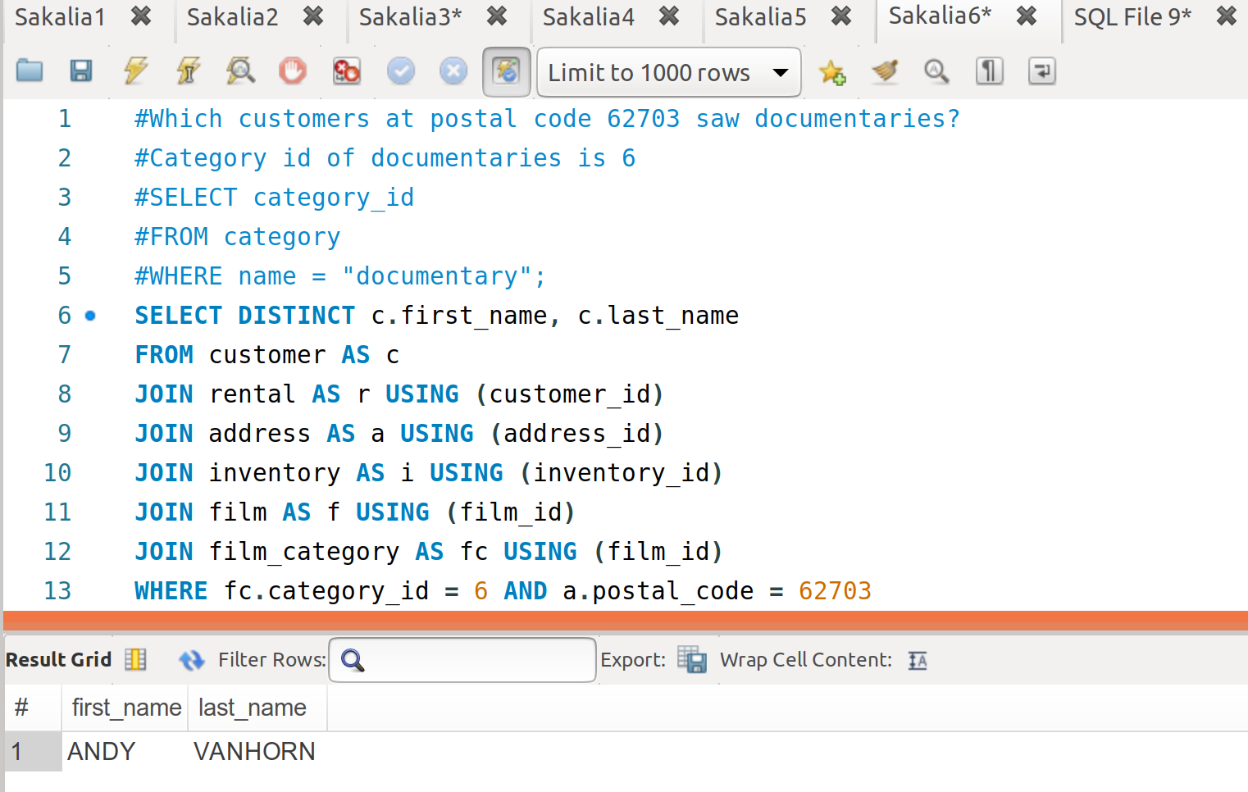

7.

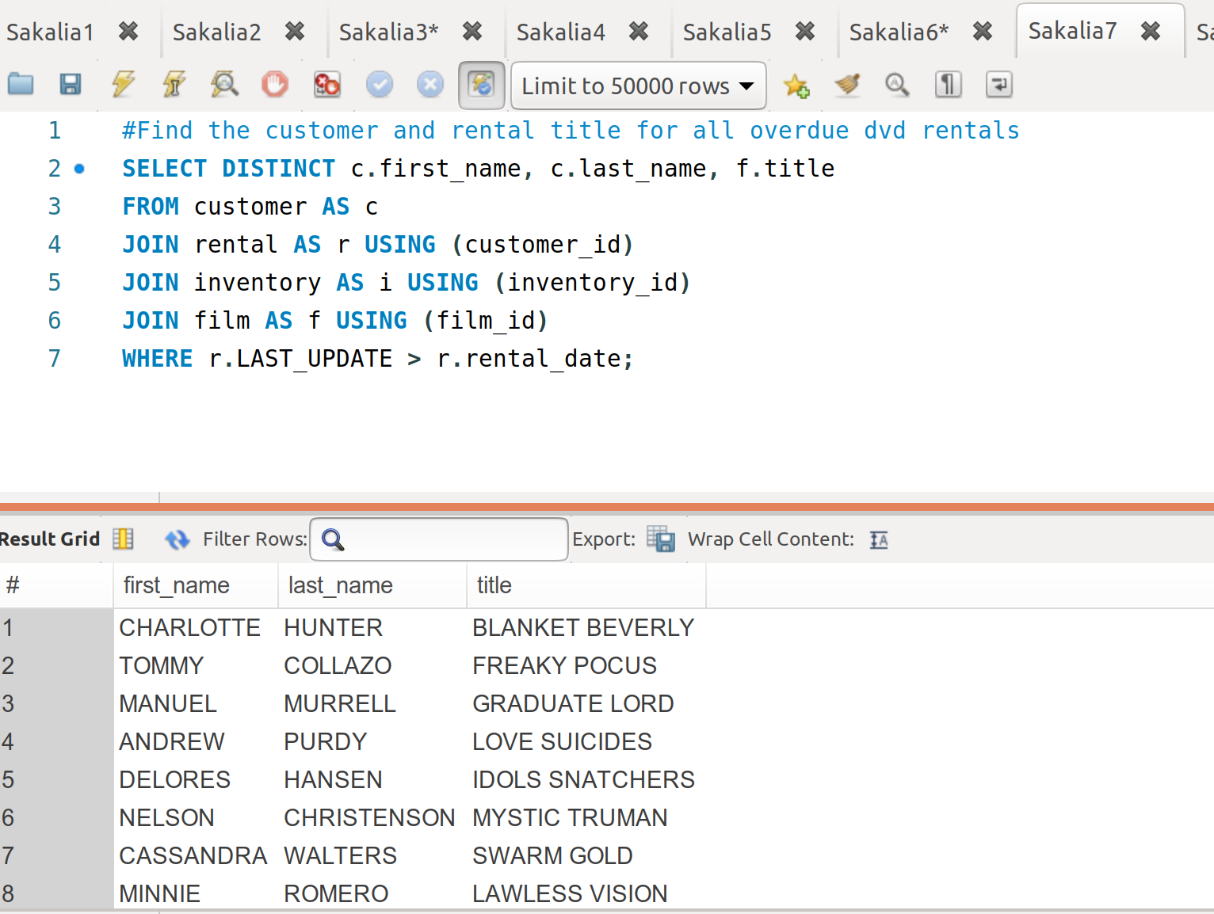

8.

I couldn’t figure this out but I’m pretty sure you need to do an intersection over horror movies and their film_id to get all horror movies. Then intersect this again with the customers who have rented the intersection.