EJ Cervantes
Mikey G
21FEB19
CSCI335

1.
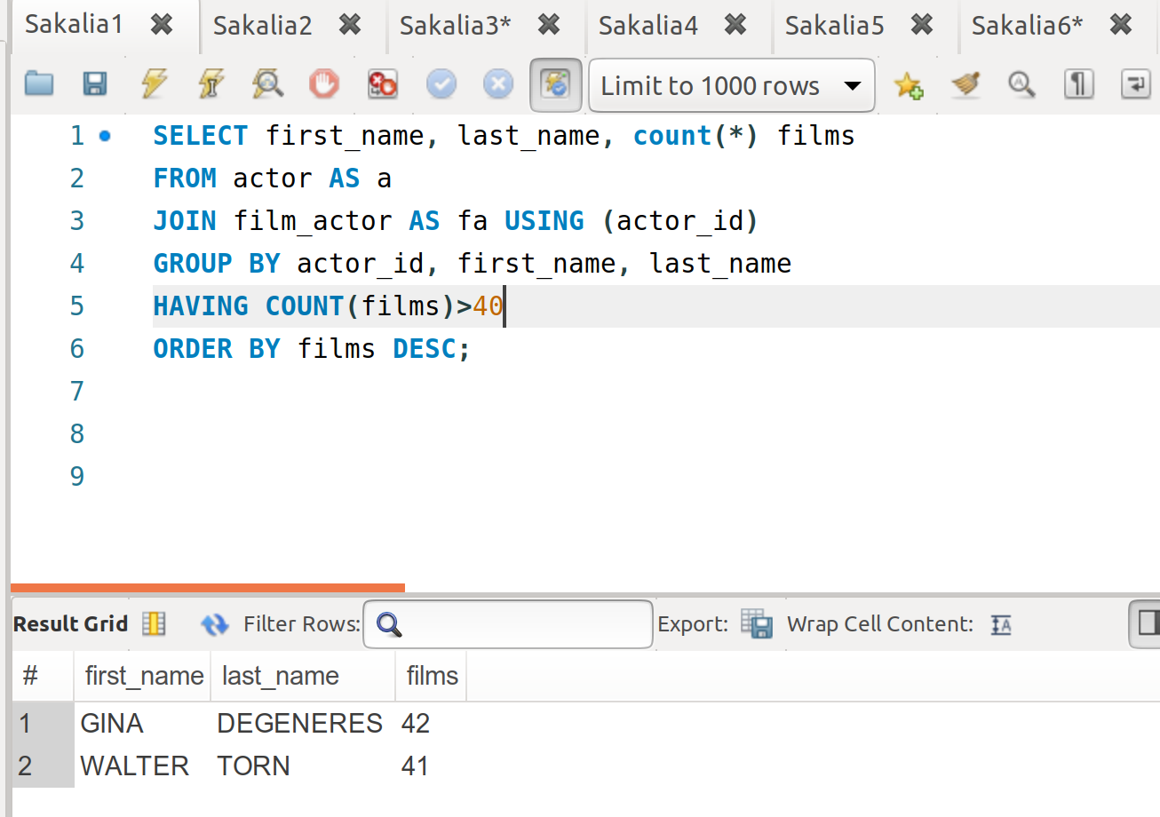

2.
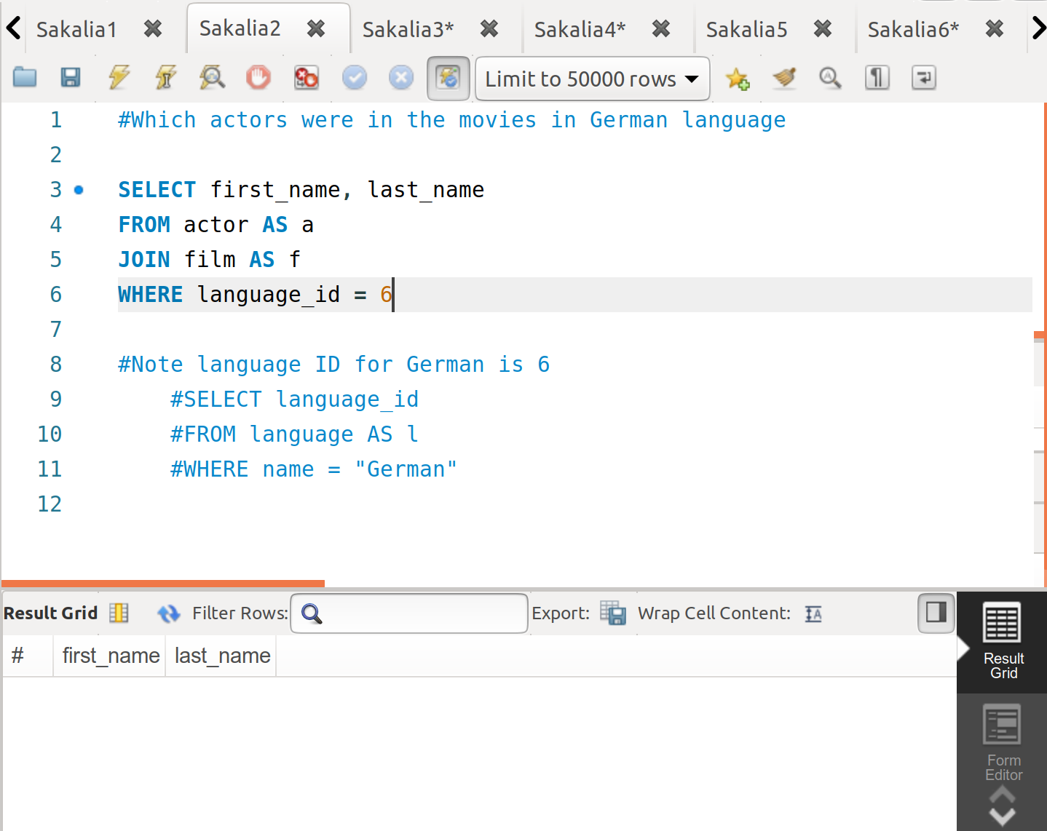

3.
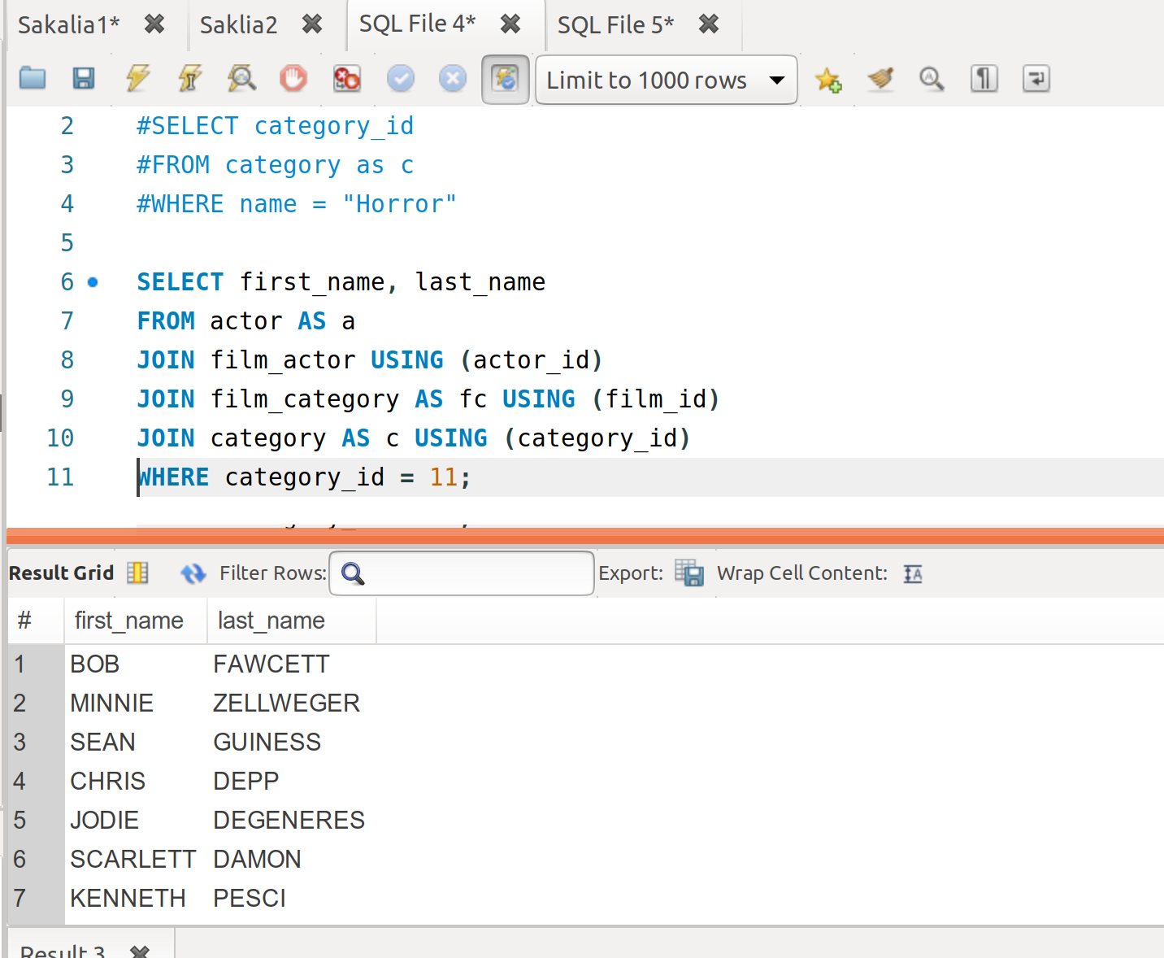

4.
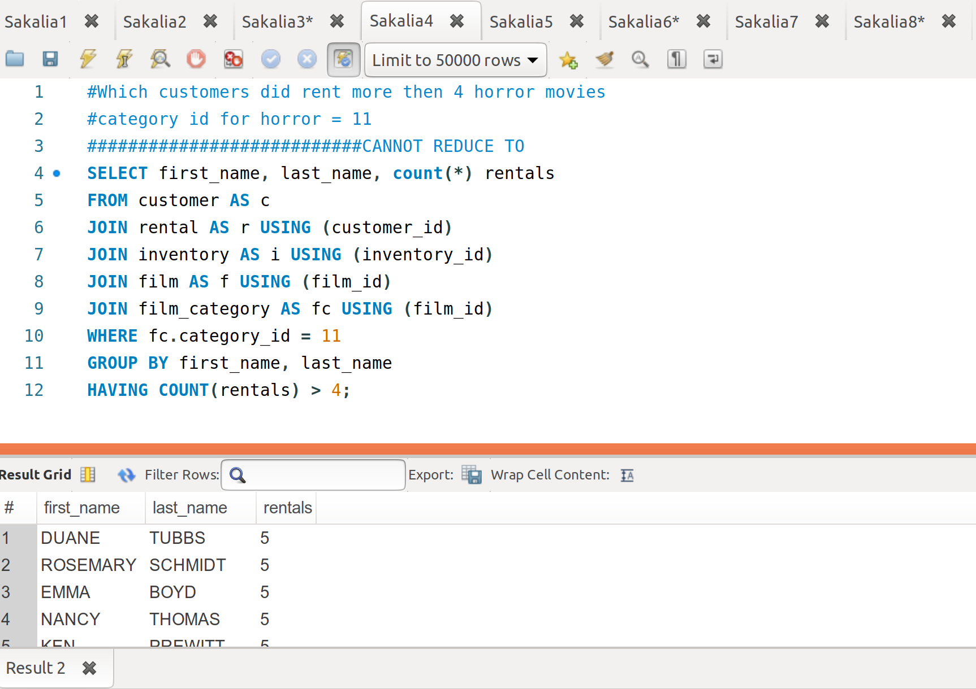

5.
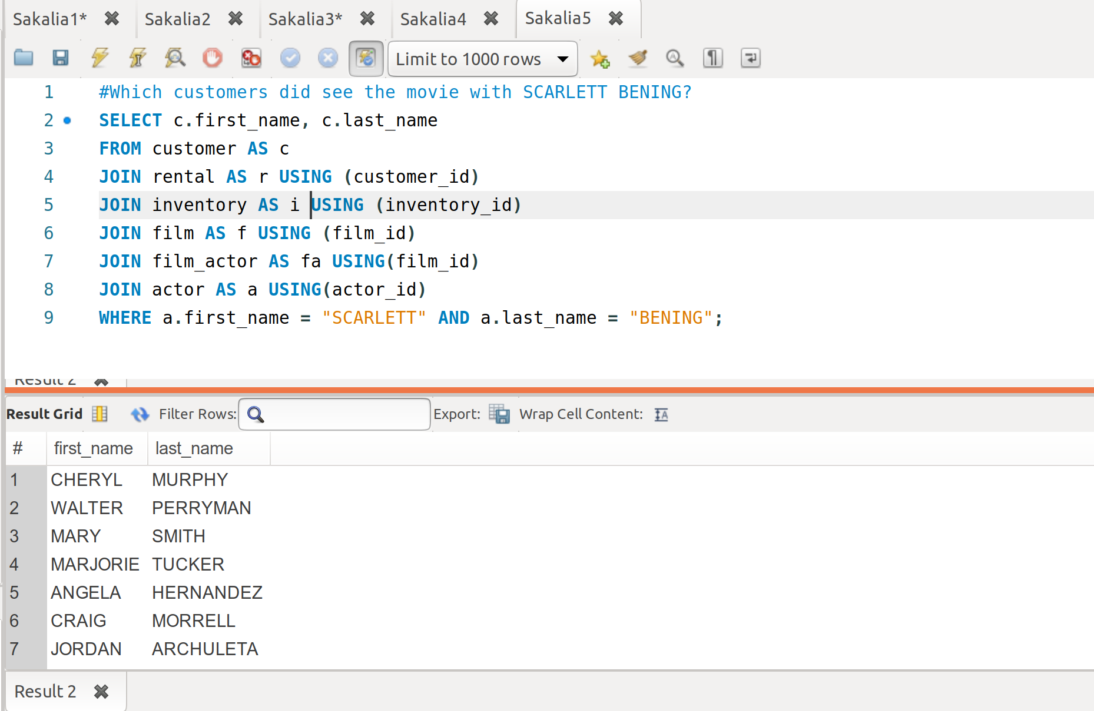

6.
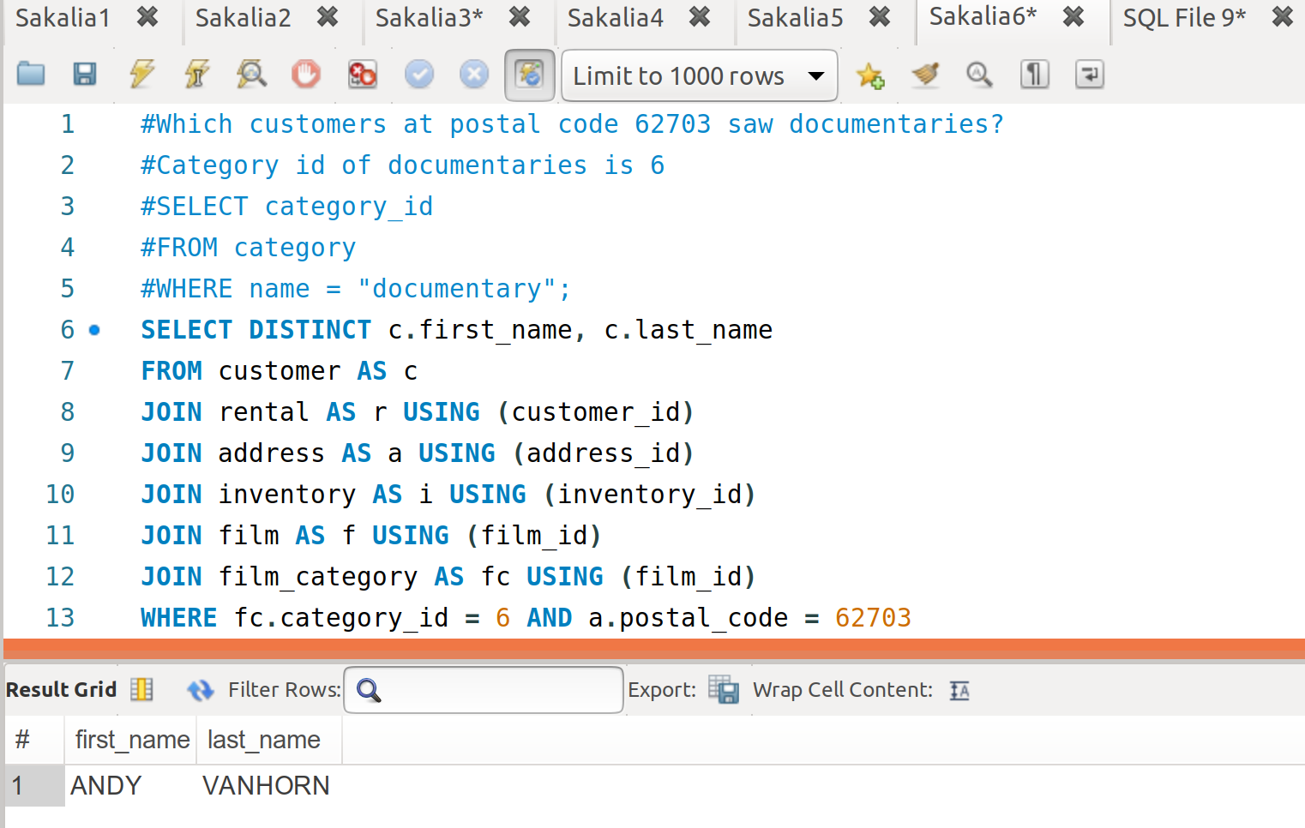

7.
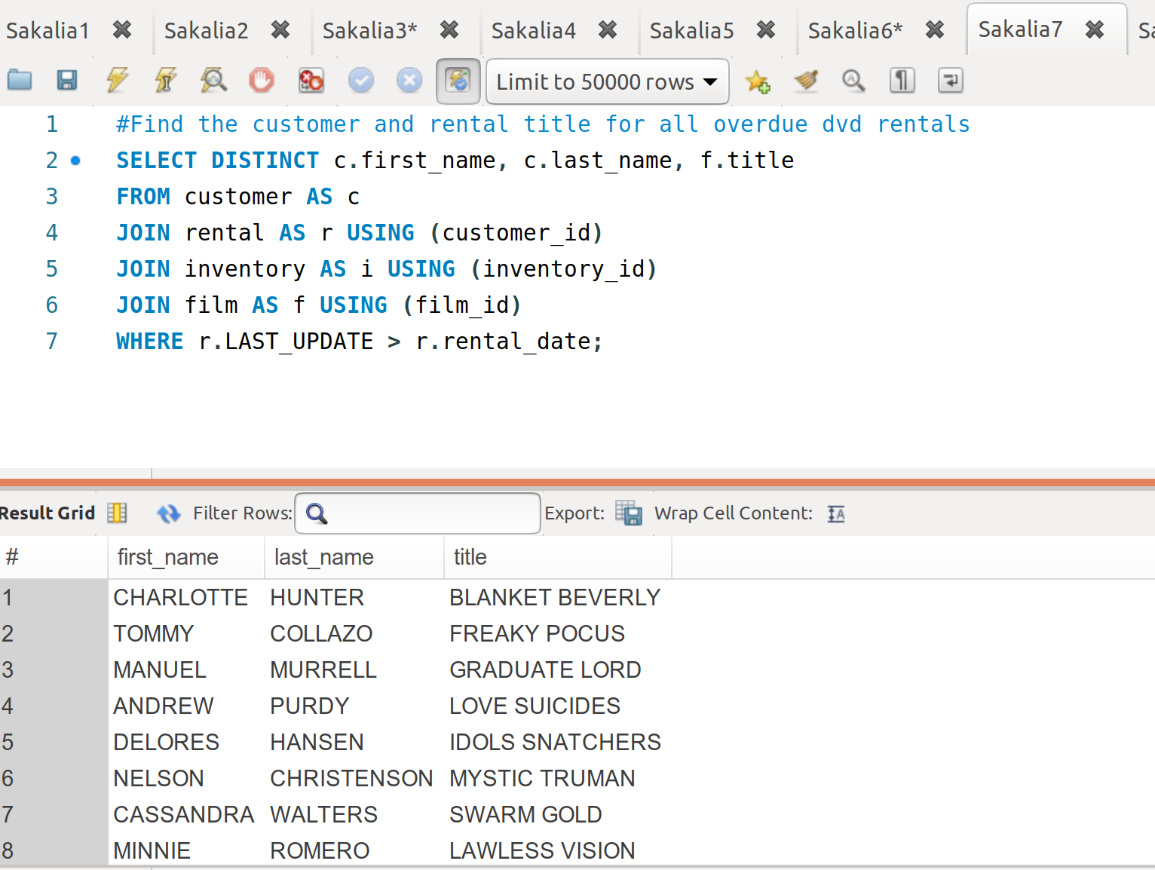

8.
I couldn’t figure this out but I’m pretty sure you need to do an intersection over horror movies and their film_id to get all horror movies. Then intersect this again with the customers who have rented the intersection.

