Lab Assignment 2: A simple application program

Question 1
The x- and y-coordinates of two points in a plane: (x1, y1) and (x2, y2) are given by the user. Develop a program that computes and prints the distance between these two points using the formula:
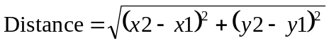

Question 2
Write a program that computes the length of the opposite and adjacent sides of a right triangle. User will input the length of the hypotenuse and an angle (in degrees).

Hypotenuse
Opposite side
Adjacent side
θ
Question 3
Write a program that calculates the squares and cubes of the numbers from 1 to 5 and uses tabs to display the following output:

Number Square Cube
1 1 1
2 4 8
3 9 27
4 16 64
5 25 125

