*****************Clip from master thesis****************

Single molecule selection and time trace analysis

For each measurement, the photoswitchable fluorophores originally stayed in the bright state without light illumination. After being illuminated, the fluorophores would switch to the dark state and recover to the bright state multiple times stochastically. For each recorded movie, to choose single molecules, the frame stack of the movie was scanned randomly. In each scanned frame, a bright spot which contains a pixel that has an intensity (counts/pixel) lying within a specific range was regarded as the image of a single fluorophore, and was circled by a 5×5 pixel region. The intensity ranges were different for different dyes or under different illumination conditions. All these selected spots should be relatively round, and should have a FWHM within 3 pixels. After that, each selected spot was further checked by sliding the movie forward and backward. For each spot being checked, if at least two switch-on:switch-off events were observed, the center of that spot didn’t drift more than one pixel over the whole movie, and the center of that spot was at least 4 pixels away from the center of another spot, that spot was regarded as valid. Any selected spots that could not fulfill the criteria were omitted from further analysis.

For each valid spot, the intensity (counts) within its 5×5 pixel region was integrated after subtracting the background, and was converted to photons. This calculation was executed for the same region over the whole movie to get the time trace of the dye molecule represented by that spot (e.g., see figure 3.6). For each movie, at least 60 valid molecules were selected to calculate the time trace.

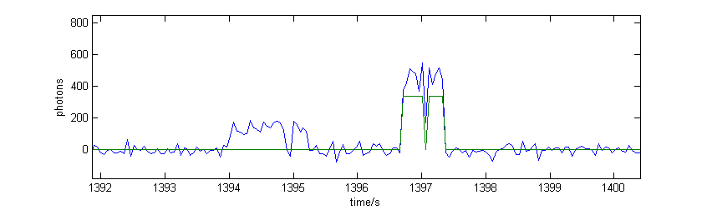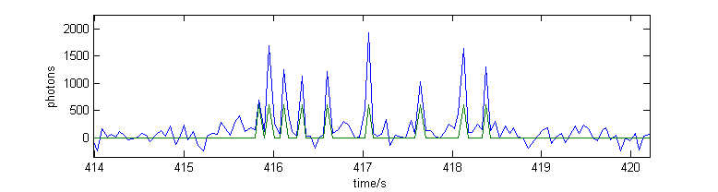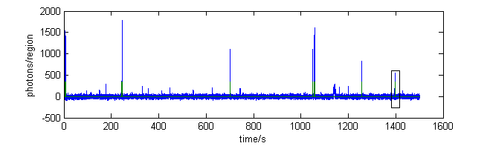

**a.**

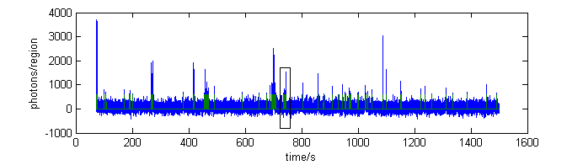

**b.**

Figure 3. 6: Examples of time traces. (a) Time trace of an Al647 molecule under 100% 647nm illumination. (b) Time trace of an Al488 molecule under 100% 488nm illumination. The green line marks the emission-bursts. For each time trace, a zoomed-in section and some raw images of the 5×5 pixel region are displayed as well. The raw images in (a) use the same look-up table (LUT). The raw images in (b) use the same LUT. The first 1300 frames of (b) were discarded due to the problem mentioned in “Negative control”.

For each time trace, the fluorophore was regarded to be in the on-state by identifying the signal that is greater than 3.5 times the standard deviation (s.d.) of the whole trace. And the fluorophore was regarded to remain in the on-state until a decline more than 2.7 times the s.d. or a signal below 2 times the s.d.. The rest of the time trace was regarded to be the off-state. Fluorescence signal of a fluorophore varied in a wide range. These thresholds were selected to make sure only those recognizable peaks in a time trace were regarded as on-state, and those closely packed peaks were separate as different emission-bursts. A process in which a fluorophore continuously stayed in the bright state was regarded as the emission-burst. The duration between the first on-state frame of an emission-burst and the first off-state frame after the emission-burst was regarded as the duration of the emission-burst, called on-state duration. The on-state duration reported in Section 3.3 is the arithmetic average from all the emission-bursts calculated from more than 60 molecules.

The signals in the emission-bursts were used as the number of photons per molecule per frame. By integrating the signals within an emission-burst, dividing the integrated result to the total exposure time (exposure time × frame number within the emission-burst), and multiplying the divided result to the duration of the emission-burst, the number of photons per molecule per emission-burst was calculated. The number of photons per molecule per frame and the number of photons per molecule per emission-burst reported in Section 3.3 are the arithmetic averages calculated from more than 60 molecules.

The on-off duty-cycle is the fraction of time that a dye stayed in the bright state. It was calculated per 100s, and was the arithmetic averaging over all the molecules not yet photobleached in that 100s period. Because fluorophores started from the on-state in each measurement, the duty-cycle was higher at the beginning of the imaging, and gradually declined to an equilibrium value. The equilibrium duty-cycle reported in Section 3.3 is the arithmetic average over 300-700s.

The survival fraction was calculated per 100s as well. The number of live molecules in a 100s period was counted at the beginning of the period, and the survival fraction of that period was calculated by dividing the number of live molecules to the total number of molecules. The survival fraction reported in Section 3.3 is the survival fraction within the period of 600s-700s.

A dye molecule was considered to be live until the last emission-burst. Because the duty-cycle and survival fraction were determined only for the first 700s, compared to the 1500s’ movie, one molecule identified to be photobleached didn’t have any emission-burst in the last 800s, which is long enough to prove the molecule’s death.

One special case that needs to be mentioned here is the first 100s of all the antibody-Al488 samples. Because the first 1300 frames (~1 minute) of each movie had been discarded, the duty-cycle and survival fraction in the first 100s actually were calculated over the duration between the 1301th frame and the 100th second.

The analysis mentioned above was performed in ImageJ and MATLAB.