【SCAN工作原理】和【19c DB与JDBC驱动支持说明】两部分

【SCAN工作原理】
由于Cluster内所有的Service均已向SCAN Listener注册，所以当客户端发起连接请求时，SCAN Listener将转发到负载最小的Local Listener地址（每个listener持续更新集群负载的统计信息），并返回给客户端提供服务，最终客户端还是要通过·Local Listener建立连接。当使用SCAN IP，所有的这些操作对客户端都是透明的，在客户端中都不需要做任何显式配置
参考文档见附件《Grid Infrastructure Single Client Access Name (SCAN) Explained (Doc ID 887522.1).html》
"When a client submits a request, the SCAN listener listening on a SCAN IP address and the SCAN port is contracted on a client's behalf. Because all services on the cluster are registered with the SCAN listener, the SCAN listener replies with the address of the local listener on the least-loaded node (Each scan listener keeps updated cluster load statistics) where the service is currently being offered. Finally, the client establishes connection to the service through the listener on the node where service is offered.All of these actions take place transparently to the client without any explicit configuration required in the client."

检查SCAN Listener的状态
[oracle@ol7-121-rac2 db_1]$ lsnrctl status cluster-scan
……………省略部分信息…………………
Services Summary...
Service "-MGMTDBXDB" has 1 instance(s).
Instance "-MGMTDB", status READY, has 1 handler(s) for this service...
Service "_mgmtdb" has 1 instance(s).
Instance "-MGMTDB", status READY, has 1 handler(s) for this service...
Service "o121_cluster" has 1 instance(s).
Instance "-MGMTDB", status READY, has 1 handler(s) for this service...
Service "racdb" has 2 instance(s). >>> 两个db实例的service已经注册到SCAN Listener
Instance "racdb1", status READY, has 1 handler(s) for this service...
Instance "racdb2", status READY, has 1 handler(s) for this service...
Service "racdbXDB" has 2 instance(s).
Instance "racdb1", status READY, has 1 handler(s) for this service...
Instance "racdb2", status READY, has 1 handler(s) for this service...
Service "taf_session" has 1 instance(s).
Instance "racdb2", status READY, has 1 handler(s) for this service...
The command completed successfully
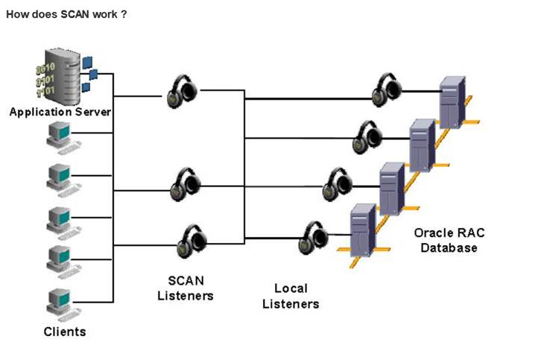

【Oracle Database 19c对于JDBC的版本要求】
对于19c版本，JDBC最低要求是11.2.0.3，参考附件文档，JDK+JDBC+DB的组合关系互相支持，这是升级的前提条件，如果JDK升级后，所有应用代码最好通过升级后的JDK重新执行编译、打包、部署。建议在满足支持版本的情况下对JDBC驱动程序使用与数据库版本相同的版本。附件是jdk + jdbc + db的支持矩阵和一篇非常好的MOS文档《开始使用 Oracle JDBC 驱动程序 (Doc ID 1602866.1)》给开发参考。
