Presence based scalable Smart Home assiatant

Edwin Jose ^{[1]}
Department of Electronics
Cochin University of Science and Technology
Kochi , India
edwin.jose@cusat.ac.in
Greeshma Manikandan^{[2]}
greeshma27@cusat.ac.in

Mithun Haridas T. P.^{[4]}
mithuntp@cusat.ac.in
Jithin Raj^{[3]}
jithinjr7@cusat.ac.in

Abstract—The advancements in technology are so rapid that the applications and relevance of smart IoT concepts are of great importance. But scalability and feature adding to a particular smart system is limited. In this scenario, we are developing smart Home automation which works side by side with a smart Assistant.
Keywords—smart home, smart assistant, smart audio, multiroom voice detection, Home automation, MQTT, chatterbot, Mycroft, picroft

Introduction
Smart technologies are becoming more relevant in the twenty first century. Device are being made able to communicate with each other just like the humans. But as these technologies evolve there is an effective need to bridge the gap between the humans and technology [1], for this an amalgamation of several smart concepts and sensor networks are being utilised. From lights to alarm most of the devices are made smart and enables to communicate with the world wide web for a broader access, Most of these technologies are dependent of each other. But each of the appliances along with new smart methods inherently makes [2] human lives easier.

Related Works
Intelligent Smart home automation [3] and smart grids has been implemented using various algorithms and various sensor networks. Most being implemented on portable computers like raspberry pi or edge IOT [1] devices. The processing and computing of most of these algorithms are online. Also the application of the smart algorithms [4] are rarely applied in the field of audio management. The main attraction of this implementation is the smart audio management which is much relevant in the era of smart assistants.

Implementation
Divide and Conquer method was adopted for implementation, several of the state of the art smart home mechanisms along with the novel smart audio was adopted for this. The method is to integrate the Solutions-Smart Audio for multi-room Audio channelling according to presence, Smart appliance for presence-based and voice-controlled Appliance with respect to the specific region of command, Smart Assistant that ensure the voice recognition and can also access Wikipedia and wolfram alpha for knowledge database and Chatterbot library for basic chatbot, also enabled with wake word detection.The assistant could also be implememted using the Mycroft opensource Virtual assistant and the performances and ease of use of the systems shall also be discussed. The system will be having the following basic features:

Smart Audio
Consider a situation where a person while listening to music from a sound system in one room moves to another room, the volume of music fades away.
This smart music system when incorporated, if the person moves from first room to second room, the volume of music gradually decreases in first room and increases in the second room and vice versa.This could be achieved by using a Digital Potentiometer which is being controlled by a microcontroller with respect to the sensor input,say it be ultrasonic based sensor.

Smart Appliances
Automation of light and other appliances can be done based on the sensor data from the ultrasonic sensors as well as the voice wake word that is captured using a microphone. The appliance can be turned on either by using a triac and opto triac combination or by using a relay mechanism. The appliances are turned on with respect to the decision made by the program, in accordance with the sensor network data

Smart Assistant
Assistant [5] is aiding the wake word and voice recognition of the smart home mechanism. It also has enhanced features like Wikipedia and Wolfram Alpha Search. This is implemented using various API of Wikipedia,wolfram alpha, Google tts and Yandex stt,Snowboy hot word detection. The basic chat boat feature is provided by the Chatterbot Library. Reminders and Alarms are also planned to be implemented.
The Smart assistant is also proposed to be implemented using Mycroft on raspberry pi, which is loader with the picroft OS running over linux.

Components
- Microcontroller—Node MCU as MQTT client
- Microprocessor— Raspberry pi 3 as MQTT broker
- USB Audio adapters, Microphones, USB Hub, Speakers and amplifying circuits
- Shift Registers —74HC595,
- Relays OR opto triac and triac combination for controlling appliances,
- Digital Potentiometer—MCP41010,
- Ultrasonic Sensors and PIR sensors

Triac For acting as Ac Switch
The TRIAC (triode for alternating current) is an ideal power electronics switch to use for switching applications because it can control the flow of current over both positive as well as negative half cycle of alternating waveform. It's also having advantage of low cost over back to back thyristor circuit, To control current upto 4A, voltage upto 600V and low inrush I recommended Triac, above that back to back thyristor can work fine.The basic circuit diagram of opto traic ac switch is shown in figure 1
Controlling high voltage devices using optically isolated power electronics device give advantages of voltage control. This simple TRIAC circuit BT136 and Optocoupler MOC3021 can able to control high voltage devices from microcontroller. For example, arduino to control 230/220v bulb or any device which runs on high voltage. This circuit can also work for dimming and speed controlling application using PWM signal from arduino.

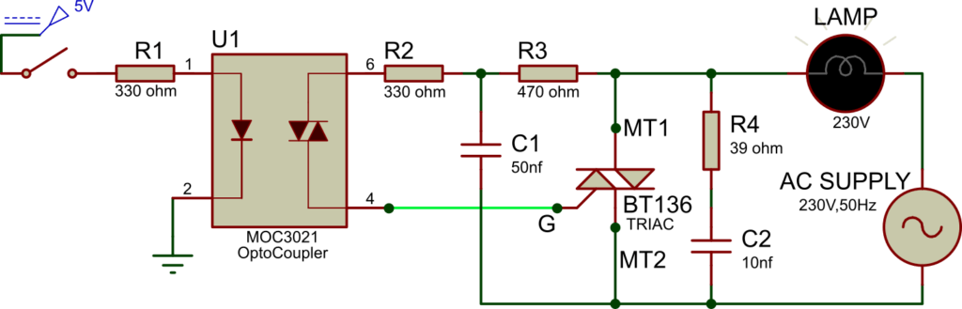

- Circuit diagram proposed for traic as ac swith [source:https://innovatorsguru.com/switching-ac-load-using-triac/]

Serial to Parallel Shifting-Out with a 74HC595
At sometime or another pins on the microcontroller board need not be available in suitable numbers and need to extend it with shift registers. Hence we use 74HC595 IC. The datasheet refers to the 74HC595 as an "8-bit serial-in, serial or parallel-out shift register with output latches; 3-state." So it is possible to control 8 outputs at a time while only taking up a few pins on your microcontroller.Pin out of the shift register is shown in figure 2 and the figure 3 shows the basic shift register circuit using an Arduino.
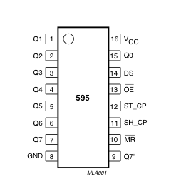
- Pin Diagram Of shift register

Digital Potenstiometer- MCP41010
A digital potentiometer (or “digipot”) operates like a traditional mechanical potentiometer (pot), which is a variable resistor, except the digipot is an integrated chip (IC) that accepts signal input rather than the physical movement of a shaft or slide for adjustment. Essentially, both types of potentiometer are analog devices that provide variable resistance. However, a mechanical pot is an adjustable voltage divider by means of an adjustable slider or rotary resistor. Pots physically change the resistance value whereas digipots modify the resistance value via digital inputs rather than a physical slider or rotary wheel. As the shaft of the mechanical pot is turned, the center pin, called a “wiper,” moves and changes the resistance on either site of the wiper.
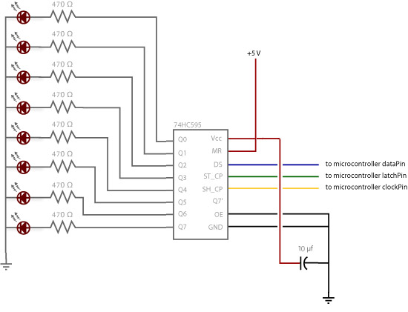
- Sample circuit diagram to test the shift registers [source:https://www.arduino.cc/en/tutorial/ShiftOut]
To program the MCP41010 as shown in figure 4 , 16-bit SPI packets are send. These packets have the format as shown in figure 5
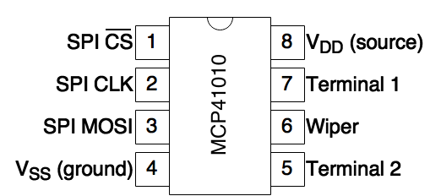
- MCP41010 pinout
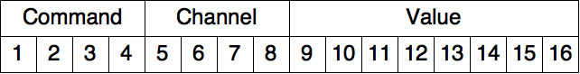
- 16 bit Channel of MCP41010
Command is
- 0001 to set a new resistance value
- 0010 to put the chip in shutdown mode
Channel determines which wiper to modify. Since the MCP41010 has only one channel, this value should always be 0001.
Value is the 8-bit to use as the resistance. Since my MCP41010 was a 10 KΩ potentiometer,
- 00000000 (0) = 0 ohms
- 11111111 (255) = 10,000 ohms
- 00010011 (19) = 19 / 255 × 10,000 = 745 ohms

ChatterBot
Library ChatterBot is a Python library that makes it easy to generate automated responses to a user’s input. ChatterBot uses a selection of machine learning algorithms to produce different types of responses. This makes it easy for developers to create chat bots and automate conversations with users. For more details about the ideas and concepts behind ChatterBot see the process flow diagram in figure 6.

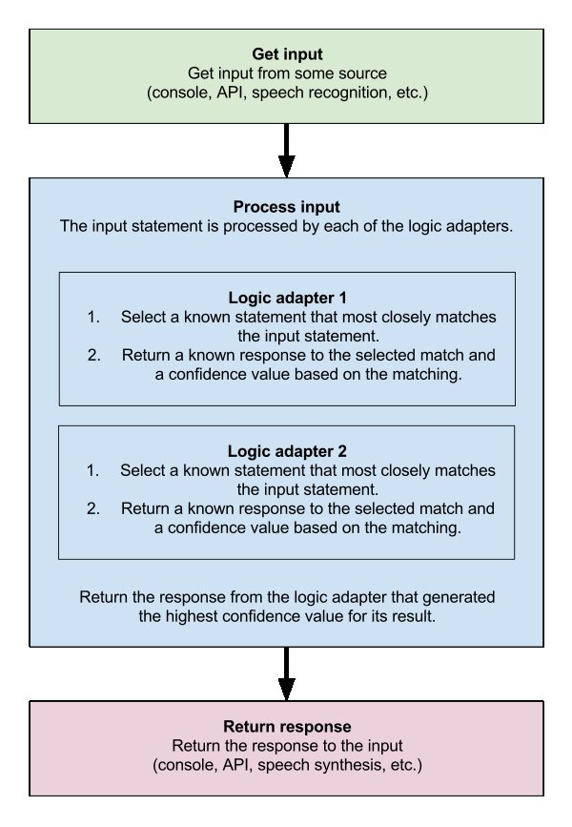

- Process flow diagram of Chatter Bot Library

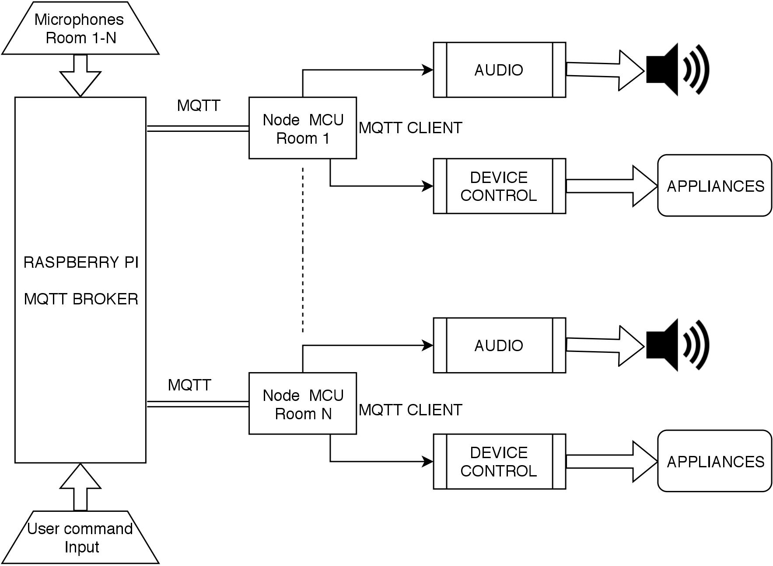
- Overall block diagram of the implementation
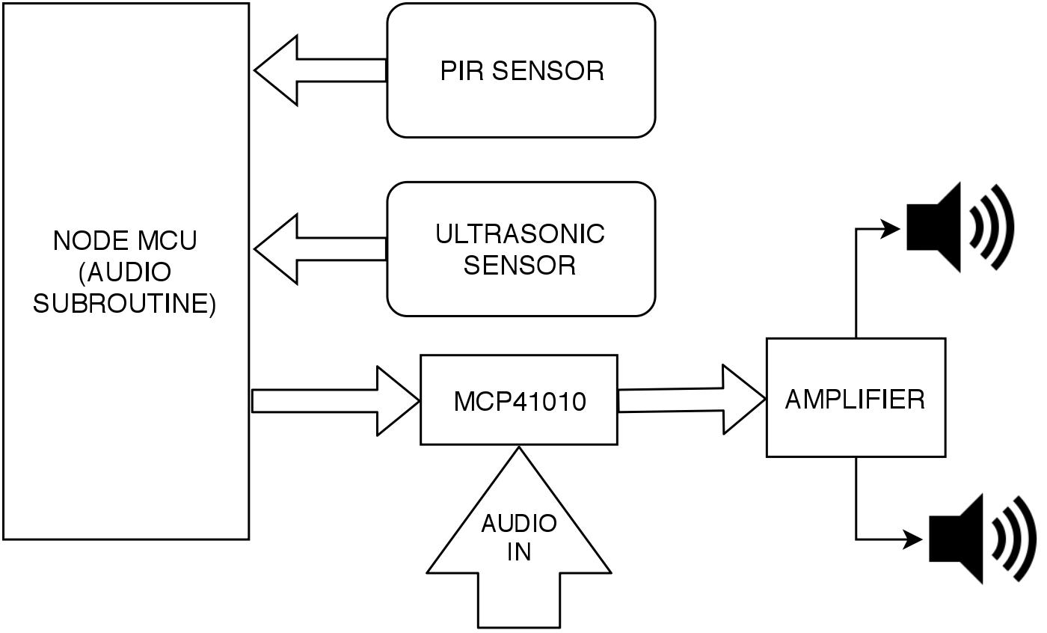
- Audio SubRoutine of the system

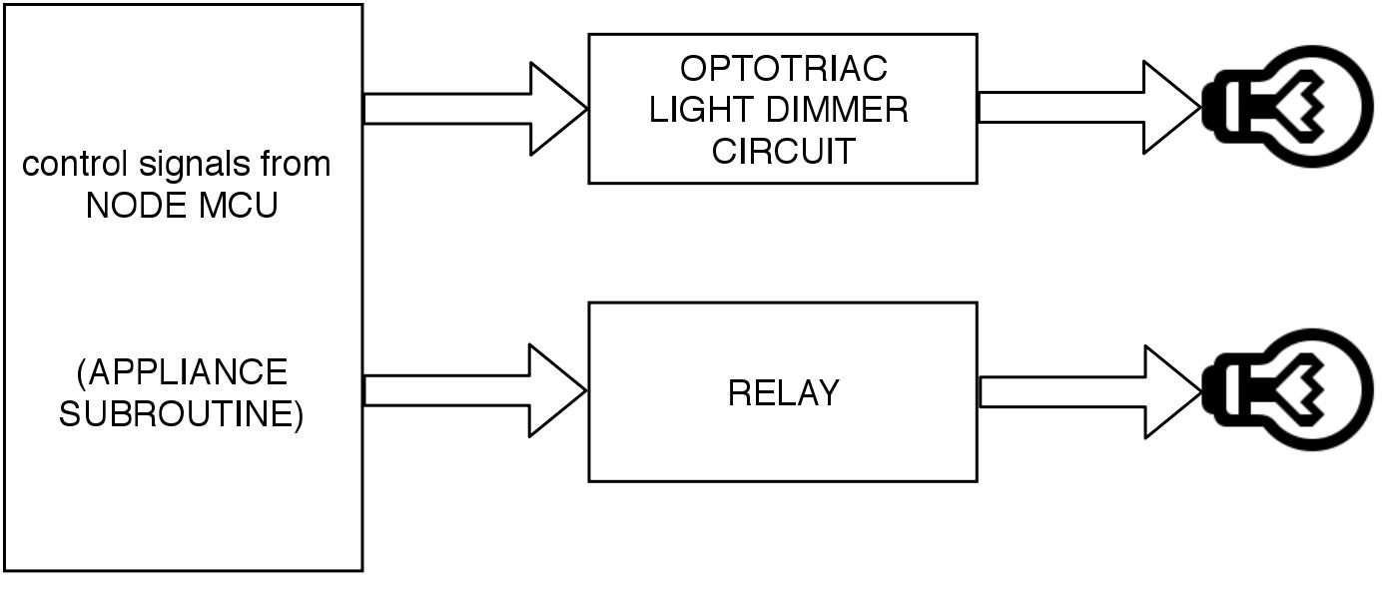
- Appliance or device control subroutine of the system.

MQTT
MQTT is a machine-to-machine (M2M)/"Internet of Things" connectivity protocol. It was designed as an extremely lightweight publish/subscribe messaging transport. It is useful for connections with remote locations where a small code footprint is required and/or network bandwidth is at a premium. For example, it has been used in sensors communicating to a broker via satellite link, over occasional dial-up connections with healthcare providers, and in a range of home automation and small device scenarios. It is also ideal for mobile applications because of its small size, low power usage, minimized data packets, and efficient distribution of information to one or many receivers. In the system designed the Raspberry pi 3 is the MQTT broker and the Node MCUs are the clients.

Working
Here the raspberry pi acts as the main controller, to which either a voice command (e.g.: TURN ON appliance name) from microphones or type in command are given, which when processed gives the identity of the room number.This is shown in the block diagram in figure 7. Thus the control signal to turn on the appliance will be moved to the NODE MCU (using MQTT broker), whose identity matches with that of the command signal, controlling the appliance i.e. either to turn on the device or to control the brightness of the light source (relay or optotriac combination) as shown in the figure 9.
Similarly, when a person enters a room, his/her presence is detected via a PIR sensor. This will turn ON the ultrasonic sensor, enabling it to measure the location of the person ensuring correct sound distribution. The room’s identity can be verified using the PIR sensor from which the person has been detected. So it seems like the audio travels with the person. The audio control block diagram is shown in the figure 8

Conclusion
The system is being implemented while the feature is being individually tested. The algorithm in which the system is being implemented dis modified after each successful trials. Thus, a foolproof and convenient smart home integrated assistant could be delivered as a finished scalable product.
The scope of scalability and the addition of more features are possible too. The proposed additional features include a smart intelligent security system and voice based remote control for the traditional entertainment devices music player and television which doesn’t have any inbuilt smart features.

References

- X. Mao, K. Li, Z. Zhang and J. Liang, "Design and implementation of a new smart home control system based on internet of things," 2017 International Smart Cities Conference (ISC2), Wuxi, 2017, pp. 1-5. doi: 10.1109/ISC2.2017.8090790
- M. Al-Amin and S. Z. Aman, "Design of an Intelligent Home Assistant," 2016 7th International Conference on Intelligent Systems, Modelling and Simulation (ISMS), Bangkok, 2016, pp. 69-71.
doi: 10.1109/ISMS.2016.34
- G. Iannizzotto, L. L. Bello, A. Nucita and G. M. Grasso, "A Vision and Speech Enabled, Customizable, Virtual Assistant for Smart Environments," 2018 11th International Conference on Human System Interaction (HSI), Gdansk, 2018, pp. 50-56.
doi: 10.1109/HSI.2018.8431232
- V. D. Vaidya and P. Vishwakarma, "A Comparative Analysis on Smart Home System to Control, Monitor and Secure Home, based on technologies like GSM, IOT, Bluetooth and PIC Microcontroller with ZigBee Modulation," 2018 International Conference on Smart City and Emerging Technology (ICSCET), Mumbai, 2018, pp. 1-4.
doi: 10.1109/ICSCET.2018.8537381
- C. Z. Yue and S. Ping, "Voice activated smart home design and implementation," 2017 2nd International Conference on Frontiers of Sensors Technologies (ICFST), Shenzhen, 2017, pp. 489-492.
doi: 10.1109/ICFST.2017.8210563
- “About ChatterBot ,” About ChatterBot - ChatterBot 0.8.7 documentation.
- “Audio Gain Control Using Digital Potentiometers,” Maxim.
- “Cloud Speech-to-Text - Speech Recognition | Cloud Speech-to-Text API | Google Cloud,” Google.
- “Digital Potentiometer - Working, Internal Structure &amp; Applications,” Electronic Circuits and Diagrams-Electronic Projects and Design, 22-Sep-2017. [Online]. Available: http://www.circuitstoday.com/digital-potentiometer.
- Home Assistant, “Yandex TTS,” Home Assistant.
- “Music Emulator System,” WIZnet Museum.
- Neeraj933, “Neeraj933/Music-Emulator,” GitHub.
- “Switching high voltage load using TRIAC,” InnovatorsGuru.
- edwinjose900, “edwinjose900/LAMP,” GitHub.

