Estimating environmental flow condition

The streamflow contribution from the renewable groundwater (i.e., baseflow) is essential for ecosystem services, sustaining freshwater habitats and associated ecosystems, in particular during low-flow conditions when the contribution from other sources is small. To include this essential aspect of groundwater resources in our analysis in addition to the mere supply of human demand, we identified the environmental flow conditions as the monthly streamflow that is exceeded in 90%, Q₉₀, of the simulated cases over the period 1958-2000 (). This streamflow results from the specific runoff over the land surface proper, including baseflow, and that over the freshwater surface (streams, lakes and reservoirs), which consists of direct gains from precipitation and losses from evaporation. Under the assumption that all sources contribute equally to the streamflow, mean discharge at the outlet can be approximated by accumulating all positive contributions along the drainage network with any negative losses over freshwater surfaces acting as sink. Thus, specific runoff from the land surface may have to compensate for losses farther downstream and heighten the fraction of renewable groundwater recharge that has to be reserved to safeguard environmental flow at the basin outlet:
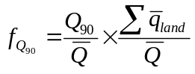,
where 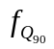is the fraction of groundwater recharge to be reserved to meet the environmental streamflow, 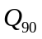, 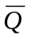 is the mean discharge at the outlet and 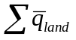 is the accumulated mean specific runoff from the land surface, all flows being represented as volumes over the basin and per year.

Here, the first ratio relates the environmental flow conditions to the mean runoff, including baseflow from recharge, while the second ratio compensates for downstream losses. Although provides a uniform fraction over the basin it indirectly accounts for local variations in recharge and changes the absolute amount of renewable groundwater for abstraction on a cell-by-cell basis. The computed fractions are generally substantially larger than 10% of the recharge (Figure) as Q₉₀ is based on the monthly discharge values and by definition exceeds that based on daily ones. Also, in several basins, subsequent downstream losses can be considerable. For example, the Q₉₀ of the endorheic basin draining towards Lake Eyre in Australia is only 15% of the mean discharge yet it requires 34% of the groundwater recharge over the basin. The assumption that the entire basin contributes homogeneously to the streamflow also inflatesas this condition will seldom exists. Notwithstanding its limitations, the approach shows the possibilities to include environmental considerations in the groundwater footprint concept.

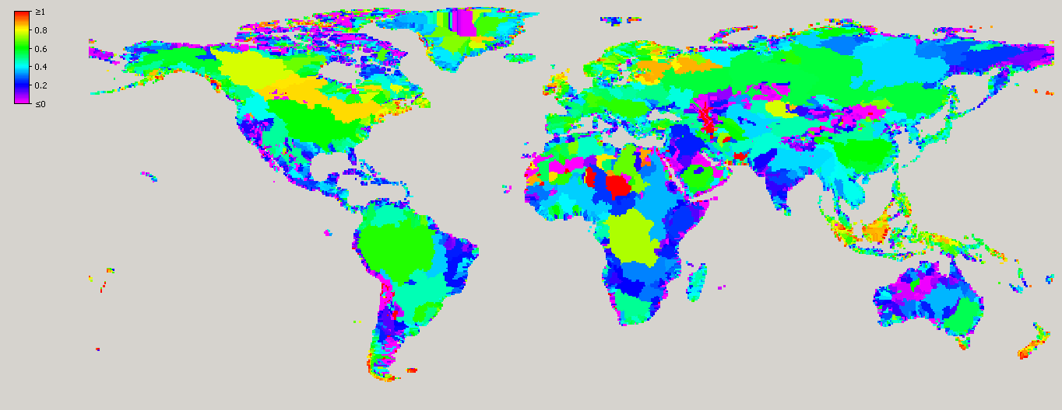
Figure: Fraction, , of groundwater recharge to be reserved to meet the environmental streamflow Q₉₀ per basin.

