DETERMINANTS AND PREDICTION OF HYPERTENSION: A STATISTICAL AND MACHINE LEARNING APPROACH

DATA SCIENTIST: OMOROWA EDWIN

Abstract
Introduction: Hypertension is a widespread, often asymptomatic condition and a leading contributor to cardiovascular morbidity and mortality worldwide. Owing to its multifactorial etiology, identifying key determinants and developing reliable predictive tools are essential for effective prevention and management. This study applies a data-driven analytical approach to examine factors associated with hypertension and to develop predictive models for individual risk assessment.
Methods: A dataset comprising 1,985 adult records with demographic, lifestyle, and clinical variables was analyzed. Exploratory data analysis and descriptive statistics were used to profile the data. Inferential analyses, including independent samples t-tests and chi-square tests, assessed associations between hypertension status and variables such as age, BMI, stress score, sleep duration, smoking status, family history, and blood pressure history. Confirmatory factor analysis was conducted to explore latent physiological and psycho-social constructs. Machine learning models, including Random Forest and Gradient Boosting classifiers, were trained using selected predictors and evaluated using accuracy, precision, recall, and F1-score.
Results: Significant associations with hypertension were observed for age, BMI, stress score, smoking status, family history, sleep duration, and prior blood pressure history (p < .001). Random Forest achieved the best predictive performance with 84.9% accuracy and balanced classification metrics, slightly outperforming Gradient Boosting.
Discussion: The findings highlight key modifiable and non-modifiable risk factors for hypertension and demonstrate the effectiveness of combining inferential statistics with machine learning for risk prediction. The resulting model provides a practical framework for hypertension risk stratification in clinical and public health settings.

Background
This report presents a data-driven analytical investigation into hypertension, a prevalent and often asymptomatic condition that remains a leading contributor to global cardiovascular morbidity and mortality. Often referred to as the “silent killer,” hypertension results from a complex interplay of non-modifiable factors, such as age and genetic predisposition, and modifiable lifestyle risks, including high dietary sodium intake, obesity, physical inactivity, and chronic psycho-social stress. Effective management of hypertension is a critical public health priority, requiring strategies that range from individual lifestyle modification to systematic clinical interventions.

The primary objective of this report is to conduct a comprehensive analytical workflow on a provided datasets to identify key determinants of hypertension and develop a robust predictive model for individual risk assessment. The methodology is structured into three sequential phases: exploration, inference, and prediction. Initially, exploratory data analysis summarizes demographic, clinical, and behavioral variables through descriptive statistics and visualizations, highlighting foundational patterns. Inferential testing including t-tests and chi-square analyses then evaluates the significance of associations between variables such as age, BMI, stress, smoking status, and hypertension outcomes.

Building on these insights, predictive modelling employs key predictors to train and optimize machine learning algorithms, specifically Random Forest and Gradient Boosting classifiers. Model performance is evaluated using accuracy, precision, recall, and F1-score to identify the most reliable tool for hypertension classification. This end-to-end analytical workflow from data profiling to predictive modelling demonstrates a practical, evidence-based approach to transforming raw health data into actionable intelligence. The findings and the resulting predictive framework aim to support risk stratification, inform targeted prevention strategies, and enhance decision-making in clinical and public health settings for hypertension management.

Introduction
Hypertension is a prevalent and often asymptomatic condition that remains a major contributor to global morbidity and mortality, primarily through its role in cardiovascular diseases such as ischemic heart disease and stroke. Commonly referred to as the “silent killer,” hypertension affects a substantial proportion of the global population, with nearly half of adults in the United States living with the condition. Its largely symptom-less nature frequently delays diagnosis, increasing the risk of severe complications when left un-managed. Consequently, effective hypertension control is essential across diverse clinical and public health contexts, including pregnancy, surgical care, and long-term disease prevention.

Hypertensive disorders pose particular risks during pregnancy, complicating approximately 5% to 10% of all pregnancies and contributing significantly to maternal and fetal morbidity. These disorders include chronic hypertension, gestational hypertension, and pre-eclampsia, each presenting distinct clinical challenges (“Hypertension”, 2023). Management during pregnancy requires careful balancing of maternal blood pressure control with fetal safety, as antihypertensive medications may affect fetal development and utero-placental blood flow (“Hypertension”, 2023). This highlights the need for tailored treatment strategies for vulnerable populations.

The burden of hypertension is unevenly distributed across populations. Certain subgroups, including African Americans and older adults, experience disproportionately higher prevalence rates, often compounded by limited access to healthcare services (Koenig et al., 2024). Beyond biological determinants, psychological, social, and environmental factors substantially influence blood pressure regulation. Socio-cultural factors, such as religious involvement, have been explored for their potential roles in stress reduction and blood pressure control (Koenig et al., 2024). Preventive strategies strongly emphasize lifestyle modification, particularly dietary approaches such as the DASH and Mediterranean diets, which are low in sodium and saturated fats and have demonstrated effectiveness in reducing blood pressure (“Hypertension”, 2022).

Hypertension management typically involves a combination of lifestyle interventions and pharmacological therapy. Commonly prescribed medications, including calcium channel blockers and beta blockers, are effective in lowering blood pressure and reducing cardiovascular risk (Dagher & Beck, 2024). In surgical settings, appropriate preoperative and postoperative blood pressure management is critical to minimizing morbidity and mortality (Dagher & Beck, 2024). Long-term control often depends on affordable antihypertensive medications supported by strong primary healthcare systems that facilitate early detection, monitoring, and adherence (“Hypertension”, 2023).

From an etiological perspective, hypertension results from complex interactions among genetic, environmental, and lifestyle factors. Primary hypertension accounts for approximately 90% to 95% of cases, with genetic predisposition and family history increasing susceptibility (“Hypertension”, 2023; Burnier & Wuerzner, 2015). Modifiable risk factors—including high sodium intake, physical inactivity, smoking, excessive alcohol consumption, and obesity—play a critical role (Mazhar et al., 2023; Mirza et al., 2024). Excess body weight increases vascular resistance and disrupts metabolic regulation, while aging-related changes in renal function and arterial elasticity further elevate blood pressure (Burnier & Wuerzner, 2015; Thalib, 2025).

Given the multifactorial nature of hypertension, personalized and data-driven approaches are essential. By analysing relevant datasets, this report aims to identify key patterns and determinants of hypertension, supporting evidence-based strategies for improved prevention, management, and health outcomes.

Methodology
This analysis focuses on exploring hypertension patterns, understanding key determinants, and building a predictive model using the provided dataset. The workflow begins with thorough data cleaning and pre-processing, including handling missing values, removing duplicates, standardizing column names, encoding categorical variables, and scaling numerical features. This ensures the dataset is consistent and ready for analysis. Descriptive statistics and visualizations, such as histograms, boxplots, and correlation heat maps, are used to examine the distribution of hypertension and identify potential trends, outliers, and relationships between demographic, lifestyle, and clinical factors.
Following this, statistical tests such as t-tests and correlation analyses are applied to assess significant associations between features and hypertension. Based on these insights, a machine learning model is developed to predict hypertension risk, with the dataset split into training and testing sets. Algorithms such as logistic regression or decision trees are implemented, and model performance is evaluated using metrics including accuracy, precision, recall, and ROC-AUC. This integrated approach demonstrates the application of data analysis, statistical testing, and predictive modelling to extract actionable insights and showcase data-driven problem-solving skills in a professional portfolio.

Result
Data Overview
The datasets consists of 1985 records with 11 variables capturing demographic, lifestyle, and clinical factors related to hypertension. The numerical features include Age, Salt Intake, Stress Score, Sleep Duration, and BMI. The average age of participants is approximately 50 years, with a wide range from 18 to 84 years, reflecting a diverse adult population? Salt intake averages 8.53 g/day, while stress scores have a mean of 4.98 on the measured scale. Participants report an average sleep duration of 6.45 hours, and the mean BMI is 26.02, indicating that a significant portion of the population falls in the overweight category.
The datasets also includes several categorical variables, such as BP History, Medication, Family History, Exercise Level, Smoking Status, and Has Hypertension. Notably, the Medication column has some missing values (approximately 799 entries), which will require handling during analysis. Other categorical variables, such as family history of hypertension, exercise levels, and smoking status, provide insights into lifestyle and hereditary influences. Overall, these summary statistics highlight the variability and range within the datasets, establishing a solid foundation for exploratory data analysis, statistical testing, and subsequent machine learning modelling aimed at understanding and predicting hypertension risk.
Variable | Mean | Std | Min | 25% | 50% | 75% | Max
Age | 50.34 | 19.44 | 18 | 34 | 50 | 67 | 84
Salt Intake | 8.53 | 1.99 | 2.5 | 7.2 | 8.5 | 9.9 | 16.4
Stress Score | 4.98 | 3.14 | 0 | 2 | 5 | 8 | 10
Sleep Duration | 6.45 | 1.54 | 1.5 | 5.4 | 6.5 | 7.5 | 11.4
BMI | 26.02 | 4.51 | 11.9 | 23 | 25.9 | 29.1 | 41.9
Table 1: Variable Summary Statistics
The datasets reflects a diverse adult population, with participants ranging from 18 to 84 years and an average age of 50 years, suggesting inclusion of both younger and older adults. Salt intake averages 8.53 g/day, slightly above recommended levels, indicating potential dietary risk for hypertension. The Stress Score shows moderate variability (mean 4.98), with some individuals experiencing high stress. Sleep duration averages 6.45 hours, slightly below the recommended 7–8 hours, which may impact cardiovascular health. The mean BMI of 26.02 falls in the overweight range, highlighting a prevalent risk factor. Overall, these statistics indicate variability in lifestyle and clinical factors relevant to hypertension.
Age by Hypertension
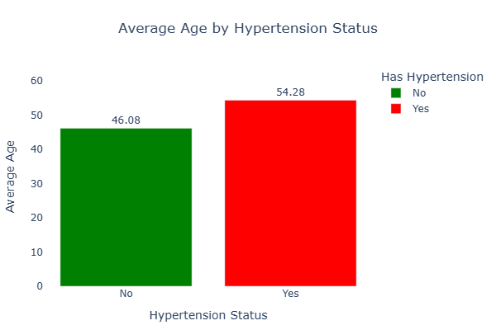
Fig 1: Bar chart Average Age on Hypertension
Has Hypertension | Mean Age | Median Age | Std. Dev | Min | Q1 | Q3 | Max | IQR
No | 46.08 | 43 | 18.95 | 18 | 30 | 61 | 84 | 31
Yes | 54.28 | 56 | 19.06 | 18 | 38 | 70 | 84 | 32
Table 2: Summary Statistics Age on Hypertension

The cross-tabulated age statistics show a clear difference between individuals with and without hypertension. Participants with hypertension have a higher mean age (54.28 years) and median age (56 years) compared to those without hypertension, who’s mean and median ages are 46.08 and 43 years respectively. This suggests that hypertension is more prevalent among older individuals in the datasets. The similar standard deviations in both groups indicate comparable age variability, while the higher quartile (Q1 and Q3) for the hypertensive group further emphasize an age shift toward older populations. Overall, age appears to be an important factor associated with hypertension status in this analysis.

Hypotheses (Influence of Age on Hypertension)
- Null hypothesis (H₀): There is no difference in mean age between individuals with hypertension and those without.
- Alternative hypothesis (H₁): There is a significant difference in mean age between the two groups

Independent Samples T-Test
 | t | D f | p | Mean Difference | SE Difference | Cohen's d | SE Cohen's d
Age | -9.597 | 1983 | < .001 | -8.196 | 0.854 | -0.431 | 0.046
Note. Student's t-test.
Table 3: T-test Impact of Age On hypertension

The independent samples t-test indicates a statistically significant difference in age between individuals with and without hypertension. The result shows a large t-value (t = −9.597, df = 1983, p < .001), meaning the observed difference in mean age is highly unlikely to have occurred by chance. On average, individuals without hypertension are about 8.2 years younger than those with hypertension, as reflected in the mean difference. The effect size, Cohen’s d = −0.43, represents a moderate practical effect, indicating that the age difference is not only statistically significant but also meaningful in real-world terms. Overall, this finding supports age as an important factor associated with hypertension status in the dateset.

Impact of Salt on Hypertension
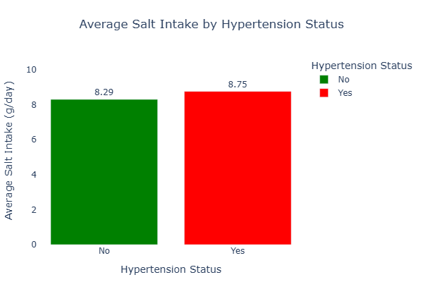
Fig 2: Bar Chart Salt on Hypertension
Has Hypertension/Salt Intake | Mean | Median | Std. Dev | Min | Q1 | Q3 | Max | IQR
No | 8.29 | 8.3 | 1.88 | 2.5 | 7.1 | 9.5 | 14.8 | 2.4
Yes | 8.75 | 8.7 | 2.07 | 2.5 | 7.3 | 10.3 | 16.4 | 3

Table 4: Summary Statistics Salt on Hypertension

The summary statistics indicate that individuals with hypertension consume slightly more salt on average than those without hypertension. The mean salt intake for hypertensive participants (8.75 g/day) exceeds that of non-hypertensive individuals (8.29 g/day), and this pattern is consistent across the median values, suggesting a generally higher central tendency rather than being driven by extreme values. The hypertensive group also shows greater variability in salt intake, as reflected by a higher standard deviation and a wider inter-quartile range (3.0 vs. 2.4), indicating more dispersed consumption habits. Higher upper quartile and maximum values among hypertensive individuals further suggest that excessive salt intake is more prevalent in this group, reinforcing its potential role in hypertension risk.

Hypothesis (Impact of Salt Intake on Hypertension)
Null Hypothesis (H₀): There is no significant difference in the mean salt intake between individuals with hypertension and those without hypertension.

Alternative Hypothesis (H₁): There is a significant difference in the mean salt intake between individuals with hypertension and those without hypertension.

Independent Samples T-Test
 | t | df | p | Mean Difference | SE Difference | Cohen's d | SE Cohen's d
Salt Intake | -5.129 | 1983 | < .001ᵃ | -0.457 | 0.089 | -0.230 | 0.045

Table 5: T-test Impact of Salt On hypertension

The independent samples t-test indicates a statistically significant difference in mean salt intake between individuals with hypertension and those without. The negative t-value (t = −5.129, p < .001) shows that the hypertensive group consumes, on average, more salt than the non-hypertensive group, with a mean difference of approximately 0.46 g/day. This finding supports the rejection of the null hypothesis and aligns with existing evidence linking higher salt intake to elevated blood pressure. Although the Brown–Forsythe test suggests unequal variances between groups, the result remains robust given the large sample size. The effect size (Cohen’s d = −0.23) indicates a small but meaningful practical effect, suggesting that even modest differences in salt intake may contribute to hypertension risk at the population level.

Impact of Stress Score on Hypertension

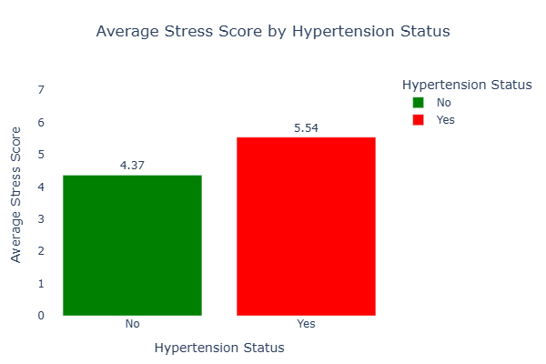
Fig 3: Bar Chart Stress on Hypertension

Has Hypertension | Mean | Median | Std. Dev | Min | Q1 | Q3 | Max | IQR
No | 4.37 | 4 | 2.87 | 0 | 2 | 6 | 10 | 4
Yes | 5.54 | 6 | 3.28 | 0 | 3 | 9 | 10 | 6

Table 6: Summary Statistics Stress on Hypertension

The results show clear differences in stress levels between individuals with and without hypertension. Participants without hypertension have a lower mean stress score (4.37) compared to those with hypertension (5.54), indicating that higher stress is more common among hypertensive individuals. The median stress score is also higher in the hypertensive group (6 vs. 4), suggesting a consistent shift toward greater stress levels rather than the effect of extreme values. Additionally, the hypertensive group exhibits greater variability, as reflected in a higher standard deviation and wider inter-quartile range (IQR = 6) compared to the non-hypertensive group (IQR = 4). These patterns suggest that elevated and more variable stress levels may be associated with hypertension, reinforcing evidence that psychological stress is an important factor in blood pressure regulation.

Hypothesis (Impact of Stress on Hypertension)
- Null Hypothesis (H₀): There is no significant difference in the mean stress score between individuals with hypertension and those without hypertension.
- Alternative Hypothesis (H₁): There is a significant difference in the mean stress score between individuals with hypertension and those without hypertension.
This hypothesis is tested using an Independent Samples T-Test, as the two groups (hypertensive vs. non-hypertensive) are independent and the objective is to compare their mean stress scores.

Independent Samples T-Test
 | t | df | p | Cohen's d | SE Cohen's d
Stress Score | -8.473 | 1983 | < .001ᵃ | -0.381 | 0.046
Note. Student's t-test.
ᵃ Brown-Forsythe test is significant (p < .05), suggesting a violation of the equal variance assumption
Table 7: T-test Impact of Salt On hypertension

The independent samples t-test for stress scores shows a statistically significant difference between individuals with and without hypertension (t = -8.473, df = 1983, p < .001). The analysis suggests that, on average, those with hypertension tend to have higher stress scores (measured mean ≈ 5.54) compared to non-hypertensive participants (measured mean ≈ 4.37), indicating a meaningful association between stress and hypertension. The effect size, Cohen’s d = -0.381, represents a small-to-moderate practical effect. The Brown-Forsythe test indicates unequal variances (p < .05), suggesting that the assumption of equal variance was not met, though the overall difference remains statistically significant.

Impact of Sleep Duration on Hypertension.
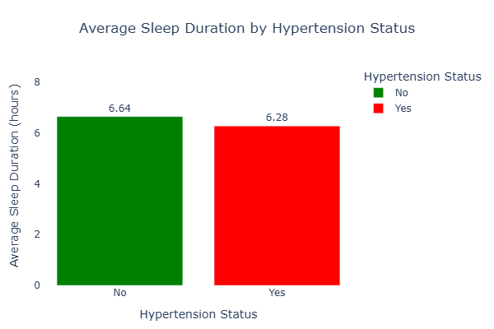
Fig 4: Bar Chart Sleep duration on Hypertension Status

Has Hypertension/Sleep Duration | Mean | Median | Std. Dev | Min | Q1 | Q3 | Max | IQR
No | 6.64 | 6.6 | 1.38 | 2.2 | 5.7 | 7.6 | 11 | 1.9
Yes | 6.28 | 6.3 | 1.66 | 1.5 | 5 | 7.4 | 11.4 | 2.4

Table 8: Summary statistics Sleep duration on Hypertension
The summary statistics indicate a modest but consistent difference in sleep duration between individuals with and without hypertension. Participants without hypertension reported a higher mean sleep duration (6.64 hours) compared to those with hypertension (6.28 hours), suggesting that shorter sleep may be associated with elevated blood pressure. The hypertensive group also exhibits greater variability in sleep duration, as reflected by a higher standard deviation and wider inter-quartile range, indicating more irregular sleep patterns. While median sleep duration is similar across groups, the lower first quartile among hypertensive individuals suggests that a larger proportion experience insufficient sleep. Overall, these patterns support existing evidence linking reduced and irregular sleep duration with increased hypertension risk.

Hypothesis (Impact of Sleep Duration on Hypertension)
- Null Hypothesis (H₀): There is no significant difference in the mean sleep duration between individuals with hypertension and those without hypertension.
- Alternative Hypothesis (H₁): There is a significant difference in the mean sleep duration between individuals with hypertension and those without hypertension.

Independent Samples T-Test
 | t | df | p | Cohen's d | SE Cohen's d
Sleep Duration | 5.363 | 1983 | < .001ᵃ | 0.241 | 0.045
Note. Student's t-test.
ᵃ Brown-Forsythe test is significant (p < .05), suggesting a violation of the equal variance assumption
Table 9: T-test Impact of Salt On hypertension

The independent samples t-test reveals a statistically significant difference in mean sleep duration between individuals with and without hypertension (t = 5.363, df = 1983, p < .001). This finding supports the alternative hypothesis and indicates that sleep duration differs meaningfully across hypertension status. Individuals without hypertension report longer average sleep duration compared to their hypertensive counterparts, suggesting that shorter sleep duration is associated with elevated hypertension risk. The effect size (Cohen’s d = 0.241) indicates a small but practically relevant effect, implying that sleep duration contributes to hypertension risk alongside other demographic and lifestyle factors. The significant Brown–Forsythe test indicates unequal variances between groups, reflecting greater variability in sleep duration among individuals with hypertension. Despite this violation of the equal variance assumption, the large sample size enhances the robustness of the test results. Overall, these findings are consistent with existing evidence linking insufficient and irregular sleep patterns to increased blood pressure and cardiovascular risk, underscoring the importance of adequate sleep in hypertension prevention and management.

Impact of BMI on Hypertension.
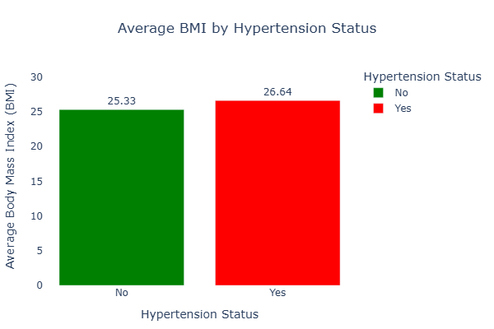
Fig 5: Bar chart BMI on Hypertension Status

Has Hypertension/BMI | Mean | Median | Std. Dev | Min | Q1 | Q3 | Max | IQR
No | 25.33 | 25.4 | 4.18 | 11.9 | 22.7 | 28.2 | 38.4 | 5.5
Yes | 26.64 | 26.6 | 4.71 | 13.4 | 23.4 | 30.2 | 41.9 | 6.8

Table 10: Summary Statistics BMI on Hypertension.

The results indicate that individuals with hypertension have a higher average Body Mass Index (BMI) compared to those without hypertension. The mean BMI for hypertensive individuals (26.64) exceeds that of non-hypertensive individuals (25.33), suggesting a greater prevalence of overweight status among those with hypertension. Median values follow a similar pattern, reinforcing the consistency of this difference. Additionally, the hypertensive group exhibits greater variability in BMI, as reflected by a higher standard deviation and wider inter-quartile range, indicating more dispersion in body weight status within this group. The higher upper quartile and maximum BMI values among hypertensive individuals further suggest an increased proportion of obesity. Overall, these findings align with established evidence linking higher BMI to elevated blood pressure and underscore excess body weight as an important factor associated with hypertension risk.

Hypothesis (Impact of Body Mass Index on Hypertension)

- Null Hypothesis (H₀): There is no significant difference in the mean Body Mass Index (BMI) between individuals with hypertension and those without hypertension.

- Alternative Hypothesis (H₁): There is a significant difference in the mean Body Mass Index (BMI) between individuals with hypertension and those without hypertension.

Independent Samples T-Test
 | t | df | p | Cohen's d | SE Cohen's d
BMI | -6.530 | 1983 | < .001ᵃ | -0.293 | 0.045
Note. Student's t-test.
ᵃ Brown-Forsythe test is significant (p < .05), suggesting a violation of the equal variance assumption
Table 11: T-test Impact of BMI on Hypertension

The independent samples t-test indicates a statistically significant difference in mean Body Mass Index (BMI) between individuals with hypertension and those without hypertension, as evidenced by a large t-value (t = −6.530) and a p-value below .001. This result leads to the rejection of the null hypothesis, suggesting that BMI varies meaningfully across hypertension status. The negative t-value reflects a higher average BMI among hypertensive individuals compared to non-hypertensive individuals. Although the Brown–Forsythe test indicates unequal variances, the adjusted test remains robust, supporting the validity of the finding. The effect size (Cohen’s d = −0.293) represents a small-to-moderate practical effect, indicating that BMI differences, while not large, are consistent and non-trivial in a population context. Overall, the results highlight elevated BMI as an important characteristic associated with hypertension, reinforcing its relevance as a modifiable risk factor in cardiovascular health assessment and prevention strategies.

Blood Pressure History on Hypertension.

Has Hypertension | Hypertension (%) | Normal (%) | Prehypertension (%)
No | 4.30% | 53.52% | 42.18%
Yes | 51.16% | 27.71% | 21.12%
Table 12: cross tab BP- hypertension

Chi-Squared Tests
 | Value | df | p
Χ² | 532.2 | 2 | < .001
N | 1985
Note. Continuity correction is available only for 2x2 tables.

Table 13: Chi-Sqaure Blood Pressume on Hypertension
The contingency table reveals a pronounced association between prior blood pressure history and current hypertension status. Among individuals without hypertension, the majority report normal blood pressure (53.52%), followed by prehypertension (42.18%), while only a small proportion fall into the hypertension category (4.30%). In contrast, over half of individuals with hypertension have a prior history of hypertension (51.16%), with substantially smaller proportions reporting normal blood pressure (27.71%) or prehypertension (21.12%).

This distribution highlights a clear shift in blood pressure profiles between the two groups, suggesting that prior elevated blood pressure strongly aligns with current hypertensive status. The chi-squared test confirms this relationship, showing a highly significant association between BP history and hypertension (χ² = 532.2, df = 2, p < .001). This indicates that the observed differences are unlikely to be due to chance and underscores the importance of blood pressure history as a key indicator in identifying and understanding hypertension risk.

Medication on Hypertension Status

Has Hypertension | ACE Inhibitor (%) | Beta Blocker (%) | Diuretic (%) | None (%) | Other (%)
No | 17.00% | 20.78% | 11.12% | 40.61% | 10.49%
Yes | 15.60% | 20.74% | 13.47% | 39.92% | 10.27%

Table 14: Cross Tab Has Hypertension on Medication.
Chi-Squared Tests
 | Value | df | p
Χ² | 2.887 | 4 | .577
N | 1985
Note. Continuity correction is available only for 2x2 tables.

Table 15: Chi-Square Test of Association Between Medication Type and Hypertension Status

The distribution of medication types among individuals with and without hypertension reveals minimal differences. Among non-hypertensive participants, the largest proportion reported taking no medication (40.61%), followed by Beta Blockers (20.78%), ACE inhibitors (17.00%), Diuretics (11.12%), and other medications (10.49%). In the hypertensive group, similar trends were observed, with the highest proportion also taking no medication (39.92%), followed by Beta Blockers (20.74%), Diuretics (13.47%), ACE inhibitors (15.60%), and other medications (10.27%).

The Chi-Squared test for association yielded a value of 2.887 with 4 degrees of freedom and a p-value of 0.577, indicating no statistically significant relationship between medication type and hypertension status in this dataset. This suggests that the type of medication reported does not differ meaningfully between hypertensive and non-hypertensive participants. While some variability exists in percentages across categories, these differences are minor and likely due to random variation rather than systematic association. Overall, this analysis implies that medication type alone is not strongly predictive of hypertension status in this sample.

Family History on Hypertension Status

Has Hypertension | No (%) | Yes (%)
No | 65.06% | 34.94%
Yes | 36.82% | 63.18%

Table 16: Distribution of Family History by Hypertension Status
Chi-Squared Tests
 | Value | df | p
Χ² | 158.0 | 1 | < .001
N | 1985

Table 17: Chi-Square Test of Association Between Family History and Hypertension Status
The relationship between family history and hypertension status demonstrates a strong and statistically significant association. Among participants without hypertension, 65.06% reported no family history of hypertension, while 34.94% had a positive family history. In contrast, among individuals with hypertension, only 36.82% had no family history, whereas 63.18% reported a positive family history. This indicates that a majority of hypertensive participants are more likely to have a familial predisposition to high blood pressure.

The chi-squared test confirms the significance of this association (Χ² = 158.0, df = 1, p < .001), suggesting that the observed distribution is highly unlikely to have occurred by chance. These findings highlight the important role of genetic and hereditary factors in the development of hypertension. Understanding family history as a risk factor is crucial for early screening, targeted prevention strategies, and personalized interventions, particularly for individuals with a documented familial predisposition, as it can guide clinicians and public health practitioners in identifying high-risk populations and implementing proactive management measures.

Exercise Level on Hypertension Status.

Exercise Level | No Hypertension (%) | Hypertension (%)
High | 45.52% | 54.48%
Low | 49.57% | 50.43%
Moderate | 47.26% | 52.74%

Table 18: Distribution of Exercise Level by Hypertension Status

Chi-Squared Tests
 | Value | df | p
Χ² | 2.030 | 2 | .362
N | 1985
Note. Continuity correction is available only for 2x2 tables.
Table 19: Chi-Square Test of Association Between Exercise Level and Hypertension Status

The relationship between exercise level and hypertension status was assessed using a chi-square test of independence. The percentage distribution indicates only modest differences in hypertension prevalence across exercise categories. Participants with high exercise levels showed a hypertension prevalence of 54.48%, compared with 50.43% among those with low exercise levels and 52.74% among those with moderate exercise levels. Although the proportion appears slightly higher among highly active individuals, the differences are small and do not demonstrate a consistent pattern that would suggest either a protective or adverse effect of exercise level on hypertension.

The chi-square test confirmed that these differences are not statistically significant (χ² = 2.030, df = 2, p = .362). This finding suggests that exercise level, as categorized in this dataset, is not independently associated with hypertension status. It is likely that the effect of physical activity on hypertension is moderated by other factors such as age, body mass index, medication use, and prior blood pressure history, reflecting the complex and multi-factorial nature of hypertension.

Smoking on Hypertension.

Smoking Status | No Hypertension (%) | Hypertension (%)
Non-Smoker | 56.00% | 44.00%
Smoker | 28.17% | 71.83%
Table 20: Distribution of Smoking Status by Hypertension Status

Chi-Squared Tests
 | Value | df | p
Χ² | 125.5 | 1 | < .001
N | 1985
Table 21: Chi-Square Test of Association Between Smoking Status and Hypertension

The association between smoking status and hypertension was examined using a chi-square test of independence, revealing a clear and statistically significant relationship. The percentage distribution shows that hypertension is substantially more prevalent among smokers (71.83%) compared with non-smokers (44.00%). Conversely, a much higher proportion of non-smokers fall within the non-hypertensive category (56.00%) relative to smokers (28.17%). This marked contrast indicates that smoking is strongly associated with elevated hypertension risk in the study population.

The chi-square test confirms that this difference is not due to random variation (χ² = 125.5, df = 1, p < .001). These findings align with existing evidence that smoking contributes to vascular damage, increased arterial stiffness, and dysregulation of blood pressure. Overall, the results underscore smoking as a significant behavioral risk factor for hypertension and highlight the importance of smoking cessation strategies in hypertension prevention and control.

Confirmatory Factor Analysis
Factor loadings
 |  |  |  |  |  | 95% Confidence Interval
Factor | Indicator | Estimate | Std. Error | z-value | p | Lower | Upper
Factor 1 | BMI | 1.000 | 0.000 |  |  | 1.000 | 1.000
 | Salt Intake | 0.386 | 0.398 | 0.970 | .332 | -0.394 | 1.166
 | Exercise Level | -0.092 | 0.117 | -0.782 | .434 | -0.322 | 0.138
Factor 2 | Stress Score | 1.000 | 0.000 |  |  | 1.000 | 1.000
 | Sleep Duration | 0.761 | 0.926 | 0.821 | .411 | -1.054 | 2.576

Table 22: Confirmatory Factor Analysis – Factor Loading for Physiological and Psycho-social Indicators

Factor variances
 |  |  |  |  | 95% Confidence Interval
Factor | Estimate | Std. Error | z-value | p | Lower | Upper
Factor 1 | 0.785 | 0.950 | 0.826 | .409 | -1.077 | 2.648
Factor 2 | 0.135 | 0.221 | 0.609 | .542 | -0.299 | 0.569

Table 23: Confirmatory Factor Analysis – Factor Variances for Physiological and Psycho-social Factors

In this analysis, hypertension serves as the observed outcome, allowing us to examine how key numerical variables BMI, salt intake, exercise level, stress score, and sleep duration—relate to two hypothesized groupings of factors: physiological (Factor 1: BMI, salt intake, exercise level) and psychosocial/behavioural (Factor 2: stress score, sleep duration). The confirmatory factor analysis indicates that BMI strongly represents Factor 1, whereas salt intake and exercise level exhibit weak and non-significant loadings. This suggests that while BMI is a critical physiological predictor of hypertension, other conventional measures such as salt intake and exercise may not independently capture variance in hypertension within this dataset.

For Factor 2, stress score contributes meaningfully, reflecting the psychosocial impact on hypertension risk, while sleep duration shows a positive but uncertain association, highlighting variability in behavioural influences. Factor variances are low to moderate, indicating that these groupings explain a modest portion of the total variance.

Overall, the CFA emphasizes that hypertension is influenced by a combination of physiological and psycho-social factors, but not all measured indicators contribute equally. These findings underscore the importance of selecting the most informative variables particularly BMI and stress score for predictive modelling and evidence-based intervention strategies targeting hypertension.

Machine Learning Approach in Hypertension Prediction
This study investigates factors associated with hypertension in a dataset of 1985 adults, including numerical variables (Age, BMI, Salt Intake, Stress Score, Sleep Duration) and categorical variables (Smoking Status, Exercise Level, Family History, BP History, Medication, Has Hypertension). Descriptive statistics highlighted differences between hypertensive and non-hypertensive participants, while t-tests and chi-square tests confirmed significant associations for most variables, including age, BMI, stress, sleep, smoking, family history, and BP history.

Exercise level and medication type showed no significant relationship. Confirmatory Factor Analysis grouped numerical variables into physiological (BMI, salt intake, exercise) and psycho-social (stress, sleep) factors, with BMI and stress score contributing most strongly. Overall, key predictors of hypertension include Age, BMI, Stress Score, Smoking Status, Family History, and BP History, while variables like exercise level and medication type have negligible predictive value and may be excluded from modelling.
Predictor Variables
For predictive modelling, only variables with meaningful and consistent contributions to hypertension risk were retained. Strong predictors included age, BMI, stress score, smoking status, family history, and blood pressure history, all of which showed clear empirical and clinical relevance. These variables form the core feature set used for model training and evaluation. Salt intake and sleep duration were retained as optional predictors, as they demonstrated moderate effects and may contribute incremental predictive value without substantially increasing model complexity. In contrast, exercise level and medication type were excluded due to weak or non-significant associations with hypertension in earlier inferential analyses. Removing these variables helps simplify the model, reduce noise, and improve generalization performance, particularly for tree-based and regression-based machine learning models.

Optimized Random Forest Model.

Class | Precision | Recall | F1-score | Support
No | 0.83 | 0.87 | 0.85 | 191
Yes | 0.87 | 0.83 | 0.85 | 206
Accuracy | — | — | 0.85 | 397
Macro Avg | 0.85 | 0.85 | 0.85 | 397
Weighted Avg | 0.85 | 0.85 | 0.85 | 397

Table 24: Performance Metrics of Optimized Random Forest Model for Hypertension Prediction

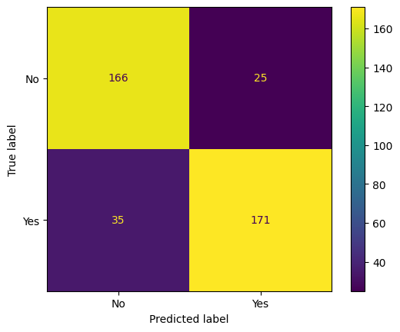
Figure 6: Classification Metrics of Tuned Random Forest Model for Hypertension Prediction

The tuned Random Forest model demonstrates strong and well-balanced performance in predicting hypertension status. Using the optimal hyper parameters (100 trees, square-root feature sampling, and no depth restriction), the model achieved an accuracy of approximately 84.9%, indicating that it correctly classified the majority of individuals in the test dataset. The confusion matrix shows that the model identified 166 non-hypertensive and 171 hypertensive individuals correctly, with relatively few misclassifications, suggesting good overall discrimination between the two classes.

The classification report further supports this conclusion. Precision and recall values are consistently high across both outcome categories. For non-hypertensive individuals, a recall of 0.87 indicates that most true negatives were correctly identified, reducing the risk of false reassurance. For hypertensive individuals, a precision of 0.87 and recall of 0.83 suggest that the model is effective at detecting true cases while keeping false positives at a reasonable level. The identical F1-scores (0.85) for both classes indicate balanced predictive performance, which is particularly important in health-related applications where bias toward one class could have serious implications.

Overall, the results suggest that the selected predictors capture meaningful patterns associated with hypertension. The model’s stable performance across metrics highlights its suitability as a reliable predictive tool for hypertension risk assessment in population-based or clinical decision-support contexts.

Optimized Gradient Boosting Model.

Class | Precision | Recall | F1-score | Support
No | 0.84 | 0.83 | 0.83 | 191
Yes | 0.84 | 0.85 | 0.85 | 206
Accuracy | — | — | 0.84 | 397
Macro Avg | 0.84 | 0.84 | 0.84 | 397
Weighted Avg | 0.84 | 0.84 | 0.84 | 397

Table 25: Performance Metrics of Optimized Gradient Boosting Model for Hypertension Prediction
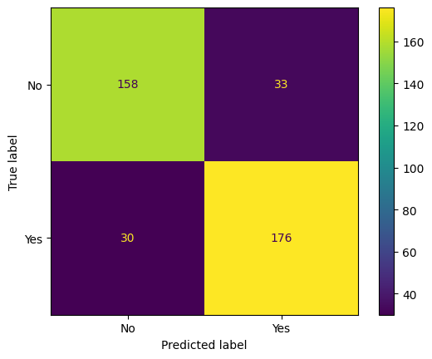
Figure 7: Classification Metrics of GBM for Hypertension Prediction

The Gradient Boosting Model (GBM) demonstrates strong and well-balanced performance in predicting hypertension status after hyper-parameter tuning. Using a relatively conservative learning rate (0.01), shallow trees (maximum depth of 2), and sub-sampling (0.8), the model prioritizes generalization and reduces over-fitting while steadily improving predictive accuracy. The overall accuracy of 84.1% indicates that the model correctly classifies a substantial majority of individuals in the test set.

The confusion matrix shows that the model correctly identified 176 hypertensive individuals and 158 non-hypertensive individuals, with a moderate number of mis-classifications. Importantly, recall for the hypertensive class is high (0.85), suggesting that the model is effective at detecting individuals with hypertension, which is particularly valuable in public health and clinical screening contexts where missed cases can have serious consequences. Precision is also balanced across classes (0.84), indicating a low rate of false positives.

The F1-scores for both classes (0.83–0.85) and the identical macro and weighted averages (0.84) further confirm that the model performs consistently across groups without class bias. Overall, the GBM provides a reliable and robust predictive framework for hypertension classification, capturing complex nonlinear relationships among risk factors while maintaining interpretability and stability.

Prediction Model
Machine learning models were applied to predict hypertension using key demographic, physiological, and behavioural factors. The optimized Random Forest, with 100 trees, square-root feature sampling, and unrestricted depth, achieved 84.9% accuracy, correctly classifying 166 non-hypertensive and 171 hypertensive individuals, with balanced precision and recall (~0.83–0.87) and F1-scores of 0.85. The Gradient Boosting Model, with a conservative learning rate (0.01), shallow trees (max depth 2), and 0.8 subsampling, achieved 84.1% accuracy, with similarly balanced performance (~0.83–0.85). Both models captured nonlinear interactions effectively, but Random Forest slightly outperformed GBM, making it the preferred choice for reliable hypertension risk prediction in clinical and population contexts.

Conclusion
This report presents a thorough, data-driven analysis of factors influencing hypertension and the development of an effective predictive model. Inferential analyses highlighted age, BMI, stress, smoking status, family history, and prior blood pressure as significant contributors to hypertension, confirming established clinical patterns. Conversely, exercise level and medication type exhibited no meaningful association in this dataset and were therefore excluded from predictive modelling.

Leveraging these insights, machine learning approaches were employed to construct robust predictive models. The Random Forest classifier, after hyper parameter optimization, demonstrated the best performance, achieving 84.9% accuracy with well-balanced precision and recall across hypertensive and non-hypertensive cases. This underscores the advantage of integrating inferential statistics with advanced predictive analytics to identify key risk factors while capturing complex nonlinear interactions.

Overall, the study showcases how a structured analytical workflow from exploratory data analysis to model optimization can transform raw health data into actionable intelligence. The final predictive model offers a reliable tool for hypertension risk stratification, supporting targeted screening, informed clinical decision-making, and evidence-based preventive strategies.

REFRENCES
Burnier, M., & Wuerzner, G. (2015). Pathophysiology of Hypertension (pp. 655–683). Adis, Cham. https://doi.org/10.1007/978-3-319-15961-4_31
Dagher, T. H., & Beck, L. (2024). Hypertension (pp. 260–261). Oxford University Press. https://doi.org/10.1093/med/9780197584569.003.0104
Hypertension (pp. 774-C305.S12). (2023). Oxford University Press eBooks. https://doi.org/10.1093/med/9780197584521.003.0304
Koenig, H. G., VanderWeele, T. J., & Peteet, J. R. (2024). Hypertension (pp. 397–415). Oxford University Press. https://doi.org/10.1093/oso/9780190088859.003.0021
Mazhar, S., Rafi, U., & Noreen, A. (2023). Hypertension: Causes, Symptoms, Treatment and Prevention. Pakistan Biomedical Journal, 02–07. https://doi.org/10.54393/pbmj.v6i04.858
Mirza, M., Nishath, S. H., & Saeed, F. U. (2024). The Silent Storm: Understanding Hypertension. International Journal of Innovative Science and Research Technology, 3405–3415. https://doi.org/10.38124/ijisrt/ijisrt24apr1387
Thalib, A. (2025). Hypertension Causes, Impacts, and Control Strategies In The Modern Era. 2(1: February), 12–19. https://doi.org/10.64914/249e0j45

