Table of Contents

1. Creating an Azure Pass Subscription 2

1.1 Retrieve your Promo Code 2

1.2 Activate your subscription. 2

2. Create a Github Account 2

2.1 Sign up a github account. 3

3. Working with github 3

3.1 Create your first project / Repository. 3

3.2 Forking existing Repository 3

3.3 Cloning Repository 3

3.4 Submitting Commits into Repository 3

4. Build Docker Image 3

4.1 Create Azure Resources (Build Machine) 4

4.2 Install Docker Dependencies 4

4.3 Clone the Sample Application 5

4.4 Build Container Image from Sample Application 5

4.5 Create Azure Container Registry and Publish the Image. 5

5. Deploy the docker image 6

5.1 Deploy into Web App. 6

5.2 Deploy into AKS 6

# Creating an Azure Pass Subscription

## Retrieve your Promo Code

* Collect your Promo code from your instructor.
* To redeem a promo code, visit [www.microsoftazurepass.com](https://www.microsoftazurepass.com/)
* Create a “New Live Account”

**Note: It is recommended you close all browsers and open a new In-Private Browser session. Other logins can persist and cause errors during the activation step.**

## Activate your subscription.

* When the redemption process is completed, it will redirect to the sign up page.
* Enter your account information and click “Next”.
* Access https://portal.azure.com , ensure your Azure pass subscriptions is activated.

# Create a Github Account



## Sign up a github account.

* Visit [**www.github.com**](http://www.github.com/) then click on sign up
* Enter your email address & create password.
* Provide the necessary information and complete the account creation process.

# Working with github



## Create your first project / Repository.

* Understand ReadME file.
* Understand .gitignore
* Understand License.

## Forking existing Repository

* Navigate to the repository then fork it.

## Cloning Repository

git clone https://github.com/edwinpantony1/demo.git

## Submitting Commits into Repository

git init

git add .

git commit -m "Some Meaningful message"

git remote add origin https://github.com/edwinpantony1/CodersHQ.git

git push origin main

# Build Docker Image



## Create Azure Resources (Build Machine)

#Step1 - Create a resource group

az group create --name codershq --location eastus

#Step2 - Create a virtual network

az network vnet create --name hqvnet1 --resource-group codershq --subnet-name devspace --address-prefix 172.16.45.0/24 --subnet-prefix 172.16.45.0/26

#Step3 - Create a docker virtual machine

az vm create --resource-group codershq --name dockervm01 --image cognosys:docker-ce-with-centos-7-7-free:docker-ce-with-centos-7-7-free:1.2019.0710 --admin-username dockeradmin --admin-password Docker#123987 --size standard_D2s_v3 --location eastus --public-ip-address-allocation static --vnet-address-prefix 172.16.45.0/24 --vnet-name hqvnet1 --subnet devspace

Login to Azure Linux Virtual Machine

From Azure Cloud Shell

SSH dockeradmin@PublicIP

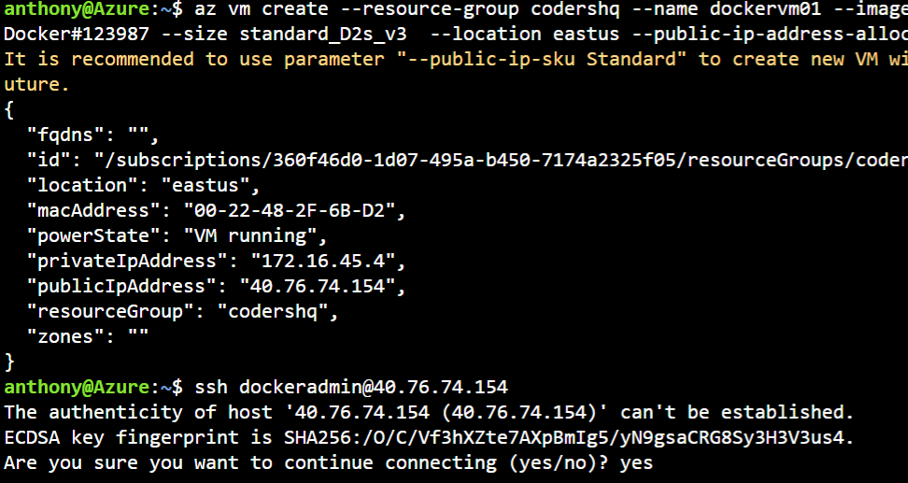

## Install Docker Dependencies

#Step1 - Install Docker-Compose

sudo curl -L "https://github.com/docker/compose/releases/download/1.29.2/docker-compose-$(uname -s)-$(uname -m)" -o /usr/local/bin/docker-compose

sudo mv /usr/local/bin/docker-compose /usr/bin/docker-compose

sudo chmod +x /usr/bin/docker-compose

sudo gpasswd -a $USER docker

newgrp docker

sudo su $USER

systemctl status docker.service

#Step2 -Install GIT

sudo yum install git

git config --global user.name "Antony Prem"

git config --global user.email "edwinpantony@hotmail.com"

## Clone the Sample Application

#Step1 - Clone the Sample Application

git clone https://github.com/aedwinp/demo.git

## Build Container Image from Sample Application

#Step1 - Build the docker image.

Docker-compose up

**Note: To test the applications locally.**

Allow port no 2000 inbound request through Network Security Group.

Access the public IP through from any browser.

Eg- http://publicip :2000

## Create Azure Container Registry and Publish the Image.

**Login to AZ CLI Console.**

#Step1 – Create Azure Container registry

az acr create -n uniquenameacr -g codershq --sku Standard

Note: Ensure name is unique

Also Record the Resource ID value.

/subscriptions/360f46d0-1d07-495a-b450-7174a2325f05/resourceGroups/codershq/providers/Microsoft.ContainerRegistry/registries/c23hqacr

#Step2 – Publish Image into Registry

Note – Ensure Copy the Secrets from the ACR.

**Now Login to Linux VM console**

#Step3 – To login to ACR

docker login c23hqacr.azurecr.io --username c23hqacr --password jHQ=fbTmANZS6tRGd3=s+0fXT8PSTb1C

#Step3 – To verify the recently build images

Docker images

#Step4 – To tag the image

docker image tag tailwindtraders/web c23hqacr.azurecr.io/twtweb

#Step4 – To publish the image into ACR

docker image push c23hqacr.azurecr.io/twtweb

# Deploy the docker image



## Deploy into Web App.

Deploy through Portal.

## Deploy into AKS

**Login to AZ CLI Console.**

#Step1 – To get the existing resource ID of ACR

az acr show --name c23hqacr.azurecr.io

#Step1 – Create a AKS Cluster

az aks create -n myAKSCluster -g codershq --generate-ssh-keys --attach-acr /subscriptions/360f46d0-1d07-495a-b450-7174a2325f05/resourceGroups/codershq/providers/Microsoft.ContainerRegistry/registries/c23hqacr

az aks create -n myAKSCluster -g aks --generate-ssh-keys --os-sku CBLMariner --nodepool-tags --attach-acr /subscriptions/360f46d0-1d07-495a-b450-7174a2325f05/resourceGroups/1-DOCKER/providers/Microsoft.ContainerRegistry/registries/twtcr

#Step2 – Create Cluster Binding

az aks get-credentials -g codershq -n myAKSCluster

#Step3 – Create Manifesto File.

Create Deployment + Service YAML File.

Kubectl apply -f deployment.yml

Kubectl apply -f service.yml