Task 1

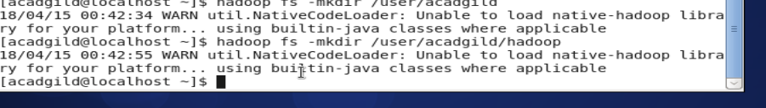

Task 2
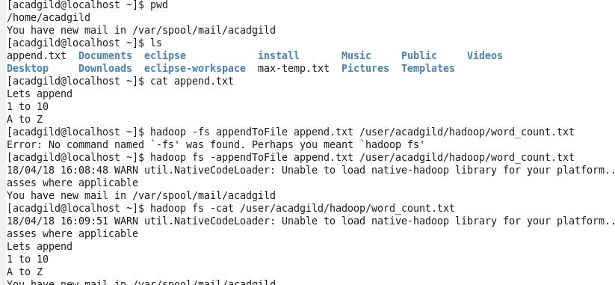

Task3

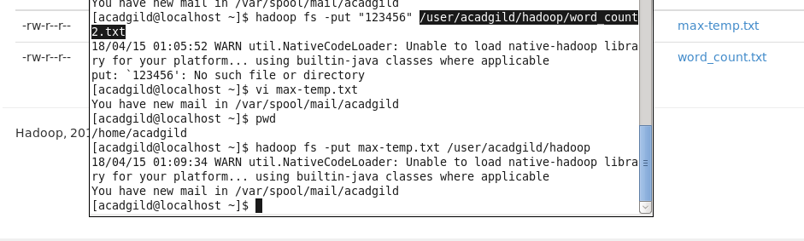

Task4
