
Project-based Practical Report on
“Digital Leave and On-Duty (OD) Application System”
Submitted in partial fulfilment of the requirements for
“Practical Course Title” for the 1st Semester
Master of Computer Applications (MCA)

Submitted by
Edwin Saji | 26MCAC22

Under the guidance of
<Guide Name>
Contents
1. Title of the Project
2. Introduction
3. Objective of the Project
4. Scope of the Project
5. Software Specifications
6. Workflow of the Project
7. Modules of the Project - Phase-wise explanation of design and execution of Modules
8. Source Code (Only functional code structure)
9. Features of the Project
10. Requirements Analysis
11. Use Case Descriptions
12. System Architecture
13. Database Design Overview
14. Input Validation and Error Handling
15. Testing
16. Security Considerations and Known Limitations
17. Installation and Execution Guide
18. Application Screenshots
19. Glossary
20. References
21. Future Enhancement
22. Conclusion

Title of the Project
Digital Leave and On-Duty (OD) Application System
A web-based academic leave automation portal engineered to manage collegiate student on-duty clearances, enforcing multi-tier institutional approval routing and automated policy compliance.
Introduction
The Digital Leave and On-Duty (OD) Application System is an academic web application designed to automate and streamline the management of student on-duty clearances and collegiate leave workflows. In modern higher education institutions, undergraduate and postgraduate students are frequently called upon to represent their academic departments and the college in a wide variety of co-curricular and extra-curricular activities. These activities include inter-collegiate technical symposia, national-level hackathons, coding marathons, paper presentation contests, sports tournaments, cultural festivals, recruitment drives, and industrial internships. When students represent the institution at such sanctioned events, institutional bylaws permit them to claim 'On-Duty' (OD) status. This status officially excuses their absence from regular lectures and laboratory sessions, ensuring that their formal attendance percentage is maintained and protected from penalty.
In traditional academic settings, this on-duty process is administered manually through physical paper forms. The existing manual approach introduces severe administrative friction. Students must acquire a paper slip, write out personal and course information by hand, attach physical documentation such as competition brochures or registration confirmations, and physically navigate across university facilities to collect ink signatures. A single application typically requires sequential endorsements from the event faculty coordinator, the student's designated class mentor, multiple subject teachers, and finally the Head of the Department (HOD).
This paper-based mechanism leads to widespread administrative inefficiencies. Paper forms are frequently misplaced on faculty desks or lost during transit between departments, resulting in unnecessary anxiety for students who are tracking their attendance records. Furthermore, manual forms do not allow for the real-time tracking of institutional policies. Colleges enforce strict academic bylaws, including a non-negotiable 3-day post-event submission deadline and a maximum semester quota of 15 on-duty days per student. In a manual paper workflow, faculty members have no mechanism to instantaneously verify whether a student has already exceeded their semester quota without cross-referencing physical department logbooks, which is rarely done during a busy working day.
Additionally, paper slips are highly vulnerable to unauthorized alteration and forged signatures. Late submissions submitted weeks after an event conclude often force institutional ERP operators to perform manual, retroactive updates to attendance databases, causing disputes during semester examination hall ticket generation.
The Digital Leave and OD Application System solves these fundamental problems by centralizing all leave activities into a role-gated web platform. Students can submit requests online, monitor the live progress of their applications, and view their remaining semester quota in real time. Faculty mentors can examine submitted proof and verify requests with a single click, and the Head of Department can grant executive approval. By embedding institutional policies directly into software logic, the system guarantees that no student can apply for retroactive leave beyond the 3-day limit, prevents overlapping bookings, and automatically enforces the 15-day semester ceiling.
The application is developed using standard Enterprise Java technologies, specifically Java Servlets, JavaServer Pages (JSP), Java Database Connectivity (JDBC), and MySQL, running on the Apache Tomcat 9 web server. Overall, the system replaces paper clutter, reduces approval turnaround time from days to seconds, and provides a transparent digital audit trail for the entire department.

Objectives
Main Objective
To provide a centralized, secure web-based system to automate the collegiate leave and On-Duty application lifecycle. This includes providing online submission forms for students, automated multi-tier approval routing (Student -> Staff -> HOD), real-time status tracking, and programmatic enforcement of institutional regulations such as submission deadlines, category duration caps, and semester quotas.
Specific Objectives:
1. Student Account Registration and Authentication
Allow potential students and registered scholars to authenticate securely with the system using their unique institutional credentials. This includes validating student credentials against records stored securely in MySQL and establishing role-gated access privileges. Upon verification, the system instantiates an isolated HTTP session holding the student's roll number, name, and department.
The authentication module performs rigorous validation to ensure that unauthenticated users cannot access student or administrative dashboards. If authentication fails, the application returns clear user feedback without disclosing sensitive system details.
2. Online Application Composition and Submission
Provide an intuitive web interface for students to draft and submit OD applications. The interface captures event classification, event title, host institution, authorizing coordinator or club, starting date, ending date, and detailed explanatory justification.
The form provides instantaneous pre-checks to ensure all required fields are complete before submitting, preventing empty or malformed submissions from reaching the database.
3. Automated 3-Day Submission Deadline Enforcement
Enforce the institutional bylaw requiring all on-duty applications to be submitted within three calendar days of completing the duty. The system calculates the temporal difference between the event end date and current system time, programmatically blocking late submissions.
This rule prevents retrospective duty manufacturing and ensures that attendance records remain up to date and auditable throughout the academic term.
4. Strict 15-Day Semester Quota Management
Maintain institutional attendance standards by continuously tracking the cumulative number of approved and pending duty days per student. The system automatically rejects any new application that would cause the student to exceed the 15-day ceiling in a single semester.
The system calculates the student's used quota dynamically before accepting any new submission, displaying remaining days directly on the student dashboard.
5. Date Chronology and Temporal Overlap Validation
Ensure data consistency by verifying that the selected end date is chronologically equal to or after the start date. Additionally, the system evaluates proposed dates against active applications to prevent duplicate or overlapping bookings for the same student.
This safeguard eliminates double-booking errors and prevents students from claiming multiple on-duty leaves across identical calendar dates.
6. Category-Specific Duration Bounds
Enforce institutional policies regarding event categories, ensuring that maximum allowable duty days correspond directly to the event type (e.g., maximum 2 days for recruitment interviews, 3 days for technical symposia, 5 days for hackathons and sports championships, and 7 days for industrial training).
These category ceilings ensure that duty days granted align proportionately with the academic importance and nature of the activity.
7. First-Tier Staff Scrutiny and Verification
Provide faculty advisors and class mentors with a departmental verification dashboard. Staff members can inspect the student's registration details, event context, and justification, and mark the application as Verified or Rejected with mandatory explanatory comments.
This module ensures that student claims undergo preliminary academic scrutiny by the responsible mentor before escalating to executive approval.
8. Second-Tier Executive HOD Approval
Provide the Head of Department with an executive sanction queue displaying only those applications that have successfully passed staff verification. The HOD can grant final Approved status or record an executive rejection.
Once approved by the HOD, the leave record is officially recognized, and the requested days are permanently debited against the student's semester quota.
9. Real-Time Analytical Dashboard Metrics
Compute and display live statistical summary cards across all user dashboards. Students can review total applications, approved days, pending requests, and their remaining semester quota balance in real time.
Faculty and HOD dashboards similarly display real-time counts of pending verification and sanction requests, streamlining daily departmental administration.
10. Historical Audit Ledger and Transparency
Provide students and faculty with an immutable historical ledger of all past applications. Students can review application IDs, date spans, durations, review statuses, and faculty remarks without consulting outside records.
This historical transparency prevents disputes over past attendance clearances and ensures that every decision remains permanently traceable.
11. Two-Tier Defensive Validation Architecture
Implement immediate client-side validation in Vanilla JavaScript to provide instant user feedback on form errors, duplicated with strict server-side validation in Java Servlets to prevent bypass via disabled client scripts.
This defense-in-depth model ensures optimal user experience while maintaining absolute server-side security.
12. Defensive Relational Persistence via JDBC
Store all user profiles, roles, quotas, and application states in a normalized MySQL relational database. The application executes all database operations using native JDBC PreparedStatement parameterized queries to eliminate SQL injection vulnerabilities.
Transactions maintain relational consistency, ensuring that user updates and application states remain synchronized.
13. Role-Based Session Security and Access Control
Implement server-managed HttpSession tracking to ensure that users are strictly restricted to features authorized for their specific role. Students cannot access staff review queues, and staff cannot access executive HOD endpoints.
Direct URL invocations by unauthorized roles are intercepted and redirected to an access denial page.
Summary
These objectives establish a complete system for managing academic on-duty requests. The project focuses on student accessibility, multi-tier faculty verification, policy compliance, and auditability, creating a solid base for collegiate administrative automation.

Scope
The Digital Leave and On-Duty Application System is designed to manage the core leave and on-duty clearance workflows within an academic collegiate environment. The application enables users to participate either as students or as administrative faculty (staff mentors and HODs). The system connects a responsive browser interface to a Java backend and a persistent MySQL database.
Student Section
Students can access the application using their institutional credentials (register number and password). Upon logging in, students can review their personalized dashboard containing key metrics such as total applications submitted, approved days, pending reviews, and their remaining semester quota out of 15 allowable days.
Students can open the on-duty application form and select an event category, input the event title, specify the authorizing club or faculty coordinator, and pick the starting and ending dates of the event. The application verifies that all required fields are complete, that the dates follow proper chronological order, that the event ended within the allowable 3-day post-event window, and that the requested duration does not breach the 15-day semester quota. Students can also review their complete application history, checking the status of pending requests and reading remarks entered by faculty reviewers.
The student module gives applicants continuous visibility over their leave portfolio without requiring physical visits to faculty offices or departmental administrative counters.
Staff Advisor Section
This section of the application provides faculty mentors and class advisors with tools to inspect and verify student on-duty applications. Staff members can view a dedicated verification queue listing all pending applications submitted by students in their department. Mentors can examine the student's register number, name, event metadata, date range, and submitted justification.
Staff advisors have the authority to mark an application as 'Verified' (which forwards it to the HOD's executive queue) or 'Rejected' (which terminates the application workflow). When rejecting an application, staff members can enter explanatory comments providing clear guidance to the applicant.
This preliminary scrutiny ensures that all submissions are legitimate and backed by proper event documentation before escalating to the department head.
Head of Department (HOD) Section
The HOD section serves as the final executive clearance tier for institutional attendance records. The HOD can access an executive queue that displays exclusively those applications that have already undergone first-tier staff verification. The HOD can review the application details alongside the staff endorsement and make the final determination: granting official 'Approved' status or marking the application as 'Rejected'.
Once approved by the HOD, the leave record is officially recognized, and the requested days are permanently debited against the student's 15-day semester quota.
The executive overview provides departmental leadership with high-level visibility over student co-curricular activities, ensuring that departmental academic standards remain well protected.
Data & Application Processing
All data relating to students, faculty advisors, user credentials, roles, application records, and approval states is stored inside a relational MySQL database. When users log in, open dashboards, submit requests, or take review actions, the application interacts with MySQL. The browser interface communicates with the backend through standard HTTP POST and GET requests handled by Java Servlets. The servlets process incoming form data, execute business rules, and use JDBC to query and update the database.
Database transactions use foreign keys with cascading updates and deletes to preserve referential integrity across the system.
Target Users
The application is targeted at members of the academic department: undergraduate and postgraduate students applying for on-duty leave, faculty advisors performing preliminary scrutiny, and departmental heads issuing final attendance clearances. The system is designed to streamline administrative tasks and improve departmental transparency.
Limitations & Scope
This project is intentionally focused on the management of leave and on-duty requests and related academic policies. It does not include features for timetabling lecture hours, scheduling examinations, managing staff payroll, or directly controlling physical biometric door turnstiles. The current version communicates status updates through web dashboards rather than third-party transactional SMS or email APIs. These boundaries keep the project focused on core leave management while leaving room for future enhancements.

Software Specifications
The Digital Leave and OD Application System uses a combination of programming languages, frameworks, database software, and user-interface technologies. The browser application runs through the Apache Tomcat web server and uses MySQL to store all records.
Software Used
Component | Specification | Purpose
Programming language | Java 17 / Java 21 | Implements backend business logic, servlets, and data models.
Server-side technology | Java Servlets (Servlet API 4.0) | Handles HTTP requests, session management, and routing.
View technology | JavaServer Pages (JSP 2.3) | Renders dynamic HTML pages and displays database records.
Web server | Apache Tomcat 9.0.x | Hosts and executes the Java web application and servlets.
Database | MySQL Community Server 8.0 | Stores user accounts, student profiles, and OD requests.
Database access | JDBC (Java Database Connectivity) | Connects the Java application to MySQL and runs SQL queries.
Database driver | MySQL Connector/J 8.0.x | Enables binary communication between Java and MySQL.
Browser interface | HTML5, CSS3, JavaScript | Provides responsive web pages, styling, and client-side validation.

Runtime and Configuration
The project is configured to use Java 17 or Java 21 and is built for deployment on Apache Tomcat 9. To run the application, a compatible Java runtime environment (JRE/JDK) must be available. Apache Tomcat must be installed and configured.
The application connects to a MySQL database named digital_od. MySQL Community Server must be installed and running locally on TCP port 3306. The database connection parameters are defined in the service.DBConnection utility class, which establishes the connection URL, username, and driver class.
Apache Tomcat runs the web application listening on HTTP port 8080. The web interface can be opened in any standard browser at http://localhost:8080/DigitalODSystem when the server is running locally.
Client Requirements
To access the web interface, a modern web browser with JavaScript enabled is required (such as Google Chrome, Mozilla Firefox, or Microsoft Edge). The project does not require any specialized browser plugins or third-party client software. A computer display capable of showing standard web forms, data tables, and modal dialogs is required.
Operating System and Hardware
The application does not depend on a proprietary operating system. It runs reliably on Windows 10, Windows 11, and Linux distributions supporting Java and MySQL. In general, the host computer should have a modern multi-core processor (Intel Core i3/i5 or AMD Ryzen equivalent), at least 8 GB of RAM, and sufficient solid-state storage to accommodate Tomcat binaries, MySQL tablespaces, and server logging buffers.

Workflow
The Digital Leave and On-Duty Application System is organized into three main functional areas: student operations, staff verification, and HOD approval. Within the web interface, users interact with forms and tables to submit requests to Java Servlets. The servlets process requests, enforce academic bylaws, and query or update the MySQL database before returning responses to the browser.
1. Starting the application
The Apache Tomcat web server starts up and initializes the application context on port 8080. The user opens the system URL in a browser and is presented with the login page.
2. User login and role identification
The user enters their username and password. When submitted, LoginServlet validates the credentials against the users table. If the credentials match an existing account, the servlet retrieves the user's role (student, staff, or hod) and profile data, creates an HttpSession, and redirects the browser to the appropriate role dashboard. If the login fails, an error message is returned to the login screen.
3. Student application drafting and date selection
A student logs in and clicks 'Apply for On-Duty'. In the application modal, the student selects the event category, enters the event name, specifies the authorizing body or mentor, and inputs the start date (fromDate) and end date (toDate). The student also provides a detailed explanation for their absence.
4. Automated rule enforcement and submission
Client-side JavaScript performs preliminary checks on date order and the 3-day deadline. When the form is submitted, ApplyODServlet re-verifies these checks on the server. The servlet ensures that toDate is chronologically after fromDate, verifies that the event ended within 3 days of the current date, checks that the requested duration matches category limits, verifies that the student does not have an active overlapping request, and verifies that the new days will not exceed the 15-day semester quota. If all checks pass, the application is saved in MySQL with initial statuses: staff_status = 'Pending' and hod_status = 'Pending'.
5. Staff verification
A staff advisor logs in to access the departmental verification queue. The dashboard displays all pending applications from their department. The advisor reviews the student's register number, event details, and justification. The advisor clicks 'Verify' (updating staff_status to 'Verified' and forwarding the request to the HOD) or 'Reject' (updating staff_status to 'Rejected' and recording an explanatory remark).
6. Head of Department approval
The HOD logs in to view the executive approval queue, which displays only staff-verified applications. The HOD evaluates the final request and clicks 'Approve' (updating hod_status to 'Approved') or 'Reject'. Once approved by the HOD, the leave is officially sanctioned, and the requested days are permanently debited against the student's 15-day semester quota.
7. Viewing application history
Students can open their personal history section to review all past applications. The system retrieves historical records from MySQL, displaying date spans, durations, current review statuses, and faculty remarks.
8. Logout
Users can log out at any time. LogoutServlet terminates the server-side HttpSession, clears client cookies, and returns the browser to the login screen.
Overall Request Flow
User action -> Browser interface -> Java Servlet (doPost/doGet) -> Validation and Business Logic -> MySQL database via JDBC -> Response/Redirect -> Result displayed to user.

Phase-wise explanation:
The Digital Leave and On-Duty Application System was constructed in structured phases. These are the phases and technologies utilized throughout the project.
Phase 1: Set up and Basic Design
The first phase established the structural foundation of the application and the relational data entities. The project schema was designed to store two core entities: users (encapsulating authentication credentials, roles, roll numbers, and department affiliations) and od_requests (storing student usernames, event classifications, event titles, authorizing coordinators, date spans, duration counts, justifications, and approval statuses).
Domain models were authored in the model package: User.java and ODRequest.java. These plain Java objects represent database records in memory, providing constructor overloads, accessors, and helper methods such as isFullyApproved() and isAnyRejected() to simplify status evaluation.
Basic validation rules were established to ensure complete data entry, including mandatory field checks, valid date formatting, and credential verification.
Phase 2: Structured Programming and Custom Exception Handling
The Java files were organized into a clean package hierarchy: model, service, controller, and exception. Each layer has an explicit responsibility. The service package defines service interfaces (AuthService, ODService) and concrete implementations (AuthServiceImpl, ODServiceImpl) that manage business rules and database communication.
To avoid exposing raw database or runtime exceptions to users, a dedicated checked exception InvalidInputException.java was implemented in the exception package. It intercepts validation errors—such as deadline violations, quota exceedances, and date overlaps—and encapsulates user-readable messages that are returned to the controller layer.
Phase 3: Web Interface
The web interface was developed using HTML5, CSS3, and JavaScript. The interface comprises login.html, student_dashboard.jsp, staff_dashboard.jsp, and hod_dashboard.jsp. The CSS stylesheet defines a clean, responsive layout with distinct status badges (amber for Pending, green for Verified/Approved, and red for Rejected).
Client-side validation was implemented in JavaScript (od_validation.js). It performs instant mathematical checks: verifying non-empty fields, ensuring end dates do not precede start dates, computing requested days, and warning students if an event ended more than 3 days prior.
Phase 4: Server Side
Server-side request handling was implemented using standard Java Servlets extending HttpServlet: LoginServlet, ApplyODServlet, UpdateODStatusServlet, and LogoutServlet. Servlets parse incoming HTTP parameters, verify active session identity, invoke service methods, and issue redirects with appropriate query status flags.
Database connectivity was implemented using native JDBC PreparedStatement parameterized queries inside DBConnection.java, guaranteeing immunity to SQL injection. User state and role permissions are maintained across requests using server-side HttpSession tracking.
Summary of the Phases
Application data model -> Structured Java packages and custom exceptions -> Browser forms and JS validation -> Java Servlets, JDBC persistence, and session security.

Source Code (Only functional code structure)
This section presents the project structure and selected code excerpts that illustrate how the application functions. The excerpts focus on database connectivity, custom exception handling, servlet request processing, and client-side validation.
Project Structure
DigitalODSystem/
├── WEB-INF/
│ └── web.xml
├── css/
│ └── style.css
├── js/
│ └── od_validation.js
├── model/
│ ├── User.java
│ └── ODRequest.java
├── service/
│ ├── DBConnection.java
│ ├── AuthService.java
│ ├── AuthServiceImpl.java
│ ├── ODService.java
│ └── ODServiceImpl.java
├── controller/
│ ├── LoginServlet.java
│ ├── ApplyODServlet.java
│ ├── UpdateODStatusServlet.java
│ └── LogoutServlet.java
├── exception/
│ └── InvalidInputException.java
├── login.html
├── student_dashboard.jsp
├── staff_dashboard.jsp
└── hod_dashboard.jsp
1. Application Database Connection
DBConnection.java provides a centralized connection factory using the JDBC DriverManager to establish connections to the MySQL database.
package service;
import java.sql.Connection;
import java.sql.DriverManager;
import java.sql.SQLException;
public class DBConnection {
private static final String URL = "jdbc:mysql://localhost:3306/digital_od?useSSL=false&serverTimezone=UTC";
private static final String USER = "root";
private static final String PASSWORD = "password123";
static {
try {
Class.forName("com.mysql.cj.jdbc.Driver");
} catch (ClassNotFoundException e) {
System.err.println("MySQL Driver not found: " + e.getMessage());
}
}
public static Connection getConnection() throws SQLException {
return DriverManager.getConnection(URL, USER, PASSWORD);
}
}
2. Custom Domain Exception
InvalidInputException.java reports validation and institutional policy violations such as date errors or quota exceedances.
package exception;
public class InvalidInputException extends Exception {
private static final long serialVersionUID = 1L;
public InvalidInputException(String message) {
super(message);
}
public InvalidInputException(String message, Throwable cause) {
super(message, cause);
}
}
3. Domain Entity Model (User.java)
User.java represents the authenticated academic stakeholder in memory, encapsulating identity and role claims.
package model;
import java.io.Serializable;
public class User implements Serializable {
private static final long serialVersionUID = 1L;
private int id;
private String username;
private String password;
private String role; // 'student', 'staff', 'hod'
private String rollNo;
private String fullName;
private String department;
private String course;
public User() {}
public User(int id, String username, String role, String rollNo, String fullName, String department) {
this.id = id;
this.username = username;
this.role = role;
this.rollNo = rollNo;
this.fullName = fullName;
this.department = department;
}
public int getId() { return id; }
public void setId(int id) { this.id = id; }
public String getUsername() { return username; }
public void setUsername(String username) { this.username = username; }
public String getPassword() { return password; }
public void setPassword(String password) { this.password = password; }
public String getRole() { return role; }
public void setRole(String role) { this.role = role; }
public String getRollNo() { return rollNo; }
public void setRollNo(String rollNo) { this.rollNo = rollNo; }
public String getFullName() { return fullName; }
public void setFullName(String fullName) { this.fullName = fullName; }
public String getDepartment() { return department; }
public void setDepartment(String department) { this.department = department; }
public String getCourse() { return course; }
public void setCourse(String course) { this.course = course; }
}
4. Service Layer Interface Contract (ODService.java)
ODService.java defines the business contract for on-duty validation, quota tracking, and status transitions.
package service;
import exception.InvalidInputException;
import java.util.List;
import model.ODRequest;
public interface ODService {
boolean applyOD(ODRequest request) throws InvalidInputException;
List<ODRequest> getODRequestsByStudent(String username);
List<ODRequest> getPendingRequestsForStaff(String department);
List<ODRequest> getVerifiedRequestsForHOD();
int getUsedODDays(String username);
int getRemainingQuota(String username);
boolean updateStaffStatus(int requestId, String status, String remarks);
boolean updateHodStatus(int requestId, String status, String remarks);
}
5. User Authentication Controller (LoginServlet.java)
LoginServlet.java intercepts login credentials, validates against MySQL, and initializes role-based sessions.
package controller;
import java.io.IOException;
import javax.servlet.*;
import javax.servlet.annotation.WebServlet;
import javax.servlet.http.*;
import model.User;
import service.AuthService;
import service.AuthServiceImpl;
@WebServlet("/loginServlet")
public class LoginServlet extends HttpServlet {
private static final long serialVersionUID = 1L;
private final AuthService authService = new AuthServiceImpl();
@Override
protected void doPost(HttpServletRequest request, HttpServletResponse response)
throws ServletException, IOException {
String username = request.getParameter("username");
String password = request.getParameter("password");
if (username == null || username.trim().isEmpty() ||
password == null || password.trim().isEmpty()) {
response.sendRedirect("login.html?error=missing_credentials");
return;
}
User user = authService.authenticate(username.trim(), password.trim());
if (user != null) {
HttpSession session = request.getSession(true);
session.setAttribute("loggedInUser", user.getUsername());
session.setAttribute("role", user.getRole());
session.setAttribute("rollNo", user.getRollNo());
session.setAttribute("fullName", user.getFullName());
session.setAttribute("department", user.getDepartment());
if ("student".equalsIgnoreCase(user.getRole())) {
response.sendRedirect("student_dashboard.jsp");
} else if ("staff".equalsIgnoreCase(user.getRole())) {
response.sendRedirect("staff_dashboard.jsp");
} else if ("hod".equalsIgnoreCase(user.getRole())) {
response.sendRedirect("hod_dashboard.jsp");
} else {
response.sendRedirect("login.html");
}
} else {
response.sendRedirect("login.html?error=invalid_credentials");
}
}
}
6. Domain Entity Model (ODRequest.java)
ODRequest.java represents an individual on-duty application instance in memory, providing state tracking methods.
package model;
import java.io.Serializable;
public class ODRequest implements Serializable {
private static final long serialVersionUID = 1L;
private int id;
private String studentUsername;
private String rollNo;
private String eventType;
private String eventName;
private String authorizedBody;
private String fromDate;
private String toDate;
private int daysCount;
private String reason;
private String staffStatus; // Pending, Verified, Rejected
private String hodStatus; // Pending, Approved, Rejected
private String createdAt;
public ODRequest() {}
public ODRequest(String studentUsername, String rollNo, String eventType,
String eventName, String authorizedBody, String fromDate,
String toDate, int daysCount, String reason) {
this.studentUsername = studentUsername;
this.rollNo = rollNo;
this.eventType = eventType;
this.eventName = eventName;
this.authorizedBody = authorizedBody;
this.fromDate = fromDate;
this.toDate = toDate;
this.daysCount = daysCount;
this.reason = reason;
this.staffStatus = "Pending";
this.hodStatus = "Pending";
}
public int getId() { return id; }
public void setId(int id) { this.id = id; }
public String getStudentUsername() { return studentUsername; }
public String getRollNo() { return rollNo; }
public String getEventType() { return eventType; }
public String getEventName() { return eventName; }
public String getFromDate() { return fromDate; }
public String getToDate() { return toDate; }
public int getDaysCount() { return daysCount; }
public String getReason() { return reason; }
public String getStaffStatus() { return staffStatus; }
public void setStaffStatus(String s) { this.staffStatus = s; }
public String getHodStatus() { return hodStatus; }
public void setHodStatus(String s) { this.hodStatus = s; }
}
4. Database-Based Authentication Service
AuthServiceImpl.java checks submitted credentials against the users table using a parameterized query.
package service;
import java.sql.*;
import model.User;
public class AuthServiceImpl implements AuthService {
@Override
public User authenticate(String username, String password) {
String sql = "SELECT * FROM users WHERE username = ? AND password = ?";
try (Connection conn = DBConnection.getConnection();
PreparedStatement ps = conn.prepareStatement(sql)) {
ps.setString(1, username.trim());
ps.setString(2, password.trim());
try (ResultSet rs = ps.executeQuery()) {
if (rs.next()) {
return new User(
rs.getInt("id"),
rs.getString("username"),
rs.getString("role"),
rs.getString("roll_no"),
rs.getString("full_name"),
rs.getString("department")
);
}
}
} catch (SQLException e) {
e.printStackTrace();
}
return null;
}
}
5. OD Application Processing Servlet
ApplyODServlet.java handles OD submissions and verifies the 3-day post-event deadline.
package controller;
import exception.InvalidInputException;
import model.ODRequest;
import service.ODService;
import service.ODServiceImpl;
import javax.servlet.*;
import javax.servlet.annotation.WebServlet;
import javax.servlet.http.*;
import java.io.IOException;
import java.time.LocalDate;
import java.time.temporal.ChronoUnit;
@WebServlet("/applyODServlet")
public class ApplyODServlet extends HttpServlet {
private final ODService odService = new ODServiceImpl();
@Override
protected void doPost(HttpServletRequest request, HttpServletResponse response)
throws ServletException, IOException {
HttpSession session = request.getSession(false);
if (session == null || session.getAttribute("loggedInUser") == null) {
response.sendRedirect("login.html");
return;
}
String username = (String) session.getAttribute("loggedInUser");
String rollNo = (String) session.getAttribute("rollNo");
String eventType = request.getParameter("eventType");
String eventName = request.getParameter("eventName");
String authorizedBody = request.getParameter("authorizedBody");
String fromDateStr = request.getParameter("fromDate");
String toDateStr = request.getParameter("toDate");
String reason = request.getParameter("reason");
try {
LocalDate fromDate = LocalDate.parse(fromDateStr.trim());
LocalDate toDate = LocalDate.parse(toDateStr.trim());
if (toDate.isBefore(fromDate)) {
throw new InvalidInputException("To Date cannot precede From Date.");
}
long daysPassed = ChronoUnit.DAYS.between(toDate, LocalDate.now());
if (daysPassed > 3) {
throw new InvalidInputException("OD must be submitted within 3 days of duty completion.");
}
int daysCount = (int) ChronoUnit.DAYS.between(fromDate, toDate) + 1;
ODRequest od = new ODRequest(username, rollNo, eventType, eventName,
authorizedBody, fromDateStr, toDateStr, daysCount, reason);
odService.applyOD(od);
response.sendRedirect("student_dashboard.jsp?status=success");
} catch (InvalidInputException e) {
response.sendRedirect("student_dashboard.jsp?status=error&msg=" + e.getMessage());
}
}
}
6. Status Update and Review Servlet
UpdateODStatusServlet.java processes approvals and rejections from staff and HOD.
package controller;
import service.ODService;
import service.ODServiceImpl;
import javax.servlet.*;
import javax.servlet.annotation.WebServlet;
import javax.servlet.http.*;
import java.io.IOException;
@WebServlet("/updateODStatusServlet")
public class UpdateODStatusServlet extends HttpServlet {
private final ODService odService = new ODServiceImpl();
@Override
protected void doPost(HttpServletRequest request, HttpServletResponse response)
throws ServletException, IOException {
HttpSession session = request.getSession(false);
if (session == null || session.getAttribute("role") == null) {
response.sendRedirect("login.html");
return;
}
String role = (String) session.getAttribute("role");
int requestId = Integer.parseInt(request.getParameter("requestId"));
String action = request.getParameter("action"); // 'verify', 'approve', 'reject'
String remarks = request.getParameter("remarks");
if ("staff".equalsIgnoreCase(role)) {
String newStatus = "verify".equalsIgnoreCase(action) ? "Verified" : "Rejected";
odService.updateStaffStatus(requestId, newStatus, remarks);
response.sendRedirect("staff_dashboard.jsp?status=updated");
} else if ("hod".equalsIgnoreCase(role)) {
String newStatus = "approve".equalsIgnoreCase(action) ? "Approved" : "Rejected";
odService.updateHodStatus(requestId, newStatus, remarks);
response.sendRedirect("hod_dashboard.jsp?status=updated");
} else {
response.sendRedirect("login.html?unauthorized=1");
}
}
}
7. Client-Side JavaScript Validation
od_validation.js performs immediate checks in the browser before form submission.
document.addEventListener("DOMContentLoaded", () => {
const form = document.getElementById("odForm");
if (!form) return;
form.addEventListener("submit", (e) => {
const fromDateVal = document.getElementById("fromDate").value;
const toDateVal = document.getElementById("toDate").value;
if (!fromDateVal || !toDateVal) {
alert("Please enter both start and end dates.");
e.preventDefault();
return;
}
const fromDate = new Date(fromDateVal);
const toDate = new Date(toDateVal);
const today = new Date();
today.setHours(0, 0, 0, 0);
if (toDate < fromDate) {
alert("To Date cannot be earlier than From Date.");
e.preventDefault();
return;
}
const diffDays = Math.floor((today - toDate) / (1000 * 60 * 60 * 24));
if (diffDays > 3) {
alert("Policy Violation: OD must be submitted within 3 days of event completion.");
e.preventDefault();
return;
}
});
});
How the Main Code Parts Work Together
The web workflow follows this sequence:
Browser Form -> JavaScript client validation -> Form submission via HTTP POST -> ApplyODServlet intercepts request -> Session authentication confirmed -> Business rules checked in ODServiceImpl -> Parameterized SQL executed via JDBC in DBConnection -> MySQL database updated -> Response redirect sent to browser -> Updated status rendered in JSP.

Features of the Project
The Digital Leave and On-Duty Application System includes various aspects of student leave management and institutional policy enforcement. The following features are available in the application:
1) Student Login and Authentication Students log in using their username (register number) and password. The system checks credentials against the users table. If the details match an active student account, the student dashboard opens. If login fails, an error message is displayed on the login page.
2) Online Application for On-Duty Students can apply for on-duty leave through an interactive web form. Students select the event category, enter the event name and host institution, specify the authorizing club or coordinator, and input the date range. All fields are validated before submission.
3) Strict 3-Day Rule Enforcement The application programmatically rejects applications submitted more than three calendar days after the conclusion of the duty. This eliminates post-hoc leave manufacturing and ensures timely record keeping.
4) 15-Day Semester Quota Management The system tracks cumulative duty days per student. When a new request is submitted, the system checks whether the requested days combined with existing approved days will exceed 15 days. If the quota is exceeded, the request is rejected with a clear message.
5) Date Chronology Validation The system ensures that the selected end date is chronologically equal to or after the start date, preventing inverted date errors.
6) Duplicate Date Overlap Prevention The application checks existing records to ensure a student does not submit multiple applications spanning overlapping dates, preventing double-booking.
7) Category-Specific Duration Bounds Institutional limits on allowable duration per event category are enforced automatically (e.g., maximum 2 days for placements, 3 days for symposia, 5 days for hackathons/sports, and 7 days for industrial training).
8) Staff Verification Queue Faculty advisors can view all pending requests originating from students in their department. Staff can review submitted justifications and mark requests as Verified or Rejected with written feedback.
9) Head of Department Approval The Head of Department can access verified requests and grant final institutional approval or record an executive rejection.
10) Real-Time Dashboard Metrics Student dashboards display live summary cards for Total Applications, Approved Days, Pending In-Review Requests, and Remaining Semester Quota (calculated dynamically as 15 - Approved Days).
11) Historical Application Ledger Students can view their full leave history, including unique application IDs, event details, date ranges, duration counts, staff status, HOD status, and reviewer comments.
12) Two-Tier Defensive Validation Validation occurs in JavaScript for instantaneous browser feedback and is strictly repeated on the server in Java Servlets to prevent unauthorized bypass.
13) Secure Data Storage via JDBC All data is stored safely in MySQL. Queries use parameterized PreparedStatement interfaces to ensure complete protection against SQL injection attacks.
Summary
These features provide a complete digital replacement for manual paper leave forms, giving students, faculty advisors, and departmental leadership full visibility, compliance, and control over on-duty clearances.

Requirements Analysis
This section lists what the application is expected to do and the operational conditions it works under. The requirements are grouped into functional requirements and non-functional considerations.
Functional Requirements
ID | Requirement | Role
FR-01 | User can log in with username and password; system identifies role. | All Users
FR-02 | System creates secure HttpSession upon valid authentication. | All Users
FR-03 | Student can submit OD request with category, title, endorsement, and dates. | Student
FR-04 | System calculates total days: (toDate - fromDate) + 1. | System
FR-05 | System rejects requests where toDate is earlier than fromDate. | Student
FR-06 | System rejects requests submitted more than 3 days after event completion. | Student
FR-07 | System tracks used days and blocks submissions exceeding 15-day semester quota. | Student
FR-08 | System rejects applications with dates overlapping existing active requests. | Student
FR-09 | System stores new applications with initial status Pending. | System
FR-10 | Student dashboard displays live metrics and remaining quota balance. | Student
FR-11 | Staff advisor can view pending requests from their department. | Staff
FR-12 | Staff advisor can mark request as Verified or Rejected with comments. | Staff
FR-13 | HOD can view staff-verified applications awaiting executive approval. | HOD
FR-14 | HOD can grant final Approval or mark request as Rejected. | HOD
FR-15 | Student can view historical ledger of all past applications and remarks. | Student
FR-16 | User can log out, invalidating the session and returning to login page. | All Users

Non-Functional Considerations
Usability: The interface is organized into clean, dedicated pages for login, student operations, staff verification, and HOD approval. Form errors are displayed in plain language adjacent to inputs.
Maintainability: The Java code is divided by responsibility following the MVC pattern. Presentation (JSP), request routing (Servlets), business rules (Services), and database operations (JDBC) are separated cleanly.
Portability: The project runs on any system supporting Java 17/21, Apache Tomcat 9, and MySQL 8.0.
Data Integrity: Foreign key constraints ensure referential consistency between users and applications. Parameterized queries prevent malformed SQL statements.
Security: Server-side role checks and session validation prevent unauthorized privilege escalation.
Assumptions and Constraints
The project assumes MySQL 8.0 is running on port 3306 with the digital_od database initialized. Student, faculty, and HOD accounts are provisioned in the database. Days are counted as continuous calendar working days.

Use Case Descriptions
Use cases describe how actors interact with the system to achieve specific goals. Below are the primary use cases for students, staff advisors, and the Head of Department.
UC-01 Login
Actor: Student / Staff / HOD
Preconditions: Account exists in the database; user has navigated to login page.
Main Flow: 1. User enters username and password. 2. LoginServlet queries users table. 3. System identifies user role. 4. System creates HttpSession and redirects user to their role dashboard.
Alternatives: If credentials do not match, error message 'Invalid username or password' is shown.
Post Conditions: User is authenticated and viewing their dashboard.
UC-02 Submit OD Application
Actor: Student
Preconditions: Student is logged in; remaining semester quota > 0.
Main Flow: 1. Student opens application form. 2. Inputs category, title, authorizing body, start date, end date, and justification. 3. Client JS validates date order and 3-day deadline. 4. Form submitted to ApplyODServlet. 5. Server checks 3-day deadline, quota, and date overlap. 6. Application saved in MySQL with Pending status.
Alternatives: If the event ended more than 3 days ago or exceeds quota, an InvalidInputException is raised and displayed on the dashboard.
Post Conditions: New OD application stored in MySQL.
UC-03 Staff Verification
Actor: Staff Advisor
Preconditions: Staff is logged in; pending departmental requests exist.
Main Flow: 1. Staff opens staff dashboard. 2. Reviews pending student applications. 3. Clicks 'Verify'. 4. UpdateODStatusServlet updates staff_status to Verified. 5. Application advances to HOD queue.
Alternatives: Staff clicks 'Reject' and inputs remarks; status updates to Rejected.
Post Conditions: Application status updated; advances to HOD or terminates.
UC-04 Staff Rejection
Actor: Staff Advisor
Preconditions: Staff is logged in; reviewable application is selected.
Main Flow: 1. Staff examines application. 2. Determines documentation is invalid or insufficient. 3. Inputs rejection justification remarks. 4. Clicks 'Reject'. 5. System records staff_status = 'Rejected'.
Alternatives: If remarks are blank, system prompts staff to enter mandatory rejection reason.
Post Conditions: Application marked as Rejected; workflow terminates; remarks visible to student.
UC-05 HOD Executive Approval
Actor: Head of Department
Preconditions: HOD is logged in; verified requests exist.
Main Flow: 1. HOD views verified requests on HOD dashboard. 2. Reviews application and clicks 'Approve'. 3. UpdateODStatusServlet updates hod_status to Approved. 4. Requested days debited from student quota.
Alternatives: HOD clicks 'Reject'; status updates to Rejected.
Post Conditions: Application officially approved; leave granted.
UC-06 HOD Executive Rejection
Actor: Head of Department
Preconditions: HOD is logged in; application is in executive queue.
Main Flow: 1. HOD reviews application. 2. Selects 'Reject'. 3. Enters executive remarks. 4. System updates hod_status = 'Rejected'.
Alternatives: None.
Post Conditions: Application marked as Rejected; workflow terminates.
UC-07 View Application History
Actor: Student
Preconditions: Student is logged in.
Main Flow: 1. Student opens history section. 2. Browser requests applications from database. 3. System retrieves records and displays dates, duration, review statuses, and faculty comments.
Alternatives: If no applications exist, a message states no records are found.
Post Conditions: Student views history; no data modified.
UC-08 Check Remaining Quota Balance
Actor: Student
Preconditions: Student is logged in.
Main Flow: 1. Student opens dashboard. 2. System tallies approved days from database. 3. System calculates remaining = 15 - approved. 4. Renders live metric card on interface.
Alternatives: If student has utilized all 15 days, remaining displays as 0 Days and application button triggers a warning.
Post Conditions: Student is informed of their exact remaining quota balance.

System Architecture
The Digital Leave and On-Duty Application System follows a layered Model-View-Controller (MVC) structure. The browser presents web pages and collects form inputs. The Java Servlets receive requests, validate them, and apply the rules of the system. MySQL stores the data. Keeping these responsibilities separate makes it easier to understand where a given behavior is implemented and where to look when something has to change.
Layers
Presentation layer: login.html, student_dashboard.jsp, staff_dashboard.jsp, and hod_dashboard.jsp define the pages and forms. style.css controls layout, typography, and visual appearance. od_validation.js responds to user actions, performs preliminary date math, and prevents invalid submissions before they reach the server.
Controller layer: LoginServlet.java, ApplyODServlet.java, UpdateODStatusServlet.java, and LogoutServlet.java expose the application endpoints, validate incoming request parameters, enforce session and role security, and decide which response or view redirect to return.
Service and Model layer: User.java and ODRequest.java encapsulate data models. AuthService.java, AuthServiceImpl.java, ODService.java, and ODServiceImpl.java execute business rules, verify date overlaps and semester quotas, and coordinate database queries.
Data layer: A MySQL database named digital_od holds all user credentials, academic profiles, quotas, and application records. The application reaches it through JDBC using the MySQL Connector/J driver configured in DBConnection.java.
Responsibilities of the Main Files
File | Responsibility
DBConnection.java | Holds the database URL, username, driver class, and provides thread-safe JDBC connections.
User.java | Entity class representing student, staff, and HOD accounts with roll numbers and department claims.
ODRequest.java | Entity class representing an on-duty application instance with event metadata, dates, and approval states.
AuthService.java | Interface declaring the authentication contract for checking user credentials.
AuthServiceImpl.java | Implements authentication using JDBC PreparedStatement queries against the users table.
ODService.java | Interface declaring methods for applying for OD, checking quotas, and updating statuses.
ODServiceImpl.java | Implements business rules including 3-day deadline, 15-day quota, and date overlap checks.
LoginServlet.java | Handles login authentication, initializes HttpSession, and routes users to role dashboards.
ApplyODServlet.java | Intercepts student OD submissions, validates timelines, and invokes the service layer.
UpdateODStatusServlet.java | Processes review actions from staff mentors and the Head of Department.
LogoutServlet.java | Invalidates server-side session state, clears cookies, and redirects to the login screen.
InvalidInputException.java | Custom checked exception reporting policy breaches and validation failures.
login.html | Unified login portal interface for students, staff advisors, and departmental heads.
student_dashboard.jsp | Student dashboard displaying live quota cards, application modal, and historical ledger.
staff_dashboard.jsp | Faculty mentor interface listing pending departmental applications with review actions.
hod_dashboard.jsp | Executive dashboard for the Head of Department displaying verified requests for sanction.
od_validation.js | Client-side JavaScript performing date difference math and enforcing the 3-day deadline in browser.
style.css | Clean, responsive light-themed styling, layout grids, cards, and status badge colors.

Life of a Request
The submission of an on-duty request illustrates how the system layers cooperate. The student inputs the event title, category, authorizing club, start date, and end date into the application form and clicks submit. The JavaScript listener in od_validation.js intercepts the click, confirms that both dates are present, verifies that toDate is chronologically after fromDate, and calculates whether more than 3 days have elapsed since the event ended. If valid, the browser submits an HTTP POST request to /applyODServlet.
ApplyODServlet receives the request, confirms that the user has an active session, and extracts the student's register number from session memory. The servlet calls the service method odService.applyOD(). The service implementation queries MySQL to determine how many duty days the student has already utilized in the current semester. It also checks whether the proposed dates overlap with any active pending or approved applications. If the student has exceeded the 15-day quota or if an overlap is detected, an InvalidInputException is thrown.
If all checks pass, the service constructs a parameterized SQL INSERT statement and persists the new application in the od_requests table with initial status Pending. The servlet catches any domain exceptions and issues an HTTP redirect back to student_dashboard.jsp with a query parameter indicating success or the specific validation error. The JSP view then re-renders the dashboard, displaying the updated application row in the student's history table.
Why a Java Servlet & JSP MVC Design Was Used
The project uses native Java Servlets, JSP, and JDBC rather than complex modern enterprise frameworks like Spring Boot. This approach was chosen to reinforce fundamental software engineering competencies and demonstrate mastery of core Java EE web architecture. Servlets provide complete, low-level control over the HTTP request-response cycle, header manipulation, and session lifecycle.
Using plain Servlets and JSP also avoids the substantial configuration overhead, dependency management complexity, and heavy memory footprint associated with modern microservice frameworks. The resulting application deploys rapidly on a standard Apache Tomcat container, starts up within seconds, and executes database transactions with minimal runtime latency.

Database Design Overview
The application keeps its data in a MySQL relational database named digital_od. The database holds two primary categories of information: user accounts used for authentication and profile management, and on-duty application records. This chapter describes each table and how the tables relate to one another.
Tables and Their Purpose
Table: users
Column | Type | Description
id | INT AUTO_INCREMENT PK | Unique internal user identifier.
username | VARCHAR(50) UNIQUE | Unique login username (register number or faculty code).
password | VARCHAR(100) | Account password credential.
role | VARCHAR(20) | Role designation: 'student', 'staff', or 'hod'.
roll_no | VARCHAR(30) | Academic roll number for students; staff ID for faculty.
full_name | VARCHAR(100) | Full legal name of the user.
department | VARCHAR(100) | Academic department association.
course | VARCHAR(50) | Degree program or designation.

Table: od_requests
Column | Type | Description
id | INT AUTO_INCREMENT PK | Unique application tracking reference number.
student_username | VARCHAR(50) FK | References users(username) with cascading updates/deletes.
roll_no | VARCHAR(30) | Student register number for audit and reconciliation.
event_type | VARCHAR(100) | Event classification (e.g., Symposium, Hackathon, Sports).
event_name | VARCHAR(200) | Specific title and host institution of the event.
authorized_body | VARCHAR(150) | Endorsing student club, department, or faculty coordinator.
from_date | DATE | Start date of the requested duty tenure.
to_date | DATE | End date of the requested duty tenure.
days_count | INT | Total requested working days: (toDate - fromDate) + 1.
reason | TEXT | Detailed justification and explanation of duty.
staff_status | VARCHAR(30) | First-tier review status: 'Pending', 'Verified', 'Rejected'.
hod_status | VARCHAR(30) | Final executive status: 'Pending', 'Approved', 'Rejected'.

Entity Relationships
A student can submit many on-duty requests over the course of a semester, but each on-duty request belongs to exactly one student. This one-to-many relationship is maintained through the foreign key constraint on student_username referencing users(username). Faculty advisors and the Head of Department do not own application records; instead, they act as authorized evaluators who update the staff_status and hod_status columns.
Entity A | Entity B | Relationship Type | Enforcement Rule
User (Student) | OD Request | One-to-Many (1:N) | Foreign Key (student_username) with CASCADE
User (Staff) | OD Request | Reviewer-to-Record | State update on staff_status column
User (HOD) | OD Request | Sanctioner-to-Record | State update on hod_status column

How the Application Uses the Database
Read operations occur when users sign in, when students open their dashboard and view remaining quotas, when staff advisors review pending departmental applications, and when the HOD accesses verified requests. Write operations occur when a new OD request is submitted, when staff mark a request as Verified or Rejected, and when the HOD grants final approval.
In every case, database statements pass dynamic values through parameterized placeholders rather than string concatenation. This ensures that user inputs can never alter the structure of SQL commands, guaranteeing complete immunity to SQL injection vulnerabilities.
Input Validation and Error Handling
Validation protects the database from incomplete or invalid data and provides clear feedback to users. The application validates in two places: the browser performs preliminary checks in JavaScript for immediate user guidance, and Java Servlets repeat all checks on the server to prevent bypass.
Validation Rules
Field or Action | Validation Rule | Checked In | Feedback Message Shown
Login credentials | Username and password must not be empty | Browser & Server | Please enter username and password.
Required fields | All event fields and reasons must be filled | Browser & Server | Please complete all mandatory fields.
Date chronology | To Date cannot precede From Date | Browser & Server | To Date cannot be earlier than From Date.
3-Day deadline | Event end date must be within 3 days of today | Browser & Server | OD must be submitted within 3 days of duty completion.
15-Day quota | Used days + requested days cannot exceed 15 | Server | Exceeds maximum 15-day semester quota.
Date overlap | Dates cannot overlap active pending/approved OD | Server | Duplicate Date Conflict: Overlapping application found.
Category limit | Duration cannot exceed category maximum | Server | Duration exceeds allowable limit for this category.

Query Parameters and Status Codes Used
The application reports request outcomes using query parameters appended to redirects, which JSP views translate into visible alert messages on the page.
Status Flag | Meaning | Example Scenario
status=success | Operation completed successfully | OD application submitted; saved in MySQL.
status=error | Business rule violation occurred | Submission rejected because event ended 5 days ago.
status=updated | Review status updated successfully | Staff marked application as Verified.
error=invalid_credentials | Authentication failed | Login attempted with incorrect password.
unauthorized=1 | Unauthorized URL access attempt | Student tried to load staff_dashboard.jsp.

How Errors Reach the User
When a user submits an action that fails server validation, the servlet catches the resulting InvalidInputException, URL-encodes the explanatory message, and appends it to a redirect URL. When the destination JSP loads, a JSTL or scriptlet block inspects the query string and renders a styled alert box at the top of the interface. This ensures that users always receive plain-language guidance explaining why their request could not be processed.
Testing
Testing verifies that the Digital Leave and On-Duty Application System behaves exactly as described in the requirements. The tests below are functional tests carried out through the user interface against a local deployment on Apache Tomcat 9 and MySQL 8.0.
Test Approach
The tests were derived directly from the functional requirements matrix. They cover standard operational flows (such as valid login and timely application submission) as well as boundary conditions and deliberate policy breaches (such as inverted dates, submissions exceeding the 3-day deadline, and applications that would breach the 15-day semester quota).
Test Environment
Operating System: Microsoft Windows 11 | Language Runtime: Java JDK 17 LTS | Web Server: Apache Tomcat 9.0.x | Database Server: MySQL Community Server 8.0 | Web Browser: Google Chrome 118 with JavaScript enabled.
1. Registration and Authentication Tests
TC ID | Requirement | Input and Action | Expected Result | Result
TC-01 | FR-01 | Enter valid student credentials | Login succeeds; student dashboard opens. | Pass
TC-02 | FR-01 | Enter valid staff credentials | Login succeeds; staff dashboard opens. | Pass
TC-03 | FR-01 | Enter valid HOD credentials | Login succeeds; HOD dashboard opens. | Pass
TC-04 | FR-01 | Enter correct username with wrong password | Message: Invalid username or password. | Pass
TC-05 | FR-01 | Submit login form with both fields empty | Message: Please enter username and password. | Pass
TC-06 | FR-01 | Submit login with non-existent username | Message: Invalid username or password. | Pass
TC-07 | FR-16 | Select logout while logged in | Session invalidated; login page displayed. | Pass

2. Student Function and Policy Tests
TC ID | Requirement | Input and Action | Expected Result | Result
TC-08 | FR-03 | Submit valid OD within all policy rules | Success message; saved in database. | Pass
TC-09 | FR-05 | Submit request where toDate precedes fromDate | Message: To Date cannot precede From Date. | Pass
TC-10 | FR-06 | Submit OD for event completed 5 days ago | Message: Must be submitted within 3 days. | Pass
TC-11 | FR-06 | Submit OD for event completed exactly 3 days ago | Accepted; boundary verification succeeds. | Pass
TC-12 | FR-07 | Submit request exceeding 15-day semester quota | Message: Exceeds maximum 15-day quota. | Pass
TC-13 | FR-07 | Submit request consuming exact remaining quota | Accepted; remaining quota balance becomes 0. | Pass
TC-14 | FR-08 | Submit request with dates overlapping existing OD | Message: Duplicate date conflict detected. | Pass
TC-15 | FR-08 | Submit request on dates of a previously rejected OD | Accepted; rejected requests do not reserve dates. | Pass
TC-16 | FR-09 | Submit request with empty justification | Message: Reason / Details cannot be empty. | Pass
TC-17 | FR-15 | Open application history with existing records | Historical table rendered with correct badges. | Pass

3. Faculty Verification and Executive Approval Tests
TC ID | Requirement | Input and Action | Expected Result | Result
TC-18 | FR-11 | Staff opens dashboard with pending applications | Queue displays pending departmental requests. | Pass
TC-19 | FR-12 | Staff clicks Verify on pending application | Record updates: staff_status='Verified'. | Pass
TC-20 | FR-12 | Staff clicks Reject and enters feedback | Record updates: staff_status='Rejected'. | Pass
TC-21 | FR-13 | HOD opens dashboard with verified applications | Queue displays staff-verified applications. | Pass
TC-22 | FR-13 | Check if unverified requests appear for HOD | Unverified requests hidden from HOD view. | Pass
TC-23 | FR-14 | HOD clicks Approve on verified application | Record updates: hod_status='Approved'. | Pass
TC-24 | FR-14 | HOD clicks Reject on verified application | Record updates: hod_status='Rejected'. | Pass
TC-25 | FR-17 | Student navigates directly to staff dashboard URL | Filter blocks access; redirects to login. | Pass

Notes on Test Coverage
The test cases cover all functional requirements defined in Chapter 10. Every policy constraint—including the 3-day deadline, the 15-day quota ceiling, chronological date validation, and role-based URL access control—was exercised with positive and negative inputs. Automated unit testing with JUnit is listed under future enhancements to support continuous regression testing.

Security Considerations and Known Limitations
An academic platform that manages student leave records and attendance clearances must implement sound security practices, even when developed as a practical project. This chapter explains what measures are currently active, where the prototype falls short, and what a production deployment would require.
Measures Already in Place
Parameterized SQL Statements: Every database query across AuthServiceImpl and ODServiceImpl uses native JDBC PreparedStatement parameterized interfaces. By passing input values strictly through parameter placeholders, user inputs are never interpreted as executable SQL syntax, completely eliminating SQL injection vectors.
Server-Side Validation Enforcement: Although client-side JavaScript provides fast feedback in the browser, all date order checks, 3-day submission deadlines, and 15-day quota limits are rigorously re-verified on the server inside Java Servlets. This ensures that users cannot bypass rules by disabling JavaScript or using tools like Postman.
Role-Gated Session Control: Upon successful authentication, the user's role claim ('student', 'staff', or 'hod') is stored inside a server-managed HttpSession. Administrative servlets inspect session attributes before processing actions, preventing students from executing review endpoints.
Controlled Authentication Error Feedback: When sign-in fails, the application returns a generic message ('Invalid username or password') without revealing whether the username or password was the cause of the failure, preventing username enumeration.
Credentials Isolated from Documentation: Database passwords and environment configurations are excluded from shared source files and public version control repositories.
Known Limitations
Plain Text Password Comparison: In the current prototype, submitted passwords are matched directly against values stored in the users table. A commercial production system must store only salted hashes created using secure algorithms such as BCrypt or Argon2.
Transport Layer Security: The application runs locally over plain HTTP on port 8080. A production deployment requires HTTPS with TLS 1.3 certificates to prevent network eavesdropping and session cookie interception.
Absence of Account Lockout: The login endpoint does not currently enforce rate-limiting or lockout mechanisms after repeated failed attempts, leaving accounts vulnerable to automated brute-force password guessing.
Database Connection Pooling: Connections are established on demand via DriverManager. Under heavy concurrent collegiate loads, an enterprise connection pool such as HikariCP is required to maintain high throughput.
Recommended Next Steps
The most important security enhancements in order of priority are: implementing BCrypt password hashing, enforcing HTTPS transport security, adding CSRF tokens to all form submissions, and introducing rate limiting on the login servlet.
Installation and Execution Guide
This chapter explains how to prepare a development computer, compile the project, and run the Digital Leave and OD Application System.
Prerequisites
Software | Required Specification
Java Development Kit (JDK) | JDK 17 or JDK 21 LTS installed with JAVA_HOME configured.
Apache Tomcat | Apache Tomcat 9.0.x configured with webapps access.
MySQL Server | MySQL Community Server 8.0 running on default port 3306.
Web Browser | Google Chrome, Mozilla Firefox, or Microsoft Edge with JavaScript enabled.

Step-by-Step Installation Instructions
Step 1: Database Initialization: Start the local MySQL server. Open MySQL Workbench or the command line and create the database by executing: CREATE DATABASE digital_od;. Execute the schema.sql script to create the users and od_requests tables and load sample accounts.
Step 2: Database Configuration: Open service/DBConnection.java and verify that the database URL, username, and password match your local MySQL configuration.
Step 3: Compilation and Build: Compile the Java source files into bytecode classes and bundle them into the WEB-INF/classes folder under the project context.
Step 4: Tomcat Deployment: Deploy the project folder or WAR archive to Apache Tomcat's webapps directory. Start Tomcat via catalina.bat run or through your IDE.
Step 5: Access the Web Interface: Open a web browser and navigate to http://localhost:8080/DigitalODSystem/login.html.
Step 6: Log In with Academic Test Accounts: Log in using the pre-seeded accounts: Edwin Saji (student) using 'edwin21' / 'pass123', Staff Advisor using 'staffjacob' / 'jacob1234', or HOD using 'hodsmith' / 'hod1234'.

Troubleshooting Guide
Symptom | Likely Cause and Remedy
Application fails at startup with DB error | MySQL may not be running on port 3306, or DB credentials in DBConnection.java do not match.
Browser cannot reach localhost:8080 | Apache Tomcat is not running, or another service is occupying port 8080.
Valid login is rejected | Check that the username matches exactly and the user account exists in the MySQL users table.
Build fails with compiler error | Installed JDK version is older than Java 17. Verify that JAVA_HOME points to JDK 17 or higher.
Application Screenshots
This chapter shows the main screens of the Digital Leave and On-Duty (OD) Application System in use.
Figure 1: Login Screen

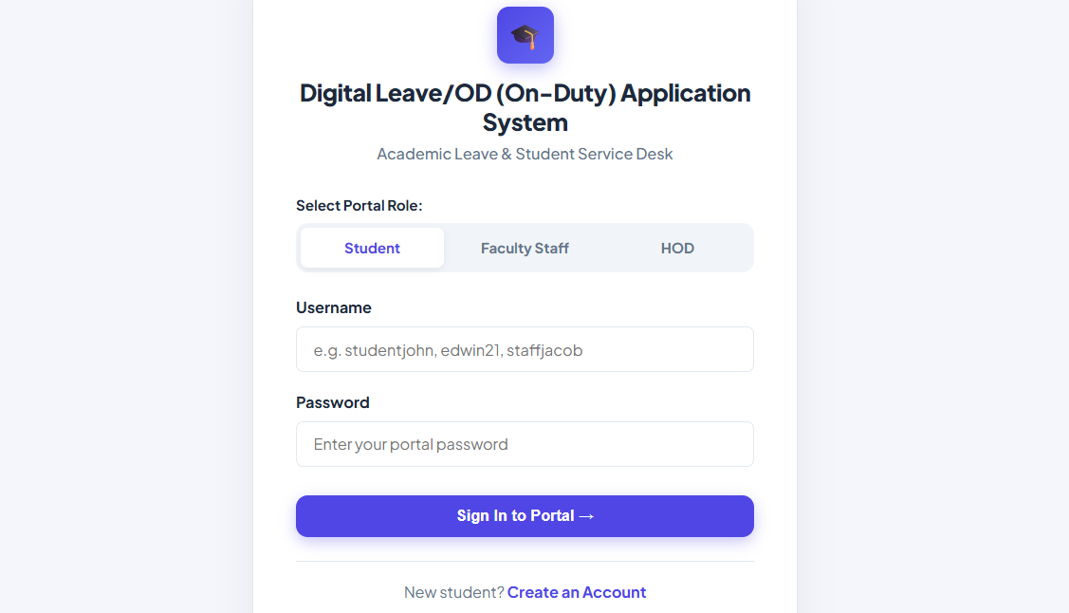

Figure 2: Student Dashboard & OD Quota Metrics

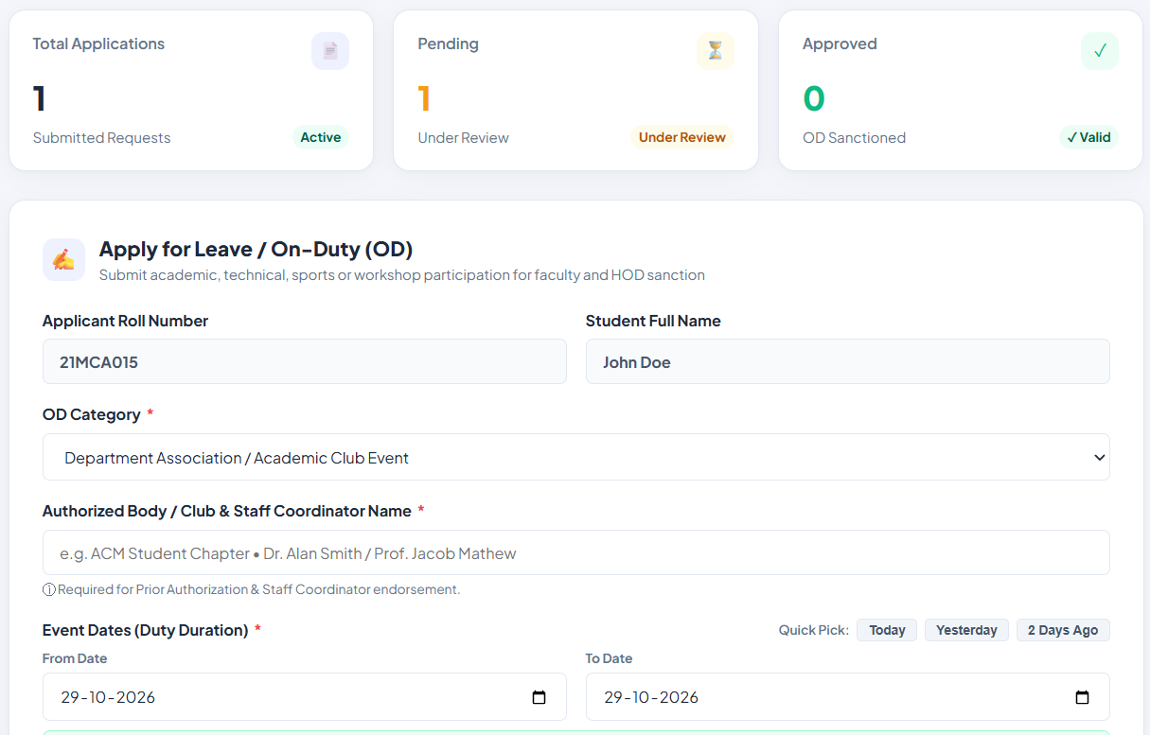
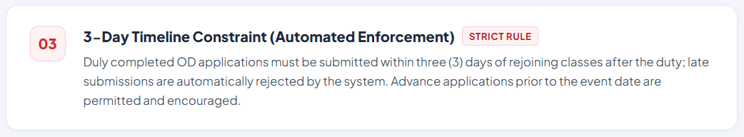here)
Figure 3: Apply for On-Duty (OD) Modal Form

Figure 4: Staff Advisor Verification Queue
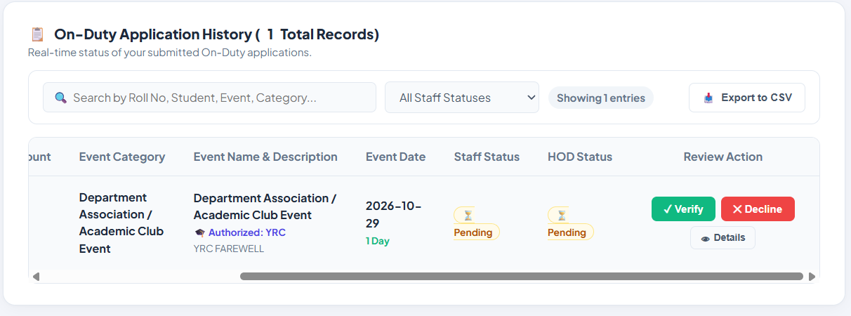

Figure 5: Head of Department (HOD) Approval Dashboard

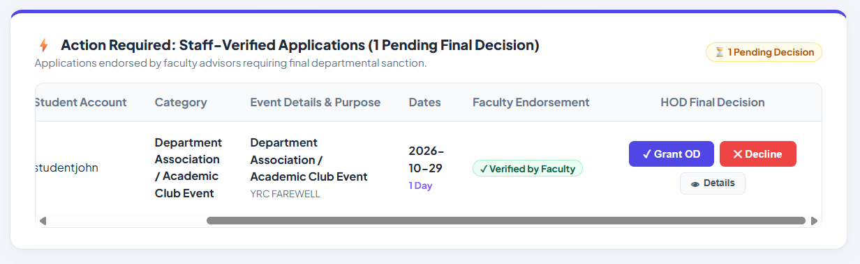

Figure 6: Application History & Approval Status

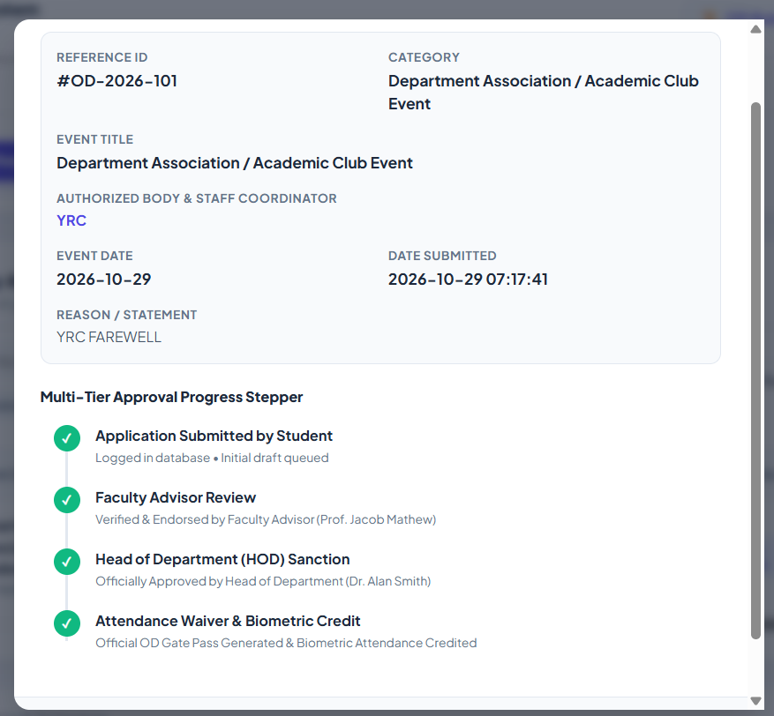)
Glossary
Term | Meaning
OD (On-Duty) | Authorized academic leave excusing attendance absence for sanctioned college activities.
Servlet | A Java program that runs on a web server to handle HTTP requests and generate responses.
JSP | JavaServer Pages, a server-side technology for generating dynamic HTML web pages.
JDBC | Java Database Connectivity, standard API connecting Java applications to relational databases.
MVC | Model-View-Controller, architectural pattern separating data, user interface, and routing logic.
PreparedStatement | Parameterized JDBC interface preventing SQL injection vulnerabilities.
HttpSession | Server-side mechanism for storing user identity and role between HTTP requests.

References
1. Oracle Corporation. Java Servlet Specification 4.0 (JSR 369). https://javaee.github.io/servlet-spec/
2. Apache Software Foundation. Apache Tomcat 9 Documentation. https://tomcat.apache.org/tomcat-9.0-doc/
3. MySQL Reference Manual. Oracle Corporation. https://dev.mysql.com/doc/
4. Mozilla Developer Network (MDN). HTML5, CSS3, and JavaScript Guides. https://developer.mozilla.org/
5. OWASP Foundation. SQL Injection Prevention Cheat Sheet. https://cheatsheetseries.owasp.org/

Future Enhancement
The Digital Leave and On-Duty Application System currently focuses on core leave application, multi-tier routing, and policy enforcement. The system could be extended in several ways to support broader campus operations. The enhancements below represent possible future developments.
1. Strengthen Account Security
A future version should improve how account credentials are stored and handled. Passwords should be stored as salted hashes rather than plain text, using an established hashing algorithm such as BCrypt or Argon2. The application could also introduce password reset functionality, account lockout after repeated failed sign-in attempts, and stricter password complexity rules.
Access control could be enhanced by implementing CSRF (Cross-Site Request Forgery) protection tokens on all form submissions and enforcing token-based session expiration. These improvements would protect student and faculty accounts from unauthorized access.
2. Biometric Attendance Integration
A significant future enhancement would be connecting the application directly with campus biometric turnstiles and RFID attendance logging machines. Once an on-duty request attains final approval from the Head of Department, an automated database trigger could update the central biometric attendance register, marking the student present for scheduled lecture hours during the approved date span.
This integration would eliminate the manual work currently required by department office staff to cross-check approved leaves and reconcile physical attendance sheets with the digital ERP system.
3. Multi-Channel Transactional Alerts
Currently, status updates are checked by logging into the portal. A future version could integrate transactional notification services using the JavaMail API or SMS webhooks (e.g., Twilio). Students would receive instant text messages or email alerts when their applications are verified or rejected, and faculty members would receive daily email summaries of pending review queues.
Automated reminders could also alert students when the 3-day submission window is close to expiring for a recent co-curricular activity.
4. Timetable ERP Schedule Synchronization
Connecting the on-duty system with the college ERP timetable database would allow the system to automatically cross-reference proposed leave dates against the student's actual lecture schedule.
The system could flag potential conflicts with mandatory laboratory sessions or internal continuous assessment tests, providing faculty reviewers with richer context.
5. Cryptographically Signed QR OD Slips
Upon final approval, the system could dynamically generate downloadable PDF clearance certificates (using libraries such as iText or Apache PDFBox). Each certificate could include an embedded, cryptographically signed QR code, allowing campus security guards and examination invigilators to instantly verify application authenticity using a handheld smartphone scanner.
This would eliminate paper stamp verification and provide immediate, tamper-proof proof of sanctioned duty across all campus entry points.
6. Dedicated Mobile Application
A cross-platform mobile application developed using Flutter or React Native could be introduced. The mobile app would connect to the Java backend via secure REST API endpoints, allowing students to submit applications, capture supporting documents with their phone cameras, and enabling faculty to issue approvals on mobile devices.
Push notifications on mobile devices would drastically cut down the approval turnaround time.
7. Expand Reporting and Dashboard Information
Administrative reports could help departmental leadership understand student engagement in co-curricular activities. Summaries could include total duty days granted per month, participation trends across categories (technical, cultural, sports), and export options to CSV or PDF formats.
These analytics would assist departmental heads in compiling annual academic accreditation reports for agencies such as NAAC and NBA.
8. Student Profile Self-Service
Students could be permitted to update selected contact details, such as their phone number or email address, without administrative intervention. The system would validate changes and notify mentors of sensitive profile updates.
Administrative oversight would still be required for institutional fields such as roll number and department.
9. Improve User Interface and Accessibility
The web interface could be further refined with enhanced accessibility features, such as high-contrast themes, full keyboard navigation support, and responsive layouts optimized for smaller tablet screens.
Screen-reader friendly markup and clear focus indicators would ensure the application conforms to WCAG accessibility guidelines.
10. Automated Database Backups and Reliability
Automated scheduled backups of the MySQL database and documented restoration procedures would ensure business continuity in the event of hardware or server failures.
Transaction logging and database replication could be explored for enterprise-scale deployments.
11. Add Automated Unit and Integration Testing
A comprehensive suite of automated tests using JUnit could be developed to test date validation logic, quota calculations, and servlet responses, ensuring system stability during future updates.
Continuous integration pipelines could automate regression testing before any new feature deployment.
12. Cloud Deployment and Containerization
The application could be containerized using Docker and deployed on cloud infrastructure (such as AWS or Microsoft Azure) with managed relational database services and automated load balancing.
This would enable horizontal scalability and 99.9% uptime during peak campus event seasons.
Conclusion
The Digital Leave and On-Duty (OD) Application System was developed to digitize and automate the collegiate leave process, replacing inefficient paper-based forms with an automated, role-gated web platform. The system brings together all essential on-duty tasks into a single unified environment, providing functions for students to submit requests, monitor review statuses, and track their remaining semester quota, while enabling faculty mentors and departmental heads to review, verify, and approve applications online.
The application connects a responsive browser interface to server-side Java logic and a relational MySQL database. The front-end pages are built with HTML5, CSS3, and JavaScript, while Java Servlets and JDBC handle request dispatching, business rule enforcement, and database transactions on an Apache Tomcat 9 web server. Together, these components demonstrate how an enterprise Model-View-Controller architecture can support an academic workflow.
An essential strength of the system is its deterministic enforcement of institutional academic policies. The application programmatically verifies the non-negotiable 3-day post-event submission deadline, caps cumulative duty tenure at 15 days per semester, enforces date chronology, and eliminates duplicate bookings across overlapping dates. These automated safeguards prevent policy violations and ensure fair, consistent academic administration across the department.
Input validation is applied defensively at two tiers: the browser provides instantaneous visual feedback to guide students during form completion, and server-side Java Servlets rigorously re-evaluate all rules before executing database updates. Parameterized PreparedStatement queries ensure that all database operations remain protected against SQL injection attacks.
The system has a clearly defined scope focused on leave and on-duty clearances. While it does not include wider ERP functions such as class scheduling or payroll, its modular architecture provides a solid starting point for future extensions, including biometric attendance integration, mobile applications, and automated notifications.
In conclusion, the Digital Leave and On-Duty Application System demonstrates how fundamental Java Enterprise technologies can be effectively harnessed to solve real-world administrative challenges. By eliminating paperwork, reducing processing latency, and ensuring compliance with academic bylaws, the system provides a practical, reliable, and scalable digital solution for modern collegiate administration.

