Bait Boat PI controller configuration

Procedure for setting the P and I values for auto steering

Requirements:
– Bait Boat
– USB cable (the common type with “A” and “B” connectors)
– Laptop or desktop PC that has the drivers installed to communicate with a Arduino board (software available at https://www.arduino.cc/en/Guide/Windows)
– PuTTY terminal emulator (free software, available at https://www.chiark.greenend.org.uk/~sgtatham/putty/latest.html)

Procedure:
– Bait Boat is powered off
– Connect the boat to the laptop or desktop computer using the USB-cable
– Switch on the bait boat
– Wait until Windows finishes driver installation
– Check the Windows device manager to see which COM-port the bait boat is at:
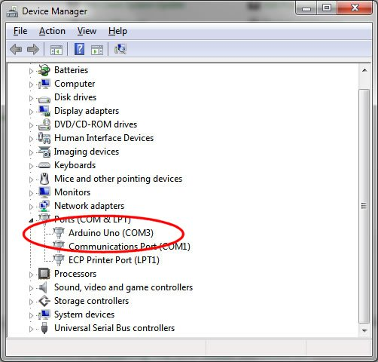
Remember the port number, in this case it's 3 but in your case it will probably be different.

– Start the PuTTY program

– In Putty, choose to make a serial connection:

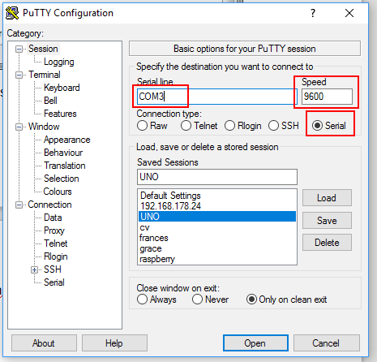

Make sure flow control is off:
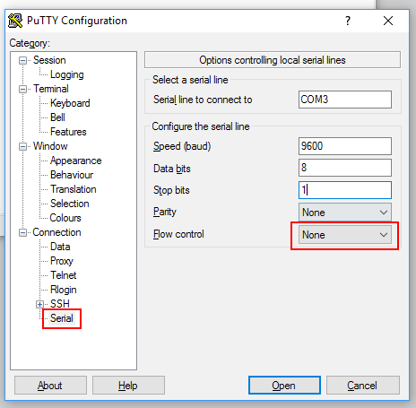

Go back to the session, and save your settings as “UNO”, so you can easily load them all at a later time:

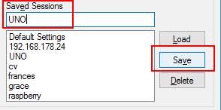
Now, connect to the bait boat:

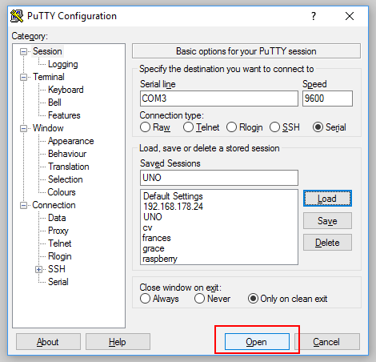
When connected to the bait boat, the program inside the boat responds to simple commands.

You will also notice it prints several status messages.
You can for instance switch between different kind of messages by typing 'c', 'g', 's' or 'e' (see below).

(compass calibration)
t: go to (compass) calibration mode
r: reset (forget) compass calibration
n: set current direction vessel is pointing at as (true) 'North'
(screens)
c: view compass data screen
g: view GPS data screen
s: view steering screen
e: servo capture screen
(settings)
p: (PID 'P'-action configuration)
i: (PID 'I'-action configuration)
(auto steer test screen)
a: go straight to auto steer mode
x: don't stop steering (even after arriving)
d: substitute PV compass heading (enter 0 for no substution)
o: substitute SP heading (enter 0 for no substitution)

"0123456789-+" (valid in PID configuration modi)

To change the P-action of the controller press 'p':
You then enter the desired (new) P setting (x1000).

Example:
'p' '1' '0' '0' (enter key)
Would set a value of 100 / 1000.0 = 0.1

To change the I-action of the controller press 'i':
You then enter the desired (new) P setting (x1000).

NOTE:
– The reason you enter it times 1000 is that the C-library on the Atmel does not support floating point parsing from a string. So the new setting is scanned as an integer and then gets divided by 1000 before being accepted by the rest of the program. The controller then uses the final floating point value for its internal calculations.
– Currently the P and I values are lost when the bait boat is switched off.

