Pack PickUp

**Proposal abstract**

Our applications want to resolve one of the most common problem faced by students, sending and receiving packages from home. Although there are some way through which parents send packages to their children (via bus or train) this is not very comfortable for either parent or student.

Pack PickUp want to help the students and parents in the above problem and proposes the next approach: if you are a student or someone who needs to receive a package then you enter our mobile application and search for someone who is traveling from, or is going through the city where you package is and if you think that person is trustworthy (this is based on comments and reviews from other users), you can get in touch to that person and negotiate the price for the package and also set up a delivery and pickup point for the package.

**Application setup**

First of all we need our users to login into to application so the other user know who are they talking with and also to help us and our user give reviews to people who offer to pick up their packages. For the login part we chose Facebook based login.

We need a database where we can store the information about who sends a package, from where he sends it and also who he picked to deliver the package, this is for the sender part and for the picker we will store when and where he will go to a specific city given by him.

We also need a server through which we will send notifications to pickers that they were chosen by someone to deliver their package.

Push Notification Server

Database

HTTP

Application on client’s mobile

**Application workflow**

For the application workflow we thought that first of all when the user first opens the app he will need to login to that the application can know his identity for security reasons.

The second step for the user will be to select if he wants to receive or to deliver a package, and based on this selection he will have different information displayed.

If the selected option is to receive a package then the user will select the town from where the package is being send and the application will return a list with all the people who are passing through that city and a 5 day interval and also this list will be sorted based on the score of each “delivery man” from higher to lower. After he selected the person whom he liked from the list he can call them or send them a message to arrange the time and place where the package will be delivered and picked up.

If the selected option is to deliver a package then the user will pick the city where he is going and also the date when he will be there and the city of return (example for someone who will go to Brasov on 1st of July from Bucharest he will pick the start city Bucharest and the destination city Brasov and the date wo be 1st of July). After he enters this information he will wait for a notification or a call from someone who needs a package to be deliver from his destination city to his start city on that specific date.

Database

Query the date base

for user that can deliver

the package

User who wants to receive a package

Store into the database information

Login page

about when he will be going to a

specific city

Push Notification Server

User who wants to deliver a package

**User interface mockup**

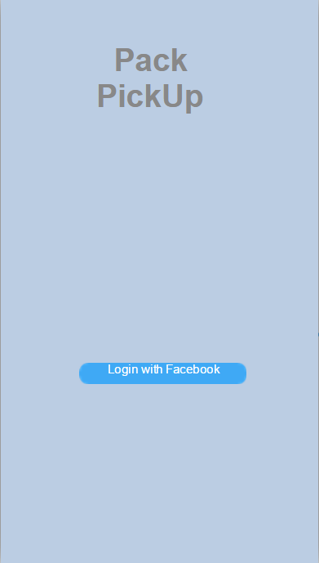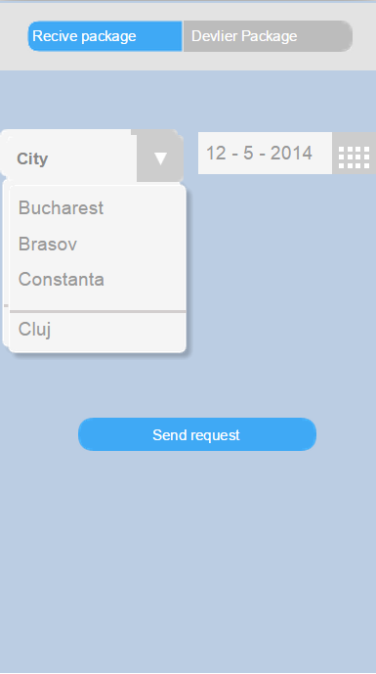

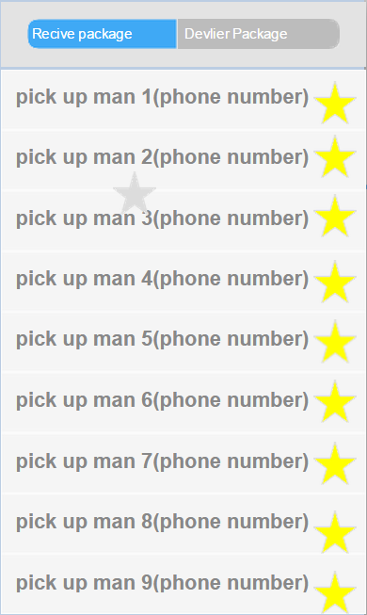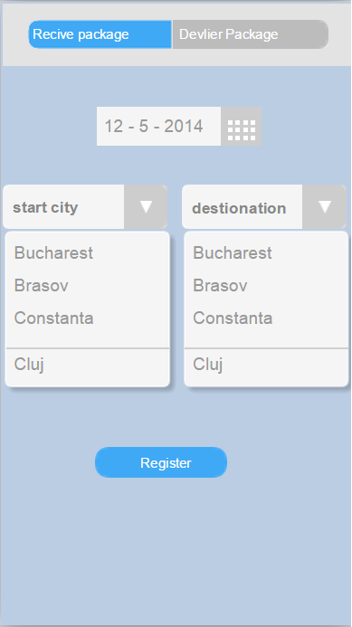

The first image is the login page.

The second image is the receiver first page.

The third image is the receiver second page.

The forth image is the picker first page.

