**How can you make a schedule?**

1. First of all, choose your major and minor (if you have one). If you want to choose only major or only minor, then choose “No major”/ “No minor” in one of the boxes. Then press the “Show requirements” button.
2. You get your list of requirements. You need to get the number of credits pointed in brackets near the directions of requirements by taking courses below. To see details of the course, click on the course twice.
3. When you have done this, you see the description of the course and its timetable in the Dialog Window. Pay attention to the prerequisites. Choose the section that you like (you can choose only one lesson from the whole section) and click “Add to the schedule” button (all the lessons from the section will be added).
4. Add all the courses you want to attend this semester with the help of this Dialog Window.
5. If you add two same courses by mistake or some classes clash, they will be highlighted with red color. You can delete courses by clicking the “Delete selected course” button.
6. When you are ready with your schedule, you have a chance to save it as a Word document. It is saved automatically in the folder of the program but you can choose any folder in Settings. Press the “Make a document” button and wait for a while. When your document is ready, you can see it in the Document Viewer. You have an opportunity to print it if it’s needed.

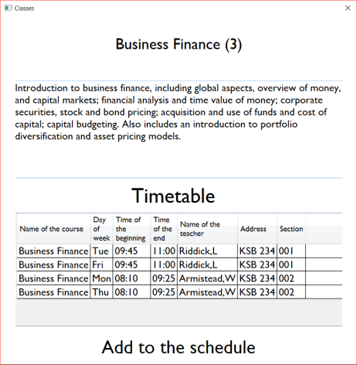

**3**

**4**

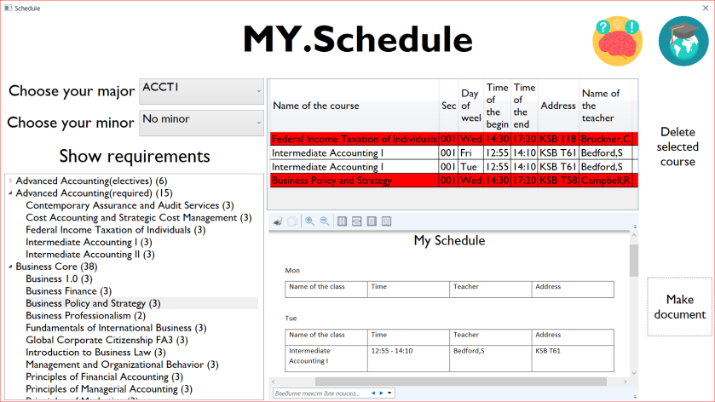

**1**

**2**

**5**

**6**