Roommate & Apartment Finding Platform

Jiaxiang Zhang  UNI:jz3275 | Edward Zhou Xiaoyu Liu  UNI:xz3014 UNI:xl3129

Abstract

The number of international students in the United States is increasing these years. It is a little hard for new international students to find roommates and apartments which fit their needs. So, this project is going to build a roommates and apartments platform for new students. We designed our own frontend website and will use KNN algorithm to get our recommendation, the result will show on the frontend back. Besides, we will compare KNN with other algorithms like k-means to find which one is better for our platform.

Introduction

Background
There are over 100,000 international students currently studying in New York City[1]. With the improvement of the epidemic situation, more and more students are returning to university communities. However, Dormitory is limited for universities in NYC. The big gap between the number of dormitories and the number of international students leads to a result that most students need to rent an apartment. Leaving home and moving to a new city is a big deal. Most students tend to have little experience in renting a house. Therefore, it’s challenging for them to find an ideal apartment in NYC. On the other hand, due to students’ limited budget, finding roommates is another necessity and challenge. In university, students come from different countries and have diverse backgrounds, so it is very risky for students to choose roommates without knowing each other very well. Based on this situation, we want to design a roommates and apartment finding platform for students to find their ideal roommate and apartment efficiently.

Importance of the project

We noticed that it’s difficult for students to find an ideal apartment and roommates. When choosing an apartment, situations like the apartment are too far away from the school, the selected neighborhood is unsafe, and the selected house does not meet their own needs and expectations always happen. There are so many different renting websites to look at, but none are designed for students, and one of the most important factors that students consider when renting apartments is the distance between their apartment and their school. Also, finding appropriate roommates is a big challenge. Since students come from different places in the world, each one has unique experiences and opinions. Different people have different hobbies and lifestyles. Some students are early birds, others are night owl. Some students may enjoy parties, while others do not. Living with people who have opposite lifestyles and hobbies may cause a lot of problems. In our roommates and apartment finding platform, users can input some basic information and then it will recommend some potential roommates and apartments. Our platform could benefit students by narrowing down their options for roommates and apartments to a few potential targets, and students can find ideal apartments and compatible roommates efficiently.

Overview
Our project includes three main parts - dataset, frontend design, algorithm selection. Two datasets are used in this project, `users` and `apartments`. This `apartment` table is found on Kaggle[2], which contains the name, address, price, room type, reviews of the apartment. For our purposes, we calculated the distance from apartments to universities and made it a new column.. The `users` dataset is the student information which includes the name, email address, gender, major, uni nationality, school, and habits of students. We found this dataset on Liveright[3]. The original dataset is the information about Airbnb in NYC. When collecting the dataset, the most important thing is to protect the privacy of users. In order to protect users’ privacy, we have rearranged part of the real personal information randomly, this arrangement will not affect our recommendation algorithm. Our user platform is designed based on the Django framework. Users can input their information and their preferences, then this data will be added to the database and the platform will recommend roommates and apartments for them. The recommendation algorithm we used includes KNN, K-means, linear regression. We will finalize the algorithm after comparing their performance.

Related Work
The author of this paper [4] pointed out that with the increase in enrollment of international students in the United States, students trying to find a successful environment usually focus on three aspects: student life/support, English fluency, and direction. Based on [4], we focus on those characteristics in the recommendation algorithm.
In this paper [5], the author proved that the algorithm can generate semi-optimal solutions. This article explores how to find a suitable roommate with social welfare security. It proposes a heuristic algorithm based on local search for general cases where the potential of each room is not limited by a constant. This article provides us with a new idea about recommendation, but the pursuit of social welfare is too theoretical, and we still hope to build a platform to satisfy our customers not only with scial welfare, but also taken other features into account.
This article [6] proposes a recommendation system that tries to keep the users who are most likely to contact each other consistent. They created a set of content-based and collaborative filtering-based algorithms, using a combination of similarity measures to use different compatibility measures between users. Most of our recommendation algorithms put relevant recommendations in the top 30% to 50% of the recommendation list. This is a good way to find core users, but in our project, we do not have so many users to test, if this project is successful, we can try this method in the future.
This paper [7] calculates the efficiency of the algorithm by considering two variables of the famous stable roommate problem. The first variant is equal and stable matching, which aims to minimize overall unhappiness. The second version of SRI is called d-SRTI. The priority list can include links with a maximum length of d. They show that the problem of determining whether a dSRTI instance accepts stable matching is NP-complete, even with d=3, the algorithm can be solved in polynomial time. By referring to these variants, the author discovered not all agents in all stable matches are automatically paired. Unknown agents can be discarded and only the remaining agents can be found. This article will give us some ideas on how to calculate efficiency, which we can use in the evaluation section below.
Author of this article [8] proposes a novel rigid priority matching method to solve the roommate problem. The characteristic of these matches is the intersection of the maximum irreversible match and the stable maximum match. This Q* stable matching algorithm is a good way to solve any roommate problem, and the largest irreversible pairing set should form part of the match. When dealing with solvable problems, it is necessary to provide a stable matching solution and some other matching, even if this method is a bit difficult for data processing.
In this book [9], the author proposes a recommendation system, which is a technique for customizing information filtering. The paper categorizes users with their interest in different preferences. With different aspects taken into consideration, suggestions can be made to users with different roommate preferences. Tags are keywords that define the characteristics of the objects to which they are applied, and can consist of one or more terms. Users can freely add various tags to the project, so as to realize the true classification from bottom to top. The popularity of social tags and how easy it is to use tags. The production, appointment and collection all stimulated a great interest in research. Labels and their potential uses. Depending on which objects are used to locate other types of related objects, tags can be used to help complete several different recommendation tasks. The focus of this chapter is to recommend label-based products. This book contains chapters on how to use tags to provide effective content search on social bookmarking sites and how to implement these content in the recommendation process. On social networking platforms such as Twitter and Facebook, it also provides an overview of some of the most commonly used item recommendation algorithms. Our project can utilize the thinking behind this book and apply those filtering methods in our recommendation system. This is a good filtering method and may be used in the following states in our project.
Similarly, in this article [10], the author states that with the gradual increase of e-commerce system customers and products, the time-consuming nearest neighbor collaborative filtering search for target customers in the total customer space has led to the incapability to ensure the real-time recommendation system requirements. Meanwhile, when the number of records in the user database increases, its quality is diluted thus requires more pre-processing before applying algorithm to those data. The sparsity of the source data set is the main cause of poor quality. In order to solve the scalability and sparsity problems in collaborative filtering, combining user clustering technology and item clustering technology, a personalized recommendation method is proposed. The users are clustered according to their ratings on the project, and each user cluster has a cluster center. The nearest neighbor of the targeted user is derived based on the similarity between the targeted user and the cluster center， leading to smooth prediction. Then, the method uses item clustering collaborative filtering to generate recommendations. The collaborative filtering recommendation that combines user clustering and item clustering is more scalable and accurate than traditional recommendations.
This paper [11] uses K-means clustering and K-nearest neighbor algorithm to construct a movie recommendation system. It uses the `movielens` dataset taken from Kaggle. This article introduces various concepts related to machine learning and recommendation systems. It includes a detailed description of K-Means clustering, KNN, collaborative filtering, and content-based filtering algorithms. In addition, after studying different types of machine learning algorithms, for the recommendation system, e-commerce, they give use cases of how to implement the proposed system and work in the movie recommendation system. Finally, for different clustering values, different root mean square error (RMSE) values are obtained. As the number of clusters decreases, the value of RMSE also decreases. The best value of RMSE obtained is 1.081648. Based on the RMSE value, the system gives better results than the existing technology. This article gives us an inspiration that we could try KNN as our recommendation algorithm for our project.
The author of paper [12] propose a KNN based on the distance between two data points. K-nearest neighbor (KNN) rule is very common in recommendation, but this algorithm is also a controversial non-parametric classifier commonly used in pattern recognition. In KNN-based classification, the sensitivity of the neighborhood size k severely reduces the classification efficiency. In this method, multiple local average sample vectors for a given query sample are determined in each class by taking its nearest neighbor, class-specific k. In our project, we decided to use KNN as our recommendation algorithm, and we will try to solve the sensitivity problem of neighborhood size k.
In this article [13], the author suggests a method to solve common problems in recommendation systems. Those problems include but are not limited to: scalability, sparsity, and cold start. They developed a domain-specific ontology based on knowledge to generate personalized recommendations. They also introduced two different ontology-based prediction models, minion representation model and projection representation model. Those two models are used to efficiently provide suggestions for various users. Predictive models are summarized by data mining algorithms, and associates user preferences and item characteristics for user modeling. They proposed a new KNN algorithm as an adaptive KNN based on collaborative filtering recommendation system. The Kaggle `movielens` dataset was used to verify the proposed method, the accuracy, recall rate, F-measure, and accuracy of the obtained results were evaluated. Experimental results show that their proposed KNN algorithm has better performance compared with other algorithms when the recommended data is highly sparse. With techniques proposed in this paper, we could deal with sparse data with higher prediction accuracy.
Besides, we found that few of the platforms are focusing on apartment recommendation. Some universities have their own platform to recommend roommates for their students, but they do not combine roommates recommendation and apartment recommendation together. Following are reviews of some apartment recommendation papers.
In this article [14], the author proposes a method to infer user satisfaction with Airbnb rooms. As a sharing economy platform, Airbnb allows customers at both ends of renting to collaborate. It uses the influence of confidence and forecast uncertainty to calculate user satisfaction with the room. The individual’s satisfaction with forecast uncertainty is modeled and predicted by an algorithm based on weighted matrix decomposition.
In this article [15], the author proposes an algorithm to analyze the listing demand of Airbnb in New York City using several machine learning paths, and compares the listing prices to choose the best model with effective accuracy. Therefore, decision trees and KNN are best suited for the purpose of their task, rather than models like Naïve Bayes and logistic regression. According to the above two papers, we want to combine their proposed method and use KNN to recommend apartments.
In this paper [16], the author proposes a method to first determine the users whose KNN may be affected by the newly upcoming information, and then update their KNN respectively. In order to support efficient search for affected users, they proposed a new index structure - HDR tree. HDR tree uses clustering and principal component analysis (PCA) to reduce dimensionality and improve search efficiency. In order to further shorten the response time, they propose a variant of HDR tree, which supports a more effective solution. The results of a large number of experiments show that this method is significantly better than the baseline method with the incorporation of PCA. Our project does not need to implement this real-time method, but this article provides us with some new ideas for further work.
The writer of this article [17] suggests that in many user-based collaborative filtering applications based on KNN (K Nearest Neighbor Algorithm), they only use the cosine similarity information between users. In some cases, no difference information is used, so the accuracy and recall rate are relatively low. In order to solve these problems, we propose a differential factor KNN collaborative filtering method called DF-KNN. DF-KNN is an example-based learning method. The main idea of the algorithm is the usage and calculation of difference factor. The second step is to mix the similarities together. Their experimental evaluation on the `MovieLens` dataset shows that the proposed DF-KNN and NDF-KNN (normally different factor KNN) are more efficient than the traditional KNN based on user neighborhoods, and provide suggestions of up to 13% quality. Since we decided to use KNN, we must learn how to effectively recommend from this article.

Current Progress
The overall progress of our project is that we have designed our frontend, data processing, and tested one of the algorithms that we would try.
3.1 Data
The data used for this project are divided into two tables: `apartments` table and `users` table. `users` table is obtained through meetup.com API, `apartments` table is found on course website datasets with Airbnb apartment data.
`Users` table stores user information. New user information is appended to the table, and when recommending roommates, an algorithm is applied to data in this table in search of an optimal candidate.
· no: Primary Key
· firstName: User entered first name
· lastName: User entered last name
· uni: User entered UNI
· gender: User gender
· nationality: See countries.txt
· email: User entered email address
· school: See schools.txt
· major: See majors.txt
· smoking: Binary, yes or no
· alcohol: Binary, yes or no
· habit: Binary, early bird or night owl
· roommate: Binary, yes or no
`Apartments` table stores New York Airbnb apartment information. An algorithm is applied to data in this table for finding apartments that satisfy user preference.
· id: Primary Key
· name: Name of apartment
· neighborhood: Apartment neighborhood
· latitude: Latitude
· longitude: Longitude
· distanceLine: Exact distance from Columbia University calculated using longitude and latitude
· distance: Enumerator. <1 mile = near, 1-3 miles = pretty near, 3-7 miles = pretty far, >7 miles = far
· roomType: Enumerator. Private room, entire home/apartment, shared room
· price: Enumerator. <$100 = cheap, $100-$200 = economical, $200-$400 = luxurious, >$400 = expensive
· reviewsPerMonth: Reviews that the apartment gets every month. Used in recommendation algorithm
3.2 Methods
The frontend is deployed with Django, with GBQ interactions embedded in the frontend code. Users can enter their preferences for apartments and roommates using this interactive frontend.
To begin with, there is a base user information database, where existing user information is already. New users would use the frontend website to enter their information and preferences, then this information is appended onto the `users` table in Google Big Query upon user information submission. Meanwhile, recommendation algorithms run on both `users` table for finding optimal roommates, and `apartments` table for recommending most suitable apartments. Finally, the output is displayed on the frontend in the `result` page recommending a couple of roommates as well as apartments.
Recommendation algorithms used in this project include KNN, K-means, linear regression. At this point, we have only implemented a linear regression model and have not yet compared accuracy between different models. Factors considered for roommate recommendation algorithm include: school, major, gender, alcohol, smoking, habit, nationality . Factors considered for the apartment recommendation algorithm include: distance, price, neighborhood, roomType, reviewsPerMonth.
3.3 System
The system is designed as follows: Original user data are collected using meetup.com API, and apartment data are obtained from Airbnb. New user data is collected via user input in the frontend. All information is stored into Google Big Query and extracted when needing to perform recommendation algorithms. After performing a recommendation algorithm with PySpark, results are shown to the frontend with Django infrastructure.

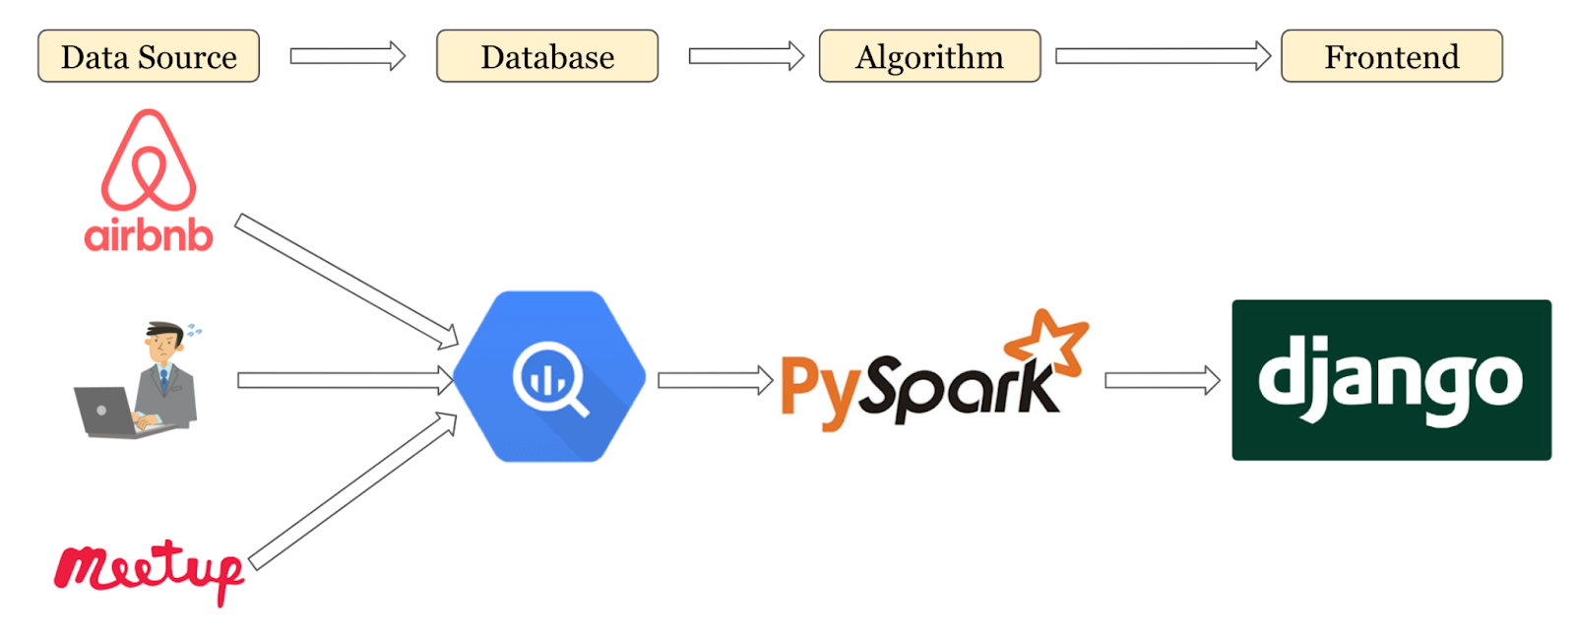
Figure 1. System Architecture
As shown in the flow diagram Figure 2. Users first submit their room and roommate preferences via frontend, then those information are appended to the `users` table and depending on their preferences the backend chooses to perform either roommate recommendation and/or apartment recommendation algorithms. After the results are obtained, they are displayed in the frontend where users can view their options.

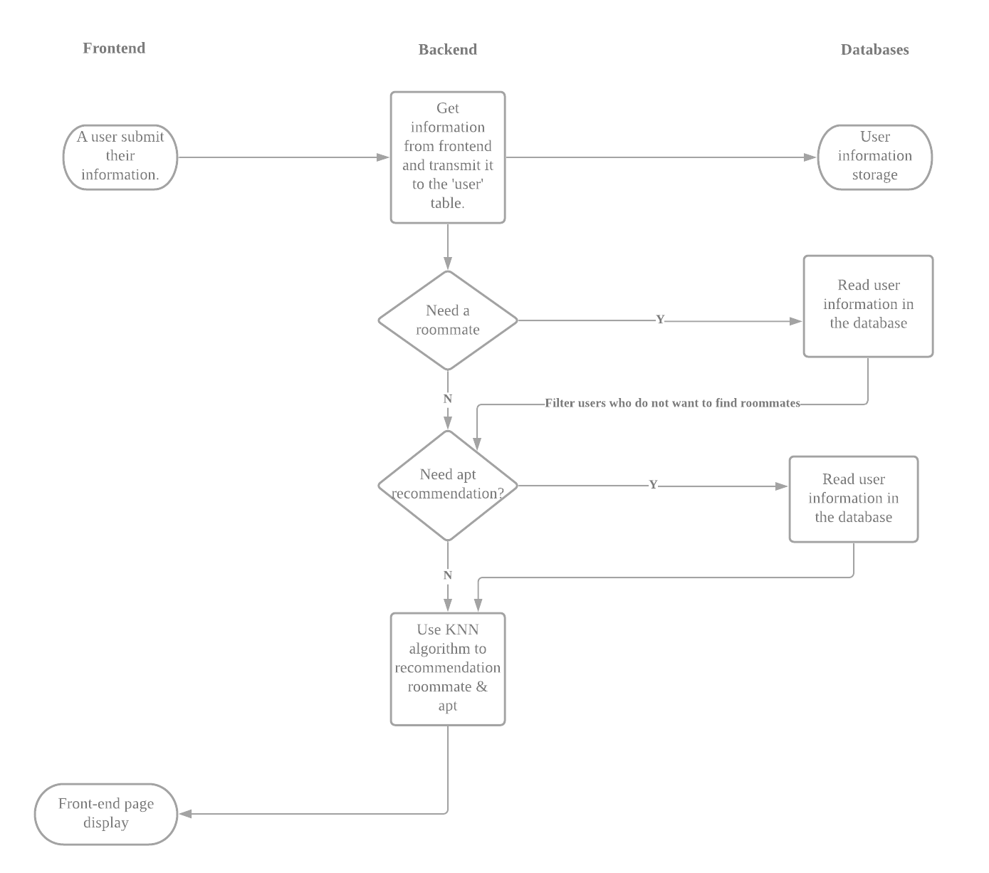
Figure 2. System Flowchart

There are two websites on our platform, the one is “search”, the other one is “result”. For the “search” part, we made a questionnaire for a user. The user has to give us his/her information, including basic information like name, gender and contact, and also some living habits as shown in figure 3.

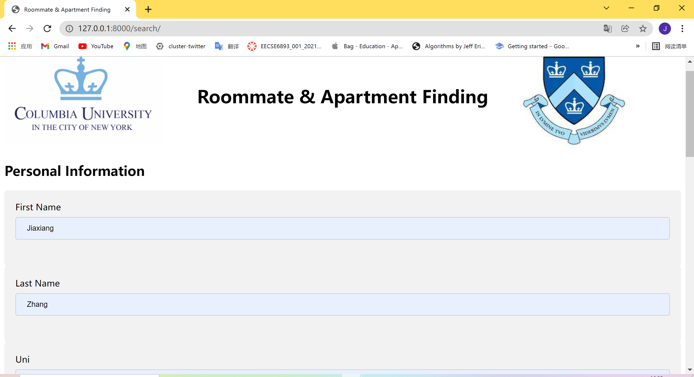
Figure 3. ”Search” Part of Platform
Then in the “result” part, as shown in figure 4, our platform could show two tables, the one is about roommates recommendation and the other is about apartment recommendation. In order to meet more people's needs, we decided to design two functions. We can show only one table if a user only needs recommendations for roommates or apartments, or we can show two tables if a user needs both recommendations.

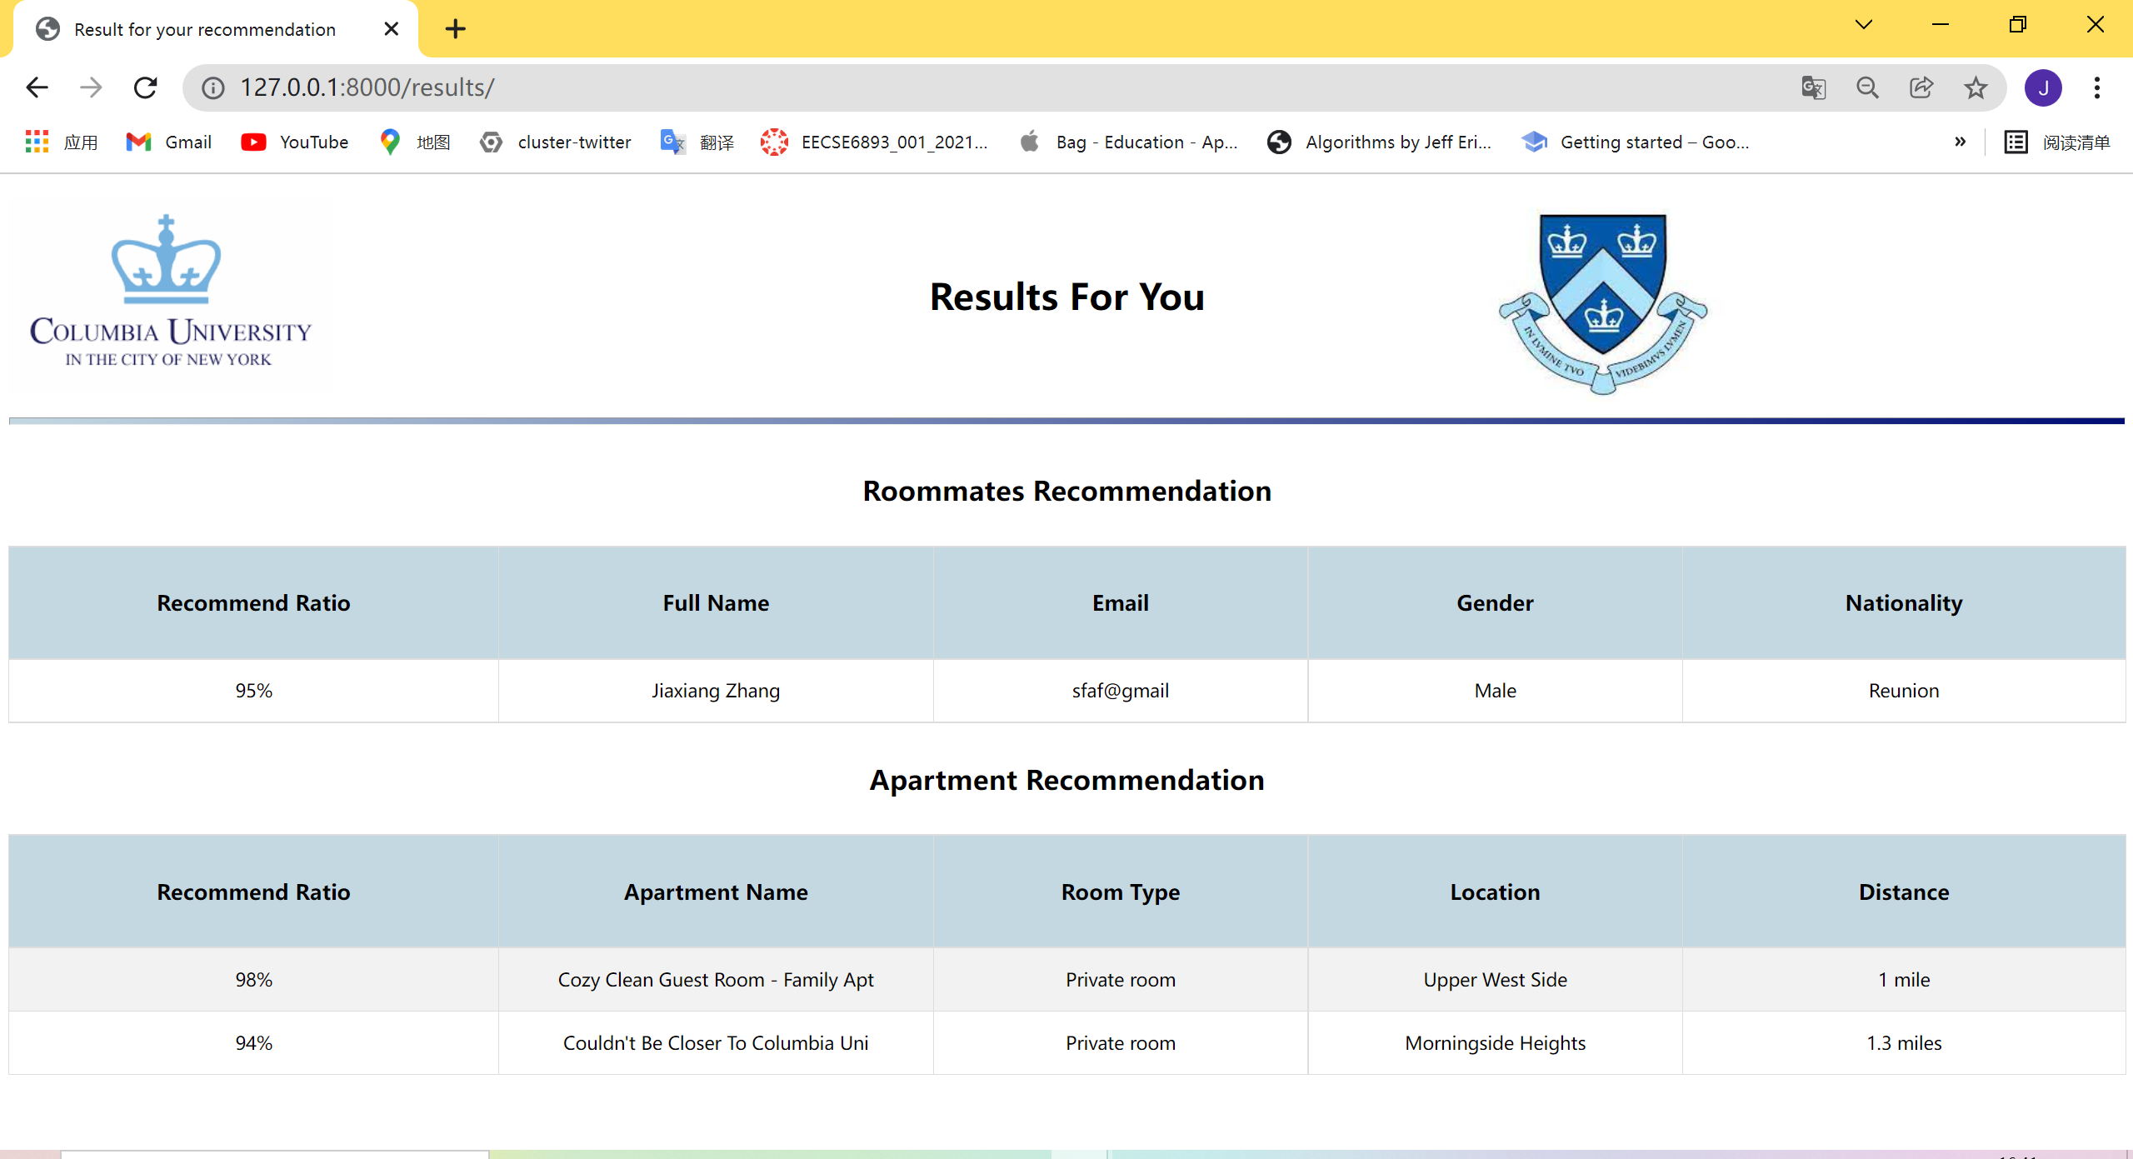
Figure 4. ”Result” Part of Platform

Planned Experiments
Until this point, we have focused on our frontend and dataset, and the algorithm is only partially designed. There are different algorithms we would like to try. To start with, we would implement a basic k-means algorithm to put different users into clusters. K-means clustering calculates the euclidean distance between different users and uses that distance to determine whether certain users belong to the same cluster. It uses the idea of centroids as the center of each cluster, and centroids are re-calculated after each iteration. For our project, the recommendation algorithm would use k-means clustering to first put all users into different clusters, and output a few users within the same cluster for the targeted user as his/her recommended roommate. We would also test the k-nearest neighbors (KNN) algorithm. KNN algorithm outputs the k-nearest neighbors to a targeted user according to its features, in our case, roommate preferences.
There are some other recommendation algorithms we would explore as we go deeper in our research, but after all algorithms are designed and implemented, we would compare training and testing accuracy among our algorithms, and then compare it with algorithms designed by other researchers.
Following are the figures that we plan to attach:
-- Frontend examples
-- Tables for accuracy comparison among different algorithms
-- Comparing our algorithm with other algorithms

Reference
- Qureshi, F. H., & Khawaja, S. (2021). IS COVID-19 TRANSITIONING CASH COWS INTERNATIONAL STUDENTS INTO CATS?. European Journal of Education Studies, 8(7).
- Kaggle: New York City Airbnb Open Data.. https://www.kaggle.com/dgomonov/new-york-city-airbnb-open-data
- Liveright. https://github.com/SiddheshAcharekar/Liveright
- Tolman, S. (2016). Evaluation of an international roommate-pairing program (Doctoral dissertation). Rutgers University, New Brunswick, NJ.
- YUNPENG LI, YICHUAN JIANG, WEIWEI WU, JIUCHUAN JIANG, AND HUI FAN, “Room Allocation With Capacity Diversity and Budget Constraints”, IEEE Access, vol.7, pp. 42968 - 42986, 2019.
- Peng Xia, Shuangfei Zhai, Benyuan Liu, Yizhou Sun, Cindy Chen, “Design of Reciprocal Recommendation Systems for Online Dating”, Springer, , June,2016.
- Agnes Cseh, Robert W. Irving, David F. Manlove, “The Stable Roommates Problem with Short Lists”, Springer, vol.63, pp.128 -149, 2019.
- P´eter Bir, Elena narra , and Elena Molis, “A new solution for roommate problems: The Q -stable matchings”, Elsevier, vol.79, pp.74 -82, 2016.
- Toine Bogers, “Tag -Based Recommendation”, Springer, vol. 10100, pp.441 -479, May 2018.
- Gong, S. (2010). A collaborative filtering recommendation algorithm based on user clustering and item clustering. J. Softw., 5(7), 745-752.
- Ahuja, R., Solanki, A., & Nayyar, A. (2019, January). Movie recommender system using K-Means clustering and K-Nearest Neighbor. In 2019 9th International Conference on Cloud Computing, Data Science & Engineering (Confluence) (pp. 263-268). IEEE.
- Jianping Goua , Hongxing Mab , Weihua Ouc , Shaoning Zengd , Yunbo Raoe , Hebiao Yanga,” A generalized mean distance -based k -nearest neighbor classifier”, ELSEVIER, vol.115, pp.356 - 372, 2019.
- Subramaniyaswamy, V., & Logesh, R. (2017). Adaptive KNN based recommender system through mining of user preferences. Wireless Personal Communications, 97(2), 2229-2247.
- L. Guo, J. Li, J. Wu, W. Chang and J. Wu, "A Novel Airbnb Matching Scheme in Shared Economy Using Confidence and Prediction Uncertainty Analysis," in IEEE Access, vol. 6, pp. 10320-10331, 2018, doi: 10.1109/ACCESS.2018.2801810.
- A. Garlapati, K. Garlapati, N. Malisetty, D. R. Krishna and G. Narayana, "Price Listing Predictions and Forthcoming Analysis of Airbnb," 2021 12th International Conference on Computing Communication and Networking Technologies (ICCCNT), 2021, pp. 1-7, doi: 10.1109/ICCCNT51525.2021.9579773.
- C. Yang, X. Yu and Y. Liu, "Continuous KNN Join Processing for Real-Time Recommendation," 2014 IEEE International Conference on Data Mining, 2014, pp. 640-649, doi: 10.1109/ICDM.2014.20.
- Liang, W., Lu, G., Ji, X., Li, J., & Yuan, D. (2014, December). Difference factor’KNN collaborative filtering recommendation algorithm. In International Conference on Advanced Data Mining and Applications (pp. 175-184). Springer, Cham.

