IT 263 – INTEGRATIVE PROGRAMMING AND TECHNOLOGIES 1

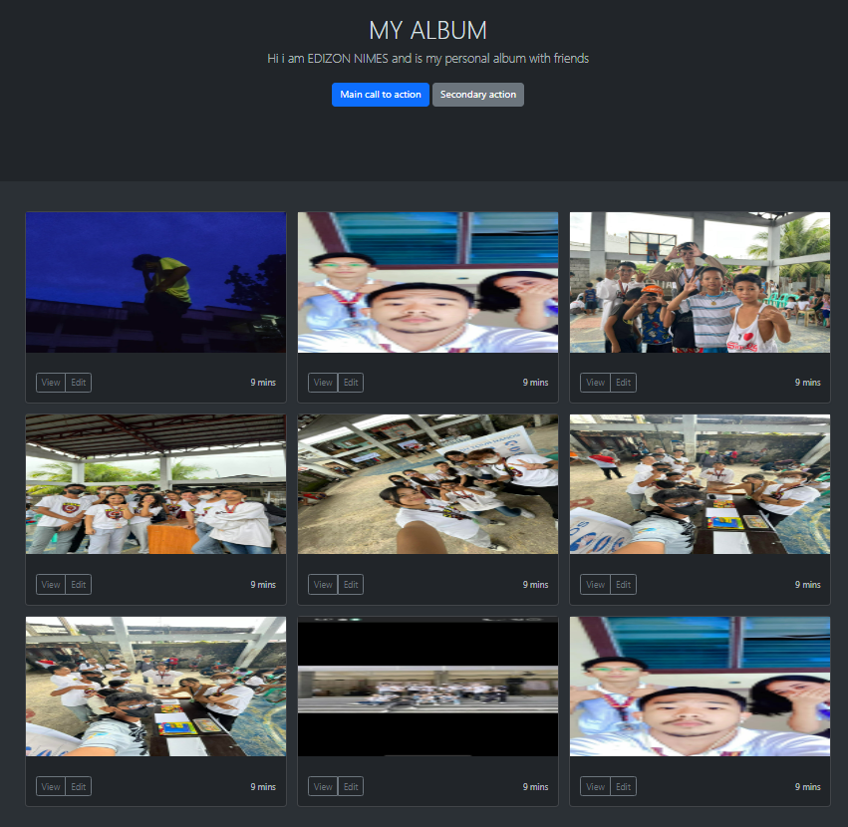EDIZON NIMES BSIT2D