Introduction

Thermal conductivity is an important property for studies and modelling of the deep earth. Controls heat flow across Core Mantle Boundary.

* “Thermal evolution of mantle and core”
* Mantle dynamics and plate tectonics (“size and stability of plumes”)
* Core dynamics and geodynamo (“generation of the magnetic field”)
* VARIOUS FIGURES

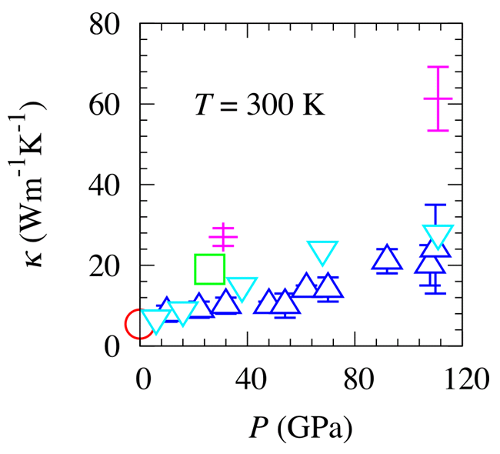Not currently possible to measure thermal conductivity experimentally, at high pressure & temperature conditions of the lowermost mantle. Results are extrapolated inducing uncertainty, but do not even agree at more ambient conditions.

Classical simulations use interatomic potentials to create systems [of atoms] capable of reproducing experimental results. Uncertainty is induced when simulations are performed outside of the P/T range where the potential was fit however, meaning the results will never be as accurate as those calculated from first principles.

FIGURE / TABLE ???

While it is necessary to employ Density Function Theory for accurate atomic simulations, classical simulations can be run at a fraction of the computational cost to constrain simulation parameters. Similarly, classic simulations can consider system sizes that would be unfeasible to perform using ab initio methods. We show how thermal conductivity varies with the size of systems used, and why care must be taken in choosing simulation cell dimensions to avoid the effects of finite system size. Using classical simulations, we find the minimum size simulation cell is accessible to DFT calculations but that previous studies may have overestimated conductivity because of finite size effects.

Oganov potential

Any graphs from the paper? My table comparing elastic constants (table from paper + LAMMPS)

Direct method

Stackhouse Stixrude 2010, Stackhouse et al. 2015.

Linear extrapolation

Schelling 2002, Stackhouse et al. 2015.

Finite size effects

Using the non-equilibrium molecular dynamics direct method, the increasing conductivity with simulation cell length size effect is addressed by an extrapolation procedure (REF). Cross sectional area of the cell also affects computed conductivity, where small areas tend to overestimate conductivity. We also show direct method conductivity results that diverge from the expected linear relation (CLARIFY), when the aspect ratio of the cell (length:area) is large. We believe this represents the behaviour of a 1-dimensional system, opposed to that of the bulk material we are interested in.

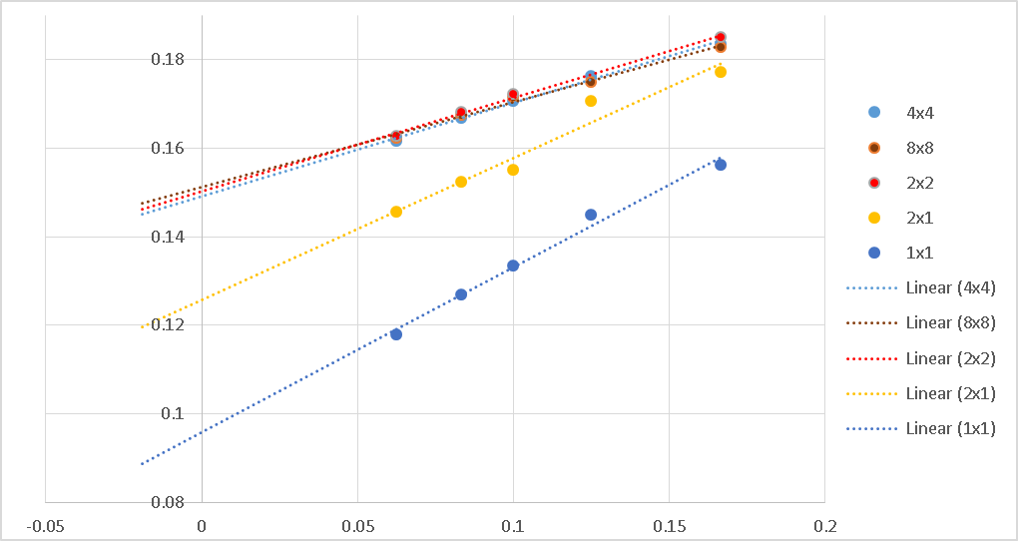Cross sectional area effect

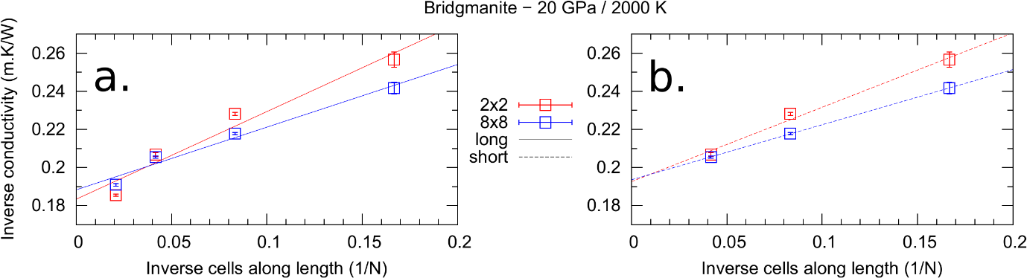1-D effect

Other results?

* Pressure derivatives
* Anisotropy
* Geotherm / grid

DON’T FORGET GREEN KUBO