Longitudinal Contrast-Enhanced T1 Synthesis from a Patient's Prior Exam with a Schrödinger Bridge
Eric Eng, Yao Wang, Li Feng

Impact
Synthesizing post-contrast MRI from pre-contrast imagery could allow patients to avoid repeated gadolinium injections, but enhancement is not always evident in pre-contrast images. Conditioning on a prior scan supplies additional enhancement information that improves synthesis quality.

Synopsis
Motivation: Synthesizing post-contrast images could avoid gadolinium injection, but enhancement is not always predictable from pre-contrast information. Patients under surveillance have a prior contrast-enhanced exam that encodes enhancement for similar anatomy.
Goal(s): Exploit prior exam information in a contrast synthesis task.
Approach: The Image-to-Image Schrödinger Bridge (I²SB) algorithm is used to map current T1 to CT1 images conditioned on FLAIR/T1/T2 imagery. To extend this to the longitudinal synthesis task, five adjacent T1/CT1 slices are provided as additional side information.
Results: On the NYUMets dataset, longitudinal I²SB produces higher quality CT1 images while remaining robust towards uninformative guide information.

Introduction
Brain metastases are monitored with serial gadolinium-enhanced MRI¹, and repeated gadolinium exposure² motivates synthesizing post-contrast images from non-contrast ones. Single-exam synthesis must infer enhancement from T1, T2 and FLAIR alone. In surveillance, however, every patient has a prior post-contrast exam, highly correlated with the current one. We condition an image-to-image Schrödinger bridge (I²SB)³ on that prior exam and evaluate it under inference-realistic conditions.

Methods
Image-to-Image Schrödinger Bridge: I²SB seeks to take some image x₁, sampled from some known distribution, and estimate some related x₀ coming from some alternative target distribution. Generating a sample x_{t} from the bridge involves generating noisy convex combinations of x₀ and x₁, where the additive noise power is time varying for t ∈ [0, 1]. A network is trained to, given bridge sample x_{t}, predict the bridge endpoint x₀. The algorithm itself iteratively predicts x₀ and then resamples a new bridge point x_{t} while annealing the time index to 0 (Figure 1). In our case, we bridge from the current pre-contrast image to the desired post-contrast image. The original I²SB paper³ uses a UNet⁴ with an appended time-dependent channel. Since we have access to other contrasts of the same anatomy, we additionally append [T1, T2, FLAIR] as input channels, so the model need only learn the enhancement pattern from T1 to CT1.
Longitudinal Conditioning: Where enhancement is not evident in the pre-contrast images, the patient's prior contrast-enhanced exam can supply it. The bridge endpoints are unchanged, and the prior exam enters only as conditioning: its T1 and CT1 at a 5-slice window are appended as ten further input channels. The neighboring slices robustify the network to through-plane misregistration.
Experiments: We trained on NYUMets⁵, a longitudinal dataset of brain-metastasis patients with FLAIR, T1, CT1 and T2 at each visit, split into a training set of 2318 exams and a holdout set of 1007 exams. Within each exam the contrasts are already co-registered and skull-stripped. We train two regressors over the same training set while only giving one access to prior-exam data. At inference, the prior exam is registered to the current one by a 3-D affine fit learned only from pre-contrast images, without relying on the CT1 being predicted. PSNR, SSIM and NRMSE were computed within the brain mask and averaged per exam, and paired Wilcoxon signed-rank tests were run over the holdout set.

Results
Across 1007 test exams, conditioning on the prior exam improved every metric (Figure 3): PSNR rose from 24.79 ± 0.09 to 25.73 ± 0.10 dB, SSIM from 87.79 ± 0.21% to 90.83 ± 0.19%, and NRMSE fell from 13.07 ± 0.19% to 11.97 ± 0.19% (mean ± s.e. over exams; all p < 10⁻³, paired Wilcoxon signed-rank test). The longitudinal model was better in 97% of exams (median PSNR gain +0.84 dB). Appending input channels to the UNet comes at little computational cost, so both methods are effectively computationally matched.
We can see strong visual improvement in Figure 2. In the first row, the single-study I²SB result overpredicts the enhancement details whereas longitudinal I²SB better preserves anatomical detail. The second row gives an example where a lesion appears in the CT1 image and not in the current T1. In this case, the single-study I²SB result correctly predicts the appearance of the lesion but the longitudinal I²SB result more accurately recovers its shape. Additionally, the prior CT1 guide seems to contain enhancement details near the brain stem that do not appear in the ground truth; longitudinal I²SB is robust to them. In the third row, single-study I²SB hallucinates a lesion absent from the acquired CT1, which is corrected in by the guide.
Figure 4 shows further cases where the guide contains irrelevant or incorrect enhancement information. In these cases, the longitudinal I²SB results remain visually comparable to their single-study counterparts, which demonstrates robustness to guide quality. In some cases, longitudinal I²SB performs slightly better, likely due to the guide still encoding structural details that may be absent from the pre-contrast input. Figure 5 quantifies this by scoring the registered prior CT1 against the current CT1. The gain grows from ≈+0.3 dB for the least similar priors to +2.5 dB for the most similar, and stays positive on average in every bin.

Discussion
The prior exam is routinely available in surveillance, yet is unused by contrast-synthesis methods. As conditioning, it lets the network transfer known enhancement rather than infer it, and a poor prior reduces the benefit without degrading synthesis on average. However, we acknowledge that the quality of registration for many of these examples is very high, and that performance may degrade under other anatomies that are not as rigid as the brain.

Conclusion
Conditioning I²SB on a patient's prior exam, registered without the scan being predicted, improves gadolinium-free synthesis of the follow-up post-contrast T1.

Acknowledgements
The authors thank NYU Langone Health UltraViolet for technical support.

References
1. Lin NU, Lee EQ, Aoyama H, et al. Response assessment criteria for brain metastases: proposal from the RANO group. Lancet Oncol. 2015;16(6):e270–e278.
2. Kanda T, Ishii K, Kawaguchi H, Kitajima K, Takenaka D. High signal intensity in the dentate nucleus and globus pallidus on unenhanced T1-weighted MR images: relationship with increasing cumulative dose of a gadolinium-based contrast material. Radiology. 2014;270(3):834–841.
3. Liu GH, Vahdat A, Huang DA, Theodorou EA, Nie W, Anandkumar A. I²SB: Image-to-Image Schrödinger Bridge. Proc ICML, PMLR 202:22042–22062. 2023.
4. Ronneberger O, Fischer P, Brox T. U-Net: Convolutional networks for biomedical image segmentation. MICCAI, LNCS 9351:234–241. 2015.
5. Link KE, Schnurman Z, Liu C, et al. Longitudinal deep neural networks for assessing metastatic brain cancer on a large open benchmark. Nat Commun. 2024;15:8170.

Figures
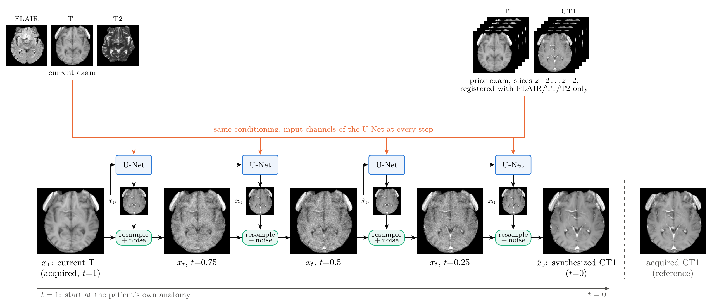
Figure 1: Longitudinal I²SB synthesis of the post-contrast T1 (CT1). The reverse bridge starts at the acquired pre-contrast T1 (x₁, t = 1) and reaches the synthesized CT1 (x̂₀, t = 0) in 20 steps; four states are shown, five steps apart. At every step the UNet predicts x̂₀ from the current state x_{t} and the conditioning: the current FLAIR, T1 and T2, and the prior exam's T1 and CT1 at slices z−2…z+2, registered using FLAIR, T1 and T2 only. Resampling then blends x̂₀ with x_{t} and adds noise to give the next state. Images are the trained model's own trajectory for one test exam; the acquired CT1 (right) is shown for reference only.
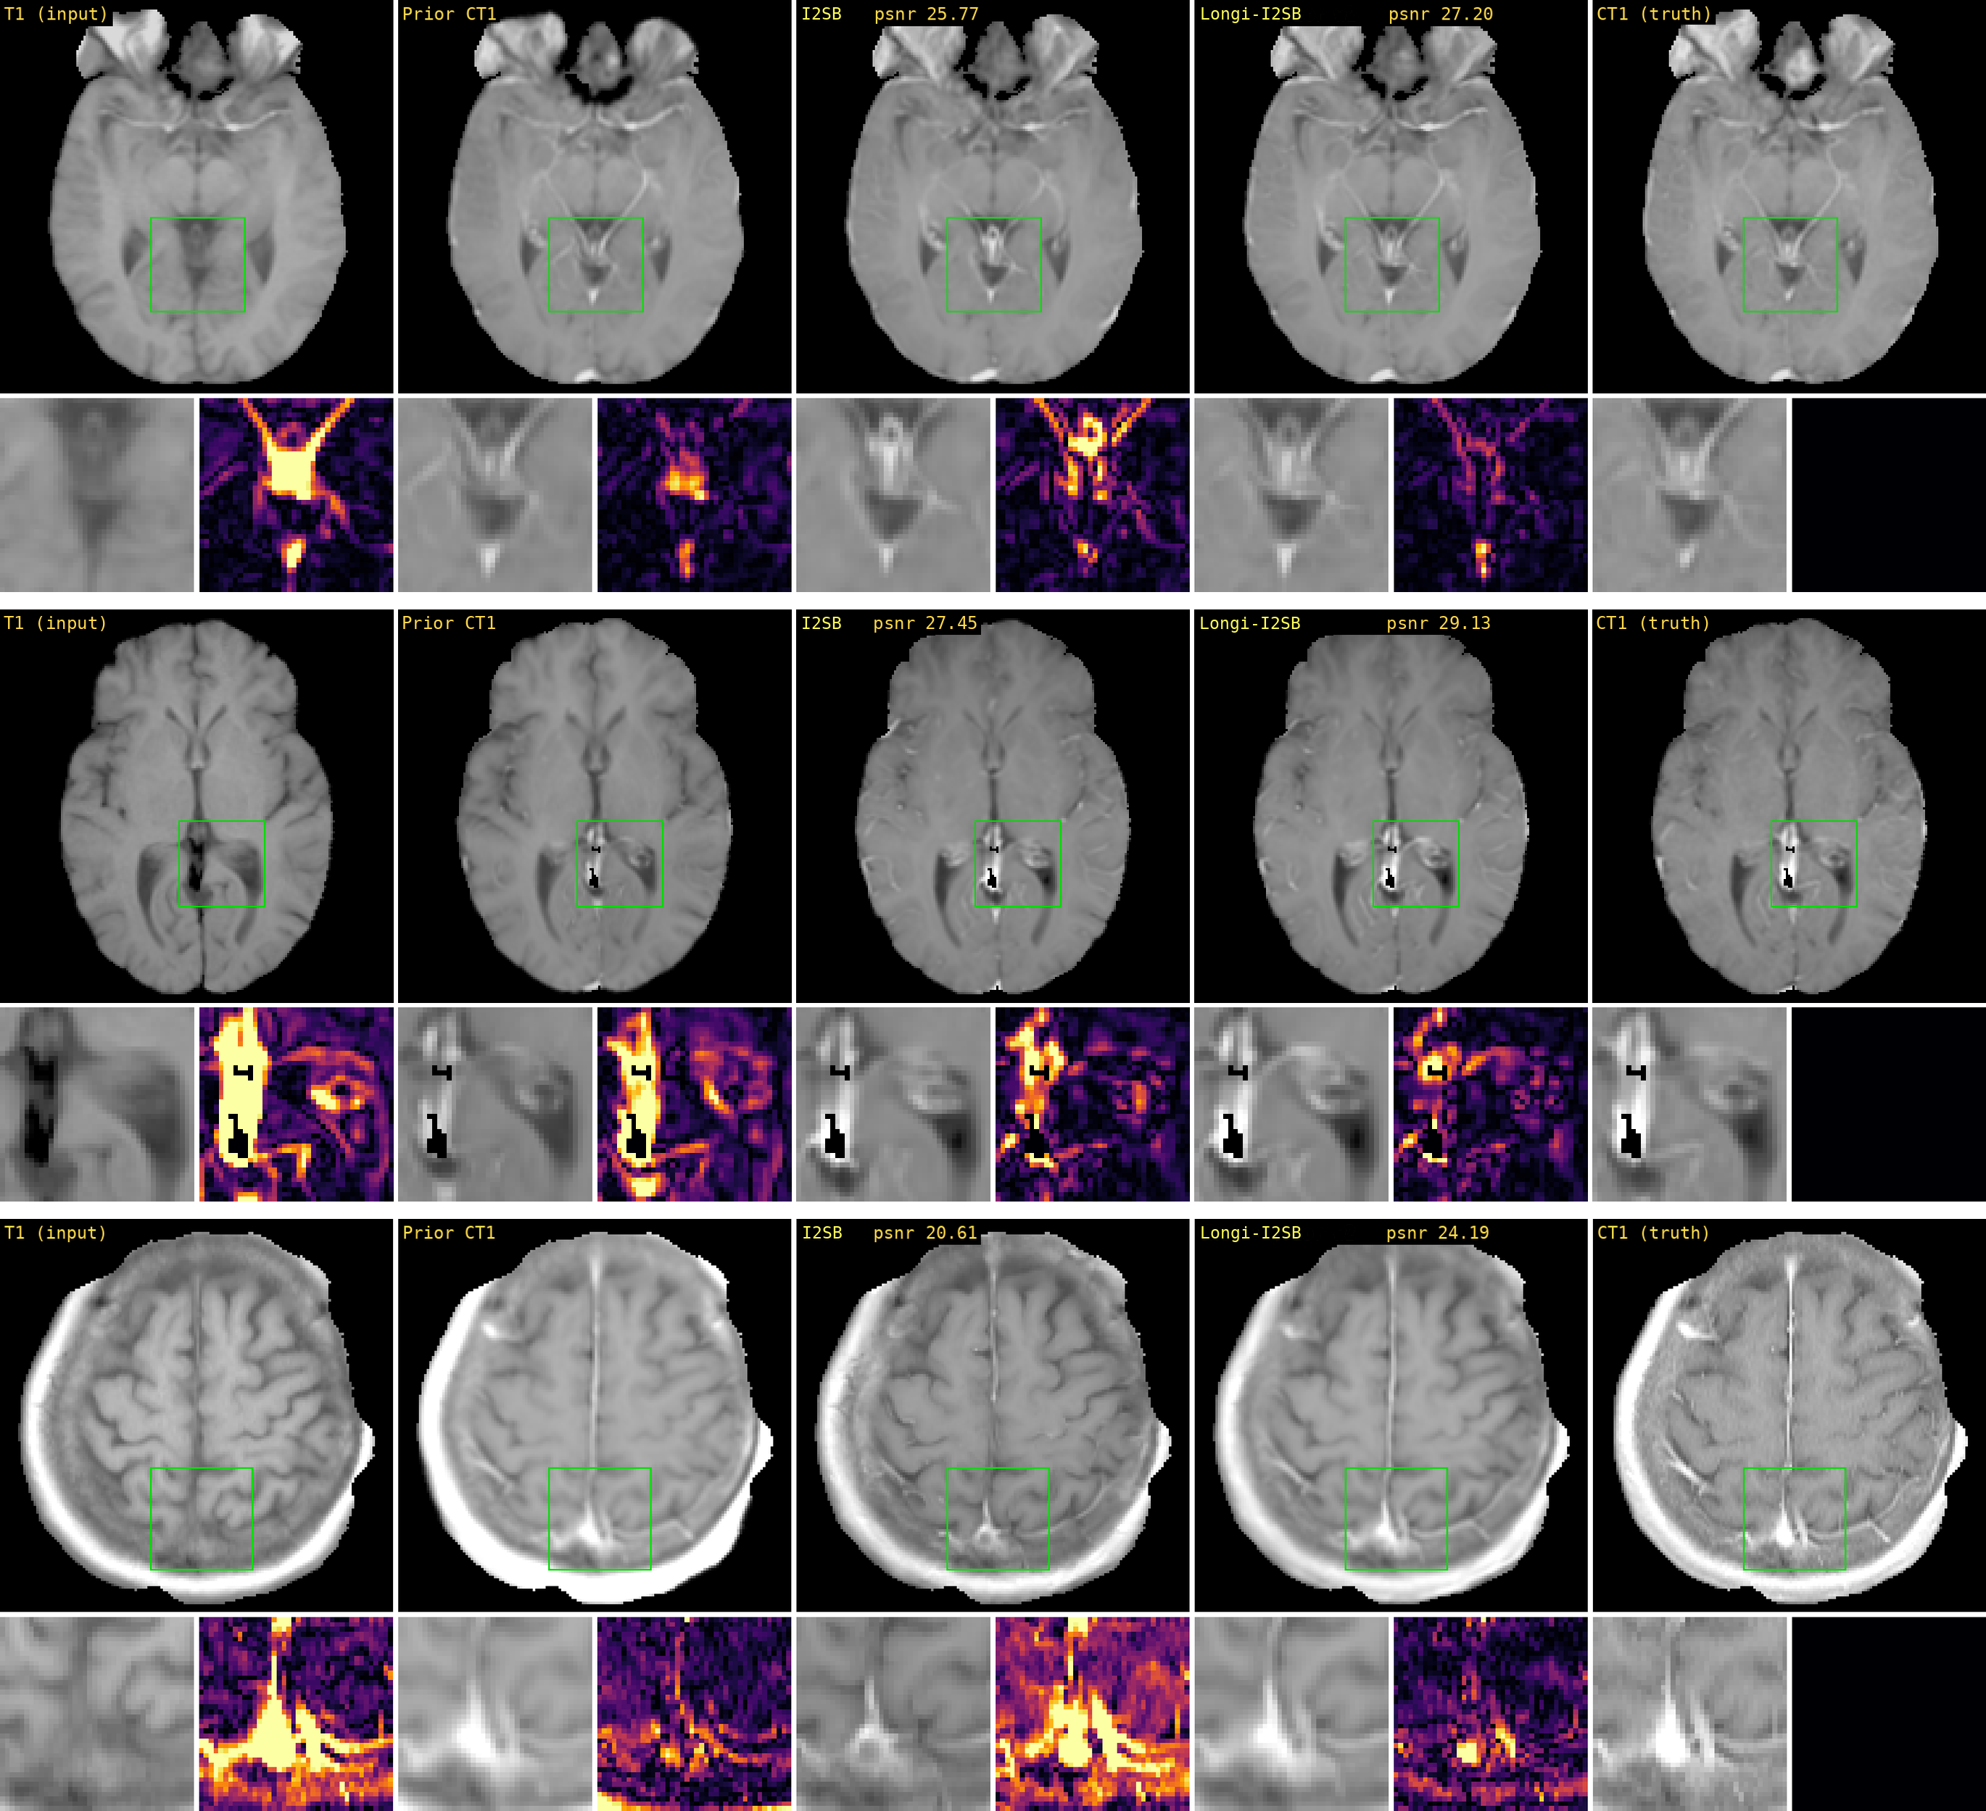
Figure 2: Example test cases. Columns: current T1 (input), registered prior CT1, I²SB without the prior exam, I2SB with the prior exam, and the acquired CT1; magnified region with its 5× residual, PSNR/SSIM per panel.
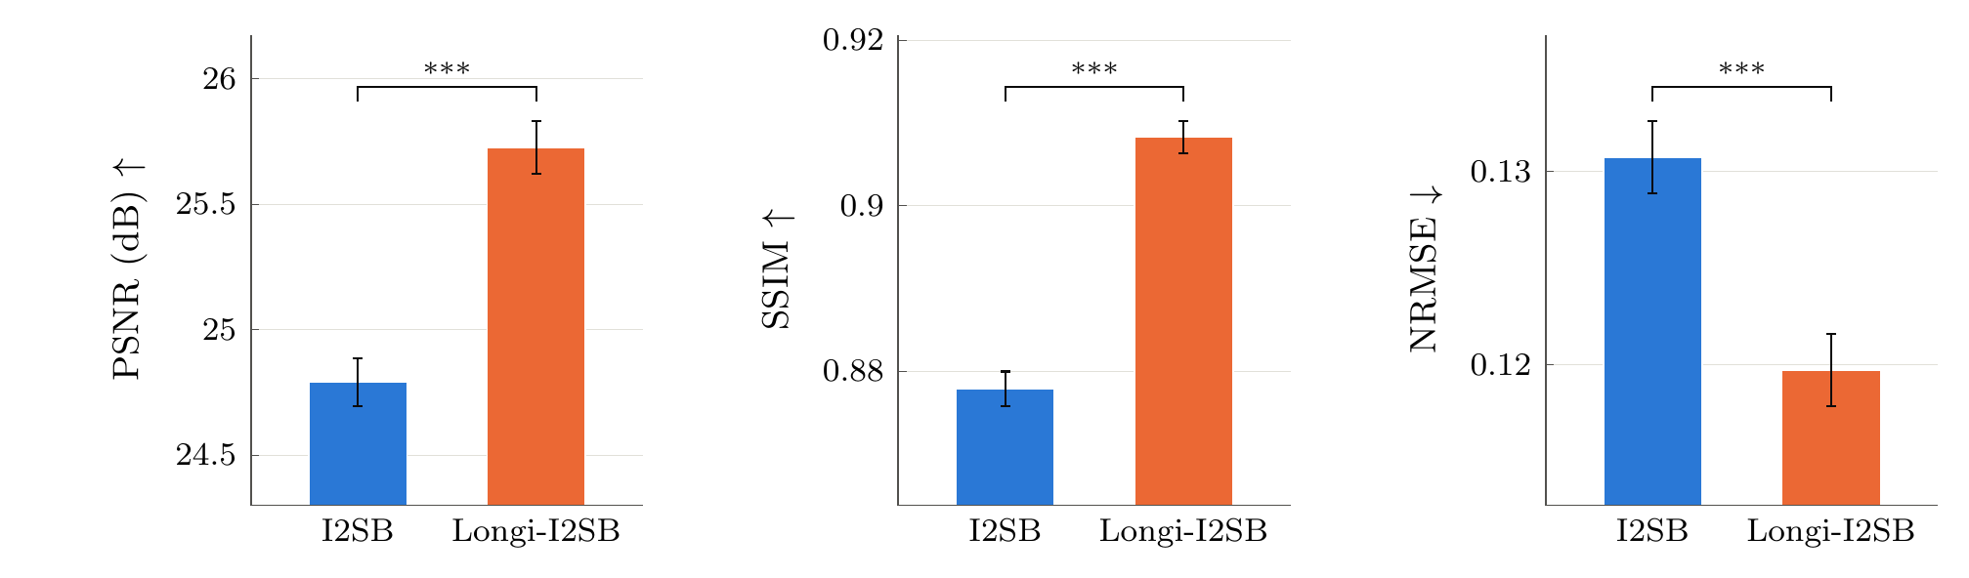
Method | PSNR (dB) ↑ | SSIM (%) ↑ | NRMSE (%) ↓
I2SB | 24.79 ± 0.09* | 87.79 ± 0.21* | 13.07 ± 0.19*
Longi-I2SB | 25.73 ± 0.10 | 90.83 ± 0.19 | 11.97 ± 0.19
Figure 3: 1007 test studies, slices 70–109, metrics within the mask. Top: mean ± s.e. over studies; *** paired Wilcoxon signed-rank p ≤ 0.001 (Holm-adjusted); value axes do not start at zero. Bottom: summary; bold best, * p < 0.05 vs. the longitudinal model.
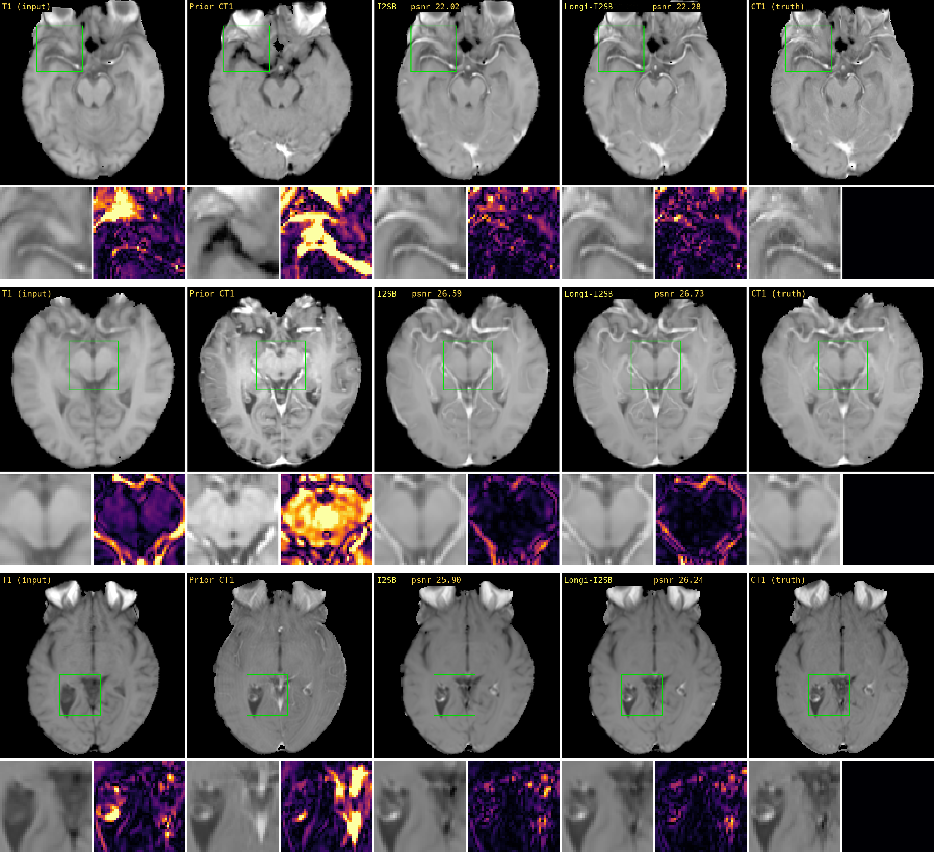
Figure 4: Robustness to a poor prior exam: cases where the registered prior CT1 differs greatly from the current one. Columns as in Figure 2.
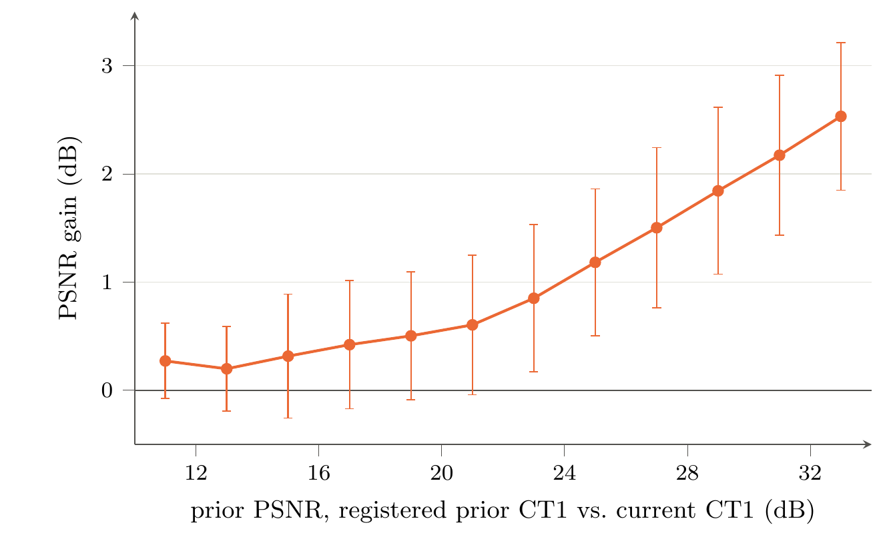
Figure 5: PSNR gain of the longitudinal model over single-exam I2SB versus the prior PSNR: the registered prior CT1 scored against the current CT1 in the same mask and with the same data range as the reported metrics. Mean ± 1 standard deviation over the slices in 2 dB bins. The gain grows with prior similarity, from ≈+0.3 dB for the least similar priors to +2.5 dB for the most similar, and its mean is positive in every bin.

