Longitudinal Contrast-Enhanced T1 Synthesis from a Patient's Prior Exam with a Schrödinger Bridge
Eric Eng, Yao Wang, Li Feng

Impact
Synthesizing post-contrast MRI from pre-contrast imagery could allow patients to avoid repeated gadolinium injections, but enhancement is not always evident in pre-contrast images. Conditioning on a prior scan supplies additional enhancement information that improves synthesis quality.

Synopsis
Motivation: Synthesizing post-contrast images could avoid gadolinium injection, but enhancement is not always predictable from pre-contrast information. Patients under surveillance have a prior contrast-enhanced exam that encodes enhancement for similar anatomy.
Goal(s): Exploit prior exam information in a contrast synthesis task.
Approach: The Image-to-Image Schrödinger Bridge (I²SB) algorithm is used to map current T1 to CT1 images conditioned on FLAIR/T1/T2 imagery. To extend this to the longitudinal synthesis task, five adjacent T1/CT1 slices are provided as additional side information.
Results: On the NYUMets dataset, longitudinal I²SB produces higher quality CT1 images while remaining robust towards uninformative guide information.

Introduction
Brain metastases are monitored with serial gadolinium-enhanced MRI¹, and repeated gadolinium exposure² motivates synthesizing post-contrast images from non-contrast ones. Single-exam synthesis must infer enhancement from T1, T2 and FLAIR alone. In surveillance, however, every patient has a prior post-contrast exam, highly correlated with the current one. We condition an image-to-image Schrödinger bridge (I²SB)³ on that prior exam and evaluate it under inference-realistic conditions.

Methods
Image-to-Image Schrödinger Bridge: I²SB seeks to take some image x₁, sampled from some known distribution, and estimate some related x₀ coming from some alternative target distribution. Generating a sample x_{t} from the bridge involves generating noisy convex combinations of x₀ and x₁, where the additive noise power is time varying for t ∈ [0, 1]. A network is trained to, given bridge sample x_{t}, predict the bridge endpoint x₀. The algorithm itself iteratively predicts x₀ and then resamples a new bridge point x_{t} while annealing the time index to 0 (Figure 1). In our case, we bridge from the current pre-contrast image to the desired post-contrast image. The original I²SB paper³ uses a UNet⁴ with an appended time-dependent channel. Since we have access to other contrasts of the same anatomy, we additionally append [T1, T2, FLAIR] as input channels, so the model need only learn the enhancement pattern from T1 to CT1.
Longitudinal Conditioning: Where enhancement is not evident in the pre-contrast images, the patient's prior contrast-enhanced exam can supply it. The bridge endpoints are unchanged, and the prior exam enters only as conditioning: its T1 and CT1 at a 5-slice window are appended as ten further input channels. The neighboring slices robustify the network to through-plane misregistration.
Experiments: We trained on NYUMets⁵, a longitudinal dataset of brain-metastasis patients with FLAIR, T1, CT1 and T2 at each visit, split into a training set of 2318 exams and a holdout set of 1007 exams. Within each exam the contrasts are already co-registered and skull-stripped. We train two regressors over the same training set while only giving one access to prior-exam data. At inference, the prior exam is registered to the current one by a 3-D affine fit learned only from pre-contrast images, without relying on the CT1 being predicted. PSNR, SSIM and NRMSE were computed within the brain mask and averaged per exam, and paired Wilcoxon signed-rank tests were run over the holdout set.

Results
Across 1007 test exams, conditioning on the prior exam improved every metric (Figure 3): PSNR rose from 24.79 ± 0.09 to 25.73 ± 0.10 dB, SSIM from 87.79 ± 0.21% to 90.83 ± 0.19%, and NRMSE fell from 13.07 ± 0.19% to 11.97 ± 0.19% (mean ± s.e. over exams; all p < 10⁻³, paired Wilcoxon signed-rank test). The longitudinal model was better in 97% of exams (median PSNR gain +0.84 dB). Appending input channels to the UNet comes at little computational cost, so both methods are effectively computationally matched.
Figure 2 shows strong visual improvement. In the first row, the single-study I²SB result overpredicts the enhancement details whereas longitudinal I²SB better preserves anatomical detail. The second row gives an example where a lesion appears in the CT1 image and not in the current T1. Single-study I²SB predicts the lesion, but longitudinal I²SB recovers its shape more accurately. Additionally, the prior CT1 guide seems to contain enhancement details near the brain stem that do not appear in the ground truth; longitudinal I²SB is robust to them. In the third row, single-study I²SB hallucinates a lesion absent from the acquired CT1, which the guide corrects.
Figure 4 shows cases where the guide contains irrelevant or incorrect enhancement; longitudinal I²SB remains visually comparable to single-study I²SB, demonstrating robustness to guide quality. In some cases, longitudinal I²SB performs slightly better, likely due to the guide still encoding structural details that may be absent from the pre-contrast input. Figure 5 quantifies this by scoring the registered prior CT1 against the current CT1. The gain grows from ≈+0.3 dB for the least similar priors to +2.5 dB for the most similar, and stays positive on average in every bin.

Discussion
The prior exam is routinely available in surveillance, yet is unused by contrast-synthesis methods. As conditioning, it lets the network transfer known enhancement rather than infer it, and a poor prior reduces the benefit without degrading synthesis on average. However, registration quality here is generally high, and performance may degrade in anatomies less rigid than the brain.

Conclusion
Conditioning I²SB on a patient's prior exam, registered without the scan being predicted, improves gadolinium-free synthesis of the follow-up post-contrast T1.

Acknowledgements
The authors thank NYU Langone Health UltraViolet for technical support.

References
1. Lin NU, Lee EQ, Aoyama H, et al. Response assessment criteria for brain metastases: proposal from the RANO group. Lancet Oncol. 2015;16(6):e270–e278.
2. Kanda T, Ishii K, Kawaguchi H, Kitajima K, Takenaka D. High signal intensity in the dentate nucleus and globus pallidus on unenhanced T1-weighted MR images: relationship with increasing cumulative dose of a gadolinium-based contrast material. Radiology. 2014;270(3):834–841.
3. Liu GH, Vahdat A, Huang DA, Theodorou EA, Nie W, Anandkumar A. I²SB: Image-to-Image Schrödinger Bridge. Proc ICML, PMLR 202:22042–22062. 2023.
4. Ronneberger O, Fischer P, Brox T. U-Net: Convolutional networks for biomedical image segmentation. MICCAI, LNCS 9351:234–241. 2015.
5. Link KE, Schnurman Z, Liu C, et al. Longitudinal deep neural networks for assessing metastatic brain cancer on a large open benchmark. Nat Commun. 2024;15:8170.

Figures
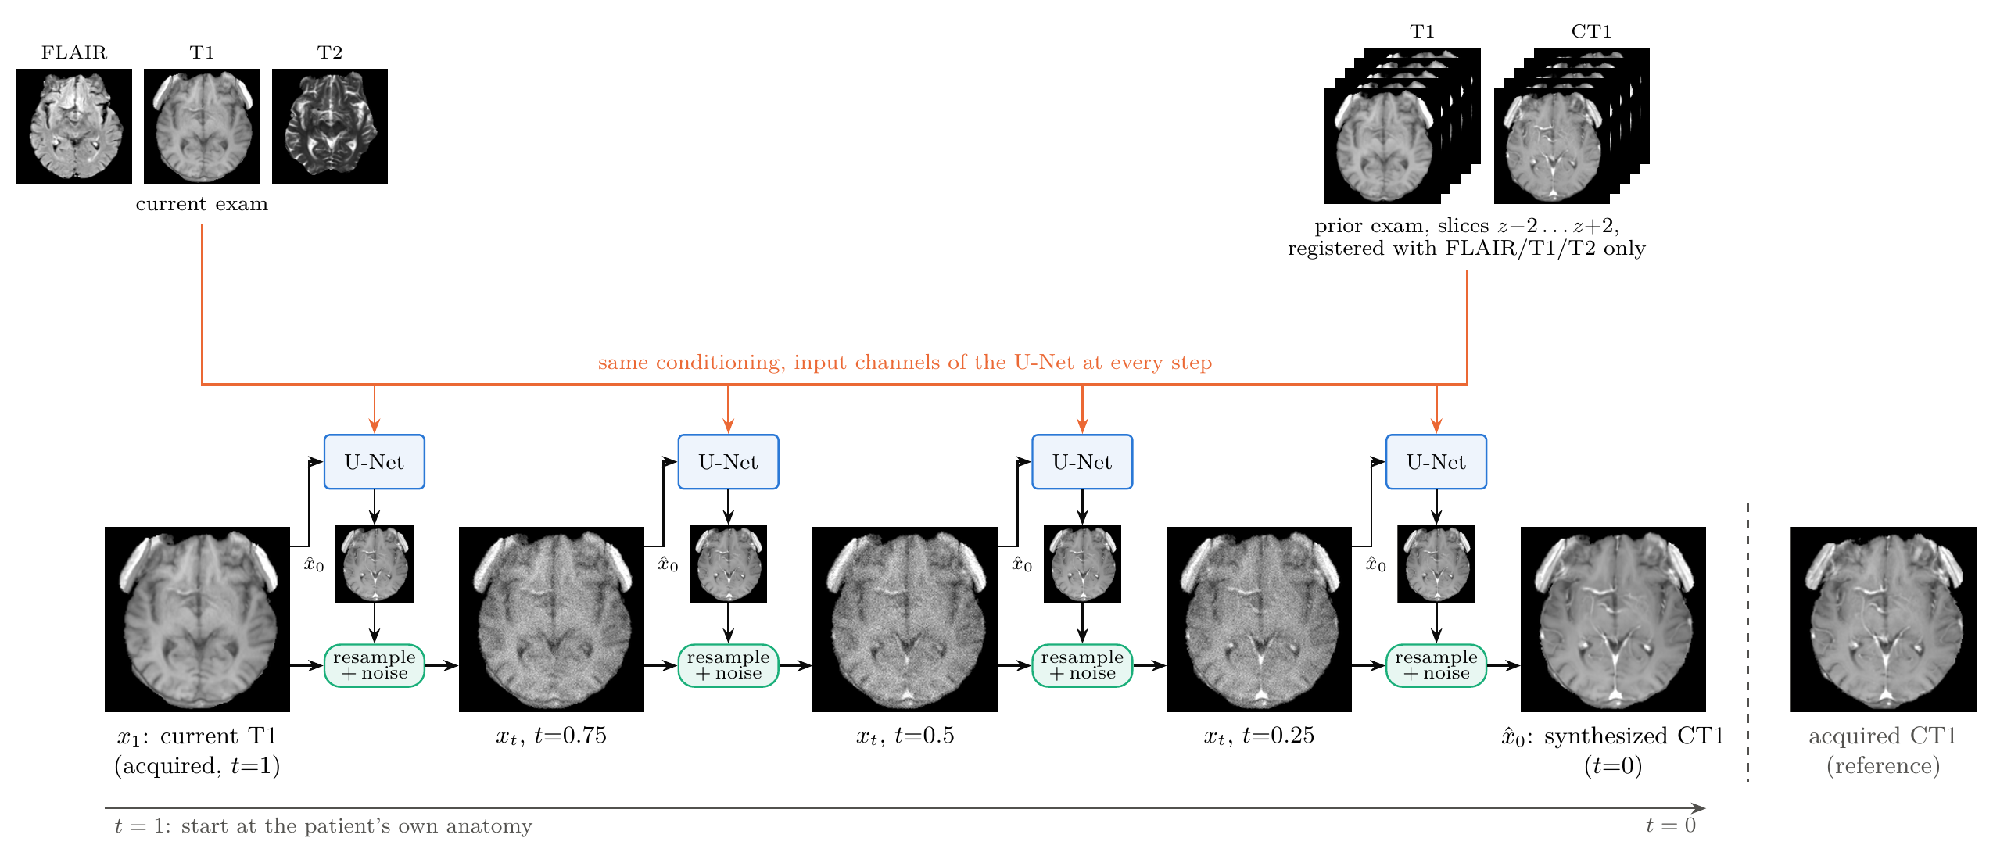
Figure 1: Longitudinal I²SB synthesis of the post-contrast T1 (CT1). The reverse bridge starts at the acquired pre-contrast T1 (x₁, t = 1) and reaches the synthesized CT1 (x̂₀, t = 0) in 20 steps; four states are shown, five steps apart. At every step the UNet predicts x̂₀ from the current state x_{t} and the conditioning: the current FLAIR, T1 and T2, and the prior exam's T1 and CT1 at slices z−2…z+2, registered using FLAIR, T1 and T2 only. Resampling then blends x̂₀ with x_{t} and adds noise to give the next state. Images are the trained model's own trajectory for one test exam; the acquired CT1 (right) is shown for reference only.
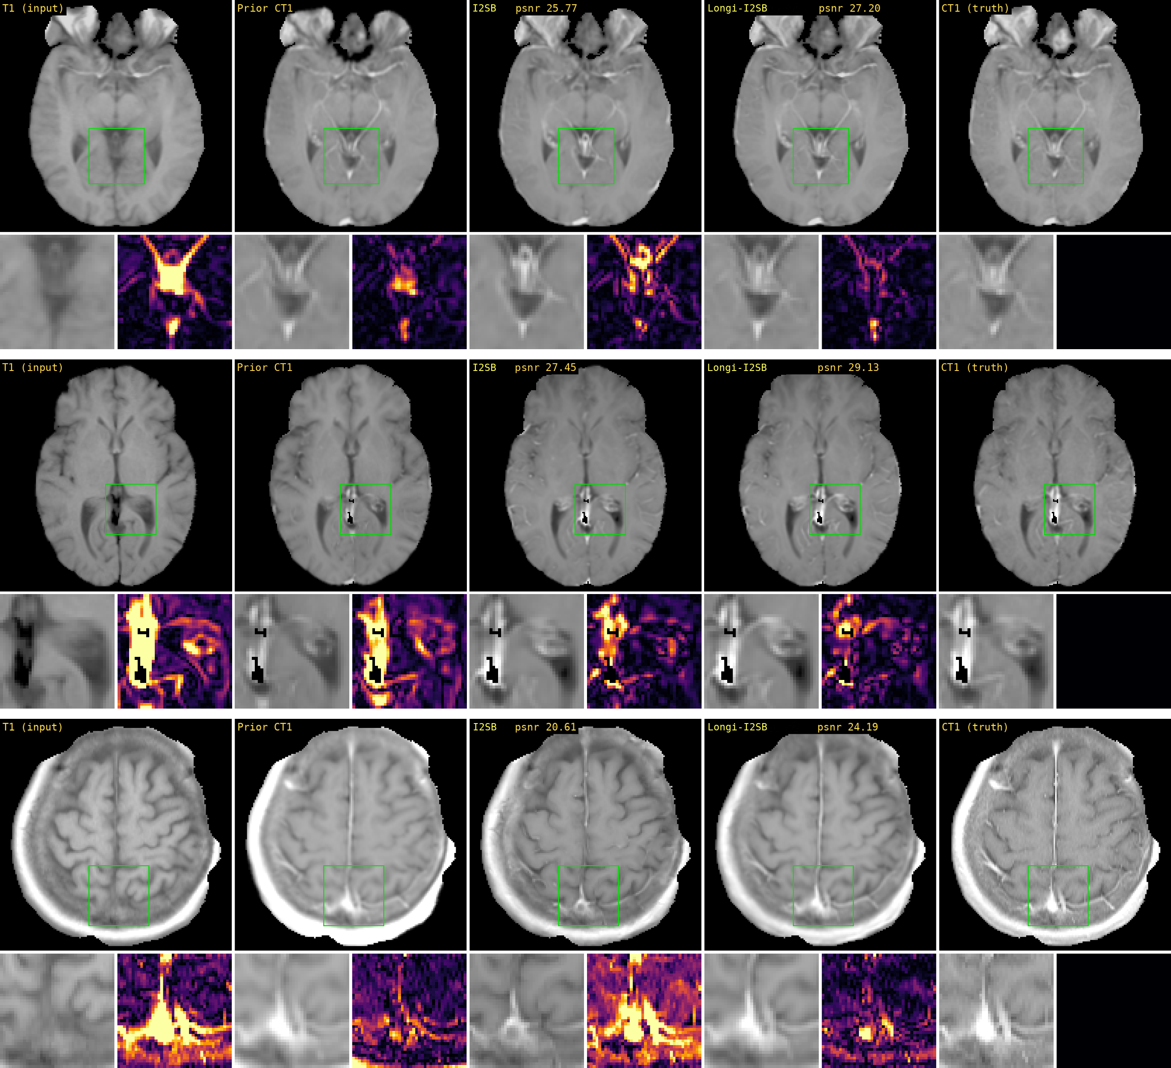
Figure 2: Example test cases. Columns: current T1 (input), registered prior CT1, I²SB without the prior exam, I2SB with the prior exam, and the acquired CT1; magnified region with its 5× residual, PSNR/SSIM per panel.
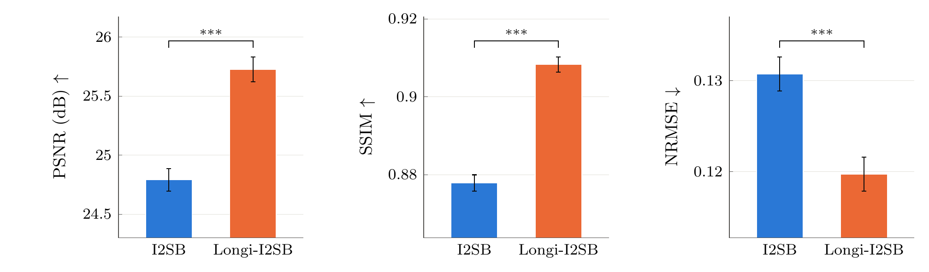
Method | PSNR (dB) ↑ | SSIM (%) ↑ | NRMSE (%) ↓
I2SB | 24.79 ± 0.09* | 87.79 ± 0.21* | 13.07 ± 0.19*
Longi-I2SB | 25.73 ± 0.10 | 90.83 ± 0.19 | 11.97 ± 0.19
Figure 3: 1007 test studies, slices 70–109, metrics within the mask. Top: mean ± s.e. over studies; *** paired Wilcoxon signed-rank p ≤ 0.001 (Holm-adjusted); value axes do not start at zero. Bottom: summary; bold best, * p < 0.05 vs. the longitudinal model.
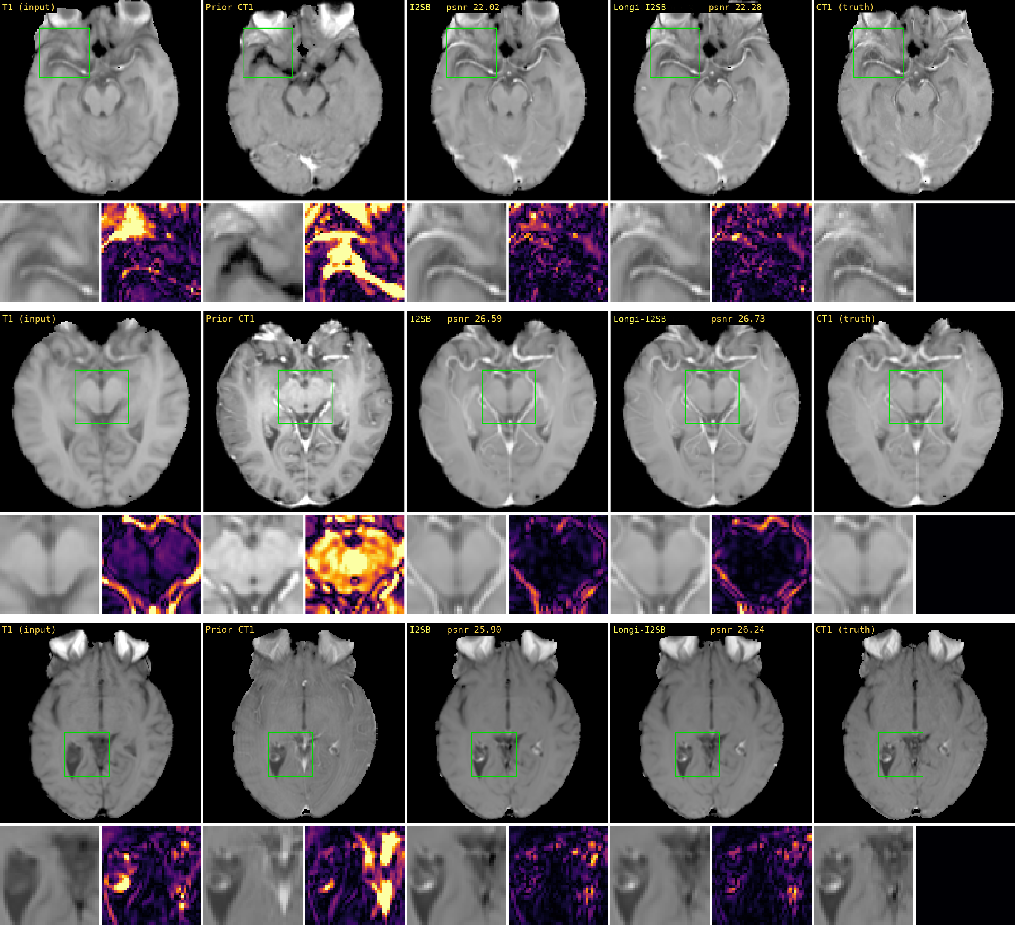
Figure 4: Robustness to a poor prior exam: cases where the registered prior CT1 differs greatly from the current one. Columns as in Figure 2.
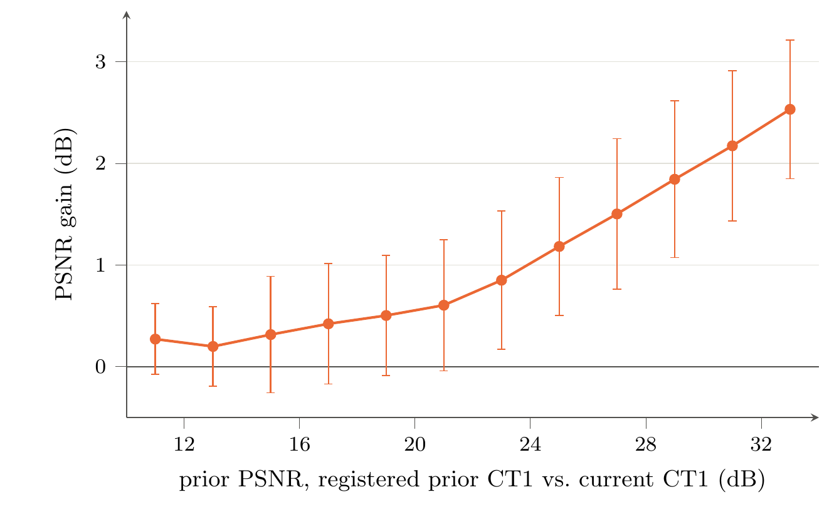
Figure 5: PSNR gain of the longitudinal model over single-exam I2SB versus the prior PSNR: the registered prior CT1 scored against the current CT1 in the same mask and with the same data range as the reported metrics. Mean ± 1 standard deviation over the slices in 2 dB bins. The gain grows with prior similarity, from ≈+0.3 dB for the least similar priors to +2.5 dB for the most similar, and its mean is positive in every bin.

