Clearinghouse Mechanism for Adaptation

Contract nr: Nº 070307/2010/569200/SER/C3

Development of the Climate Change Impacts Vulnerability and Adaptation Clearinghouse
Implementation Phase 3

Integration of GeoNetwork harvesting services

October 24, 2012
Wageningen, the Netherlands



Alterra
Wageningen University and Research;
Droevendaalsesteeg 3, 6708 PB
Wageningen, The Netherlands

In cooperation with


Version history

Version | Date | Description
1.0 | 20/01/2012 | draft
1.1 | 10/10/2012 | Add GeoNetwork harvester configuration in section 2.2  Add GeoNetwork integration in section 2.3
1.2 | 24/10/2012 | Add section 2.4 Results of executing a harvester

Table of contents

1 Introduction 2
2 Harvester configuration and management in Climate-Adapt 4
2.1 WxS harvesters 4
2.2 CSW/GeoNetwork harvesters 6
2.3 Integration with GeoNetwork 9
2.4 Result of executing a harvester: AceItems added to the database 14

Introduction

This document describes how information about web map services and their map layers can be inserted into Climate-Adapt using a semi-automatic process. Climate-Adapt integrates with the catalog GeoNetwork to achieve this.

Map services that follow OGC standards like WMS publish a document describing the service, the Capabilities document. This document also describes which map layers are available from the map service.

GeoNetwork is equipped with a function to request such Capabilities documents and generate metadata about the map server and its layers from it, in ISO19139 format. An instance of this function, targeting a particular Map service, is known as a harvester.

Climate-Adapt is integrated with GeoNetwork allowing the Climate-Adapt administrator to configure such harvesters in Climate-Adapt. These are then propagated to GeoNetwork.

From the Climate-Adapt user interface, the administrator can then tell GeoNetwork to run the harvester (this can also be configured to run periodically). Climate-Adapt retrieves the results of the harvester run from GeoNetwork and converts the results into AceItems, which are stored and indexed in Climate-Adapt. In this way Climate-Adapt users can discover the map layers described by these AceItems and load them in Climate-Adapt's map viewer.

This flow can be illustrated like in the following Component diagram:

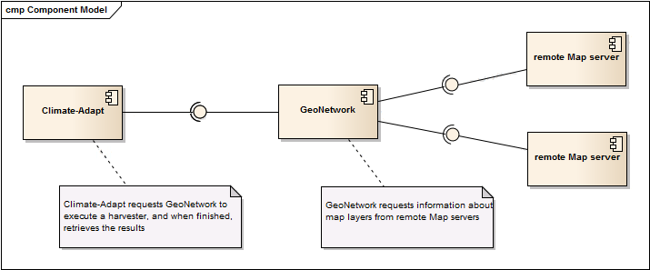

Harvesters to metadata catalogs that are compliant with OGC CSW (Catalog services for the Web) can be also configured in Climate-Adapt. In this case Climate-Adapt retrieves the results of the harvester run from GeoNetwork, processing the online resources from the harvested metadata that reference web map services into AceItems, which are stored and indexed in Climate-Adapt. In this way Climate-Adapt users can discover the map layers described by these AceItems and load them in Climate-Adapt's map viewer.

Harvester configuration and management in Climate-Adapt

Administrator users in Climate-Adapt can configure Harvesters for WxS and CSW services. To do so, you navigate to Maintain/Geonetwork. If no harvesters are configured yet, the page looks like this:

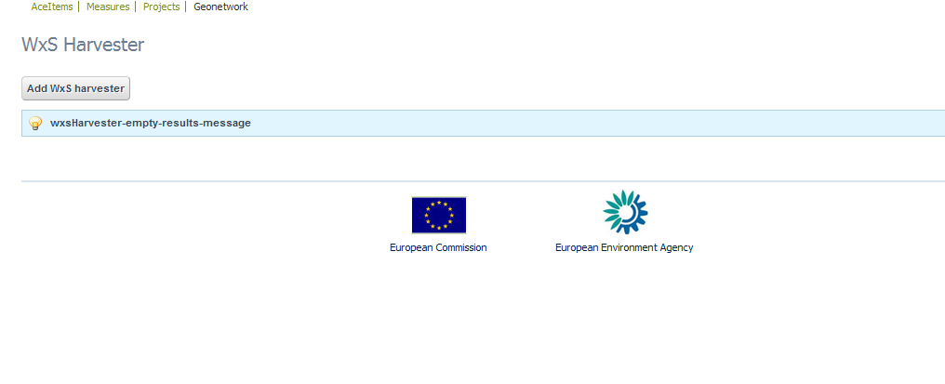

WxS harvesters
To configure a new WxS harvester click 'Add WxS harvester'. This takes you to the following page:
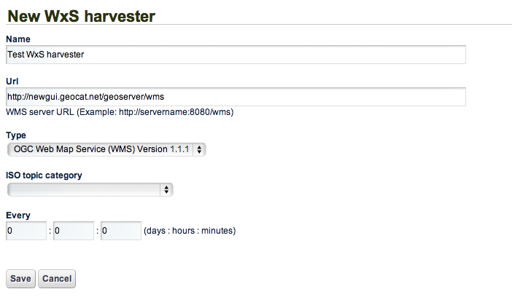

Here you give the Harvester a name, specify the URL of the targeted map service, and specify which version of WMS is supported by the targeted map service.

For better categorization in Climate-Adapt you then assign a ISO topic category, which will be applied to the AceItems resulting from this Harvester.

Next you specify the frequency that this Harvester should execute with. If you leave the period unspecified (all 0s), the Harvester will never run automatically, and will only run on request of the user. If you do specify a non-zero period, the Harvester is executed when you save the configuration after initially waiting for that period.

Now you can save the Harvester configuration and it will be listed in the Harvesters page.
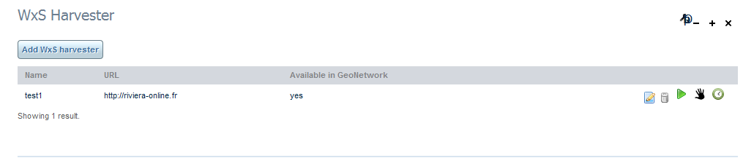

The listing shows the name of the Harvester, the URL of the target Map server, and an indication whether the Harvester configuration was propagated successfully to GeoNetwork.

The other icons to the right signify the following:

Action buttons: these you can click to initiate some action

edit: click this to open the edit page where you can change the Harvester configuration

delete: click this to delete this Harvester configuration. The configuration will also be deleted from GeoNetwork, and any AceItems that were produced by this Harvester are deleted from Climate-Adapt.

add to GeoNetwork: this icon only appears if the Harvester configuration hasn't been propagated and saved succesfully in GeoNetwork. Click this button to try to add it to GeoNetwork.

execute Harvester: if the Harvester was saved successfully to GeoNetwork, this icon appears. Click it to execute the Harvester. You can do this both for Harvesters that are configured to run only on user request (manually) and Harvesters that are scheduled to run periodically (automatically).

Status icons: these are just visual indications about the Harvester

scheduled Harvester: Just a visual clue that this Harvester is configured to run periodically.

manual Harvester: Just a visual clue that this Harvester must be executed on user request (by clicking the 'execute harvester' button).

waiting for first run: this indicates that the Harvester has not yet ever been executed

running now: this indicates that the Harvester is running at this moment. You need to refresh the page (F5) to see this indicator change when the Harvester finishes running.

last run successful: indicates that the last time the Harvester has run, it ran successfully.

last run unsuccessful: indicates that the last time the Harvester has run, an error has occurred.

An illustration of the Harvesters page with various of these icons is this:
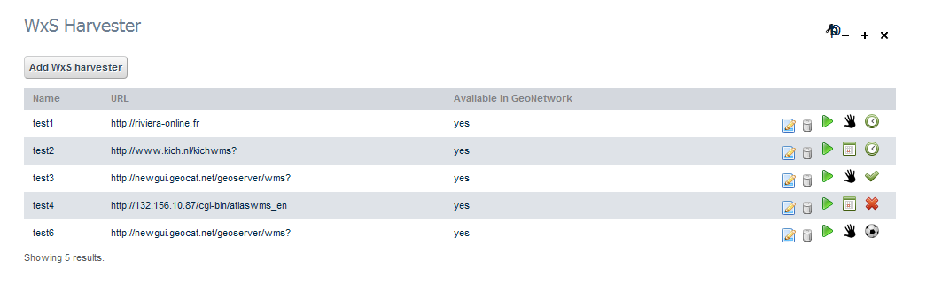
This list shows harvesters with the following properties:

- the first one is not scheduled, and has never run;
- the second one is scheduled, but has not yet run;
- the third is not scheduled and has successfully completed its last run
- the fourth is scheduled and has not successfully completed its last run
- the fifth is not scheduled and is running now (i.e. when you opened this page or after you clicked on the 'execute Harvester' button).

CSW/GeoNetwork harvesters
To configure a new CSW/GeoNetwork harvester click 'Add CSW harvester'. This takes you to the following page:

This harvester has 2 modes of operation:

- Use standard CSW protocol: This protocol is used when is required to harvest public metadata from another CSW catalogue server.

To use it set the Harvester protocol to the value CSW as in following screen:

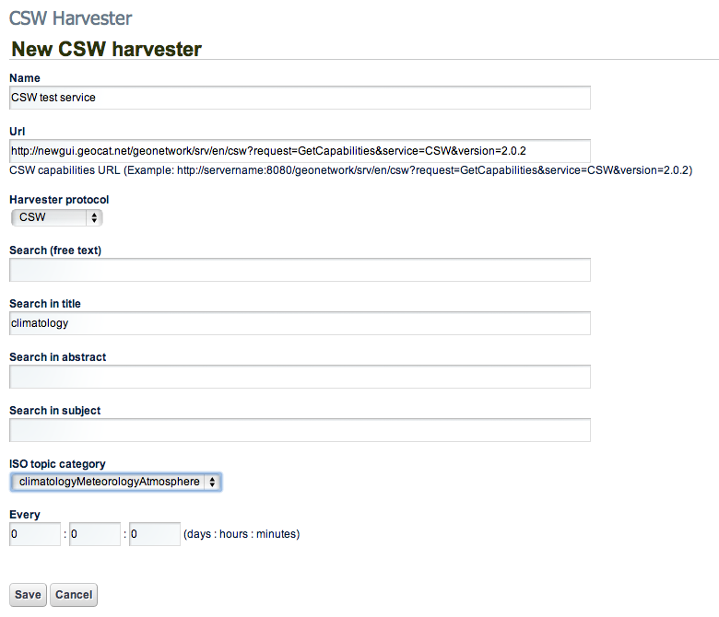

Here you give the Harvester a name, specify the URL of the targeted CSW service capabilities document, and optionally specify different search criteria to filter the metadata to harvest.

For better categorization in Climate-Adapt you then assign an ISO topic category, which will be applied to the AceItems resulting from this Harvester.

Next you specify the frequency that this Harvester should execute with. If you leave the period unspecified (all 0s), the Harvester will never run automatically, and will only run on request of the user. If you do specify a non-zero period, the Harvester is executed when you save the configuration after initially waiting for that period.

- Use GeoNetwork protocol: This protocol is used when is required to harvest no public metadata from a GeoNetwork catalogue (can be use also for public metadata if no credentials are provided).

To use it set the Harvester protocol to the value GeoNetwork as in following screen:

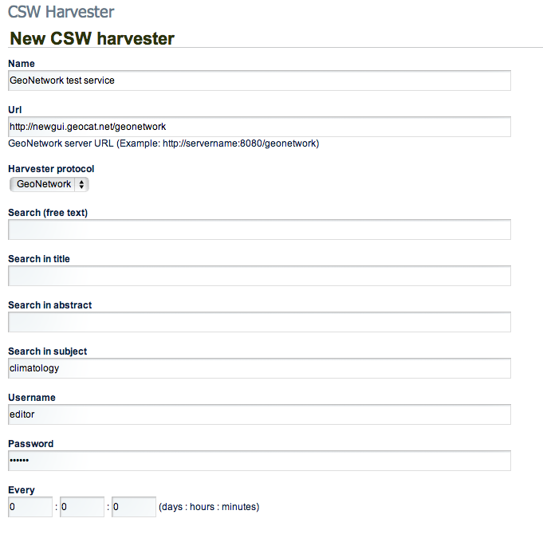

Here you give the Harvester a name, specify the URL of the targeted GeoNetwork service using this format:

http://servername[:port]/geonetwork

And optionally specify the remote GeoNetwork catalogue credentials and the different search criteria to filter the metadata to harvest.

Next you specify the frequency that this Harvester should execute with. If you leave the period unspecified (all 0s), the Harvester will never run automatically, and will only run on request of the user. If you do specify a non-zero period, the Harvester is executed when you save the configuration after initially waiting for that period.

When the Harvester information is filled, you can save it and it will be listed in the Harvesters page.

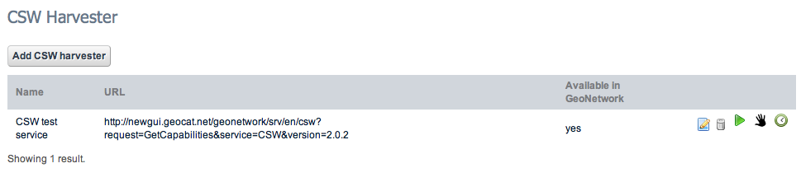

The listing shows the name of the Harvester, the URL of the target CSW service, and an indication whether the Harvester configuration was propagated successfully to GeoNetwork.

The other icons to the right signify the same as described in the section 2.1 WxS harvesters.

Integration with GeoNetwork

The portal provides a UI to configure and execute harvester processes to retrieve climate related metadata for external sources (WxS servers and CSW servers).

As described in section 1, the execution of these harvester processes is done in GeoNetwork catalogue server.

In this section are described the different actions that can be done in the portal to manage the harvesters and how interact with GeoNetwork catalogue server.

To access to the GeoNetwork catalog server you should access to URL like this:

http://portalserver/geonetwork

And provide credentials for Administrator user. Once the user has log in the system, harvesters management is accessible in Administration > Harvesting management option or directly with this URL:

http://portalserver/geonetwork/srv/en/harvesting

This option displays the list of available harvesters in GeoNetwork:

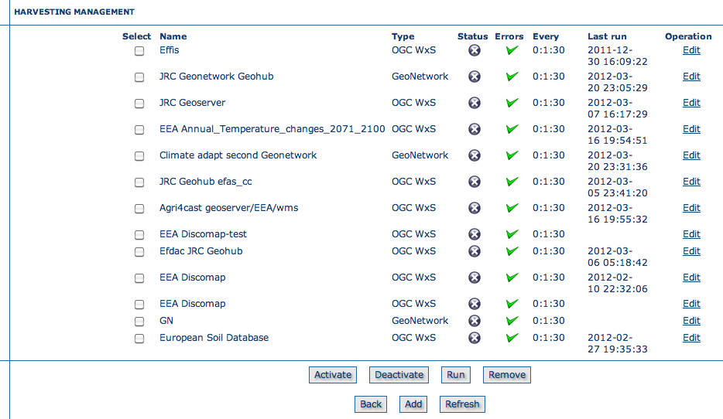

Create a new harvester

When the harvester configuration is saved in the portal, a request with this configuration is send to GeoNetwork where is created a related harvester process with that configuration.

Following pictures show the harvesters list after creating a new WxS harvester in the portal as described previously:
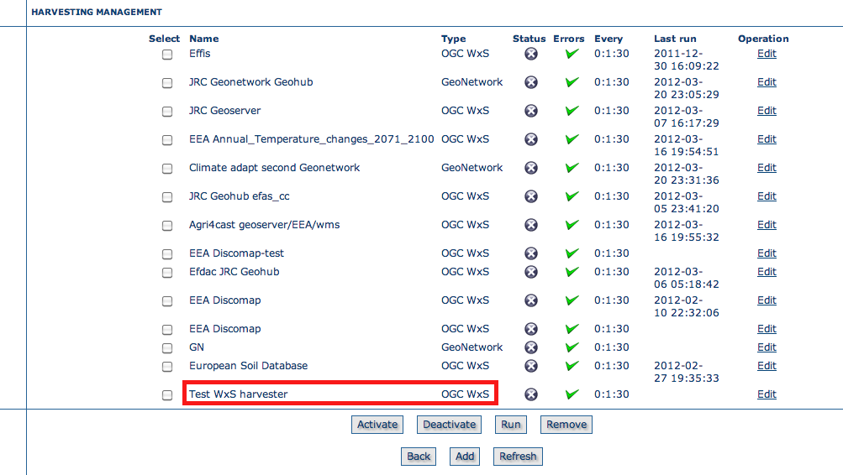

Clicking on Edit button the full configuration of the harvester is displayed, with the same configuration provided in the portal:

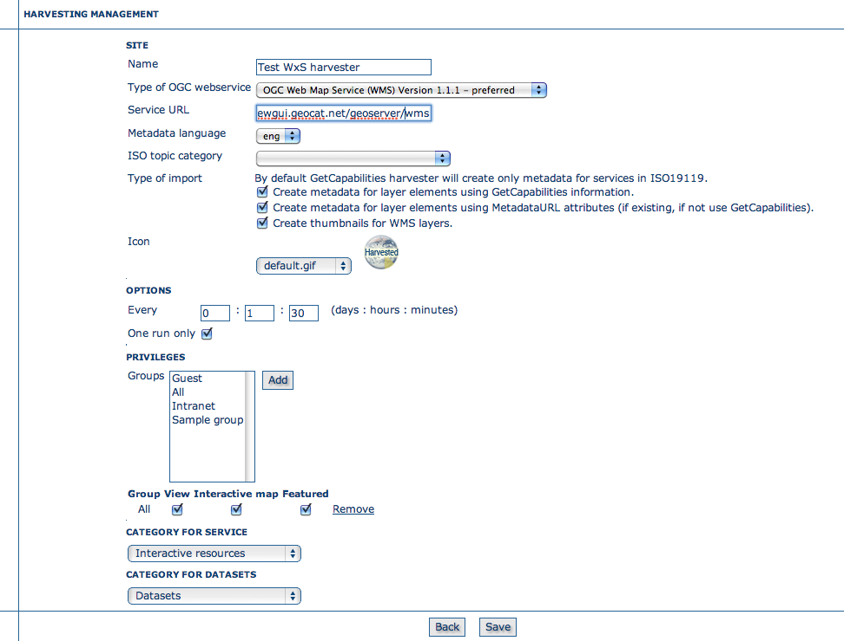

Note: the configuration of the harvesters must be changed from the portal forms to configure the harvesters, not from this previous form.

Update harvester configuration

When the harvester configuration is edited in the portal, for example if we configure an ISO Topic category in the WxS harvester created in section 2.1:

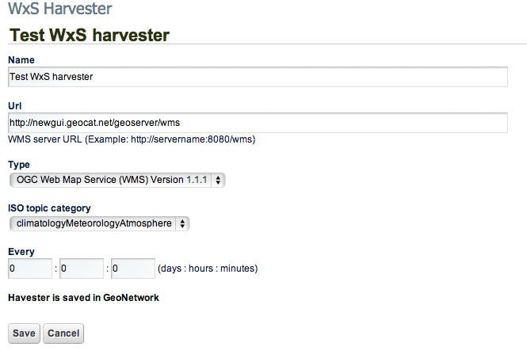

A request with the new configuration is send to GeoNetwork where is updated the related harvester process with the new configuration:

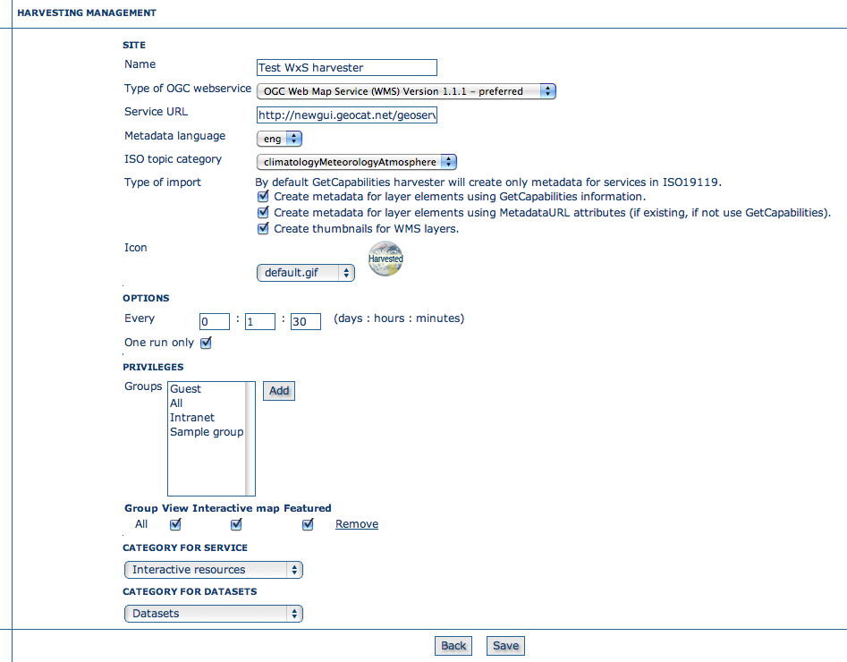

Delete a harvester

When the harvester is deleted in the portal using the button, the related harvester process is deleted from GeoNetwork.

This action removes the harvested metadata for that harvester in GeoNetwork and all related AceItems in the portal.

Execution of a harvester

When the harvester is executed in the portal using the button, a request is send to the GeoNetwork metadata catalogue to start the related harvester process.

While the harvester is running, refreshing the list of harvesters in GeoNetwork displays the status as running :

Refreshing the harvester list once the harvester process finishes the execution, the status icon is updated to indicate the harvester process finished.

If the harvester execution succeed, a green arrow is displayed to indicate that process finished successfully, if the mouse is positioned over the arrow icon, a report of metadata harvested records in GeoNetwork is displayed:

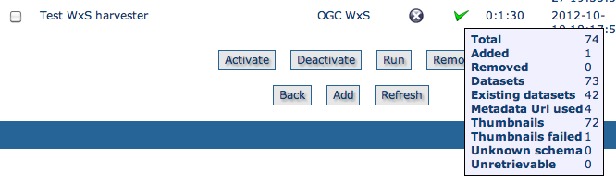

After finishing successfully the harvester, Climate-Adapt retrieves the results of the harvester run from GeoNetwork, processing the online resources from the harvested metadata that reference web map services into AceItems, which are stored and indexed in Climate-Adapt. In this way Climate-Adapt users can discover the map layers described by these AceItems and load them in Climate-Adapt's map viewer.

If the harvester execution failed for any reason (in the example, we configured an invalid WMS server url, so the harvester retrieves an invalid Capabilities document), the status icon is updated to indicate process finished and also an error icon is displayed in the harvester :

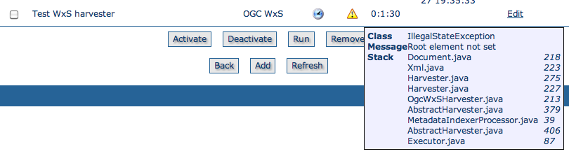

If the mouse is positioned over the error icon, a report of the error is displayed. This error can help to identify the problem (server not available, invalid url provided, etc.).

Result of executing a harvester: AceItems added to the database
By executing a harvester all the elements that are provided by an extern service are added to the Climate-Adapt database. They end up as AceItem with type 'MAPGRAPHDATASET' . If you - directly after executing a harvester - go to the maintenance pages and order the items by aceItemId in descending order, you will see all the added items on top of the list:

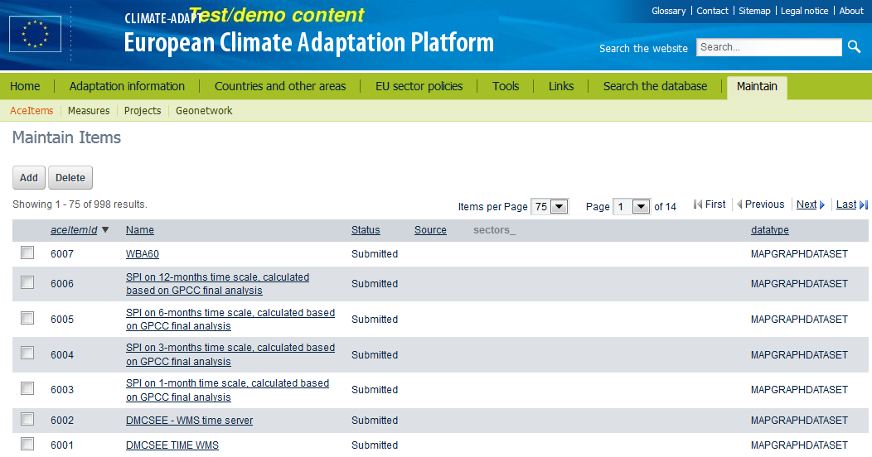

Note all the items have status 'submitted'. They have to be approved in order to publish them to web site visitors. It is quite possible that only a subset off the exposed services is valuable for Climate-Adapt. Therefor an explicit approval has to be given for each item.

