Clearinghouse Mechanism for Adaptation

Contract nr: Nº 070307/2010/569200/SER/C3

Development of the Climate Change Impacts Vulnerability and Adaptation Clearinghouse
Implementation Phase 3

Integration of GeoNetwork harvesting services

January 20, 2012
Wageningen, the Netherlands



Alterra
Wageningen University and Research;
Droevendaalsesteeg 3, 6708 PB
Wageningen, The Netherlands

In cooperation with


Version history

Version | Date | Description
1.0 | 20/01/2012 | draft

Table of contents

1 Introduction 2
2 Harvester configuration and management 3
2.1 WxS harvesters 3
2.1 CSW harvesters 5

Introduction

This document describes how information about web map services and their map layers can be inserted into the Clearinghouse using a semi-automatic process. The Clearinghouse integrates with the metadata catalog GeoNetwork to achieve this.

Map services that follow OGC standards like WMS publish a document describing the service, the Capabilities document. This document also describes which map layers are available from the map service.

GeoNetwork is equipped with a function to request such Capabilities documents and generate metadata about the map server and its layers from it, in ISO19139 format. An instance of this function, targeting a particular Map service, is known as a harvester.

The Clearinghouse is integrated with GeoNetwork allowing the administrator to configure such harvesters in the Clearinghouse. These are then propagated to GeoNetwork. From the user interface, the administrator can then tell GeoNetwork to run the harvester (this can also be configured to run periodically). The Clearinghouse retrieves the results of the harvester run from GeoNetwork and converts the results into AceItems, which are stored and indexed in the Clearinghouse. In this way the Clearinghouse users can discover the map layers described by these AceItems and load them in the map viewer.

This flow can be illustrated like in the following Component diagram:

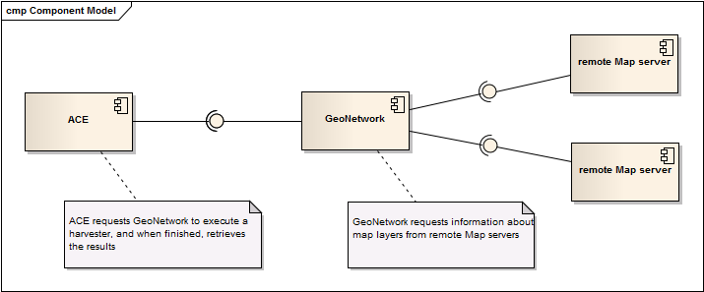

Harvesters to metadata catalogs that are compliant with OGC CSW (Catalog services for the Web) can be also configured in the Clearinghouse. In this case the Clearinghouse retrieves the results of the harvester run from GeoNetwork, processing the online resources from the harvested metadata that reference web map services into AceItems, which are stored and indexed in the Clearinghouse. In this way the Clearinghouse users can discover the map layers described by these AceItems and load them in the map viewer.

Harvester configuration and management

Administrator users in the Clearinghouse can configure Harvesters for WxS and CSW services. To do so, you navigate to Maintain/Geonetwork. If no harvesters are configured yet, the page looks like this:

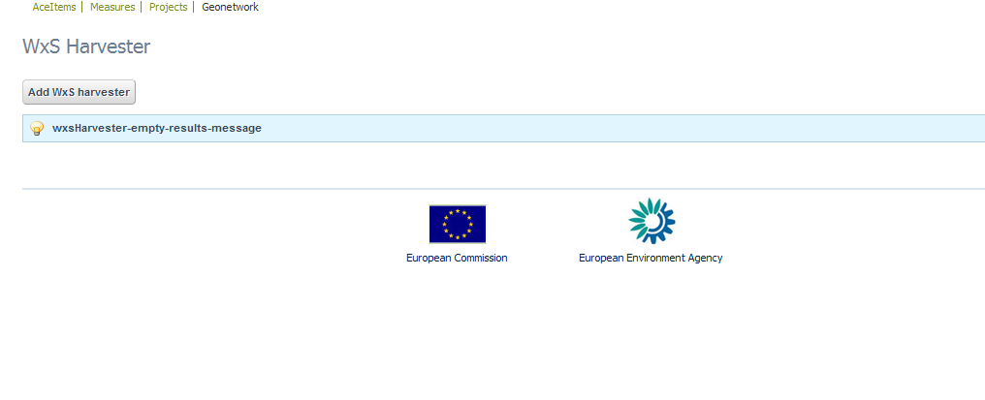

WxS harvesters
To configure a new WxS harvester click 'Add WxS harvester'. This takes you to the following page:
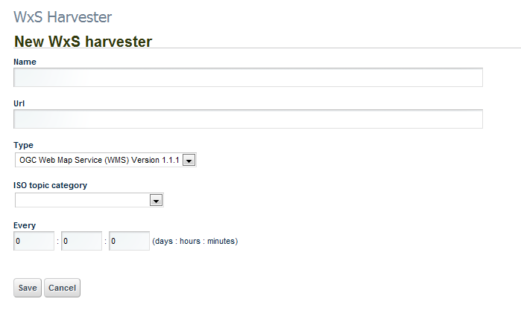
Here you give the Harvester a name, specify the URL of the targeted map service, and specify which version of WMS is supported by the targeted map service.

For better categorization in the Clearinghouse you then assign a ISO topic category, which will be applied to the AceItems resulting from this Harvester.

Next you specify the frequency that this Harvester should execute with. If you leave the period unspecified (all 0s), the Harvester will never run automatically, and will only run on request of the user. If you do specify a non-zero period, the Harvester is executed when you save the configuration after initially waiting for that period.

Now you can save the Harvester configuration and it will be listed in the Harvesters page.
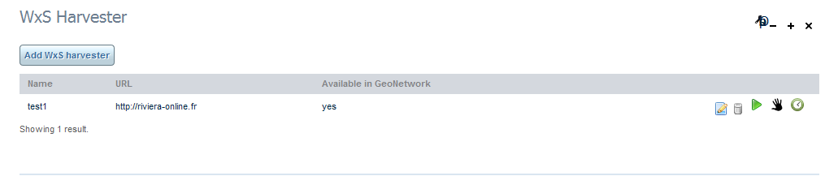

The listing shows the name of the Harvester, the URL of the target Map server, and an indication whether the Harvester configuration was propagated successfully to GeoNetwork.

The other icons to the right signify the following :

Action buttons: these you can click to initiate some action

edit: click this to open the edit page where you can change the Harvester configuration

delete: click this to delete this Harvester configuration. The configuration will also be deleted from GeoNetwork, and any AceItems that were produced by this Harvester are deleted from the Clearinghouse.

add to GeoNetwork: this icon only appears if the Harvester configuration hasn't been propagated and saved succesfully in GeoNetwork. Click this button to try to add it to GeoNetwork.

execute Harvester: if the Harvester was saved successfully to GeoNetwork, this icon appears. Click it to execute the Harvester. You can do this both for Harvesters that are configured to run only on user request (manually) and Harvesters that are scheduled to run periodically (automatically).

Status icons: these are just visual indications about the Harvester

scheduled Harvester: Just a visual clue that this Harvester is configured to run periodically.

manual Harvester: Just a visual clue that this Harvester must be executed on user request (by clicking the 'execute harvester' button).

waiting for first run: this indicates that the Harvester has not yet ever been executed

running now: this indicates that the Harvester is running at this moment. You need to refresh the page (F5) to see this indicator change when the Harvester finishes running.

last run successful: indicates that the last time the Harvester has run, it ran successfully.

last run unsuccessful: indicates that the last time the Harvester has run, an error has occurred.

An illustration of the Harvesters page with various of these icons is this:
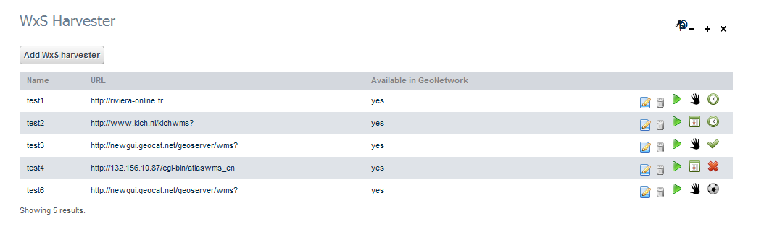
This list shows harvesters with the following properties:

- the first one is not scheduled, and has never run;
- the second one is scheduled, but has not yet run;
- the third is not scheduled and has successfully completed its last run
- the fourth is scheduled and has not successfully completed its last run
- the fifth is not scheduled and is running now (i.e. when you opened this page or after you clicked on the 'execute Harvester' button).

CSW harvesters
To configure a new CSW harvester click 'Add CSW harvester'. This takes you to the following page:

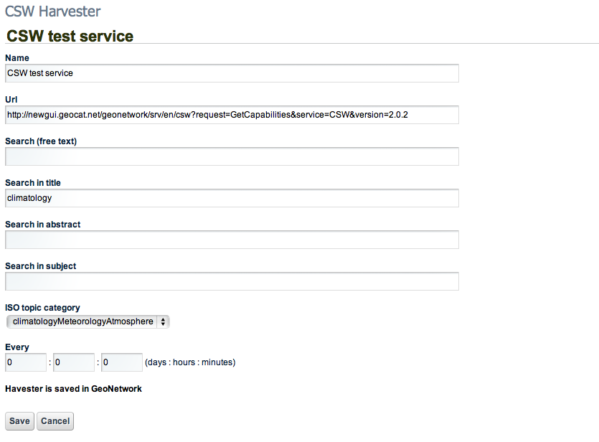

Here you give the Harvester a name, specify the URL of the targeted CSW service capabilities document, and optionally specify different search criteria to filter the metadata to harvest.

For better categorization in ACE you then assign a ISO topic category, which will be applied to the AceItems resulting from this Harvester.

Next you specify the frequency that this Harvester should execute with. If you leave the period unspecified (all 0s), the Harvester will never run automatically, and will only run on request of the user. If you do specify a non-zero period, the Harvester is executed when you save the configuration after initially waiting for that period.

Now you can save the Harvester configuration and it will be listed in the Harvesters page.

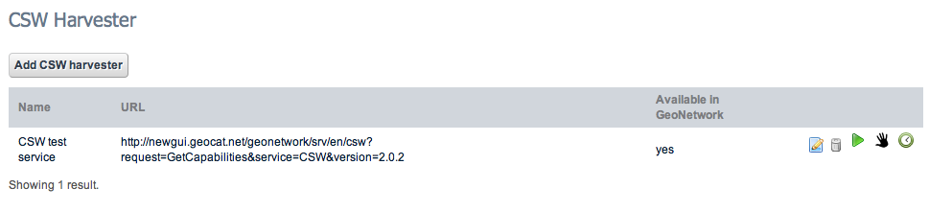

The listing shows the name of the Harvester, the URL of the target CSW service, and an indication whether the Harvester configuration was propagated successfully to GeoNetwork.

The other icons to the right signify the same as described in the section 2.1 WxS harvesters.

