

Technical Architecture
Reportnet 3.0 Design and Development

Date: 15/03/2019
Doc. Version: v0.1

Document Control Information

Settings | Value
Document Title: | Technical Architecture
Project Title: | Reportnet 3.0 Design and Development
Document Author: | Jose Luis Antón Bueno
Leader | Jorge Sáenz Puchau
Reviewer | Jorge Sáenz Puchau
Project Owner: | Stefan Jensen
Business Manager (BM): | Jonathan Maidens
Solution Provider (SP): | Søren Roug
Project Manager: | Christian-Xavier Prosperini
Doc. Version: | v0.1
Sensitivity: | Limited
Date: | 15/03/2019

Document Approver(s) and Reviewer(s):
Name | Role | Action | Date
 | Project owner | Review
Christian Xavier Prosperini | Project manager | Review/Approve

Document history:
The Document Author is authorized to make the following types of changes to the document without requiring that the document be re-approved:
- Editorial, formatting, and spelling
- Clarification
To request a change to this document, contact the Document Author or Owner.
Changes to this document are summarized in the following table in reverse chronological order (latest version first).
Revision | Date | Created by | Short Description of Changes
0.1 | 15.03.2019 | Jose Luis Antón Bueno | Early draft
0.2 | 22.03.2019 | Jose Luis Antón Bueno | Updated Transversal layer (CheckMK, Kafka explaination, ElasticSearch), Added Use Cases and Permission and Conceptual Data Model
0.3 | 01.04.2019 | Jose Luis Antón Bueno | Detailed Harvester microservice and IndexSearch microservice. Added schema of Roles Hierarchy, deployment schema of Harvester microservices and RecordStore microservice
0.4 | 14.05.2019 | Jose Luis Antón Bueso | Services Layer restructured, Added Mockito last version, Lombok, Drools, Apache JackRabbit and Reddis to technological stack. Detailed Use Cases and Permission System
0.5 | 10.06.2019 | Jose Luis Antón Bueso | Removed ROD Microproxy from Context Model. Clarified unclear points on the different databases. Added Keycloak Feasibility Study as proposal for IAM System and removed EIONET as Authentication Provider
0.6 | 06.08.2019 | Jose Luis Antón Bueso | Updated point 3.3.5 and added Gatling as Performance Test engine. Corrected Spring Security Version. Added Keycloak references and Deployment Model
0.7 | 17.12.2019 | Jose Luis Antón Bueso | Updated Context Model to restructure ROD Microproxy approach, added Helm v3 and list of charts to deploy side services.
0.8 | 29.06.2020 | Jose Luis Antón Bueso | Added ROD microservice to Reportnet 3.  Added new Interaction between Keycloak and EULogin based on OpenId. CAS is dismissed.  Update technological Stack

Configuration Management: Document Location
The latest version of this controlled document is stored in XXXXXX

TABLE OF CONTENTS
1 Introduction 7
1.1 Overview 7
1.2 Assumptions 7
1.3 References 7
1.4 Terms, acronyms and abbreviations 7
2 High Level Architecture (HLA) 8
2.1 Reference Architecture Alignment 8
2.1.1 Reference Architecture 8
2.1.2 Applicable Standards 8
2.1.3 Approved Exception Requests 8
2.2 Architecture Overview 8
2.2.1 Constraints 8
2.2.2 Architectural Principles 8
2.2.3 Architecture Decisions 9
2.2.4 Context Model 9
2.2.5 Logical Model 10
2.2.6 Concern-Stakeholder Traceability 22
2.2.7 Requirement Traceability 22
2.3 Functional View 23
2.3.1 Functional Elements 23
2.3.2 Use Cases 23
2.3.3 System specific functions 27
2.4 Non-functional View 32
2.4.1 Availability 32
2.4.2 Performance 32
2.4.3 Scalability 33
2.4.4 Security 33
2.4.5 Accessibility 33
2.4.6 Extensibility 33
2.4.7 Internationalization and Localization 33
2.5 Information View 33
2.5.1 Conceptual Data model 34
2.5.2 Data Ownership 34
2.5.3 Timelines, Latency and Age 34
2.5.4 Data Quality 34
2.5.5 Reference and Mappings 34
2.5.6 Data Volumes 34
2.5.7 Regulation 35
2.6 Deployment View 35
2.6.1 Deployment Model 35
2.6.2 Development Environment Specifications 42
2.6.3 Deployment Options 42
2.7 Process view 43
2.8 Risks 43
3 System Architecture Design (SAD) 44
3.1 Information View 44
3.1.1 Logical Data Model (LDM) 44
3.1.2 Information Flow 44
3.1.3 Status Diagram 44
3.1.4 Transaction Management 44
3.1.5 Archives and Data Retention 44
3.2 Concurrency view 44
3.2.1 Synchronization and Integrity 45
3.2.2 Re-entrancy 45
3.3 Technology view 45
3.3.1 Presentation tier 45
3.3.2 Service tier 45
3.3.3 Information tier 45
3.3.4 External Dependencies 45
3.3.5 Internal Modules Reuse 45
3.3.6 Environment Specification 46
3.3.7 Development Environment 46
3.3.8 Technology Selection 46
3.3.9 Third-party Software License Overview 49
3.4 Design justification 49
3.4.1 Concern-Stakeholder Traceability 49
3.5 Implementation view 50
3.5.1 System Specifics 50
3.5.2 Inter-process Communication 50
3.5.3 Component Packaging 50
3.6 Deployment view 50
3.6.1 Deployment Model 50
3.6.2 Infrastructure Model 50
3.6.3 Physical Model 50
3.6.4 Types of Hardware Required 50
3.6.5 Specification and Quantity of Hardware Required 50
3.6.6 Network Requirements 51
3.6.7 Network Capacity Required 51
3.6.8 Physical Constraints 51
3.7 Operational view 51
3.7.1 Installation and Upgrade 51
3.7.2 Functional Migration 51
3.7.3 Data Migration 51
3.7.4 Monitoring and Control 51
3.7.5 Start-up and Shutdown 52
3.7.6 Configuration Management 52
3.7.7 Backup and Restore 52
4 Data Model Design (DMD) 53
4.1 Data Model Design Decisions 53
4.2 Data Model Design Diagram 53
4.3 Physical Data Model document reference 53
4.4 ORM Documentation 53
5 Service Definition (SD) 54
5.1 Interface view 54
5.2 Scope 54
5.3 Services dependency model 54
5.4 Services provided 54
5.4.1 Service name 1 54
5.4.2 Service name 2 55
5.5 Services Consumed 56
5.5.1 Service name 1 56

Introduction
The purpose of this document is to establish the design for the system and to support the communication among the technical stakeholders. The most important reasons why IT Architecture matters in the context of this project would be:
- To enhance communication among stakeholders through documentation.
- To define a set of constraints on subsequent implementation by the development team.
- To focus attention on the assembly of components rather than simply on their creation.
- To restrict design alternatives by channelling the creativity of developers, therefore reducing design and system complexity.
- To be the foundation for training new team members.

Overview
TBD

Assumptions
This Design Document is based on the version 2.2 of the Architecture of To Be (see [R1]).
Given that there are still some decisions to make, Architectural and technology choices shown in this document could be reviewed in future versions of the document, or during the final implementation.

References
Ref. | Version | Location
[R1] | 2.2 | Architecture of To Be
[R2] | 3.1 | Business Vision
[R3] | 1.1 | Requirements Catalogue Final
[R4] | 1.0 | Keycloak Integration Feasibility Study

Terms, acronyms and abbreviations
Term | Description
DaaS | Database as a service
IAM | identity and access management

High Level Architecture (HLA)

Reference Architecture Alignment
Reference Architecture Alignment sections, are suggested as follows:
- Reference Architecture
- Applicable Standards
- Approved Exception Requests (when applicable)

Reference Architecture
TBD

Applicable Standards
TBD

Approved Exception Requests
TBD

Architecture Overview

Constraints
- Open source software is preferred over proprietary software to avoid vendor lock-in and encourage flexibility and customizability.
- Usage of standard APIs must be prioritized over specific API extensions to avoid product lock-in. For instance, JPA2 Criteria API should be used instead of specific implementations coming from the Hibernate Criteria API, whenever both provide the same functionality.
- Environment agnostic: Microservices must be develop in such way that they can work in any environment such as cloud or on premise.
- The HTTP endpoints exposed by the new components to develop in the context of the project should be implemented following the REST principles.
- EU Style guides must be observed in the front end development.
- The architecture must be secured by design. OWASP secure coding practices shall be respected

Architectural Principles
- Loose Coupling: Every component of the system has little or no knowledge at all of the other components
- High Cohesion: degree to which the elements inside a component belong together
- Abstraction: means exposing a functionality hiding the implementation details.
- Separation of concerns: Breaking down a problem in several parts or concerns. This separation must be driven by functional and non-functional requirements
- Information hiding: In terms of micro services, the interface of a service must be public for everybody to consume but inner functionality should be hidden, so the service can be changed easily
- Modularity: is the degree to which a system's components may be separated and recombined. This is a combination of the Abstraction, Separation of concerns and Information hiding
- Design for change: The architecture should be open to modification.
- Self-documentation: Documentation of a software building block should be part of that software building part
- Traceability: ability to link product requirements back to stakeholders' rationales and forward to corresponding design artefacts, code, and test cases
- Incrementality: means applying the separation of concerns principle to the development steps in the development of the system

Architecture Decisions
The system must be extensible, resilient, fault tolerant, scalable and easy to deploy on any environment. Due to this the following decisions have been taken:
- Micro service pattern: This is the architectural pattern that will guide the whole development. This pattern has a bucketful of benefits:
  - Each microservice is relatively small, which helps out developers to understand it, makes the IDE faster and developers more productive, and decreases the startup time for containers.
  - Each microservice can be deployed independently of other services, encouraging the deployment of new versions of services frequently.
  - Easier to scale development, by organizing the implementation around multiple teams, each responsible for a single microservice. Each team can develop, deploy and scale their service without any impact on other teams whatsoever.
  - Improved fault isolation – if there is a memory leak in one service then only that service will be affected and the other services can continue to handle requests, as opposite to the monolithic architecture where such an issue can bring down the entire system.
  - Eliminates any long-term commitment to a technology stack.

- Each Domain Entity will be managed by a single Micro service.
- Communication among microservices will be done via Rest HTTP for synchronous calls and via Events for asynchronous calls. This means that all the micro services will be listening to the events that may come from the Event Bus. In the same way, when a micro service finishes a task, if it is necessary, it will be able to publish an event in the Event Bus so the rest of the micro services can manage it in the way it is considered to implement the Business Logic
- There will be a single entry point to the Business Logic: The API Gateway. This gateway will be used by the Legacy Systems as well as the Reportnet 3.0 Web Interface
- Client/User Interface: Client technology must be isolated from Server Technology. Due to this, there will be a microservice to contain the User Interface
- Circuit Breaker Pattern will be used to avoid failures propagation.
- Correlation ID in logs to help detecting what request are going wrong and at what point of the system.
- Given the distributed and asynchronous nature of the architecture, Eventual Consistency will be chosen instead of the classical Transactional Consistency
- Lightweight technologies: Over engineering must be avoided in the development process.
- User credentials will be managed out of Reportnet 3.0, so the system must support Single Sign On. However, permissions and authorities will be managed in Reportnet 3.0.
- There will be a Rules Common Repository to provide validation about the reported data at all levels: Fields, Records, Dataset…

Context Model
The Context Model of a system defines the relationships, dependencies and interactions between the system and its environment, i.e. people, systems and external entities with which it interacts. It sets the scope of what the system will and will not do, where the boundaries are between it and the outside world (if any), and how the system interacts with other systems, organizations and people across these boundaries

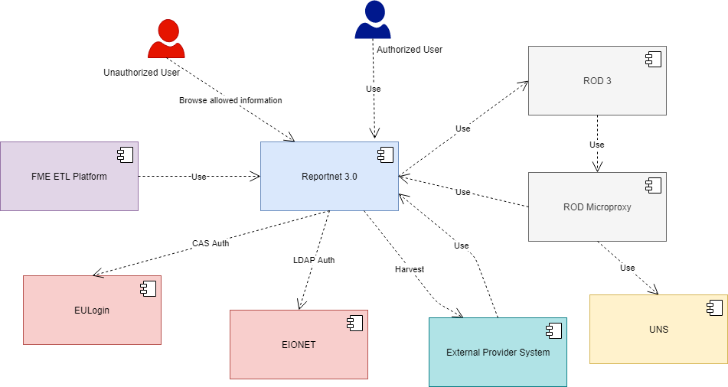
Figure 1. Context Diagram

- UNS: A notification service where users subscribe to receive notifications for interesting events.
- FME ETL Platform: Is the platform that will be used to migrate data from Reportnet 2.0 to Reportnet 3.0. Migration will be done using Rest APIS instead of migrating from data base to data base
- EULogin: Is the European Authetication Service that works under OpenId (among others) protocol to provide Single Sign On functionality.
- EIONET: Is the Users and Organizations directory.
- External Provider System: Represent any reporting system based on any of the countries managed by EEA
- ROD Microproxy: Is a microproxy to be develop to to redirect messages from ROD 3 to Reportnet 3 and to UNS. This is a temporal solution in the meantime that Reportnet 2.0 and Reportnet 3.0 are working at the same time.
- Unauthorized User: Users with no credential can browse disseminated datasets and visualizations
- Authorized User: Can access to private information. Depending on the role, the user will be able to read or write different kind of data: Creating a dataflow, feed a dataset…

Logical Model
Reportnet 3.0 is divided in four layers that are meant to be independent one from each other:

Presentation Layer
Presentation Layer is the entry point to the system. It exposes basically to ways of accessing the system: Web and Rest. It is composed by two microservices: Frontend microservice and API-Gateway microservice
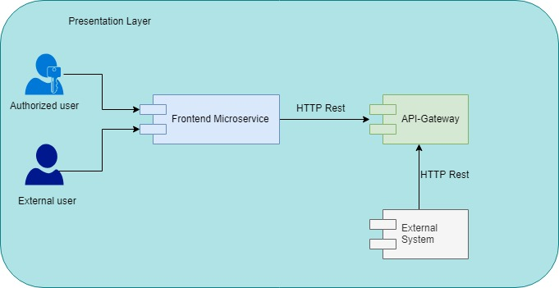
Figure 2. Presentation Layer
Frontend microservice: Exposes a web interface where the user can see data retrieved from the backend and composed in a logical way. This microservice never will access to the backend microservices. All the requests will go through the API-Gateway
As Frontend Microservice contains the User interfaces, this service will be built to add several languages in an easy way. In the same way, the service will allow the user to use the language that he considers
API-Gateway: Exposes Rest API’s of backend services making them available to external services. This microservice relies on external services (EULogin and EIONET) for user authentication. As this service is going to be validating credentials and given that Core Layer is protected by infrastructure, as a proposal it could be done that Core Layer is not validating Tokens/Credentials.

Service Layer
The second (from top to bottom) logical tier encompasses all the logical components where the business logic of the application resides. Communication among the different microservices in this layer can be done synchronous or asynchronously. Synchronous communication will be done using a declarative approach with Feign Client as well as Service Discovery pattern. This kind of communication will be supported by Consul on server side and Spring Cloud on client side. Asynchronous communication will be implemented based on events using as Enterprises Event Bus Apache Kafka.

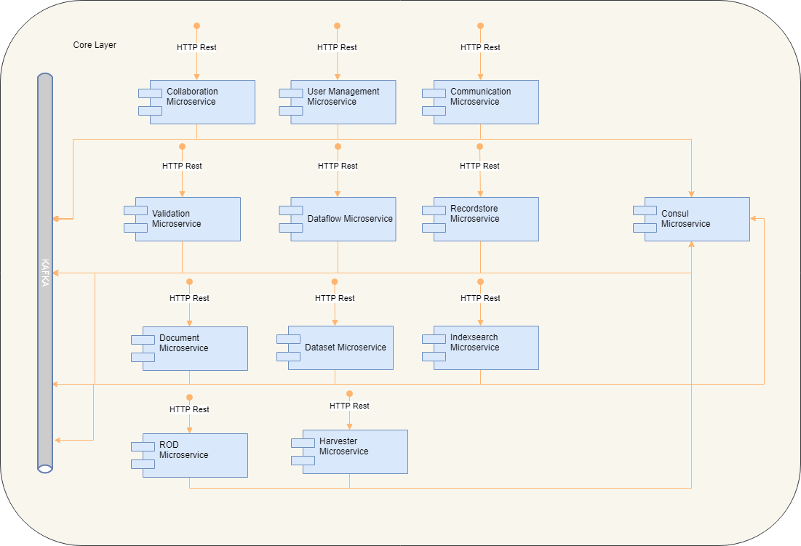
Figure 3 - Service Layer
Collaboration microservice: this services allows stakeholders to collaborate each other giving the infrastructure to make comments at dataflow and dataset levels.

Communication Microservice: Capture events on Reporter’s interests and send notifications via email using for this EEA’s mail infrastructure

User Management Microservice: is the system responsible for all account-related functions such as synchronizing EU Login accounts in the EIONET directory. This service also provides all necessary read APIs for searching users and getting an account's details through the user interface. Keycloak will be used as IAM provider. Please see References regarding Keycloack

Validation Microservice: Provides features to allow relevant Stakeholders to define new rules and evaluate them in the context of a dataflow. These rules cover from individual attributes (data types…) to dataset wide and they are stored in the metabase as well.

Dataflow Microservice: This service manages everything about dataflow entities, namely, CRUD operations, participants, datasets designs creation…

Recordstore Microservice: Provides the required infrastructure to create, close and restore dataset snapshots as well as manages dataset backups.

Document Microservice: Manages all the document type resources involved in the Dataflow and Dataset lifecycle (Attachment type fields, dataflow documentation, collection data files…). This microservice will rely on Apache Jack-Rabbit Oak

Dataset Microservice: This service provides Rest APIS to perform CRUD operations on dataset schemas, visualizations, dataset records and Read operations for validation errors

Indexsearch Microservice: Provides search mechanisms over all the system’s entities. The entities that will be searched are:
- Subimission agreements
- Data flows
- Data collection
- EU data sets
- Registered users
- Roles
- Organization

Harvester Microservice: Provides features to define and implement data harvesting jobs. INSPIRE Harvester microservice will work based on the Information Service’s URL that the Data Requestor will introduce as metadata of a Harvested INSPIRE Dataset. The Data Requestor can either supply one of the following information:

- Dataset metadata and a coupled download service metadata,
- Direct link to an Atom feed containing entries to datasets,
- Direct link to a WFS StoredQuery for retrieving the dataset.

In addition, there will be a feature to discover Dataset Download Services in the future based on INSPIRE Geoportal

The information will be download in one of the following formats:
- GML (could be compressed in a Zip file)
- Shapefile (could be compressed in a Zip file)
- geoJSON
- Atom Feed
- WFS
- FTP (Zip Compressed file)

There will be two kinds of Dataset Download Services:

- Pre-defined dataset download service(s) which provides the simple download of pre-defined datasets (or pre-defined parts of a dataset) with no ability to query datasets or select user-defined subsets of datasets
- Direct access download service(s) with the ability to query and download subsets of datasets.

Once the file is downloaded it will be parsed to extract info that Dataset Service can use to extract data to add to the dataset. This mapping will be done based on the mappings that the Data Requestor will define during the Dataset Definition phase.

Rod Microservice: This service will act as ROD 3 proxy so any interaction between Reportnet 3 and ROD will be done through this service. In the future ROD 3 might be absorbed by Reportnet 3, if this is the case, Rod Microservice will become the new ROD system.
Every microservice will be structured as follows:

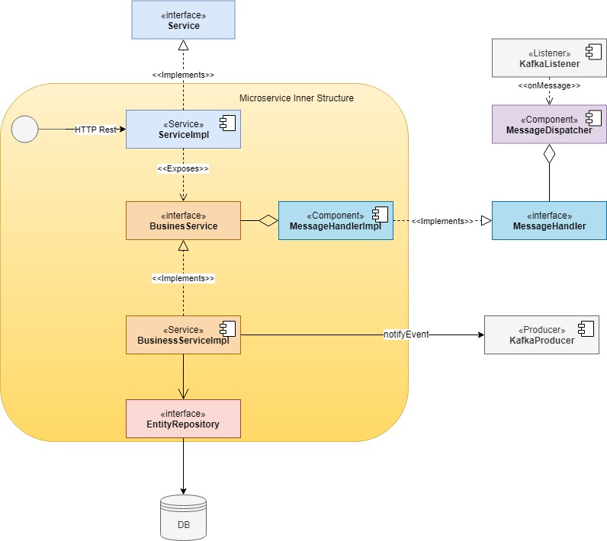
Figure 3.2. Microservice Structure

<<Interface>> Service: is the public interface of the microservice. If the microservice itself is complex, there could be more than one Interface for the same microservice. It is not defined inside the microservice but in an external library. That way it is decouple the implementation from the interface easing the use of Feign Clients

<<Service>> ServiceImpl: Is the implementation of <<Interface>> Service and it will manage the Rest invocations

<<Interface>> BusinessService: Defines the interface of Business Logic implementation

<<Service>> BusinessServiceImpl: Implements business logic based on tine Interface given by <<Interface>> BusinessService. It will give support as well to KafkaListener to manage received events

<<Interface>> EntityRepository: Gives access to data bases (NoSQL or SQL). Implementation will be provided by Spring Data Framework unless there is a special case that requires custom development. In that Case, the same approach Interface – Implementation will be followed in the most generic way to ease the reusability and decoupling inside the microservice’s components.

<<Listener>> KafkaListener: It will receive events from Kafka according to some prefixed criteria and send it to the MessageDispatcher. This component will not be defined in the microservice but in an external library.

<<Component>> MessageDispatcher: This component will dispatch the receive message from <<Listener>> KafkaListener to the appropriate handler. This component will not be defined in the microservice but in an external library.

<<Interface>> MessageHandler: This interface will define a single method to expose the event handling functionality. This component will not be defined in the microservice but in an external library.

<<Component>> MessageHandlerImpl: This component will implement <<Interface>> MessageHandler to provide the required functionality to deal with the received event. This component will not implement business logic itself but it will invoke to the Business Services to accomplish with the desired behavior.

<<Producer>> KafkaProducer: This component will send whatever message the microservice requires to notify some event to the rest of the microservices in the system.

Repository Layer
This layer contains the storage infrastructure for all of the components of the system:
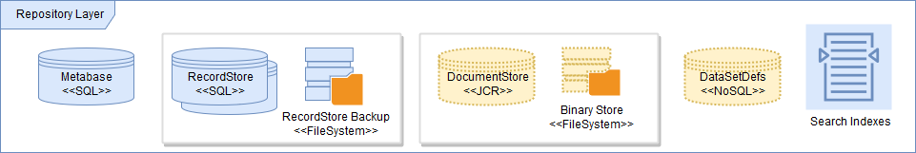
Figure 4. Repository Layer

Metabase
The Metabase will store all the metadata related with the Dataflows and their related Datasets. The data reported by countries will not be stored in this database.
This will include:

- Collaboration and communication: Comments, messages and helpdesk tickets.
- Notifications about certain Dataflows.
- Data Collections, requested by a Data Requestor and filled by a Data Reporter.
- Dataflow definitions, type and status. It will also store the published resources.
- Dataflow workflow definitions, and the history of status they have been in.
- Dataset definitions, containing a Reporting Entity’s own database. Each dataset has a type: documents dataset, design dataset, data collection dataset (final dataset or template), reporting dataset or European dataset (finished and publicly visible), database definitions.
- Codelists definitions: Lists of previously reported data that can be used in other reportings.
- codelist/vocabulary/reference-data

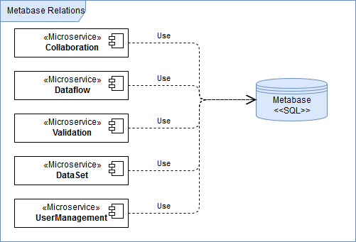
Encoding of Data Base must be UTF-8

RecordStore
This database will persist the actual Dataset records. The physical structure will be designed to allow the maximum flexibility in a dataset schema. Every entity in the physical data model will have a reference to the pertinent table in the DataSetDef. For instance, table storing Field Values in RecordStore will have a field pointing to Field Schema in DataSetDefs. By this it is achieved to what value corresponds to what field. A separate physical database will be instantiated for each dataset’s tables and records during the lifecycle of a given Dataflow.
Together with this, and in order to support the backup and creation of snapshots, a Record backup store would be required to be instantiated.
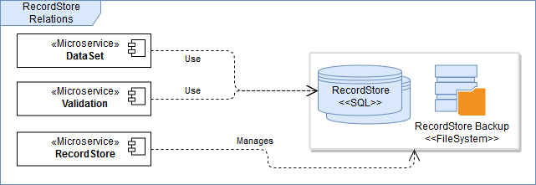
Encoding of Data Base must be UTF-8

DocumentStore
This storage system will be in charge of persisting the different binaries related to the system. It will be composed by:
- A filesystem for storing physically the binaries
- A store for storing the metadata related to each binary.
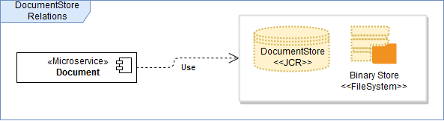

DataSetDefs
The goal of this NoSQL Data Repository is to keep the definitions of the DataSets while they are being defined by the Data Reporters, in order to reduce the complexity of all the related information and entities managed in the DataSet Definition (tables, columns, validations, test data, validation rules definition etc.).
Once the DataSet is released, the definition will be persisted in the Metabase.
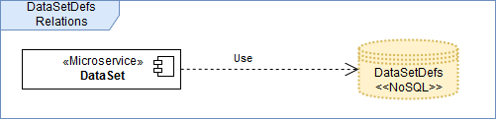

Search Indexes
Searchable information in Reportnet 3.0 will be stored in a Search Index, by the means of an ElasticSearch instance.
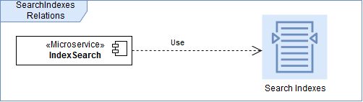
The following entities are to be indexed for further search:

- Subimission agreements
- Data flows
- Data collection
- EU data sets
- Registered users
- Roles
- Organization
- Entity Event
As proposal the following index structures will be stored:
- Subimission agreements / Data Collection / EU Data Set
  - Name
  - Countries
  - Issue
  - Release/Deadline Date
  - Access URL
  - User info:
    - User Id
    - Favourite Flag
  - Crossover Filter:
    - Dataflow data
    - Dataset data
    - Datacollection data
    - Organization
    - …
- Roles
  - Role name
- Registered user
  - Name
  - Authorization
  - User Url
- Organization:
  - Organizaction Name
- Entity Event:
  - Entity Type
  - Event Type
  - URL Entity
  - Entity Name
  - Event Description.

Cross Functional Layer
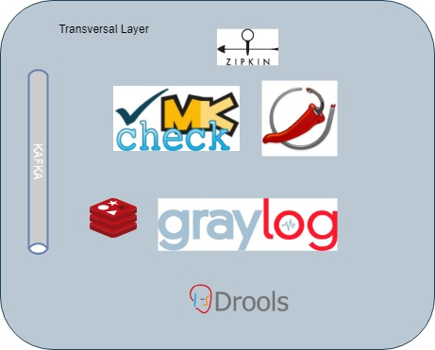
Figure 5. Transversal Layer

This layer will cover non business features such as Logging, Metrics gathering/aggregation, request traceability, … According to the functionalities they provide the components might be categorized as follows:
- Validation Rules: Drools is a Business Rules Management System (BRMS) solution. It provides a core Business Rules Engine (BRE), a web authoring and rules management application (Drools Workbench)

- Logging:
  - Graylog 2: Is an open source Log manager. It performs Log analysis, Log collection and Log viewer functions.

- Metrics Analysis:
  - Jolokia JMX: is a JMX-HTTP bridge giving an alternative to JSR-160 connectors. It is an agent based approach with support for many platforms. In addition to basic JMX operations it enhances JMX remoting with unique features like bulk requests and fine grained security policies.

- Monitoring:
  - Check_MK: It’s a comprehensive Solution for IT Monitoring of applications, servers, and networks. It’s a service that EEA already owns and it will be used for monitoring Reportnet 3.0 along with Jolokia JMX
- Request Treceability:
  - Zipkin: is a distributed tracing system. It helps gather timing data needed to troubleshoot latency problems in microservice architectures. It manages both the collection and lookup of this data. Zipkin’s design is based on the Google Dapper paper.
- Redis:
  - Redis is an open source (BSD licensed), in-memory data structure store, used as a database, cache and message broker. It supports data structures such as strings, hashes, lists, sets, sorted sets with range queries, bitmaps, hyperloglogs, geospatial indexes with radius queries and streams

- Event Bus:
  - Apache Kafka: is an open-source stream-processing software platform. The project aims to provide a unified, high-throughput, low-latency platform for handling real-time data feeds. In Kafka there are several items to be taken into account:
    - Topic: is a category or feed name to which messages are published. Each topic contains several partitions.
    - Partition: is an ordered, immutable sequence of messages that is continually appended to, a.k.a. a commit log. Partitions are distributed among the different Kafka nodes in the clusters.
    - Messages: Contains the information to be transferred. They have an incremental id called Offset
Based on this, this is the common structure of a Topic:
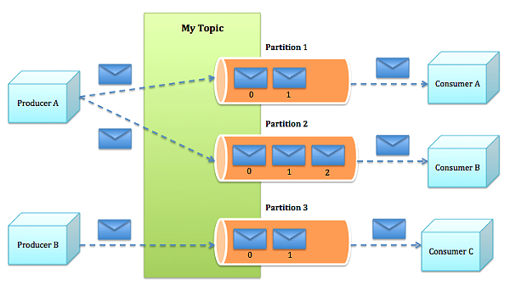
Messaging traditionally has two models: queuing and publish-subscribe. In a queue, a pool of consumers may read from a server and each message goes to one of them; in publish-subscribe mode, the message is broadcast to all consumers. Kafka offers a single consumer abstraction that generalizes the best of both worlds: the consumer group

Consumers label themselves with a consumer group name, and each message published to a topic is delivered to one consumer instance within each subscribing consumer group. Consumer instances can be in separate processes or on separate machines. Then:
- If all the consumer instances have the same consumer group, then this works just like a traditional queue balancing load over the consumers.
- If all the consumer instances have different consumer groups, then this works like publish-subscribe topic and all messages are broadcast to all consumers.
Kafka has stronger ordering guarantees than traditional messaging systems as well, even in the presence of heavy parallel consumption. This can be achieved by having a notion of parallelism as partitions within the topics where each partition is consumed by exactly one consumer in the group. As such, Kafka provides a total order over messages within a partition, not between different partitions in a topic.
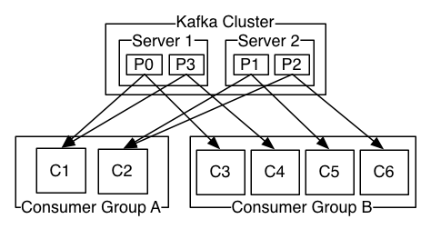
Given that Reportnet 3.0 is based on an Event Oriented Architecture, Kafka will play a main role in the system communications. Due to this, several brokers will be necessary to implement fault tolerance and resilience. Apache Zookeper will be used to achieve this. Zookeeper is a distributed, hierarchical file system that facilitates loose coupling between clients and provides an eventually consistent view of its znodes, which are like files and directories in a traditional file system. It provides basic operations such as creating, deleting, and checking existence of znodes. It provides an event-driven model in which clients can watch for changes to specific znodes, for example, if a new child is added to an existing znode. Zookeeper achieves high availability by running multiple Zookeeper servers, called an ensemble, with each server holding an in-memory copy of the distributed file system to service client read requests. This is how Zookeeper maintains consistency among ZNodes:
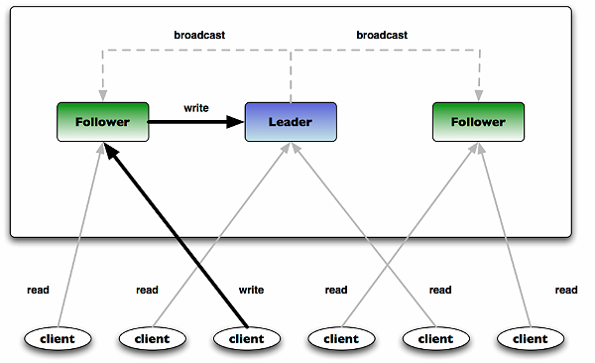
The image above shows a typical Zookeeper ensemble in which one server acting as a leader while the rest are followers. On start-up, a leader is elected first and then followers replicate their state with the leader. All write requests are routed through the leader and changes are broadcast to all the followers. A change broadcast is termed as atomic broadcast.

Based on this, a common Kafka Architectures loos like as follows:
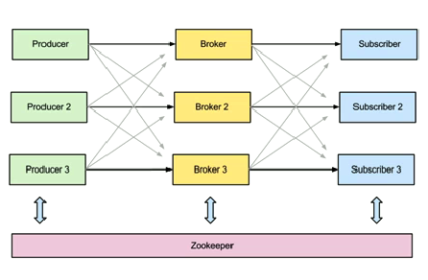
Producers and Consumers obtains metadata about the Brokers ZNodes. Once they have required data, Producers can publish events on broker’s topic and Subscribers will be able to subscribe to those topics.
Every published event will be replicated in the rest of the brokers before they are visible to the subscribers, so consistency will be ensured.

Concern-Stakeholder Traceability
TBD
 | Users | System/Service Admins | QA | QC | DevOps | Architecture | PM | DEV
Concern: Effectiveness |  |  | X |  |  | X | X
Concern: Schedule |  |  | X |  |  |  | X
Concern: Requirements traceability |  |  | X | X |  | X | X
Concern: Feasibility and risk assessment |  |  | X |  |  |  | X
Concern: Consistency with requirements and usage scenarios |  |  | X | X |  | X | X
Concern: Non-functional requirements | X | X | X | X | X | X | X | X
Concern: Completeness, consistency of architecture |  |  | X |  |  | X | X | X
Concern: Sufficient detail for design / implementation |  |  | X |  |  | X | X | X
Concern: Accommodate future requirements / change requests | X |  | X |  |  |  | X
Concern: Integration with existing systems |  | X | X | X | X | X | X | X

Requirement Traceability
A table of requirements that impact the design should be shown. Against each of these requirements we should have a design response column where a description of how the requirement has been fulfilled is added.
Ref. | System | System Version | Compliance | MoSCoW | Requirement | Design Response
 |  |  | Partial | Must
 |  |  | None | Should
 |  |  | None | Won't

Functional View
The functional view summarises what the key functions of the system are. It shows an explicit link between the functional aspects of the system (use cases, stories, etc.) and explains why they are significant to the architecture. It shows the user roles (actors) and the main features (use cases).
The functional view sections, are suggested as follows:
- Functional Elements
- Use Cases
- System specific functions (when applicable)

Functional Elements
The functional requirements should be mapped to Functional elements.
Figure 2.1 Example of Functional Elements

Use Cases
The following diagram represents a set of initial Use Cases extracted from the Business Vision document.
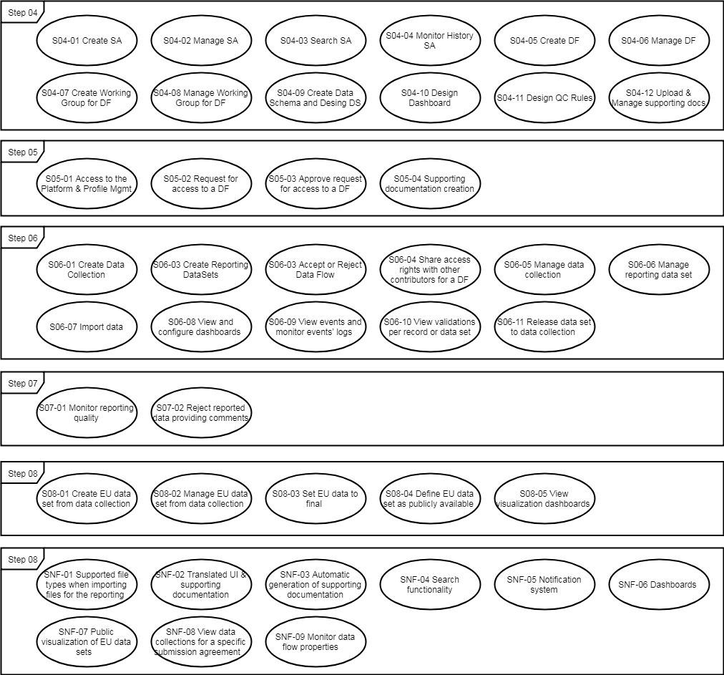

Use Cases to Components Traceability
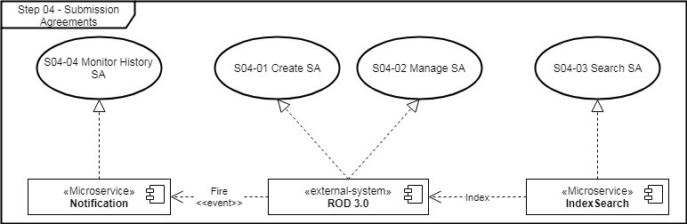

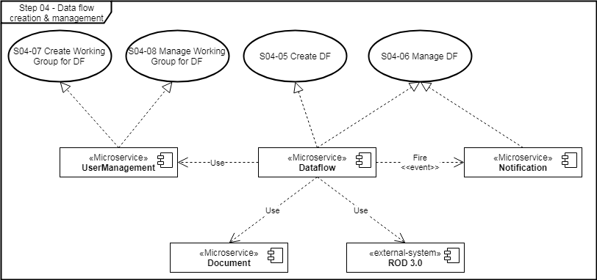

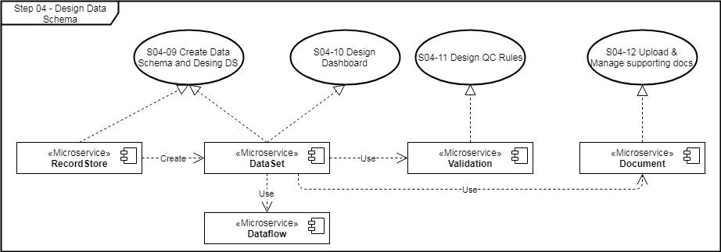

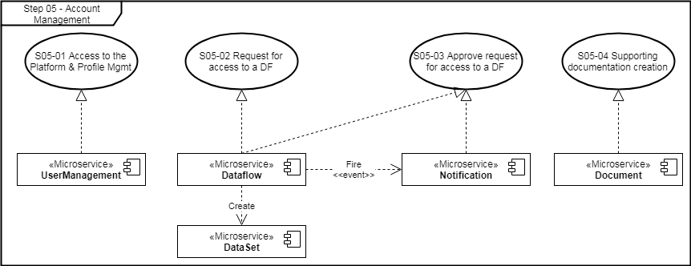
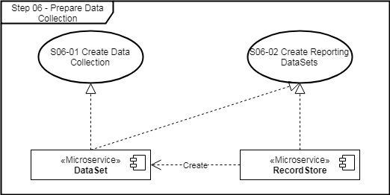
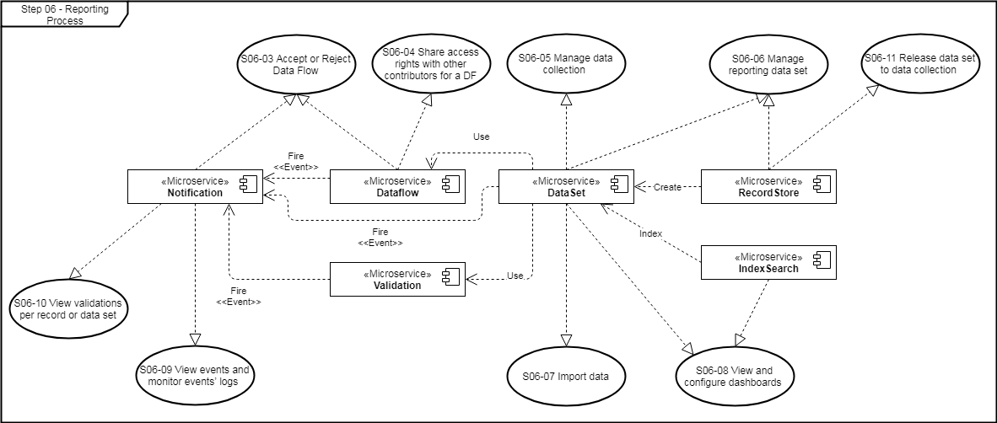
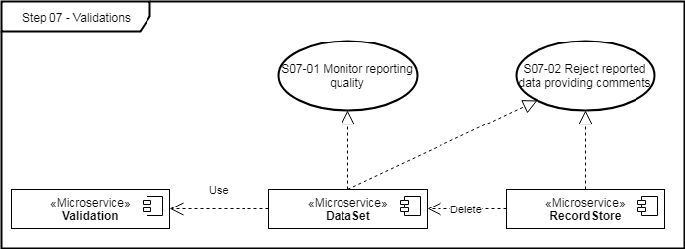
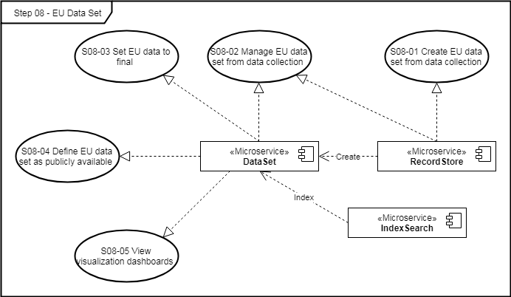
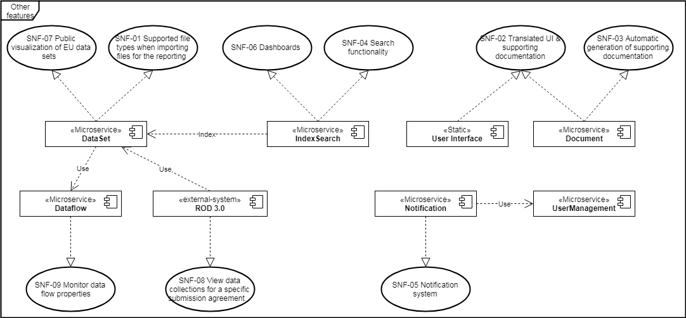

System specific functions

Authentication & Authorization

Token based authentication
ReportNet 3.0 will include a User Management component in charge of managing the Authentication against the User Repositories existing (EULogin). In order to manage the authentication in a Distributed environment, the User Management component will issue a token that will be used by the different components of the system to validate the identity of the request, the authorisation profile and the validity of the token, enabling the Single Sign On between the different components.
In the following graph, it is described how the authentication mechanism will work:
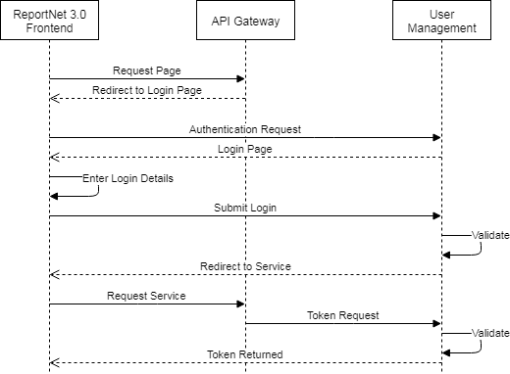
process followed here is:
- ReportNet 3.0 Frontend requires to access to any of the system’s components through the API Gateway. The API Gateway notices the user is not logged in, so it redirects the browser to the User Management Service to be authenticated. The API Gateway passes along a call-back URL (a redirect URL) as a query parameter in this browser redirect that User Management Service will use when it finishes authentication.
- User Management Service authenticates the user and creates a one-time, very short lived, temporary code. User Management Service redirects back to the API Gateway using the call-back URL provided earlier and additionally adds the temporary code as a query parameter in the call-back URL.
- The API Gateway extracts the temporary code and makes a background out of band REST invocation to User Management Service to exchange the code for an identity, access and refresh token. Once this temporary code has been used to obtain the tokens, it can never be used again. This prevents potential replay attacks.

User Federation mechanism
ReportNet 3.0 user information will be distributed in the following User Database:
- EULogin OpenId
So, Authentication mechanism should ideally deal with EULogin User Database in a transparent way to the user. For achieving this, User Management Service will implement a User Federation mechanism that will work in the following way:
- When a user logs in, the User Management will check against the User Database (EULogin).
- Data from the external User Database will be mapped to an internal common user model, so the User Management component can retrieve the information stored.
Configuration of external User Databases should be configurable, in order to allow the definition of further Databases or just to exchange the values from DEV to PROD environments.

Role Hierarchy
According to the Requirements, we have extracted the following Role Hierarchy:
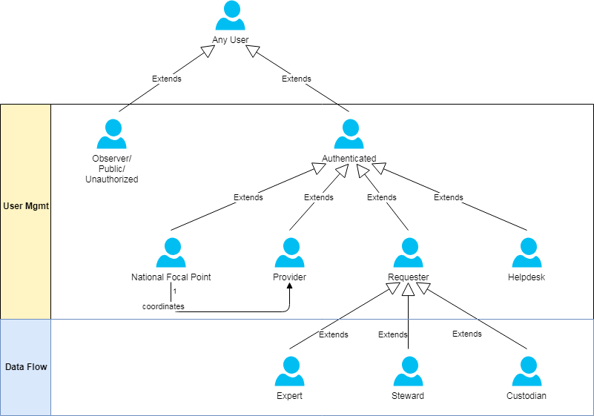
Within this diagram, there is an important technical aspect to consider:
- Authorization Schema will be defined in the User Management component.
- However, for the specialization of the Data Requester role, users assigned to each role will be mapped and maintained at DataFlow level, so it will be under the boundaries of the DataFlow service.

Authorization Schema
Authorization of the system will be based in a Role-based Access Control. Considering this approach, Authorization will be defined in terms of:
Permission:
Permission can be defined as an action allowed over a resource. For example: CREATE DATASET, READ SUBMISSION AGREEMENT, etc.
Role:
A role is a set of permission put together to define the functionality allowed to a given kind of user. For example:
DATA REQUESTOR role will be formed by the permissions: CREATE SUBMISSION AGREEMENT, CREATE DATAFLOW, CREATE DATASET, RELEASE DATASET, etc.
Group:
A group is a set of users that form a Logic Unit within the Business implemented in the system. This could include several users with different roles.
For example, Member States’ users will form a group per Reporting Entity, where one of those users will have the role of National Focus Point (with its related extra permissions).
In the same way, Working Groups can be defined as Groups related to an existing DataFlow.

Permission Definitions and Role Mapping
In the following table, it is listed the different permissions identified, and under which role can be included:
Entity | Action | Description | Role(s)
Legal Instrument | MANAGE | Can manage (Create, Read, Update and Delete) any Legal Instrument. | DATA_STEWARD
 | READ | Can Read (list and get into details) any Legal Instrument. | DATA_PROVIDER,  DATA_CUSTODIAN
Submission Agreements | MANAGE | Can manage (Create, Read, Update and Delete) any Submission Agreement. | DATA_STEWARD
 | READ | Can Read (list and get into details) any Submission Agreement. | DATA_PROVIDER,  DATA_CUSTODIAN
DataFlow | READ | Can Read (list and get into details) any DataFlow where the user has been assigned with the given role. | DATA_STEWARD, DATA_PROVIDER
 | MANAGE | Can manage (Create, Read, Update and Delete) any Data Flow where the user has been assigned with the given role. | DATA_CUSTODIAN
Working Group Entry | CREATE_OWN | Can Create its own entries (requests to join to a given DataFlow). Entries are create in Pending status. | DATA_PROVIDER
 | MANAGE_ALL | Can manage (Create, Read, Update and Delete) any Working Group Entry in the Data Flows where the user has been assigned with the given role.  This includes accept or reject requests to Join. | DATA_STEWARD, DATA_CUSTODIAN
 | VALIDATE | Can Validate (Accept or Reject) any Entry related to the user. | DATA_PROVIDER
 | MANAGE_OWN | Can Manage the Working Group entries related to the user. This means Delete or Share them to another Data Providers. | DATA_PROVIDER
DataSet | READ | Can Read (list and get into details) any DataSet where the user has been assigned with the given role. | DATA_STEWARD
 | MANAGE_DATA | Can manage (Create, Read, Update and Delete) the Data included in the DataSets assigned to the user. | DATA_PROVIDER
 | RELEASE | Can release a Reporting DataSet into a DataCollection. | DATA_PROVIDER
 | EXPORT | Can export a Reporting DataSet. | DATA_PROVIDER
 | IMPORT | Can import data to a Reporting DataSet, if the DataFlow has been configured to allow it. | DATA_PROVIDER
DataSetTemplate | MANAGE | Can Read (list and get into details) any DataSet Template where the user has been assigned with the given role. | DATA_CUSTODIAN
 | READ | Can manage (Create, Read, Update and Delete) any DataSet Template where the user has been assigned with the given role. | DATA_STEWARD, DATA_PROVIDER
Dashboard | MANAGE | Can manage (Create, Read, Update and Delete) any Dashboard definition where the user has been assigned with the given role. | DATA_CUSTODIAN
 | READ | Can Read (list and get into details) any Dashboard definition where the user has been assigned with the given role. | DATA_PROVIDER
 | UPDATE | Can Update any Dashboard definition where the user has been assigned with the given role, related to the Datasets the user has been assigned. | DATA_PROVIDER
Validation Definitions | MANAGE | Can manage (Create, Read, Update and Delete) any Validation Rule where the user has been assigned with the given role. | DATA_CUSTODIAN
 | READ | Can Read (list and get into details) any Validation Rule where the user has been assigned with the given role. | DATA_STEWARD, DATA_PROVIDER
Validation Results | READ | Can Read (list and get into details) any Validation Results where the user has been assigned with the given role. | DATA_REQUESTER
 | READ_OWN | Can Read (list and get into details) any Validation Results in the Reporting DataSets assigned to him. | DATA_PROVIDER
Documents | MANAGE | Can manage (Create, Read, Update and Delete) any Document in the DataFlows where the user has been assigned with the given role. | DATA_CUSTODIAN
 | READ | Can Read (list and get into details) any Document in the DataFlows where the user has been assigned with the given role. | DATA_STEWARD, DATA_PROVIDER
User Profile | MANAGE_OWN | Can manage (Create, Read, Update and Delete) its own User Profile information.. | AUTHENTICATED_USER
Data Collection | MANAGE | Can manage (Create, Read, Update and Delete) any Data Collection in the DataFlows where the user has been assigned with the given role. | DATA_CUSTODIAN
 | READ | Can Read (list and get into details) any Data Collection in the DataFlows where the user has been assigned with the given role. | DATA_STEWARD
 | READ_PUBLIC | Can Read (list and get into details) any Data Collection marked as Public. | ANY_USER
DataSet EventLog | READ | Can Read (list and get into details) any Event Log in the DataFlows where the user has been assigned with the given role. | DATA_PROVIDER
EU DataSet | MANAGE | Can manage (Create, Read, Update and Delete) any EU DataSet in the DataFlows where the user has been assigned with the given role. | DATA_CUSTODIAN
 | READ | Can Read (list and get into details) any EU DataSet in the DataFlows where the user has been assigned with the given role. | DATA_STEWARD
Search | EXECUTE | Can execute and see Search Results. | ANY_USER
Notifications | MANAGE_OWN | Can Manage (Read and Delete) any Notification generated by the System. | AUTHENTICATED_USER

NOTE: MANAGE action means it can be done any operation on the Entity.

Non-functional View
The following are typical non-functional requirements. Maybe the architecture needs other non-functional requirements, if it is the case add more subsections.

Availability
TBC
Business: The system must be available for use 24/7 and it must achieve 99% up time. Maintenance breaks must be scheduled outside working hours and the system shall present appropriate user notifications before becoming unavailable.

Technical: The architecture discussed in this document guarantees this non-functional requirement by means of high availability (HA) in active-active mode

Performance
TBC
Business: The system's user facing components must achieve response times with their 98th percentile not exceeding 300ms as measured from the user interface.

Technical: As part of the building process in the CI pipeline performance tests will be done in order to ensure metrics that show the system works as expected on this regards.

Scalability
TBC
Business: The system shall be developed in a way that allows to increment the number of users avoiding to develop a single line of code (horizontal scalability).
Technical: The architecture ensures horizontal scalability due to the distributed nature of its components.

Security
Business: The system must be secured by design and be compliance with OWASP best practices.
Technical: Security is present during all the phases of the development. See point 1.6.1 of this document to find how microservices are protected. Also the architecture proposes frameworks that ensure security at all levels of the application

Accessibility
TBC

Extensibility
TBC

Internationalization and Localization
TBC
Business: Though at initial stage the system will show tags and messages in English, in the future other languages must be supported
Technical: The system will be prepared for this maintaining one file per language. The same tags and messages will be parametrized in all the files with the corresponding translation.

Information View
The Information View sections, are suggested as follows:
- Conceptual Data Model
- Data Ownership (when applicable)
- Timelines, Latency and Age(when applicable)
- Data Quality (when applicable)
- Reference and Mappings (when applicable)
- Data Volumes
- Regulation(when applicable)

Conceptual Data model
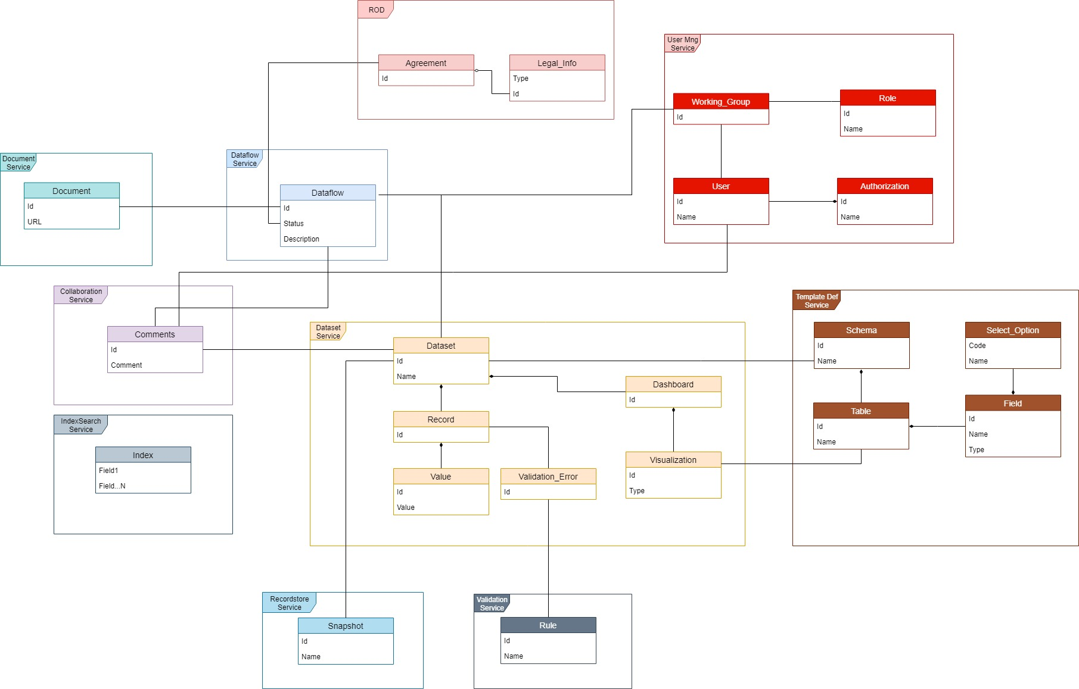

Data Ownership
In cases where the data is physically distributed across multiple data stores, defining the owner of each data item, will ensure that data consumers are always working with the most current data, the producers are storing the data in the correct place, the validation and business logic are applied and the potential conflicts can be resolved.

Timelines, Latency and Age
The time lag between the visibility of information to providers and consumers, is expressed by means of latency; the length of time between the data being updated at the data source and the updated value being available to all parts of the system. Within this section we must identify key points where time-based inconsistencies may arise.

Data Quality
Data Quality should show a correlation between the expected value and actual value.

Reference and Mappings
Where data is spread over multiple repositories, identifiers often become an issue. Different systems may use different mechanisms to identify the same data item, and these mechanisms will need to be reconciled at points where data exchanges occur.

Data Volumes
As the data volumes increase, the architecture comes up against various physical, technical, and operational limitations:
- The amount of data that can be physically addressed, stored on a disk, tape or other media,
- The time required to move data from one location to another,
- The maximum capacity of communication networks,
- The time to complete large batch jobs.
The typical and worst-case operational scenarios should be documented and justified in terms of the data transfer rates and volumes arising. For each scenario, anaylsis should be done to review and explain how the system will cope and what may happen if it cannot keep up.

Regulation
This section should describe the legislation around personal privacy and data security may have an impact on the information architecture related to accuracy, security, data retention times, and even the scope of the data that must be held.

Deployment View

Deployment Model
In the Architecture it is foreseen two main zones where containers will be deployed: Private Zone and Public Zone.
Public Zone will contain the services that give access to the system, namely, Frontend Container, the Gateway Container and the Side Systems (Logging, Monitoring, Traceability…). Frontend will expose a Web interface so the User (Requestors, Providers, Stakeholders…) will be able to interact with Reportnet 3.0. Gateway Container will contain the API Gateway that will give access through its Rest API to the other Systems in the EEA. Furthermore, this Gateway will be responsible to interact with the Security System in the EEA in order to validate whether the external requests are legitimate meaning by this that the user exists in the EEA and has the right to make it. Side Systems has their own way to authenticate so there is no need to hide them in the private zone
Private Zone will contain the Microservices that will implement the Business Logic as well as the data bases, data stores and the Event Bus. These components will be behind a Firewall so they won’t be accessible from outside, only via administration console
Every container by default will be deployed as follows:
- Microservice core: Component managing the System Entity (Dataflow, Datasets…). This will contain the library Hystrix that will implement Circuit Breaker pattern
- STDOUT/STDERR is caught by the Container itself and sent to Graylog.
- Exception will be sent to Sentry
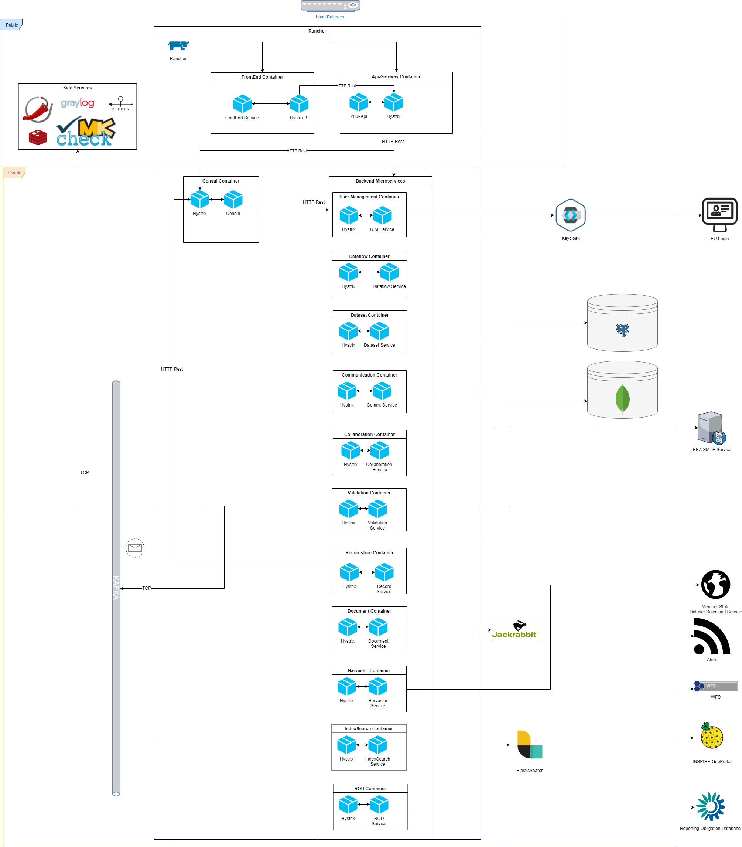
Figure 6. Deployment Diagram

Zuul Deployment Model
API Gateway will be implemented by Zuul Api Gateway. It will be assisted by Consul when routing since it will be done using Service Discovery.
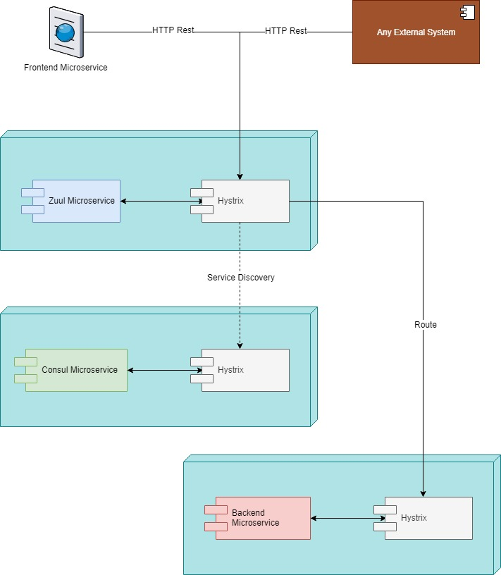

Given that API-Gateway will be the sole entry point to the system it will be implementing a second level Load Balancer based on Ribbon.

Kafka Deployment Model
Kafka will be deployed as a cluster synchronized by Zookeper as follows:
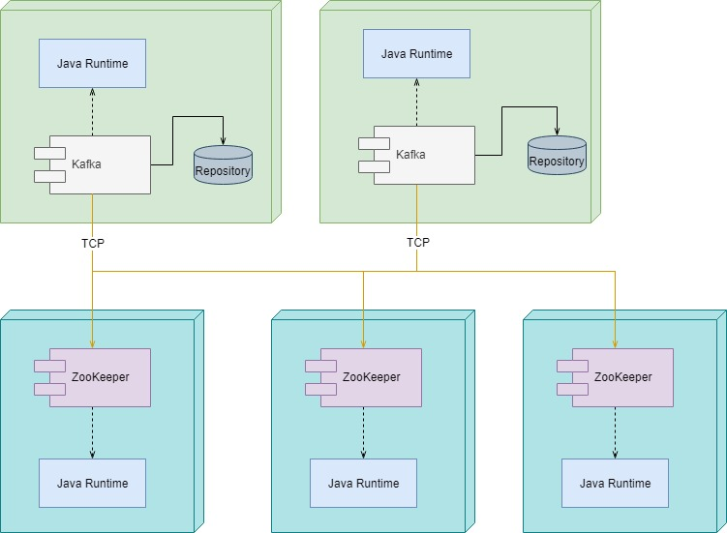

In order to preserve the messages order, when an event is published in Kafka it will be assigned to the partition = Hash(message.key) % number_of_partitions. This way the same type of messages will be queued up in the same partition.
Kafka Cluster will be structured as follows:
- Kafka and Zoopkeeper will be deployed as Docker Containers (one for each) in Rancher
- There will be two nodes configured as Leader and Follower
- In every node there will be two topics:
  - Schema Definitions Topic structured in 2 partitions. This topic will have as subscribers the following services:
    - Dataflow Service
    - Dataset Service
    - Storage Service
    - IndexSearch Service
    - Communication Service
  - Data Reporting Topic structured in 4 partitions. This topic will have as subscribers the following services
    - Dataflow Service
    - Dataset Service
    - Harvester Service
    - Validation Service
    - Communication Service
    - IndexSearch Service
- There will be one Consumer Group per Service. This is due to the fact that there will be several instances of a single service running at the same time.

IndexSearch Deployment Model
IndexSearch Service engine will be based on ElasticSearch analytic tool. IndexSearch Service will get the events from Kafka Event Bus and will process it before indexing it into ElasticSearch.
User will be able to query ElasticSearch through the FrontEnd Microservice that will expose a screen for this regard.
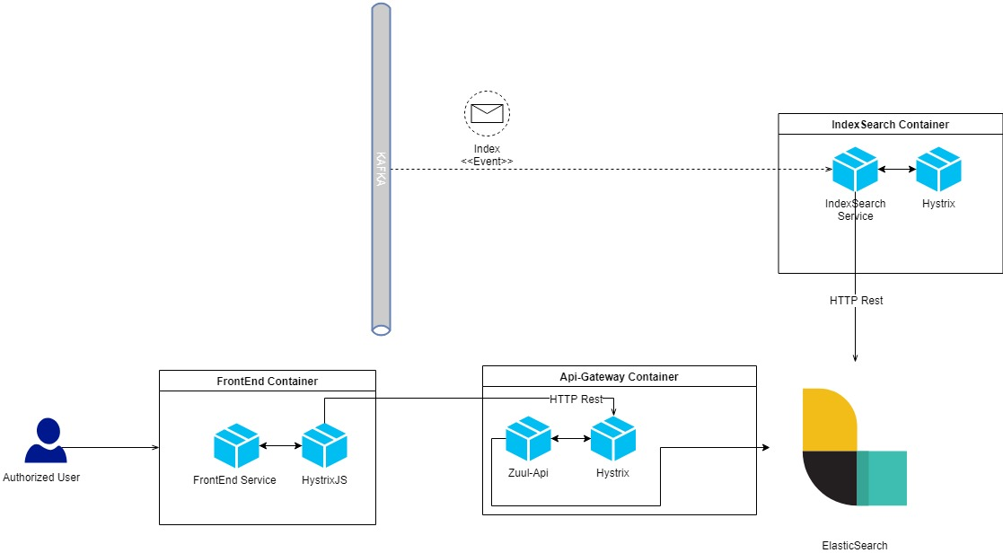
ElasticSearch will be deployed as Docker Container in Rancher. There will be 3 nodes of ElasticSearch and in order to avoid “split-brain” problem, property discovery.zen.minimum_master_nodes will be set to (Nodes / 2) + 1, that means, 2

INSPIRE Harvester Deployment Model
INSPIRE Harvester Microservices will download information in several format (geoJSON, ShapeFile, Atom feed, GML…) from different Dataset Download Services. Once the information is downloaded it is transformed into a format understandable by Dataset Microservice and published in Kafka Event Bus. This information will be taken by Dataset Microservice and added to the corresponding dataset.
It is not foreseen that this service is accessible from outside of Reportnet 3.0 but the infrastructure will allow it (API-Gatway will be able to redirect requests to INSPIRE Harvester microservice) if it turns necessary at any point.

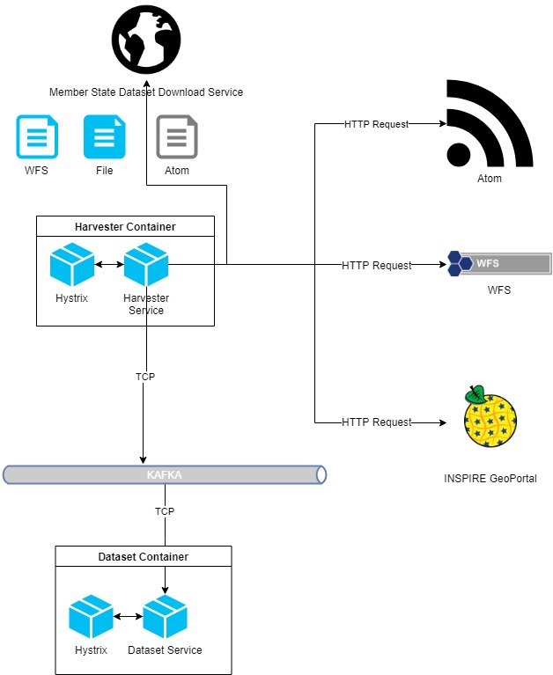

Record Store Service Deployment Model
This service will be responsible of managing access to the different datasets data bases meaning by this: creation, snapshotting, activation/deactivation, backing up, data connection providing…
The DaaS feature will be implemented based on two basic items:
- Crunchy Containers: They are docker images ready to be launched. More information here
- Docker-Java api: Is a java based API that allows to interact with Docker programmatically. This API is deployed as a library in the Record Store service’s classpath
These Crunchy Containers comes with tools for making data base dumps as well as backup so it will be necessary to define some folders in the physical file system in order to store them avoiding this way data losts.
Finally, Record Store service will provide connection data to services that request it but it will not be managing connection itself. This way, it will be the client services (i.e: Dataset microservice) the ones stablishing connections to the corresponding data base directly using the data retrieved from Record Store service.

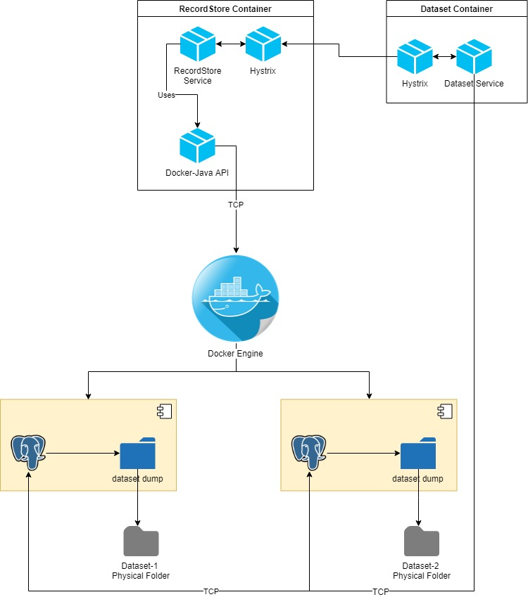

Zipkin Deployment Model
Zipkin’s default configuration is receiving Trace info via HTTP from the microservices and storing it in memory. For Production purposes it’s necessary to have a more complex schema.
Though services will not fail if Zipkin is not available, it is necessary to ensure that trace info will be captured and stored. Due to this, Services will be publishing the trace info via Kafka. Zipkin will be consuming this event asynchronously (polling Kafka). Once this event is consumed, the retrieved tracing info will be indexed and stored in ElasticSearch, so it will be available to be queried whenever it is necessary.
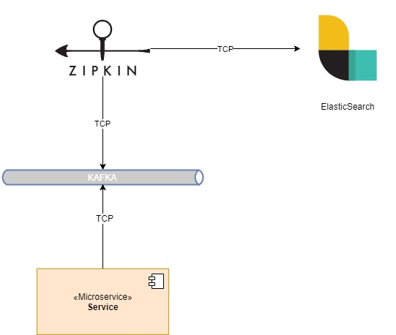

Redis Deployment Model
Redis will be deployed to be used as a Distributed cache so any service will have access to it in Read and Write mode meaning by this that they will be able to publish data to be cached as well as retrieving those data.
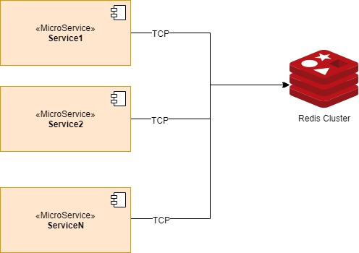

Drools Deployment Model
Drools will be deployed as Library in Validation Microservice, so no extra server will be set up for this regard. Escalation will be done according to the needs as any other Microservice. Rules will be stored in Metabase

Apache Jack Rabbit Deployment Model
Jack Rabbit Oak will be deployed as a Library in the DocumentStore Service. Escalation will be done according to the needs as any other Microservice.

Keycloak Deployment Model
Keycloak will be deployed as an independent service inside Rancher in such way that it will be able to connect with EULogin for user authentication purposes. Interaction between Keycloak and EUlogin will be done via OpenId. Reportnet’s UMS will be able to invoke it via Rest Services in order to implement de User Managemn Logic required by Reportnet 3.0

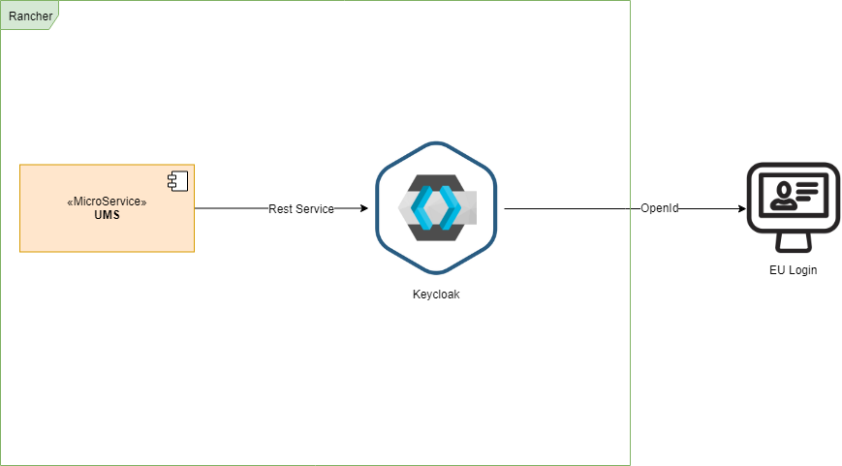

Development Environment Specifications
TBC
Based on the standards that are going to be implemented as well as the already existing infrastructure, the development Environment should be set up as follows:
- Code Repository: Git
- Build: Maven
- IDE: Eclipse, IntelliJ
- CI: Jenkins.
- Test: JUnit, Mockito, ARC/Postman, Gatling, Cypress
- Issues & Tasks: Taskman.
- Code Quality: Sonar, Checkstyle, FindBugs, PMD.
- Performance: JMeter

Deployment Options
TBC

Process view
The process view shows what the system does at a high level. This can be used to highlight aspects such as parallelism, concurrency, where processes fork or join, etc. if the system is implementing or automating a business process.
Within this section a UML activity diagram should be provided. It should show the main steps in the process(es), some of which are performed concurrently. For Example
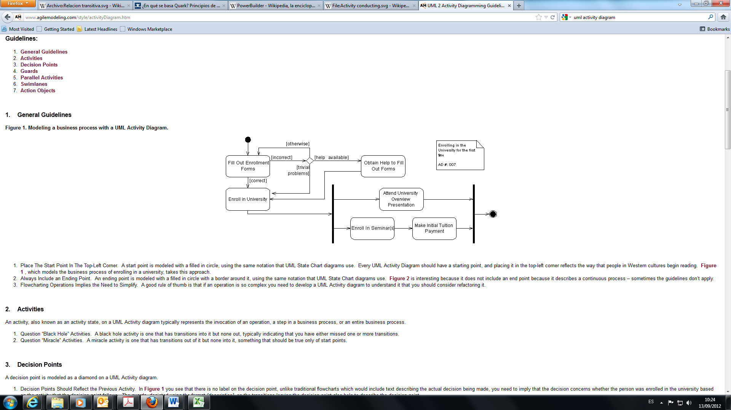

Risks
TBC – Maybe better to add a link to TASKMAN
In this section we should specify the potential risks related to various factors (hardware, software, external factors) and what we can do to minimising these risks. Risks and Mitigation Plans should be listed and described.
ID | Description | Severity | Mitigation Plan
RISK01 |  | Choose an item.
RISK02 |  | Choose an item.
RISK03 |  | Choose an item.
RISK04 |  | Choose an item.

System Architecture Design (SAD)
This part describes the physical architecture of the system, using a number of different architectural views to depict different aspects of the system.

Information View
This section describes the way that the architecture stores, manipulates, manages and distributes information.
The Information View sections, are suggested as follows:
- Logical Data Model
- Information Flow
- Status Diagram
- Transaction Management
- Archives and Data Retention

Logical Data Model (LDM)
The representation of an organisation's data should be organised in terms of entities and relationships. This should be independent of any particular data management technology. Only the core entities should be represented and a UML Logical Data Model should be provided.
The LDM sections, are required as follows:
- Diagram(s) extracted from the logical data model document.
- A reference to the logical data model document (including the version number)

Information Flow
A UML Flow Diagram should be provided showing where the data is created/destroyed, where the data is accessed/modified and how individual data items changes as they move around the system.

Status Diagram
A UML Status Diagram should be provided defining the possible set of states that each functional element of the system can be in at runtime, the set of valid transitions between those states and the causes and effects of the interstate transitions.

Transaction Management
This section should define the transaction management technique (two-phase commit, compensating transactions, etc.) which will be used. A rationale should be provided.

Archives and Data Retention
This section should define the archiving and data retention strategy.

Concurrency view
Optional section
This section describes the concurrency structure of the system, mapping functional elements to concurrency units to clearly identify the parts of the system that can execute concurrently, and shows how this is coordinated and controlled.
The Concurrency View sections, are suggested as follows:
- Synchronization and Integrity (when applicable)
- Re-entrancy (when applicable)

Synchronization and Integrity
This section should address how concurrent activity will be coordinated so that the system operates correctly and maintains the integrity of the data within it.

Re-entrancy
Re-entrancy refers to the ability of a software element to operate correctly when used concurrently by more than one processing thread.

Technology view
Technology dependencies are usually captured on a node-by-node basis in simple tabular form.
The Technology View sections, are suggested as follows:
- Presentation tier
- Service tier
- Information tier
- External Dependencies
- Internal Modules Reuse
- Environment specification
- Development environment (when applicable)
- Technology Selection
- Third-party Software License Overview

Presentation tier
TBC

Service tier
TBC

Information tier
TBC

External Dependencies
TBC

Internal Modules Reuse
COMMON-INTERFACES: Is a library where all the public interfaces implemented by backend microservices are defined:
- Controllers Interfaces and FeignClients
- VO’s and Enums involved in microservices communications

COMMON-UTILITIES: Is a library where common utilities used by all the microservices are implemented. Among these utilities there are:
- Kafka interface utilities
- Basic mapper infrastructure
- Multitenancy rules
- Security infrastructure

Environment Specification
In this section, the set of hardware nodes that are required should be described, which nodes need to be connected to which other nodes via network (or other) interfaces, and which software elements are hosted on which hardware nodes.
Clarify all the dependencies between the system and any third-party software products, including operating systems, programming libraries, messaging systems, application servers, databases, data movement products, web servers and so on.

Development Environment
TBC

Technology Selection

Backend Services
Feature | Technology | Version
Programming Language | Java | 1.8
Dependency Injection | Spring-Boot | 2.1.3.RELEASE
Cloud Computing | Spring-Cloud | Greenwich.RELEASE
Persistence | JPA | 2.2
 | Hibernate | 5.3.7
 | Spring-Data | Spring-Boot bundle
 | PostgreSql driver | 42.2.5
 | Spring-Boot-Data-Mongodb | Spring-Boot bundle
Circuit Breaker | Hystrix | 1.5.8
 | Spring-Cloud-Netflix-Hystrix | Spring-Cloud bundle
Transaction Tracing | Spring-Cloud-Sleuth | Spring-Cloud bundle
 | Spring-Cloud-Zipkin | Spring-Cloud bundle
 | Zipkin | 2.12.0
Service Discovery | Spring-Cloud-Consul-Discovery | Spring-Cloud bundle
Service Config | Spring-Cloud-Consul-Config | Spring-Cloud bundle
Service Communication | Spring Openfeign | Spring-Cloud bundle
Metrics | Micrometer | 1.1.3
Logging | SLF4J | 1.7.26
 | Logback-Classic | 1.2.3
 | sentry-logback | 1.7.22
JSON | jackson-databind | 2.10.13
Service Management | Spring-Boot Actuator | Spring-Boot bundle
Rest | Jersey | 2.27
 | Spring-Boot-Jersey | Spring-Boot bundle
 | Spring-Boot-HATEOAS | Spring-Boot bundle
Structure Mapping | MapStruct | 1.3.0.Final
Rest Documentation | Swagger | 2.9.2
Unit Test | Junit | 4.12
 | Mockito | 2.27.4
BDD | Cucumber-Java | 4.2.6
Performance Test | Gatling | 2.2.5
Automatic Code Generation | MapStruct | 1.3.0.Final
 | LomBok | 1.18.0
Security | Spring-Security | 5.1.4.RELEASE
Harvesting* | Rome | 1.12.0
 | GeoTools | 23.1
 | Gt-gml | 2.5.5
Rules Engine Client*** | kie-services-client | 6.1.0
 | kie-server-api | 7.0.0.Final

*Note: This only applies to INSPIRE Harvester microservice
**Note: This only applies to RecordStore microservice
***Note: This only applies to Validation Service

Frontend Service
Feature | Technology | Version
Web Language | HTML | 5
Programming Language | JavaScript | 9
 | React | 16.8.6
 | NodeJS | 11.11.0
State Container | React Redux | 6.0.1
Style | Bootstap | 4.3.1
 | CSS | 3
Component Libraries | PrimeReact | 3.10
 | PrimeIcons | 1.0.0
 | Material-UI | 3.9.2
 | Leaflet | 1.4.0
 | RAWGraphs | 1.3.0
 | D3js | 5.9.1
Circuit Breaker | HystrixJS | 0.2.0
Test | cypress | 4.5.0
 | cypress-cucumber-preprocessor | 1.16.2
 | cypress-file-upload | 3.5.3
 | cypress-multi-reporters | 1.2.3
 | Mocha | 5.2.0
 | mochawesome | 4.1.0

API-Gateway Service
Feature | Technology | Version
Programming Language | Java | 1.8
Dependency Injection | Spring-Boot | 2.1.3.RELEASE
Cloud Computing | Spring-Cloud | Greenwich.RELEASE
Circuit Breaker | Hystrix | 1.5.8
 | Spring-Cloud-Netflix-Hystrix | Spring-Cloud bundle
Transaction Tracing | Spring-Cloud-Sleuth | Spring-Cloud bundle
 | Spring-Cloud-Zipkin | Spring-Cloud bundle
 | Zipkin | 2.12.0
Service Discovery | Spring-Cloud-Consul-Discovery | Spring-Cloud bundle
Service Config | Spring-Cloud-Consul-Config | Spring-Cloud bundle
Metrics | Micrometer | 1.1.3
Logging | SLF4J | 1.7.26
 | Logback-Classic | 1.2.3
 | sentry-logback | 1.7.22
JSON | jackson-databind | 2.10.13
Service Management | Spring-Boot Actuator | Spring-Boot bundle
Rest | Jersey | 2.27
 | Spring-Boot-Jersey | Spring-Boot bundle
 | Spring-Boot-HATEOAS | Spring-Boot bundle
Reverse Proxy | Zuul | 1.3.1
 | Spring-Cloud-Zuul | Spring-Cloud bundle
Rest Documentation | Swagger | 2.9.2

Logging Services
Feature | Technology | Version
Log Management | Graylog | 2.0.0

Metric Services
Feature | Technology | Version
Monitoring System | Eionet.jolokia | 1.0-SNAPSHOT

Service Discovery and Configuration Services
Feature | Technology | Version
Service Discovery and Configuration | Consul | 1.4.3

Storage and Data Base service
Feature | Technology | Version
File Storage | Apache Jack Rabbit Oak | 1.12.0
SQL DBMS | PostgreSQL | 11
NoSQL DBMS | MongoDB | 4.0.6
Cache | Redis | 5.0.4

Index services
Feature | Technology | Version
Indexing | ElasticSearch | 6.7.1

Event Bus
Feature | Technology | Version
Event Bus | Kafka | 2.1.1

Container Engine
Feature | Technology | Version
Container Orchestration Engine | Rancher | 1.6
Container Engine | Docker | 18.09

Third-party Software License Overview
All the third party tools and frameworks are under open source licenses so they add no extra cost to the project. These licenses are:
- Spring Framework: Apache License 2.0
- Check_MK: License owned by EEA
- Jolokia JMX: EEA’s implementation
- Graylog: License owned by EEA
- Consul: Free License
- Zipkin: Apache License 2.0
- Hystrix: Apache License 2.0
- React: MIT License
- PrimeReact: MIT License
- Kafka: Apache License 2.0
- PostgreSQL: PostgreSQL License (liberal Open source)
- MongoDB drivers: Apache License 2.0
- MongoDB Software: Server Side Public License
- Docker : Apache License 2.0
- Rancher: Apache License 2.0
- Leaflet: BSD-2-Clause
- Material-UI: MIT License
- D3js: BSD-3-Clause
- Cucumber: MIT License
- Sentry: BSD 3-clause
- Rome: Apache License 2.0
- Geotools: GNU Lesser General Public License
- Apache Jack Rabbit Oak: Apache License 2.0
- Gatling: Apache License 2.0
- Cypress: MIT License

Design justification
This chapter should contain all the design decisions (rationale) which has been taken in order to cover the requirements.

Concern-Stakeholder Traceability
An association of stakeholders to concerns should be provided.
 | StakeHolder: 1 | StakeHolder: 2 | StakeHolder: 3 | StakeHolder: 4
Concern: 1 | x | - | x | -
Concern: 2 | - | x | x | x

Implementation view
The implementation view is where the lower level implementation details start to make an appearance. For example, this could include information such as how your architectural layering will be implemented through to documenting blueprints/common usage patterns for the technologies/frameworks you have chosen for the implementation.

System Specifics

Inter-process Communication
The mechanisms used to link elements in different processes should be identified (e.g. remote procedure calls, messaging, shared memory, pipes, and queues).

Component Packaging

Deployment view
The Deployment View sections, are suggested as follows:
- Deployment Model
- Infrastructure Model
- Physical Model
- Types of Hardware Required (when applicable)
- Specification and Quantity of Hardware Required
- Network Requirements(when applicable)
- Network Capacity Required(when applicable)
- Physical Constraints(when applicable)

Deployment Model
The deployment model describes the way the different system components are deployed to e.g. application servers, servlet containers etc. - the logical infrastructure. This is a detailed version of the HLA Deployment Model.

Infrastructure Model
The infrastructure model details how the software will be deployed onto the physical infrastructure.

Physical Model
The physical model is used to describe the physical hardware and networks on which the software will be deployed.

Types of Hardware Required
Identify general types of hardware required and map each of your functional elements to one of the hardware types. In effect, this is a logical model of the hardware your system requires.

Specification and Quantity of Hardware Required
Address the specific details of the hardware that will need to be procured and commissioned in order to deploy the system - in effect, a physical model of the hardware your system needs.

Network Requirements
Identify the required links between machines, the required capacity and reliability of the links, and any special network functions that the system requires (load balancing, firewalls, encryption, and so on).

Network Capacity Required
Calculate and record the amount and type of network traffic that needs to be carried out over each inter-machine link in the proposed network topology.
WS
WS name | Requester/Provider | Requester/provider endpoint name | Output (xml, json, jpg) | request size (kb) | response size (kb) | frequency/minute
GetObject | R | http://domain/ws/tm | Json | 1.5 | 200 | 100

Physical Constraints
Considerations such as desk space for client workstations, floor space for servers, power, temperature control, cabling distances...

Operational view
This view describes how the system will be operated, administered, and supported when it is running in its production environment.

Installation and Upgrade

Both side services and Reportnet microservices will be deployed on Kubernetes cluster using Helm v3 as deployment tool. In order to deploy the side services the following charts repositories have been selected:
Consul: stable https://kubernetes-charts.storage.googleapis.com/
Postgres: Custom charts based on crunchy charts
Mongo DB: stable https://kubernetes-charts.storage.googleapis.com/
Kafka: bitnami https://charts.bitnami.com/bitnami
Redis: stable https://kubernetes-charts.storage.googleapis.com/
ElasticSearch: elastic https://helm.elastic.co
Zipkin: Custom charts based https://github.com/Financial-Times/zipkin-helm

In order to deploy/update Reportnet Microservices a set of charts will be delivered along with the System

Functional Migration
Functional Migration is the process of replacing existing capabilities with the ones provided by your system. This usually means migrating users of an older system to use your new system. Possible approaches are big bang, parallel run or staged migration.

Data Migration
This section should describe process and tools used to load data from existing systems into the new ones. Where migrated data is very old, of variable quality, or poorly modelled, data migration may be extremely complex. Also consider the time required to migrate massive data stores and reorganise databases, create indexes, and so on.

Monitoring and Control
Once a system is running in its production environment, it will require some amount of routine monitoring, to ensure that it is working correctly, and some routine control operations, to keep it working that way (start up, shutdown, transaction resubmission, and so on).

Start-up and Shutdown
This section should describe the start-up and shutdown processes. For example, inter-task dependencies may mean that tasks need to be started and stopped in very specific orders so that if some task fails to start, others will not be started.

Configuration Management
This section should describe the processes and technologies to group, modify, and track element configuration parameters in a reliable and predictable manner.

Backup and Restore
This section should describe the processes and planning to backup and restore, considering transactional consistency across a system's entire distributed data set.

Data Model Design (DMD)
The Data Model Design should be presented.
The Data Model Design sections, are required as follows:
- Data Model Design Decisions
- Diagram(s) extracted from data physical model document.
- A reference to the physical data model document (including the version number)
- Object-Relational Mapping Documentation (put in annex and refer to it if very large)

Data Model Design Decisions

Data Model Design Diagram

Physical Data Model document reference

ORM Documentation

Service Definition (SD)
The Service Definition sections, are suggested as follows:
- Interface View
- Scope
- Services Dependency Model
- Services

Interface view
Closely related to the logical view is the interface view. Interfaces are one of the riskiest parts of any software system, so it’s very useful to show what the internal/external interfaces are and how they work.

Scope

Services dependency model
This section should provide a services dependency diagram model

Services provided
Tip: Use the “Quick Parts” function in the Insert menu to add new services!

Service name 1

Description
The Service description should provide a narrative of what the artifact is, what it does, and its relevance to the architecture.

Functional Requirements
The Functional Requirements should be listed here detailing specifically what this service accomplishes. The language should be such that it allows test cases to prove the functionality has been accomplished.

Type
The type of the service to help distinguish it in the layer in which it resides; e.g., data, process, functionality, presentation, functional.

Operations
Description of the operations supported.

Source
The source of the artifact, along with a date to support traceability of the architecture.

Version
The version of the service contract. i.e. 0.26-SNAPSHOT

Business objects
Business objects transferred by the service.

Importance to the process
What is the business impact if the service is unavailable?

Quality of service
Determines the allowable failure rate and the amount of latency the service is allowed to have to perform its actions.

Throughput
Volume of transactions estimated; e.g., 100 000 requests per hour.

Growth
The growth rate of transactions over time (estimated based on service take-up and business growth); e.g., 10 000 additional requests per year.

Service times
The available hours/days the service is needed; for example, 9 to 5 Monday to Friday (excluding Bank Holidays).

Security requirements
Who can execute this service in terms of roles or individual partners, etc. and which invocation mechanism they can invoke?

Service name 2

Services Consumed

Service name 1
See Services Provided for subsection contents.

Description

Functional Requirements

Type

Operations

Source

Version

Business objects

Importance to the process

Quality of service

Throughput

Growth

Service times

Security requirements

