w Project / Subproject  IDA/EINRC framework 501998  Specific Agreement-6/EIONET | Authors  Kaido Laine,  TietoEnator Corporation | Date issued / Version  08 March 2004 / v2.0 | Design Report
Client  European Commission  DG Environment/ B 1 | Info  AIT ACL Mechanism |  | Reference / Page  AIT-ACL-DDv2.0.doc  / Page 1 of 38

EUROPEAN COMMISSION

ENVIRONMENT DIRECTORATE-GENERAL

IDA-Programme -Framework Contract No 501 998 - 6th Specific Agreement

Einrc - Eionet

Detailed Design
Access Control List Mechanism
ACL Admin Tool



Modification HISTORY
Version | Date | Author(s) | Description
1.1 | 10.02.2004 | Kaido Laine | Descriptions of ACL –developments under SA6/AIT-project have been updated to the previous ACL Mechanism Detailed Design document prepared under SA5/-UIT-project
2.0 | 08.03.2003 | E.Palosuo | Status updated to final approved

APPROVAL PROCEDURE
Reviewer | Version(-s) | Start  Date | Finish  Date | Required modification/Approval/Comments
Frmwork Mgr | 1.1 | 12.02.04 | 20.02.04 | Approved
Project Leader | 1.1 | 22.02.04 | 26.02.04 | Approved
CMT review | 1.1, 2.0 | 22.02.04 | 08.03.04 | Approved
Commission's written approval

Table of Contents

1. Introduction and Requirements 4
1.1. Introduction 4
1.2. User Requirements 4
2. Functionality 5
2.1. Authentication 5
2.2. Access Control List Mechanism 5
2.2.1. Introduction 5
2.2.2. Hierarchy of ACLs 6
2.2.3. Localusers 6
2.2.4. Localgroups 7
2.2.5. Access Permission Types 7
2.2.6. Access Control List 8
2.2.7. Anonymous and authenticated access 9
2.2.8. Default Object Creation (DOC) ACLs 10
2.3. ACL Admin Tool 11
2.3.1. Login and choosing an application 11
2.3.2. Managing localgroups 15
2.3.2.1. Add a new localgroup 16
2.3.2.2. Manage group members 17
2.4. Managing the Access Control List 22
2.4.1. Adding an entry to the Access Control List 22
2.4.2. Removing an entry from the ACL 24
2.4.3. Manage access permissions for an entry 25
3. Architecture 27
3.1. Architecture of the ACL Mechanism 27
3.1.1. Developers guide 27
3.1.2. Class Architecture 28
3.1.3. RPC methods 28
3.2. Architecture of the ACL Admin Tool 31
3.2.1. Common Description 31
3.2.2. Class Architecture 31
3.3. Future Development needs 33
3.3.1. Design of XML-ized ACL-mechanism information 33
4. Configuring an application for ACL Component 36
4.1. Configuring an application for the ACL mechanism 36
4.2. Configuring an application for ACL Admin Tool 37
5. Installing ACL Admin Tool in EIONET Environment 38
5.1. Folder Structure 38
5.2. Libraries 38
5.3. JSP files 38
5.4. Properties files 38
5.5. web.xml 39

Introduction

Introduction and Requirements
The tools described in this document were implemented under UIT project under SA5 and in AIT project under SA6, considering the “Single Signon” User Requirement.
The aim of Single Signon is to have a common authorising and authentication mechanism when using multiple applications. The Access Control List (ACL) Mechanism has been designed to be the “first step” of the “Single Signon” user requirement that was to be implemented under SA-6.
The mechanism was intended to provide a common and flexible tool for handling user permissions that can be used in several applications.
ACL Mechanism is a common framework for authenticating and authorising users. Currently it is in operational use, integrated to ROD, Content Registry, Data Dictionary and ACLAdmin Tool.
ACL Admin Tool is a tool with a graphical user interface that makes possible to manage and change the user access permissions in ACL Mechanism. It can be used with any application, where ACL Mechanism is integrated or any other application having the similar API over XML/RPC. It is in an operational use and integrated with several EIONET applications.

User Requirements
- Login action must be performed against Circa User Directory.
- Integration to other authentication mechanisms must be supported as well.
- User permissions can be defined for several actions in the application (e.g. add an entity record, change a record, delete a record).
- Groups, containing users, can be combined “locally” by the application administrator (‘Localgroups’).
- Permissions can be admitted to the localgroups, users and roles in the Circa User Directory.
- The localgroup members and user, localgroup, and role permissions can be described in simple format text files. (There may be need for more advanced storing later, database or XML format.)
- The ACL mechanism may have an XML/RPC interface, to make possible to have a common ACL Administration Tool for several applications.
- Object based ACL’s must be implemented.

Authentication

Functionality
In this project, the authentication mechanism was improved. In the earlier SA5 project, login against the Circa User Directory was implemented. Now there is a possibility to introduce a “local-authentication mechanism” where the users’ credentials are held in a local file. If a user is not described there an authentication against the User Directory (LDAP) is performed.

The authentication procedure goes as follows:
- first the system tries to authenticate the user against the local-auth mechanism. If the user is listed there then the authentication is performed. If the user exists but the credentials do not match with the correct ones, the authentication fails.
- If the user is not listed in the local-auth mechanism, an authentication is made against the LDAP. If the user exists in the Directory and gives correct credentials, the authentication succeeds otherwise an error appears
- If the LDAP server does not respond in the step above the system tries to access a backup LDAP server to check if the user is hspecified previously in the properties file.

Access Control List Mechanism

Introduction
The principle behind the ACL is derived directly from a framework called DCE. You can read up on DCE here:
http://www-3.ibm.com/software/network/dce/library/publications/admingd/html/ADMING39.HTM and here:
http://www-3.ibm.com/software/network/dce/library/publications/
However, Reportnet ACL deviates quite a bit, so the above links are only relevant to gain a broad understanding of the concepts.
The only thing the ACL mechanism really understands is the syntax of an ACL (Access Control List). The ACL consists of lines that are split into four segments: {entrytype [subject] permissions [acltype]}. The possible entry types are specified by the application server, and are typically “user”, ”localgroup”, ”authenticated”, “anonymous” etc. The subject is a string, whose semantic is derived from the type. If the type is “user”, then expect a username. The permissions are binary values denoted by a short (typically one character) token. The set of legal tokens are specified by the application server in the getAclManagerInfo() method, which also returns descriptions of the permission flags. The allowed acl types are “object”, “doc” and “dcc” More descriptions below. At the moment DCC ACL’s are not supported yet.

Hierarchy of ACLs
Toplevel ACL
The system imposes that all websites must have a toplevel ACL. In its simplest invocation it controls access to the website itself. If flag 'a' means access then it could look like this:

anonymous:-
authenticated:a

In slightly more complex scenarios, it also describes what you can do:

anonymous:a,r
group:admins:a,r,w,d

The toplevel ACL must always have the same name, namely '/' - as seen from the XML-RPC client side. You can call it 'root' on the hard disk. This will correspond nicely with Zope and websites, whose toplevel is also called '/'.
ACL discovery
Some websites have more than one ACL - they have e.g. one for each database table. The ACL mechanism tool should not need to know the structure of a remote website, therefore we introduce ACL discovery. In essence you would be able to do the XML-RPC call getChildrenAcls("/") and for ROD you'd get an array of three elements: ["RO","RA", "OTHER"] - one for each ACL object that is implemented. You'd then be able to do an getAclInfo("/obligations") call to get the ACL for the obligations table.
The getChildrenAcls () is recursive, so you can do getChildrenAcls ("/obligation") and get the empty list (of course, until the object-based ACL-mechanism is not introduced in ROD).
Audit functionality
Finally there is an audit functionality.
getPermissions("/obligations","kaido"), which will return an array of permissions the user kaido has, after going through evaluation of the ACL.

Localusers
Local users can be described additionally in a XML file that resides in the local file system. A need for such users, not existing in the LDAP may occur if there is a need to give a controllable access to another application that obviously does not have a user account in Circa.

The format of localusers.xml file is very simple:
<?xml version="1.0" encoding="utf-8" ?>
<local-users>
<user username="ander" password="mx5" fullname="Ander Tenno" />
<user username="_harvester" password="zzz" fullname="ROD harvester” />
<user username="test" password=”st65ll” fullname="Test Jonsson" />
</local-users>

Localgroups
Localgroups are the application-based groups, that the system administrator can combine him or herself of the users in the User Directory or in the LocalAuthMechanism. The localgroup users are described in the Localgroups Descriptor File. The format of the row in the file, describing one group, is:
localgroup:[groupname]:[username1],[usename2],…,[usernameN]
The usernames are the Circa User Directory user names or local-user names.
Example of the Localgroups descriptor:

localgroup:rod_applications:_harvester
localgroup:rod_admin:roug,haigh
localgroup:rod_user:palosuo,tennoan,jensen,roug,haigh
localgroup:rod_visitor:guest

Access Permission Types
Introduction
Each application connected to the ACL Mechanism has 'Access Permission Types'. EEA defines the Access Permission Types for each Reportnet application connected to the ACL Mechanism. These are stored in the 'Access Permission Types Descriptor Files'.
The Application Administrator grants Access Permissions to a user/role/localgroup by selecting relevant Permission Types. Then the user/role/localgroup has access rights to those functionality.
All granted Access Permissions to the application to all users/roles/localgroups are held in the Access Control Lists of the Application. Each row specifies all Access Permissions for one user/role/localgroup.

Access Permission Types Descriptor file
All the user actions in the application are mapped to the Access Permissions. The Access Permission Type descriptions are free-text values (o, l, , t, p4, xxx…), but they must not include commas (,) and they are case sensitive. (A and a are different access permissions)

The Access Permission Types are described in the Access Permission Types Descriptor File. The format of the row in the file, describing one permission type, is:
[access permission type]:[Free text description]
Example of the Access Permission Types Descriptor (See also chapter 2.4.4):

a:access
i:insert
d:delete
u:update
c:Control ACL

Access Control List
An Access Control List (ACL) is a table that tells an application which access permissions each user has to a particular action.
The access permissions in the ACL can be granted either to:
- localgroups, described in 2.2.4
- Roles in the User Directory
- Users in the Circa User Directory. Users are identified by their Directory usernames.
All granted Access Permissions to an application to all users/roles/localgroups are held in the Access Control Lists of the application. The ACLs are stored in ACL descriptor files or in database tables.

ACL files
The ACL descriptor files must have *.acl extension.
The format of the row in the Access Control List file, describing permissions to one group, is:
[localgroup|circarole|username]:[ name]:[permission1, permission2,…permissionN]:[aclType]

Example of the Access Control List rows:
localgroup:rod_admin:a,i,d,u
localgroup:rod_user:a,i,u
circarole:eea-rnc:a,u
user:haigh:c
user:roug:c
user:authenticated:v
user:owner:c,u:doc

ACL database tables
In some applications the amount of ACL’s can be changed programmatically (see the description of DOC ACLs below) Storing those ACLs in text files would be very inefficient. That’s why the ACLs data can be stored in database tables:

The ACL data is stored in 2 database tables that must be created in each database using the ACL mechanism and expected to use object-based ACL’s

The common ACL data (name, owner, ID, description) is held in a table called ACLS.
The ACL rows (acl_type, entry_type, principal_name, permissions) are stored in
ACL_ROWS

ACL logic

- When a user belongs to a localgroup or role and an access permission is assigned to the localgroup or role, the user does not get this permission
- No negative permissions can be set with the current version of the ACL Mechanism.
- One application may have several Access Control Lists
- There are reserved usernames: authenticated, anonymous and owner

The access permissions can be managed without any graphical tool, just by editing the Localgroup Descriptor and Access Control List text files. NB! The Access Permission Types must not be modified. Only EEA’s authorised System manager is allowed to modify them based on identified user needs and a commonly agreed decision.
However, the following ACL Admin Tool allows simple web-editing of the access permissions.

Anonymous and authenticated access
Also an access for users not described in the ACL entries can be described with the ACL-mechanism. Usernames authenticated and anonymous are meant for this purpose. If a user is not logged in, permissions for anonymous are granted for her. If a user is logged in but is listed neither in the ACL entry rows or any of the localgroups, she gets permissions of authenticated user.
NB! If a user is authenticated and listed in ACL entry rows, she does not get the permissions of authenticated and anonymous.

The authorisation procedure goes as follows:
- Check if the user is listed in ACL entry rows and got the permission
- If not listed, check if the user is a member of any localgroup and if any of the groups, listed in the ACL has got the permission
- If not check if the authenticated entry has got the permission
- If not, check if the anonymous entry has got the permission

Example:
Imagine, we have a localgroup, having 2 members:
app_admin:jaanus,ander

If we have an ACL with these rows:
localgroup:app_admin:u,i
user:jaanus:d
user:authenticated:x
user:anonymous:v

user jaanus (member of app_admin but listed as an extra ACL entry), has got only permission “d”

user ander” as a member of app_admin group has got permissions “u” and “i”
user “enriko” (not listed in ACL but authenticated) has got permission “x”
not authenticated user has got permission “v”

Default Object Creation (DOC) ACLs
Sometimes having a common access to all the records in the table is not fine-grained enough and the system must be able to protect each user's data from the others. For that purpose the object-based ACL mechanism was designed
If an ACL has got acl_type “DOC” it is not handled when checking user permissions. If an ACL is created under this ACL, entry rows with type “DOC” in the parent ACL are admitted to the newly created one.

Example:

If there is an ACL called “/datasets”

localgroup:dd_admin:i
user:heinlaid:c
user:owner:w,d,c:doc
user:authenticated:v:doc

All the users belonging to the dd_admin group can create a new dataset (a record in the table)

If a new dataset is created, also a new ACL is created There is a method in ACL-mechanism API:

addAcl(aclPath, owner);

If a user (for example with username “stefan” creates a dataset with ID=345 the application calls the ACL mechanism API:

addAcl(“/datasets/345”, “stefan”);

Now a new ACL (“datasets/345”) is added to the ACL hierarchy with those ACL entry rows:

user:stefan:w,d,c
user:authenticated:v

Those are copied from the “DOC” type ACL rows in the aprent ACL. As “owner” is a reserved username, it is replaced with the real username (who created the dataset)

ACL Admin Tool

The ACL Admin Tool is based on “RPC Services Framework”, implemented under UIT project and improved under AIT project. Using RPC methods it makes possible to change access permissions of different applications by using one tool.
The ACL Admin Tool is using the ACL mechanism itself.

Login and choosing an application
First a user (‘Application Administrator’) has to log in with the credentials to the EIONET User Directory.

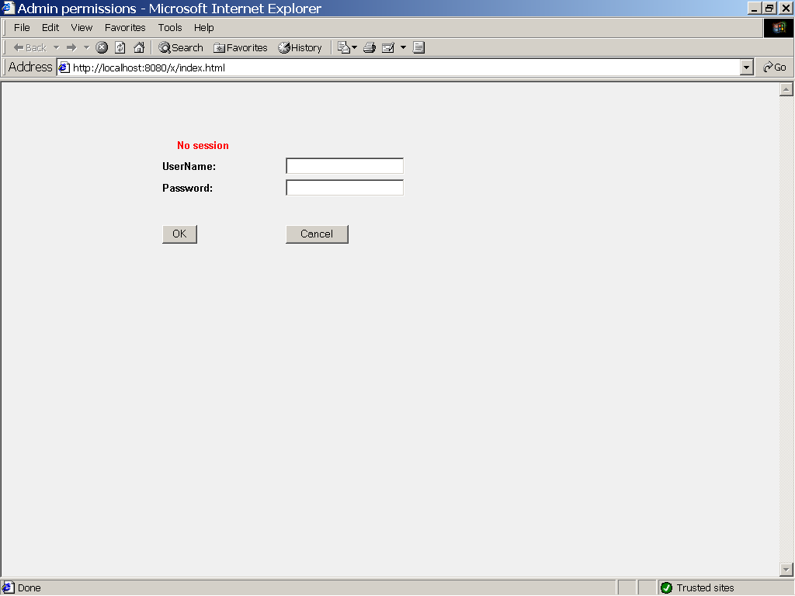
- Login screen

If the login succeeds, the “Index” screen appears, with the list of all applications whose Access Control Lists can be administrated.

NB! If the “anonymous” entry has got the “View” permission, login is not required and the index page is displayed without login.

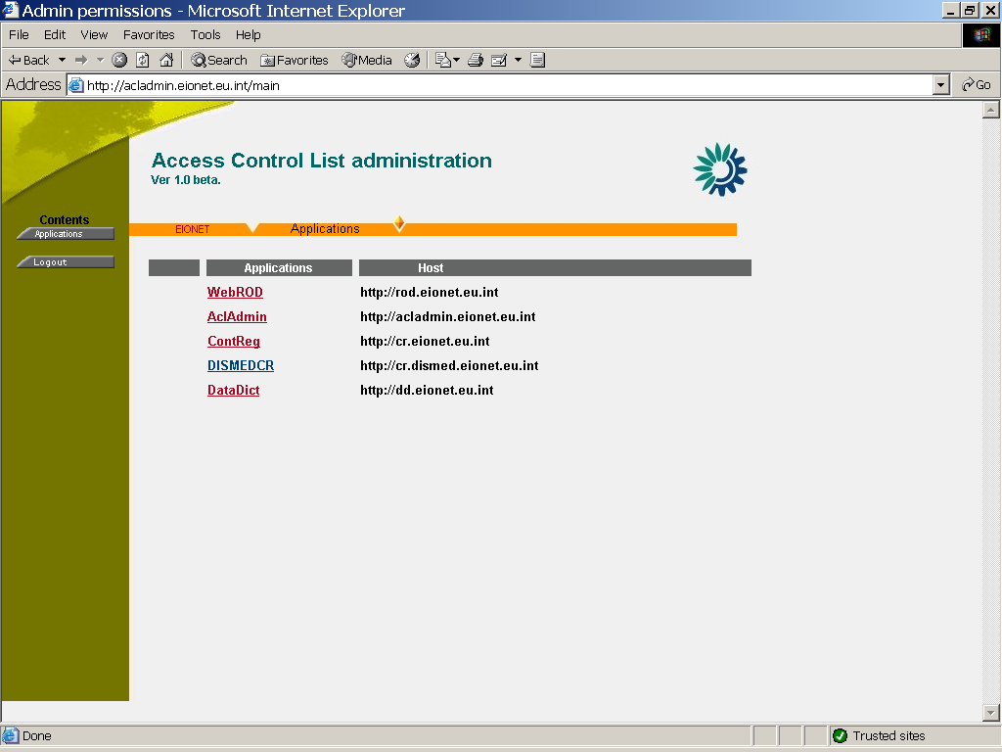

- The Index Page

The next step is choosing an application.

If the user has clicked on the application name, she is asked for the credentials. Usually they are same in all Reportnet applications but in principle they may be different when another application will be integrated to the AclAdmin Tool.

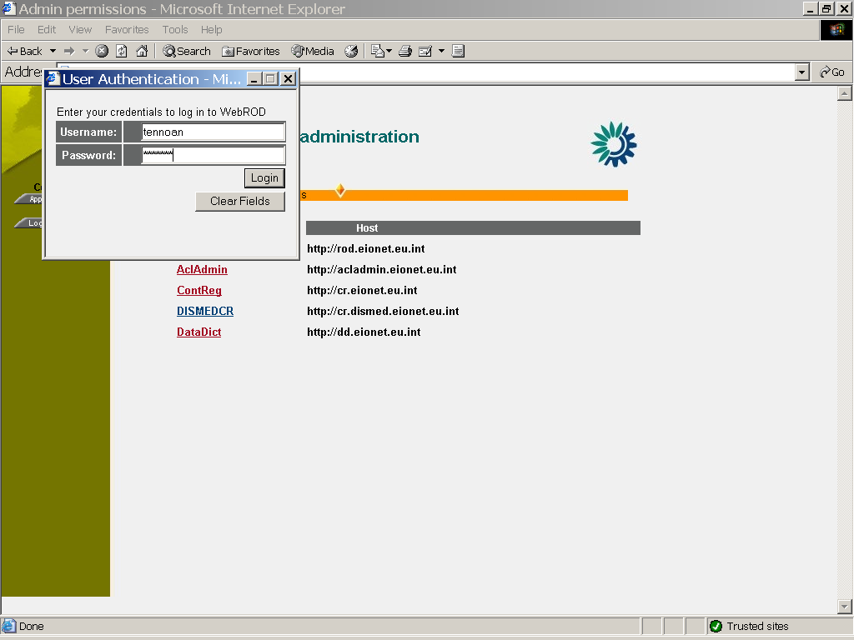

- Login to an application

The application screen, showing a combobox with all ACLs of the application appears. After selecting the ACL, the main screen, showing the ACL data will be displayed:

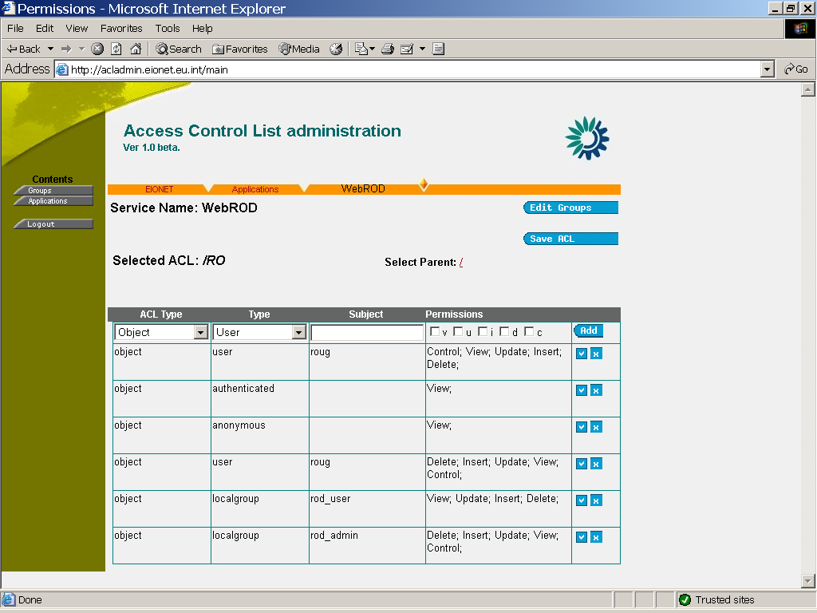
- The main screen for administration of ACL, called “obligations”

Managing localgroups
Localgroups, described in this application, can be managed by clicking the “Edit localgroups” button.

- For seeing localgroups’ data, the user has to have the “v” permission in ACL “/localgroups”
- For changing localgroups’ data, the user has to have the “u” permission in ACL “/localgroups”
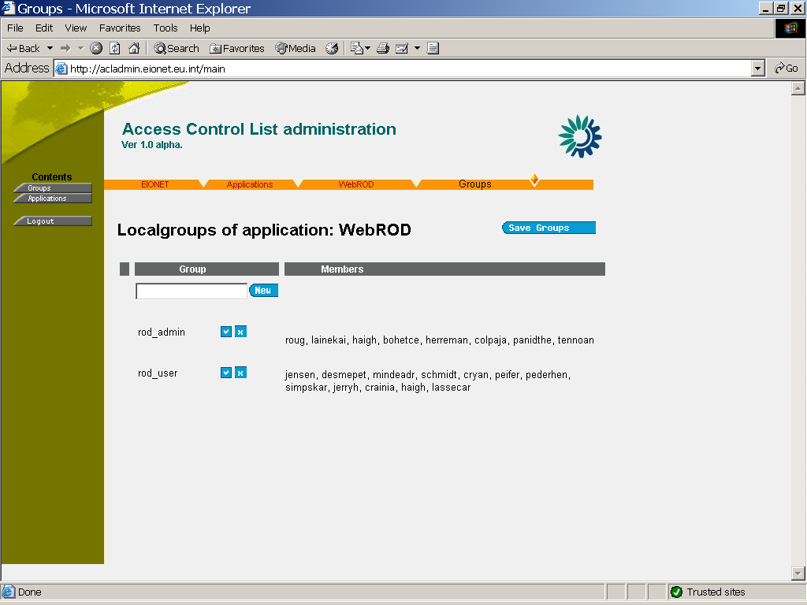
- Localgroups page

Add a new localgroup
To add a new localgroup, the user has to write the name of the group to the text box and click on the icon, next to it:

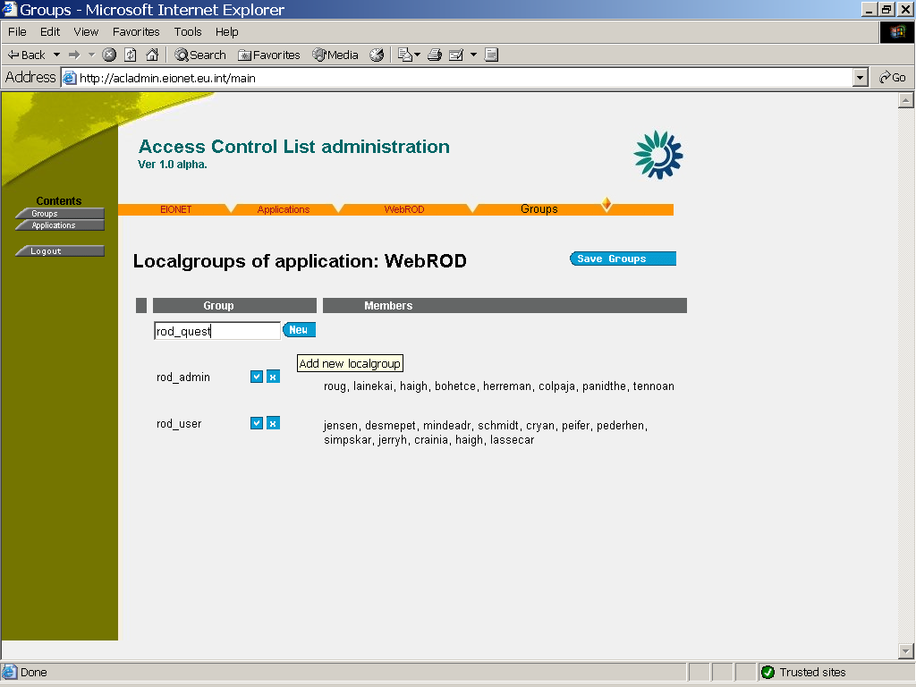
- Adding a new localgroup

Manage group members
To add or delete members of existing localgroup, the icon has to be clicked, and then a Localgroup Members page appears:

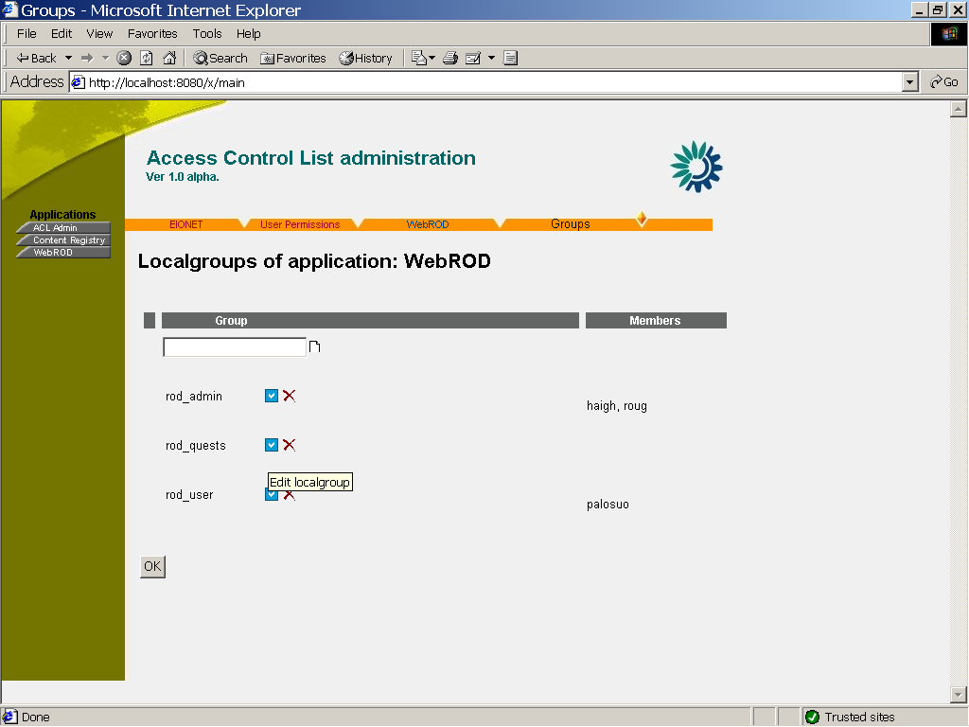
- Going to edit the localgroup members

NB! The Localgroup Edit page is accessed directly from the main ACL page.

Adding a user

The login username (from User Directory) of the user has to be written in the text box and the icon has to be clicked. NB! The application does not check if the user exists in the User Directory or in the localusers file.
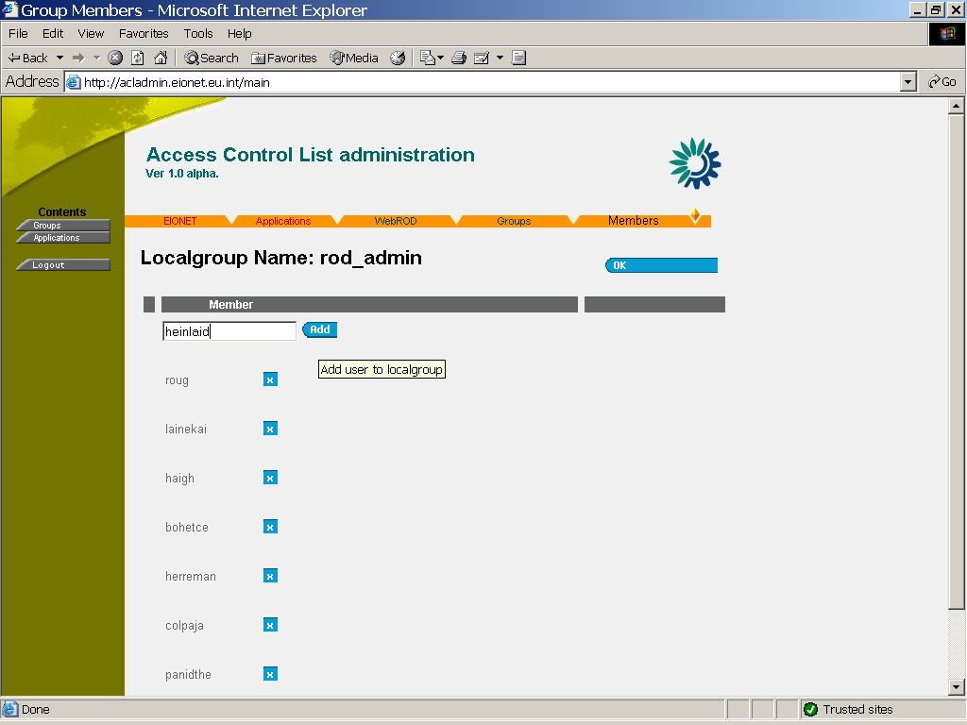

- Adding a user to the localgroup

- User was added to members of the localgroup

Removing a user

For removing a user, the little “cross” image has to be clicked:

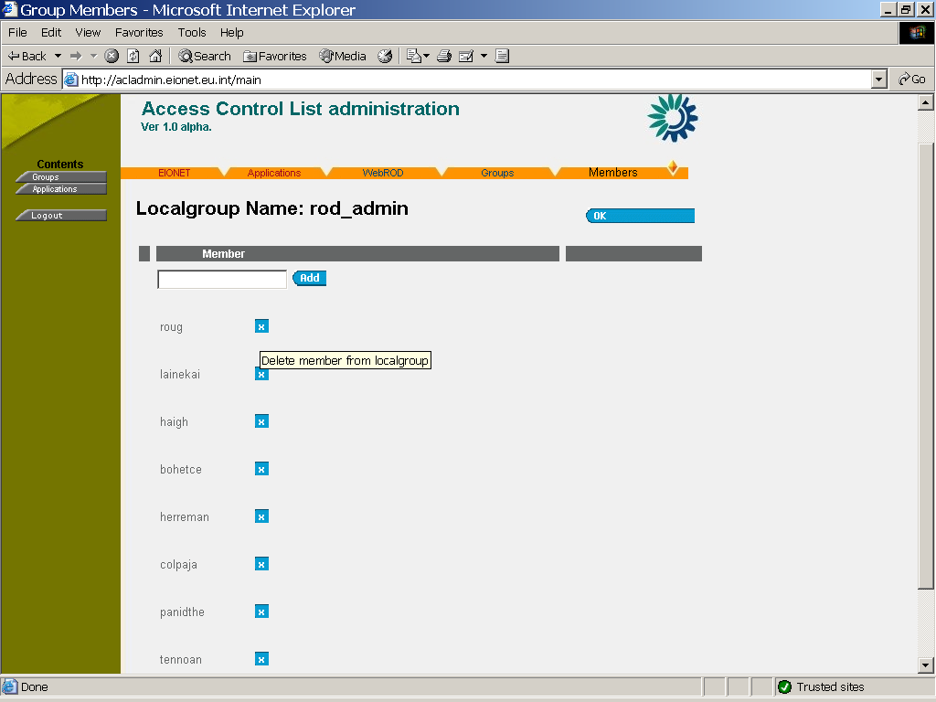
- Removing a user from the localgroup

Saving the localgroup

After all the necessary members have been added and deleted, the localgroup has to be saved by clicking “OK”

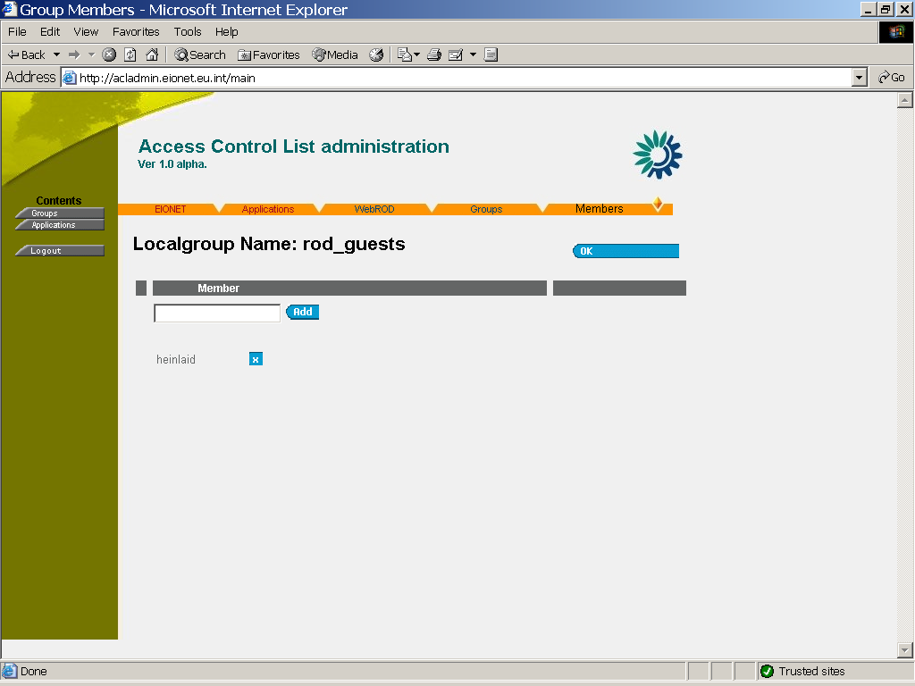
- Saving the updated localgroup

The added localgroup appears in the Localgroups of the application page:

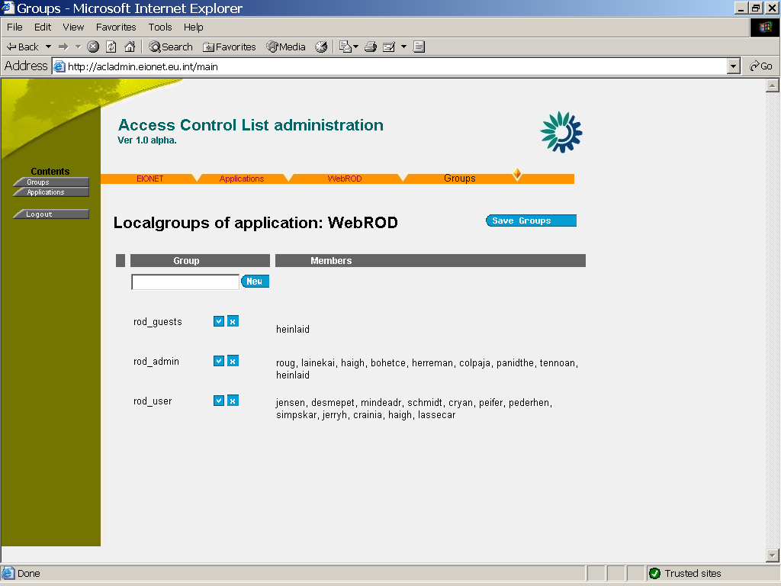

- The Localgroups page, after adding the new one “rod_quests”

Managing the Access Control List

Adding an entry to the Access Control List
The ACL Entry type, ACL Type, entry name and permissions have to be selected from the controls in the screen

ACL Type:
object- a regular ACL entry for permissions checking
DOC: this entry is admitted to a children ACL of this ACL
DCC: not implemented yet

Entry type:
Localgroup: A group of users, defined locally in a text file, see specification above
Circarole: A role in the User Directory
Authenticated: Any authenticated user not listed in the ACL entry rows
Anmonymous: Not authenticated user
Owner: Used only in DOC ACLs: the creator of a child ACL, will be replaced with the username

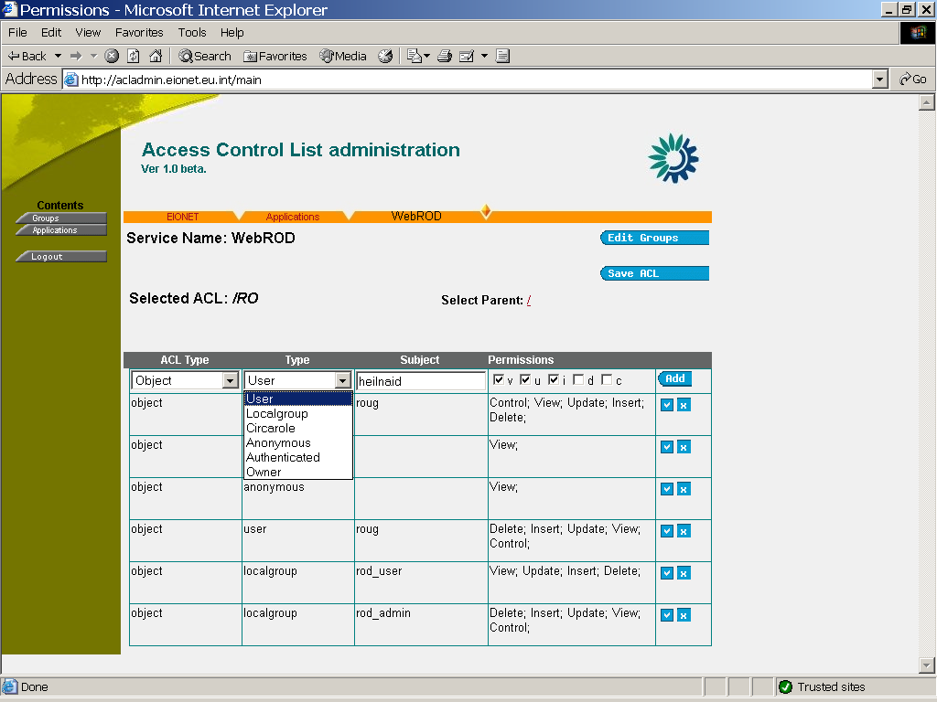
- Adding an entry “heinlaid” with permissions “v,u,I” to the ACL “/obligations”

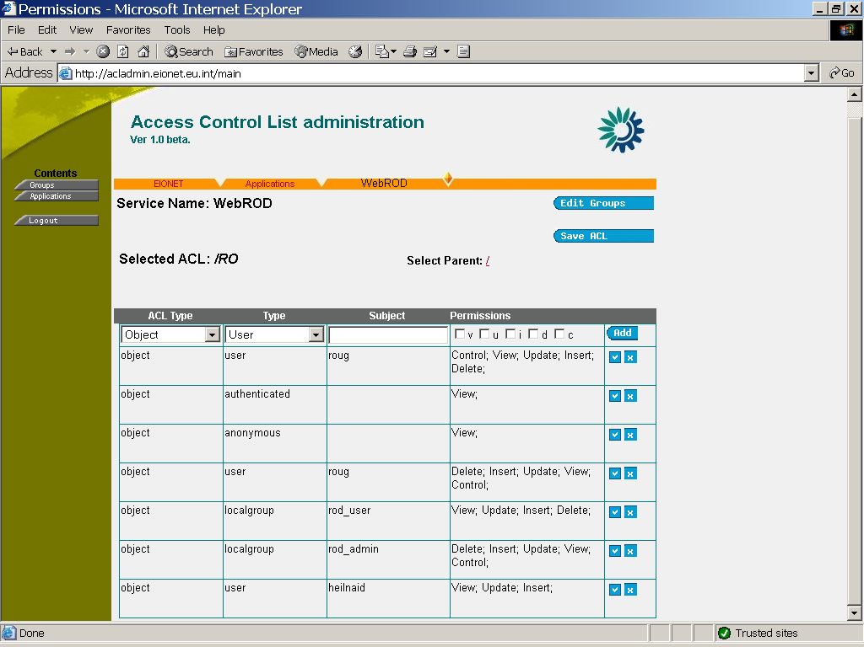
- The entry added to the ACL

Removing an entry from the ACL

For removing an entry, the little cross image has to be clicked:

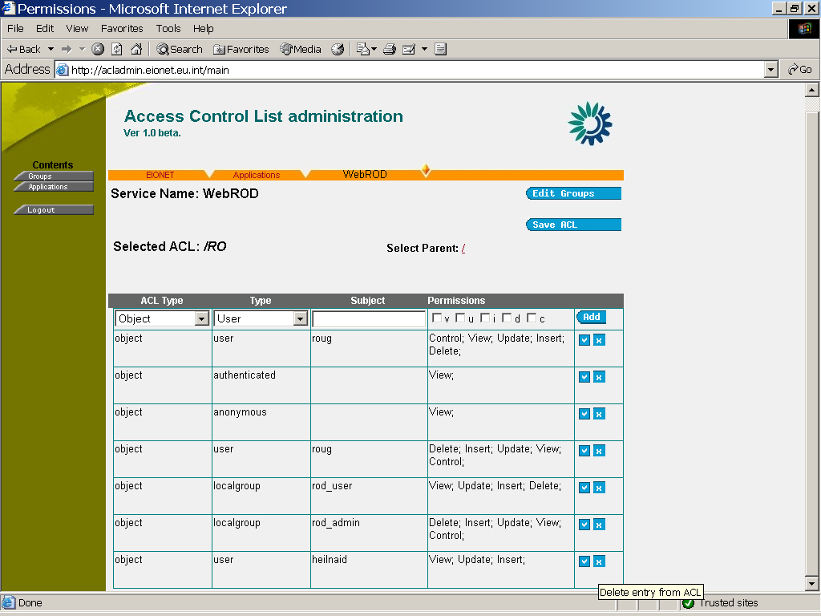
- Removing an entry “heinlaid” from the ACL

Manage access permissions for an entry
For managing access permissions of the entry, the image at the right side of the page has to be clicked. In the appearing page, the needed access permissions have to be selected and finally the “OK” button has to be clicked.

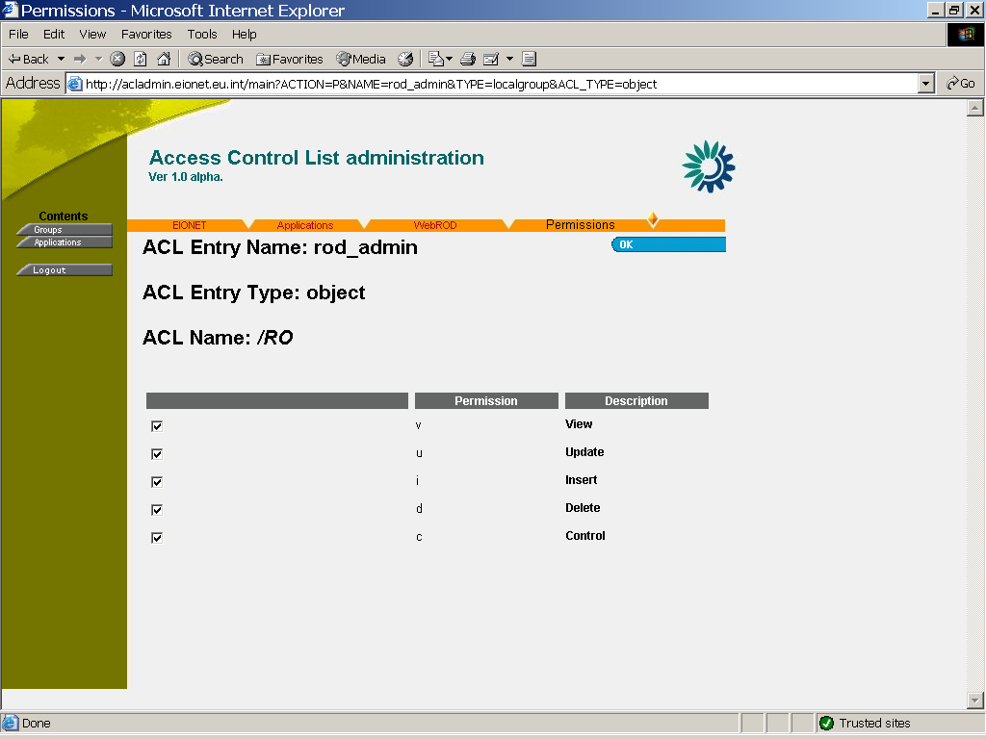

- Modifying access permissions of “rod_admin”

Architecture of the ACL Mechanism

Architecture

Developers guide
The ACL Mechanism is based on Java SDK 1.4 Access Control List architecture. The mechanism can be used by any Java based application to handle authorizing users and self-composed groups. As an additional feature, the Access Permissions for Roles, specified in Circa User Directory, can be managed.

The component is packed into a Java Archive uit-security.jar that must be added to the each application’s CLASSPATH.

The user authentication must be performed by another component. In EIONET applications, the DirectoryService package eionet-dir.jar is used.

All the ACL’s of the application are returned in a HashMap and can be returned from the container AccessController.

HashMap acls = AccessController.getAcls();

The application has to get the application’s Access Control List instance AccessControlListIF from the container AccessController.

AccessControlListIF acl = AccessControler.getAcl(“/obligations”);

For authorising, the application has to know the username and his/her Access Permissions . For checking, if the user “heinlaid” has got an access permission “X”, the following method has to be called

boolean ok = acl.checkPermission(“heinlaid”, “X”);

if (ok)
goAhead();
else
throw new Exception(“No permission”);

Class Architecture
The class architecture of the component is quite simple and consists of only one Java package. The architecture is shown in the following figure.
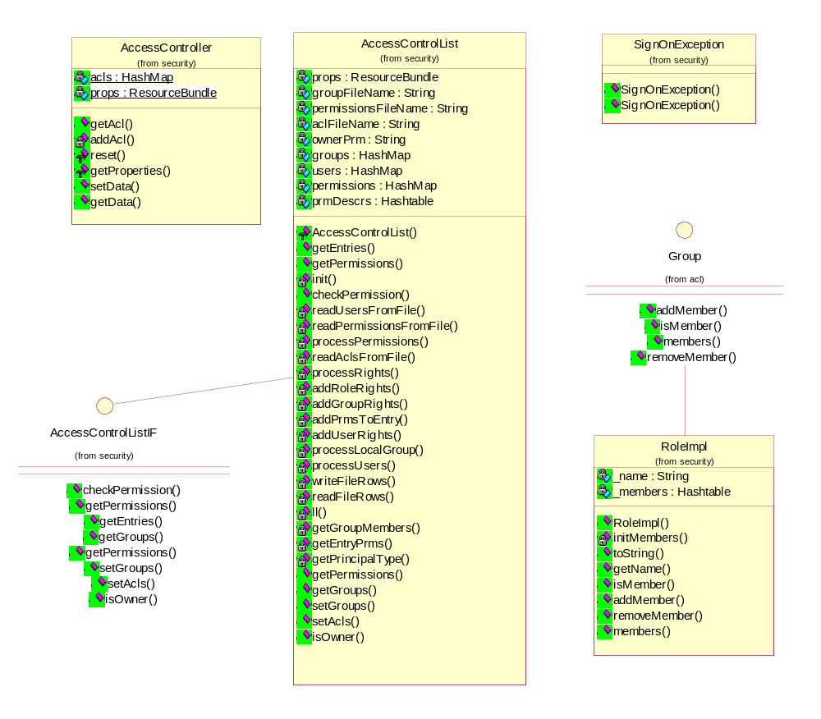
- com.tee.uit.security package class architecture

RPC methods

All these methods need authorisation. HTTP Basic Auth mechanism is used. All methods, related to a particular ACL require the control permission of this ACL;

getLocalGroups() requires the”r” permission of the localgroups’ ACL (“/localgroups”).
setLocalGroups() requires the”u” permission of the localgroups’ ACL (“/localgroups”).

XML-RPC Service name: XService

getChildrenAcls(aclName)

parameters: String – full “path” of ACL
returns: Array of Strings: names of children ACL’s

Examples: getChildrenAcls(“/”)= [“obligations”, “instruments”]

If “obligations” had children, getChildrenAcls(“/obigations”) could be used.

getAclInfo(aclName)

parameters: String: Name of ACL
returns: Struct: Information of ACL

The structure of the method value is:

{ 'name': '/obligations',
'description': 'Reporting Obligations',
'flags':'tableperms',
‘entries’:[ {‘id’:’roug’, ‘type’:’user’, ‘perms’:’v,i,c’ },
{‘id’:’rod_admin’, ‘type’:’localgroup’, ‘perms’:’i,u,d’ },
{‘id’:’rod_admin’, ‘type’:’localgroup’, ‘perms’:’i,u,d’ },
{‘acltype’:’doc’, ‘type’:’user’, ‘id’:’haigh’, ‘perms’:’i,u,d,c’ },
]
}

setAclInfo(aclName, aclInfo)

parameters: String: Name of ACL, Struct: Information of ACL (same as returned by getAclInfo() )

getUserPermissions(aclName, userName)

parameters: String –ACL name, String – user name

returns: Array of Strings: permissions of the users in the ACL, returns permissions of “authenticated”, if user does not exist in the ACL.
returns permissions of “anonymous” if given userName=””

Example: getPermissions(“/obligations”, “roug”)= [r,u,i,d,c]

getLocalGroups()

Parameters:
returns: Array of Structs: localgroups, defined in the application, having the group name as the key and array of Strings as the value. The array contains of user names belonging to the group
Example:

getLocalGroups()= [{rod_admin:[lainekai, tennoan, haigh,roug] } , {rod_user:[palosuo, jensen] }]

setLocalGroups( groups )

parameters: Array : groups’ data, as returned by getLocalGroups()

If a group is missing from the array, it has the effect of deleting the group in the datastorage

getAclManagerInfo()

Method returns human readable descriptions of permission flags, constants, versions supported, etc

returns: STRUCT:

minor_ver : minor version, the AclAdmin suppports
major_ver : major version, the AclAdmin suppports
flags:[] : STRUCT of STRUCTs, containing STRING:STRING = permFlag:permDescription
entrytypes[] : array of STRUCTs=legal entrytypes for these ACL’s
control_flag : flag for control the ACL
ownership : if the ACL mechanism supports ownership

Example:
{ ‘minor_ver’:1, ‘major_ver’:2,
‘flags’: {‘tableperms’:{‘r’:’Read’, ‘i’:’Insert’,’u’:’Update,’d’:’Delete’}, ‘rootperms’:{‘a’:’Access’},
‘ownership’:true, ‘control_flag’:’c’,
‘entrytypes’: [ {‘type’:’user’, ‘arg’:’y’},{‘type’:’anonymous’, ‘arg’:’n’},{‘type’:’localgroup’, ‘arg’:’y’},{‘type’:’circarole’, ‘arg’:’y’},{‘type’:’authenticated’, ‘arg’:’n’} ] }
}

Architecture of the ACL Admin Tool

Common Description
The ACL Admin Tool is a servlet-based application. It communicates with other applications through XML/RPC protocol and can be used for handling access permissions of several applications. See the more detailed descriptions from the installation chapter.

Class Architecture
The class architecture is shown in the following figure:
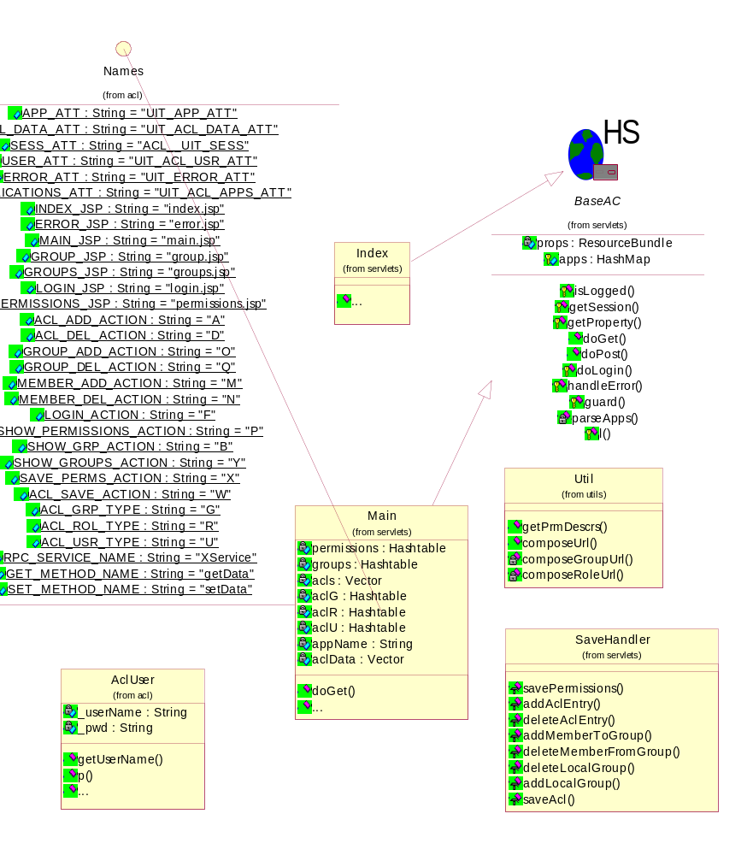

- The class architecture of the ACL Admin Tool

Future Development needs
- XML-ization of ACL’s
- Moving singon mechanism to JAAS (JAva Authorisation and Authentication Mechanism) interface (not required)

Design of XML-ized ACL-mechanism information
During SA-6 project an XML format for the ACLs data was designed. XML would be more efficient for holding ACLs and localgroups’ data than text files. The examples of designed files can be seen below.

An example XML file for authentication and authorisation mechanisms descritpion:

<?xml version="1.0" encoding="UTF-8" ?>
<mechanisms>
<authentication>
<mechanism name="ldap" module="eionet.directory.DirectoryService" evalorder="2">
<ldap context="o=Eionet,l=EUROPE" ref="throw" role.dir="ou=Roles" user.dir="ou=Users" attr.rolename="cn" attr.fullname="cn" attr.roledescription="description" attr.uid="uid" attr.mail="mail" url="ldap://eea.eionet.eu.int:8983/" url2="ldap://ldap2.eionet.eu.int:8983/" />
</mechanism>
<mechanism name="local" module="com.tee.uit.security.FileService" evalorder="1">
<local file.accounts="/dev/null/users.xml" file.groups="inline" />
</mechanism>
</authentication>
<authorization>
<mechanism mech="local-user" entrytype="user" arg="y" evalorder="1" notfound="continue" />
<mechanism mech="ldap-user" entrytype="user" arg="y" evalorder="1" notfound="return" />
<mechanism mech="local-group" entrytype="localgroup" arg="y" evalorder="2" />
<mechanism mech="ldap-role" entrytype="circarole" arg="y" evalorder="3" />
<mechanism mech="authenticated" entrytype="authenticated" arg="n" evalorder="4" />
<mechanism mech="anonymous" entrytype="anonymous" arg="n" evalorder="5" />
</authorization>
</mechanisms>

An example XML file for localgroups:
<?xml version="1.0" encoding="UTF-8" ?>
<groups>
<group id="rod_admin">
<member userid="roug" />
<member userid="tennoan" />
<member userid="lainekai" />
<member userid="haigh" />
<member userid="peifer" />
<member userid="palosuo" />
<member userid="cryan" />
<member userid="mindeadr" />
<member userid="bohetce" />
<member userid="herreman" />
<member userid="colpaja" />
</group>
<group id="rod_user">
<member userid="jensen" />
</group>
<group id="dd_admin">
<member userid="roug" />
<member userid="heinlja" />
<member userid="tennoan" />
</group>
</groups>

An example file for ACLs data:
<?xml version="1.0" encoding="UTF-8" ?>
<access xmlns="http://www.w3.org/2001/XMLSchema">
<aclmanager ownership="true" controlflag="c">
<!-- collections of flags -->
<flags id="rootperms">
<flag short="a" label="Access" />
<flag short="c" label="Control ACL" />
</flags>
<flags id="tableperms">
<flag short="a" label="Access" />
<flag short="i" label="Insert" />
<flag short="x" label="Execute" />
<flag short="u" label="Update" />
<flag short="d" label="Delete" />
<flag short="c" label="Control ACL" />
</flags>
</aclmanager>
<acls>
<acl name="/">
<aclmanager flags="rootperms" />
<entry type="user" id="roug" perms="c" />
<entry type="anonymous" perms="a" />
</acl>
<acl name="/obligations" description="Reporting Obligations">
<aclmanager flags="tableperms" />
<entry type="localgroup" id="rod_admin" perms="a,i,u,d" />
<entry type="localgroup" id="rod_user" perms="a" />
<entry type="user" id="lainekai" perms="c,i,u,d" />
<entry type="circarole" id="eionet-eea-stuff" perms="a,u" />
</acl>
<acl name="/DataSets" description="Datasets">
<aclmanager flags="tableperms" />
<entry type="localgroup" id="dd_admin" perms="a,i,d,u" />
<entry type="localgroup" id="dd_user" perms="a" />
<entry type="authenticated" perms="a" />
<entry acltype="doc" type="owner" perms="c,w" />
<entry acltype="doc" type="user" id="heinlja" perms="c,w" />
<entry acltype="doc" type="localgroup" id="dd_admin" perms="c,w" />
<entry acltype="dcc" type="owner" perms="c,w" />
</acl>
<acl name="/DataSets/112" description="Dataset for dataflow X">
<aclmanager flags="tableperms" />
<entry type="owner" id="roug" perms="a,i,d,u" />
<entry type="localgroup" id="dd_admin" perms="a,i,d,u" />
<entry type="localgroup" id="dd_user" perms="a,u" />
<entry type="anonymous" perms="a" />
</acl>
</acls>
</access>

Configuring an application for the ACL mechanism

Configuring an application for ACL Component
To integrate an application with the ACL mechanism, some properties have to be configured in the file uit.properties, and the 2 files: Access Permission Types, Localgroups have to be created. (See the example above) Aslo, the file(s), including the ACLs information have to be saved in a folder, specified:

The file uit.properties must be copied into the CLASSPATH of the application. The locations of the 3 files, described above, have to be specified and the Access Permission description for the ACL Control specified. Example:

# file for acl permissions
application.acl.folder=/webapps/webrod/xxx/acls

# file for localgroups and users
application.localgroups.file=/webapps/webrod/xxx/rod.group

# file for permission types + descriptions
application.permissions.file=/webapps/webrod/xxx/rod.prms

#Access permission specification for controlling the ACL
application.owner.permission=c

Properties for the localusers authentication mechanism. If the mecahnism is not used, the property is not needed.

#XML file holding local users
acl.localusers.xml= webapps/webrod/xxx/users.xml

Properties for database settings. If the object-baed ACLs are not used and storing the ACL information in text files is preferred, the properties are not needed.

# settings for DB connection
db.driver=com.gjt.mm.mysql.Driver
db.url=jdbc:mysql://localhost:3306/ROD
db.user=RO_admin
db.pwd=aaa

Configuring an application for ACL Admin Tool
To allow the ACL of the application being administrated by the ACL Admin Tool, a property has to be added to the properties file, uit.properties that must be copied in the CLASSPATH.

#property for allowing the ACL to be administrated by the ACL Admin tool
acl.admin=true

Using an application with the ACL Admin Tool assumes that the application is integrated with the UIT RPC Services Framework. (See the documentation for more details). Setting this property, described above, true creates an additional service, called “XService” in the RPC Services with methods:

"getAclInfo", "getLocalGroups", "getChildrenAcls", "getUserPermissions", "setAclInfo", "setLocalGroups", "getAclManagerInfo"

The specification of those methods is above.

This service is not described in the RPC Deployment Descriptor XML-file.
Those methods enable managing permissions through XML/RPC or SOAP interface, using ACL Admin Tool.

If object-based part of the ACL mechanism is used, some additional tables are needed in the database. They can be created by this SQL script:
CREATE TABLE IF NOT EXISTS ACLS (ACL_ID int default '0' not null auto_increment primary key, ACL_NAME varchar(100) DEFAULT '' NOT NULL, PARENT_NAME varchar(100), OWNER VARCHAR(255) NOT NULL DEFAULT '' , DESCRIPTION VARCHAR(255) DEFAULT '');

CREATE TABLE IF NOT EXISTS ACL_ROWS (ACL_ID int default '0' not null , TYPE ENuM('object','doc','dcc') default 'object' not null, ENTRY_TYPE enum('owner','user','localgroup','other', 'foreign','unauthenticated','authenticated', 'mask') default 'user' not null, PRINCIPAL char(16) default ' ' not null, PERMISSIONS char(255) default ' ' not null, STATUS int(1) );

Folder Structure

Installing ACL Admin Tool in EIONET Environment
The following folder structure has to be created. (“acladmin” may be replaced with another word, it is used as an example here)

acladmin
images
WEB-INF
classes
lib

Libraries
uit-server.jar, uit-security.jar, eionet-dir.jar must be copied into the libraries path (e.g. /acladmin/WEB-INF/lib)

JSP files

*.jsp files must be copied into the root folder ( /acladmin )

Properties files

acladmin.properties containing the settings for the ACL Admin Tool must be copied into the class path (e.g.
/acladmin/WEB-INF/classes )

Settings in the properties file:

# applications to be administrated, separated by comma
# NB! each app should have an image "button_<appName>.gif" in images folder
applications=WebROD,ContReg

# applications' router URL(s)
WebROD.router.url=http://rod.eionet.eu.int/rpcrouter
ContReg.router.url=http://cr.eionet.eu.int/rpcrouter

ACL Admin Tool is using ACL Mechanism itself as well, so uit.properties file must be copied into the classpath and the ACL files must be configured for the ACL Admin Tool as described in chapter 4.1.

web.xml
A configuration file for tomcat servlet engine
<?xml version="1.0" encoding="ISO-8859-1"?>

<web-app>

<display-name>AclAdmin</display-name>
<description>EIONET ACL ADMIN application</description>

<context-param>
<param-name>application-name</param-name>
<param-value>acladmin</param-value>
</context-param>
<context-param>
<param-name>log-level</param-name>
<param-value>9</param-value>
</context-param>
<servlet>
<servlet-name>applogin</servlet-name>
<servlet-class>eionet.acl.servlets.AppLogin</servlet-class>
</servlet>
<servlet>
<servlet-name>main</servlet-name>
<servlet-class>eionet.acl.servlets.Main</servlet-class>
</servlet>
<servlet>
<servlet-name>rpcrouter</servlet-name>
<servlet-class>com.tee.uit.servlets.XmlRpcRouter</servlet-class>
</servlet>

<servlet-mapping>
<servlet-name>main</servlet-name>
<url-pattern>/main/*</url-pattern>
</servlet-mapping>
<servlet-mapping>
<servlet-name>rpcrouter</servlet-name>
<url-pattern>/rpcrouter</url-pattern>
</servlet-mapping>

</web-app>

