User Guide
Data Dictionary
Prepared by
Jaanus Heinlaid, TripleDev
Enriko Käsper, TripleDev
Enver Atabek, TripleDev
Kaido Laine, TripleDev
April 2015
Version 1.05
User Manual
Version management
No | Date | Changes | Author
0.1 | 18.02.02 | First draft, triggered by the publication of a major update at demo site | Jaanus Heinlaid
0.2 | 24.03.03 | Situation at demo site at the end of SA-5 | Enriko Käsper
0.3 | 08.04.03 | Some changes requested by project leader. The structure of the document was organized according to the each users needs. Chapter 1 added. | Enriko Käsper
0.4 | 08.09.03 | Updates related to the release of DD version 1.2test | Jaanus Heinlaid, Enriko Käsper
0.41 | 27.10.03 | Additions to cp 4.2.3: Recycle Bin for deleted datasets and Cp 4.4.9 Foreign Key relations | Jaanus Heinlaid, Enriko Käsper
0.42 | 07.11.03 | Additions & changes regarding developments since last updates | Jaanus Heinlaid, Enriko Käsper
0.43 | 21.11.03 | Documenting new features and bug fixes | Jaanus Heinlaid, Enriko Käsper
0.5 | 31.03.04 | Documenting new features | Jaanus Heinlaid
0.51 | 30.07.04 | Documenting new features | Jaanus Heinlaid
0.52 | 30.08.04  24.10.04 | Documenting new features | Jaanus Heinlaid
0.53 | 10.12.04 | Final reviewed draft for EEA’s comments approval | Heinlaid, Palosuo
1.0 | 22.03.2007 | Lots of updates regarding the many changes that have been made in the DD application since previous updates to this document. | Jaanus Heinlaid
1.01 | 30.05.2007 | Minor stylistic changes | Søren Roug
1.02 | 27.10.2008 | Added information on handwritten XML for the import tool | Søren Roug
1.03 | 30.01.2015 | Draft Chapter about how to use vocabulary | Enver Atabek
1.04 | 05.03.2015 | Updates to chapter Vocabularies | Kaido Laine
1.05 | 27.04.2015 | Common elements with RDF names | Kaido Laine
1.06 | 30.04.2015 | CDDA site codes service, Schemas and schema sets | Enriko Käsper

Contents
Foreword 6
1. Content & Concepts 7
1.1. Dataset definitions 7
1.2. Table definitions 7
1.3. Data element definitions 7
1.4. Attribute 9
1.5. Unique identification of datasets, tables & elements 10
1.6. User groups 11
1.6.1. Data suppliers 11
1.6.2. Data definers 11
1.6.3. DD administrators 11
1.7. Registration statuses 12
1.8. Versioning of released data definitions 12
1.9. Working copies 13
2. Functionality overview 13
2.1. Opening view 13
2.2. All-users functionality 16
2.3. Data definers and administrators functionality 16
2.4. Administrators-only functionality 17
2.5. Online help 18
3. All-users functionality 18
3.1. Datasets 18
3.1.1. Browse datasets 18
3.1.2. Search datasets 19
3.1.3. Dataset view page 20
3.2. Tables 23
3.2.1. Browse tables 23
3.2.2. Search tables 24
3.2.3. Table view page 24
3.3. Data elements 26
3.3.1. Search data elements 26
3.3.2. Data element search results 27
3.3.3. Data element view page 28
3.4. GIS tables and elements 30
3.5. Schema sets and schemas 31
3.5.1. Browse schema sets 32
3.5.2. Search schema sets and schemas 32
3.5.3. View schema set contents 33
3.6. Vocabularies 34
3.6.1. Browse Vocabularies 34
3.6.2. Search Vocabularies and Concepts 36
3.6.3. Browse Vocabulary 42
3.6.4. Vocabulary Concept View Page 43
3.6.5. Vocabulary Export Formats 43
3.7. CDDA dataflow site code service 46
4. Data definers & administrators functionality 47
4.1. Simultaneous editing- checking in & checking out 47
4.2. Versioning details 48
4.3. Datasets 49
4.3.1. Add a new dataset 49
4.3.2. Edit a dataset working copy 50
4.3.3. Delete a dataset version 51
4.3.4. Working with a dataset’s tables 51
4.3.5. Dataset models 52
4.3.6. Uploading documents for a dataset 53
4.3.7. Dataset links to ROD 54
4.3.8. Restoring non-permanently deleted dataset definitions 55
4.4. Table definitions 55
4.4.1. Add a new table 55
4.4.2. Copy another table 56
4.4.3. Edit a table 57
4.4.4. Delete a table 58
4.4.5. Working with definitions of elements in a table 59
4.4.6. Adding images to table definitions 60
4.5. Data element definitions 62
4.5.1. Add a new data element 62
4.5.2. Copy an element, convert non-common element to common element 63
4.5.3. Edit a data element 63
4.5.4. Delete a data element 65
4.5.5. Managing fixed values of data elements 66
4.5.6. Managing suggested values of data elements 66
4.5.7. Foreign key relations 67
4.5.8. Adding images to data element definitions 68
4.6. Working with complex attributes of a dataset, table or data element 68
4.6.1. The complex attributes list 68
4.6.2. A complex attribute’s editing page 69
4.7. Vocabularies 70
4.7.1. Adding New Vocabulary 70
4.7.2. Copying Existing Vocabulary 71
4.7.3. Updating/Editing a Vocabulary 72
4.7.4. Importing Data into Vocabulary 89
4.8. Get notifications in your email 92
5. Administrators-only functionality 93
5.1. Defining attributes 93
5.1.1. Defining simple attributes 95
5.1.2. Defining complex attributes 97
5.1.3. Deleting an attribute definition 100
5.1.4. Attribute’s inheritance 100
5.1.5. Harvested complex attributes 101
5.2. The cleanup function 104
6. Import tool 106
6.1. Table structure 106
6.1.1. DATASET table 107
6.1.2. DS_TABLE table 107
6.1.3. DATAELEM table 108
6.1.4. FIXED_VALUE table 109
6.1.5. TBL2ELEM table 110
6.2. Insert data 110
6.2.1. Main form 110
6.2.2. Add a new dataset definition 110
6.2.3. Add a new table definition 111
6.2.4. Add a new data element definition and fixed values 112
6.3. Generate XML file 112
6.3.1. Setup data 113
6.4. Importing the data into DD 114
6.5. Import results 114
6.6. Importing fixed values only 115
6.7. Limitations 116
6.8. Making your own XML 116

Foreword
This document presents the guidelines for usage of the Data Dictionary (DD) system developed under the IDA/EINRC framework contract No 501 998. Operational software is running at the European Environment Agency’s site http://dd.eionet.europa.eu .
The document has 5 main chapters.
Chapter 1 starts off by describing the basic concepts and content of Data Dictionary that are absolutely essential for understanding the rest of the document. It includes definitions of the three main concepts (datasets, tables and data elements), definition of metadata needed to describe those concepts (attributes) and also the definition of main user groups in Data Dictionary and what is their relation to the application.
Chapter 2 makes an overview about all the functionality provided by Data Dictionary. While this is a general description of use cases and opening view, chapters 3 and 4 will go more into the details.
Chapter 3 is meant for all the Data Dictionary’s user groups and mainly describes how to search, browse and view the DD content. In other words it covers the read-functions.
Chapter 4 is meant for the user group of data definers, i.e. those users who have the rights, knowledge and skills to define the data for data suppliers to report. So this chapter covers the write-functionality, as opposed to chapter 3. It includes functions to add, delete and update data definitions. You will find the descriptions of all such functions illustrated with screenshots. The chapter also includes the description of a helper tool, used for the data’s initial upload- the so-called Import tool.
Finally, chapter 5 is meant for the user group of administrators, i.e. those who should have all imaginable permissions both on DD contents and application itself, including the permission to edit DD’s metadata which is mainly the dynamical attribute set used for creating data definitions.

Content & Concepts
DD holds definitions of datasets, tables and data elements exchanged over the Eionet-network. They are defined by a set of attributes, the core set of which corresponds to ISO 11179 standard for describing data elements. The whole attribute set is flexible and an administrator can dynamically add/remove attributes from/to the system.

Dataset definitions
In the context of data exchange from countries to international level, the structure of data to be delivered is defined as a dataset, which is a collection of tables that will hold the reported data. Often the "tables" will actually recede to a single table only. In a way delivered datasets are stand-alone databases. Usually they come as MS Access databases or MS Excel files. They are subject to certain data flows and obliged to be reported by Eionet network parties according to legislation. In many cases a dataset corresponds to a data flow. For example there is the CDDA dataset defined in DD, which contains the definitions and guidelines about data to be delivered within that same-named data flow.

Table definitions
Datasets consist of tables. Each table is defined by its columns and in DD they are called data elements (for historical reasons).

Data element definitions
So data elements are building blocks of tables and in DD data elements are divided generally into two groups:
- non-common elements belong into a certain single table and they cannot be used in any other table. They are defined within that certain table and they do not have a “life” outside of that table.
- common elements are not strictly attached to a single table. Instead, they can be used in many tables, i.e. they can be part of many tables. You could also call them harmonised elements. They are potential candidates to be used in many datasets and tables and thus have been harmonised to avoid repetitions. A perfect example of a common element is for example CountryCode. It is obvious that CountryCode is probably needed in all datasets and in many tables.
  - A common element can be a representation of an RDF element. If a colon is included in the element identifier the element name is enetered in format namespace:elementname. The RDF namespace specified in the element name has to be defined in T_RDF_NAMESPACE database table. (Currently there is no UI for editing the table values)
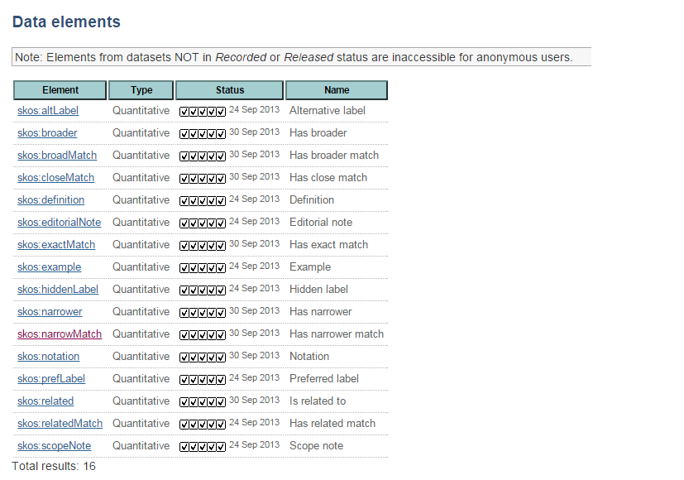

Illustration 1: RDF data elements
Data elements could be for example StationCode, StationType, Longitude, etc. And while Longitude can be measured and StationCode could be anything, StationType would probably have values from a pre-fixed set. These differences in value domain divide the data elements into two:
- Data elements with fixed values (aka allowable values or code lists), also know in ISO 11179 terms as “characteristics 1” or “characteristics of type 1”.
- Data elements with quantitative values (a.k.a measured values), also known in ISO 11179 terms as “characteristics 2” or “characteristics of type 2”. For these elements DD enables to define suggested values. The latter are DD’s suggestions for data suppliers who are not sure which values exactly to supply.
- Data elements with values from a vocabulary have a linked vocabulary. The vocabulary concept values are valid values for the common data element.
NB! Both common and non-common elements can be elements with fixed values or quantitative values.

Illustration 2 tries to give a visual representation of what are tables and data elements.
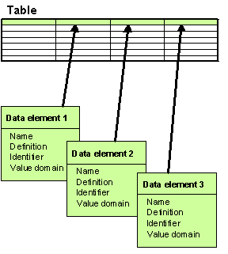Illustration 2: Data element tabular format

Attribute
Datasets, tables and elements in DD are defined by a set of attributes, the core set of which corresponds to ISO 11179 standard for describing data elements. The rest of the attributes are usually specific to Reportnet business rules and in any case the attribute set is flexible; an administrator can dynamically add/remove attributes to/from the system. Most common attribute of all is 'Name', standing for the name of the defined object. Other attributes could be for example 'Definition', 'Version', etc.
In ISO11179 two types of attributes are recognized and they are also used in DD:
- Simple attribute
Every such attribute is a name-value pair. They represent the same concept of attributes as in ISO 11179 part 3. For example 'Name', 'Definition' and 'Version' are good examples of simple attributes.
NB! Note that simple attributes can have a pre-fixed set of values. Also, some simple attributes can have many values at the same time. These attributes are sometimes called repeating attributes. A good example of such an attribute is 'Keywords'. It is natural that there can be many keywords describing an object.
- Complex attribute
A complex attribute is almost the same as a simple attribute. The difference is that while a simple attribute is a name-value pair, a complex attribute is a set of name-value pairs. Every such pair is called the complex attribute’s field. For example address would consist of country, city and street. So address is a complex attribute and country, city and street are its fields. A set of fields combines a complex attribute’s value row. The set of rows is what is called the complex attribute’s value.

Important simple attributes when defining a data element in DD are:
- Datatype
Indicates if the element’s values are strings, integers, booleans, etc. Also specifies if decimals are to be used, and how many decimals are accepted.
NB: For a Boolean datatype the allowable values according to ISO are ‘true’ and ‘false’.
- MaxSize/MinSize
The max/min length of a data element value in terms of digits or characters. For example if an element’s MaxSize is 4, its value 'hello' is one char too long. Or if an element’s MinSize is 5, its value '146' is one digit too short.
- MaxValue/MinValue
Can be applied only to data elements of numeric Datatype and they limit the element’s numeric value. i.e. value '9.55' is too much if MaxValue is '9'.

Important complex attributes when defining a dataset, table or element are:
- SubmitOrganisation
The organisation that has added or changed the data element definition. This is mandatory to specify for all dataset, table and element definitions!
Fields of this complex attribute are: name, name abbreviation, contactPerson, e-mail, url, address, PhoneNr )
- RegistrationAuthority
Institution authorised to register the data definitions.
Fields of this complex attribute are: name abbreviation, name, address, contactPerson, url.

More about each and every attribute you can learn through using the DD, because each and every attribute in the DD user pages is provided with on-line help about its meaning and usage.

Unique identification of datasets, tables & elements
Definitions of data elements, tables & datasets in DD are uniquely identified by an attribute, which is called Identifier.
Identifier is a character string used in DD to distinguish definitions of different elements, tables and datasets within the same context. Its maximum length is 50 characters and it must contain no white space! Identifiers will be used as tag names to distinguish elements in XML-formatted data reporting, so they must apply to the same rules, as do the XML tags.
A dataset Identifier must be unique!
A table Identifier must be unique within its owner dataset!
A non-common data element Identifier must be unique within its table!
A common element Identifier must be unique among all common elements!
So logically a dataset is uniquely identified by its Identifier. A table is uniquely identified by its Identifier and owner dataset. A non-common data element is uniquely identified by its Identifier and owner table. A common element is uniquely identified by its Identifier among all common elements.

User groups

Data suppliers
These are the users who, according to reporting obligations, are responsible for reporting data over Reportnet,. The relation of such users to DD is as follows:
- According to Reportnet business process, Reporting Obligations Database (ROD) is the application where the data supplier starts.
- ROD’s obligation pages provide users with links to reporting guidelines and definitions of data to be reported. The latter reside in DD.
- So when definitions are in DD, data suppliers will get from DD the detailed definitions of data to be reported, guidelines as a PDF-document and also templates for inputting their data.
As you can see, DD suppliers do not usually need more than read-only access to DD. And since read-only access is permitted to all anonymous users, data suppliers do not usually have a user account in DD.

Data definers
These are the users who have the responsibility, permissions and skills to define the data for data suppliers to deliver. The best examples of such users are the ETCs, working as representatives of EEA. Each reporting obligation in ROD has a “report to” institution, so it’s natural that those institutions define "their" data flows in DD. Since EEA has delegated the data collection and definition tasks to ETCs, it is also they who are usually responsible for maintaining the data definitions and reporting guidelines in DD.
Data definers must have a user account in DD, because otherwise they cannot be identified for the system and unidentified users are certainly not allowed to edit DD content.

DD administrators
DD administrators do not have to be involved in the reporting process and their role is mainly to perform the following administrative tasks:
- create and maintain user accounts for data suppliers and definers (not done from DD user interface, hence not covered in this interface)
- grant permissions to user accounts (also not done from DD user interface)
- maintain the definitions of attributes used in the definitions of datasets, tables and data elements
- clean the DD contents from inconsistent data that might result from exceptions and errors in system
- create and manage online help that is displayed on DD pages (done from another application that connects to DD, not covered in this document)

Registration statuses
Each dataset and common element definition in DD goes through a life cycle. Its phases are marked by Registration status (a.k.a simply status). The Registration status of a dataset or common element definition is specified by the data definers and can be any one of the following:
Released (sometimes marked with 5 ticks in DD user interface pages)
The definition is accepted by ETCs and EEA and is released for countries to use for download of technical guidelines and templates. Definitions in this status can be accessed by countries.
Qualified (sometimes marked with 5 ticks in DD user interface pages)
This level is for closing discussions between ETCs and EEA. Definitions in this status cannot be accessed by countries.
Recorded (sometimes marked with 5 ticks in DD user interface pages)
This level is for discussions between ETCs and countries if applicable. Otherwise the definition will skip this status and move directly to the Qualified status. Definitions in Recorded status can be accessed by countries.
Candidate (sometimes marked with 5 ticks in DD user interface pages)
Definitions that are included in the DD by the EEA or ETC data managers. This level is for opening discussions between ETCs and EEA. Definitions in this status cannot be accessed by countries.
Incomplete (sometimes marked with 5 ticks in DD user interface pages)
This can be existing definitions under consideration to be included in the DD or new definitions under development where the DD is used as a structuring tool or to test data flows. Definitions in this status cannot be accessed by countries.

Versioning of released data definitions
DD keeps history of released definitions of datasets and common elements. Note that it is indeed only released definitions whose history is kept. Definitions with other registration statuses are left out of it. There is one exception though- the latest version of a definition can actually be something else than Released! But all non-latest versions surely always have the Released status. More about that exception is told in the chapter for data definers and DD administrators.
Keeping history is called versioning in DD terms.
Keeping history is needed for the case when a data supplier has downloaded a released dataset definition some time ago, does not check if the definition has changed in the meantime and reports the data according to the old released definition. Then in order to validate such data, the validation services need to get the old definition. And that’s why DD needs to keep the old versions of data definitions.
And since non-released dataset and common element definitions are not used in live reporting anyway, it is only released datasets that are versioned.
Dataset versions are uniquely identified by Dataset number (sometimes called DatasetNo or simply Version). Comment element versions are uniquely identified by Element number (sometimes called ElementNo or simply Version).

Working copies
If a data definer is editing a dataset/table/element definition then that definition is locked for others to edit. In DD terms a definition in such a state is checked out (= locked for editing). If a definition is checked out, its working copy is created and that’s what the data definer is working with. Nobody else can see the changes being made to the working copy. The original copy (the one that was checked out), even if locked for editing, is still readable and viewable for all.

Functionality overview
DD’s functionality can be roughly divided into 3 sets:
- All-users functionality
- Data definers and administrators functionality
- Administrators-only functionality

In the next chapters you will find both use case diagrams and in-depth guidelines on how DD functions work.

Opening view
The opening view (Illustration 3) of the DD is divided into 5 sections:
- released dataset definitions
This is a list of quick-links to dataset definitions that have been officially released for data suppliers to use in live reporting.
- news
This is an area listing all the latest DD-related news.
- documentation
This area provides links to the texts that explain the DD purpose, main concepts and functions.
- support
This is an area helping you to find the sources which to contact for feedback.

The opening view, as well as every other non-popup view of DD has a left panel containing the buttons that lead to the application’s main top-level functions from where you can descend to lower levels of DD functionality.
The non-popup pages of DD have a tool ribbon as the top-most section of the page. The ribbon contains several useful tools, including those for printing the current page, switching to/from full screen and most importantly- for logging into the DD. The latter function enables, users data definers and DD administrators to identify themselves. Once they do so, the left panel will reveal more buttons leading to more functions, depending on the profile of the user. A successful login will always reload the current DD page and the Login button will be substituted by Logout.
All the non-popup views have a location bar (aka breadcrumb) right under the page header, displaying the location where you at the current moment in DD functions. It also contains the link to the application’s opening view, so that you can always return back there.

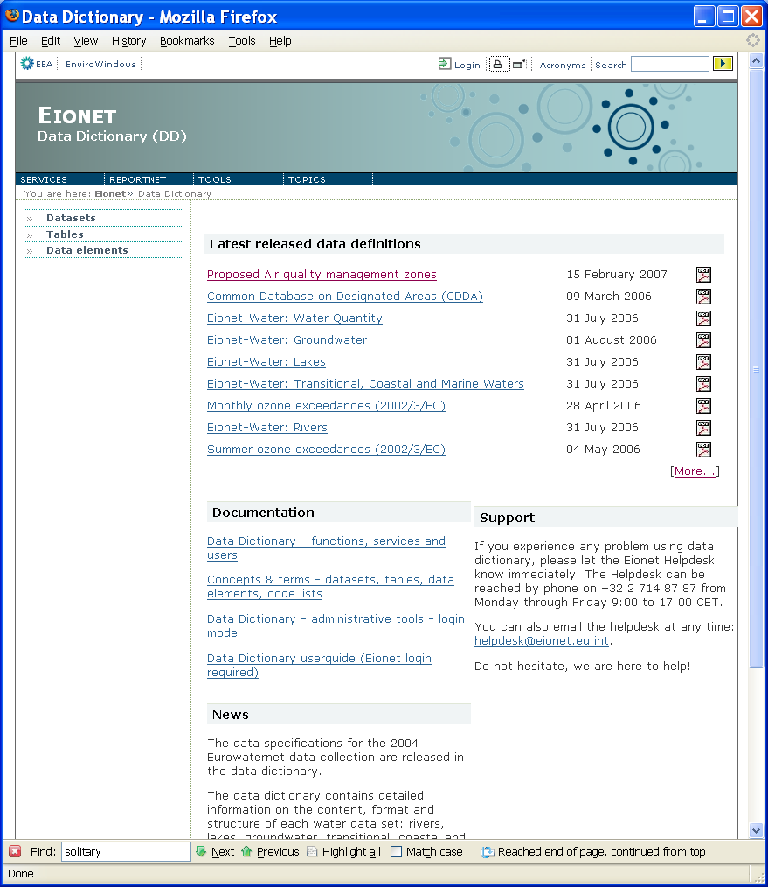Illustration 3: Opening view of the DD

All-users functionality
These are functions accessible to all DD users, including anonymous ones (ie those that do not log in or do not have a user account in DD). So this chapter can also serve as a user guide document for data suppliers, because they are usually anonymous to DD.
An overview of use-cases accessible to all users is given on Illustration 4.
Illustration 4: Use-Cases for all users

Data definers and administrators functionality
These are functions usually accessible only to data definers and DD administrators. They enable to add, edit and delete the DD contents.
In order to access these functions, users must first identify themselves by logging in. Once this is done, DD checks which operations on which content are permitted for the user and renders the user interface accordingly. Permissions are controlled by DD administrators and decided by the DD owners (in this case EEA).
Illustration 5 gives an overview of use-cases available for data definers and administrators. Note that the picture also includes functions from the previous picture, because what’s available for all users, is naturally available for data definers and administrators too.
Illustration 5: Use-Cases for data definers and administrators

Administrators-only functionality
These are functions available only for DD administrators. The user groups chapter above listed the tasks that DD administrators must perform. Some of them are not accessible via DD user interface, but some are. Illustration 6 describes the latter by use-cases.
Illustration 6: Use cases for DD administrators only

Online help
Throughout the DD pages you will find question-mark icons or icons like this:
These icons open a pop-up window with on-line help on the area/or function where the icon is located.
Also, most DD pages have a “Page help” link in the tool ribbon. This opens a pop-up window with general help and background information on the page you’re working with.

All-users functionality

Datasets

Browse datasets
Links to the latest released datasets are displayed in the DD opening page.
Clicking Datasets on the left panel opens a list of latest versions of datasets in any Registration status (Illustration 7). It has 3 columns. Dataset column contains the dataset’s short name and it is sortable. Clicking a dataset leads to its view page. Status indicates the dataset’s Registration status and is sortable too. Tables lists the tables in the dataset. Clicking a table leads to the table’s view page.
Data definers and administrators can see check-boxes in front of listed datasets which they have permission to delete. Select the ones you need and press the Delete selected button. New datasets can be defined by pressing Add new button. Non-permanently deleted dataset definitions can be restored by clicking the Restore link in the upper right corner which leads to the list of non-permanently deleted datasets.
If a dataset is checked out, the list has it marked with a red asterisk (*, displayed only for authenticated users). Pointing the mouse over the asterisk displays the user name of the person who checked out.
NB! Datasets not in Recorded or Released status are inaccessible for anonymous users.
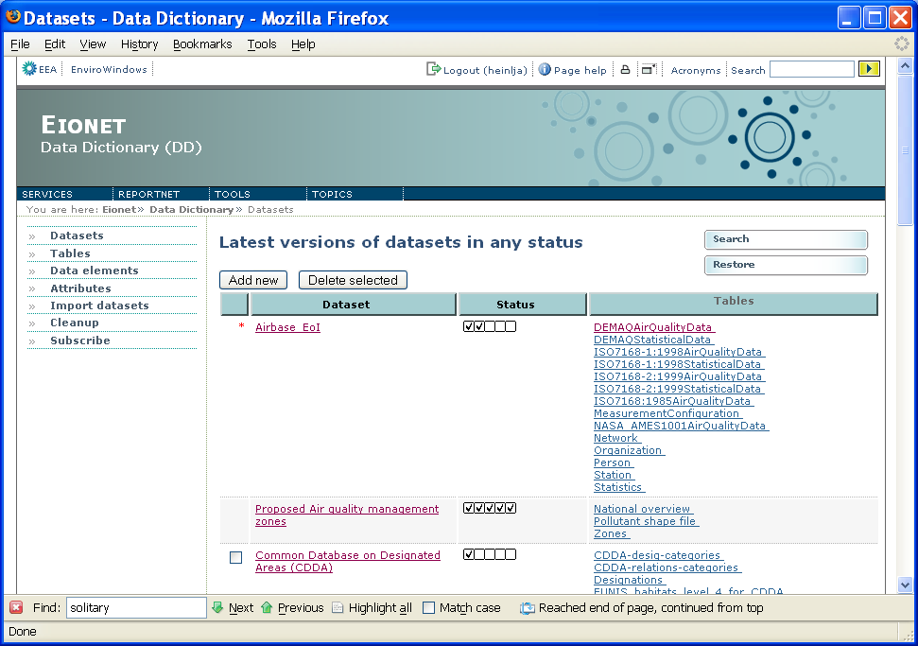Illustration 7: List of datasets

Search datasets
Dataset search page (Illustration 8) can be reached by clicking Search link in the datasets list that was described above. The dataset search page has several search criteria and more of them can be added by using the Add criteria select box. Added criteria can be removed by using the – sign that appears next to it. Help on every criterion is opened when you click the relevant help icon next to them.
The 3 radio buttons enable to set the search precision. The Working copies only check-box (displayed only if have the required permissions), if checked, searches for your working copies only. If the Include historic versions check-box is left unchecked, search is performed in latest versions only. If checked then search is done in all versions. Reset clears the criteria.
In the upper right corner, data definers and administrators can see the Add dataset link for defining new datasets.
The search result list looks just like the one described in the previous chapter. The only difference is that if you chose to search in historic versions too, the list has an extra column showing the datasets' Version number.
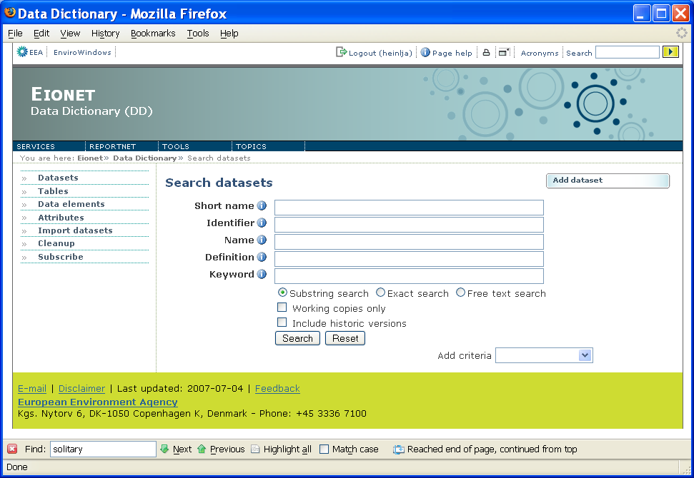Illustration 8: Search for a dataset definition

Dataset view page
Dataset view page (Illustration 9) is divided into the following sections (which you can quickly access by using the quicklinks at the top of the page):
- Documents & templates available for this dataset. If you have the required permissions, this section also contains links for uploading new documents and managing the documents cache.
- Simple attributes. Empty ones are not displayed.
- Data model. This section is displayed only if a data model has been specified for this dataset. The section simply displays the data model.
- The list of tables in this dataset given in two columns: the table’s full name and short name. Clicking the full name leads to the table’s view page.
- The list of reporting obligations corresponding to this dataset in the Reporting Obligations Database (ROD). Each obligation is given by its title, the title of the legal instrument it belongs to and the link to the obligation’s detailed view in ROD
- Complex attributes. Empty ones are not displayed. Clicking the attribute’s title opens a more detailed view of that attribute.
- Other versions of this dataset. Every version is uniquely identified by the dataset number in the left-most column. The list also indicates the version’s Registration status and the date is was released (relevant only when the Registration status is Released). The right-most column of this list provides the link to the view page of that version.

NB! If you go to the view page of the dataset that you have checked out, DD automatically redirects you to the view page of the corresponding working copy.
If you have authenticated yourself and you have the required permissions and this IS NOT a dataset working copy , the upper right corner of the page contains the following buttons:
- New version will create a new version of this dataset. You will be instantly led to the view page of that new version where you can start editing it. It will be a working copy until you check it in.
- Check out will do the same as New version, the only difference is that the working copy will not become a new version when checked in. Instead, it will simply overwrite the current dataset copy.
- Delete deletes this dataset copy. This does not mean that if you are viewing a Lakes dataset and you press Delete, then all versions of Lakes dataset will be deleted. Only the version you are viewing will be deleted!
If you have authenticated yourself and you have the required permissions and this IS a dataset working copy and it is YOUR working copy, the simple attributes section contains premonitory text saying '(Working copy)' and the upper right corner of the page contains the following buttons:
- Edit will open the working copy in edit mode (more on that in chapters below).
- Check in will check in all edits that you did to the working copy.
- Undo checkout cancels the checkout and deletes the working copy.
If you are viewing a dataset that has been checked out by somebody, the simple attributes section contains premonitory text saying '(checked out by username)'.

Also in the upper right corner of the page you may find these action links:
- Go to newest leads you the view page of the newest version of this dataset. Seeing this action link indicates that you are viewing an historic version of this dataset.
- Subscribe will subscribe you to any changes made to any version of this dataset. Eionet’s Unified Notification System (UNS) will send you notifications about those changes.
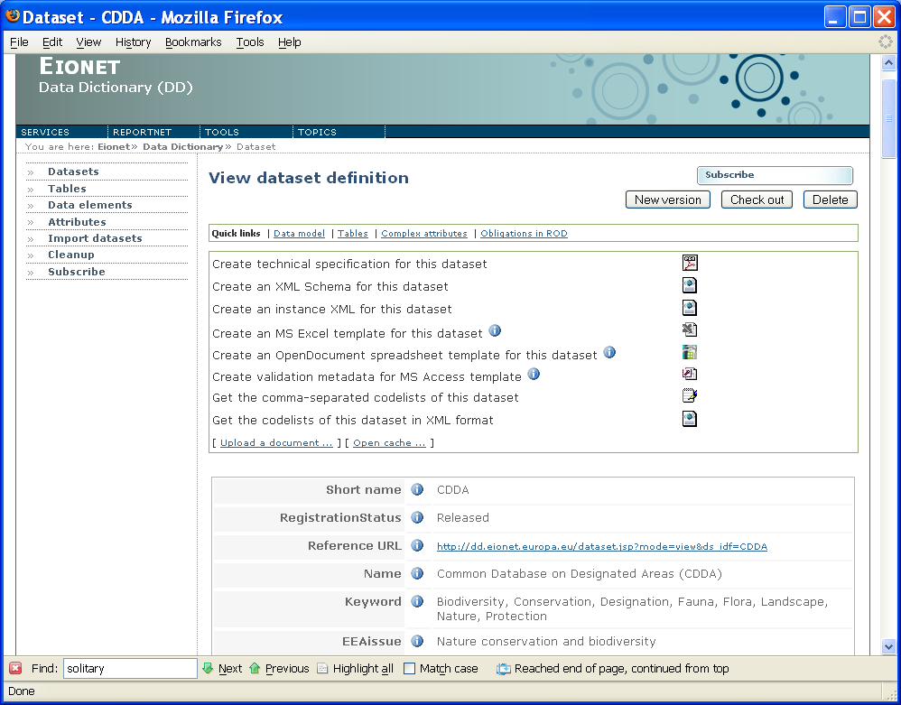Illustration 9: Dataset view page

Tables

Browse tables
Clicking on the Tables button on the left panel opens the list of tables from the latest versions of datasets in any status (Illustration 9). Tables from datasets not in Recorded or Released status are inaccessible for anonymous users!
All users can see 4 columns here. Full name indicates the table’s full name. Short name indicates the table’s short name. Dataset indicates the dataset where the table belongs to. Note that if a dataset name is marked by a red asterisk (*, displayed only for authenticated users), it means the dataset has been checked out by somebody and the Eionet user name of that somebody is displayed if you point the mouse over the asterisk. Dataset status indicates the Registration status of the dataset where the table belongs to. The different statuses are marked by certain icons. The status names are displayed when placing the mouse over those icons.
If you place the mouse over column header and the latter activates, it means the list is sortable by that column. Click the column header to perform the sorting.

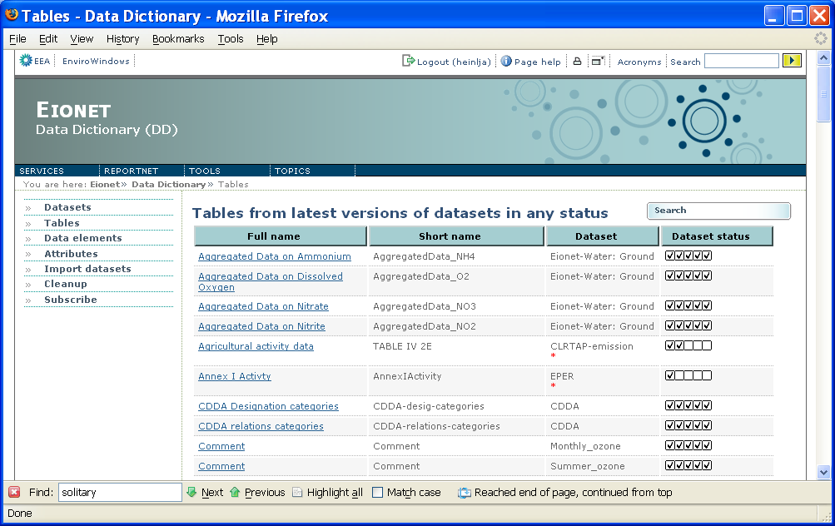Illustration 10: List of tables

Search tables
Table search page can be reached by clicking Search link in the tables list that was described above. It looks almost the same as the search page for datasets and follows the same rules too (see the relevant chapter above). Some notes though:
- In tables' case, searching for working copies means that you search for tables in dataset working copies.
- You cannot search for tables in historical dataset versions. And unlike the search page for datasets, the table search page does not have a link to adding new tables. Tables can only be added from dataset edit page and there’s more on that below.
The search result list looks and behaves exactly like the tables list described in the previous chapter.

Table view page
Table view page (Illustration 11) is divided into the following sections (which you can quickly access by using the quicklinks at the top of the page):
- Documents & templates available for this table.
- Simple attributes. Empty ones are not displayed. The Dataset attribute indicates the dataset this table belongs to. If this is a dataset working copy and it is your working copy, the dataset name is followed by premonitory text saying '(Working copy)'. If it is a dataset checked out by somebody, the premonitory text says '(checked out by username)'. The dataset name is clickable and leads to the dataset’s view page.
- Following the simple attributes is either a section titled Elements or a section titled Metadata elements or both. They both list the elements in this table. The former lists NON-GIS elements, the latter lists GIS elements (below chapters will tell you what is GIS and what is NON-GIS).
Each element is given by its short name, GIS type (only in the Metadata elements section, more details in chapters below), data type and element type. The latter can be either Quantitative or Fixed values.
Elements in a table can be common elements and non-common elements. The common ones are marked by C.
A non-common element in a table can also have foreign key relations to elements in other tables in this dataset. Such elements are marked by (FK).
- The last section is the one listing the table’s complex attributes. Empty ones are not displayed. Clicking the attribute’s title opens a more detailed view of that attribute.

If this is a table in your dataset working copy, the upper right corner of the page contains the following buttons:
- Edit leads to the edit page this table (more in chapters below).
- Delete deletes this table from this dataset working copy and redirects you to the view page of the dataset working copy.

The upper right corner of the page also has a Subscribe action link. This will subscribe you to any changes made to this table in its dataset’s any version. Eionet’s Unified Notification System (UNS) will send you notifications about those changes.
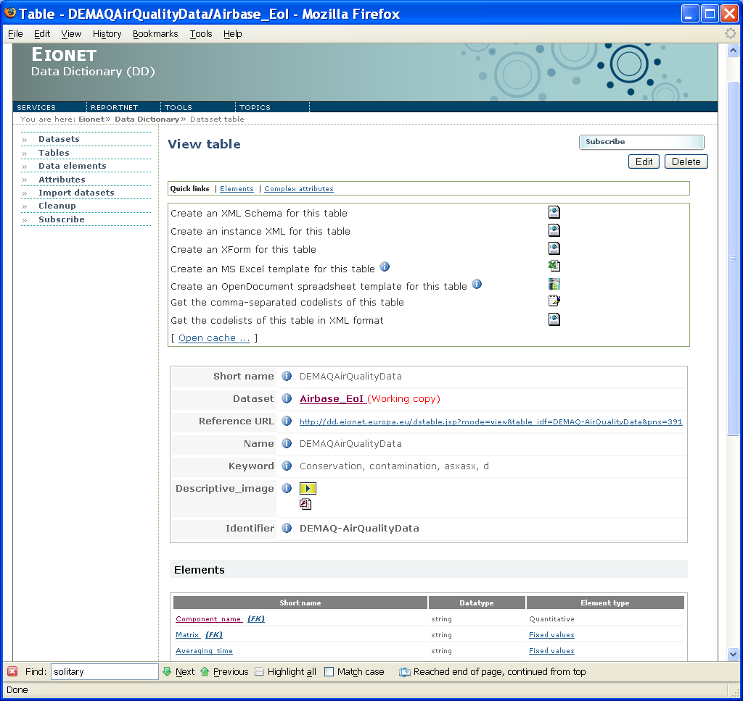Illustration 11: Table view page

Data elements

Search data elements
Data element search page (Illustration 12) is reachable by clicking Data elements on the left panel. It looks almost the same as the search page for datasets and follows the same rules too (see the relevant chapter above). The differences are:
- Data element search has 2 radio buttons for specifying if you want to search for common elements or non-common elements.
- If you selected to search for non-common elements, the page enables you to select the dataset you want to search from (top-most select-box) and disables the Working copies only check-box (displayed only if you have the required permissions) which is irrelevant for non-common elements.
- If you selected to search for common elements, the page disables the dataset select box and enables the Working copies only check-box. If you check the latter, search will be performed only among your working copies of common elements.
- Include historic versions check-box, if checked, searches in all versions of common elements or owner datasets of non-common elements, depending on which radio button you selected. If unchecked, only the latest versions are searched.
- New common elements action link in the upper right corner is displayed only if you have the required permissions and it leads you to the page where you can define a new common element. New non-common elements can only be added from the elements management page of a table in your dataset working copy.
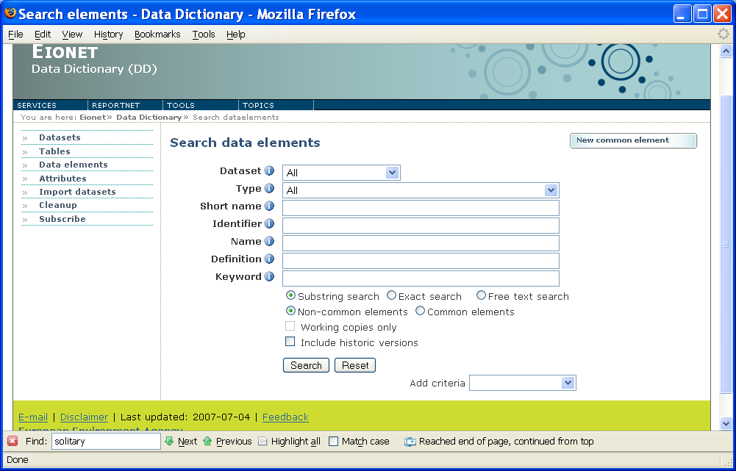Illustration 12: Data element search page

Data element search results
The look of the data element search result list depends on whether you searched for common or non-common elements and whether you wanted historic versions to be included too.

The list for non-common elements (Illustration 13) has at least 5 columns:
- Element contains the element’s short name, is clickable and the click leads to the element’s view page.
- Type indicates whether this is an element with fixed values or quantitative values.
- Table and Dataset columns indicate the table and dataset where the element belongs to.
- Dataset status indicates the Registration status of the dataset this element belongs to. See for more above on how different statuses are marked.
If you searched for historic versions too, there is also a 6th column: Dataset version, the name speaking for itself.
All mentioned columns are sortable. If an element’s dataset is checked out, the dataset is marked with red asterisk (*, displayed only for authenticated users). Pointing the mouse over the asterisk displays the user name of the person who checked out.

The list for common elements ( Illustration 14) has at least 3 columns:
- Element contains the element’s short name, is clickable and the click leads to the element’s view page.
- Type indicates whether this is an element with fixed values or quantitative values.
- Status indicates the element’s Registration status.
If you searched for historic versions too, there is also a 4th column: Version, indicating the element’s version.
All mentioned columns are sortable. If an element is checked out, it is marked with a red asterisk (*, displayed only for authenticated users). Pointing the mouse over the asterisk displays the user name of the person who checked out.

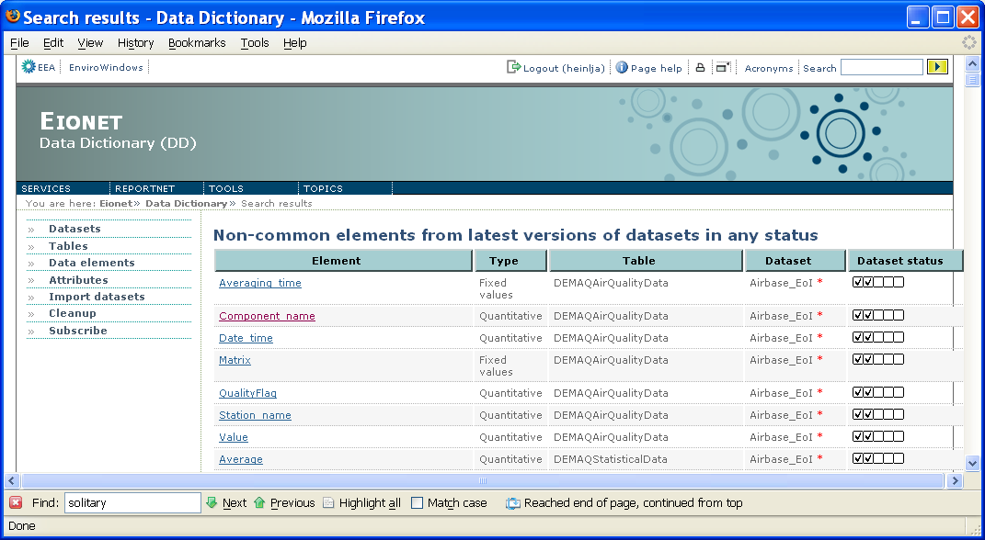Illustration 13: Search result list for non-common elements
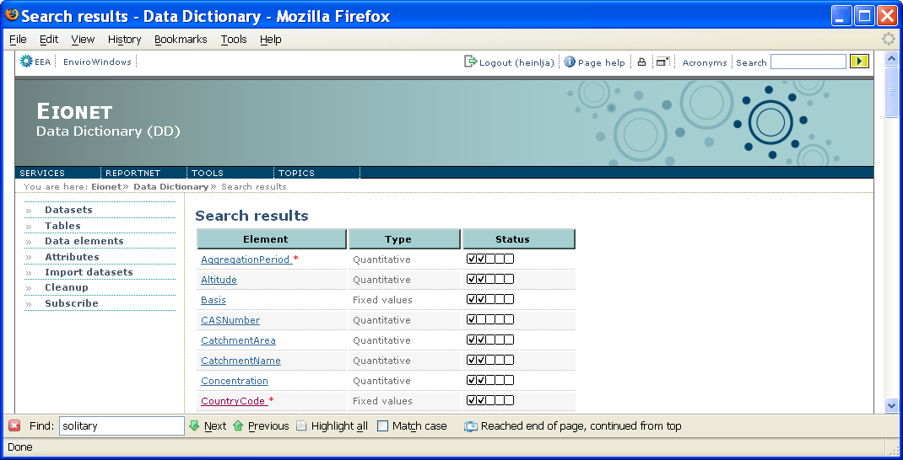Illustration 14: Search result list for common elements

Data element view page
Element view page (Illustration 15) is divided into sections which you can quickly access by using the quicklinks at the top of the page:
- Documents & templates available for this table.
- The element’s Type. This section simply states whether this is a data element with fixed values or a data element with quantitative values.
- Simple attributes. Empty ones are not displayed. If this is a non-common element, the list of attributes includes Dataset and Table, which indicate the table and dataset this element belongs to. If this elements belongs to a dataset working copy, the Dataset attribute is marked with premonitory text saying '(Working copy)'. If it is a dataset checked out by somebody, the premonitory text says '(checked out by username)'. Both Dataset and Table are clickable and lead to their view pages.
- Allowable values/Suggested values. Depending on the element’s type, this section lists either the element’s allowable values (element type is fixed values) or suggested values (element type is quantitative values) if any have been specified.
- Foreign key relations. This section is listed only if this a non-common element and it has relations to some other non-common elements in this dataset. The section lists precisely those relations. The 1st column contains the name of the related element (it is clickable and the click leads to the view page of that element). The 2nd column contains the name of the table where the related element resides.
- Tables using this common element. As the name suggests, this section is displayed only when this is a common element. It lists the tables that use this common element. Every table is given with its name (clickable and leads to the table’s view page), dataset name (also clickable and leads to the dataset’s view page) and the table’s owner given by user name.
- Complex attributes. Empty ones are not displayed. Clicking the attribute’s title opens a more detailed view of that attribute.
- Other versions. This section is listed for common elements only and it lists the common element’s other versions (given that there are any). Every version is uniquely identified by the element number in the left-most column. The list also indicates the version’s Registration status and the date it was released (relevant only when the Registration status is Released). The right-most column of this list provides the link to the view page of that version.
If you have authenticated yourself and this is a common element in a dataset working copy and it is your working copy then the upper right corner has the following buttons:
- Edit leads to the edit page this element.
- Delete deletes this element from this table in this dataset working copy and redirects you to the view page this table.
If this is a common element and you have the required permissions, the upper right corner of the page may contain the following buttons:
- New version will create a new version of this element. You will be instantly led to the view page of that new version where you can start editing it. It will be a working copy until you check it in.
- Check out will do the same as New version, the only difference is that the working copy will not become a new version when checked in. Instead, it will simply overwrite the current element copy.
- Delete deletes this element copy. This does not mean that if you are viewing a CountryCode common element and you press Delete, then all versions of CountryCode common element will be deleted. Only the version you are viewing will be deleted!

For common elements only, the upper right corner also has these action links:
- Go to newest leads you the view page of the newest version of this element. Seeing this action link indicates that you are viewing an historic version of this element.
- Subscribe will subscribe you to any changes made to any version of this element. Eionet’s Unified Notification System (UNS) will send you notifications about those changes.

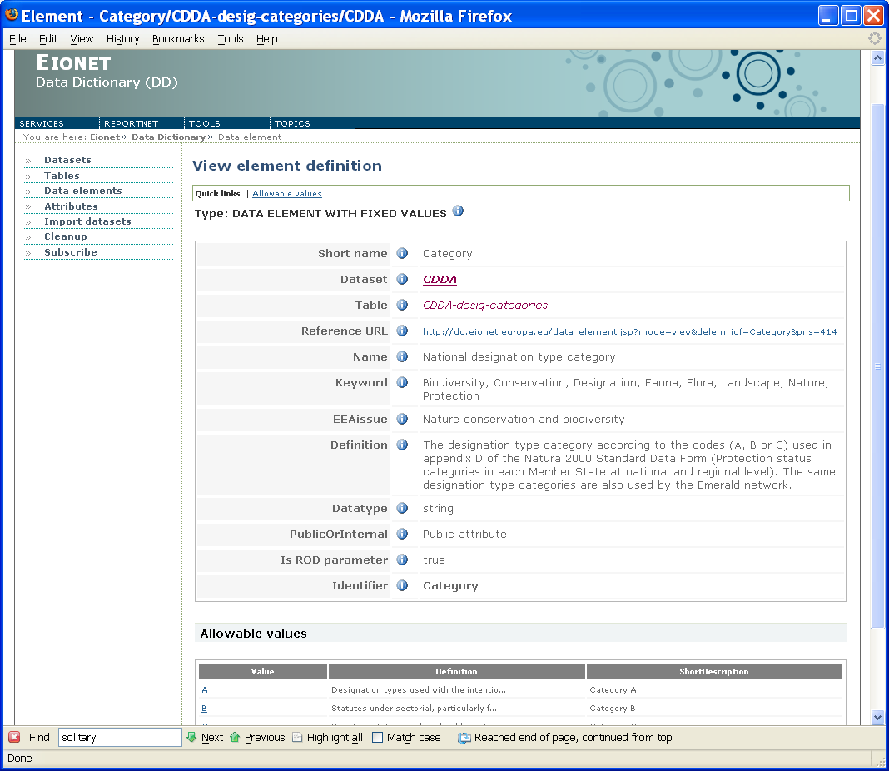Illustration 15: Data element view page

GIS tables and elements
Some of the tables defined in DD might contain GIS (Geographic Information System) data. In DD terms, data elements (i.e. table columns) containing such data are called GIS elements. Tables containing such elements are called GIS tables.
You can distinguish GIS elements in DD by the value of the GIS attribute. If such an attribute is missing from the element’s view page then it means that the element is not a GIS element. Otherwise the GIS attributecan have one of the following values, called the GIS types:
- [blank]
- class
- subclass
- subtype
Users with required permissions can assign these values when working with the element in edit mode (see chapters below).
The moment an element in a table is defined as a GIS element, is the moment the table becomes a GIS table and it’s view page becomes slightly different from that of non-GIS tables. More precisely (and as also mentioned above), the list of elements becomes split into 2: one for the so called non-GIS elements and one for the GIS elements. The former is titled Elements, the latter is titled Metadata elements (Illustration 16) where the GIS type is reflected in the GIS type column.

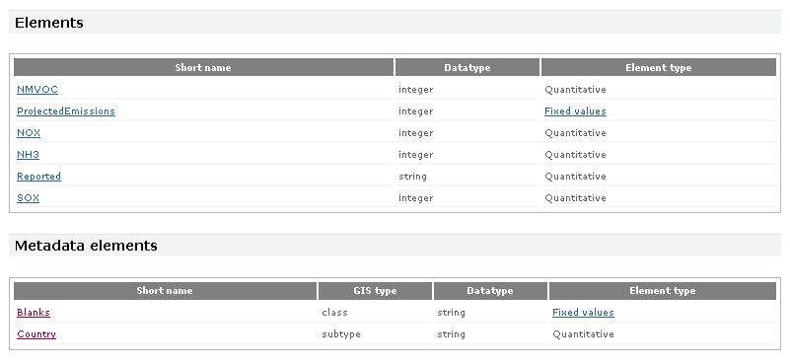Illustration 16: Elements of a GIS table

Schema sets and schemas
Data Dictionary schemas area is the official place where to store XML Schemas developed for different reporting obligations at EEA. Schemas that logically belong together, can be collected into a schema set. For example a schema set can represent a reporting obligation, and bring together all schemas relevant to that particular obligation.
There can also be schemas, that don't belong into any specific set. These could be, for example, schemas that are used across many sets, and they are called root-level schemas. Example: http://dd.eionet.europa.eu/schemas/countryCodes.xsd.
So, just like datasets are collections of tables, so are schema sets collections of schemas. And root-level schemas are little bit like common data elements.

Browse schema sets
Schemas can be accessed by clicking Schemas link in the left side menu. The page contains the list of schema sets in alphabetical order. The schema sets are divided into two blocks. The first list contains active schema sets and deprecated schema sets are displayed in the lower part of the page. Click on the schema set name to browse the contents of schema set. Operations menu in the right corner provides searching functionality.
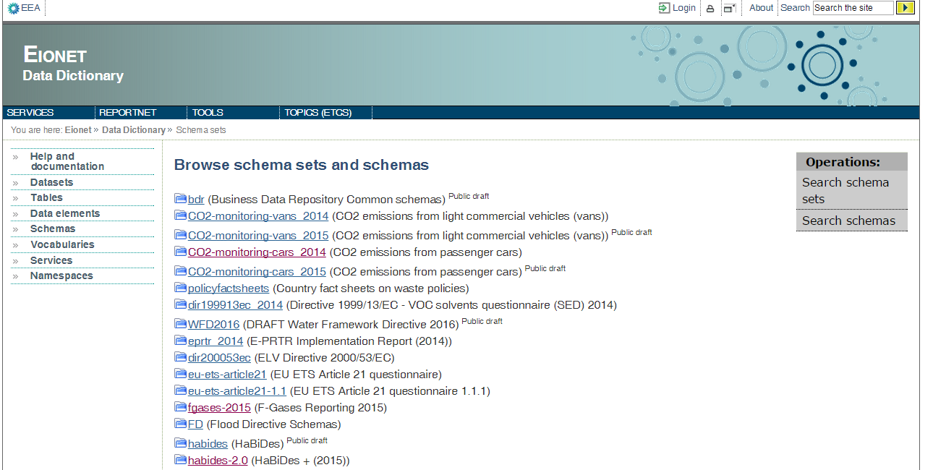Illustration 17: Browse schema sets

Search schema sets and schemas
It is possible to search for schemas schema sets when you click on relevant link in Operations menu in the upper right corner. The schema search can be performed by schema file name, schema set identifier, schema name or definition. The schema set can be searched by identifier, name or definition. The action performs case insensitive substring search and the query parameters are separated with the logical AND operator.
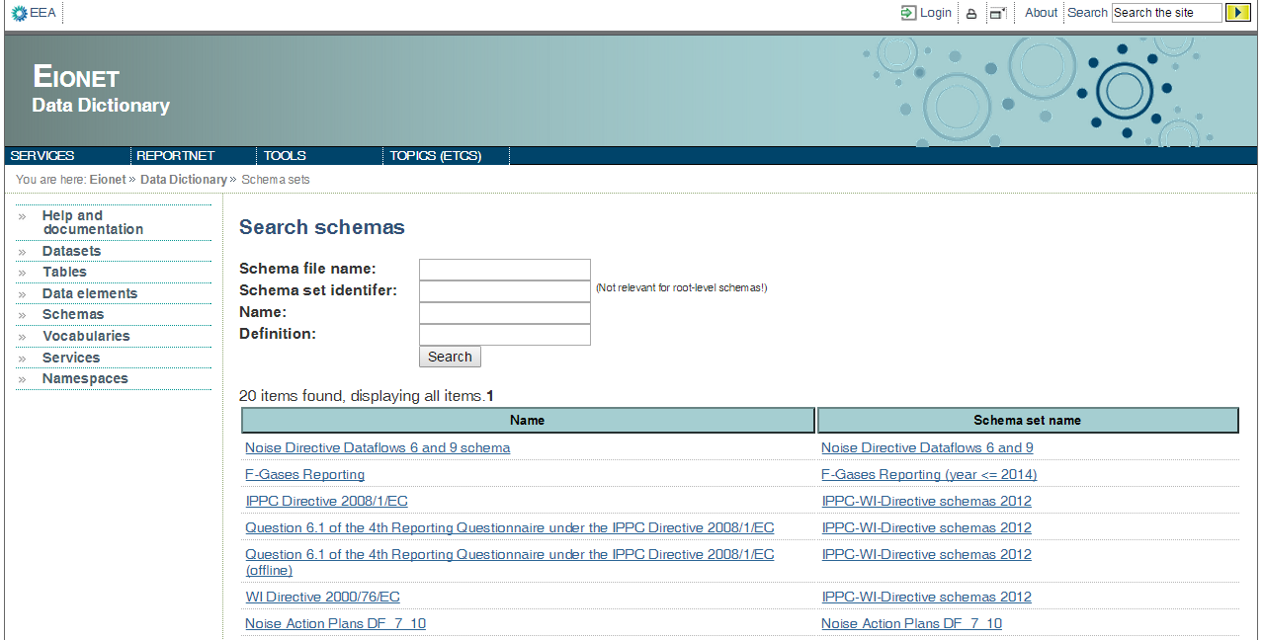Illustration 18: Search schemas

View schema set contents
Click on the schema set name in the list of schema set page to see the contents of the set. The schema set page displays the metadata about schema set:
Identifier – unique identifier of the schema set (part of the schema URL)
- Registration status - draft, public draft, released, deprecated
- Status changed – the date when the registration status was last changed
- Name – name of the schema set
Schemas and documents area can contain one or multiple XML schemas or supporting documents. Click on the file name to see the metadata of the file and to be able to download the file contents.
Most of the schema sets are related to reporting obligation. The reporting obligation information is stored in complex attributes area. CDR uses the ROD property to query all released (or public draft) schemas for a given obligation.
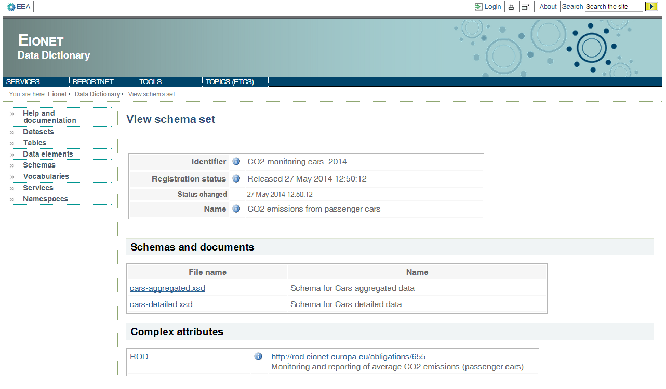Illustration 19: View schema set contents

Vocabularies
Vocabularies hold relational data. Hierarchical structure of vocabularies are as follows:
Vocabulary Set > Vocabulary > Vocabulary Concept(s) > Data element(s)/Attribute(s)
One vocabulary set usually has more than one vocabulary. It is used in a way of logical grouping. A vocabulary may have more than one concept. Vocabulary plays a role to define and encapsulate its concepts. Concepts are data definitions of the vocabulary. Concepts may be related to each other (whether in same vocabulary or not) with some attributes. So this is basically linking data to each other. Concepts may have reference attributes or data attributes. Reference attributes (or data elements) are used to relate/reference concept to another concept either in Data Dictionary or not. Data attributes are used store data of concept.

Browse Vocabularies
Browsing vocabulary on data dictionary is simple. From left menu, go to link “Vocabularies”, and data dictionary will redirect you browse vocabularies page where you can see list of vocabulary sets. See Browse Vocabularies Page

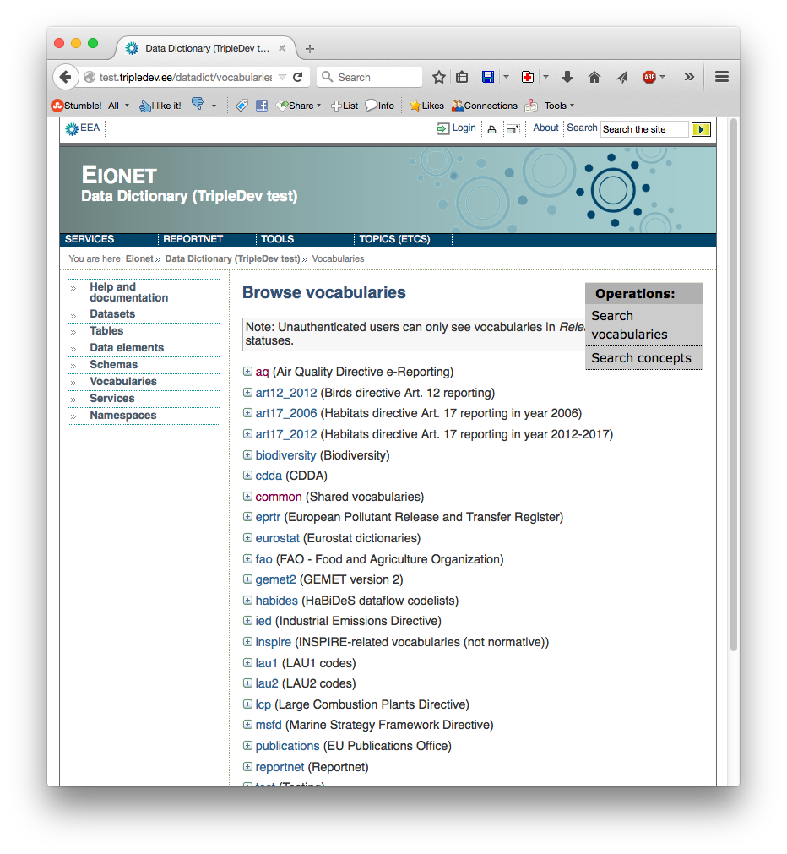Illustration 20: Browse Vocabularies Page
You can go to a vocabulary by expanding a vocabulary set and then clicking vocabulary item, or use search functionality from upper right corner dropdown-menu.
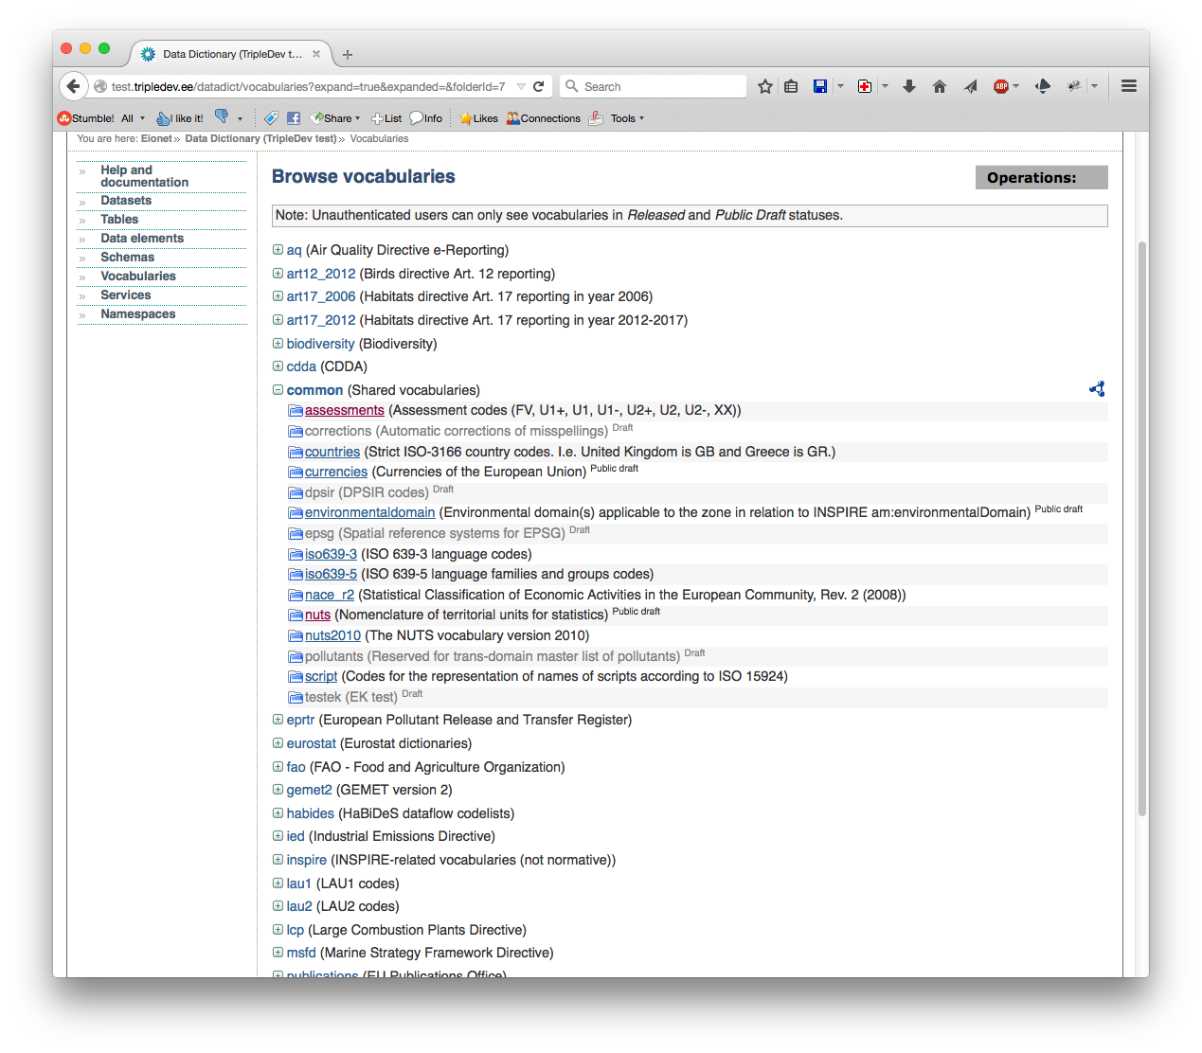Illustration 21: Vocabulary Set Expanded
When a vocabulary set is expanded, user can click a vocabulary to browse it. At the end of same line with expanded vocabulary set, an RDF icon can be seen. It is used to export all vocabularies in the set to RDF format. Draft vocabularies are disabled for unauthorized users.

Search Vocabularies and Concepts
To search vocabularies, upper right dropdown menu is used. You can hover mouse over “Operations” and it will display you available operations.
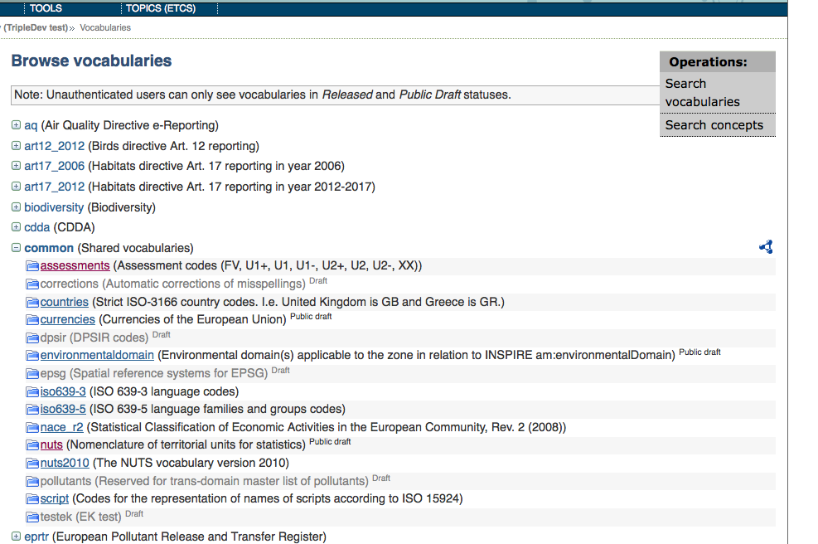Illustration 22: Browse Vocabularies Page Operations
When you click on search vocabularies a dialog will be displayed. In this dialog you can search a vocabulary, or a concept or vocabulary and concept together. When search is performed list of vocabularies found displayed to user. By clicking links, you can go to vocabulary.
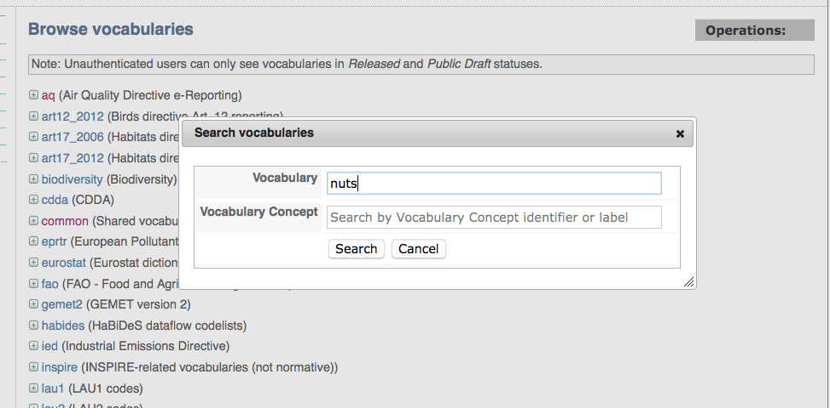Illustration 23: Vocabulary Search
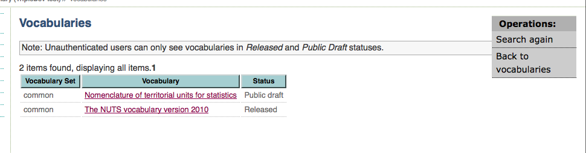Illustration 24: Vocabulary Search Results
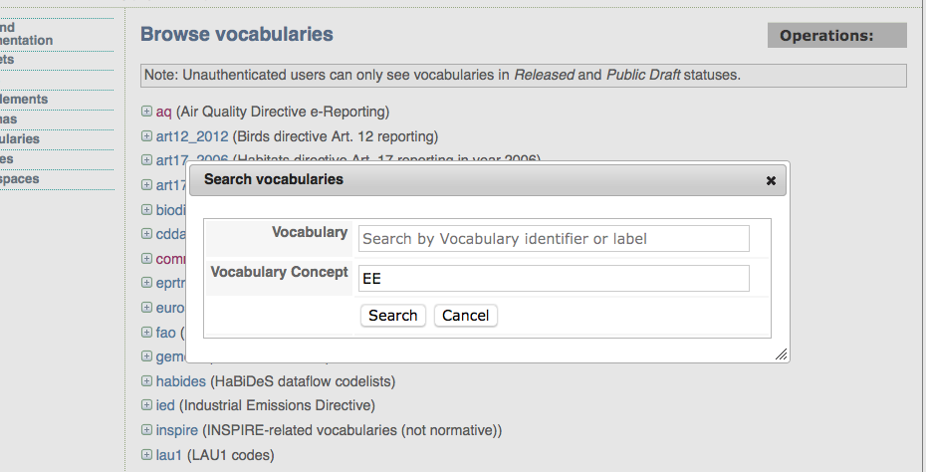Illustration 25: Vocabulary Search by Concept

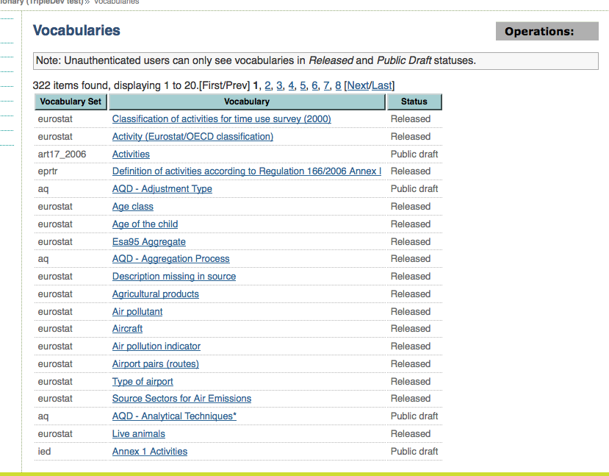Illustration 26: Found Vocabularies by Concept
Similar to vocabulary search, concept search can be queried using “Search concepts” from upper right “Operations” menu. This will perform a search on all concepts and will display found concepts as a result. Then you can click a concept link to see fact sheet of concept (encapsulating vocabulary has also link).
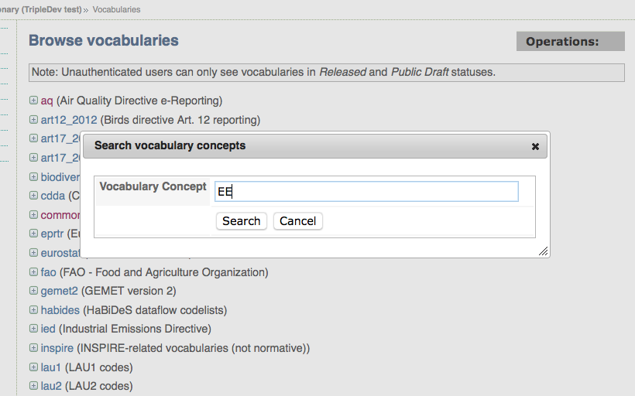Illustration 27: Browse Vocabularies Page Concept Search
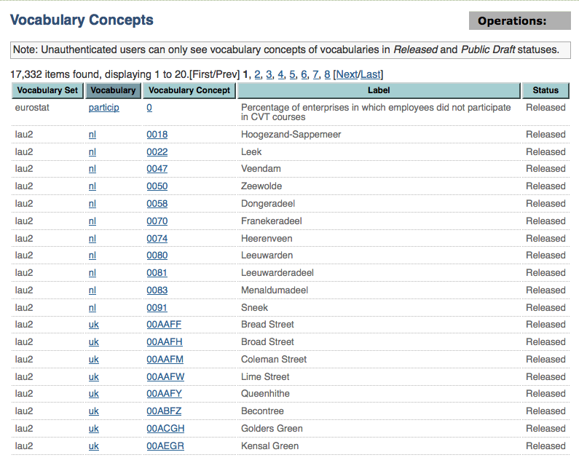Illustration 28: Vocabulary Concept Search Results

Browse Vocabulary
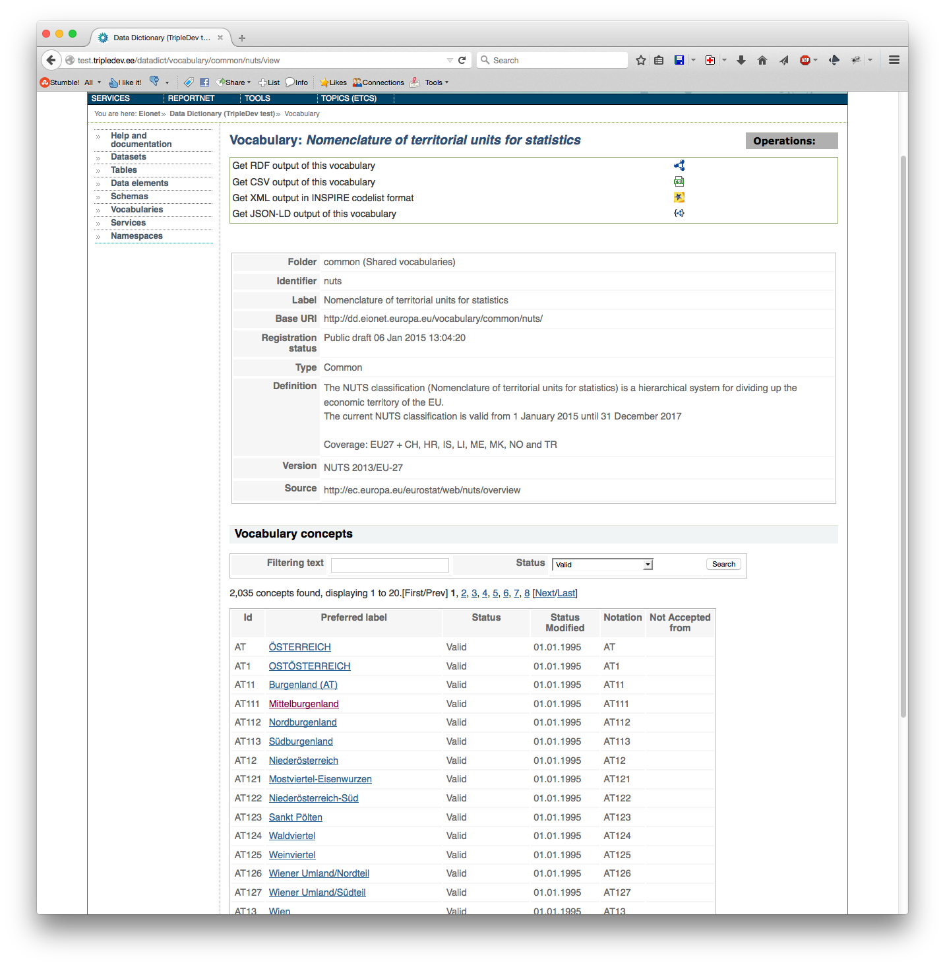Illustration 29: Vocabulary Browse Page
When a vocabulary link is clicked (either from browse vocabularies or search results), vocabulary browse page is displayed (See: Vocabulary Browse Page). This page has vocabulary definition data and defined concepts. Concepts are shown in table in which 20 items are shown at a time. User can search concepts using a free text search and/or filtering status dropdown menu.
Vocabularies are available to download/export in some formats. Exporting is used when migrating data from one system to another or when supplying data to other systems, or basically display data in tabular format. Available export formats are: RDF, CSV, Inspire XML and JSON-LD. CSV and RDF exported files can be re-imported to vocabulary by authenticated users (See section?)

Vocabulary Concept View Page
When a concept link is clicked (either from vocabulary browse page or search result), vocabulary concept view page (i.e. concept fact sheet) is displayed (See: Concept View Page). On this page, a brief information can be found about concept and its relations.

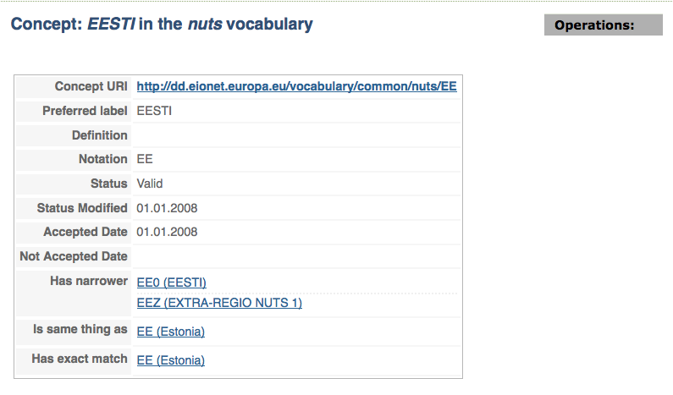Illustration 30: Concept View Page

Vocabulary Export Formats
A vocabulary can be exported in several formats by clicking an icon next to the format description in the Vocabulary page:

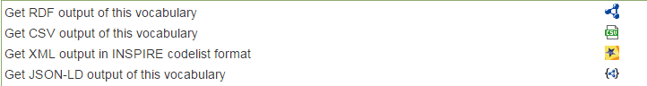
Illustration 31: Vocabulary export formats

RDF
RDF is a standard model for data interchange on the Web. See more at: http://www.w3.org/RDF/

Illustration 32: RDF Export Example

CSV
Comma Separated Values. Values are separated by comma and surrounded by quatation marks
"URI","Label","Definition","Notation","Status","AcceptedDate"
"http://dd.eionet.europa.eu/vocabulary/art17_2012/methods_threats/2","modelling","","2","Valid","2013-03-22"
"http://dd.eionet.europa.eu/vocabulary/art17_2012/methods_threats/1","expert opinion","","1","Valid","2013-03-22"
Illustration 33: CSV Export Example

INSPIRE
INSPIRE is a EU Directive which aim is to create European Union Spatial data infrastructure. It has its own xml format for exchaning data. See more at: http://inspire.ec.europa.eu/
Illustration 34: INSPIRE format Example

JSON
JSON (JavaScript Object Notation) is a format for transmitting data objects between web servers and applications. http://en.wikipedia.org/wiki/JSON

{
"@context" : {
"@base" : "http://dd.eionet.europa.eu/vocabulary/art17_2012/assessments/",
"skos" : "http://www.w3.org/2004/02/skos/core#",
"concepts" : "skos:Concept",
"prefLabel" : "skos:prefLabel",
"broader" : "skos:broader",
"narrower" : "skos:narrower",
"@language" : "en"
},
"concepts" : [ {
"@id" : "FV",
"@type" : "skos:Concept",
"prefLabel" : [ {
"@value" : "Favourable",
"@language" : "en"
} ]
}, {
"@id" : "U1",
"@type" : "skos:Concept",
"prefLabel" : [ {
"@value" : "Inadequate",
"@language" : "en"
} ]
}, {
"@id" : "U2",
"@type" : "skos:Concept",
"prefLabel" : [ {
"@value" : "Bad",
"@language" : "en"
} ]
}, {
"@id" : "XX",
"@type" : "skos:Concept",
"prefLabel" : [ {
"@value" : "Unknown",
"@language" : "en"
} ]
} ]
}

Illustration 35: JSON Export Example

CDDA dataflow site code service
CDDA dataflow site code service is available in Services area accessible from the left side menu. Site code is a unique identifier of site records in the Common database of designated areas (CDDA) which is annually updated in one of the EEA's priority dataflows. Appointed Reportnet users, which are all Eionet NFPs and NRCs for Biodiversity data and information, can reserve a set of new site codes for their new sites after logging into the service. The process is called allocation of site codes. The exact guidance of how to allocate site codes can be found in a dedicated user guide.
All users can see the allocated site codes and their statuses.
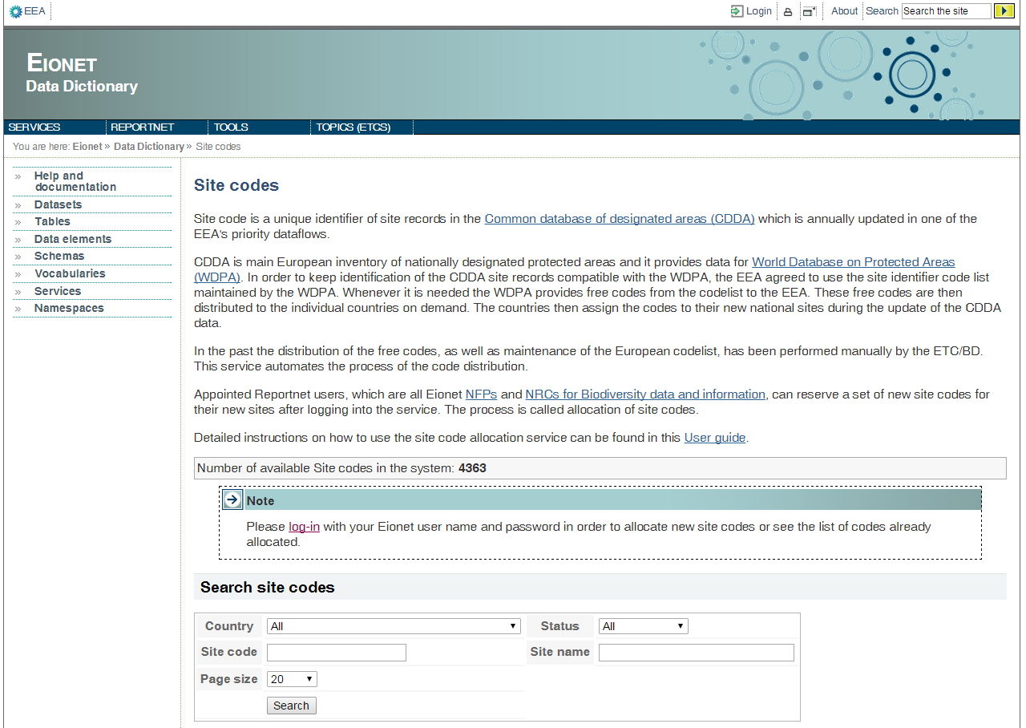Illustration 36: CDDA site code allocation service

Data definers & administrators functionality
As it was mentioned above, these are functions enabling to add, edit and delete DD content. They can only be enabled for users who have identified themselves by logging. DD checks which operations on which content are permitted for the identified user and renders the user interface pages accordingly. Permissions are controlled by DD administrators.
Login can be done either by pressing the relevant button on the left pane or using the login section on the opening page. The latter, however, is empty if the DD has been configured to use Central Authentication Service (CAS, http://www.ja-sig.org/products/cas/).

Simultaneous editing- checking in & checking out
Before we can proceed to editing the DD content, there are some things essential to know beforehand.
It is natural that two users might want to edit the definition of the same dataset or common element simultaneously at one time. That might cause a lot of confusion and in order to prevent it, counter-measures have been taken in DD.
If a user wants to edit an existing or add a new dataset or common element, then that object will be locked and others cannot edit it. In DD terms it is also called checking out. Once an object is checked out (= locked for editing), a working copy of that object is created and that’s what the user will be working with. User in such a stage is also called the working user. During that time no other user can edit the checked-out (locked) object, nor can they see any of the changes that the working user is doing to the working copy.
Once the working user is done with edits and the object is ready to be released and published for others, he/she will check in the working copy. As a result, the object will be unlocked and the changes will become visible for other users as well. The object is ready for others to edit.
Changes to a working copy can also be cancelled, by performing undo checkout (= Undo changes & Unlock). In that case the working copy will simply deleted, all changes made to it will be lost, the object becomes unlocked and remains exactly as it was before checkout.
You cannot check out a table or non-common element. If you want to change a table or non-common element, you must check out the dataset they're in. That’s because a dataset is made up of tables and non-common elements. So changing any one of them means you're changing the whole dataset.

Versioning details
As it was told above, DD keeps history of released definitions of datasets and common elements. Versions of released datasets and common elements are created as follows.
A released dataset or common element always has a New version button on its view page. Pressing the button will clone the dataset or common element and the clone will become a working copy. The Registration status of the latter will be set to Incomplete. If you change the registration status back to Released and check in the working copy, the clone will instantly become released, ie it will become a new released version. The one that you cloned remains untouched, because DD prevents from editing a released copy (naturally because some data suppliers somewhere might already be counting on it), unless you have been granted the permission to modify released datasets or common elements.
On the view pages of datasets and common elements whose Registration status is not Released, the New version button is never displayed! Instead, you will see the Check out button which creates a working copy just like it was in the case of New version. But the difference is that when that working copy is checked in, it overwrites the copy that you checked out.
Those who can modify released datasets and common elements, will see both the New version and Check out button on the view page.
Notice that the working copy created with New version does not necessarily have to be checked in with the Released status. In that case the new version will simply not be released, it’s Registration status will be whatever else you chose. So as you can see, the status of the latest version can actually be something else than Released. So this is an exception to the above-mentioned rule that only released definitions are versioned. An exception-less formulation of that rule would be: all non-latest versions always have the Released status.
NB! New version can only be created from the latest released version! In other words the new New version button is only displayed on the view pages of latest released versions!

Datasets

Add a new dataset
Dataset adding page (Illustration 37) can be reached from 2 places- clicking Add dataset on the dataset search page or clicking Add new on the datasets search results page or the datasets list that is displayed when you click Dataset on the left panel.
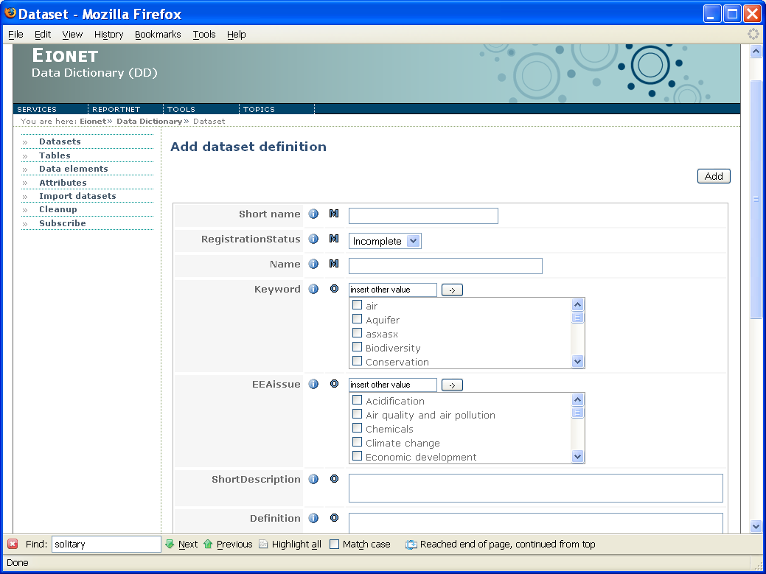Illustration 37: Dataset adding page
The page lists the dataset’s simple attributes whose values you can specify. Every simple attribute is a name/value pair. Some simple attributes can have several values at the same time. Possible values are listed and provided with check boxes enabling you to mark your selection. Currently selected values are checked. A text box with pre-set value 'insert other value' enables to insert a value not listed.
Mandatory attributes are marked with M, optional ones with O. Conditional ones marked with C are rare.
Information about every attribute is available by clicking the relevant icon next to it.
The dataset adding page enables you to specify no more than simple attributes of the dataset. The rest of things that a dataset definition consists of, you can specify once you've clicked the Add button. That will create the dataset working copy in the DD database and lead you to its view page.

Edit a dataset working copy
The edit page of a dataset working copy (Illustration 38) is the one you reach when you click Add on the dataset adding page or click Edit on the working copy’s view page.
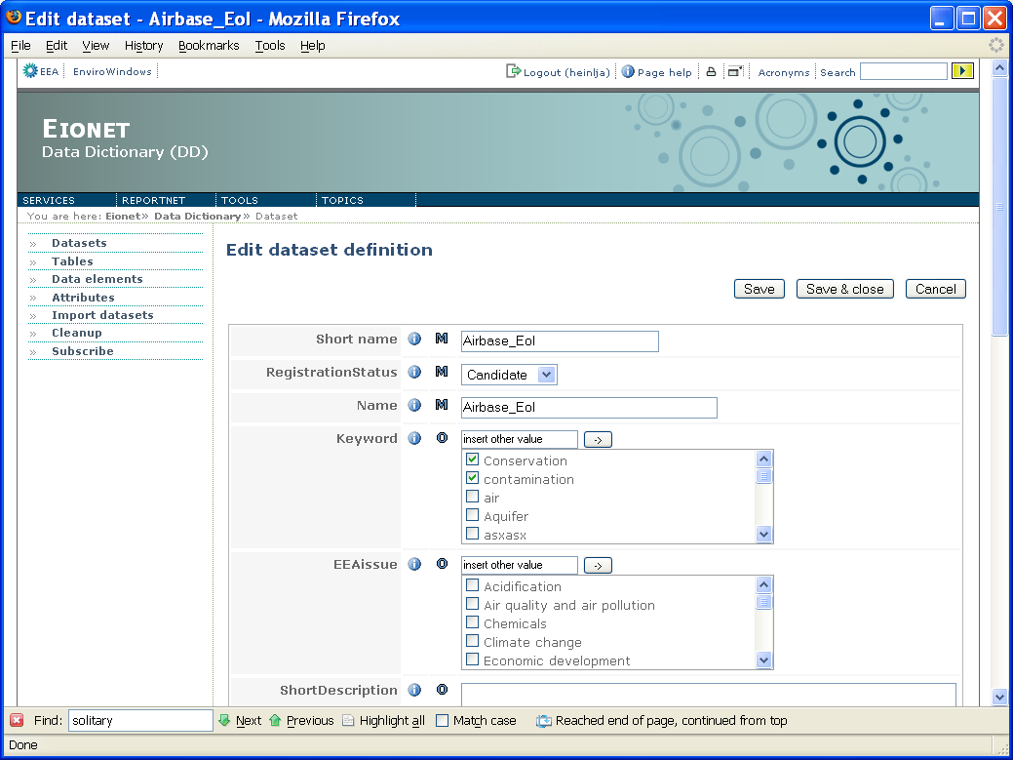Illustration 38: Dataset edit page
Your working copy and its changes will not be seen by anybody else until you check it in. This you can do by going back to working copy’s view page and using buttons there.
The upper right corner of this page contains the following buttons:
- Save saves whatever you have entered into the inputs on this page. They will be saved to this working copy. They will not be seen by anybody until the working copy is checked in.
- Save & close does the same as Save, but it also leads you back to the view page of this working copy. There you will be able to check in whatever you saved.
- Cancel leads you to the view page of this working copy, without saving anything you entered into the inputs.
Below these buttons, the page is divided into the following sections.
Simple attributes. Some simple attributes can have several values at the same time. Possible values are listed and provided with check boxes enabling you to mark your selection. Currently selected values are checked. A text box with pre-set value 'insert other value' enables to insert a value not listed.
Mandatory attributes are marked with M, optional ones with O, conditional ones with C. Information about every attribute is available by clicking the relevant icon next to it.
Following the simple attributes is the section that lists the links to other editable parts of this dataset working copy:
- Data model leads you to the page where you can provide a visual data model to this dataset.
- Dataset tables is probably the most important link as it leads you to the page where you can manage the tables in this dataset.
- Obligations in ROD leads you to the page where you can manage the links that this dataset has to ROD (Reporting Obligations Database).
- Complex attributes is also quite an important link, because it leads you to the page where you can edit the complex attributes of this dataset. Some of them may be mandatory to specify!

Delete a dataset version
There are two ways to delete a dataset version:
- Go to the dataset view page and click the Delete button. The latter is only displayed if the version is the latest (ie you cannot delete an old version). If the version’s Registration status is Released (remember that the status of a latest version can be something else than Released), the Delete button is only displayed if you have the powerful “edit released” permission.
- Select the dataset with the help of checkbox and Delete selected button in the datasets list that opens from the Datasets button on the left panel or is returned as a search result list. The checkbox and the button are displayed only if it’s the dataset’s latest version and the Registration status is not Released (the latter condition does not apply if you have the “edit released” permission).
So as you can see, to delete all versions of a dataset, you must delete them one-by-one.
NB! DD does not allow to delete a version that has been checked out by somebody (that somebody must have clicked New version or Check out on that version).
NB! A working copy is deleted by clicking the Undo checkout button on the copy’s view page.

Working with a dataset’s tables
To work with a dataset’s tables, the dataset must be checked out. On the view page of the working copy, click Edit to open the working copy’s edit page. On the latter, there’s a link saying “[Click HERE to manage tables of this dataset]”. This will open the page enabling to work with the tables in this dataset working copy (Illustration 39).
The page lists the tables in 3 columns: Name, Short name and Definition. Every row has a checkbox, enabling you to select the tables you want to delete. Click Remove selected to delete them.
Add new is the button that leads to the page where you can add a new table to this dataset working copy.
If you see no tables in this list, it means the dataset has no tables.

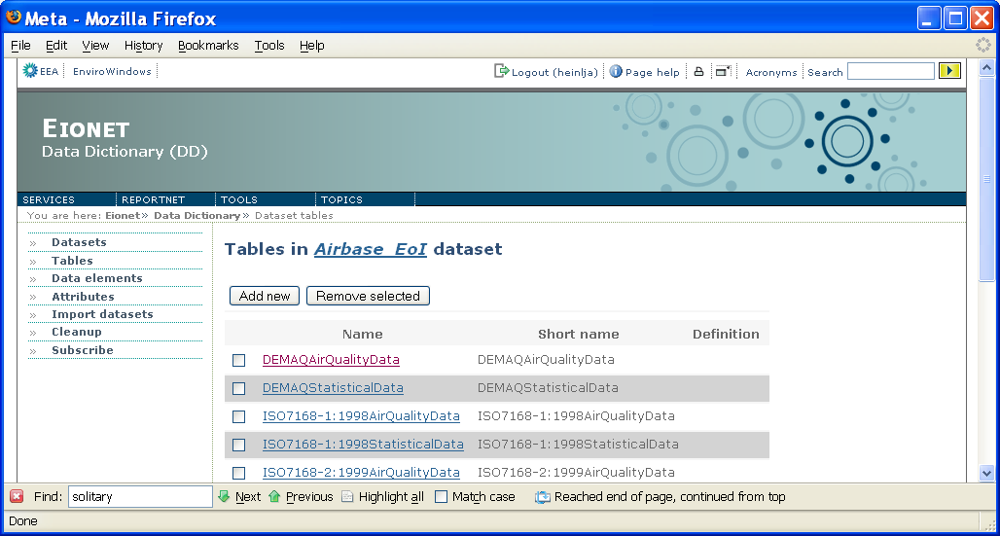Illustration 39: Working with a dataset’s tables

Dataset models
As mentioned above, the edit page of a dataset working copy has a link to the page where you can set the dataset’s data model (Illustration 40).
The role of the data model is to visually describe the dataset structure (down to the level of elements if needed) in a modelling language. For now, models can be attached to datasets only as simple image files. DD recognizes 3 image types- JPG, GIF and PNG. So in order to provide a dataset definition with a data model, you should first draw the model with your modelling tool and then save it as an image file of one of those 3 types.
As you can see from the illustration, the data model is divided into 2 tabs: simple and detailed. On the former you can set the dataset’s simple model, while as on the latter you can set the dataset’s detailed model. A simple model should describe the dataset structure no deeper than the level of tables. A detailed model can also contain the structure down to the very level of elements in tables. The 2 tabs are identical in functionality, only the model picture is different. If there is no model specified yet, there is no picture displayed.
To add a model, specify the image file location either on your local file system (select the 1st radio button and use the Browse button to locate the file) or in the web (select the 2nd radio button and type the URL). And then press Upload. As a result, the image is downloaded from given location, stored in the DD file system and displayed on this same page. The Remove button obviously removes the current model.
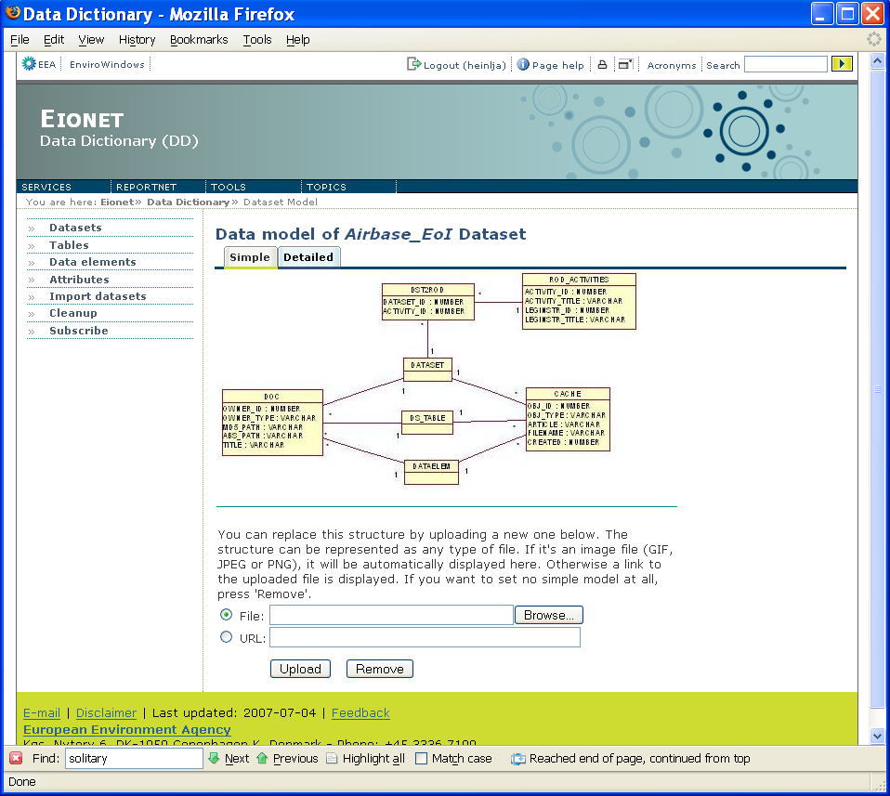
Illustration 40: Dataset model page

Uploading documents for a dataset
For every dataset definition a data definer can upload documents (or actually any files for that matter) that the users can download as additional information about the dataset. This can be done by pressing the [ Upload a document ... ] link in the dataset view page. The dataset does not have to be checked out for this. The link is displayed both on the pages of the dataset and its working copy and it opens a page (Illustration 41) where one can do the upload.
Using the Browse button, one must select the file to upload. As an option, in the Title box one can specify the title that DD will display for the uploaded file. If the title box is left empty, DD will use the uploaded file’s name as the title.
Pressing Upload will upload the selected file into DD. Pressing Clear will clear the inputs. The uploaded document will appear as a downloadable in the upper section of the dataset view page. For data definers the downloadables in that section are featured with a delete icon (a red cross) enabling to delete the downloadable.
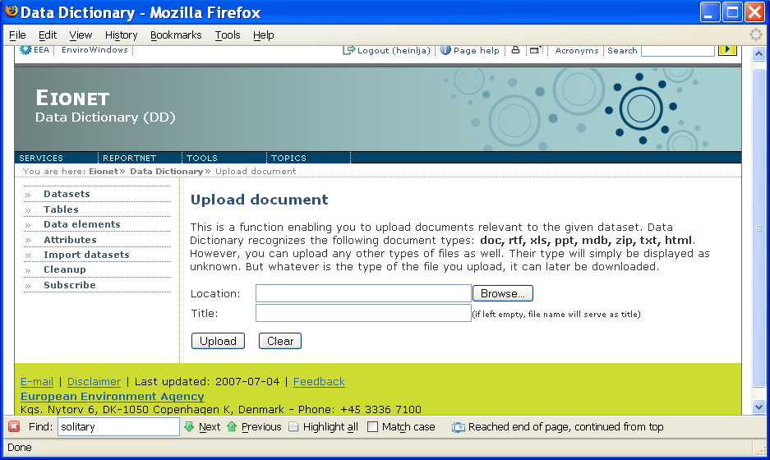Illustration 41: Document upload view

Dataset links to ROD
The list of reporting obligations corresponding to a dataset can be managed by clicking the relevant link in the bottom part of the edit page of the dataset’s working copy. It will open a page like the on Illustration 42. The view lists the already specified obligations and enables to add more by clicking the Add new button. A click on this button connects on line and on the fly to ROD and returns the list of all obligations defined in there. In that list you can select obligations by clicking their titles. To remove existing links, use the Remove selected button and the checkboxes for selection.
Once you've managed editing links on this page, you must return to the dataset definition’s edit view and click Check in to submit your changes.
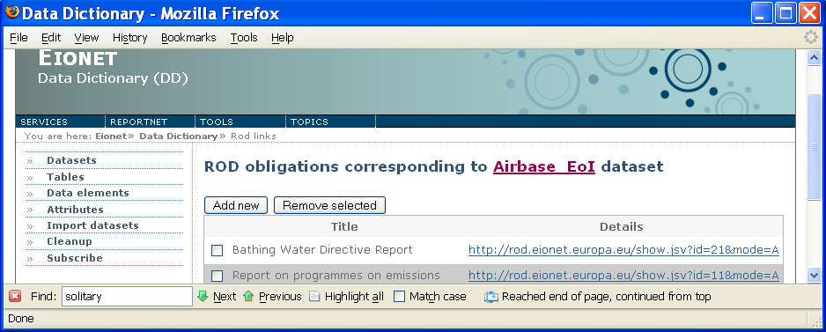Illustration 42: Working with dataset links to ROD

Restoring non-permanently deleted dataset definitions
In the above chapters it was described how to delete a dataset definition. Whenever you do that, DD asks if you want to delete the definition permanently. If you choose no, DD will keep the definition for later restoration if needed. The list of restorable dataset definitions (Illustration 43) can be reached by clicking the Restore link in the datasets list that opens from the Datasets button on the left panel or is returned as a search result list. You can restore the desired definitions by checking the relevant checkboxes and clicking Restore selected. The Delete selected will delete selected definitions permanently.
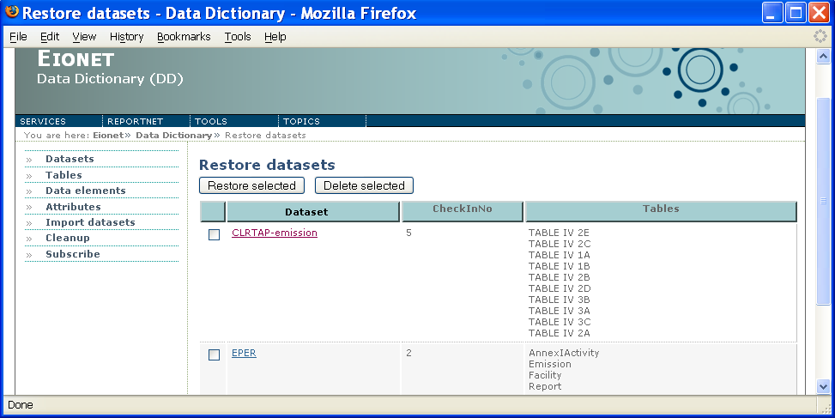Illustration 43: Restoring dataset definitions

Table definitions

Add a new table
To add a new table to a dataset, you must have the dataset checked out. Open the working copy in Edit mode. The latter contains a link that leads you the page where you can work with the dataset’s tables (see relevant chapter above). On that you page click the Add new button. It will lead you to the page (Illustration 44) where you can set the new table’s simple attributes.
The upper right section of the page contains the following buttons:
- Add creates the new table with the values you enter into the form below it. It will lead you to the edit page of that new table where you can edit the rest of the table’s definition.
- Copy enables you to create a new table by copying the basic attributes and non-common elements from another, already existing table. It will open a page where you can search for the table you want to copy. Once you've clicked the desired table in the search results, DD will create a new table where everything but the attributes that you specified before pressing Copy have been taken from the table you copied. You will then be led to the edit page of that newly created table where you can edit the rest of its definition.
Please note that both Add and Copy buttons require you to specify the mandatory attributes marked with M. Inputs on this page represent the simple attributes. Some simple attributes can have several values at the same time. Possible values are listed and provided with check boxes enabling you to mark your selection. Currently selected values are checked. A text box with pre-set value 'insert other value' enables to insert a value not listed.
The Dataset attribute indicates the dataset working copy this table belongs to. It is clickable and leads to the dataset working copy’s view page.
Once you've entered the data, you are ready to press either Add or Copy.

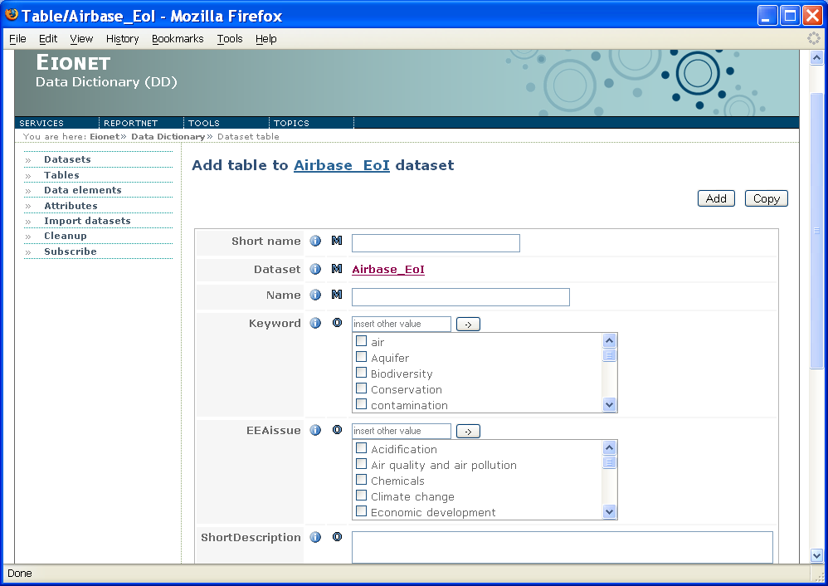Illustration 44: Table adding page

Copy another table
Sometimes you might want to define a new table with exactly the same attributes and/or structure (i.e. set of elements) as another table in another dataset and change it only a little bit. For that purpose DD enables you to copy another table when you start adding a new table to a dataset. This can be done with the help of Copy button on the table adding page and it was described in more detail in the previous chapter.

Edit a table
To edit a table definition in a dataset, the dataset must be first checked out. On the view page of the dataset working copy, you simply click the table you want to edit and you will be led to the table’s view page. Since this is a dataset working copy, you will notice the premonition text saying '(Working copy)' on that page. You will also notice the Edit and Delete buttons. Pressing the Edit will open the table’s edit page (Illustration 45).
The upper right section of that page contains the following buttons:
- Save saves whatever you have entered into the inputs on this page. But they will not be seen by anybody else, until you check in the dataset working copy where this table belongs to.
- Save & close does the same as Save, but it also leads you back to the view page of this table.
- Cancel leads you to the view page of this table, without saving anything you entered into the inputs.
Below the buttons, the page lists the table’s simple attributes. Some simple attributes can have several values at the same time. Possible values are listed and provided with check boxes enabling you to mark your selection. Currently selected values are checked. A text box with pre-set value 'insert other value' enables to insert a value not listed.
NB! Some attributes you might see as uneditable. This means that they have been inherited from dataset level. More about attribute inheritance is in the chapter 5.
Below the simple attributes, you can find links to other editable parts of this table:
- Elements link leads you to the page where you can manage the elements that belong to this table.
- Complex attributes it leads you to the page where you can edit the complex attributes of this table. Some of them may be mandatory to specify!

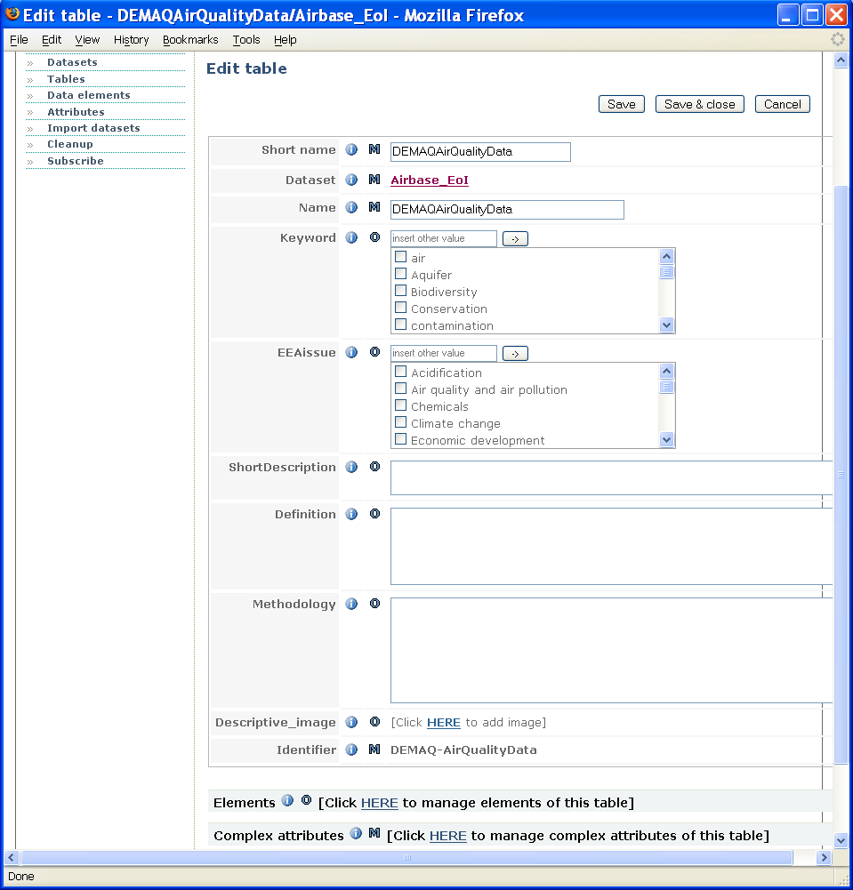Illustration 45: Table edit page

Delete a table
A table can only be deleted from a dataset working copy. There 2 ways to do it:
- On the view page of the dataset working copy, click the table you want to delete. This will open the table’s view page. There you should see the Delete button in the upper right corner. This will delete the table and return you the view page of the dataset working copy where the deleted table is now gone from the tables list.
- On the view page if the dataset working copy, click Edit button. This will open the dataset working copy in edit mode. There you will see a link saying “[Click HERE to manage tables of this dataset]”. Clicking that link willopen the page where you can work with the dataset’s tables (see also the relevant chapter above). On that page you simply select the table(s) you want to delete and press Delete selected. The page will refresh and the deleted table is gone from the tables list.

Working with definitions of elements in a table
To work with elements in a table, the dataset must be checked out. On the view page of the dataset working copy, click the table whose elements you want to work with. This will open the table’s view page. On the latter, click Edit. That will open the table in edit mode where you can see the link saying “Click HERE to manage elements of this table”. This is the link that opens the page where you can work with a table’s elements (Illustration 46).
The page lists the table’s elements in 3 columns: Short name, Datatype and Element type (fixed or quantitative values). Each element is clickable, leading to the element’s view page.
On top of the page you will see inputs and buttons enabling you to add new elements to this table or remove existing ones.
- To add a new non-common element enter the new element’s alphanumeric identifier into the Identifier box, select the element’s Type and click Add or Copy. The element’s type can be either either Quantitative or Fixed values. The first one means elements that can have any value within their data type. The second one means elements whose value-set is pre-determined.
Add creates a new element with the Identifier and Type you selected and it will lead you to the element’s edit page where you can enter the rest of the element’s attributes.
Copy too creates a new element with the Identifier and Type you selected, but it will prompt you to select another element from which to copy the rest of the new element’s attributes. The prompt will open a view where you can search for the element whose attributes you want to copy. Once you've clicked the desired element in the search results, DD will create a new non-common element where the attributes have been taken from the element you selected to copy, but the Identifier and Type are the ones you entered above. It will then lead you to the edit page of that newly created element where you can edit the rest of the element’s definition.
- To add an existing common element click the Link button. It will open a search page where you can search for the common element you want to add to this table. In the search results, click the desired element and you will be led back to this view where you will see the selected common element among the table’s elements.
- To remove existing elements from this table, select the elements with the help of checkboxes in the left-most column and click Remove selected. As a result, the page is refreshed and the selected elements should be gone. Note that removing a common element does not delete it from the DD. It will simply be removed from this table, but it remains in DD to be used by other tables and datasets.
- The Save order button saves the order of the elements. You can change the order by clicking on the row of the element you want to move up or down. This will paint the row to blue. Once this is done, use the moving buttons on the table’s right. One arrow will move by one position, two arrows will move the selected row to the beginning or the end. Just like CD player. Click Save order to save the changes.

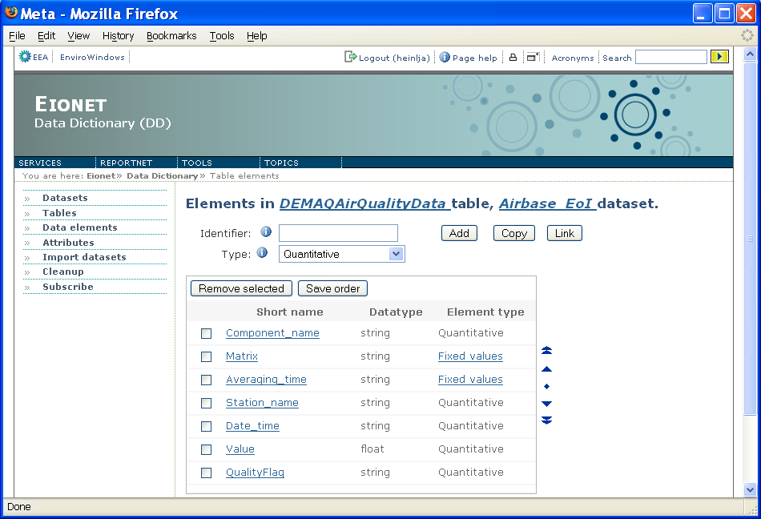Illustration 46: Working with elements in a table

Adding images to table definitions
DD enables to illustrate a table definition with images as long as they are of JPG, GIF or PNG file type. This can be done by using the so-called image attributes. It’s an attribute whose value is an image. Illustration 47 shows how the Descriptive image attribute looks in a table’s view page (note that like any other attribute whose value has not been specified, this image attribute is not displayed if no image has been specified). The image is displayed as a thumbnail. Clicking the thumbnail opens the image in a separate window where you can see it in full size.
In order to edit the image attributes, you must go to the table’s edit page (see relevant chapter above). There the thumbnails will become links titled [Click HERE to add image]. The link opens a apge like the one on Illustration 48. The form in that oage enables you to upload new images (by browsing them on your local PC) and remove selected ones.
NB! Please note that all images ever uploaded into DD, whether as dataset models or illustrative images for table definitions, must have unique file names, because they’re all stored in the same directory on DD server. So name your images carefully.

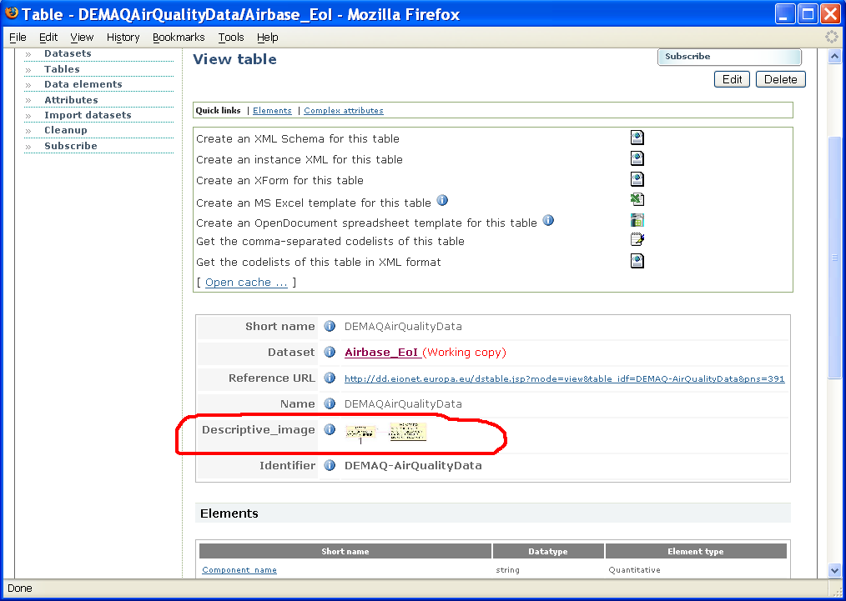Illustration 47: Image attribute in a table view page
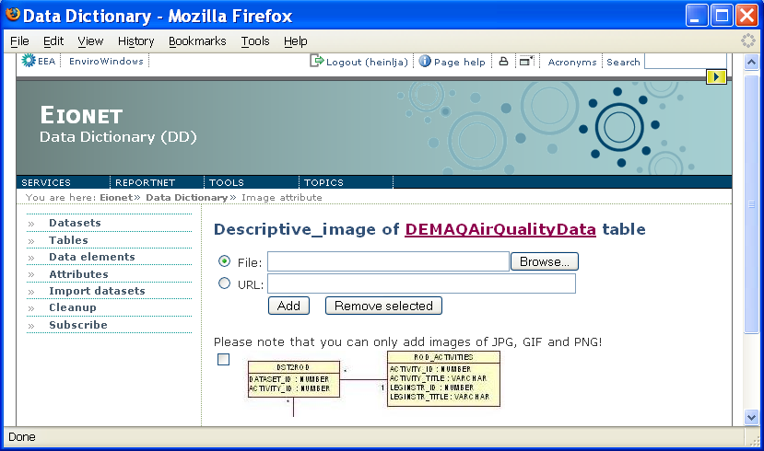Illustration 48: Image attribute window

Data element definitions

Add a new data element
The page for adding a new data element (Illustration 49) can be reached from two places, depending on whether you are adding a common or non-common elements:
- To reach the page for adding a common element, click the New common element action link in the upper right corner of the data element search page that was described in chapters above.
- To reach the page for adding a non-common element, use the page for working with a table’s elements as was described in the relevant chapter above.
There is little difference between the pages of adding a common element and adding a non-common element. The above-mentioned illustration shows the latter. But both pages have these 2 buttons in the upper right corner:
- Add creates the new element with the values you enter into the form below these 2 buttons. It will lead you to the edit page of that new element where you can edit the rest of its definition.
- Copy enables you to create an element by copying the basic attributes from another, already existing element. It will open a view where you can search for the element you want to copy. Once you've clicked the desired element in the search results, DD will create an element where everything but the attributes you specified before pressing Copy have been taken from the element you copied. You will then be led to the edit page of that newly created element where you can edit the rest of its definition.
NB! If you're adding a common element, the first thing you must do on this page is to select the element’s type (in terms of whether it’s fixed values or quantitative values). If you're adding a non-common element, you selected the element’s type already on the page from where you got here.
NB! The first thing that you must do on this page when adding a non-common element and the second thing when adding a common one is to select the element’s datatype if the element’s type is quantitative values. For fixed-values elements this is irrelevant.
Once you've done the above mentioned selections, you can enter data into the rest of inputs which represent the element’s simple attributes. Some simple attributes can have several values at the same time. Possible values are listed and provided with check boxes enabling you to mark your selection. Currently selected values are checked. A text box with pre-set value 'insert other value' enables to insert a value not listed.
NB! Note that since common elements are versioned, the common element adding page contains Registration status among other attributes.
NB! Note that unlike the adding page for common elements, the one for non-common elements contains the Dataset and Table attributes, indicating the table and dataset where the new non-common element is going to belong to.

Copy an element, convert non-common element to common element
Sometimes you might want to define a new element with exactly the same attributes and/or value domain as another element and change it only a little bit.
For that purpose DD enables you to copy another element when you start adding a new element. This can be done with the help of Copy button on the element adding page and it was described in more detail in the previous chapter.
NB! If you want to create a new common element by converting a non-common element into common one, simply go the common element adding page and copy a non-common element.
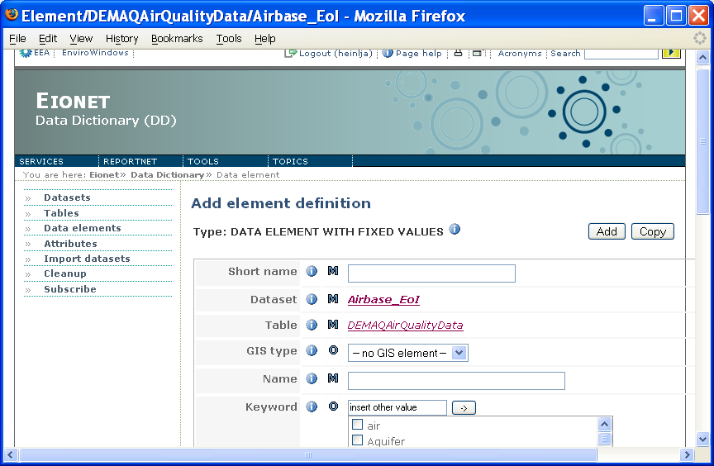Illustration 49: Data element adding page (non-common element)

Edit a data element
Data element editing page (Illustration 50) can be reached from two places, depending on whether it’s a common or non-common element:
- for a non-common element the page is reached when clicking Edit on the element’s view page;
- for a common element the page is reached when clicking Edit on the view page of the element’s working copy.

The upper right section of the page contains the following buttons:
- Save saves whatever you have entered into the inputs on this page. But they will not be seen by anybody else, until you check in the working copy of the dataset (if it’s a non-common element) or the working copy of the element itself (if it’s a common element).
- Save & close does the same as Save, but it also leads you back to the view page of this element.
- Cancel leads you to the view page of this element, without saving anything you entered into the inputs.
Below the above-mentioned buttons, the page is divided into the following sections.
- The element’s Type. This section simply states whether this is a data element with fixed values or a data element with quantitative values.
- Simple attributes. Empty ones are not displayed. If this is a non-common element, the list of attributes includes Dataset and Table, which indicate the table and dataset this element belongs to. They are not editable and both of them are clickable, leading to the view pages of the dataset working copy and the table inside it.
If this is a common element, the attributes include Registration status, because common elements are versioned.
Some simple attributes can have several values at the same time. Possible values are listed and provided with check boxes enabling you to mark your selection. Currently selected values are checked. A text box with pre-set value 'insert other value' enables to insert a value not listed.
Following the element’s Type and Simple attributes, is a section that lists the links to other editable parts of this element:
- Allowable values is a synonym for fixed values and this link is displayed only if the element’s type is FIXED VALUES. It leads you to the page where you can manage this element’s allowable/fixed values.
- Suggested values link is displayed only if the element’s type is QUANTITATIVE VALUES. They are values suggested to the data supplier if he does not know or is not sure what to enter. The link leads you to the page where you can manage this element’s suggested values.
- Foreign key relations link is displayed only if this is a non-common element and it leads you to the page where you can manage the element’s foreign key relations to other non-common elements in the dataset.
- Complex attributes is quite an important link, because it leads you to the page where you can edit the complex attributes of this element. Some of them may be mandatory to specify!
NB! You cannot edit the fixed values of an element of boolean data type. They are set to true and false by force.

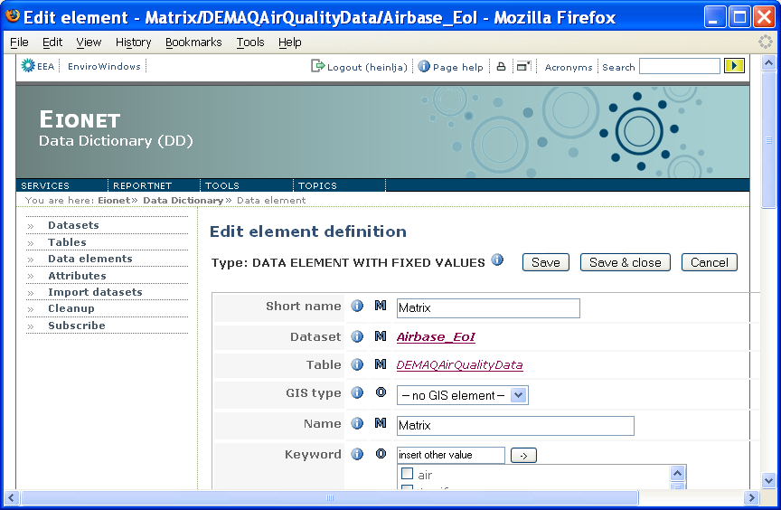Illustration 50: Data element editing page (non-common element)

Delete a data element
A data element, whether common or non-common can be deleted by clicking the Delete button on the element’s view page.
For common elements the Delete button is only displayed if you have the necessary permission and it is the element’s latest version. Also, the Registration status of that latest version must not be Released, unless you have the powerful permission to delete released common elements. Clicking the button will delete only the element’s version you're looking at. So to delete all versions of a common element, you must delete them one by one.
For non-common elements the Delete button is only displayed if you have checked out the dataset, and the element is in the dataset’s working copy. The element will be deleted from the dataset’s working copy. Its deletion will be published to other users once you check in the dataset’s working copy.
There is actually one more place where you can delete a non-common element from a dataset copy. It is the page meant for working with a table’s elements. See the relevant chapter above for more information.

Managing fixed values of data elements
As mentioned in chapters above, you can reach the manageable list of fixed values of an element by clicking the relevant link on the element’s edit page. On the opening list you must click Edit to open it in edit mode. As a result, you will be taken to a page like the one on Illustration 51. This page lists the fixed values in 3 columns: Value (the fixed value itself), Definition (the value’s full definition) and Short Description (the value’s short description). Value is clickable and leads to the value’s edit page (where you can set the Definition and ShortDescription, save them by clicking Save and return to the list).
New values can be added by using the input box and Add button on top of the list. The checkboxes and the Remove button enable to remove existing values.
Another option for adding values is to import the whole value list from an XML-formatted file. Import button leads the user to the import page. See chapter 5 about importing data into DD.

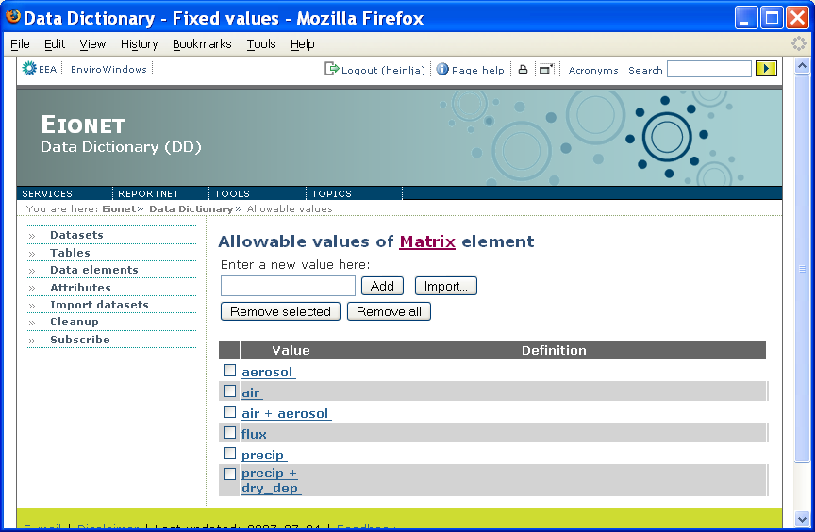Illustration 51: Manageable list of fixed values

Managing suggested values of data elements
As it was mentioned in chapters above, data elements with quantitative values can have suggested values, i.e. values that the data element definition suggests if the data supplier is unsure what kind of values to submit..
You can reach and manage suggested values by clicking the relevant link on the element’s edit page. The rest of the procedure is exactly like the one for fixed values explained in the previous chapter!

Foreign key relations
Since tables in a reported dataset might have foreign key relations to each other, DD enables to define them as well.
A foreign key relation between two tables in DD is handled simply by defining a foreign key relation between some of their non-common elements (for common elements this feature is not enabled, because a single common element can participate in many datasets). On both sides, several non-common elements can participate in the relation. Elements participating in a foreign key relation are called each other’s foreign keys.
To view and manage foreign keys of a non-common element, click the relevant link on the element’s edit page. As a result you will see a page like the one on Illustration 52. It lists the foreign keys of the given element in 3 columns: Element (the foreign key element’s name), Table (foreign key element’s table name) and Cardinality. The latter indicates whether the foreign key relation is one-to-many (1 to *), one-to-at-least-one (1 to +) or one-to-one (1 to 1).
To add a new foreign key, click Add. This will open a page where you can search for non-common elements (in the same dataset) that you want to be the foreign keys of the given element. In search result list you will simply click on the desired element’s name. As a result, you will be returned to the foreign key list where the the element that you clicked appears as a new foreign key. To edit the relation’s cardinality and description, click on the Cardinality in the right-most column (and follow your intuition on the page that opens as a result). The left-most column enables to select relations that you want to delete. You can delete them by clicking the Remove button.
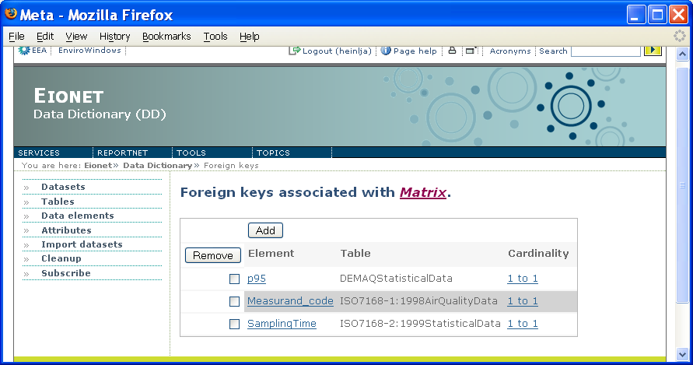Illustration 52: Foreign key relations of a non-common element

Adding images to data element definitions
You can illustrate a data element definition with images and it follows exactly the procedureas it was with table definitions (see same chapter for tables above).

Working with complex attributes of a dataset, table or data element
In order to understand some parts of this chapter, please note that complex attribute values of non-common elements and tables can be inherited from upper levels. (upper levels of a non-common element are table and dataset, upper level of a table is dataset). This depends on whether the complex attribute has been defined as inheritable (see below chapters about attribute definitions).

The complex attributes list
As you saw in previous chapters, edit pages of datasets, tables and elements have a link to their complex attributes list, which is editable and shown on Illustration 53. It is a list of tables where each table represents one complex attribute and the table’s columns represent the attribute’s fields.
Each row in such a table stands for one value of the given complex attribute. The titles of these tables are the names of the complex attributes. In the left upper corner these tables may have a checkbox which you can can use for selecting attributes you want to remove with the Remove button. They may also have an Edit button leading to the attribute’s editing page which is described in the next chapter. NB! The checkbox and the Edit button are displayed only if the attribute is not inherited from upper level.
New attributes can be added by selecting the attribute name from the select box in the page header and pressing Add new. This leads to the new attribute’s editing page, described in the next chapter.
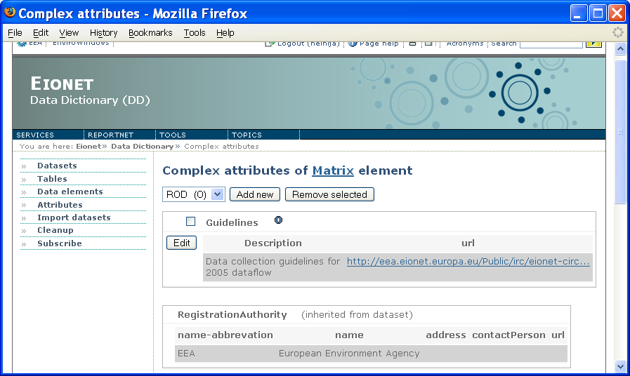Illustration 53: Working with complex attributes of a dataset, table or element

A complex attribute’s editing page
This (Illustration 54) is the page that you reach from the previously described complex attributes list if you chose to edit an existing complex attribute or add a new one.
It lists the attribute’s value rows in columns that represent the attribute’s fields. Existing rows can be removed by using the checkboxes for selection and pressing Delete to remove the selected.
On top of the list there is a section enabling to add new value rows. The section contains a text input for the attribute’s every field and an Add button which creates a new value row with what you put into the inputs. There is also a Copy button. The latter enables to copy previously inserted value rows. It opens a page where you can select the desired row by clicking it. As a result, you will be taken back to the attribute's edit page where the selected row will show up in the above mentioned text inputs. Now you just have to click Add to create a new row with those inputs.
The values can also be taken from those harvested from outer sources (see below chapters about harvesting complex attributes). Each complex attribute can be linked with exactly one type of harvested complex attribute. The values of the latter will open if you click Get (displayed only when the attribute is indeed linked with harvesting). You will see a view, where selecting a row will copy the row’s fields into the above mentioned text inputs. And then again, clicking Add will create a new row with those inputs
As it was mentioned, complex attributes can be inherited. There are two types of inheritance. NB! If inheritance is set to be over-writeable, then adding a new row using the above mentioned text inputs will lose all inherited rows! If inheritance is set to be not over-writeable then you can add new rows without losing any inherited rows.
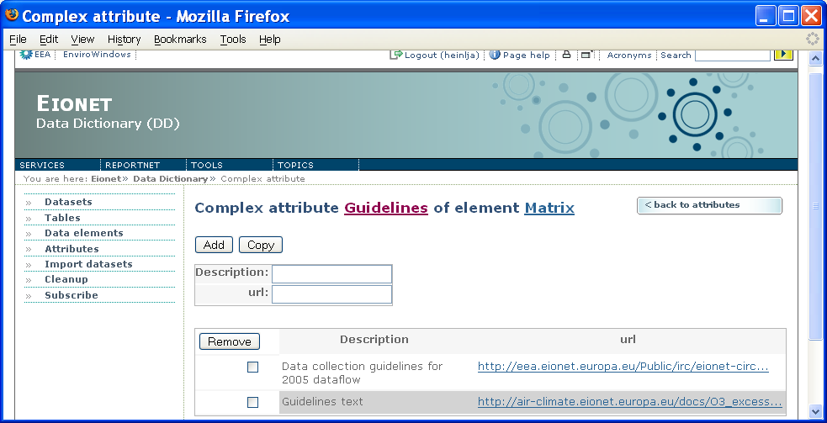Illustration 54: A complex attribute’s editing page

Schema sets and schemas
This chapter contains information about schemas update functionality. Before proceeding it would be better to understand how vocabulary update procedure works.
A schema set may have two states 'Checked in' and 'Checked out' (i.e. working copy). In order to edit a schema set, user has to check out schema set first. Checking out gives user ability to change data without effecting any other depending data. It basically makes a copy of the schema set and gives the users permission to edit it. User can update schema set contents as needed. These changes are not applied to 'Checked in' version of schema set unless schema set is checked in. User can revert changes by undoing check out (it deletes working copy), or apply changes by checking in. This prevents data not to be changed accidentally. Also, simultaneous editing of the same schema set by several users is avoided.

Vocabularies
This chapter contains information about vocabulary update functionality. Before proceeding it would be better to understand how vocabulary update procedure works.
A vocabulary may have two states 'Checked in' and 'Checked out' (i.e. working copy). In order to edit a vocabulary, user has to check out vocabulary first. Checking out gives user ability to change data without effecting any other depending data. It basically makes a copy of the vocabulary and gives the users permission to edit it. User can update vocabulary as needed. These changes are not applied to 'Checked in' version of vocabulary unless vocabulary is checked in. User can revert changes by undoing check out (it deletes working copy), or apply changes by checking in. This prevents data not to be changed accidentally. Also, simultaneous editing of the same vocabulary by several users is avoided.

Adding New Vocabulary
To add a new vocabulary, first you need to go to Browse Vocabularies page (See: Browse Vocabularies). You will see 'Add Vocabulary' on the upper right 'Operations' drop-down menu. When this item is clicked you will be navigated to add vocabulary page where you can fill information about your vocabulary. You can choose either existing vocabulary set to create vocabulary in, or create a new one. Vocabulary Set identifier must not exist in Data dictionary before.
Mandatory fields are indicated by letter 'M' and optional fields are indicated by letter 'O'. If you leave 'Base URI' field empty, it will be populated by data dictionary automatically.
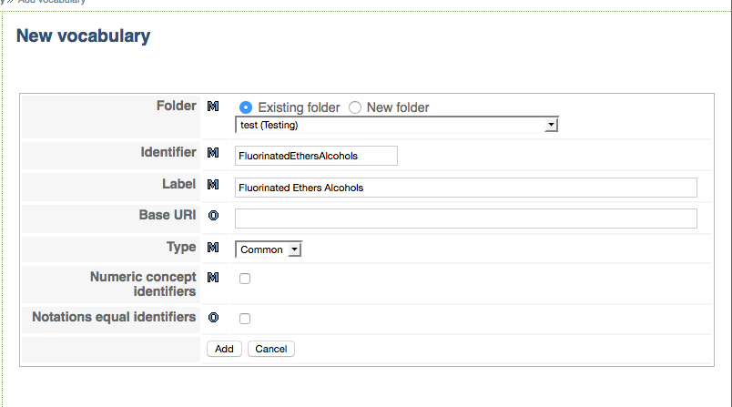Illustration 55: New vocabulary definition page

After that a screen appears where vocabulary metadata has to be entered.

- Identifier: unique Vocabulary identifier in the set (NB! Identifiers are case insensitive)
- Label: Free text label
- Base URI: Base URI of the vocabulary. Optional, will be generated if not entered
- Type: indicates if it is a common or Site code. The latter is a specific functionality for EEA purposes and rarely used
- Numeric concept identifiers: Check if identifiers are numeric or can be self-generated by the application.
- Notation equals identifiers: If checked the notation values of the vocabulary concepts will be generated automatically from the identifiers.

After vocabulary added, system will redirect you to vocabulary view page (see: Browse Vocabulary).

Copying Existing Vocabulary
Go to vocabulary browse page of vocabulary you want to copy (see: Browse Vocabulary). On the upper right 'Operations' menu, you will an action named 'Create new copy'. By clicking that button you will be redirected to new vocabulary definition window where you can define values for copied vocabulary. When you are done with that, vocabulary will be copied with all its concepts and data elements.
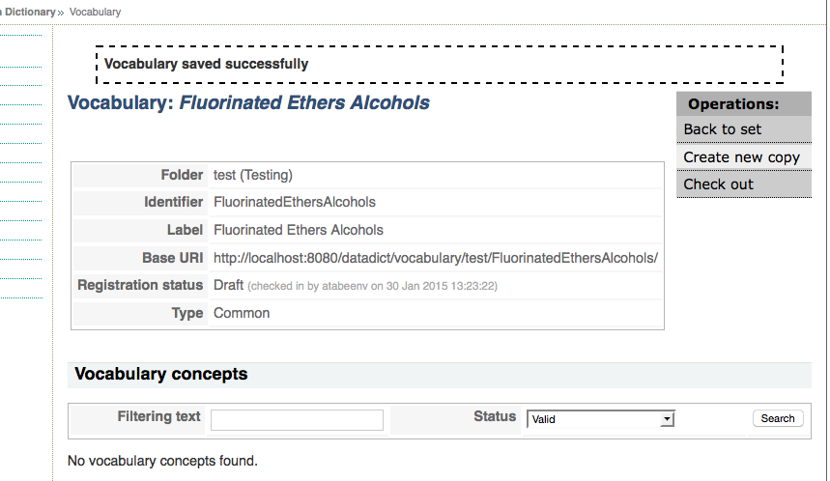Illustration 56: Vocabulary Copy Action

Updating/Editing a Vocabulary
To update or edit a vocabulary, vocabulary should be checked out first. Go to vocabulary browse page and using upper right 'Operations' drop down menu, select 'Check out'. This will create working copy version of vocabulary. When you have a checked out vocabulary, you can update vocabulary info, add/delete (bind/unbind) data elements to vocabulary, add or delete vocabulary concepts, update/edit vocabulary concepts.
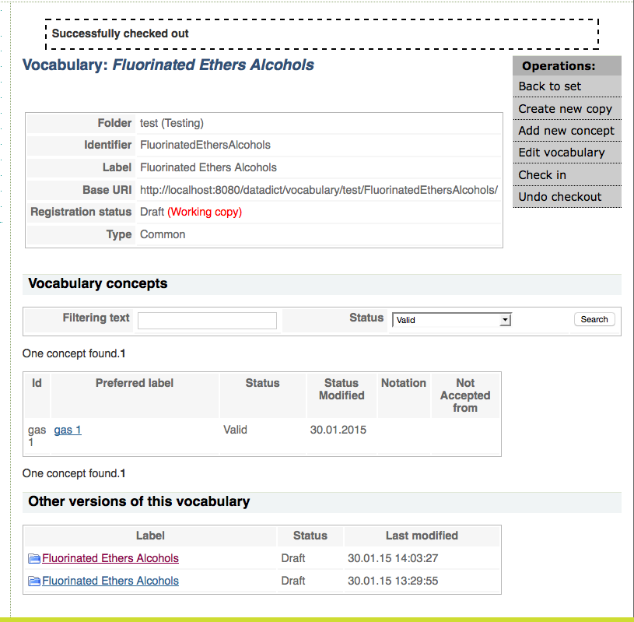Illustration 57: Check out vocabulary page
To edit vocabulary, select 'Edit vocabulary' item from upper right 'Operations' drop down menu. This will redirects you to vocabulary edit page.
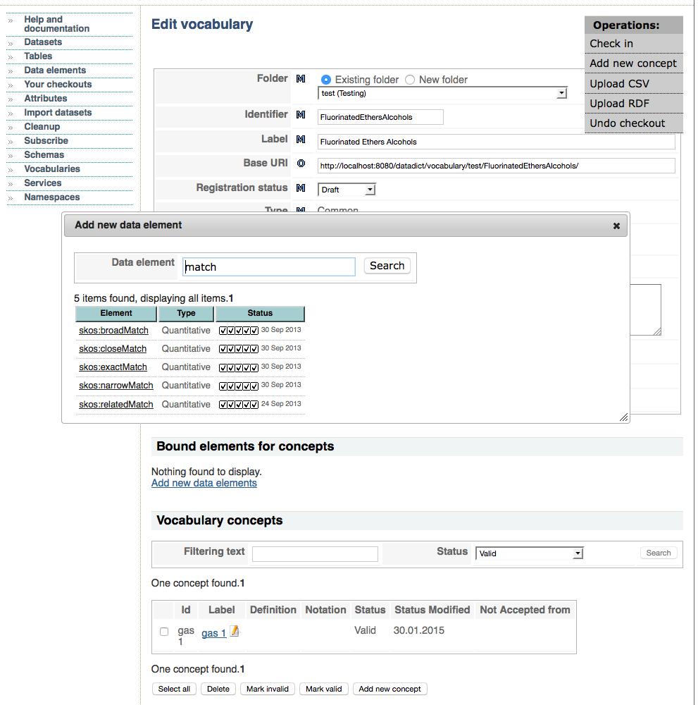Illustration 58: Vocabulary Edit Page
On Vocabulary Edit Page you can update vocabulary information (e.g. label, identifier, version etc), bind and unbind data elements, add new concept, and import data to vocabulary (Import operations will be described later). After completing your changes, you can save and return back to view page.

To add a new concept to vocabulary, you have to select 'Add new concept' from upper right 'Operations' drop-down menu on working copy view or edit pages. This will show you a dialog where you can enter vocabulary concept data. After defining concept data, press add button to save concept into vocabulary.

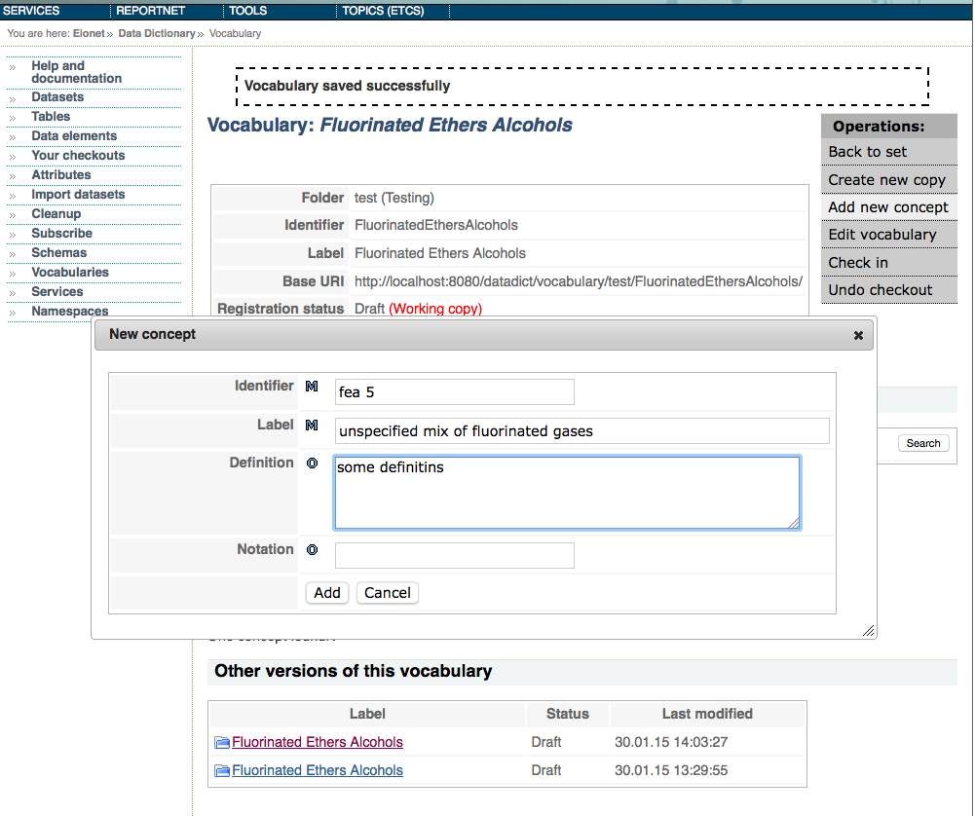Illustration 59: New Vocabulary Concept Definition
If you want to edit a concept, then click concept link. If you click concept link from working copy view page it will direct you to concept view page where you can select 'Edit concept' from upper right 'Operations' drop-down menu, this will display concept update page. If you are already on vocabulary working copy edit page and click vocabulary concept link, it will just navigates to concept update page. On edit page, you can update concept fields, bound data element fields and relations of concept.
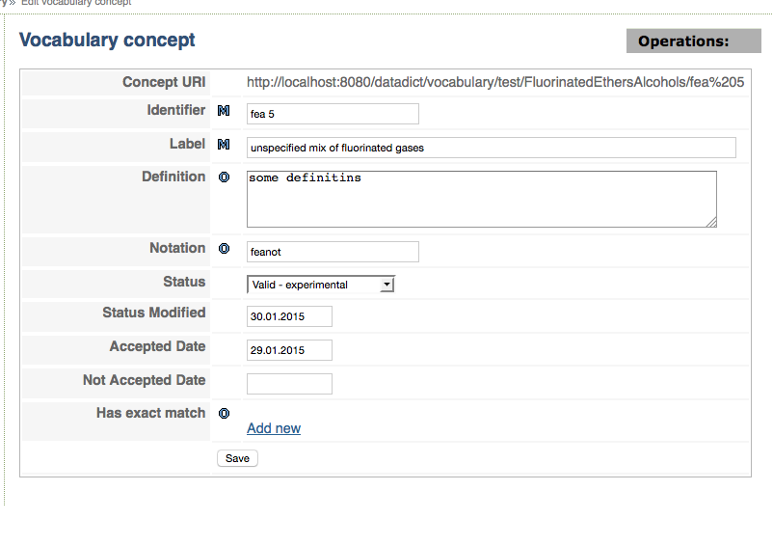Illustration 60: Vocabulary Concept Edit Page
By pressing Save button, changes will be saved to working copy of vocabulary.

Quick edit
Vocabulary concepts can be edited directly on Vocabulary page by clicking an icon next to Vocabulary Concept name.
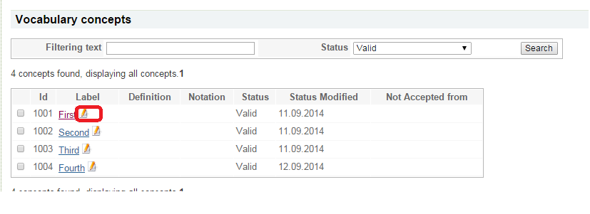
Illustration 61: Quick Edit button
After that data of the concept can be changed in the appearing pop-up
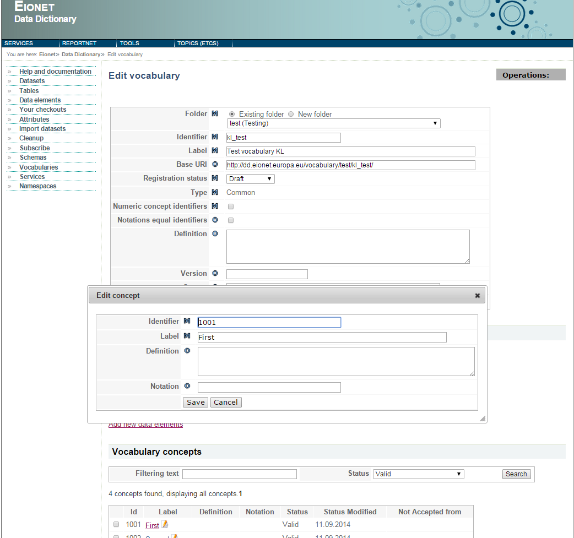
Illustration 62: Editing a concept in quick edit window

Bound Elements

As seen above each vocabulary concept has a pre-defined set of attributes: Label, definition. Notation etc. Besides these additional attributes can be defined for a concept. The attributes are defined at Vocabulary level as Bound Elements.

Before binding the elements to a Vocabulary the elements must be defined in Data Elements as Common Elements. See the relevant Chapter about data elements See Data element definitions.

For adding a bound element click the link “Add new Data Elements” on the Vocabulary screen. A dialog appears where a common element can be searched.

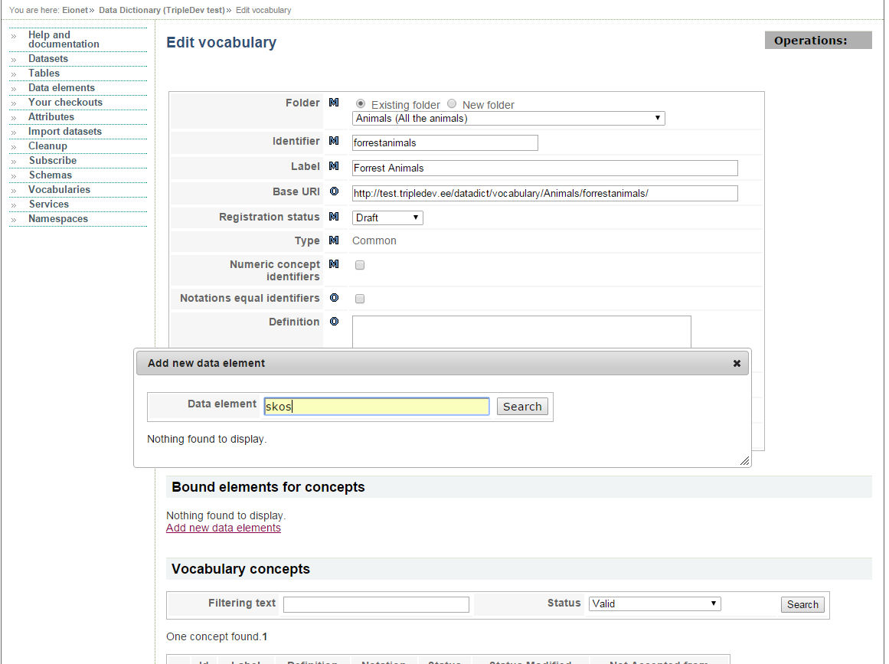

Illustration 63: Search a common element to be bound to a vocabulary

If the correct element is found the element name has to be clicked in the popup screen:

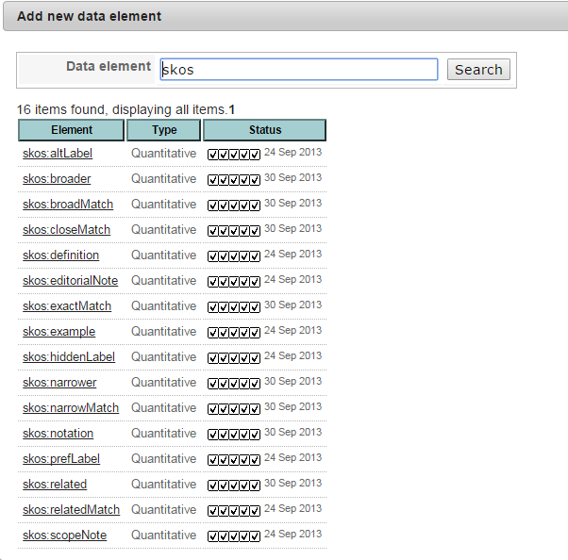
Illustration 64: Bind a common element to a vocabulary

After that the bound element appears in the “Bound elements for concepts” table on the Vocabulary page. The adding can be repeated until all the elements have been added.

If all the desired bound elements have been defined the attribute fields appear on the concept page when eh concept is opened for editing or viewing.

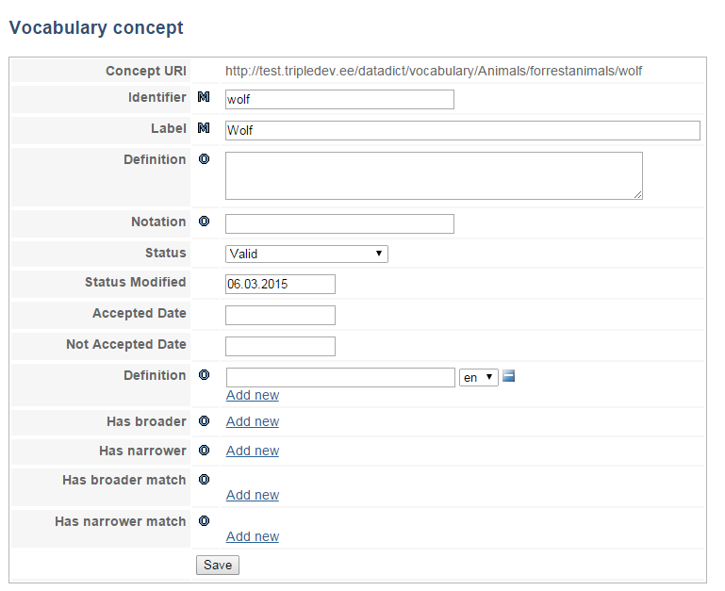
Illustration 65: Concept with bound element attributes

All the bound element attribute values are also printed in RDF, CSV and other outputs.

Related Concepts

As mentioned above relations cab be defined between different concepts.

The relations are defined by using bound elements. The common elements has to be of type localref or reference. The type is shown on the Element page:
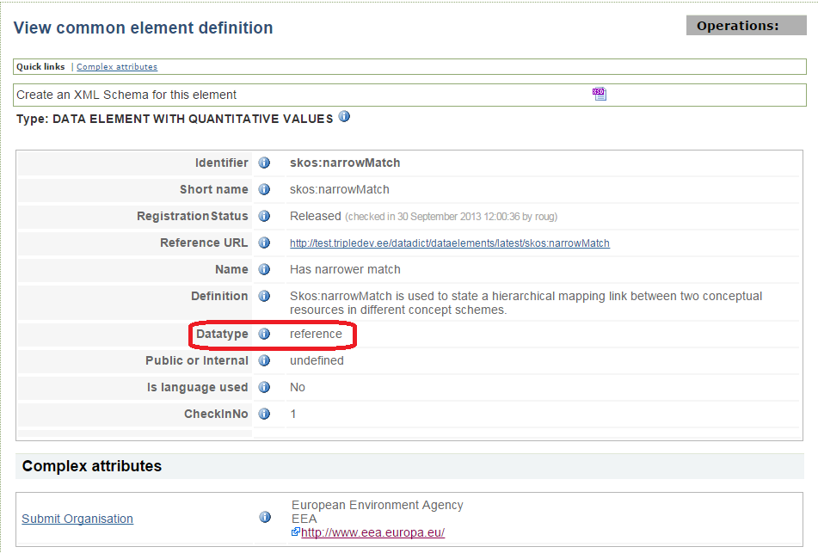
Illustration 66: Common relational element

Note: When Data Dictionary has been installed there are some pre-defined common elements can be added to the database provided in the installation package. Mostly there are SKOS (http://www.w3.org/2004/02/skos/) set elements that can be used for defining relations.

- localref: this type is used for defining relations between concepts in the same vocabulary
- reference: in an attribute of type reference a relation can be defined :
  - to a concept in another vocabulary in Data Dictionary
  - to a concept in an external source

Binding a localref element value
Assuming there are two concepts in the vocabulary: wolf and Maned wolf. If the vocabulary has skos:related element bound other concepts in the vocabulary can be selected in a drop-down.

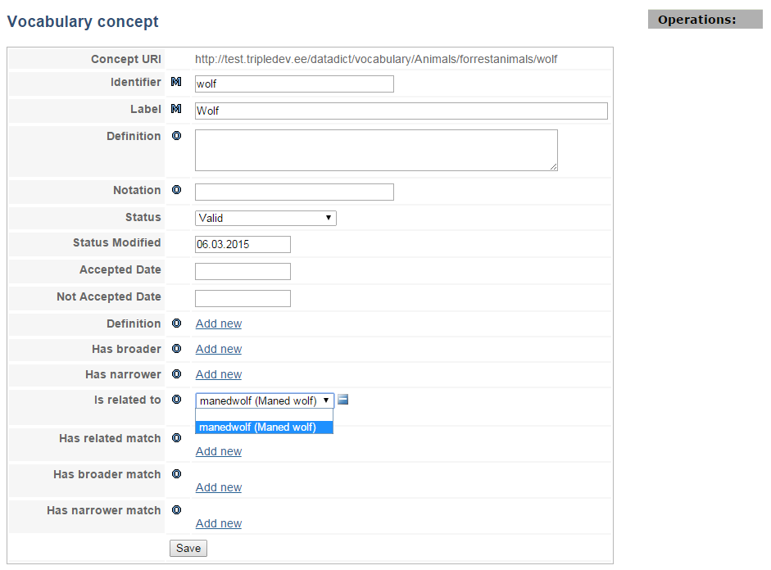
Illustration 67: Concept with bound element attributes

Element Rules

For certain elements inverse rules can be defined. The rules are defined in the database level and there is no user interface.
Currently only owl:inverseOf rule is implemented. If an element is an inverse element of another then the attribute value of the related concept is automatically filled if the vocabulary concept is changed.

Some of the inverse rules are included in the Data Dictionary seed data package provided with the installation.

Element identifer | Rule type | Target element identifier
skos:broader | owl:inverseOf | skos:narrower
skos:narrower | owl:inverseOf | skos:broader
skos:related | owl:inverseOf | skos:related
skos:broadMatch | owl:inverseOf | skos:narrowMatch
skos:narrowMatch | owl:inverseOf | skos:broadMatch
skos:relatedMatch | owl:inverseOf | skos:relatedMatch
skos:exactMatch | owl:inverseOf | skos:exactMatch
skos:sameAs | owl:inverseOf | skos:sameAs
dct:replaces | owl:inverseOf | dct:isReplacedBy
dct:isReplacedBy | owl:inverseOf | dct:replaces

For example, if an element A is entered as skos:broader value of element B then element B gets element A as value for skos:narrower attribute.

If “Scottish Sheperd” is added as a narrower concept of “Dog” :
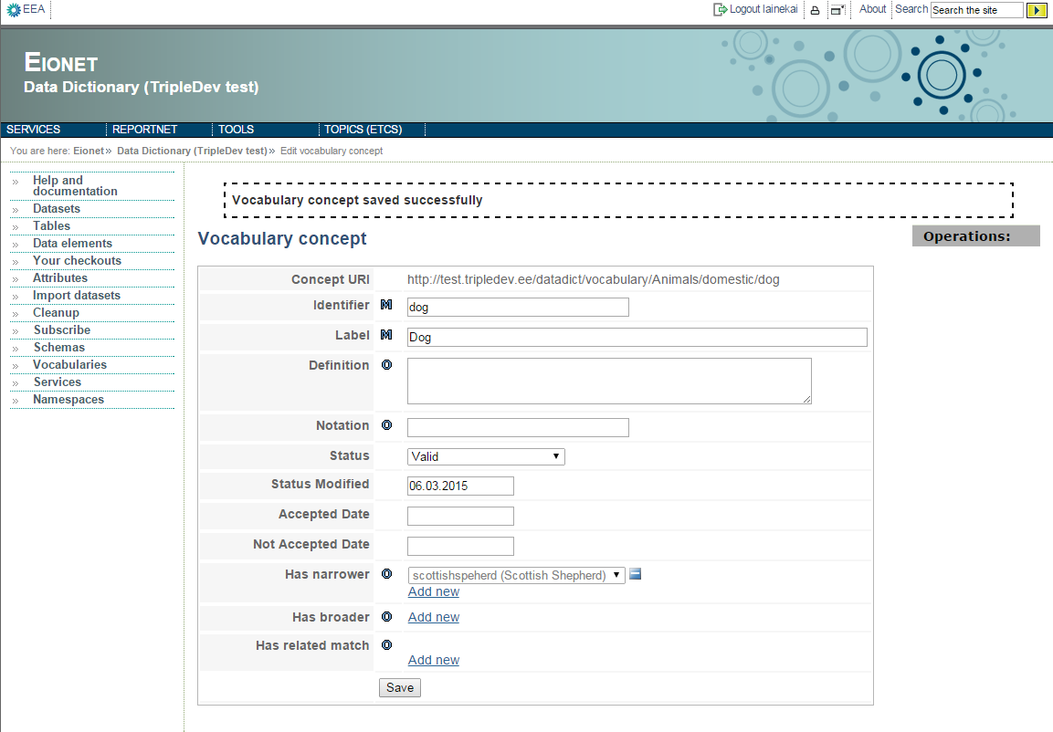
Illustration 68: Concept with a skos:narrower attribute

it gets “Dog” as a broader concept automatically:

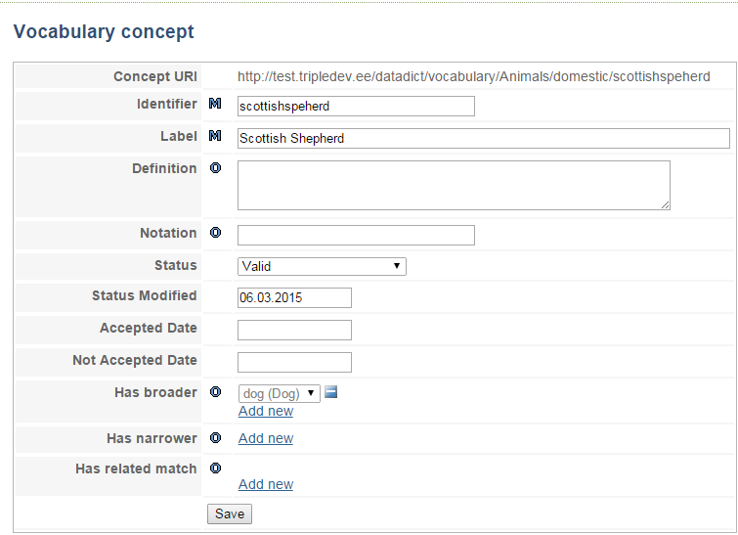
Illustration 69: Automatically filled skos:broader attribute

Binding a reference element value
For concepts in other vocabularies or outside of the Data Dictionary common elements of type reference have to be bound.

The element value for a related element can be added in two ways:

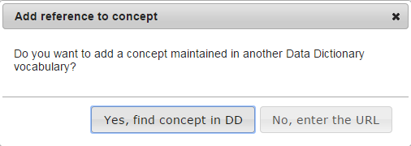
- After clicking “No” option the URL of the concept can be entered directly in a text field
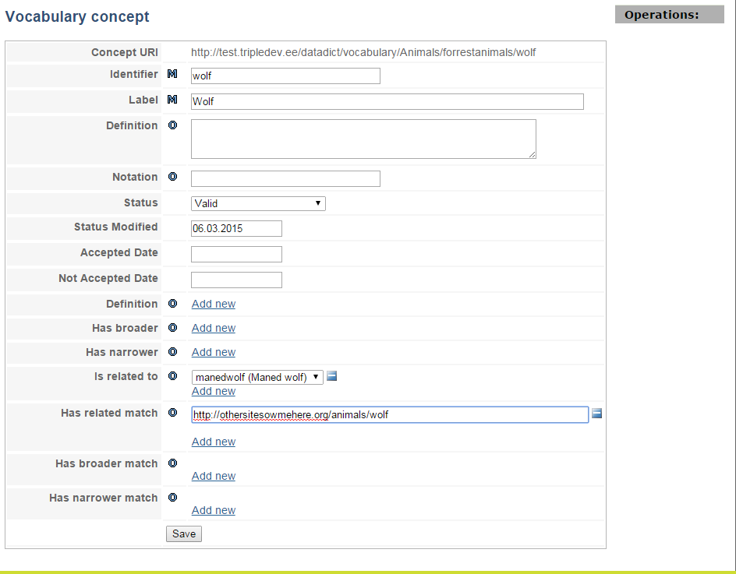
Illustration 70: Entering relational element URL

- The concept can be searched in Data Dictionary by using a two-level search:

  - A Vocabulary can be searched,
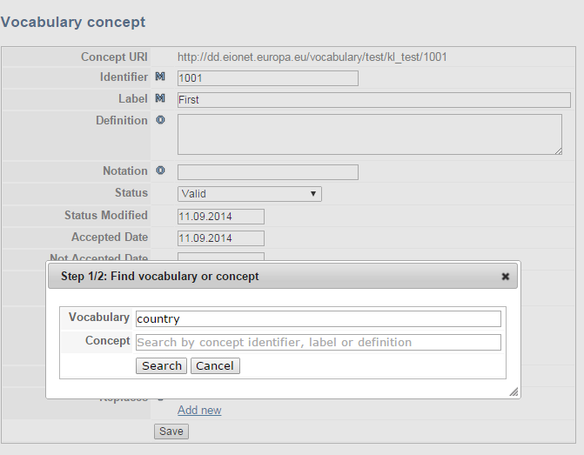
Illustration 71: Searching a vocabulary
  - List of found vocabularies is displayed.
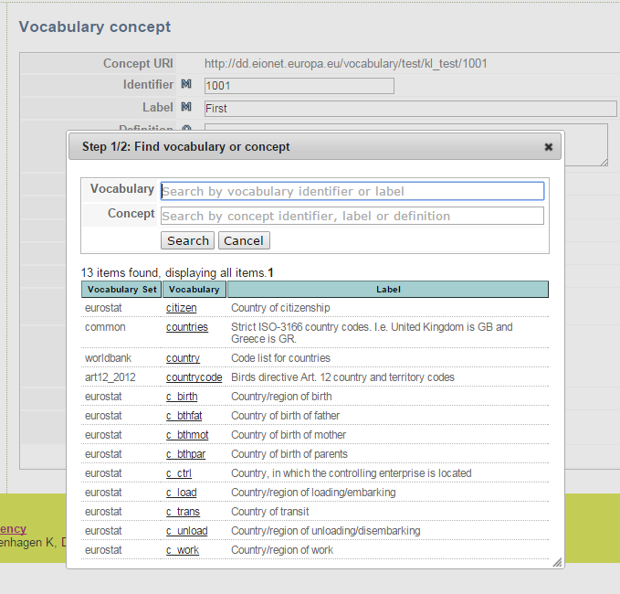
  - Then the desired vocabulary can be chosen and a concept can be selected in the list of vocabulary concepts
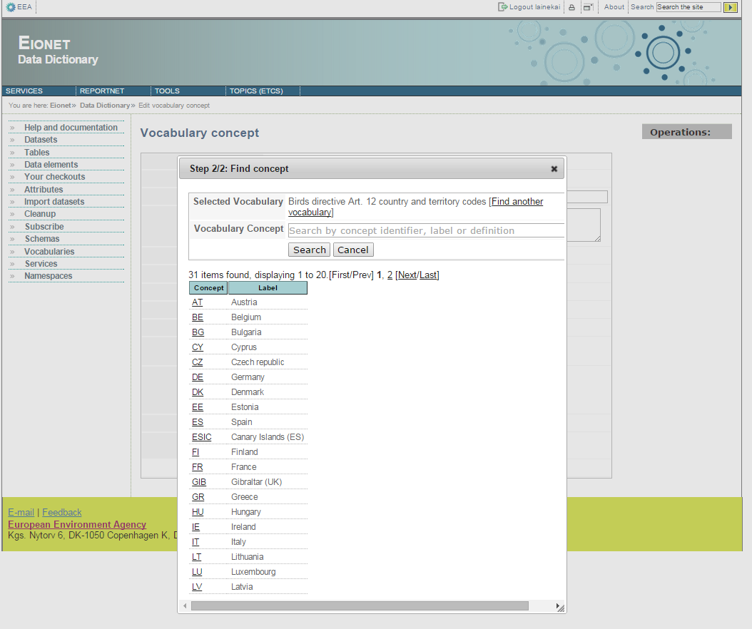
Illustration 72: Vocabulary search results
  - If a after that a concept in the found vocabulary can be selected

Illustration 73: Vocabulary concepts of the selected vocabulary
  - Another option is to search a concept and leave the vocabulary field empty. In this case found vocabulary sets are displayed and can be excluded from the search results to find a correct concept
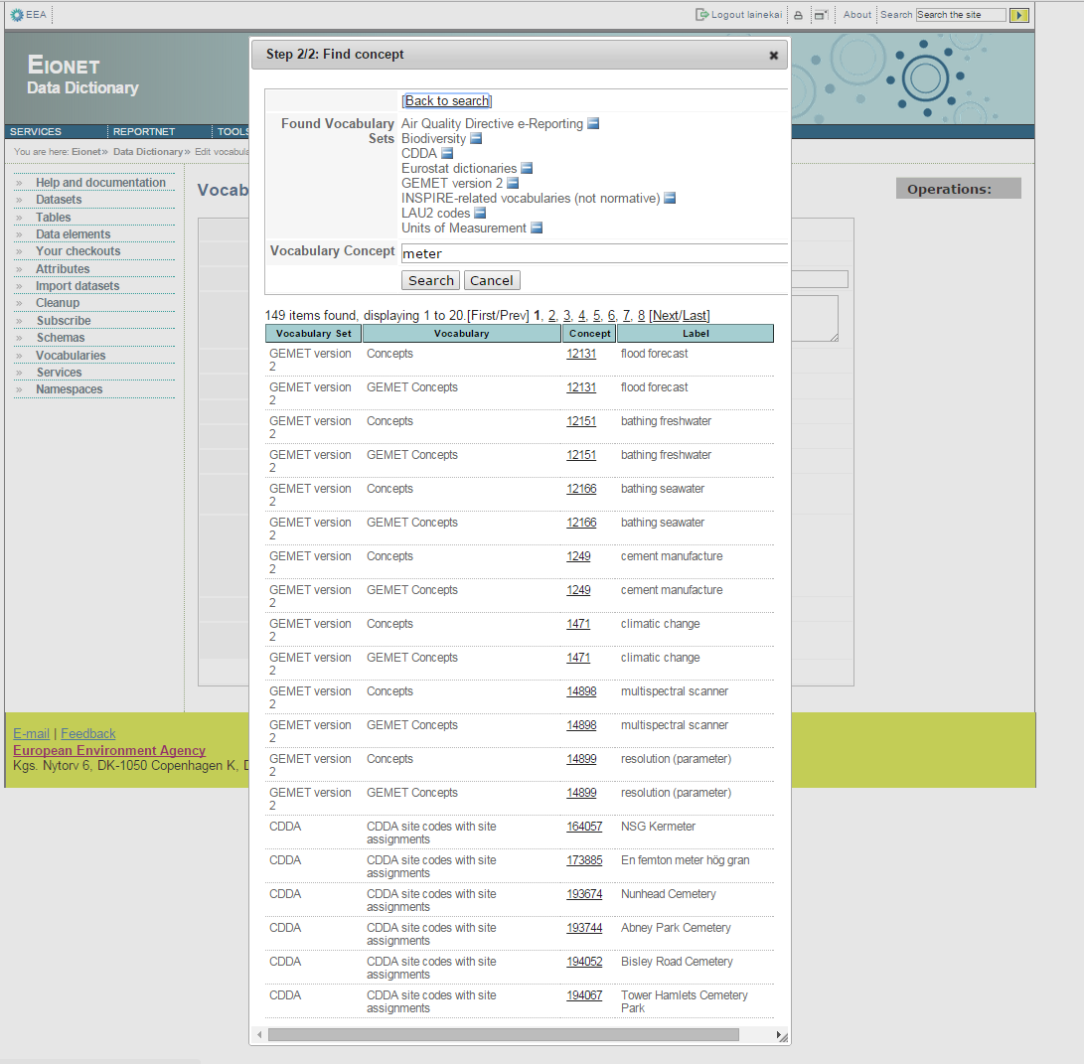
Illustration 74: Search result by concept

Check-in
In order to publish your all changes on a vocabulary, you have to check in the vocabulary. This will overwrite 'Checked in' version of vocabulary and will delete working copy. When a vocabulary is checked in, operation is no longer reversible. To check in a vocabulary, please use 'Check in' action from upper right 'Operations' drop-down menu on working copy view or edit page. After checking, you will be redirected to vocabulary browse page.

If you don't delete working copy and not publish your changes, you can simply select 'Undo checkout' item from upper right 'Operations' drop-down menu. This will delete working copy and keep existing 'Checked in' version of vocabulary, no changes will be applied. This can be used to revert changes in working copy.

Importing Data into Vocabulary
Once a vocabulary is checked out, you have a chance to import data in two formats. These formats are CSV and RDF. Import operations can be found under 'Operations' drop-down menu on vocabulary edit page, 'Upload CSV' and 'Upload RDF' respectively.
Primary purpose of CSV import is to give user ability to bulk edit concepts in a vocabulary. It is recommend to use this functionality after exporting vocabulary in CSV format, and then doing necessary changes and then importing it into vocabulary.
Imported CSV file may contain new data elements. If these elements are found in data dictionary, they will be automatically bound to vocabulary and import operation will continue. If a data element is not found, then CSV import will be aborted. Upload operations has two options. One is to purge vocabulary data. If this option is selected all vocabulary data (all concepts and values) will be deleted. After deletion, all valid lines in CSV file will be imported into vocabulary. They will be added as new concepts. Another option is to purge bound elements. This will delete all bound elements of vocabulary (concepts will be kept but their bound attributes will be deleted). After deletion bound elements, all valid lines in CSV file will be imported into vocabulary either adding a new concept (unless concept is found), or updating existing concept. During import, unbound data elements will be searched on data dictionary and will be bound automatically to vocabulary. If none of the options is selected, then import operation will insert new concepts to vocabulary and updates existing concepts. It will also do automatic binding of unbound data elements.
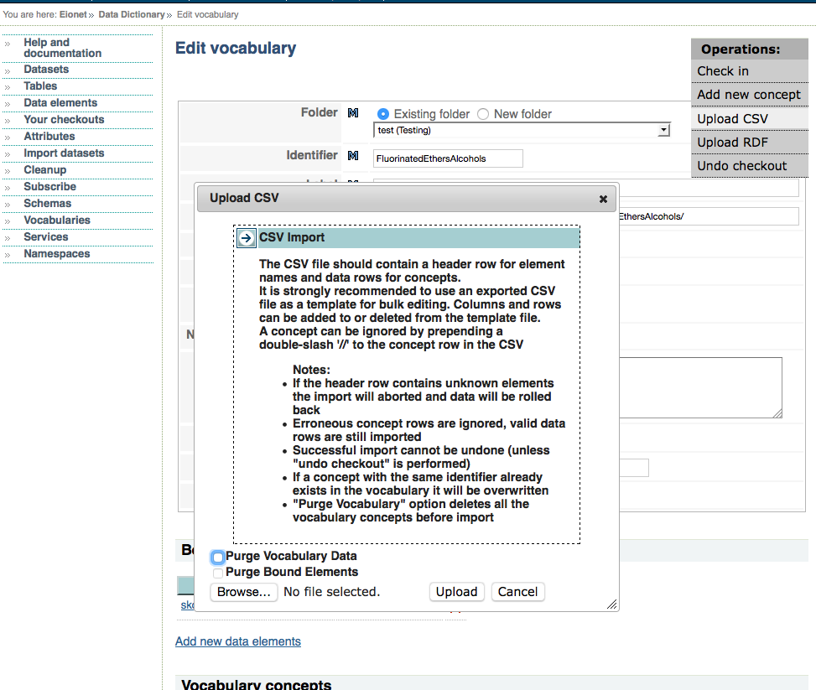Illustration 75: Vocabulary CSV Import Dialog
When CSV upload dialog is on, you can select options and then browse file. After file selection, press 'Upload' button to start import operation. Depending on data amount this operation may take some time. On progress, dialog will be displayed on the screen, when operation is completed (successfully or unsuccessfully) you will be shown by results.

Intentional usage of RDF import is to import vocabulary data into data dictionary from external systems.
Imported RDF file may have unbound data elements, these elements will be skipped and not imported into vocabulary. In order to import all data elements, they should be bound to vocabulary before import operation.
Data will be imported into vocabulary for valid triples. For valid triple definition, please see: http://taskman.eionet.europa.eu/issues/17685.
Before import, you can select one of three options. These are; 'Don't purge vocabulary data' (by default), 'Purge Per Predicate' and 'Purge All Vocabulary Data'. If 'Don't purge vocabulary data' is selected, already existing concepts and data elements will be kept, valid triples will be imported into vocabulary either updating existing concepts or creating new concepts. If 'Purge Per Predicate' is selected, then when the importer sees an importable predicate for the first time, it will remove all existing values for that predicate (i.e. data element or concept attribute) in the vocabulary, then valid triples will be imported into vocabulary either updating existing concepts or creating new concepts. If 'Purge All Vocabulary Data' is selected, all concepts and their attributes will be deleted from vocabulary, all valid triples will be imported into vocabulary from scratch (by creating new concepts and their attributes).

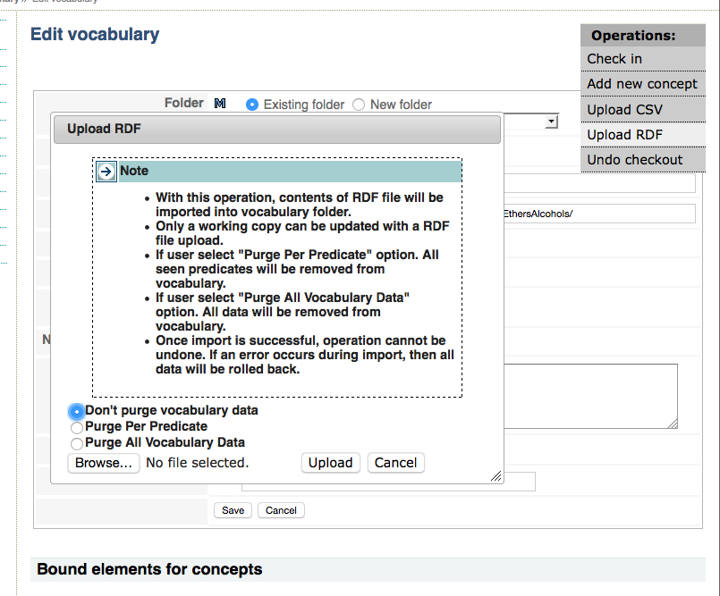Illustration 76: Vocabulary RDF Import Dialog
When RDF upload dialog is on, you can select options and then browse file. After file selection, press 'Upload' button to start import operation. Depending on data amount this operation may take some time. On progress, dialog will be displayed on the screen, when operation is completed (successfully or unsuccessfully) you will be shown by results.

Get notifications in your email
As you see in above chapters, the view pages of datasets, tables and common elements have a Subscribe action link that will subscribe you to any changes made to any version of that dataset or common element. Eionet’s Unified Notification System (UNS) will then send you notifications about those changes.
Subscribing to certain datasets, tables or common elements can also be done from the page that opens clicking Subscribe on the left panel. It is shown on Illustration 34. The page enables you to specify your interests and then UNS will send you a notification every an event occurs that matches your interests. You can specify the following interests (represented by checkboxes and select boxes):
- New datasets
- New tables
- New common elements
- Changes in any dataset, table or common element that you specify, matching the Registration status you can also specify.
You can submit your interests by pressing Subscribe at the bottom of the page. If subscription was successful, DD displays a success message. Otherwise an error is displayed.
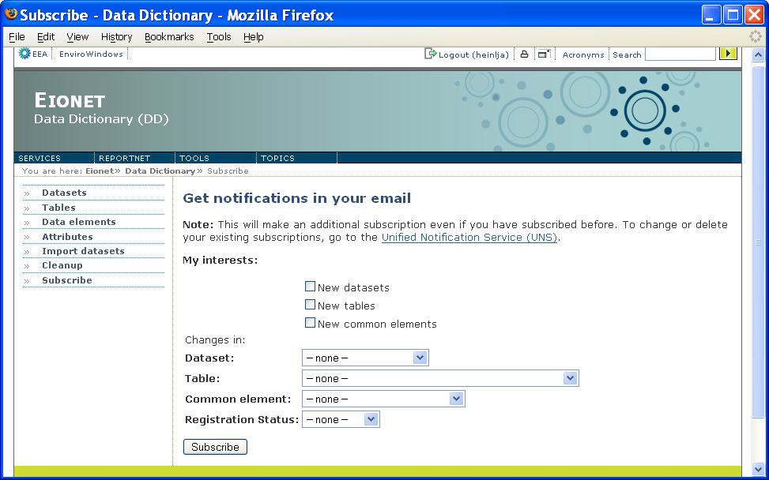Illustration 77: Get notifications in your email

Administrators-only functionality
Administrators-only functionality is visible and accessible only for DD administrators after they have logged into the system. In the following sub-chapters it is assumed that the reader is a DD administrator. Every sub-chapter represents one administrator-only function and is titled with the function’s name.

Defining attributes
Most of the attributes you see in dataset/table/element definitions are dynamic, i.e. they can be defined/removed via DD web interface. Only the following attributes are static, i.e. not definable or removable via DD web interface:
- Identifier
This is an alphanumeric identifier of dataset/table/element definitions used for internal purposes in DD. It must contain no white space and restrictions on which characters can be included. It is also used as tag name in XML-formatted data reporting. A table Identifier must be unique within its dataset. A non-common element Identifier must be unique within its table. A common element Identifier must be unique among all common elements.
- Short name
A character string used to operationally identify dataset/table/element definitions in the DD, i.e. how users commonly refer to a table or an element or a dataset. A short name is not used as a unique identifier in DD.
- RegistrationStatus
Relevant only for datasets and common elements. See the chapter about Registration statuses above.
- Version
Relevant only for datasets and common elements. See the chapter about versioning above.
- Reference URL
Relevant for datasets and common elements only. It is the URL to use as a reference always pointing to the latest version.
- Public outputs
Relevant for datasets only. Enables to specify which templates and documents should be displayed for anonymous users in the upper section of the dataset’s view page where links to templates and documents are displayed (see for more in the chapter about dataset view page).
- Type
Relevant for elements only and indicates the element’s type, i.e. whether it’s an element with fixed values or quantitative values.
- Is ROD parameter
Relevant for elements only and indicates if the given element is to be considered a parameter by ROD when the latter asks for the list of parameters by given reporting obligation ID.
Even though you cannot add/remove static attributes via DD web, you can nevertheless manage the on-line help that is displayed for these attributes. That is done with the help of Help Admin Tool which is another application having its own documentation. Contcat EEA for more about that.

For dynamic attributes you have completely free hands in that you can define/remove new/existing attributes and manage existing attribute definitions. The moment you define an attribute, the moment it becomes visible in the dataset/table/element edit pages. The list of all dynamical attributes defined in DD (Illustration 78) is accessible by clicking Attributes on the left panel. It has 6 columns and an Add attribute action link for defining new attributes. Short name of every attribute is clickable and leads to the attribute’s definition view page. Type indicates if the attribute is simple or complex (see more about attribute types in the beginning of the document). The rest of the columns indicate the definitions for which the attribute is valid by having a check-mark in the relevant column.
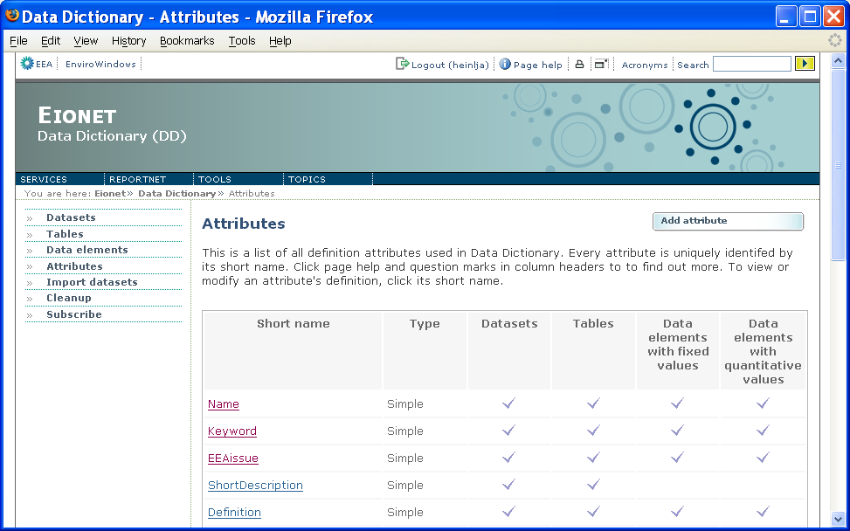Illustration 78: Dynamical attributes list

Defining simple attributes

Simple attribute definition view
Simple attribute definition view (Illustration 79) can be reached by clicking its Short name in the dynamical attributes list (see previous illustration). It lists the attribute’s properties. A simple attribute can have the following properties:
- Short name (is part of an attribute’s unique identifier)
A character string by which the users refer to an attribute in different data definition views. It should be compact while still reflecting the attribute’s concept.
- Name
The full name of the attribute. Usually not used in data definition views, but more wide-spread in oral communication and documents.
- Context (is part of an attribute’s unique identifier)
Indicates if the attribute originates from ISO 11179 standard or is specific to DD.
- Definition
The attribute’s full definition (i.e. description of its meaning).
- Obligation
Indicates if the attribute is mandatory in the definitions it is valid for (see the Display for property below). Possible values are Mandatory, Optional, Conditional.
- Display type
Indicates if the attribute is displayed (in dataset/table/element edit pages) as a text box, text area, select box or an image.
- Fixed values
A simple attribute can have fixed values and if any have been specified, they are listed under this property in the attribute definition view. Their details can be found by clicking the property’s title.
- Display multiple
Indicates if this attribute can have multiple values at the same time. For example a Keyword could be 'environment', 'water' and 'lake' all at the same time.
- Inheritance
Tells if and how the attribute’s value(s) is(are) inheritable from higher levels (i.e. from dataset level to table level and from table to element level).
- Display order
Indicates the attribute’s position in the overall attributes list and in the definitions of datasets/tables/elements.
- Display for
Indicates the definitions where this attribute can be used. This can be any combination of the following values:
- dataset
- table
- elements with fixed values
- elements with quantitative values
- Display width
This property has effect only if the attribute’s Display type is text box. In such a case it indicates the width of the text box in terms of characters.
- Display height
This property has effect only if the attribute’s Display type is text area. In such a case it indicates the height of the text area in terms of rows.
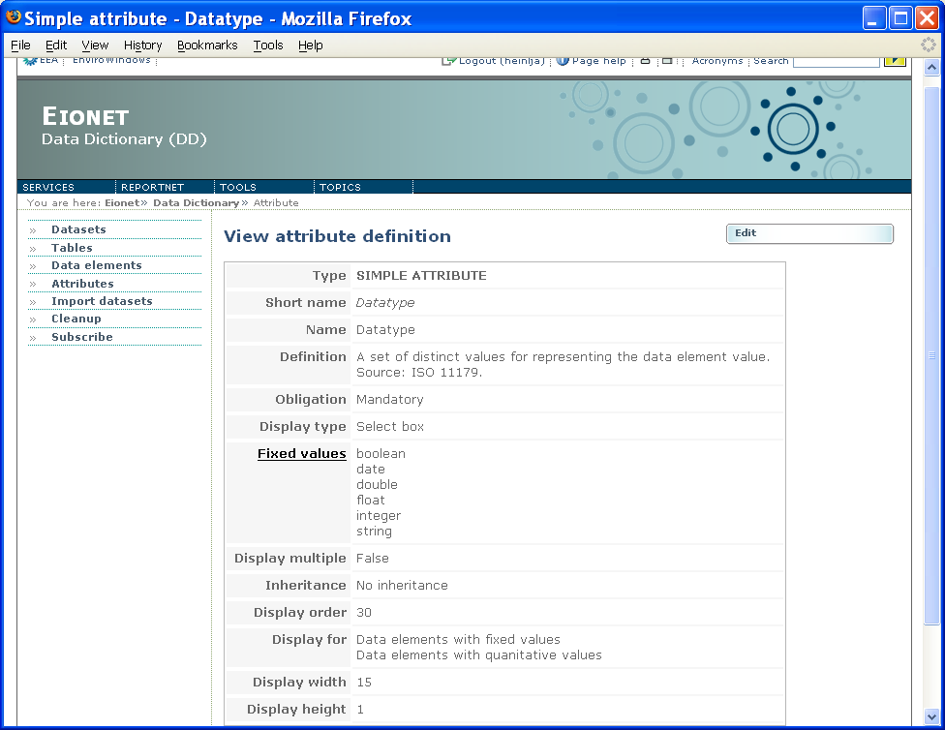Illustration 79: Simple attribute definition view

Simple attribute definition edit view
The view for editing a simple attribute’s definition can be reached by clicking the Edit button in the definition’s view page (see previous chapter). Compared to the latter, in edit page the attribute’s properties simply become editable, so no extra illustration given here. Some of the properties are mandatory to specify (marked with (M)) and some are optional (marked with (O)). The Save button submits your changes, Delete deletes the attribute, i.e. removes its existence. But be aware that only an attribute that is not used by any definition can be deleted!

Simple attribute definition adding view
The view for defining a new simple attribute can be reached by clicking Add attribute in the dynamic attributes list described above. This will open a page where you will have to specify if you want to define a new simple or new complex attribute. By choosing to define a simple attribute, you will finally reach the view for defining a new simple attribute. It looks almost exactly like the one for editing. The only difference is that here you must enter the attribute’s Short name. Keep in mind that it must be unique among all simple and complex attributes!
At the bottom of the page is an Add button, which creates the new attribute and leads you to its edit view. There you can continue editing the attribute’s properties and submit them by clicking Save. But you can also go straight to the attributes list to make sure if your newly created attribute has appeared there.

Defining complex attributes
A complex attribute definition view (Illustration 80) can be reached by clicking its Short name in the dynamical attributes list (see above). The definition view lists the attribute’s properties. A complex attribute can have the following properties:
- Short name (is part of an attribute’s unique identifier)
A character string by which the users refer to an attribute in different data definition views. It should be compact while still reflecting the attribute’s concept.
- Name
The full name of the attribute. Usually not used in data definition views, but more wide-spread in oral communication and documents.
- Context (is part of an attribute’s unique identifier)
Indicates if the attribute originates from ISO 11179 or is specific to DD.
- Definition
The attribute’s full definition (i.e. description of its meaning).
- Inheritance
Tells if and how the attribute’s value(s) is(are) inheritable from higher levels (i.e. from dataset level to table level and from table to element level).
- Display order
Indicates the attribute’s position in the overall attributes list and in the definitions of datasets/tables/elements.
- Linked harvester
Indicates the the value-harvester associated with this complex attribute. More on this is available in the chapter about harvested complex attributes below.
- Fields
This is the most important property of a complex attribute. It is the list of fields in this complex attribute. Each field has a Name and a Definition.
NB! Unlike simple attributes, complex ones do not have the Obligation property. They are almost always optional to specify for a definition. The only exception is the SubmitOrganisation attribute which is mandatory to specify for each and every new dataset or common element. Tables and non-common elements inherit SubmitOrganisation from the dataset!
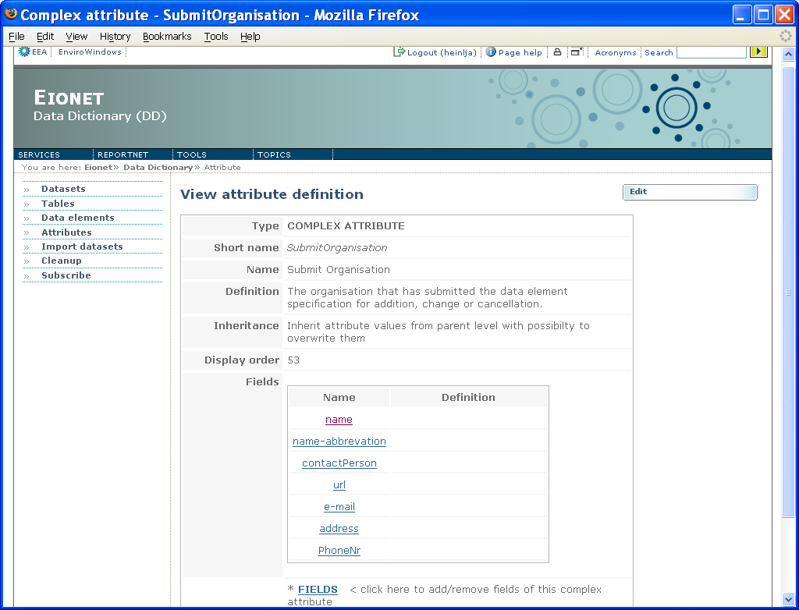Illustration 80: Complex attribute definition view

Complex attribute definition edit view
The view for editing a complex attribute’s definition can be reached by clicking the Edit button in the definition’s view page (see previous chapter). Compared to the latter, in edit page the attribute’s properties simply become editable, so no extra illustration given here. Some of the properties are mandatory to specify (marked with (M)) and some are optional (marked with (O)). The Save button submits your changes, Delete deletes the attribute, i.e. removes its existence. But be aware that only an attribute that is not used by any definition can be deleted!
For more on how to work with the Linked harvester property, see the chapter below about harvested complex attributes below!
More on how to work with definitions of the fields of a complex attribute is in a chapter below!

Complex attribute adding view
The view for defining a new complex attribute can be reached by clicking Add attribute in the dynamic attributes list described above. This will open a page where you will have to specify if you want to define a new simple or new complex attribute. By choosing to define a complex attribute, you will finally reach the view for defining a new complex attribute. It looks almost exactly like the one for editing. There are only two differences:
- here you must enter the attribute’s Short name. Keep in mind that it must be unique among all simple and complex attributes!
- here you cannot specify the attribute’s fields. You can do them via edit view later, but see a chapter below for more on how to do it exactly!
At the bottom of the adding page is an Add button, which creates the new attribute and leads you to its edit view. There you can continue editing the attribute’s properties, including the definitions of its fields. Or you can also go straight to the attributes list to make sure if you’re newly created attribute has appeared there.

Defining the fields of a complex attribute
The view for defining a complex attribute’s fields (Illustration 81) can be reached by clicking the [FIELDS < click here to add/remove fields of this complex attribute] link either in the attribute definition’s edit page or viewing page.
The view lists the already defined fields (if any) in 3 columns- the field’s Name, the field’s Definition and the field’s Priority. The latter specifies whether the field should be displayed in the definitions of datasets/tables/elements in order to save space on the page. A field with priority High is displayed, while the field with priority Low is not. In the detailed views of complex attributes of data definitions, however, all fields are always displayed.
You can remove the already defined fields by checking the boxes in front of those you want to remove and then clicking Remove selected.
You can also change the order in which they are displayed in the detailed views of complex attributes of data definitions. For that you have to click on the row of the field that you want to move (the click paints the row into light blue) and then use, use the classic moving icons on the right and finally click Save order to store the new order.
New fields can be defined by using the inputs and Add button above the list of already defined fields. There’s an input for the field’s Name and another one for the field’s Definition. Clicking Add creates a field with whatever you have entered and adds it to the bottom of the list of already defined fields.
A field’s Priority (as well as Definition) can be changed by clicking the field’s name in the list of defined fields. This will take you to the field’s details where you can change the Priority and the Definition and submit your changes by clicking Save. Clicking Delete will remove the field from existence.
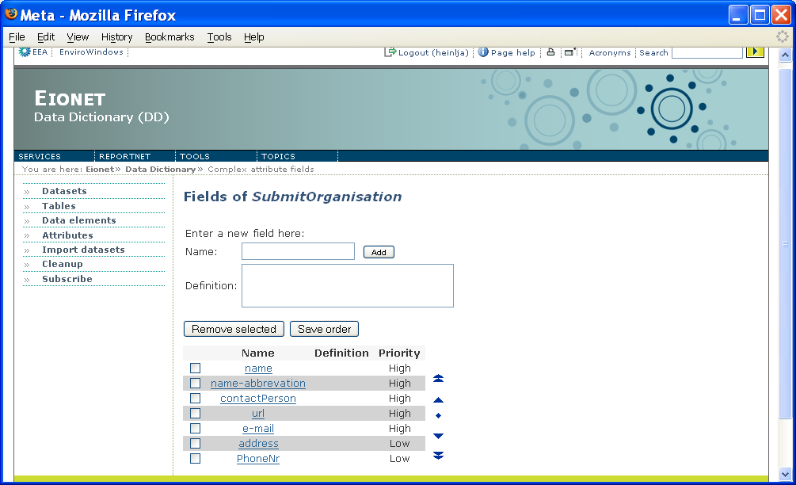Illustration 81: Defining the fields of a complex attribute

Deleting an attribute definition
As it was mentioned above, an attribute’s definition and usage can be removed from existence by clicking the Delete button in the attribute’s edit view, be it a simple or a complex attribute. So you must delete them one-by-one.
But be aware that only an attribute that is not used by any definition can be deleted! And usually attributes aren’t defined, unless they are also used. So it is a rare occasion that you must delete an attribute’s definition.

Attribute’s inheritance
Attribute inheritance means that, if defined so, an attribute of a definition of a table can inherit its value(s) from its datasets. Similarly, if defined so, an attribute of a definition of a non-common element can inherit its value(s) from its table and/or dataset. And the definition can be done in the edit views of attribute definition as it was described in chapters above. You must have noticed that in these views you can define an attribute to be not inheritable at all (the default) or you can choose between two types of inheritance for the attribute:
- Inherit attribute values from parent level with possibility to add new values.
This means that the attribute inherits its value(s) from parent level(s), but in addition to those it can also have some values of that level itself. In other words, such an attribute of the definition of a non-common element inherits values from its table and dataset, but in addition to those it could also have a couple of values of its own.
For example if Keyword is an attribute of such inheritance and Keyword ‘Marine’ has been defined at dataset level, keyword ‘Ocean’ has been defined at table level and keyword ‘Sea’ has been defined at element level, then:
the valid value for the dataset is ‘Marine’
the valid values for the table are ‘Marine’ and ‘Ocean’
the valid values for the element are ‘Marine’, ‘Ocean’ and ‘Sea’

- Inherit attribute values from parent level with possibility to overwrite them.
This means that the attribute inherits its value(s) from parent level(s). But the moment a value is added on that very level only, it overrides the value(s) inherited from upper levels and they are lost. For example the moment a new non-common element is defined, an attribute with such type of inheritance automatically acquires the values of the same attribute of its table and dataset. But the moment a new value is added, the latter are lost.

Harvested complex attributes
Imagine that you have specified one and the same Submitting Organisation (including for example its address and phone number) for many data elements, tables and datasets. Now all of the sudden the organisation’s phone number changes. You’d have to go through all the places where this organization has been specified and change the Phone Number field. This is very tedious. To help you out, DD enables to link selected complex attributes to values harvested from outside world. That outside world would most likely be some kind of LDAP directory. This way, whenever something changes in the latter, it will automatically also reflect in your complex attribute in DD. And you won’t have to enter the changes manually in all the different places.
DD can have several harvesters running in the background for you.
You can link a complex attribute to a certain harvester by using the ‘Linked harvester’ field in complex attribute definition edit view. See Illustration 82 below. It lists the currently available harvesters. Choosing ‘—no link –‘ means you don’t want the attribute to be linked to any harvesters (the default behaviour). Choosing a certain harvester means that whenever specifying this complex attribute for data elements, tables or datasets, you can choose its values from the ones harvested by the linked harvester. Later they will automatically change whenever something changes in the harvester source.
Once you’ve linked your complex attribute to a certain harvester and pressed Save, two things will happen:
- A Harvest button will appear next to the ‘Linked harvester’ field. By pressing this you can perform a harvesting session of the linked harvester. But be aware that depending on the network connection speed and the amount of harvested values this operation might take minutes. You should do this only when the linked harvester in the background has for some reason stopped working and you have an emergency situation!
- Your complex attribute’s fields will become “linkable” with the corresponding fields in the linked harvester. This is needed, because the fields of the linked harvester are not always the same as those of the complex attribute to which you linked it. So you can (and must) define mappings between the fields of your complex attribute and the linked harvester. This can be done by opening the list of your complex attribute fields (see above), going to each field’s editing view (figure 83) by clicking on its name and then choosing a linked harvester field from ‘Linked harvester field’ select box. You must link only those fields that the DD business logic defines as mandatory.
Currently DD has only one complex attribute harvester, which in the list of harvesters provided by ‘Linked harvester’ field is titled ‘Organisations harvester’. It harvests organisation data from EEA’s LDAP directory.
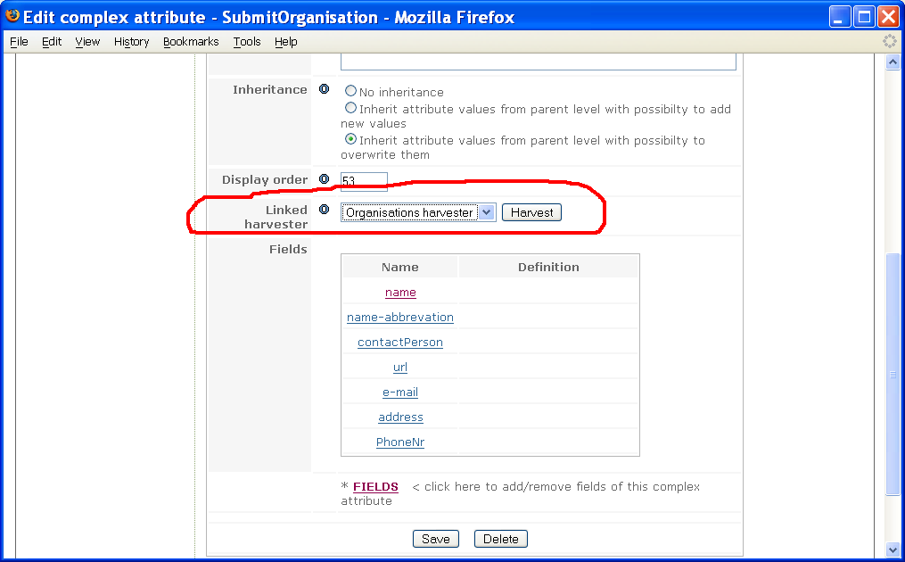Illustration 82: Linking a complex attribute with a harvester

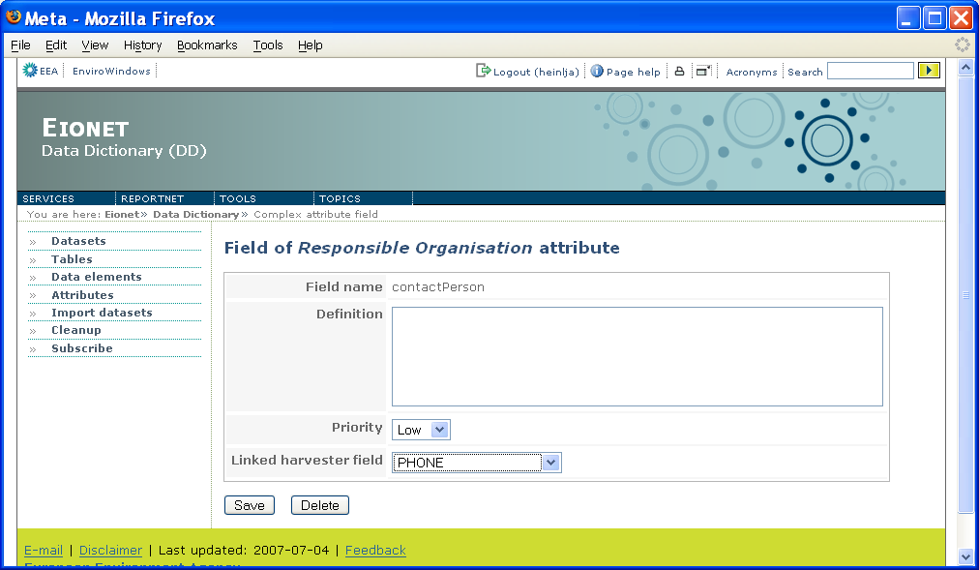Illustration 83: Linking complex attribute fields with linked harvester fields

The cleanup function
The Cleanup function enables to clean the database from all kinds of leftovers that might result from exceptional situations. It must be used with great caution, because one might accidentally delete some important data.
The function is reachable by clicking Cleanup button in the left panel. Naturally, it is visible and accessible only when the user has rights to perform the Cleanup function.
The Cleanup function page looks like on Illustration 84:

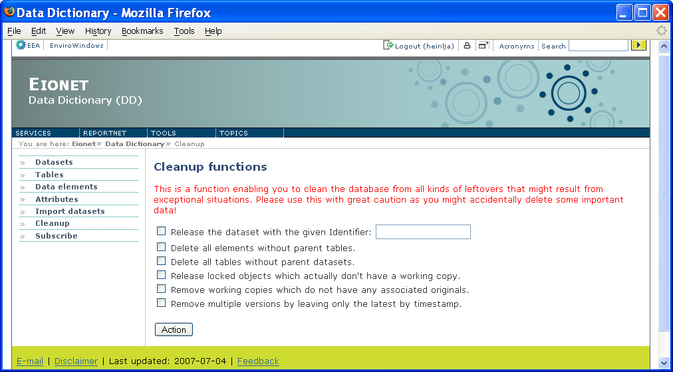Illustration 84: The cleanup function
You can select the following operations:
- Release the dataset with the given Identifier
This is to be used when a dataset is locked, but it is actually not checked out and nor does it have any tables or elements checked out.
- Delete all elements without parent tables
This deletes all elements that have a link to a table, which doesn’t actually exist. This might happen if a table gets deleted, but its links to elements do not.
- Delete all tables without parent datasets
This deletes all tables that have a link to a dataset, which doesn’t actually exist. This might happen if a dataset gets deleted, but its links to tables do not.
- Release locked objects which actually don’t have a working copy
This one deletes all such elements, tables and datasets that are checked out, but don’t have a working copy.
- Remove working copies which do not have any associated originals
This one is sort of opposite to the previous one. It deletes all working copies of elements, tables and datasets that don’t have the original that was actually checked out.
- Remove multiple versions by leaving only the latest by timestamp
If a logically unique element, table or dataset has several instances of one and the same version (for example there are 3 instances of version 1 of element X) then this function leaves only the instance latest by creation time. By version we mean the CheckInNo.

Selected operations will be executed by pressing Action.
NB! Normally the Cleanup user does not actually have to understand the essence of the above functions. If selecting all functions, DD takes care of performing them in the safest order. This should result in the total cleanup of all currently identified abnormalities

Import tool
Import tool is an MS Access-based utility enabling to define datasets, tables and data elements (but not attributes!) in a flat table and then afterwards populate the definitions into DD database, using XML as an intermediate format. The reason for such a tool is simply because when entering large amounts of definitions, a flat table might be handier than the web-based user interface with its many different views and clicking back and forth in between them. To find out more about the import tool and it’s purpose please read the detailed design document. The following chapters will give an overview about the functionality of import tool and some guidance about how to use it.

Table structure
There are 4 main tables, one link table and one lookup table in MS Access import tool:
- DATASET – stores dataset’s auto generated id, identifier, short name and attributes
- DS_TABLE – stores table’s auto generated id, link to dataset, table identifier, short name and attributes
- DATAELEM – stores data element’s auto generated id, identifier, short name, type and attributes
- FIXED_VALUE – stores fixed value’s auto generated id, link to data element, value and attributes
- TBL2ELEM – link table for linking data elements and tables
- DATAELEM_TYPE – lookup table for storing data element type’s codes and descriptions.
The main tables have attributes, which are taken from DD and converted into tabular formats. One attribute is one column in the table. The attribute names in the tables should be the same as in DD e.g. there is a column Definition in DATASET table and there is also Definition attribute in DD for dataset.
For complex attributes, it is a little bit different as complex attributes may have several fields and several values. We have used some kind of simplification in the import tool. For example, if there is an attribute Guidelines with fields Url and Description, then in Access tables the corresponding fields would be: Guidelines_Url_1 and Guidelines_Description_1. If there should be two guideline attributes, then the number should be incremented: Guidelines_Url_2 and Guidelines_Description_2.
Next chapters will give an overview about the table’s fields in the import tool.

DATASET table
DATASET table has auto-generated id DATASET_ID. This field is required for linking tables and datasets and the user cannot change this value. The following table gives the brief descriptions of the fields in the DATASET table.

Field name | Description | Data type | Field size
SHORT_NAME | This is the technical/abbreviated name of the dataset | Text | 20
Version |  | Text | 20
Name | Single or multi word designation assigned to a data element. Source: ISO 11179 | Text | 255
Identifier | The unique identifier used in DD and described above in the chapter of concepts. | Text | 50
ShortDescription | Brief text about the content | Text | 255
Definition | Statement that expresses the essential nature of a dataset and permits its differentiation from all other datasets. Source: ISO 11179 | Text | 1000
DescriptionOfUse | Brief description of common/ anticipated use | Text | 1000
Theme | Predefined list of themes | Text
Sub-theme | Predefined list of sub-themes. This describes where in the hierarchical thematic structure the dataset belongs/is placed | Text
Keywords | One or more significant words used for retrieval of data elements. Source: ISO 11179. | Text | 1000
SynNames_name_1 | Other common name | Text | 255
EEAissue_name_1 | Predefined list of issues as used by EEA | Text | 255
Methodology | Brief description of methodology | Text | 1000
PlannedUpdFreq | Planned updating frequency of the dataset | Text | 255
References | References on more information about the definition of dataset sub elements of reference | Text | 1000
RegistrationAuthority_name_1 | institution in charge of the specification | Text | 255
Guidelines_url_1 | Guideline link to document | Text | 255
Guidelines_description_1 | Guideline’s description | Text | 1000

DS_TABLE table
DS_TABLE has two system fields - auto generated id DATASET_ID and link to the dataset DATASET_ID. The first field is required for linking tables and data elements and user cannot change this value. DATASET_ID is actually displayed for the user as a select box with datasets’ short names. The following table gives brief descriptions of the other fields in DS_TABLE table.

Field name | Description | Data type | Field size
SHORT_NAME | This is the technical/abbreviated name of the dataset | Text | 40
Name | Single or multi word designation assigned to a data element. Source: ISO 11179 | Text | 255
Definition | Statement that expresses the essential nature of a dataset and permits its differentiation from all other datasets. Source: ISO 11179 | Text | 1000
Methodology | Brief description of methodology | Text | 1000

DATAELEM table
DATAELEM table has auto-generated id DATAELEM_ID. This field is required for linking data elements to tables and fixed values. Its type is a field with values specified in DATAELEM_TYPE table. The following table gives brief descriptions about the other fields in DATAELEM table.
Field name | Description | Data type | Field size
SHORT_NAME | This is the technical/abbreviated name of the data element | Text | 50
Name | Single or multi word designation assigned to a data element. Source: ISO 11179 | Text | 255
SynNames_name_1 | Other common name | Text | 100
Definition | Statement that expresses the essential nature of a data element and permits its differentiation from all other data elements. Source: ISO 11179 | Text | 1000
Datatype | A set of distinct values for representing the data element value. Source: ISO 11179. | Text | 50
MinValue | Data element minimum value | Integer
MaxValue | Data element maximum value | Integer
DecimalPrecision | Number of digits after comma | Integer
MinSize | The minimum number of storage units to represent the data element value. Source: ISO 11179. | Text | 50
MaxSize | The maximum number of storage units to represent the data element value. Source: ISO 11179. | Text | 50
Methodology | Brief description of methodology | Text | 1000
Identifier | A language independent unique identifier of a data element within a Registration authority. Source: ISO 11179. | Text | 50
Version | Version of the element definition | Text | 25
ShortDescription | Brief text about the content of the element | Text | 100
Unit | Unit of which data element value has been measured | Text | 50
RegStatus | A designation of the position in the registration life cycle of a data element. Source: ISO 11179. | Text | 50
References | References on more information about the definition of dataset sub-elements of reference | Text | 255
Keywords | One or more significant words used for retrieval of data elements. Source: ISO 11179. | Text | 1000
EEAissue_name_1 | Predefined list of issues as used by EEA – 1 | Text | 255
Guidelines_url_1 | Guideline link to document | Text | 255
Guidelines_description_1 | Guideline’s description | Text | 1000
RegistrationAuthority_name_1 | Institution in charge of the specification | Text | 255

FIXED_VALUE table
FIXED_VALUE table has auto-generated id FIXED_VALUE_ID. Users cannot change this field, because that is system field. DATAELEM_ID is a link to data element. Users can see the data element name and not the real value there. The following table gives brief descriptions about the other fields in FIXED_VALUE table.

Field name | Description | Data type | Field size
VALUE | This is the technical/abbreviated name of the data element | Text | 255
DEFINITION | The definition of the fixed value | Text | 1000
SHORTDESCRIPTION | Short description of the fixed value | Text | 255

Copying a large amount of values into FIXED_VALUE table is a typical problem when you have your values ready somewhere in another table, possibly in another program too. Suppose you want to copy and paste values for an element called EUNIS_hab. Follow the next procedure:
You go to the fixed values table of EUNIS_hab element. It opens when you press 'Data elements' on the main form and go to the row of EUNIS_hab. In the left-most column you click the plus sign. That opens the fixed values of EUNIS_hab.
Now you go to the program and table where you have EUNIS_hab values ready. We assume you got the columns of values and definitions right next to each other (values left, definitions right). You select both columns and do Ctrl+C..
Now you go back to EUNIS_hab fixed values that you opened in Import tool. In the new row (where the AutoNumber is waiting) you select Value and Definition cells. You do this by clicking in the Value cell. No you point the mouse over the blinking cursor. The mouse pointer should look like the medical cross now. You hold down shift and press the left mouse button. Value becomes selected. Keep the shift down and left-click in the Definition. The latter becomes selected as well. Now press Ctrl+V and the values you copied above will be pasted into EUNIS_hab fixed values table.
That should be it.

TBL2ELEM table
This is the link table and ordinary users shouldn’t know much about this table. The most important fields are TABLE_ID and DATAELEM_ID. These ones tell in which the data element belongs to. The other fields are not in use currently.

Insert data
In this chapter we look step by step, how to insert the data definitions about one dataset into the import tool. All the definitions should be inserted straight to the tables or queries. This way of implementation decreases checking possibilities of inserted data definitions to minimum. But on the other hand it’s very easy to copy and paste the data definitions into tables by selecting multiple rows. Tables have easy sorting possibilities by clicking on the top of the column with right button and selecting ascending or descending. To delete the data, select the row or rows by clicking on the left most column and pressing Delete button.

Main form
There is a special ‘Main’ form (Illustration 85), where it is easier to reach the data tables. The form is opened automatically at start up and it has 5 buttons. Click on Datasets, Tables or Data elements button will open the corresponding table, where it’s possible to insert data definitions. The Make xml button will open the form, where it’s possible to generate xml file with inserteddefinitions. And the button in the downside right corner will close the application.
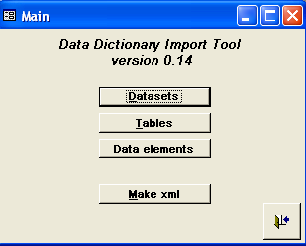Illustration 85: Main form

Add a new dataset definition
The first thing is to define dataset. As mentioned before, all the data about datasets is stored in DATASET table. Select Tables from the left-hand pane and table click on that table. New dataset can be inserted into the last row of the table. DATASET table is described on Illustration 86.
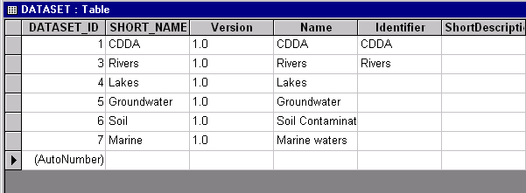Illustration 86: DATASET table

Add a new table definition
For adding a new table definition into a dataset, please open the dataset table’s table by double-clicking on DS_TABLE. The first thing to do is to select the dataset, where does the new table belong. And then add all the attributes as needed. Pay attention to the + signs in the left most column. These ones open a data elements table inside DS_TABLE and it’s possible to see right away which data elements are belonging into the selected table.
DS_TABLE is described on Illustration 87.
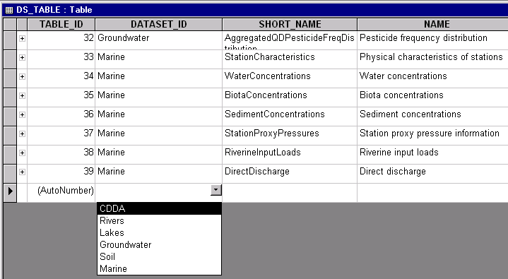Illustration 87: DS_TABLE table

Add a new data element definition and fixed values
Data element definition is related to a table and fixed values. That is the reason, why it is not convenient to insert the data into DATAELEM table, but special query is created for that. Please select Queries on the left-hand panel and open q_DATAELEM query. DATAELEM_ID is auto generated and user should not pay attention to that field. TABLE_ID is select box, where user can select the table name, where the data element belongs. And other fields are exactly the same as described in DATAELEM table above. The left most column contains the + sign. It opens the fixed values subsheet by clicking on that. Be sure that TYPE = CH1, before you will insert the fixed values.
Q_DATAELEM query is described on Illustration 88.

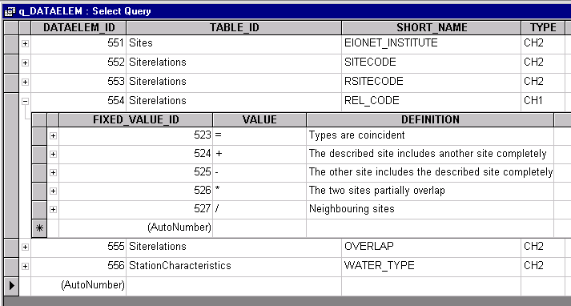Illustration 88: q_DATAELEM query

Generate XML file
It is possible to generate two types of XML files:
- All datasets
This is for generating an XML file with all the data inserted into the database. It means that all the datasets and their components (tables, datasets, dataelements and fixed values) are involved in the xml file.
- Code list
This is for generating an XML file that will contain only fixed values (code list) of a selected data element and nothing else. In other words this the option to use if you only want to Import the fixed values of a selected data element and no other information from Import tool.
Once you select the Code list option, you will be provided with a drop-down list of elements form where you select the element whose values you want to import. Make sure you select an element! The list has only elements of fixed values type. For making the selection easier the data elements are displayed together with dataset and table name.
Once you have chosen the type of XML generation you want, you must write down the location and file name, where the file should be generated (e.g. C:\Temp\importtables.xml) and press Generate button. The generating process may take some time, if there are many rows in the database tables. After finishing the process, a message box appears and lets the user know about the results.
Close button closes the form. For changing the default file name displayed on the form, please click on the ‘Change default file’ button. A new table is opened, where the file name is stored. Read more about that in the next chapter.
XML generation form is described on Illustration 89.
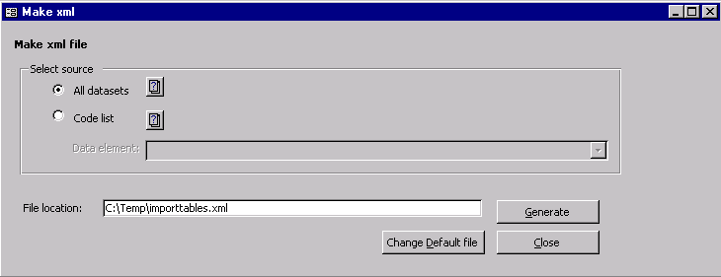Illustration 89: Make xml form
Once the XML has been generated, the user uploads it into DD, using the corresponding form in DD user interface and the importing code transports it all into the DD database. The import web page has been described above.

Setup data
SETUP_DATA table stores the default file location and file name, where to generate XML file. If the file destination is the same every time, then it’s handy to use setup data table. If you store the filename and location info into this table, then next time the name will appear on the xml form.
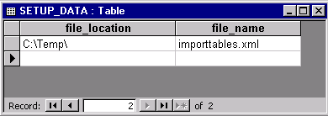Illustration 90: Setup data

Importing the data into DD
The generated XML file you can import into DD by pressing the Import datasets button on the left panel (it will become visible after you have logged in). As a result, you will be presented with a form (Illustration 91) where you can upload the generated XML file. You can either locate the file on your local file system or type the URL from where the DD should download this file. In both cases you submit your data definitions by pressing the Import.
Currently it is possible to import only the definitions of whole datasets and not tables or data elements separately. If there is already a dataset with the same name, then it should be deleted first or the new one should be renamed.
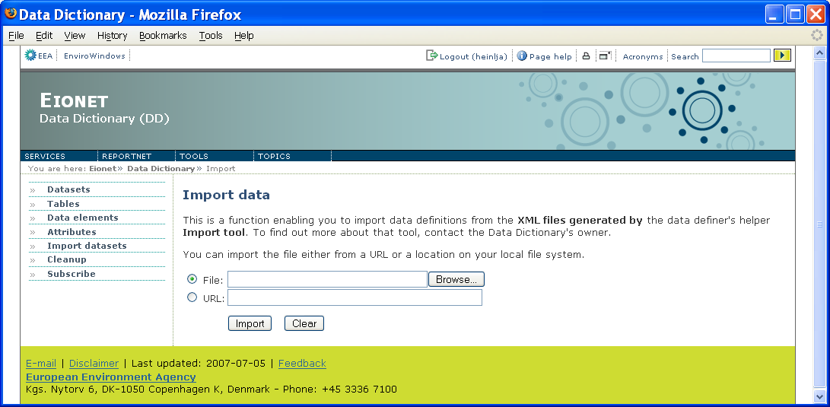Illustration 91: Data import view in DD user interface

Import results
The result of the import is a log with messages as plain text. The page starts with errors and warnings. Most commonly the errors are caused from duplicate entries or database connections. And warning messages tells that some of the mandatory attributes do not have values. Please remember that this is just a warning and the values can be inserted later on the web pages. Please find the possible messages and their descriptions from the following table. Besides these error messages, there might be XML parsing messages.
A link at the top of the page enables to save the listed import results into a PDF file.
Message | Description
Not authorized to store data! | User has not logged in or the session is expired. Please log in again.
Could not find mandatory attribute (Identifier) value from specified xml for dataset - Lakes! | Mandatory attribute field was empty in XML file. This is just a warning. The value can be inserted later on web forms.
Dataset import failed! Could not store dataset into database - CDDA  java.sql.SQLException: A dataset with this identifier and version already exists! | There is already a dataset called CDDA. This means that all the tables and data elements within CDDA dataset have not imported either. Please delete the old dataset or rename the new one.
Dataset id was not found for table: Designations | The message is caused by previous error. The table could not be imported since the corresponding dataset were not imported
Dataset import failed! Could not store data element into database - YEAR  java.sql.SQLException: identifier or namespace not specified! | The message is caused by previous errors. The data element could not be imported since the corresponding dataset and table were not imported.
Data element id was not found for fixed value Annual | The message is caused by previous error. The fixed value could not be imported since the corresponding data element was not imported.
Data element id was not found for complex attribute | The message is caused by previous error. The complex attribute could not be imported since the corresponding data element was not imported.

The second part of the page is information about the import results in numbers. It tells how many datasets, tables and data elements were found from XML file and how many of them were successfully imported.
The third part lets the user know, if there were any unknown attributes in the XML file. If there are any, then these should be defined in the DD by the user. These are not automatically updated.

Importing fixed values only
As it was hinted for many times above, you can use Import tool for importing only the fixed values of a selected data element and nothing else. But since it’s a much needed feature, it deserves a closer look. Step-by-step, the procedure is as follows:
- If you have a large amount of fixed values for some data element ready in another application in some kind of table, you can copy and paste them into the tool’s FIXED_VALUE table as described in the FIXED_VALUE table chapter above.
- Once you have the values of your target element ready and entered into FIXED_VALUE table, you can generate them into an XML file by choosing the ‘Code list’ option in the tool’s ‘Generate XML’ form (see above chapters about the main form and XML generation form).
- As a result of step 2, you will have an XML formatted file containing the fixed values of your target element. Now you go to the element’s fixed values list in DD User Interface (see chapters for fixed values lists). In there you should see a button titled ‘Import’. Click the button and DD will guide to the import page. That’s where you select the file generated in step 2 and press Import.
Since you came from a specific data element’s fixed values view, DD knows that it’s a fixed values import and it knows the element you want to import for.

Limitations
NB! There are some important limitations to the Import tool that you should know:
- The tool does not have a link to DD database. This means that its model is not automatically self-updating when the model in the DD database has changed. The most concrete example can be given on the basis of attributes. In Import tool they are represented as columns in the tables worked with. In other words the attribute set in Import tool has been hard-coded. While in the DD database attributes are defined in rows, rather than in columns. This finally means that whenever a new attribute is added to the DD database, or an existing one is changed or deleted, it will not automatically reflect in Import tool and the changes must be done by hand. This sounds like quite a drawback, but luckily the changes do not concern the code. Only a new column has to be added/removed to/from a selected table.
- Whenever the user induces an XML generation, all the contents of tool’s database at that moment will be generated into XML.
This means that if the user has defined several different datasets, but wants to import only one of them into DD, he/she has to create a separate instance of the tool for that dataset and use that instance for entering and importing the definition of the desired dataset.
So it is highly recommended that before you start entering any definitions into the Import tool, make it clear if you want to actually import only some of them. And if so, create a separate tool instance for those.
While this might sound rather primitive, creating a separate instance of Import tool is luckily rather easy. Because Import tool is just another MS Access file (.mdb) and all you have to do is to make a copy of it.

Making your own XML
If you already have your dataset definition in a database, you can write a script to generate the XML file and then import it.
The general format is like this:
<?xml version="1.0" encoding="UTF-8"?>
<import name="datasets">
<RowSet name="Dataset">
<DATASET>
<Row>
<DATASET_ID>4</DATASET_ID>
<Identifier>MYID</Identifier>
<SHORT_NAME>shortname</SHORT_NAME>
<Version>1</Version>
<Name>name</Name>
<ShortDescription></ShortDescription>
<Definition></Definition>
<RegStatus></RegStatus>
<Keyword_1></Keyword_1>
<Keyword_2></Keyword_2>
<Keyword_3></Keyword_3>
<Keyword_4></Keyword_4>
<Keyword_5></Keyword_5>
<Keyword_6></Keyword_6>
<Keyword_7></Keyword_7>
<Keyword_8></Keyword_8>
<Keyword_9></Keyword_9>
<EEAissue_1></EEAissue_1>
<EEAissue_2></EEAissue_2>
<EEAissue_3></EEAissue_3>
<EEAissue_4></EEAissue_4>
<ROD_name_1></ROD_name_1>
<ROD_url_1></ROD_url_1>
<Methodology></Methodology>
<PlannedUpdFreq></PlannedUpdFreq>
<Guidelines_url_1></Guidelines_url_1>
<Guidelines_description_1></Guidelines_description_1>
<Guidelines_url_2></Guidelines_url_2>
<Guidelines_description_2></Guidelines_description_2>
<RegistrationAuthority_name_1></RegistrationAuthority_name_1>
<RegistrationAuthority_name-abbrevation_1></RegistrationAuthority_name-abbrevation_1>
<RespOrganisation_name_1></RespOrganisation_name_1>
<RespOrganisation_name-abbrevation_1></RespOrganisation_name-abbrevation_1>
<SubmitOrganisation_name_1></SubmitOrganisation_name_1>
<SubmitOrganisation_name-abbrevation_1></SubmitOrganisation_name-abbrevation_1>
<SubmitOrganisation_url_1></SubmitOrganisation_url_1>
<SubmitOrganisation_PhoneNr_1></SubmitOrganisation_PhoneNr_1>
</Row>
</DATASET>
</RowSet>
<RowSet name="DS_Table">
<DS_TABLE>
<Row>
<TABLE_ID>3</TABLE_ID>
<DATASET_ID>4</DATASET_ID>
<Identifier>tableid</Identifier>
<SHORT_NAME></SHORT_NAME>
<NAME></NAME>
<Definition></Definition>
<Methodology></Methodology>
<ShortDescription></ShortDescription>
</Row>
</DS_TABLE>
</RowSet>
<RowSet name="tbl2elem">
<TBL2ELEM>
<Row>
<TABLE_ID>3</TABLE_ID>
<DATAELEM_ID>92</DATAELEM_ID>
</Row>
</TBL2ELEM>
</RowSet>
<RowSet name="Dataelem">
<DATAELEM>
<Row>
<DATAELEM_ID>92</DATAELEM_ID>
<Identifier>elemid</Identifier>
<SHORT_NAME></SHORT_NAME>
<GIStype></GIStype>
<NAME></NAME>
<TYPE>CH2</TYPE>
<Definition></Definition>
<Datatype></Datatype>
<MinValue></MinValue>
<MaxValue></MaxValue>
<DecimalPrecision></DecimalPrecision>
<MinSize></MinSize>
<MaxSize></MaxSize>
<Methodology></Methodology>
<Unit></Unit>
<Keyword_1></Keyword_1>
<Keyword_2></Keyword_2>
<Keyword_3></Keyword_3>
<Keyword_4></Keyword_4>
<Keyword_5></Keyword_5>
<Keyword_6></Keyword_6>
<Keyword_7></Keyword_7>
<Keyword_8></Keyword_8>
<Keyword_9></Keyword_9>
<EEAissue_1></EEAissue_1>
<EEAissue_2></EEAissue_2>
<EEAissue_3></EEAissue_3>
<EEAissue_4></EEAissue_4>
<Guidelines_url_1></Guidelines_url_1>
<Guidelines_description_1></Guidelines_description_1>
<Guidelines_url_2></Guidelines_url_2>
<Guidelines_description_2></Guidelines_description_2>
</Row>
</DATAELEM>
</RowSet>
<RowSet name="Fixed_value">
<FIXED_VALUE>
</FIXED_VALUE>
</RowSet>
</import>

- The five RowSets must exist even if they are not used. But generally, the elements you don't use need not be present in the file.
- All dataset, table and dataelem ids will be changed on import to avoid overwriting existing records.
- The tbl2elem table establishes a many-to-many relation between a table and a data element. However, currently, if you use a data element twice in two tables, the second occurrence will be silently ignored.
- You can't create common elements with this tool.

