Project / Subproject  IDA/EINRC framework 501998  Specific Agreement-7/EIONET | Authors  TietoEnator Corporation | Date issued / Version  02 April 2004/0.4 | Design Report
Client  European Commission  DG Enterprise / B 6 | Info  Detailed Design of Data Dictionary |  | Reference / Page  0000.doc  / 1 of 45

EUROPEAN COMMISSION

ENTERPRISE DIRECTORATE-GENERAL

IDA-Programme -Framework Contract No 501 998 - 7th Specific Agreement

Einrc - Eionet

Detailed Design
Data Dictionary


Modification history
Date | Version | Author | Reason for modification
24.03.2003 | 0.1 | J.Heinlaid | First Draft
09.04.2003 | 0.2 | J.Heinlaid | Updated incorporating changes requested by project leader
12.12.2003 | 0.3 | J.Heinlaid | Updates documenting developments done within SA-6
02.04.2004 | 0.4 | J.Heinlaid | Documentation of changes since the end of SA-6
09.11.2004 | 0.5 | J.Heinlaid | Documentation of DD releases 2.2, 2.3 and 2.4 in SA-7

APPROVAL PROCEDURE
Reviewer | Version | Start  Date | Finish  Date | Required modification/Approval/Comments
Project Team
Proj. Leader
CMT review
Commission/Project Officer's Approval

Background material:

A1: ' Data Dictionary: Current Situation and User Requirements' document from SA-5
http://nmc.eionet.eu.int:8980/Members/irc/eionet-nmc/einrc/library?l=/einrc_sa5_2002/dd/dd_ur_v1_2_doc/_EN_1.0_&a=d
A2: 'Data Dictionary: Software Requirements and Architectural Design' document from SA-5
http://nmc.eionet.eu.int:8980/Members/irc/eionet-nmc/einrc/library?l=/einrc_sa5_2002/dd/dd_sr_ad_v1_doc/_EN_1.2_&a=d
A3: 'Data Dictionary - part of REPORTNET' document, created by Arvid Lillethun
http://nmc.eionet.eu.int:8980/Members/irc/eionet-nmc/einrc/library?l=/einrc_sa5_2002/dd/021213_dictionary/_EN_1.0_&a=d
A4: 'Data Dictionary: Current Situation and User Requirements' document from SA-6
http://nmc.eionet.eu.int:8980/irc/DownLoad/cgut1gLBhpL0qe4m4KSm4q-eqGZ0EHm1pU5R978bRspj2601d-q5vk0j3lG4u1LfGpxAoMfGZ0o/DD%20UR%20031003v01.doc
A5: 'Data Dictionary: Current Situation and User Requirements' document from SA-7
http://nmc.eionet.eu.int:8980/irc/DownLoad/cjuy1ULHhoLtqu4f4TS34P-Cqc2CGFle3rjF4t4-ZU-C784CfZ5SbNfZsTR6Fh-qMZq69-QXC4/DD%20SA-7%20UR%20v0.2.doc
A6: 'DD: Project Management Plan' document from SA-7
http://nmc.eionet.eu.int:8980/irc/DownLoad/c5uG1hLVhRLFqt444NS345-6quCw0XLNZRc9YW4Gotp9pLkcH-jPb20s-pAhF5AjDs46S0Us-xHQK/DDPMP%20v1.0.doc
A7: Task lists for DD releases in DD folder of EINRC/NMC library:
http://nmc.eionet.eu.int:8980/Members/irc/eionet-nmc/einrc/library?l=/einrc_sa7_2004/dd&vm=detailed&sb=Title
Table of Contents

Foreword 6
1. Objectives and scope 8
2. Concepts 11
2.1 Dataset 11
2.2 Table 11
2.3 Data element 11
2.4 Attribute 13
2.5 Namespaces 14
2.6 GIS tables & elements 15
2.7 User groups 15
2.7.1 Data reporters 15
2.7.2 Data definers 16
2.7.3 DD administrators 16
3. Functionality overview 17
3.1 All-users functionality 18
3.2 Data definers and administrators functionality 19
3.3 Administrators-only functionality 20
4. Database model 21
5. Business rules 24
5.1 Unique identification of datasets, tables & elements 24
5.2 Versioning of data definitions 24
5.3 Registration statuses 25
5.4 Working copies and definitions in work 26
5.5 Details of the database model 26
5.5.1 table: DATASET 27
5.5.2 table: DS_TABLE 28
5.5.3 table: DATAELEM 28
5.5.4 table: DST2TBL 29
5.5.5 table: TBL2ELEM 30
5.5.6 table: M_ATTRIBUTE 30
5.5.7 table: M_COMPLEX_ATTR 32
5.5.8 table: M_COMPLEX_ATTR_FIELD 33
5.5.9 table: ATTRIBUTE 33
5.5.10 table: COMPLEX_ATTR_ROW 34
5.5.11 table: COMPLEX_ATTR_FIELD 34
5.5.12 table: NAMESPACE 35
5.5.13 table: FXV 35
5.5.14 table: FK_RELATION 36
5.5.15 table: HARV_ATTR 36
5.5.16 table: HARV_ATTR_FIELD 37
5.5.17 table: DOC 38
5.5.18 table: CACHE 38
5.5.19 table: ROD_ACTIVITIES 39
5.5.20 table: DST2ROD 39
5.5.21 tables: ACLS and ACL_ROWS 40
5.5.22 tables: HLP_SCREEN and HLP_AREA 40
6. Implementation 41
6.1 System architecture 41
6.2 Directory structure 42
6.3 The DD Java code 43
6.3.1 Class hierarchy 43
6.3.2 Used external libraries 44
6.4 The DD web 46
6.4.1 Java Servlet Pages 46
6.4.2 Static HTML 47
6.4.3 Javascript 47
6.4.4 Cascading StyleSheets (CSS) 47
6.4.5 XML-RPC service descriptor 47
6.5 XML-RPC methods 47
6.6 User authentication & Access Control Lists (ACL) 48
6.7 Dynamical Online Help (DynOHelp) mechanism 49
6.8 Configuration Error! Bookmark not defined.
6.9 Import tool 49
7. Configuration & installation 55
7.1 Configuring DD web 55
7.1.1 Servlets 55
7.1.2 Context parameters 56
7.2 Configuring DD application 57
7.2.1 eionetdir.properties 57
7.2.2 log4j. properties 57
7.2.3 teXDBMsg.properties 57
7.2.4 uit.properties 57
7.2.5 datadict.properties 58

Foreword
This document presents the detailed design of the Data Dictionary (DD) system, which by the end of SA-7 has reached its operational stage and contains the first publicly released content. Therefore no changes to the major design concepts are expected in the system and in this document. However, if the system will be updated during support phases, those updates might also become reflected in this document if found significant enough. Still, the documentation of basic design principles and implementations that have not changed for quite some time and that are not very likely to substantially change in the future as well, has been provided here. Most notably it includes:
- basic types of data that the DD handles,
- description of DD's main use cases and working sequences,
- all the functionality that the DD provides (note that this document contains only the list of functions which are covered in more detail in the user guide document),
- data model framing the concepts and functionality,
- business logic rules,
- basic principles and technical documentation of how it has all been implemented,
- technologies used in implementing DD.

The document is closely related to the background material listed above:

- The basic concepts and the functionality that the DD handles are mostly based on user requirements set in A1, A4 - A7
- A2 has been the basis of the general layout of DD's User Interface, of its data model, technical architecture and of how it handles the support for XML Schema formatted definitions and ISO11179.
- A3 and A6 is the sole basis of principles on how the DD handles the concrete and realistic business needs of Reportnet currently. Meaning the functionality and concepts circling around datasets and tables, import/export formats based on Microsoft and selected pilot content.

In a way this document can be seen as a consolidation of the above background material.

Objectives and scope
Objective
Data Dictionary is to become a web-based data semantics registry for the Reportnet. It will hold definitions of datasets, tables and data elements exchanged over the Reportnet, whether by humans or applications. These are called data definitions and DD will provide functions to import such definitions in a machine-readable form, manage them through a web-based user interface and export them both in machine and human readable formats. An API for other applications to perform selected operations shall be included as well.
Data Dictionary shall follow the common standards, technologies and recommendations in data semantics field as much as concrete business needs make it possible. The main standard of those is ISO 11179.

Scope
The following scope has been implemented by the end of Specific Agreement-7:

- A database model supporting about ~70% of the data semantics functionality suggested by ISO11179 (http://www.diffuse.org/meta.html - ISO11179):
- Part 1 (Framework for the specification of data elements)
- Part 2 (Classification for Data Elements)
- Part 3 (Basic Attributes of Data Elements)
- Part 5 (Naming and Identification Principles for Data Elements)
Part 4 about "Rules and Guidelines for the Formulation of Data Definitions" and part 6 about "Registration of Data Elements" are not directly followed, as found cumbersome for DD needs.
NB! Note that the above listed implemented parts have not been implemented to their fullest. It would be more appropriate to say that they have been used as the main source of inspiration for coming up with DD functionality and data model. But some parts have been copied almost one-to-one, like for example the basic set of attributes of data definitions (part 3).
- On top of the ISO functionality-compliant data model, a user interface for
- managing definitions of datasets,
- managing definitions of tables,
- managing definitions of data elements,
- managing definitions of metadata (i.e. attributes in DD terminology)
- Transparently for the user, support for representing any of these definitions in XML Schema format has been implemented. However, only a fraction of XML Schema specification is supported, because building a web-interface for managing XML Schema to its full specs was not the object of DD. Supported are:
- declaration of elements
- element annotations
- value domain annotations
- simple types
- restrictions based on simple types
- complex types
This XML Schema fraction is supported both in the UI and export function. Note that aggregate data elements are not supported in DD. XML Schema complex types, sequences and choices have been used to represent the hierarchical structure of datasets > tables > data elements.
- To enable comfortable data definition process, a trivial Import tool was implemented, based on MS Access and enabling to manage definitions in a flat table format. The tool generates XML of whatever has been entered into its tables and the XML is then finally imported into DD database.
- By the end of SA-7 DD database has been filled with real data definitions, of which several have already reached the status of being released for the public and ready for use in Reportnet business process.
- DD is supplemented with documents helping to support its usage, installation and understanding:
  - User Guide document for data reporters and data definers
  - Installation guide for those about to install the software
  - the current document for helping to understand how DD is built

Concepts
Note that this chapter repeats the same chapter from User Guide document, so if you’ve read the latter, you may pass this chapter.
Data Dictionary holds definitions of datasets, tables and data elements exchanged over the Reportnet. Each of these three main objects is defined by a set of attributes, the core set of which corresponds to ISO 11179 standard for describing data elements. The whole attribute set is flexible and an administrator can dynamically add/remove attributes from/to the system.

Dataset
In Reportnet and DD's context a dataset is a collection of tables containing the reported data. Often the "tables" will actually recede to a single table only. In a way DD datasets are stand-alone databases. Usually they come as MS Access databases or MS Excel files. They are subject to certain data flows and obliged to be reported by Reportnet players according to legislation. In many cases a dataset corresponds to a dataflow. For example there is the CDDA dataset defined in DD, which contains the information about reported data within that same-named data flow.

Table
A table in DD's context is a table in dataset. Columns in a table stand for data elements, rows stand for their values.

Data element
A data element in Data Dictionary's context is a column in a table. Figure 1 provides a visual representation of what a table and its elements (columns) are.
On the highest level there are two classes of data elements in DD:
- non-common elements belong into a certain single table and they cannot be used in any other tables. They are defined within that certain table and they do not have a life outside of that table.
- common elements do not belong into a certain single tables. They can be used in many tables, i.e. they can be part of many tables. You could also call them harmonised elements. They are potential candidates to be used in many datasets and tables and thus have been harmonised to avoid repetitions. A prefect example of a common element is for example CountryCode. It is obvious that CountryCode is probably needed in all datasets and many tables.

Data elements could be for example StationCode, StationType, Longitude, etc. And while Longitude can be measured and StationCode could be anything, StationType would probably have values from a pre-fixed set. These differences represent the 2 distinct data element types that DD recognizes:
- Element with fixed values (aka allowable values or code lists)
An element where predefined values are the only accepted values. In ISO 11179 terms referred as “characteristic 1” or “characteristic of type 1”.
- Element with quantitative values (aka measured values)
An element that can have any values within the element’s data type. In ISO 11179 terms referred as “characteristic 2” or “characteristic of type 2”. DD enables to define suggested values for these elements.

NB! Both common and non-common elements can be either elements with fixed values or elements with quantitative values.

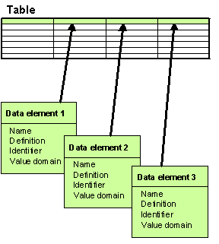
Figure 1. Data element tabular format

Attribute
Datasets, tables and elements in DD are defined by a set of attributes, the core set of which corresponds to ISO 11179 standard for describing data elements. The rest of the attributes are usually specific to Reportnet business rules and in any case the attribute set is flexible- an administrator can dynamically add/remove attributes to/from the system. Most common attribute of all is 'Name', standing for the name of the defined object. Other attributes could be for example 'Definition', 'Version', etc.
There are two types of attributes recognized by DD:
- Simple attribute
Every such attribute in its instance is a name/value pair. They represent the same concept of attribute as in ISO 11179 part 3. For example the mentioned 'Name', 'Definition' and 'Version' are a good examples of simple attributes.
NB! Note that simple attributes can have pre-fixed sets of allowable values, just like the elements. Often these values are some kind of codes.
- Complex attribute
A complex attribute in DD's context is almost the same as a simple attribute. The difference is that while a simple attribute is a name/value pair, a complex attribute is a set of name/value pairs. Every such pair is called a field. For example address would consist of country, city and street fields. A set of these fields combines a complex attribute value row. The set of these rows is what is called the complex attribute's value.

Important simple attributes when defining a data element are:
- Datatype
Indicates if the element’s values are strings, integers, booleans, etc. Also specifies if decimals are to be used, and how many decimals are accepted.
- MaxSize/MinSize
The max/min length of a data element value in terms of digits or characters. For example if an element's MaxSize is 4, its value 'hello' is one char too long. Or if an element's MinSize is 5, its value '146' is one digit too short.
- MaxValue/MinValue
Can be applied only to data elements of numeric Datatype and limits the element's numeric value. i.e. value '9.55' is too much if MaxValue is '9'.

Important complex attributes when defining a dataset, table or element are:
- SubmitOrganisation
The organisation that has added or changed the data element definition. This is mandatory to specify for all dataset, table and element definitions!
- RegistrationAuthority
Institution authorised to register the data definitions.

More about each and every attribute you can learn through using theDD, because each and every attribute in the DD user pages is provided with online help about its meaning and point.

Namespaces
Every dataset represents a namespace. It is called the dataset’s corresponding namespace. The Identifiers of the tables in a dataset “live” within the dataset’s corresponding namespace.
Similarly, every table represents a namespace too. It is called the table’s corresponding namespace. The Identifiers of the non-common elements in a table “live” within the table’s corresponding namespace. The corresponding namespace of the dataset where a non-common element belongs to, is called the top namespace of that element.
Namespaces are managed by DD in the background and transparently for the users. It needs the namespaces for the purpose of distinguishing tables and elements in XMLSchema-formatted representations of data definitions.

GIS tables & elements
Some of the tables defined in DD might contain GIS (Geographic Information System) data. In DD terms, non-common elements (i.e. table columns) containing such data are called GIS elements. Tables containing such elements are called GIS tables.
You can recognise GIS elements in DD by the value of the GIS attribute in their definitions. If such an attribute is missing in an element definition then it means the element is not a GIS element. Otherwise the GIS attribute can have one of the following values, called the GIS types:
- [blank]
- class
- subclass
- subtype

User groups

Data reporters
These are the users responsible for reporting data over Reportnet, according to reporting obligations in ROD database and legislation where the latter proceed from. The relation of such users to DD is as follows:
- According to Reportnet business process, ROD is where the a data reporter starts
- ROD provides the user with a link to a web-site with reporting guidelines document. ROD will also provide a link to DD to the definitions of data to be reported under each reporting activity.
- So principally a data reporter does not necessarily need to reach the DD or know about it at all!
- But naturally, nobody can be denied to go and take a closer look at the definitions in DD if one desires to. So data reporters can use all the read-functions in DD.

Data definers
These are the users responsible and having the rights and skills to define the data for data reporters to report. Whilst data reporters can principally escape accessing the DD directly at all, for data definers there is no other way to carry out their responsibilities but to directly work with DD. The best examples of such users are the ETCs, working as representatives of EEA. Because:
- DD is designed to withhold definitions of any of the data flows (reporting activities - RA) registered in ROD
- Each RA in ROD has a 'report to' institution (i.e. CDDA to EEA)
- So it's natural that those institutions define "their" data flows
- Since EEA has delegated the data collection and definition tasks to ETCs, it is exactly they who shall be responsible for maintaining the data definitions in DD. They can access both the read-and write functions in DD.

DD administrators
These are the users who basically have to maintain the functions that the other two user groups are using in DD. They don’t have to be involved in the reporting process, but they can nevertheless access all its functions and contents in DD, plus some administrative functions for managing the DD contents outside business rules (e.g. by force). The tasks of DD administrators are (in the order of importance):
- Maintaining (adding, editing, removing) attributes used in definitions of data (i.e. maintaining metadata about the defined data).
- Cleaning the DD database of redundant "trash" and "leftovers" that might result from complications coming from simultaneous data definition and versioning cases. Over time DD shall evolve into a more foolproof dictionary where the possibility of such exceptions should be limited to the minimum.

Functionality overview
Data Dictionary’s functionality is divided according to the 3 user groups:
- All-users functionality
Available for all user groups.
- Data definers and administrators functionality
Available both for data definers and DD administrators.
- Administrators-only functionality
Available both for DD administrators only.

The following chapters give an overview of these functionality groups in the form of UML-notified use cases. The details of each and every function, illustrated with relevant UI screenshots, you can find in DD User Guide document.

All-users functionality
At this moment all the users should have possibility to search and browse three kinds of data – datasets, tables and data elements. Usually the functions for administrators are either invisible or they are disabled for use if the user has not logged in or is not in administrators group. The use-cases for all users are described on figure 2. The use case figures can also be handled as navigation maps.
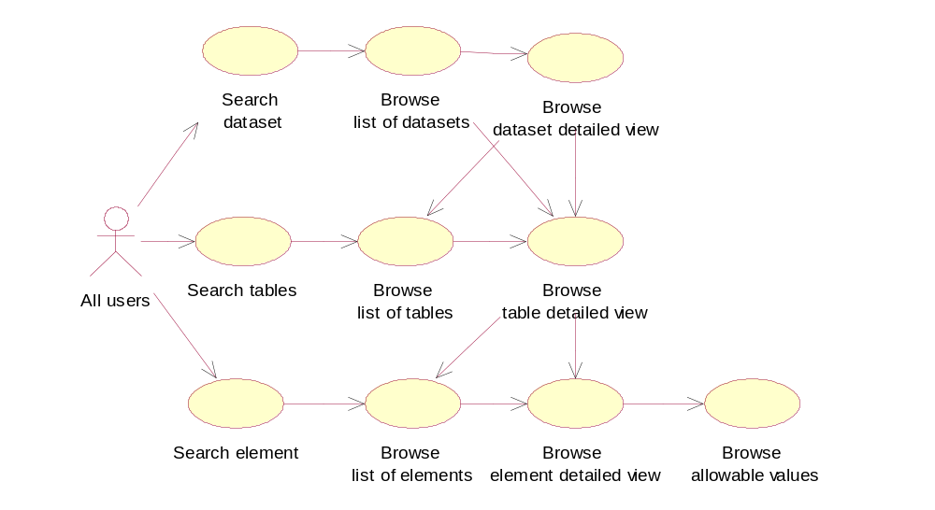
Figure 2. Use-Cases for all users

Data definers and administrators functionality
In addition to all-user functionality, data definers and DD administrators have access to the functions covered in the use-case in figure 3 (note that it also includes all use cases from all-users functions). These functions will become visible and/or available after successful login.
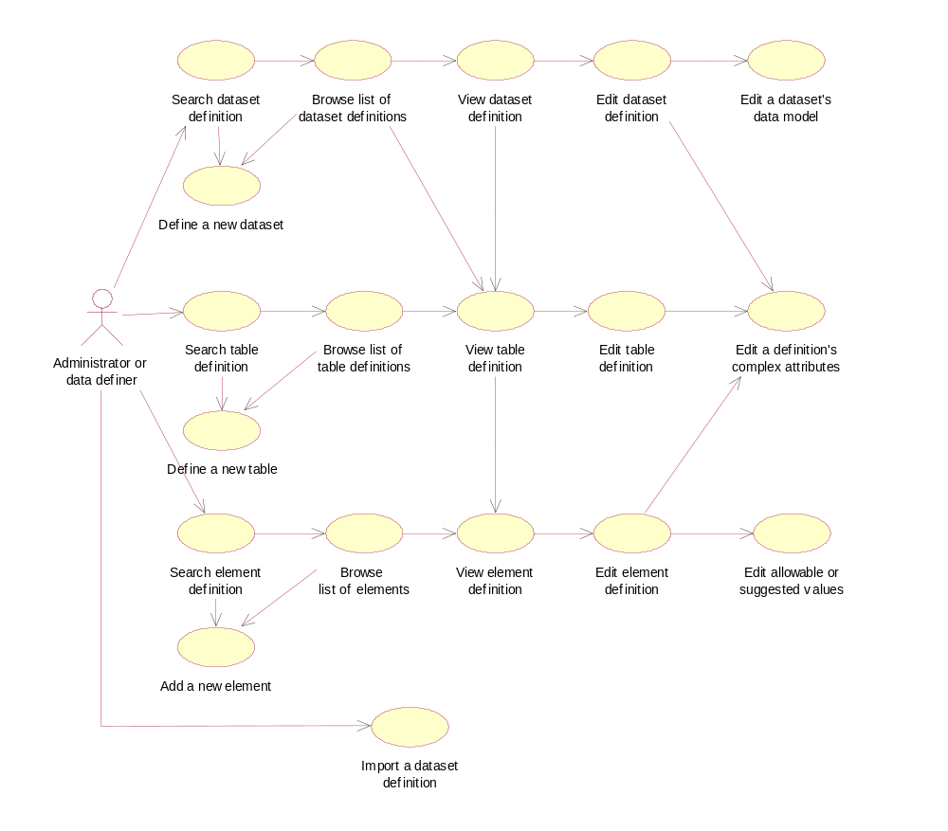
Figure 3. Use-Cases for data definers and administrators

Administrators-only functionality
The use-cases on figure 4 describe the functions accessible only for DD administrators.
More on what they actually mean and contain is described in chapters below.
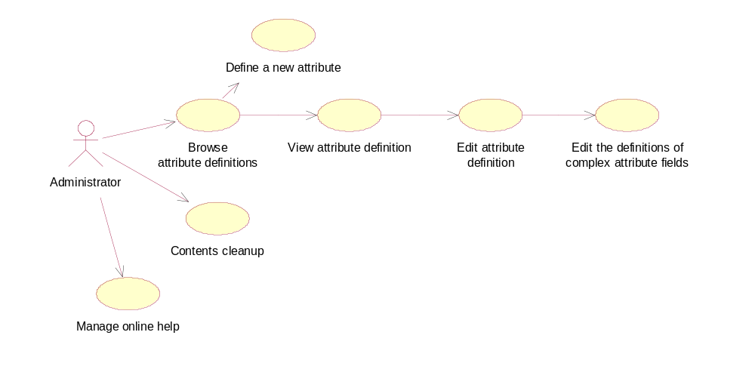
Figure 4. Use cases for DD administrators only

Database model
This chapter presents the DD relational database model in two figures, simply because the whole model does not fit onto one page in a readable form. The first one (figure 5) presents the tables involved in dealing with the most important contents, like definitions of datasets, tables, elements and the value domains of elements. The second one (figure 6) presents tables that are sort of helper tables or tables containing administrative information. Both figures are drawn in UML notification and will be covered in detail in the chapter about DD business rules.
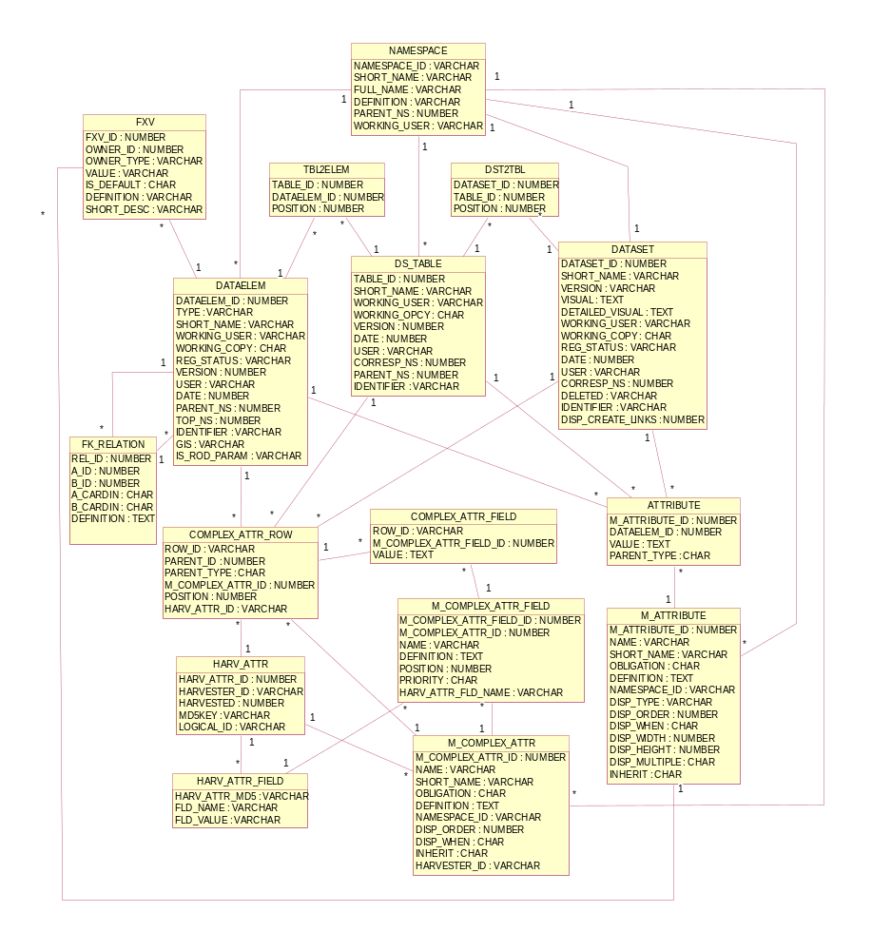

Figure 5. DD database model (part 1)

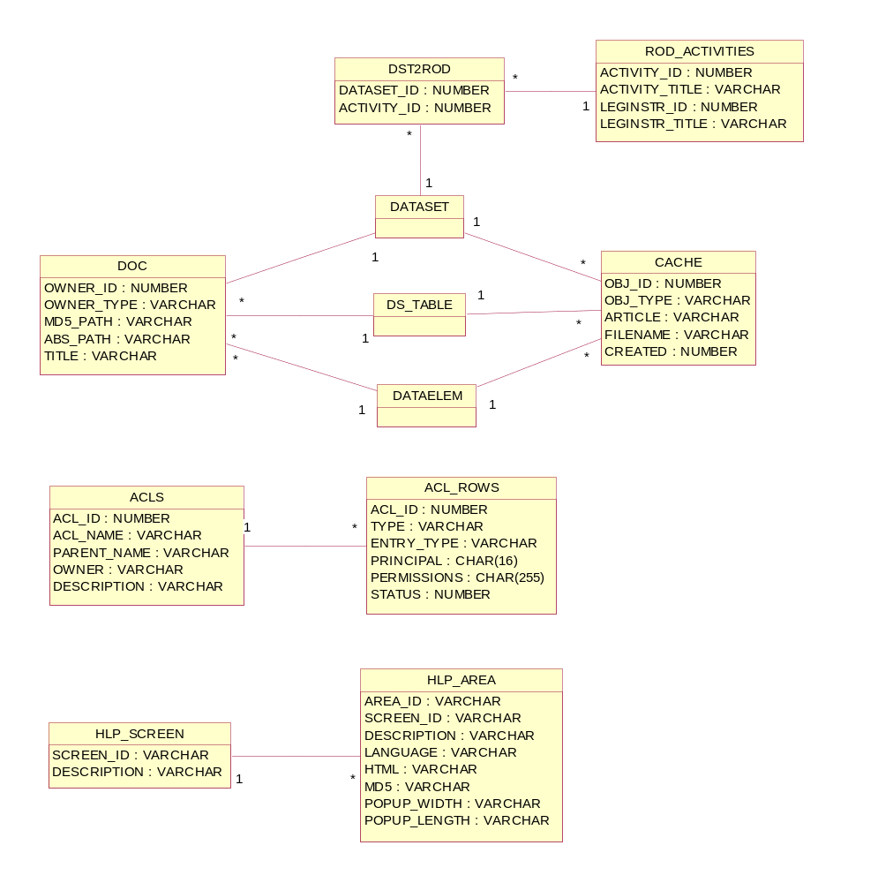
Figure 6. DD database model (part 2)

Business rules

Unique identification of datasets, tables & elements
Data elements, tables & datasets in DD are uniquely identified by an attribute which is called Identifier.
Identifier is a character string used in DD to distinguish different elements, tables and datasets within the same context. It's maximum length is 50 characters and it can have no white space! Identifiers are used as tag names to distinguish elements in XML-formatted data reporting, so they apply to the same rules as do the XML tags.
A dataset Identifier is unique among all datasets!
A table Identifier is unique within its owner dataset!
A non-common element Identifier is unique within its owner table!
A common element Identifier is unique among all common elements!
So logically a dataset is uniquely identified by its Identifier. A table is uniquely identified by its Identifier and owner dataset. A non-common element is uniquely identified by its Identifier and owner table. And a common element is uniquely identified by its Identifier.

Versioning of data definitions
DD keeps history of definitions of datasets and common elements.
Keeping history is needed for the case when a data reporter has downloaded a dataset definition some time ago, does not check if the definition has changed in the meantime and reports the data according to the old definition. Then in order to validate such data, the valuator needs to get the old definition. And that's why DD needs to keep the old versions of data definitions.
Every version of the definition of a dataset or a common element is uniquely identified by the dataset’s or element’s Identifier and the version number. In DD the version number is called CheckInNo, because it indicates how many times changes to a dataset or common element definition have been checked in. The number is updated only when the data definer lets the DD to do so!
NB! Since dataset definition consists of the definitions of its tables and non-common elements then creating a new version of a dataset definition means also creating the new versions of the definitions of its tables and non-common elements. So in fact, tables and non-common elements are versioned as well. But it happens transparently for the users. They see versioning happen for datasets and common elements only. So in the background, tables and non-common elements have a version attribute as well and DD handles it by itself and automatically. When the user chooses to create a new version of a dataset definition, DD copies the whole definition, including the definitions of sibling tables and non-common elements, and increments the version number (i.e CheckInNo) of all these definitions by one.

Registration statuses
Each dataset and common element definition in DD goes through a life-cycle. Its phases are marked by Registration status (aka simply status). The Registration status of a dataset or common element definition is specified by the data definers and can be any one of the following (in the descending order of “age”):
Released (marked with 5 ticks in dataset and common element lists)
The definition is accepted by ETCs and EEA and is released for countries to use for download of technical guidelines and templates. Definitions in this status can be accessed by countries.
Qualified (marked with 4 ticks in dataset and common element lists)
This level is for closing discussions between ETCs and EEA. Definitions in this status cannot be accessed by countries.
Recorded (marked with 3 ticks in dataset and common element lists)
This level is for discussions between ETCs and countries if applicable. Otherwise the definition will skip this status and move directly to the Qualified status. Definitions in Recorded status can be accessed by countries.
Candidate (marked with 2 ticks in dataset and common element lists)
Definitions that are included in the DD by the EEA or ETC data managers. This level is for opening discussions between ETCs and EEA. Definitions in this status cannot be accessed by countries.
Incomplete (marked with 1 tick in dataset and common element lists)
This can be existing definitions under consideration to be included in the DD or new definitions under development where the DD is used as a structuring tool or to test data flows. Definitions in this status cannot be accessed by countries.

Working copies and definitions in work
If a data definer is editing a data definition then that definition is locked for others to edit. In DD terms a definition in such a state is checked out. If a definition is checked out, its working copy is created and that's what the data definer is working with. Nobody else can see the changes being made to the working copy. The original, however, is still readable and viewable for all.
NB! If a dataset definition is checked out, nobody can edit the definitions of its tables and elements. Not even the user who checked out the dataset definition!
NB! If a table definition is checked out, the definitions of its elements, its parent dataset and other tables in that dataset cannot be edited by anybody. Not even the user who checked out the table definition!
NB! If a non-common element definition is checked out, the definitions of its parent table, parent dataset and other tables in that dataset cannot be edited by anybody. Not even the user who checked out the element definition!
The dataset definition that has one of its table or element definitions checked out, is said to be locked or in work. Similarly, the table definition that has one of its element definitions checked out, is said to be locked or in work.

Details of the database model
This chapter covers the details of the database model described above, while expecting that you have also read the above business rules.

table: DATASET
This table holds the definitions of datasets. Every row in this table represents a concrete version of a logically unique dataset definition. The unique identifier and primary key of a row is DATASET_ID. The unique identifier of a dataset is IDENTIFIER. The unique identifier of a dataset definition’s concrete version is assembled by IDENTIFIER and VERSION. Remember that in user interface (UI) the version is called CheckInNo. Due to restrictions from the way the business logic was implemented, there is no unique SQL restriction on IDENTIFIER + VERSION.
SHORT_NAME holds the attribute that is called Short name in the UI. A short name is a character string used to operationally identify datasets (ie how users and data definers commonly refer to a dataset). A short name is not used as a unique identifier in DD. For example, several datasets can have the same short name.
WORKING_USER holds the name of the user who’s working with the dataset’s definition. WORKING_COPY indicates if the definition corresponding to this row is a working copy. Possible values are ‘Y’ and ‘N’, the latter being the default.
REG_STATUS holds the dataset definition’s registration status. For possible values see the chapter about registration statuses.
DATE is a Unix timestamp of the moment the definition was created.
USER is the name of the user who created the definition.
CORRESP_NS is the ID of the dataset’s corresponding namespace. Namespaces are kept in the NAMESPACE table (see below for more).
DELETED contains the name of the user who has non-permanently deleted the concrete dataset definition. If the value of this field is NULL then the dataset is not deleted. If the value contains a concrete username, it means the user has non-permanently deleted the dataset definition. The latter means that the definition does not appear in DD UI, except for the page of non-permanently deleted dataset definitions, from where it can be restored back into “live”. If a dataset definition is deleted permanently, the corresponding row is deleted from DATASET table.
DISP_CREATE_LINKS holds a number indicating the so-called “Create ...” links that should be displayed for this dataset definition in user interface (see the User Guide for more on this). Every possible “Create ...” link has a weight. If the division of DISP_CREATE_LINKS by a link’s weight is not a multiplicand of 2, then that link should not be displayed for this dataset definition in user interface.

table: DS_TABLE
This table holds the definitions of tables. Every row in this table represents a concrete version of a logically unique DD table. The unique identifier and primary key of a row is TABLE_ID. The unique identifier of a table is IDENTIFIER + PARENT_NS, because the latter holds the ID of the corresponding namespace of the dataset where the given table belongs to. The unique identifier of a table definition’s concrete version is assembled by IDENTIFIER + PARENT_NS + VERSION. Remember that in user interface (UI) the version is called CheckInNo. Due to restrictions from the way the business logic was implemented, there is no unique SQL restriction on IDENTIFIER + PARENT_NS + VERSION.
SHORT_NAME holds the attribute that is called Short name in the UI. A short name is a character string used to operationally identify tables (ie how users and data definers commonly refer to a table). A short name is not used as a unique identifier in DD. For example, several tables in a dataset can have the same short name.
WORKING_USER holds the name of the user who’s working with the table’s definition. WORKING_COPY indicates if the definition corresponding to this row is a working copy. Possible values are ‘Y’ and ‘N’, the latter being the default.
DATE is a Unix timestamp of the moment the definition was created.
USER is the name of the user who created the definition.
CORRESP_NS is the ID of the table’s corresponding namespace. Namespaces are kept in the NAMESPACE table (see below for more).

table: DATAELEM
This table holds the definitions of elements, both common and non-common. Every row in this table represents a concrete version of a logically unique element. The unique identifier and primary key of a row is DATAELEM_ID. The unique identifier of an element is IDENTIFIER + PARENT_NS, because the latter holds the ID of the corresponding namespace of the table where the given element belongs to. If this is a common element, the value of PARENT_NS is NULL. The unique identifier of an element definition’s concrete version is assembled by IDENTIFIER + PARENT_NS + VERSION. Remember that in user interface (UI) the version is called CheckInNo. Due to restrictions from the way the business logic was implemented, there is no unique SQL restriction on IDENTIFIER + PARENT_NS + VERSION.
SHORT_NAME holds the attribute that is called Short name in the UI. A short name is a character string used to operationally identify elements (ie how users and data definers commonly refer to a table). A short name is not used as a unique identifier in DD. For example, several non-common elements in a table can have the same short name. Similarly, several common elements can have the same short name
WORKING_USER holds the name of the user who’s working with the element’s definition.
WORKING_COPY indicates if the definition corresponding to this row is a working copy. Possible values are ‘Y’ and ‘N’, the latter being the default.
DATE is a Unix timestamp of the moment the definition was created.
USER is the name of the user who created the definition.
TOP_NS is the ID of the corresponding namespace of the dataset where the non-common element belongs to. For common elements the value of TOP_NS is NULL. Namespaces are kept in the NAMESPACE table (see below for more).
GIS indicates the element’s GIS type (see the chapter of DD concepts above). If the value is NULL, it means the element is not a GIS element at all.
REG_STATUS indicates the registration status of the definition of a common element. For non-common elements this field is irrelevant. For possible values see the chapter about registration statuses.
IS_ROD_PARAM indicates if the element is to be considered a parameter by ROD (Reporting Obligations Database) when the latter asks for the list of parameters by given reporting obligation ID (for more see the chapter about XML-RPC bridge below). Possible values are ‘Y’ and ‘N’, the latter being the default.

table: DST2TBL
As it was described above in the chapter about versioning, versioning of dataset definitions requires versioning of table definitions as well, only the latter happens transparently for the users. And so it follows that a concrete version of a table’s definition can participate in many versions of the definition of its parent dataset. And since a dataset definition, in turn, may contain definitions of several tables, it appears that there is a many-to-many relationship between DATASET and DS_TABLE tables. Hence an associative table to implement that relationship is needed. And that’s what the DST2TBL is. The POSITION field indicates the table’s position in the dataset. It is relevant only when displaying the list of tables in a dataset.

table: TBL2ELEM
As it was described above in the chapter about versioning, versioning of dataset definitions requires versioning of the definitions of its sibling tables and non-common elements as well. Only the latter happens transparently for the users. And so it follows that a concrete version of a non-common element’s definition can participate in many versions of the definition of its parent table. And since a table definition, in turn, may contain definitions of several non-common elements, it appears that there is a need for a many-to-many relationship between DS_TABLE and DATAELEM tables. The need also follows from the fact, that a common element might be re-used in many tables. Hence an associative table is needed and that’s what the TBL2ELEM is. The POSITION field indicates the element’s position in the table. It is relevant only when displaying the list of elements in a table.
NB! Notice that the TBL2ELEM table is used for representing table-to-element relations both for common and non-common elements.

table: M_ATTRIBUTE
As it was told in the chapter about DD concepts, the set of possible data definition attributes is flexible. In other words, users can define new definition attributes at any time and they can remove existing ones as well. Actually, the whole attribute set is not flexible! Some attributes are static, hard-coded into the tables of the database model. Such are attributes like IDENTIFIER, SHORT_NAME, IS_ROD_PARAM, etc. But the ones that users can dynamically define and remove, are called static dynamic attributes and their definitions are kept in M_ATTRIBUTE and M_COMPLEX_ATTR tables. The first one contains the definitions of simple attributes, the second one contains the definitions of complex attributes. Let’s concentrate on M_ATTRIBUTE.
M_ATTRIBUTE_ID is the unique identifier and primary key of rows in this table. It is also used as the unique identifier of simple attributes defined.
SHORT_NAME is used by users for commonly referring to attributes. Even though there is no SQL unique restriction on this field, each attribute must have a unique SHORT_NAME. In UI, the value of this field is called Short name. The values of SHORT_NAME must have no white space.
NAME is not as commonly used as SHORT_NAME. It contains the full name of the defined attribute. In UI, the value of this field is called Name.
OBLIGATION indicates if this attribute is mandatory, optional or conditional for the data definitions to specify. Possible values are (respectively) ‘M’, ‘O’, ‘C’. In UI, the value of this field is called Obligation.
DEFINITION contains the definition of the attribute. This is free text explaining the essence and the meaning of the attribute. In UI, the value of this field is called Definition.
NAMESPACE_ID indicates the namespace where this attribute belongs to and is related to the NAMESPACE_ID field in NAMESPACE table (see for more below). DD comes with two pre-defined namespaces for dynamical attributes: ISO11179 attributes and Data Dictionary attributes. Attributes originating from ISO should be defined in the ISO namespace, while as attributes originating from DD should be defined in the Data Dictionary namespace. In UI, the value of this field is called Context.
DISP_TYPE reflects how the given attribute should be displayed in web forms. Possible values are ‘text’ (corresponding to <input type=”text”> in HTML), ‘textarea’ (corresponding to <textarea> in HTML), ‘select’ (corresponding to <select> in HTML) and ‘image’. The latter is a special simple attribute type, because it means the attribute is displayed as an image and the attribute’s value is the relative path to the image in DD visuals directory (more in chapters below). In UI, the value of this field is called Display type.
DISP_ORDER reflects the position at which the attribute should be displayed in the overall attributes list and the data definition views. In UI, the value of this field is called Display order.
DISP_WHEN indicates for which data definitions the attribute is relevant. There is 4 options here: an attribute could be relevant for datasets, tables, elements with fixed values or elements with quantitative values. All 4 options have a weight and when the division of DISP_WHEN by that weight is a multiplicand of 2 then the attribute is relevant for that particular weight. In UI, the value of this field is called Display for. The field is displayed as a set of 4 checkboxes, each corresponding to one of the above-described options.
DISP_WIDTH is relevant only if the value of DISP_TYPE is ‘text’. In such a case it indicates the width of the text box in terms of characters. In UI, the value of this field is called Display width.
DISP_WIDTH is relevant only if the value of DISP_TYPE is ‘textarea’. In such a case it indicates the height of the text area in terms of rows. In UI, the value of this field is called Display height.
DISP_MULTIPLE indicates if this simple attribute can have multiple values at a time. For example an attribute like Keyword could have several values at the same time. Possible values are ‘0’ (no multiple values allowed and this is the default) and ‘1’ (multiple values allowed). In UI, the value of this field is called Display multiple.
INHERIT indicates the given attribute’s inheritance type. For details about attribute inheritance see the relevant chapter(s) in User Guide document. Possible values are ‘0’ (no inheritance, the default), ‘1’ (inherit attribute values from parent level with possibility to add new values) and ‘2’ (inherit attribute values from parent level with possibility to overwrite them).

table: M_COMPLEX_ATTR
As stated above, this table contains the definitions of complex attributes. Let’s look at its fields.
M_COMPLEX_ATTR_ID is the unique identifier and primary key of rows in this table. It is also used as the unique identifier of complex attributes defined.
SHORT_NAME is used by users for commonly referring to attributes. Even though there is no SQL unique restriction on this field, each complex attribute must have a unique SHORT_NAME. In UI, the value of this field is called Short name. The values of SHORT_NAME must have no white space.
NAME serves exactly the same purpose as it did in M_ATTRIBUTE table, see the relevant explanation above
NAMESPACE_ID serves exactly the same purpose as it did in M_ATTRIBUTE table, see the relevant explanation above.
OBLIGATION field is not used! Almost complex attributes are considered optional, except for SubmitOrganisation attribute which is mandatory for all data definitions. Definitions of tables and non-common elements inherit the values of the SubmitOrganisation attribute of the parent dataset!
DEFINITION serves exactly the same purpose as it did in M_ATTRIBUTE table, see the relevant explanation above.
DISP_ORDER serves exactly the same purpose as it did in M_ATTRIBUTE table, see the relevant explanation above.
DISP_WHEN is not used!
INHERIT serves exactly the same purpose as it did in M_ATTRIBUTE table, see the relevant explanation above.
HARVESTER_ID is the ID of the value-harvester associated with this complex attribute. More on this is available in the chapter about harvested complex attributes in User Guide document. This field is related to the HARVESTER_ID field in HARV_ATTR table (see for more below) and in UI this field is called Linked harvester.

table: M_COMPLEX_ATTR_FIELD
In the chapter about DD concepts it was told that complex attributes consist of fields and a complex attribute value is row of values of those fields. The set of fields of a complex attribute is flexible just like the attributes themselves. New fields can be defined and removed at any time via UI. The definitions of complex attribute fields are kept in M_COMPLEX_ATTR_FIELD table. It has the following fields.
M_COMPLEX_ATTR_ID holds the ID of the complex attribute for which the field is relevant. It is in foreign key relation with the same-named field in M_COMPLEX_ATTR table.
NAME is the name of the field. That’s what the users commonly use for referring to complex attribute fields. Field names within a complex attribute must be unique!
M_COMPLEX_ATTR_FIELD_ID is the unique identifier and primary key of the rows in this table. It is also used as the unique identifier of complex attribute fields.
DEFINITION defines the field. This is free text explaining the field’s meaning.
POSITION indicates the field’s position in its owner complex attribute. This is relevant for display purposes.
PRIORITY specifies weather the field should be displayed in the definitions of datasets/tables/elements in order to save space on the page. A field with priority ‘0’ (displayed as ‘High’ in user views and used as the default) is displayed, while the field with priority ‘1’ (displayed as ‘Low’ in user views) is not. In the detailed views of complex attributes of data definitions, however, all fields are always displayed.
HARV_ATTR_FLD_NAME maps the given field to a field of a complex attribute value-harvester. This is relevant only if the owner attribute of this field is defined to be harvestable by some complex attribute value-harvester. For more about complex attribute harvesting see the relevant chapter in User Guide document.

table: ATTRIBUTE
As you saw above, M_ATTRIBUTE is the table that defines dynamic simple attributes in DD. ATTRIBUTE is the table where the values of those attributes are kept.
M_ATTRIBUTE_ID indicates the id of the simple attribute and is related to the same-named field in M_ATTRIBUTE table.
DATAELEM_ID is the field containing the ID of the object for which the attribute value goes. As it was said above, a simple attribute could be relevant for a dataset, table or element. So DATAELEM_ID identifies the dataset, table or element the attribute goes for. So the field’s name could be actually something like PARENT_ID or OWNER_ID, but for historical reasons the name is DATAELEM_ID.
PARENT_TYPE indicates if the ID in DATAELEM_ID is ID of a dataset, table or element. Possible values (respectively) are ‘DS’, ‘T’, ‘E’.
VALUE holds the value of M_ATTRIBUTE_ID attribute for the given DATAELEM_ID and PARENT_TYPE. It is of text type, meaning it could be as long as the database engine has been configured to allow text fields to be.

table: COMPLEX_ATTR_ROW
A complex attribute value is a row of values of the attribute’s fields. Rows are managed in COMPLEX_ATTR_ROW table and the values of attribute fields are stored in COMPLEX_ATTR_FIELD table. Let’s concentrate on COMPLEX_ATTR_ROW.
PARENT_ID identifies the object for which the row goes. It could be a dataset, table or element. PARENT_TYPE tells you which one it is. A value of ‘DS’ indicates a dataset, a value of ‘T’ indicates a table and a value of ‘E’ indicates an element.
M_ COMPLEX_ATTR_ID indicates which complex attribute are we talking about. It is in foreign key relation with the same-named field in M_ COMPLEX_ATTR table.
ROW_ID is the primary key and unique identifier of rows. DD uses it to refer to concrete rows. Tthe PARENT_ID + PARENT_TYPE + M_COMPLEX_ATTR_ID must be unique.
If the given complex attribute value row is linked to a concrete harvested value row then it is identified by the HARV_ATTR_ID field which is in foreign key relation with the same-named field in HARV_ATTR table (see below and more on complex attribute harvesting in User Guide document).
POSITION is not used!

table: COMPLEX_ATTR_FIELD
As you saw, the COMPLEX_ATTR_ROW table is used to identify for which attribute and for which object the complex attribute value row goes. The values of the row’s fields are stored into COMPLEX_ATTR_FIELD table. It has the following fields.
ROW_ID is the ID of the complex attribute row we’re talking about. It is in foreign key relation with ROW_ID in COMPLEX_ATTR_ROW table.
M_COMPLEX_ATTR_FIELD_ID identifies the complex attribute field we’re talking about. It is in foreign key relation with M_COMPLEX_ATTR_FIELD_ID in M_COMPLEX_ATTR_FIELD table.
And finally, VALUE contains the value of M_COMPLEX_ATTR_FIELD_ID field in ROW_ID row.

table: NAMESPACE
This is the table where the corresponding namespaces of datasets and tables are managed. In addition, it also contains 3 pre-defined namespaces coming with the DD software package. These are the namespace where all the datasets “live” (called datasets), the namespace where all the ISO-originating attributes must “live” (called ISO11179 attributes) and the namespace where all the DD-originating attributes must “live” (called Data Dictionary attributes).
NAMESPACE_ID is the unique identifier and primary key of rows in this table. It is also used as the unique identifier of namespaces.
SHORT_NAME is the short name of the give namespace. FULL_ANME is the namespace’s full name.
DEFINITION designates the meaning of the given namespace.
If the given namespace corresponds to a dataset or a table, then PARENT_NS contains the ID of the namespace where the given namespace belongs to. Corresponding namespaces of datasets belong into the pre-defined namespace datasets. Corresponding namespaces of tables belong into the corresponding namespaces of their parent datasets.
If the given namespace corresponds to a dataset, then WORKING_USER contains the name of the user who’s working with that dataset. If the dataset is not in work, the value of WORKING_USER is null.

table: FXV
As you know, a data element can be defined to have values only from a pre-fixed value set. Also, a dynamic attribute can be defined to have pre-fixed values only. These value sets are kept and managed in the FXV table.
OWNER_ID states the ID of the object for which the value goes. It could be either a data element or a dynamic attribute. OWNER_TYPE tells you which one it is. Possible values are (respectively) ‘elem’ and ‘attr’.
VALUE contains the value itself. The field is of TEXT type, so it can be as long as the configuration of the data engine allows it to be.
IS_DEFAULT indicates if the given fixed value is the default. Possible values are ‘Y’ and ‘N’, the latter being the default.
DEFINITION tells us the meaning of the given value. So does the SHORT_DESC but in a shorter way that can be conveniently displayed in value lists in UI.
Finally, every fixed value and row in the FXV table is uniquely identified by FXV_ID.

table: FK_RELATION
Since tables in a reported dataset might have foreign key relations to each other, DD enables to define them as well.
A foreign key relation between two tables is handled simply by defining a foreign key relation between some of their elements. On both sides several elements can participate in the relation.
Foreign key relations are managed in FK_RELATION table. Every row in this table represents a foreign key relation and is uniquely identified by the REL_ID field.
A_ID contains the DATAELEM_ID of the element for which the relation was specified. B_ID contains the DATAELEM_ID of the element that was selected to be a foreign key for the element for which the relation was specified.
A foreign key relation can have a cardinality. It specifies whether this is a one-to-one, many-to-many, etc relationship. In FK_RELATION table A_CARDIN indicates the cardinality’s side represented by the element in A_ID. Similarly, B_CARDIN indicates the cardinality’s side represented by the element in B_ID. Possible values of both sides can be '0' (zero), '1' (one), '+' (one or many), '*' (zero or many).
Finally, DEFINITION contains comments on the given relation, if any specified.

table: HARV_ATTR
From the DD User Guide document you will learn that complex attributes can be associated with a harvester that harvests the attribute’s values from an outer source over HTTP. Such an harvester acts automatically in the background and over certain interval, thus making sure the harvested values are always up to date. This is a useful feature for complex attributes that represent some administrative information that might be a subject to frequent change. For example if an organisation’s metadata is used a complex attribute’s value in many dataset definitions then the users don’t need to go through all those definitions and change the organisation’s metadata every time it changes. If the attribute has been associated with a value-harvester then the latter does such tedious work for the user.
Harvested complex attribute values are managed in the HARV_ATTR table. Every row in this table represents a harvested complex attribute row. Every such row is uniquely identified by MD5KEY field.
HARVESTER_ID is a string by which the user identifies the harvester. It is recommended that the string is chosen so that you understand what the harvester is about. The field is used as a foreign key to the same field in M_COMPLEX_ATTR table.
HARVESTED is a Unix timestamp indicating the time of the harvest session when the given row was harvested. This is needed because one and the same row might have been harvested at different sessions and the business logic makes sure that always the latest is kept and used.
HARV_ATTR_ID is the harvested value row’s ID as given by the outer source that is harvested.
LOGICAL_ID is a combination of HARVESTER_ID + HARV_ATTR_ID and is used as foreign key to the HARV_ATTR_ID field in COMPLEX_ATTR_ROW table.
MD5KEY is a combination of HARVESTER_ID + HARV_ATTR_ID + HARVESTED and is used as foreign key to the HARV_ATTR_MD5 field in HARV_ATTR_FIELD table. The latter holds the values of the fields of the given harvested complex attribute row.

table: HARV_ATTR_FIELD
As the last sentence of the previous chapter stated- this is the table where the values of the fields of the harvested complex attribute rows are kept. The harvested row is identified by HARV_ATTR_MD5 field (foreign key to MD5KEY in HARV_ATTR table). The harvested row field is identified by FLD_NAME which is a foreign key to the NAME in M_COMPLEX_ATTR_FIELD table. And the harvested field value is kept in FLD_VALUE field.

table: DOC
This table is illustrated in the second part of the database model. It is a table the metadata on documents uploaded for data definitions is kept. As you might have learned from the User Guide document, for every dataset, table and element definition data definers can upload informative documents that can later be downloaded by data reporters for further guidelines. These documents are stored into a directory whose path is configured by the “doc-path” parameter in DD’s configuration in web.xml (see for more in Installation Guide). And their metadata is kept in DOC table with following fields.
The document’s full Unix path is kept in ABS_PATH field. The MD5-hash of that path is kept in MD5_PATH field. OWNER_ID is the ID of the object for which the document goes and OWNER_TYPE identifies the object’s type. The latter could either be ‘dst’ (dataset, the default), ‘tbl’ (table) or ‘elm’ (element). The document’s title (displayed in UI as a hint about the document’s contents) is kept in TITLE field.
Primary key of the rows in DOC table is formed by OWNER_ID + OWNER_TYPE + MD5_PATH. So you notice that a physically single document could be represented several times in this table, because it could be used for several different objects.

table: CACHE
For every dataset, table and element definition users can download differently formatted outputs (the so-called “Create ...” links in UI), unless the data definers have prohibited them for certain definitions. In the beginning DD was developed so that these outputs were always generated on the fly. It soon came out that such generation took a lot of time if the definition was capacious and the output format was either PDF or MS Excel. So it was decided that the data definers should be given a possibility to cache at least outputs in these two formats. The caching means simply that the generated output is stored into DD host machine’s file system and so later it can be retrieved for quick download. Metadata on such cached outputs (i.e. files) is kept in CACHE table.
All these cached files are always stored into the directory whose path is configured by the “doc-path” parameter in DD’s configuration in web.xml (see for more in Installation Guide). The cached file’s name is kept in the FILENAME field. The cached file’s type is kept in the ARTICLE field. The values of the latter can be 'pdf' (the default), 'xls' (MS Excel), 'xform' (XForm on top of XML) , 'xmlinst' (an empty XML instance file for the data reporting). All these foru types can be cached, but at the moment of writing this document only PDF and XLS are supported in UI.
CREATED holds the Unix timestamp of the moment the file was cached.
OBJ_ID is the ID of the object for which the file goes and OBJ_TYPE identifies the object’s type. The latter could either be ‘dst’ (dataset, the default), ‘tbl’ (table) or ‘elm’ (element).
The primary key of rows in CACHE table is formed by OBJ_ID + OBJ_TYPE + ARTICLE.

table: ROD_ACTIVITIES
Dataset definitions in DD can be associated with corresponding reporting obligations in the Reporting Obligations Database (ROD). Metadata on reporting obligations can be downloaded on the fly from ROD at the moment the data definer starts to create the association (there’s an XML-RPC bridge for that, see for more in the below chatpters). Metadata on associated obligations (and associated obligations only, meaning not all obligations found from ROD) is kept in the ROD_ACTIVITIES table. For historical reasons, one can assume that an activity and an obligation is one and the same thing.
The ACTIVITY_ID field contains the ID of the obligation as received from ROD. ACTIVITY_TITLE contains the title of the obligation as received from ROD.
Since several reporting activities (i.e. obligations) can have the same title in ROD, we need some kind of way to distinct them when displayed by title in DD UI. Therefore the table also tells which is the legal instrument the activity belongs to. That’s because there can no two activities with the same title within a single legal instrument. The instrument’s ID as received from ROD is kept in LEGINSTR_ID field. The instrument’s title is kept in LEGINSTR_TITLE.

table: DST2ROD
Activities in ROD_ACTIVITIES table are associated with concrete datasets by the help of DST2ROD table, because the relation between DATASET and ROD_ACTIVITIES tables is of many-to-many nature. The table has two fields.
DATASET_ID contains the ID of the dataset for which the association goes. Associated activity is identified by ACTIVITY_ID. Both together for the primary key of rows in this table.

tables: ACLS and ACL_ROWS
These are the two tables needed to implement the Access Control Lists (ACL) mechanism that was designed in another project and is used as an external Java library in DD. So for more details see the detailed documentation on ACL mechanism at the following link:
http://nmc.eionet.eu.int:8980/Members/irc/eionet-nmc/einrc/library?l=/einrc_sa6_2003/ait/ait-acl-_ddv11doc/_EN_1.1_&a=d

tables: HLP_SCREEN and HLP_AREA
These are the two tables needed to implement the Dynamical Online Help (DynOHelp) mechanism that was designed within DD project as a separate Java library, usable by many Reportnet applications, as long as they have the library and the two tables. So for more details see the detailed documentation on DynOHelp mechanism at the following link:
http://nmc.eionet.eu.int:8980/Members/irc/eionet-nmc/einrc/library?l=/einrc_sa7_2004/dd/dynohelp_hatdoc/_EN_1.1_&a=d

Implementation

System architecture
The overall system architecture of the Data Dictionary concsists of 3 layers. The database layer (implemented on MySQL platform), the business layer (implemented on Java and HTTP latforms and communicating with database layer over JDBC drivers) and the presentation layer which is basically a set of any imaginery clients communicating with DD over HTTP protocol. These could be simple WWW browsers, but also the Data Dictionary Import tool (see the chapter about Import tool below) and the applications communicating with DD over XML-RPC protocol (like ROD).
The business layer is implemented on top of Apache Web Server and Apache’s Java server called Tomcat. The Data Dictionary Import tool has been implemented as a MS Access database which is capable of producing XML which can later be imported into DD via the latter’s web interface.

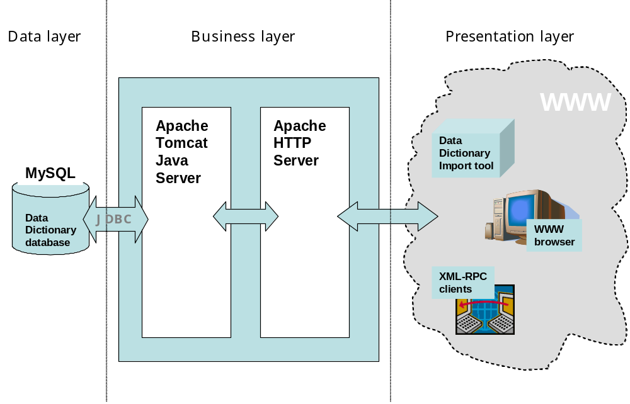
Figure 7. System architecture of the Data Dictionary

Directory structure
The DD installation package comes as a simple compressed file which, after unpacking, becomes a directory structure like this:

/datadict
/acl
Access control files
/public
HTML files, JSP files, CSS files, JavaScript files
/images
JPG, GIF and other image files
/visual
directory where DD stores user-uploaded images
/src
Java source files and descriptors for build
/WEB-INF
/lib
the used JAR libraries
/classes
output directory where the Java classes should be compiled to, home directory for properties

The DD Java code

Class hierarchy
As you might have notice from the above-described DD directory structure, DD Java source is stored in the /src directory of the DD home directory. The sub-directories of /datadict/src follow the DD Java class hierarchy which reflects from the following list of all DD java packages:
- eionet.meta
This is the root package of DD’s Java source. Classes in this package deal with the basic objects of dd business logic, but it also contains classes representing several of DD’s Java servlets.
- eionet.meta.exports
This is the root package of DD’s export logic which is responsible for generating outputs of data definitions in different output formats (pdf, xml, etc). Classes in this package deal with output that are cachable. Sub-packages of this package are each dedicated to a concrete output format.
- eionet.meta.exports.pdf
This package deals with generating outputs in PDF format.
- eionet.meta.exports.schema
This package deals with generating outputs in XML Schema format.
- eionet.meta.exports.xforms
This package deals with generating outputs in XForm format.
- eionet.meta.exports.xls
This package deals with generating outputs in MS Excel format.
- eionet.meta.exports.xmlinst
This package deals with generating empty XML instance files for the data to report.
- eionet.meta.harvest
Above it was described how values of complex attributes can be automatically harvested and in User Guide you can learn more about this function. But the function itself is implemented in this package.
- eionet.meta.imp
The idea of DD Import tool is that it is capable of putting its contents into XML format and DD is capable of importing that format. The logic of this import is implemented in this package.
- eionet.meta.inservices
DD is able to collect data about reporting obligations from ROD over XML-RPC. This package contains implementation of a framework supporting incoming XML-RPC communication with any outer source, including ROD.
- eionet.meta.outservices
Besides being able to download information about reporting obligations from ROD, DD is also able to provide information for ROD and for any other application for that matter. This package implements a framework for carrying out such communications.
- eionet.meta.savers
DD web interface contains a lot of forms from where the users submit their inputs. This package contains several different handlers of submitted data, each dealing with getting the data stored into the right tables, all business rules taken into account.
- eionet.meta.util
This is a package containing several different utility and helper classes helping to carry out several routine operations in many places of the DD code.

Used external libraries
The external Java libraries (JAR files) used in DD both at compile-time and run-time are kept in the /datadict/WEB-INF/lib directory and they are as follows:
- activation.jar
This is library needed for carrying out XML-RPC communication.
- castor.jar
This is library needed for carrying out XML-RPC communication.
- eionet-dir.jar
This is library needed for carrying out communication with EIONET’s LDAP service.
- itext-0.99.jar
This library contains an API for generating PDF outputs.
- jndi.jar
This is a library needed to carry out the JDBC communication.
- ldap.jar
As the name suggests, this is another library needed to carry out communication with EIONET’s LDAP service.
- log4j.jar
This library is an API provided by Sun and it contains utility classes and functions for handy logging of messages.
- pja.jar
This is a library needed to carry out operations with images in a so-called “headless” operation system, like for example Linux with X-Windows.
- poi-2.5-final-20040302.jar
This library is provided by Apache and contains the API for generating outputs in MS Excel format
- providerutil.jar
This is library containing utility classes and functions for carrying out XML-RPC communication.
- tomcat-util.jar
This is a library provided by Apache and as the name suggests, it is used for making DD to support Tomcat servlet engine, especially the latter’s database connection pool.
- uit-client.jar
This is a library originating from another EIONET project called UIT and contains the code for implementing the client side of XML-RPC communications.
- uit-definition.jar
This is a library originating from another EIONET project called UIT and contains the code for implementing mapping of data types in XML-RPC communications.
- uit-help.jar
Above it was mentioned, that DD model contains tables used by EIONET’s Remotely Administered Help (RAH) mechanism that was designed within DD project as a separate Java library. uit-help.jar is the library.
- uit-security.jar
DD model contains tables used by EIONET’s Access Control Lists (ACL) mechanism that was designed as part of the UIT project. The resulting functionality is packed into uit-security.jar.
- uit-server.jar
This is a library originating from another EIONET project called UIT and contains the code for implementing the server side of XML-RPC communications.
- xerces.jar
This is the classic SAX parser, provided by Apache for XML parsing.
- xmlrpc.jar
This library contains the code for carrying out XML-RPC communications.
- xmlserver.jar
This is a library developed by TietoEnator and containing the framework for implementing a fully XML-based web application with a relational database below it. However, DD uses only the library’s useful utility classes.

The DD web
The root directory of the DD web files is /datadict/public.

Java Servlet Pages
Java Server Pages are the basis for dynamic web in DD. They are stored in /datadict/public directory into *.jsp files. The names of the files have been chosen to represent what they’re about. They don’t need to be built as Apache’s Tomcat does it by itself. DD Java Server Pages contain a lot of business code, both in scriptlets as well as in Javascript sections.

Static HTML
DD web does not contain a lot of static content. The latter is kept in static HTML pages kept in /datadict/public directory.

Javascript
DD uses Javascript quite a lot and it is scattered over Java Server Pages and *.js files, all kept in the /datadict/public directory.

Cascading StyleSheets (CSS)
According to the design principles set out at http://www.eionet.eu.int/software/design, all EIONET sites must rely on the usage of CSS. Since DD development was started long before these principles were stated, you don’t see CSS used everywhere in DD web pages. However, in several places it is used and the styles are defined in *.css files residing in /datadict/public directory.

XML-RPC service descriptor
The services that DD provides over XML-RPC are described in an XML-formatted file called DataDictService.xml which must be publicly accessible via WWW and is therefore stored into the /datadict/public directory.

XML-RPC methods
DD has an API for applications. It is accessible over XML-RPC service. The name of that service is DataDictService and it is provided by the eionet.meta.outservices.OutService class. For all details about the API, see the DD XML-RPC service descriptor file.
The DD API consists of the following methods:
- getParametersByActivityID
As you might have noticed by now, data elements in DD have a static attribute indicating if the element is to be considered a ROD parameter. So that’s how DD identifies parameter. For identifying parameters by a given reporting activity, the DD first associates the given activity ID with a concrete dataset and then returns all elements that are defined as ROD parameters and defined within the concrete dataset.
The method itself is called getParametersByActivityID. As an input parameter, it takes a STRING containing the ID of reporting activity. As an output, it returns an ARRAY of STRUCTs where each STRUCT represents one ROD parameter matching to the given reporting activity. Possible keys in every STRUCT are:
- elm-name
Contains the parameter’s short name.
- tbl-name
Contains the short name of the table where the parameter belongs to.
- dst-name
Contains the short name of the dataset where the parameter belongs to.
The ARRAY is sorted first by dst-name, then by tbl-name and then by elm-name.
- getObligationsWithDatasets
This one returns the IDs and titles of all obligations that have a released dataset definition present in DD.
It has no input parameters.
It returns a list of structures where every structure represents one obligation whose metadata is given by the following keys:
- http://purl.org/dc/elements/1.1/identifier
- http://purl.org/dc/elements/1.1/title
The value of http://purl.org/dc/elements/1.1/identifier is given as an URI. The value of http://purl.org/dc/elements/1.1/title is given as string literal.

User authentication & Access Control Lists (ACL)
For authenticating users DD uses the EIONET’s LDAP directory, because all DD user must also be EIONET users. So the DD does not have a user database of its own.
A given username and password (and they are given via eionet.meta.LoginServlet servlet) are authenticated by using the utility methods coming with eionet-dir.jar. The properties for finding and connecting the EIONET LDAP directory must be set in /datadict/public/WEB-INF/classes/eionetdir.properties file. See for more in the chapter about configuration and also the DD Installation guide document.
For checking an authenticated user’s permissions, DD uses the Access Control Lists (ACL) mechanism that was developed as part of another EIONET project. Full documentation about the concept of this mechanism, about how it works and how applications (including DD) can use it is available at http://nmc.eionet.eu.int:8980/Members/irc/eionet-nmc/einrc/library?l=/einrc_sa6_2003/ait/ait-acl-_ddv11doc/_EN_1.1_&a=d
The ACL mechanism is hidden in the uit-*.jar libraries in /datadict/public/WEB-INF/lib directory and certain properties must be configured in /datadict/public/WEB-INF/classes/uit.properties file. For details about this configuration, see the above-mentioned ACL documentation, the chapter about configuration in this document and also the DD Installation guide document.

Dynamical Online Help (DynOHelp) mechanism
As part of the DD project a Dynamical Online Help (DynOHelp) system was developed in order to create online help that could be dynamically administered via web. The system relies on two tables in DD database where the help data is stored- HLP_SCREEN and HLP_AREA. DD Java code can retrieve help from these tables by the help of com.tee.uit.help.Helps class available in the uit-help.jar library. The latter is where the DynOHelp is hidden and is re-usable in any applications having that library and the above-mentioned two tables.
The content in the HLP_SCREEN and HLP_AREA tables can be dynamically administered via web by using the Help Admin Tool (HAT) that was also developed as part of the DD project. The tool has a simple web interface for the changing an application’s online help. It can be configured to run against many applications and connects to the applications over XML-RPC bridge. Every such application must have the above-mentioned two tables, the uit-help.jar and certain configuration in uit.properties file. More about the latter and the full documentation of the DynOHelp system and its usage is available at
http://nmc.eionet.eu.int:8980/Members/irc/eionet-nmc/einrc/library?l=/einrc_sa7_2004/dd/dynohelp_hatdoc/_EN_1.1_&a=d

Import tool
Import tool is an MS Access-based utility enabling to define datasets, tables and data elements (but no attributes and namespaces!) in a flat table and then afterwards populate the definitions into DD database, using XML as an intermediate format. The reason for such a tool is simply because when entering a large amount of definitions, a flat table might be handier than the web-based user interface with its many different views and clicking back and forth in between them.
By the end of DD project the tool is still quite trivial as it received less focus in project plans. This is due to the fact that Import tool is really only used for two purposes of which neither require much complexity. Those two purposes are:
- Initial import of a logically unique datasets (meaning only the first versions of datasets; the following version will be created by editing through web UI)
- Import of only the fixed values of a selected data element
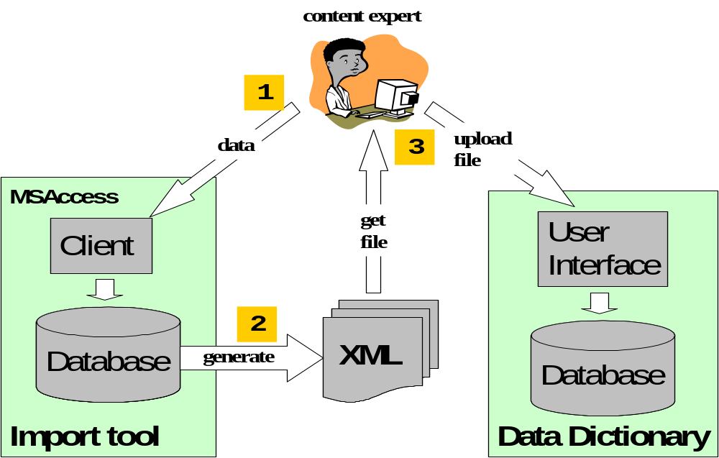
The basic principle of how this tool works is presented on figure 8.

Figure 8. Basic working principle of Import tool

Actions in Import tool's working sequence are as follows:
- Content expert, using the usual MS Access flat table editing view, enters the definitions into the tool's database.
- Content expert forces the tool to generate an XML file of the definitions entered.
- Content expert takes the generated XML file and uploads it into the DD which then parses the file and stores the found data into its database.

The reason for using XML as an intermediate format is to ensure that while still enabling the user to get the best of MS Access handiness, the definitions can be imported into a Data Dictionary on any imaginable platform. And normally DD would run exactly on Linux where MS Access files would be difficult to work with.
A sample working view of Import tool is given on figure 9.
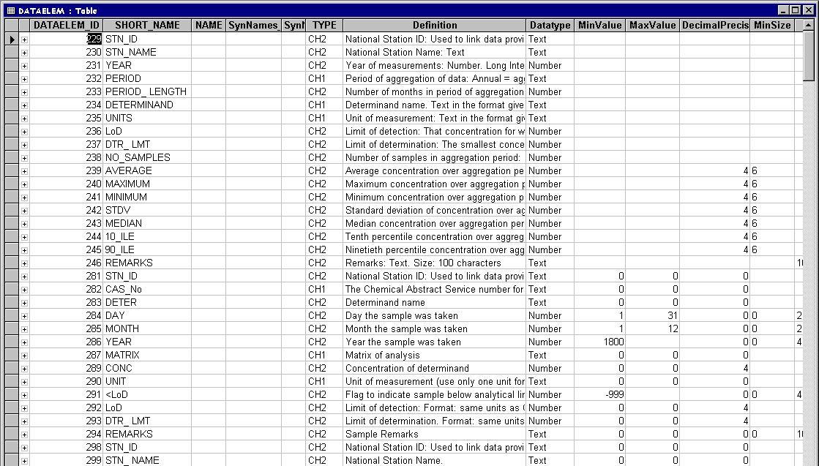

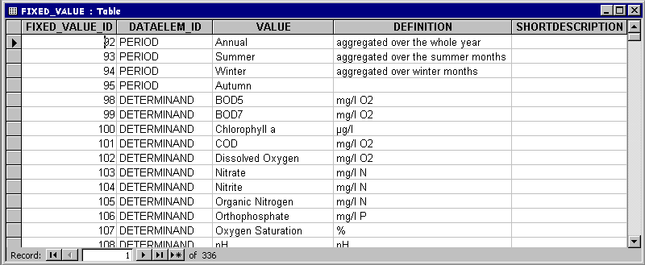
Figure 9. Screen shots of Import tool

In the upper part of figure 9 you can see a snapshot of the view for working with data elements, the lower part presents how the view looks for working with fixed values of data elements. As you can see, they are simple flat tables, giving a better overview than the web-based user interface would enable. Note that these two shots are just a small part of all different views in Import tool.
Mostly there's a separate table for each of the dictionary's basic concepts. The columns in table stand for the concept’s fields and attributes, corresponding to the fields of the concept's table and rows of attribute tables in the DD database. This of course means that each row in such tables does not necessarily represent exactly once concept, because for each new attribute one has to add a new row, repeating all the rest of attributes for the given concept.
The views provide helping drop-down lists wherever possible.
Once the definitions have been entered, the user forces the tool to generate an XML representation of them. For that the tool has a form where the user can specify the file where the XML must be generated to and press 'Generate' for performing the generation. But before doing so, the user also has a chance to specify which exactly type of import he/she is going to perform:
- Import of all the dataset definitions present in the tool
- Import of only the fixed values of a selected data element
Layout of the generated XML file is no subject to any of the common standards, it is designed by the developer just for the mere purpose of getting the data from Import tool to DD database and no other parties will need to work with this XML. Except for the parser at the DD end of course.
A snapshot of a generated XML is shown on figure 10 below.
Once the XML has been generated, the user uploads it into DD, using the corresponding form in DD user interface and the importing code transports it all into the DD database.

NB! There are some important limitations to the Import tool that you should know:

- The tool does not have a link to DD database. This means that its model is not automatically self-updating when the model in the DD database has changed. The most concrete example can be given on the basis of attributes. In Import tool they are represented as columns in the tables worked with. In other words the attribute set in Import tool has been hard-coded. While in the DD database attributes are defined in rows, rather than in columns. This finally means that whenever a new attribute is added to the DD database, or an existing one is changed or deleted, it will not automatically reflect in Import tool and the changes must be done by hand. This sounds like quite a drawback, but luckily the changes do not concern the code. Only a new column has to be added/removed to/from a selected table.

- Whenever the user induces an XML generation, all the contents of tool's database at that moment will be generated into XML.
This means that if the user has defined several different datasets, but wants to import only one of them into DD, he/she has to create a separate instance of the tool for that dataset and use that instance for entering and importing the definition of the desired dataset.
So it is highly recommended that before you start entering any definitions into the Import tool, make it clear if you want to actually import only some of them. And if so, create a separate tool instance for those.
While this might sound rather primitive, creating a separate instance of Import tool is luckily rather easy. Because Import tool is just another MSAccess file (.mdb) and all you have to do is to make a copy of it.

<?xml version="1.0" encoding="UTF-8"?>
<import>
<RowSet name="Dataset">
<DATASET>
<Row>
<DATASET_ID>1</DATASET_ID>
<SHORT_NAME>CDDA</SHORT_NAME>
<Version>1.0</Version>
<Name>CDDA</Name>
<Identifier>CDDA</Identifier>
<ShortDescription/>
<Definition/>
<DescriptionOfUse/>
<Theme>CDDA</Theme>
<Sub-theme/>
<Keywords/>
<SynNames_name_1/>
<SynNames_name_2/>
<EEAissue_name_1/>
<EEAissue_name_2/>
<EEAissue_name_3/>
<EEAissue_name_4/>
<ROD/>
<Indicators/>
<Methodology>Over the last few years, several requests for validation . . . </Methodology>
<PlannedUpdFreq/>
<References/>
<RegistrationAuthority_name_1/>
<RegistrationAuthority_name_2/>
<Guidelines_url_1/>
<Guidelines_url_2/>
<Guidelines_description_1/>
<Guidelines_description_2/>
</Row>
<Row>
<DATASET_ID>3</DATASET_ID>
<SHORT_NAME>Rivers</SHORT_NAME>
<Version>1.0</Version>
<Name>Rivers</Name>
<Identifier>Rivers</Identifier>
<ShortDescription/>
<Definition/>
Figure 10. Snapshot of the XML used between Import tool and DD

Configuration & installation
Guidelines for installing and configuring Data Dictionary have been provided in a separate DD Installation Guide document. However, configuration details are also a suitable subject for the Detailed Design, so see the following chapters.

Configuring DD web
DD runs on top of two servers- Apache Web Server and Tomcat Java Server (the latter also being a product of Apache’s). Guidelines on how to set the two up and interact with each other are available in DD Installation Guide document. Once you’ve managed to set the two up, you will have a web.xml file in the root of /datadict/public/WEB-INF directory and that’s the file where you can configure DD’s servlets and context parameters.

Servlets
DD has the following servlets listed by the servlet class name, required url-pattern and the servlet’s purpose:
servlet-class | url-pattern | servlet’s purpose
com.tee.util.EnvServlet | /env/* | Returns info on servlet context (hidden in xmlserver.jar)
com.tee.uit.servlets.XmlRpcRouter | /rpcrouter | The XML-RPC router for API  (hidden in uit-servlets.jar)
eionet.meta.LoginServlet | /Login | Performing the user login.
eionet.meta.LogoutServlet | /Logout | Performing the user logout.
eionet.meta.DocUpload | /DocUpload | Performing the document upload.
eionet.meta.DocDownload | /DocDownload | Performing the download of an uploaded document.
eionet.meta.GetSchema | /GetSchema | Retreiving definitions in XMLSchema format.
eionet.meta.GetPrintout | /GetPrintout | Retreiving definitions in PDF format.
eionet.meta.exports.xmlinst.XmlInstServlet | /GetXmlInstance | Retreiving definitions in XML instance format.
eionet.meta.exports.xforms.XFormServlet | /GetXForm | Retreiving definitions in XForm format
eionet.meta.exports.xls.XlsServlet | /GetXls | Retreiving definitions in MS Excel format
eionet.meta.exports.CacheServlet | /GetCache | Retreiving cahced documents
eionet.meta.ImgUpload | /ImgUpload | Performing the upload of an image for image attribute.
eionet.meta.DsVisualUpload | /DsVisualUpload | Performing the upload of a data model image.
eionet.meta.HarvestingServlet | /HarvestingServlet | Performing the routine of harvesting complex attributes.
eionet.meta.inservices.InServicesServlet | /InServices | Performs a call to an outer application by given inputs.
eionet.meta.Import | /Import | Importing XML from Import tool.
eionet.meta.GetImportResults | /GetImportResults | Producing results of an import from Import tool.

Context parameters
DD has only the following context parameters that one could change:
Parameter name | Parameter purpose
log-level | Integer from 1 to 5. The higher the number, the more log will be produced. Default is 5.
visuals-path | Full path of the directory where DD can store the image files uploaded by users to describe dataset models and image attributes.  So make sure that the user under which the Tomcat is running, has read-write rights to that directory. If you won't specify this parameter, Tomcat will try to store into the home directory of the user under which it is running.
temp-file-path | Full path of the directory where DD can store the temporary files it uses when importing datasets in XML formats (the files will be deleted after import).  Make sure that the user under which the Tomcat is running, has read-write rights to that directory. If you won't specify this parameter, Tomcat will try to store into the home directory of the user under which it is running.
doc-path | Full path to the directory where DD stores the documents uploaded and/or cached.  Make sure that the user under which the Tomcat is running, has read-write rights to that directory. If you won't specify this parameter, Tomcat will try to store into the home directory of the user under which it is running.

NB! Please make sure that the visuals-path, temp-file-path and doc-path parameters point to the correct directories.

Configuring DD application
DD application is configured by the help of *.properties files in /datadict/public/WEB-INF/classes directory. Every sub-chapter below will focus on one such file.

eionetdir.properties
This is the file where the configuration of DD communication to EIONET’s LDPA directory is held. One only needs to make sure that the ldap.url property points to the URL of the LDPA directory one wants to use.

log4j. properties
This is the configuration of log4j.jar library used for logging messages. Here one only needs to make sure the log4j.appender.f.File property is pointing to the full path of the DD log file. Also it must be ensured that Tomcat has write access to this file.

teXDBMsg.properties
This is a configuration of pre-fixed messages used by the xmlserver.jar library. This file does not need to be changed!

uit.properties
This is the most crucial DD properties file. The following properties must be taken of notice here:
Property | Purpose/Idea/What it must contain
services.definition.file | Full physical path to the DD XML-RPC service descriptor file.
application.acl.folder | Full physical path to the directory where the ACL-related files are residing.
application.localgroups.file | Full physical path to the file where the ACL user groups are defiend.
application.permissions.file | Full physical path to the file where the possible ACL permissions are declared.
db.url | URL of the DD database, with jdbc:mysql protocol and 3306 port (of MySQL).
db.user | The DD database username that the DD application must use to operate.
db.pwd | The password that db.user uses.

More about ACL-related properties is available in the above-referenced full documentation of ACL mechanism.
Properties not listed above should be of no interest.

datadict.properties
This the second-most important DD properties file. The following properties must be taken of notice here:
Property | Purpose/Idea/What it must contain
db.url | URL of the DD database, with jdbc:mysql protocol and 3306 port (of MySQL).
db.usr | The DD database username that the DD application must use to operate.
db.psw | The password that db.user uses.
harvester.log | Full physical path to the directory where the complex attributes harvester must log its messages.
pdf.uni-font | Full physical path to the True Type Font file that DD must use for handling UNICODE in generated PDF documents.
xforms.templ.url | The full URL from where the DD should retrieve the template for XForm outputs it generates.
xls.schema-url | The full URL to the servlet providing XML Schemas, with the value of ’id’ parameter missing. DD will use this in generated MS Excel files.
xls.schema-url-sheet | The name of the MS Excel workbook sheet where the DD will hide the URL of the XML Schema corresponding to the generated MS Excel workbook.
jsp.url-prefix | Full URL to the DD website. This is used by certain JSP file in order to build reference URL to certain definition views in DD.
inserv.webrod.url | Full URL to the XML-RPC router of ROD that DD must communicate to.
inserv.webrod.name | The name of ROD’s XML-RPC service.
inserv.webrod.ra-url-pattern | The pattern of the full URL to the detailed views of reporting activities in ROD. The part that DD must substitute with activity ID must be marked in this pattern by ”<RA_ID>” string (quotes not included).
outserv.elm-details-url | The pattern of the full URL to the detailed views of element definitions in DD. This is used by ROD and the part that ROD must substitute with element ID must be marked in this pattern by ”<ELM_ID>” string (quotes not included).

